Barrel Shape and Chromophore Rigidity Predict Fluorescent-Protein Photophysics

Luke P. Begg, Madeline L. Mason, Marc Zimmer*
Chemistry Department, Connecticut College, New London, CT 06320

Keywords: fluorescent proteins; beta-barrel geometry; chromophore rigidity; photophysical properties; Protein Data Bank; AlphaFold; computational structural biology; agentic AI

Abstract
The 11-stranded β-barrel of fluorescent proteins (FPs) is universally conserved, yet its quantitative geometry has not been systematically characterized. We analyzed cross-sectional barrel geometry across 908 FP crystal structures in the RCSB PDB by PCA-based axis determination and convex hull analysis of protein-atom slices at the chromophore plane; 780 structures (210–245 residues, with the chromophore-containing chain selected in FP-complex co-crystals) form the canonical analysis cohort. Barrel shape, but not size, correlates with emission wavelength: red-shifted proteins have narrower, more elliptical barrels (ρ = –0.329 for minor axis, p = 1.9 × 10⁻¹⁷). Fluorescence quantum yield, by contrast, is not governed by barrel size: it tracks how rigidly the barrel holds the chromophore (chromophore-to-barrel B-factor ratio, ρ = –0.49 per unique FP), together with the chromophore’s ground-state planarity (ρ = –0.42) as an independent signal of comparable strength; the planarity term is concentrated in red fluorescent proteins and is examined in detail in a companion study. Principal correlations survive Benjamini–Hochberg correction and partial correlation controlling for resolution. The barrel is not a passive scaffold: it constrains chromophore rigidity and thereby shapes photophysical output. The pipeline was developed with Claude (Anthropic) via Claude Code.

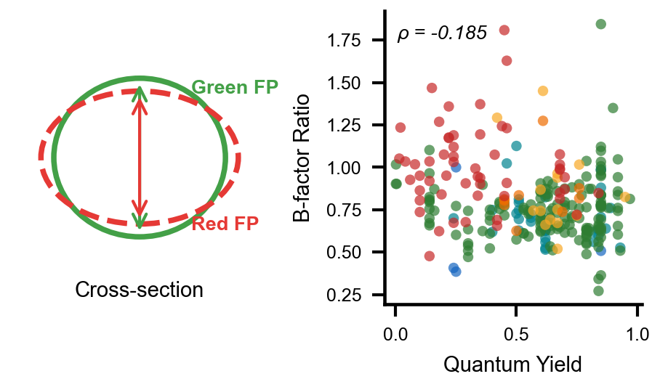

Introduction
Green fluorescent protein (GFP), first observed in the jellyfish Aequorea victoria by Shimomura et al. in 1962,¹ has fundamentally transformed biological research by enabling the direct visualization of proteins, organelles, and cellular processes in living systems.² The subsequent cloning and heterologous expression of GFP by Chalfie et al.³ demonstrated that the protein fluoresces without requiring cofactors or external enzymes, establishing GFP as a genetically encodable marker. The significance of this discovery was recognized with the 2008 Nobel Prize in Chemistry, awarded to Shimomura, Chalfie, and Tsien.⁴ In the decades since, fluorescent proteins have become indispensable tools across cell biology, neuroscience, and biotechnology, serving as reporters, biosensors, and partners in FRET⁵ and, more recently, super-resolution microscopy.⁶ˉ⁷
The three-dimensional structure of GFP, resolved by X-ray crystallography in 1996, revealed a distinctive 11-stranded beta-barrel fold approximately 42 Å in length and 24 Å in diameter.⁸ˉ⁹ This barrel encases a central alpha-helix, with the chromophore, formed by autocatalytic post-translational cyclization of residues Ser65–Tyr66–Gly67, is positioned at the geometric center and shielded from solvent.¹⁰ˉ¹¹ The rigid encapsulation minimizes non-radiative decay, enabling high fluorescence quantum yields (the fraction of absorbed photons re-emitted as fluorescence; hereafter quantum yield for brevity). The same 11-stranded topology is conserved across all known fluorescent protein families, including GFP-derived variants and fluorescent proteins from anthozoan organisms such as DsRed, despite sequence identities as low as 25%.¹²ˉ¹³
Protein engineering has produced a palette of fluorescent protein variants spanning the visible spectrum. Substitution of Tyr66 with tryptophan or histidine yields cyan or blue variants, respectively.¹⁴ The Thr203Tyr mutation introduces a π-stacking interaction that red-shifts emission by ~20 nm.¹⁵ In the DsRed family, an additional oxidation extends the conjugated π-system, producing red emission.¹⁶ Structure-guided engineering has achieved notable results: Goedhart et al. obtained a quantum yield of 0.93 in mTurquoise2 through a single packing mutation (I146F) identified by structure-guided saturation mutagenesis,¹⁷ while Campbell and colleagues have systematically monomerized and optimized coral-derived variants.¹⁸,¹⁹ Hirano et al. developed StayGold, a green fluorescent protein from the jellyfish Cytaeis uchidae, which exhibits exceptional photostability.⁴¹ A persistent trend across this engineering is that quantum yield decreases with increasing emission wavelength.²⁰ This has been attributed to increased vibrational degrees of freedom in extended conjugation systems, which open additional non-radiative relaxation pathways.
Despite the wealth of structural data now available, over 800 crystal structures classified within the GFP-like superfamily by SCOP, CATH, and Pfam, the quantitative geometry of the beta-barrel itself has received little systematic attention. Previous studies have focused on chromophore chemistry, hydrogen bonding networks, and site-specific mutation effects on spectral properties.²¹⁻²³ Computational studies have shown that the barrel contracts upon chromophore maturation and that water permeability through the barrel wall varies between GFP variants.²⁴,²⁵ Analysis of conserved glycine residues at positions 31, 33, and 35 demonstrated that these residues are essential for proper barrel folding and assembly.²⁶ Megley et al. showed that the φ and τ dihedral angles of the chromophore differ between yellow, blue, and green variants and correlate with non-radiative decay.²⁷ Ahmed et al. used molecular dynamics to guide engineering of YuzuFP, identifying a mutation at residue 148 that increased brightness 1.5-fold.²⁸ However, the beta-barrel has generally been treated as a static scaffold. Whether barrel geometry varies systematically across fluorescent protein families, and whether such variation relates to photophysical properties, has not been addressed.
Here, we report a systematic analysis of beta-barrel cross-sectional geometry across 908 fluorescent protein crystal structures from the RCSB Protein Data Bank. For each structure, the barrel axis was determined by principal component analysis (PCA) of backbone Cα coordinates, the structure was rotated to align this axis with the z-axis, and a perpendicular cross-sectional slice was extracted at the chromophore level. Convex hull analysis yielded area, eccentricity, circularity, and axis lengths for each barrel. Chromophore τ and φ dihedral angles were extracted and incorporated into the analysis. These measurements were integrated with spectral data from FPbase,³⁴ crystallographic B-factors, and chromophore–barrel contact counts. The results show that emission wavelength varies with barrel shape, that quantum yield depends not on barrel size but on how rigidly the barrel holds the chromophore (chromophore-to-barrel B-factor ratio, ρ = –0.49 per unique FP) and on the chromophore’s ground-state planarity (ρ = –0.42, an independent signal developed in a companion study), and that barrel eccentricity correlates with chromophore dihedral twist.
Prior AI applications in FP research have used models trained on protein sequence or structural data for design: AlphaFold2 and RoseTTAFold to predict chromophore-related post-translational modifications,³¹ ESM3 to design the de novo FP esmGFP at 58% identity to known GFPs,³² and protein-specific transformers to predict fluorescence properties from sequence.³³ In contrast, the analysis presented here uses a general-purpose conversational LLM (Claude, Anthropic; via Claude Code²⁹) as a coding assistant for systematic crystallographic and statistical analysis of an existing structural database — a role following the disk-mediated multi-task pattern recently described for theoretical physics by Schwartz.³⁰ A short failure-mode case study (chromophore mis-detection) is provided in Note S1 to illustrate the human-validation discipline required. All scientific decisions, interpretation, and responsibility for the claims rest with the human authors.

Methods
Dataset Assembly.
The RCSB Protein Data Bank was queried for all X-ray crystal structures belonging to the GFP-like superfamily using annotations from SCOP (b.67.1), CATH (2.60.120.200), Pfam (PF01353), and InterPro (IPR011584, IPR000786). The union returned 885 entries. Coordinate files in mmCIF format were downloaded for all entries. Eight structures were removed after inspection (APOBEC3H complexes, a DNA co-crystal, and misannotated entries). Sequences were extracted and aligned using Clustal Omega³⁵ and inspected in Jalview³⁶ to confirm GFP/DsRed motifs. The initial dataset comprised 877 structures; cross-referencing against additional RCSB annotations identified 31 confirmed FP barrels deposited after the last SCOP update, yielding a final dataset of 908 structures (Table S1).
Chromophore Detection.
Each structure was classified by scanning non-standard residues for known chromophore residue names. The detection list encompasses all major fluorescent chromophore variants, requiring two criteria: (i) an imidazolinone ring (atoms N2, C2, O2 in the PDB CONECT record), and (ii) a π-conjugated aromatic ring at position 66, irrespective of whether that ring carries a heteroatom donor. Phenol-based (Tyr66), indole-based (Trp66), imidazole-based (His66), and phenyl-based (Phe66) rings are all accepted; the detection logic checks for any of the standard aromatic-ring atom inventories associated with these four side chains as well as known non-standard naming conventions used in modified chromophore residues. Detection covered Tyr66-based GFP-type chromophores (CRO, CR2, CRQ, GYC, CRG, NYG, and others), Trp66-based CFP-type chromophores (PIA, CRF, CRK, CR7, CFY, CCY, and others), His66-based BFP-type chromophores (GYS, IIC, CSH, and others), Phe66-based variants where present, and red/orange-shifted variants (NRQ, CH6, CH7, SWG, OHD, RC7, B2H, C12, XYG, DYG, and others; 71 distinct residue codes in total, including CR8 whose aromatic ring uses non-standard PDB atom names). Residues with an intact imidazolinone ring but no aromatic ring at position 66 (CRX, MDO, C99, CLV, KWS, Q2K, NRP, and related synthetic analogs) were excluded as non-fluorescent. Structures in which the chromophore precursor is stored as standard residues SER65–TYR66–GLY67 (uncyclized/immature state) were likewise classified as lacking a mature chromophore. Of 908 structures, 861 contained a validated mature chromophore and 47 did not (Table S1). The chromophore detection step provides an instructive example of AI failure (Note S1).
Chromophore Torsion Angles.
Chromophore dihedral angles were defined following Megley et al.:²⁷ τ = N₁–C₁–C₂–C₃ (PDB atoms N2–CA2–CB2–CG2), describing rotation about the imidazolinone–bridge bond, and φ = C₁–C₂–C₃–C₄ (atoms CA2–CB2–CG2–CD1), describing rotation about the bridge–phenol bond. Structures with |τ| < 30° were classified as cis, |τ| > 150° as trans, and the remainder as twisted. Absolute magnitudes |τ| and |φ| are used in correlation analyses as descriptive measures of out-of-plane chromophore distortion, irrespective of cis/trans configuration; the algebraic sum τ + φ is likewise treated as a descriptive composite of the two rotations and is not interpreted in the mechanistic sense of the hula-twist photoisomerization pathway. Valid angles were obtained for 690 structures (Table S1).
Barrel Axis Determination.
The barrel axis was determined independently for each structure by PCA of backbone Cα coordinates. The eigenvector corresponding to the largest eigenvalue (PC1) was taken as the barrel axis. The eigenvalue ratio λ₁/λ₂ averaged 2.18, confirming elongated barrel geometry. A rotation matrix mapping PC1 onto [0, 0, 1] was applied to all non-hydrogen coordinates. The cross-sectional slice was centered on the chromophore (mean z of chromophore atoms = 0) and defined as the protein heavy atoms (standard amino-acid + chromophore residues) with |z| ≤ 2.0 Å; see Geometry Quantification below.
Geometry Quantification.
All non-hydrogen atoms of the standard amino-acid and chromophore residues of the analyzed chain (i.e., protein heavy atoms) in each slice were projected onto the xy-plane (i.e., the plane perpendicular to the barrel axis). Ordered solvent molecules, crystallization additives, and ions were excluded from the slice so that the convex hull represents the protein barrel itself rather than the crystallographic solvent shell. The convex hull was computed using scipy.spatial.ConvexHull.³⁷ Cross-sectional area, perimeter, and an ellipse fit (via the 2D covariance matrix) yielded major and minor axis lengths. Eccentricity was calculated as e = √(1 – b²/a²). Circularity was defined as 4πA/P². A ring-shape test confirmed that slices captured the barrel wall (peripheral:central density ratios of 5.4–7.0). These measurements describe the outer envelope of the beta-barrel including the wall atoms; they are therefore larger than the inner channel diameter (~24 Å in avGFP⁸) reported in the original crystallographic papers, which refers to the solvent-accessible cavity through which the central alpha-helix passes. The beta-sheet walls add approximately 2–3 Å on each side, consistent with the mean minor axis of 29.5 Å reported here.
Canonical FP-Barrel Cohort.
Inspection of the 908 structures revealed that the extremes of the cross-sectional area distribution are dominated by entries whose PCA-derived barrel axis and chromophore-plane slice do not isolate a single 11-stranded barrel. Sequence-length outliers fall into two classes: (i) short constructs (< 210 residues, e.g., PDB 6LOF at 163 residues) corresponding to fragments, split-GFPs, or partial barrels, and (ii) long constructs (> 245 residues, e.g., GCaMP calcium sensors at ≈ 390 residues fused to calmodulin and the M13 peptide) in which the PC1 axis is tilted by fused domains so that the chromophore-level slice intersects non-barrel coordinates. The monomeric FP barrel has a sequence length of approximately 220–240 residues; we therefore restrict the geometric analysis to structures with seq_length between 210 and 245 (inclusive). A secondary chain-selection audit (Note S1(b)) identified 15 FP-complex co-crystals in which the original pipeline analyzed the binding partner rather than the FP chain; these entries were reprocessed using the chromophore-containing chain, which placed 13 of them into the canonical cohort and reclassified one (4XL5) from chromophore-absent to chromophore-positive. Two entries are excluded by name because their geometry is dominated by non-standard quaternary structure: 6H01 (domain-swapped sfGFP) and 3U0K (RCaMP, a circularly permuted red FP fused to calmodulin). The final canonical cohort comprises 780 structures. This canonical cohort eliminates major-axis outliers exceeding 50 Å while retaining all monomeric FPs identified by name-matching against FPbase. All reported barrel-geometry statistics, color-class comparisons, B-factor and dihedral correlations, and multivariate models in this paper refer to this 780-structure cohort. Section-level sample sizes (e.g., n = 633 for spectral correlations, n = 310 for quantum-yield correlations) reflect the further availability of FPbase spectral data within the canonical cohort. The full 908-structure dataset, including the seq-length outliers, is retained in Table S1 and is used only for the population-level descriptive statistics in the Dataset Composition subsection.
Spectral and Photophysical Data.
Spectral data were obtained from FPbase³⁴ using a hierarchical four-strategy matching protocol. (1) A manually curated dictionary mapped 176 PDB entries to known FPbase proteins. (2) The FPbase GraphQL API was queried by PDB identifier for entries with registered structures. (3) PDB titles were searched against a dictionary of over 150 fluorescent protein variant names (e.g., EGFP, mCherry, Venus, Dronpa) using case-insensitive keyword matching. (4) Remaining structures were assigned spectral properties by chromophore residue type where unambiguous. When multiple strategies returned matches, the highest-priority match was retained; each PDB identifier was mapped to at most one FPbase entry. Of 908 structures, 694 (76.4%) were matched to 74 unique FPbase protein names; 214 remained unmatched (predominantly structures with abbreviated or novel variant names not registered in FPbase). Standard FP databases often assign the wild-type avGFP quantum yield (0.79) by keyword inheritance, which obscures real within-color quantum-yield variation. We therefore re-curated quantum-yield values directly from FPbase. Whenever possible a crystal structure was matched to an FPbase entry by PDB identifier; when no direct PDB match was available, the chain-A sequence was matched to FPbase, accepting matches with at least 99% sequence identity to an entry with a curated quantum yield. This recovered quantum-yield values for 354 structures, spanning 0.0001 to 0.97, in place of uncurated annotations that contained only 14 distinct values and were dominated by repeated use of the wild-type avGFP value, 0.79. For statistical analysis involving quantum yield, replicate crystal structures were collapsed so that each fluorescent protein contributed a single data point. Extinction-coefficient values from published sources²⁰,³⁴,³⁸ were likewise drawn from the matched FPbase entries. Color classes were assigned by emission wavelength: blue (<460 nm), cyan (460–505 nm), green (505–545 nm), yellow (545–575 nm), orange (575–610 nm), red (>610 nm). The complete mapping is provided in Table S1.
B-Factor and Contact Analysis.
For each structure, two atom sets in the analyzed chain were defined: the chromophore set (all non-hydrogen atoms of the non-standard residue identified as the chromophore — imidazolinone ring, methine bridge, and pendant aromatic ring, for Tyr66-, Trp66-, His66-, or Phe66-derived chromophores alike), and the scaffold set (all non-hydrogen atoms of the standard amino-acid residues in the same chain). The latter is referred to throughout this paper as the "barrel" set for brevity, but it is not restricted to the eleven β-strands of the barrel wall — it also includes the central α-helix that bears the chromophore-forming tripeptide and the capping loops at both ends of the barrel. Mean B-factors were computed for each set, and the B-factor ratio (chromophore / scaffold) quantifies chromophore rigidity relative to the rest of the chain. Chromophore–barrel contacts were counted as the number of (chromophore-atom, scaffold-atom) pairs within 4.0 Å of one another (i.e., pair count, not unique scaffold-atom count).
Statistical Analysis.
Analyses were performed in Python 3.14 using SciPy³⁹ and scikit-learn.⁴⁰ Spearman rank correlations assessed monotonic relationships between continuous variables. Mann–Whitney U tests compared two groups; Kruskal–Wallis H tests compared multiple groups. All reported p-values were corrected for multiple testing using the Benjamini–Hochberg false discovery rate (FDR) procedure; the family comprised 63 pre-specified hypothesis tests covering all meaningful pairwise Spearman correlations among the six geometry metrics, four photophysical variables (em_max, lit_qy, stokes_shift, b_factor_ratio), and crystallographic resolution; eleven dihedral correlations involving τ, φ, |τ|, |φ|, the signed sum τ + φ, and ground-state planarity; plus the five Mann–Whitney chromophore-present vs absent tests, the three cis-vs-trans tests, and the three Kruskal–Wallis by color class tests. The complete list with raw and BH-corrected p-values is provided in Table S4; 45 of 63 tests survive the FDR threshold at q < 0.05. Partial Spearman correlations controlling for crystallographic resolution were computed by the rank-residual method: all three variables were rank-transformed, the rank-transformed dependent and independent variables were each regressed on rank-transformed resolution by ordinary least squares, and the Pearson correlation of the residuals was reported (equivalent to the partial Spearman correlation).
AI-Assisted Computation.
All scripts were generated by Claude (Anthropic, Opus 4) via Claude Code and reviewed by the authors before execution. Each computational task was specified in plain language; the model produced code, results were written to disk, and intermediate files were used for cross-checking against known structures. Observed failure modes (steps reported as validated without performing checks, simplification based on unrelated patterns, premature halting on first error) were mitigated by mandatory intermediate output files and repeated verification prompts; the chromophore-detection failure is documented in Note S1. All scientific questions, methodology choices, and interpretations were made by the human authors.
AlphaFold Structure Analysis.
AlphaFold DB v6 coordinate files were downloaded for FP sequences via the EBI AlphaFold API and matched to crystal structures via the UniProt REST API. Two analyses were performed: a paired comparison between 51 wild-type FPs for which both an AlphaFold model and the highest-resolution crystal structure exist (mean crystal resolution 1.63 ± 0.37 Å, mean pLDDT 96.7 ± 1.3); and a population-level analysis of the 309 successfully predicted AlphaFold structures whose sequence length falls within the canonical 210–245 residue window (327 successful predictions in total; 18 fell outside the window). Because AlphaFold structures lack the cyclized chromophore, the slice was centered on the barrel centroid (z = 0 in the PCA frame) rather than the chromophore z; the rest of the geometric pipeline matched the crystal-structure pipeline exactly. The pLDDT confidence scores in the AlphaFold B-factor field were not used in cross-structure comparisons with crystallographic B-factor ratios. Paired comparisons used two-sided Wilcoxon signed-rank tests; the 95% confidence intervals reported in Results are normal-approximation intervals on the mean paired difference (Δ̄ ± 1.96 SE); the Bland–Altman plots in the Supporting Information show the 95% limits of agreement (Δ̄ ± 1.96 SD).

Results and Discussion
Dataset Composition.
The dataset comprises 908 fluorescent protein crystal structures: 861 with a validated mature chromophore and 47 without. The 861 chromophore-containing structures span 69 distinct residue types (CRO, CR2, NRQ, CRQ, GYS, PIA, and others). Spectral data from FPbase were matched to 694 structures. Quantum yield data were available for 354. The color class distribution was green (n = 464), red (n = 95), yellow (n = 69), cyan (n = 48), orange (n = 11), and blue (n = 10). The ten blue entries comprise nine Y66H variants identified from their His66-derived chromophore residue codes (IIC, CRG, CSH, XXY; including PDB 1BFP, 1KYP/R/S, 1EMF, 2EMD/N/O, 2FWQ) plus one Tyr-based blue variant (PDB 4ORN, ex/em 380/440 nm). The Y66H entries had been mis-assigned em_max = 507 nm by FPbase keyword matching to generic "green fluorescent" titles and were re-classified directly from their chromophore residue identities. BFPs remain underrepresented in the PDB because His66-derived variants typically exhibit lower brightness and photostability than Tyr66-based counterparts, and their near-UV excitation overlaps with cellular autofluorescence; most modern applications requiring short-wavelength emission use cyan variants such as mCerulean or mTurquoise2 instead. Resolution ranged from 0.77 to 3.60 Å (mean 1.86 ± 0.47 Å). Because the PDB contains multiple entries for the same or closely related proteins. Under a granular per-protein identity (matched FPbase entry plus chain-A sequence; Table S7), the 780 canonical structures represent 430 unique proteins. The effective sample size for cross-protein comparisons is therefore smaller than the total structure count, and robustness to pseudoreplication and sampling imbalance is assessed in Tables S2 and S7.
After applying the canonical sequence-length filter (210 ≤ residues ≤ 245) and the chain-selection audit described in Methods, the geometric analysis cohort comprises 780 structures: 739 with a validated mature chromophore and 41 without. Within this cohort the color class distribution is green (n = 414), red (n = 90), yellow (n = 64), cyan (n = 47), orange (n = 11), and blue (n = 10), and FPbase spectral matches are available for 633 structures (318 with quantum yield data). All subsequent results refer to this canonical cohort unless explicitly stated otherwise.
Barrel Geometry.
Cross-sectional geometry was computed for the 780 structures in the canonical cohort. Mean cross-sectional area was 689 ± 40 Å² (range 566–914 Å²). Mean eccentricity was 0.41 ± 0.12, indicating moderately elliptical cross-sections. Circularity averaged 0.92 ± 0.02. Major and minor axes averaged 32.7 ± 1.4 Å and 29.5 ± 1.3 Å, respectively. Barrel length averaged 49.3 ± 3.6 Å. Area and eccentricity were weakly positively correlated (ρ = +0.117, p = 0.001), reflecting the slightly larger major axis of more elliptical barrels. For comparison, when the same pipeline is applied to the full 908-structure dataset with crystallographic solvent included in the slice and no chain-selection audit, the area distribution is much wider (818 ± 194 Å², range 330–1975 Å²); the residual variance in the present canonical cohort is approximately 4.7-fold smaller, demonstrating that both the cohort definition and the exclusion of crystallographic solvent from the slice remove major methodological artifacts without altering the qualitative shape of the distribution.
Chromophore Maturation and Barrel Shape.
Within the canonical cohort, structures with a validated mature chromophore (n = 739) were compared to those without (n = 41). Cross-sectional area did not differ (689 ± 41 vs 691 ± 34 Å², p = 0.62), nor did circularity (0.922 ± 0.020 vs 0.919 ± 0.016, p = 0.25) or eccentricity (0.41 ± 0.12 vs 0.39 ± 0.11, p = 0.15). At the structure level, both axes were narrower in the chromophore-containing group: minor axis 29.4 ± 1.2 Å vs 30.9 ± 1.1 Å (p = 3.9 × 10⁻¹¹) and major axis 32.6 ± 1.4 Å vs 33.8 ± 1.4 Å (p = 3.1 × 10⁻⁸), while the convex-hull area was preserved (Figure S1). However, the two groups in this comparison are highly unbalanced both in size (739 vs 41) and in protein diversity (210 unique chromophore-positive proteins, six unique chromophore-absent proteins, mostly avGFP precursor variants), and the structure-level axis differences should be interpreted with this imbalance in mind. After pseudoreplication collapse to one highest-resolution structure per unique protein, the minor- and major-axis differences and the eccentricity trend do not survive (Table S2); only the circularity difference reaches significance (p = 4.6 × 10⁻⁴), and that effect is small in absolute terms (0.922 vs 0.919). The paired AlphaFold–crystal comparison provides only weak, partial support for the maturation hypothesis: AlphaFold, which lacks the cyclized chromophore, yields axes shifted in the direction expected if AlphaFold barrels resembled the chromophore-absent (uncyclized) crystals, but the shifts are much smaller than the within-crystal contraction. The minor-axis shift is not significant (Δ_minor = +0.23 Å, p = 0.25); the major-axis shift is significant but small (Δ_major = +0.45 Å, p = 0.02), both ≪ 1.2–1.5 Å within-crystal effect. We therefore conclude only that the gross barrel cross-section is largely established at the pre-cyclization stage and that any geometric imprint of chromophore maturation, if real, is too small to detect cleanly in this dataset.
Barrel Geometry by Emission Color Class.
Barrel geometry varied with emission color class (Figure S2). Eccentricity (Kruskal–Wallis H = 113.2, p = 8.6 × 10⁻²³), minor axis (H = 108.9, p = 7.0 × 10⁻²²), and circularity (H = 103.0, p = 1.2 × 10⁻²⁰) all differed across groups. Red fluorescent proteins had the most elliptical barrels and narrowest minor axes; green had the most circular. At the single-structure level (Figure 1), emission wavelength correlated with eccentricity (Figure 1B; ρ = +0.320, p = 1.4 × 10⁻¹⁶), minor axis (Figure 1A; ρ = –0.329, p = 1.9 × 10⁻¹⁷), and circularity (Figure 1C; ρ = –0.258, p = 4.5 × 10⁻¹¹). Emission was weakly correlated with the major axis (Figure 1D; ρ = +0.176, p = 8.3 × 10⁻⁶) and uncorrelated with barrel length (ρ = –0.028, p = 0.47). All reported p-values were corrected for multiple testing using the Benjamini–Hochberg procedure (q < 0.05); the key correlations remain significant after correction. These associations also strengthen after collapse to one highest-resolution structure per unique FPbase protein (n = 69 unique proteins): minor axis ρ = –0.54, p = 1.9 × 10⁻⁶; eccentricity ρ = +0.50, p = 1.5 × 10⁻⁵; circularity ρ = –0.47, p = 4.3 × 10⁻⁵ (Table S2), ruling out pseudoreplication of related variants as a driver. The correlations of emission with eccentricity, minor axis, and circularity also survive partial correlation analysis controlling for resolution. The major axis and barrel length are uninformative. These data are consistent with a red-shift associated with narrowing of the barrel in one dimension, rather than a general contraction. In DsRed-type red chromophores, an additional oxidation step extends the π-conjugated system by forming an acylimine group at the peptide bond N-terminal to the chromophore-forming tripeptide.¹⁶ The resulting larger chromophore occupies a different steric volume within the barrel pocket, which may contribute to the observed asymmetric narrowing; however, the causal direction of this relationship cannot be established from static crystal structures alone.

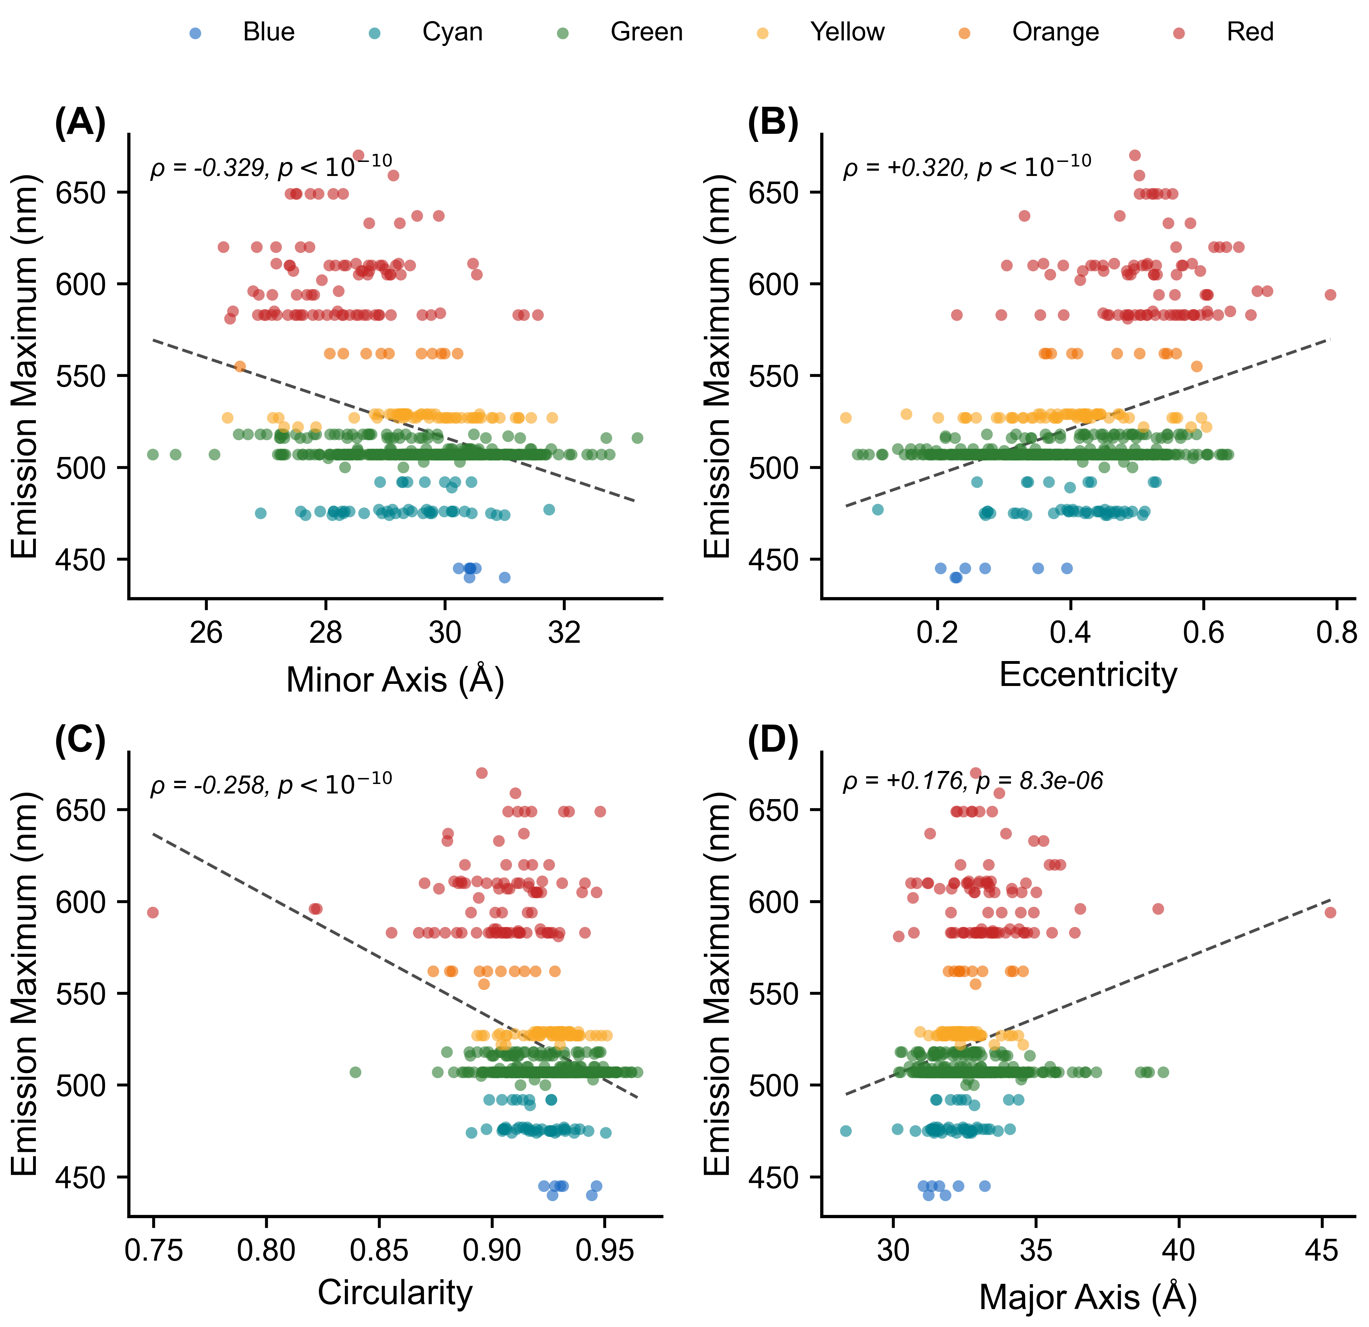
Figure 1. Continuous relationships between barrel geometry and emission wavelength in the canonical cohort (n = 633 structures with FPbase em_max). Each point is one structure, colored by emission class. (A) Minor axis (ρ = –0.329). (B) Eccentricity (ρ = +0.320). (C) Circularity (ρ = –0.258). (D) Major axis (ρ = +0.176). The relationships are monotonic but modest and display substantial scatter at the single-structure level; the reported Spearman ρ (rank correlation) and its p-value, not the visual spread, quantify each association, and the dashed lines are linear least-squares fits included only as guides to the eye (the trends are not assumed to be linear). The associations strengthen when replicate crystals are collapsed to one point per protein (Tables S2, S7). Red-shifted variants populate the narrower, more elliptical tail of each distribution. The same data summarized by emission color class are shown as bar charts in Figure S2.

B-Factor Ratio and Quantum Yield.
The B-factor ratio (chromophore/barrel) was computed for 739 structures in the canonical cohort. The mean ratio was 0.81 ± 0.22; in 86.3% of structures the chromophore was more rigid than the barrel (ratio < 1). The B-factor ratio was a significant predictor of quantum yield at the cohort level (Figure 2A; ρ = –0.309, p = 2.7 × 10⁻⁸, n = 310), surviving partial correlation controlling for resolution (partial ρ = –0.282). Collapsed to one entry per protein, it remains a strong and independent QY correlate (ρ = –0.49, n = 123; Table S6), comparable to chromophore ground-state planarity (see Chromophore Dihedral Geometry, below); the two capture distinct structural routes to brightness and are not an artifact of replicate structures. The ratio varied by color class (Figure 2C): blue 0.66 ± 0.19, cyan 0.70 ± 0.15, green 0.76 ± 0.17, yellow 0.79 ± 0.16, orange 0.88 ± 0.22, red 1.02 ± 0.24. In red fluorescent proteins, the chromophore is on average no more rigid than the barrel. This is not simply a chromophore-size effect: although the acylimine-extended red chromophore is larger and forms more barrel contacts than the green HBI chromophore (mean 138 vs 122 non-hydrogen atoms within 4 Å), its absolute B-factor (≈ 28 Å²) is comparable to that of its barrel rather than lower, so the additional bulk and contacts do not translate into greater relative thermal immobilization. Whether this reflects genuine chromophore dynamics or the refinement behavior of the extended conjugated system cannot be resolved from crystallographic B-factors alone.
The correlation between B-factor ratio and quantum yield is not simply a proxy for emission wavelength. Although emission correlates with the B-factor ratio (Figure 2B; ρ = +0.423), the B-factor ratio carries information about quantum yield beyond emission wavelength alone. The physical interpretation is direct: quantum yield depends on the competition between radiative and non-radiative decay. Non-radiative decay requires conformational motion, particularly rotation about the methine bridge. A chromophore that is rigid relative to its barrel has fewer accessible conformational states and therefore fewer decay pathways. This interpretation is consistent with the engineering examples discussed in the Implications section below. The extended conjugation that produces red emission introduces torsional degrees of freedom that the barrel does not fully constrain, explaining the mean B-factor ratio of 1.02 ± 0.24 for red variants compared to 0.70 ± 0.15 for cyan.

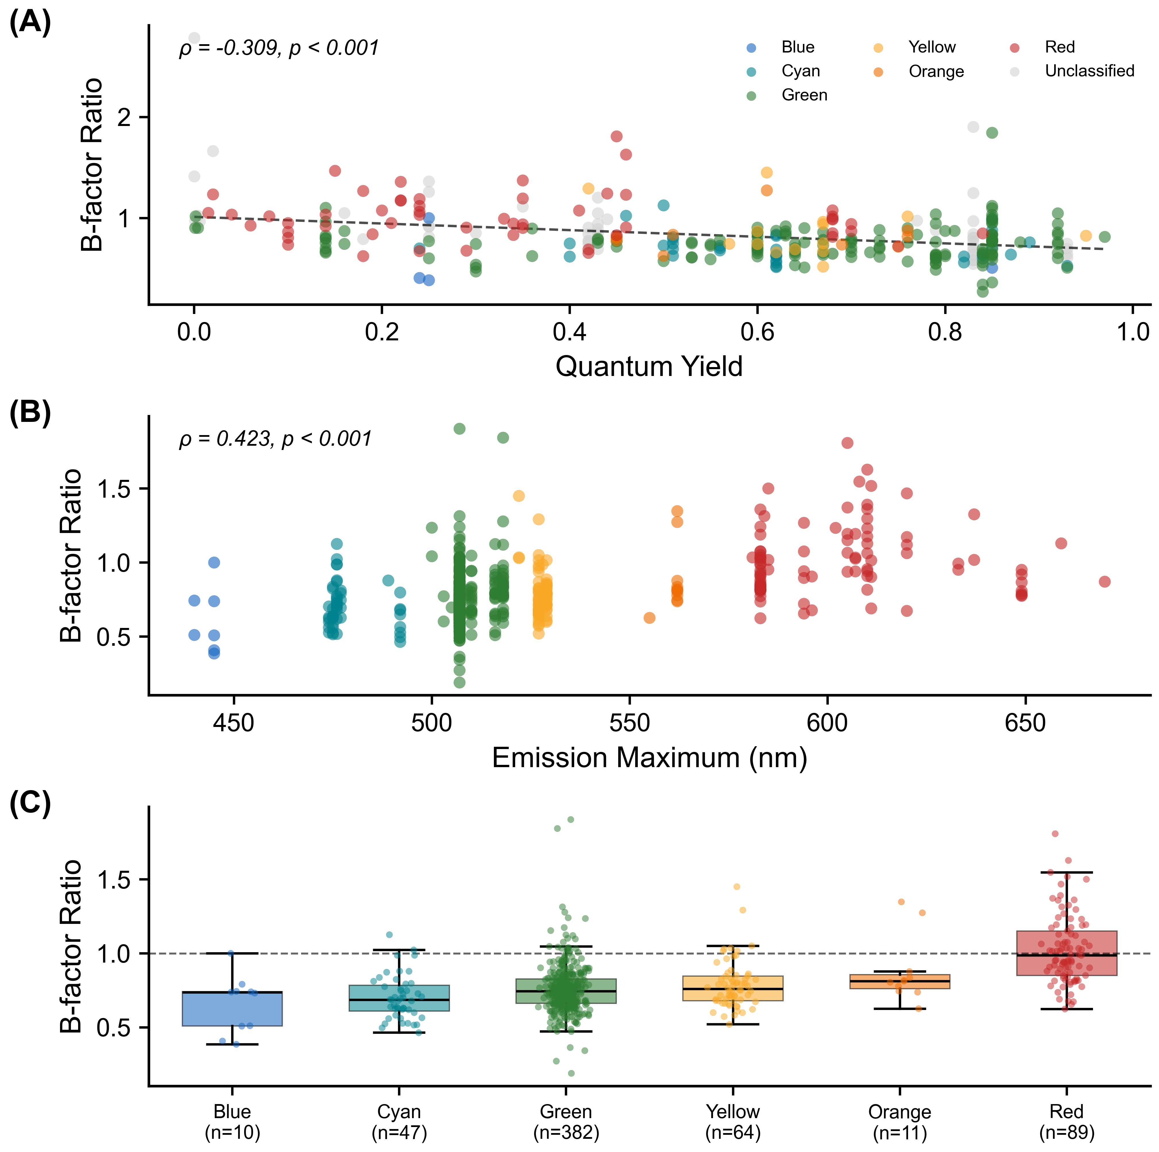
Figure 2. B-factor ratio analysis (canonical cohort, n = 780). (A) B-factor ratio vs quantum yield (ρ = –0.309). (B) B-factor ratio vs emission wavelength. (C) B-factor ratio by color class: box shows median and IQR with whiskers at 1.5 × IQR; individual structures are overlaid as jittered points; the dashed line at 1.0 indicates equal chromophore and barrel rigidity.

Chromophore–Barrel Contacts.
Restricting to the 739 chromophore-containing canonical structures, the mean number of (chromophore-atom, scaffold-atom) pairs within 4.0 Å was 133 ± 63 (pair count, not unique scaffold-atom count; see Methods). Pair count correlated with emission wavelength (ρ = +0.203, p = 5.6 × 10⁻⁷, n = 600).
Chromophore Dihedral Angles.
τ and φ dihedral angles were computed for 603 canonical-cohort structures (590 of which were classifiable as cis, trans, or twisted). Cis configurations predominated (441, 74.7%), with 111 trans (18.8%) and 38 twisted (6.4%). The τ angle correlated with eccentricity (ρ = –0.197, p = 1.1 × 10⁻⁶). Absolute twist magnitudes correlated with eccentricity (|τ|: ρ = +0.167; |φ|: ρ = +0.197) and B-factor ratio (|τ|: ρ = +0.158; |φ|: ρ = +0.155). The signed sum τ + φ was the strongest dihedral predictor of emission (ρ = –0.311, p = 1.0 × 10⁻¹²; Figure S3C). We note that τ + φ is used here as a descriptive algebraic sum of two static crystallographic dihedral angles, not in the mechanistic sense of the hula-twist photoisomerization pathway. To relate chromophore geometry to quantum yield we use the angular distance from the deposited (τ, φ) to the nearest planar reference, taking the minimum over the four planar settings (0°, 0°), (0°, 180°), (180°, 0°), and (180°, 180°). This folds the 180° phenol symmetry and the cis/trans degeneracy, so that a near-planar trans or ring-flipped chromophore is correctly scored as planar; an unfolded |τ| + |φ| sum instead misregisters such structures as maximally twisted (for example, near-planar mScarlet, φ ≈ 179°, which scores 180° rather than 2° from planar). Barrel cross-sectional metrics — area, minor axis, and eccentricity — are at best weak correlates of quantum yield (all |ρ| < 0.16), confirming that within-class brightness is not set by barrel size; the quantum-yield-relevant structural signals lie instead in how the barrel restrains the chromophore. Collapsing replicate crystals to one entry per protein (n = 123 unique FPs with both metrics; Table S6), two such features carry independent signals: the chromophore-to-barrel B-factor ratio (ρ = –0.49, p < 10⁻⁴) and the chromophore’s ground-state planarity (distance-from-planar vs QY, ρ = –0.42, p = 1 × 10⁻⁴); each survives adjustment for the other (partial ρ = –0.43 and –0.35). Neither is dominant, and both are modest, consistent with quantum yield being shaped by several structural routes — ground-state geometry, thermal damping, and local electrostatics — rather than a single geometric lever. The pooled, per-crystal correlation using the unfolded twist sum (ρ = –0.37) overstates this relationship: it is inflated by replicate crystals and by between-class structure and conflates the phenol-flip coordinate with genuine non-planarity. The within-class structure of the planarity–brightness association — its concentration in red FPs, which span a wide range of ground-state twist, versus green FPs, which cluster near planar with little spread — is characterized in detail in a companion analysis of chromophore torsional space.⁴² These two structural routes are consistent with recent excited-state studies: in red FPs a pre-twisted ground-state chromophore brings the S₁/S₀ conical intersection to or below the Franck–Condon energy, making non-radiative decay nearly barrierless,⁴³ while chromophore rigidity — not planarity alone — can be the decisive factor in engineered variants,⁴⁴ paralleling the independent B-factor-ratio signal reported here. This extends the findings of Megley et al.²⁷ from a small set of structures to 603. Within this dataset, τ and φ are negatively correlated across all structures (ρ = –0.357, p < 0.001; Figure S3A), forming two parallel bands in the τ–φ plane corresponding to cis and trans configurations. This anticorrelation primarily reflects the bimodal distribution of configurational states: cis structures (τ ≈ 0°) and trans structures (τ ≈ ±180°) each occupy distinct, non-overlapping regions of the τ–φ plane, such that the negative population-level correlation is a geometric consequence of the discrete classification rather than evidence for dynamic coupling between the two bonds in individual structures. Nevertheless, the relative positioning of τ and φ within each class may influence effective conjugation length. Twisted chromophores reside in more eccentric barrels with narrower minor axes. These observations are consistent with a model in which extended conjugation is associated with an asymmetric barrel that provides less symmetric constraint on torsional freedom, potentially allowing greater non-planar distortion and increased non-radiative decay. Trans-configured chromophores had higher eccentricity than cis (0.44 vs 0.40, p < 0.001), lower circularity (0.918 vs 0.923, p = 0.019), and narrower minor axes (29.2 vs 29.6 Å, p = 0.003; Figure S4). The full dihedral analysis is shown in Figure S3. In panel C, the signed sum τ + φ falls into three groups — a central cluster near 0° (cis chromophores) and two flanking clusters near ±200° (trans chromophores, split by the sign of the wrapped dihedrals) — so the visible structure reflects the discrete cis/trans configurations rather than a continuous emission trend, with red-shifted variants sitting toward the top of each cluster. Panel B instead plots the symmetry-folded distance from planar, which collapses the cis/trans and ring-flip degeneracies: most chromophores lie near planar and are bright, while a sparse tail of strongly twisted chromophores — predominantly red FPs, including the isolated point beyond 90° — are consistently dimmer, giving the negative distance-from-planar–quantum-yield association.
Resolution Confound and Barrel Size.
If crystallographic water and other ordered solvent atoms are included in the slice, a strong negative correlation appears between resolution and cross-sectional area (ρ ≈ –0.5), because higher-resolution structures resolve more ordered water molecules and these pad the convex hull. With the slice restricted to protein heavy atoms only (Methods), the resolution dependence of area essentially vanishes (ρ = –0.037, p = 0.30); the same holds for minor axis (ρ = –0.047, p = 0.19) and eccentricity (ρ = +0.003, p = 0.93). Partial correlations controlling for resolution are therefore nearly identical to the zero-order correlations: emission vs eccentricity (partial ρ = +0.322), emission vs minor axis (partial ρ = –0.328), and QY vs B-factor ratio (partial ρ = –0.282). Cross-sectional area is uncorrelated with emission (ρ = +0.039, p = 0.33), and barrel length is similarly uninformative (ρ = –0.027, p = 0.50). Resolution-vs-minor-axis and emission-vs-minor-axis scatters, with resolution color-coded, are shown in Figure S5. The photophysically relevant variation is in barrel shape, not size. This suggests that optimization of quantum yield should target the symmetry and tightness of chromophore packing in the minor-axis direction, not overall barrel volume.
Stokes Shift and Barrel Geometry.
The Stokes shift, which is the difference between excitation and emission maxima, was available for 633 canonical-cohort structures (mean 23.7 ± 18.6 nm, range 9–180 nm). Stokes shift varied by color class, with rankings dominated by a small long-Stokes-shift (LSS) subset of the blue class: blue 62.9 ± 2.0 nm (n = 7; all LSS variants), red 40.8 ± 36.3 nm (n = 90, very high variance reflecting a mix of standard and large-Stokes-shift red FPs), cyan 37.9 ± 4.4 nm (n = 47), green 19.5 ± 9.6 nm (n = 414), orange 16.6 ± 8.7 nm (n = 11), and yellow 13.3 ± 1.3 nm (n = 64). Stokes shift correlated negatively with quantum yield (ρ = –0.314, p = 1.7 × 10⁻⁷, n = 265), consistent with the interpretation that greater excited-state reorganization energy competes with radiative decay.
Stokes shift correlated significantly with barrel shape: proteins with larger Stokes shifts reside in more elliptical barrels (eccentricity: ρ = +0.127, p = 0.001), with narrower minor axes (minor axis: ρ = –0.132, p < 0.001), lower circularity (ρ = –0.142, p < 0.001), and shorter barrel length (ρ = –0.127, p = 0.001). Cross-sectional area was uninformative (ρ = –0.018, p = 0.66). Partial correlations controlling for emission wavelength confirmed that these associations are not simply driven by the color-class dependence of Stokes shift: eccentricity (partial ρ = +0.179), minor axis (partial ρ = –0.186), circularity (partial ρ = –0.186), and barrel length (partial ρ = –0.127) each remained significant. The barrel length association is notable given that barrel length was uninformative for emission wavelength (ρ = –0.027, p = 0.50), suggesting it captures variation relevant to excited-state reorganization independently of ground-state spectral tuning.
Multivariate Analysis.
To disentangle the contributions of correlated predictors, multiple linear regression was performed with quantum yield as the response variable. A model including eccentricity, minor axis, B-factor ratio, and ground-state planarity yielded R² = 0.18 (n = 250). Standardized regression coefficients show that the B-factor ratio (β = –0.257, p = 6.0 × 10⁻⁵) and chromophore ground-state planarity (β = –0.245, p = 6.4 × 10⁻⁵) are the two independently significant geometric predictors, of comparable magnitude; eccentricity (β = +0.005, p = 0.96) and minor axis (β = +0.074, p = 0.39) were not significant after controlling for the other predictors. This indicates that the bivariate correlations between barrel geometry and quantum yield are mediated through chromophore planarity and rigidity rather than barrel shape per se.
For emission wavelength, a model including minor axis, circularity, B-factor ratio, and resolution yielded R² = 0.33 (n = 600). Standardized regression coefficients again identified the B-factor ratio as the largest contributor (β = +0.394, p = 1.4 × 10⁻²⁵), with circularity (β = –0.225, p = 6.3 × 10⁻¹⁰) and minor axis (β = –0.177, p = 1.8 × 10⁻⁶) each making smaller but independently significant contributions; resolution was marginal (β = –0.063, p = 0.07). Barrel shape and chromophore rigidity thus contribute to emission wavelength through partially independent pathways.
A Random Forest model (500 trees, bootstrap aggregation) predicting quantum yield achieved out-of-bag R² = 0.18, with the chromophore-to-barrel B-factor ratio the dominant feature (permutation importance 0.53) and chromophore ground-state planarity second (0.41); barrel cross-sectional metrics ranked well below both. The modest R² values of both the linear (0.18) and Random Forest (0.18) models are expected and informative rather than a deficiency: quantum yield is set at the electronic-structure level — by excited-state potential-energy-surface topology, conical-intersection accessibility,⁴³ chromophore protonation and intramolecular charge transfer, local electrostatic fields, and dark-state-mediated pathways — none of which is encoded in a static ground-state crystal geometry. A structure-only predictor therefore has a natural ceiling; the companion study, adding hydrogen-bond and electrostatic descriptors, reaches only a leave-one-protein-out rank correlation of ≈ 0.44,⁴² and rigidity itself can outweigh geometry in individual variants.⁴⁴ Our models are best read as identifying which static structural features carry reproducible quantum-yield signal (chromophore-to-barrel rigidity and ground-state planarity), not as quantitative predictors of brightness.
Implications for Engineering.
These correlations do not establish causation, and the hypotheses below remain to be tested experimentally. Nevertheless, the observed trends suggest candidate strategies. If the B-factor ratio–quantum yield correlation reflects an underlying causal relationship, then mutations that rigidify the chromophore relative to the barrel would be expected to increase quantum yield. Similarly, barrel eccentricity in a crystal structure might serve as a coarse diagnostic: high eccentricity could flag variants that are candidates for improvement, though other factors — chromophore chemistry,⁴⁷ protonation state and electrostatic environment,⁴⁶ and excited-state dynamics⁴⁵ — will also be important. The engineering successes of mTurquoise2,¹⁷ StayGold,⁴¹ and YuzuFP²⁸—each achieved through mutations altering chromophore–barrel packing—are consistent with these hypotheses but do not constitute a prospective test of them.
AlphaFold Structural Predictions.
To assess whether AlphaFold-predicted structures recapitulate crystallographic barrel geometry, a paired analysis was performed for all 51 wild-type FP sequences for which both an AlphaFold model and a matched crystal structure exist in the dataset (UniProt–PDB cross-references from the UniProt REST API; highest-resolution crystal structure selected per protein; mean crystal resolution 1.63 ± 0.37 Å; mean AlphaFold pLDDT 96.7 ± 1.3). Wilcoxon signed-rank tests showed that barrel shape metrics were indistinguishable between AlphaFold and crystal structures: eccentricity (Δ = 0.00, p = 0.59) and circularity (Δ = 0.00, p = 0.74) did not differ. The minor axis also did not differ (Δ = +0.23 Å, p = 0.25, 95% CI [−0.07, +0.54]), and cross-sectional area was statistically indistinguishable (Δ = +9.6 Å², p = 0.23, 95% CI [−5.6, +24.8]). Two metrics did show small but significant offsets: AlphaFold predicted a marginally wider major axis (Δ = +0.45 Å, p = 0.02, 95% CI [−0.05, +0.96]) and a longer barrel (Δ = +3.74 Å, p < 10⁻⁴, 95% CI [+0.98, +6.49]). Bland–Altman plots for all six metrics are shown in Figure S6. The barrel-length excess likely reflects AlphaFold modeling of flexible terminal regions that are disordered and excluded from electron density in crystal structures. The lack of a measurable cross-sectional offset is notable given that AlphaFold DB models are sequence-based and do not explicitly include the cyclized chromophore (or any post-translational modification) in the predicted structure: the chromophore-forming residues are output as the uncyclized Ser–Tyr–Gly precursor. The barrel cross-section is therefore reproduced from sequence information alone.
Second, a population-level comparison was performed between the 309 AlphaFold structures and the 739 chromophore-containing crystal structures in the canonical cohort. With crystallographic solvent excluded from the crystal slice, the size of the AlphaFold and crystal barrels is similar — AlphaFold area is only 11 Å² larger than the crystal mean (700 ± 49 vs 689 ± 41 Å², p = 1.5 × 10⁻⁴) — but the *shape* of the predicted barrel differs systematically. AlphaFold barrels have a narrower minor axis (28.7 ± 1.3 vs 29.4 ± 1.2 Å, Δ = –0.7 Å, p < 10⁻¹⁵), a wider major axis (33.8 ± 1.6 vs 32.6 ± 1.4 Å, Δ = +1.1 Å, p < 10⁻²⁸), higher eccentricity (0.51 ± 0.11 vs 0.41 ± 0.12, p < 10⁻³²), and lower circularity (0.91 ± 0.02 vs 0.92 ± 0.02, p < 10⁻³²). These population differences partly reflect the distinct protein compositions of the two datasets: the AlphaFold set includes many uncrystallized FPs that may be enriched in red-shifted, more eccentric variants, while the crystal set is dominated by well-studied green FPs. Notably, the correlation between emission maximum and minor axis length prominent in crystal structures (ρ = −0.33, p < 10⁻¹⁶) was absent in the AlphaFold ensemble (ρ = −0.018, p = 0.85). Instead, sequence length remained a structural correlate even within the canonical filter window (ρ = −0.42 with eccentricity, p < 0.0001). This pattern indicates that the barrel distortions correlated with emission wavelength in crystal structures are driven by the mature chromophore, which is absent in AlphaFold models, rather than by primary sequence alone. AlphaFold therefore provides a useful geometric baseline for uncrystallized FPs, but reproducing the spectral correlations requires experimentally determined or computationally modeled chromophore geometry.
Limitations.
The canonical cohort is unevenly distributed (green n = 414; blue and orange ≤ 11), and the PDB itself is not a random sample of all FPs — heavily studied variants such as GFP and mCherry are overrepresented while many natural and engineered FPs have no deposited structure. We addressed sampling imbalance and pseudoreplication directly (Table S7). Using a granular per-protein identity (430 unique proteins in the cohort, assigned by matched FPbase entry and chain-A sequence rather than by generic name), the principal correlations are preserved or strengthened when replicate crystals are collapsed to one entry per protein — redundancy attenuated rather than inflated them. They also hold in a monomer-only re-run (emission vs minor axis ρ = –0.46; FQY vs B-factor ratio ρ = –0.51), ruling out oligomeric-packing artifacts, and the emission–geometry relationship holds within the green class alone (minor axis ρ = –0.20, p = 3 × 10⁻⁵). The blue (n = 10) and orange (n = 11) classes are too small for within-class inference and are reported descriptively only. We therefore restrict within-class quantitative claims to the well-sampled green, red, cyan, and yellow classes, and note that the family-wide correlations are robust across the monomeric subset; generalizability to FPs outside the crystallized subset remains to be established. Crystal-lattice contacts impose non-physiological forces that can distort eccentricity, particularly for proteins crystallized in multiple space groups.
Crystallographic B-factors are influenced by resolution, refinement protocol, occupancy, TLS treatment, and packing as well as genuine mobility. The B-factor ratio normalizes within each structure and survives partial correlation controlling for resolution (partial ρ = –0.282), but should be regarded as a proxy for relative chromophore mobility rather than a direct measure of dynamics. The geometry pipeline itself is robust: sensitivity tests across slice thicknesses (1.5–2.5 Å) and atom selections (protein heavy atoms vs backbone only) preserve the rank order of structures by eccentricity, circularity, and minor axis (Table S3). Quantum-yield values were available for only 293 canonical-cohort structures, from measurements under heterogeneous conditions. The full Spearman correlation matrix (Figure S7) and barrel geometry by chromophore type (Figure S8) are provided in Supporting Information.

Conclusions
Across a canonical cohort of 780 fluorescent protein crystal structures (drawn from 908 total deposits by an FP-barrel sequence-length filter of 210–245 residues, a chain-selection audit that recovered 14 FP-complex co-crystals analyzed on the binding-partner chain, and exclusion of two entries whose topology is not a standard monomeric β-can; see Note S1(b)), and using protein heavy atoms only (no crystallographic solvent) for the chromophore-plane slice, beta-barrel geometry varies systematically with photophysical output. Barrel shape, not size, tracks emission wavelength: red-shifted variants are narrower and more elliptical, while cross-sectional area and barrel length are largely uninformative. Quantum yield, in turn, is set not by barrel size but by how rigidly the barrel holds the chromophore: the chromophore-to-barrel B-factor ratio is the strongest barrel-relative correlate (ρ = –0.49 per unique FP), with the chromophore’s own ground-state planarity an independent signal of comparable strength (ρ = –0.42) whose red-FP–specific structure is resolved by a companion torsional-scan analysis.⁴² Barrel eccentricity in addition correlates with chromophore dihedral twist, extending the observations of Megley et al.²⁷ from a handful of structures to 603 (canonical cohort). AlphaFold reproduces both the size and shape of the FP barrel; in the paired comparison against high-resolution crystal structures, only the major axis (+0.5 Å) and barrel length (+3.7 Å) differ measurably, while minor axis, area, eccentricity, and circularity are statistically indistinguishable from the crystallographic ground truth. Together these results argue that the barrel is not a passive scaffold: it constrains chromophore rigidity and, through that constraint, shapes photophysical output. The B-factor ratio offers a candidate structural diagnostic for variants amenable to quantum-yield improvement, particularly among red-shifted FPs where the chromophore is on average no more rigid than its barrel.
The structural patterns identified here motivate prospective experimental work, particularly mutations targeting the minor-axis-defining strands of red FPs aimed at restoring the rigidity differential that characterizes brighter green and cyan variants. On the methodological side, the entire pipeline was generated with AI assistance (Claude Code); the chromophore-detection failure documented in Note S1 illustrates that intermediate output files and explicit cross-checks against known structures remain essential when LLMs are used as coding agents on scientific data.

Author Information
Corresponding Author.
Marc Zimmer — Chemistry Department, Connecticut College, New London, CT 06320, United States. ORCID: 0000-0000-0000-0000. *E-mail: mzimconncoll.edu.
Authors.
Luke P. Begg — Chemistry Department, Connecticut College, New London, CT 06320, United States. ORCID: 0000-0000-0000-0000.
Madeline L. Mason — Chemistry Department, Connecticut College, New London, CT 06320, United States. ORCID: 0000-0000-0000-0000.
Author Contributions.
L.P.B. conceived the project, designed and implemented the computational pipeline (CIF parsing, PCA-based barrel axis determination, cross-sectional slicing, convex-hull and ellipse-fit geometry, B-factor and contact analysis, dihedral computation, AlphaFold comparison, and statistical analysis), curated the dataset, generated the figures, and wrote the original draft. M.L.M. compiled the FPbase UniProt sequence list used for the AlphaFold comparison, performed independent validation of the geometric pipeline, and contributed to manuscript revision. M.Z. supervised the project, contributed to its conception and interpretation, and revised the manuscript. All authors have given approval to the final version of the manuscript.
Notes.
The authors declare no competing financial interest.

References
(1) Shimomura, O.; Johnson, F. H.; Saiga, Y. Extraction, Purification and Properties of Aequorin, a Bioluminescent Protein from the Luminous Hydromedusan, Aequorea. J. Cell. Comp. Physiol. 1962, 59, 223–239.
(2) Stepanenko, O. V.; Verkhusha, V. V.; Kuznetsova, I. M.; Uversky, V. N.; Turoverov, K. K. Fluorescent Proteins as Biomarkers and Biosensors: Throwing Color Lights on Molecular and Cellular Processes. Curr. Protein Pept. Sci. 2008, 9, 338–369.
(3) Chalfie, M.; Tu, Y.; Euskirchen, G.; Ward, W. W.; Prasher, D. C. Green Fluorescent Protein as a Marker for Gene Expression. Science 1994, 263, 802–805.
(4) The Nobel Foundation. The Nobel Prize in Chemistry 2008. https://www.nobelprize.org/prizes/chemistry/2008/ (accessed 2026-04-07).
(5) Tsien, R. Y. The Green Fluorescent Protein. Annu. Rev. Biochem. 1998, 67, 509–544.
(6) Day, R. N.; Davidson, M. W. The Fluorescent Protein Palette: Tools for Cellular Imaging. Chem. Soc. Rev. 2009, 38, 2887–2921.
(7) Rodriguez, E. A.; Campbell, R. E.; Lin, J. Y.; Lin, M. Z.; Miyawaki, A.; Palmer, A. E.; Shu, X.; Zhang, J.; Tsien, R. Y. The Growing and Glowing Toolbox of Fluorescent and Photoactive Proteins. Trends Biochem. Sci. 2017, 42, 111–129.
(8) Ormö, M.; Cubitt, A. B.; Kallio, K.; Gross, L. A.; Tsien, R. Y.; Remington, S. J. Crystal Structure of the Aequorea victoria Green Fluorescent Protein. Science 1996, 273, 1392–1395.
(9) Yang, F.; Moss, L. G.; Phillips, G. N., Jr. The Molecular Structure of Green Fluorescent Protein. Nat. Biotechnol. 1996, 14, 1246–1251.
(10) Heim, R.; Cubitt, A. B.; Tsien, R. Y. Improved Green Fluorescence. Nature 1995, 373, 663–664.
(11) Cubitt, A. B.; Heim, R.; Adams, S. R.; Boyd, A. E.; Gross, L. A.; Tsien, R. Y. Understanding, Improving and Using Green Fluorescent Proteins. Trends Biochem. Sci. 1995, 20, 448–455.
(12) Matz, M. V.; Fradkov, A. F.; Labas, Y. A.; Savitsky, A. P.; Zaraisky, A. G.; Markelov, M. L.; Lukyanov, S. A. Fluorescent Proteins from Nonbioluminescent Anthozoa Species. Nat. Biotechnol. 1999, 17, 969–973.
(13) Stepanenko, O. V.; Kuznetsova, I. M.; Verkhusha, V. V.; Turoverov, K. K. Beta-Barrel Scaffold of Fluorescent Proteins: Folding, Stability and Role in Chromophore Formation. Int. Rev. Cell Mol. Biol. 2013, 302, 221–278.
(14) Heim, R.; Tsien, R. Y. Engineering Green Fluorescent Protein for Improved Brightness, Longer Wavelengths and Fluorescence Resonance Energy Transfer. Curr. Biol. 1996, 6, 178–182.
(15) Wachter, R. M.; Elsliger, M. A.; Kallio, K.; Hanson, G. T.; Remington, S. J. Structural Basis of Spectral Shifts in the Yellow-Emission Variants of Green Fluorescent Protein. Structure 1998, 6, 1267–1277.
(16) Gross, L. A.; Baird, G. S.; Hoffman, R. C.; Baldridge, K. K.; Tsien, R. Y. The Structure of the Chromophore within DsRed, a Red Fluorescent Protein from Coral. Proc. Natl. Acad. Sci. U.S.A. 2000, 97, 11990–11995.
(17) Goedhart, J.; von Stetten, D.; Noirclerc-Savoye, M.; Lelimousin, M.; Joosen, L.; Hink, M. A.; van Weeren, L.; Gadella, T. W. J., Jr.; Royant, A. Structure-Guided Evolution of Cyan Fluorescent Proteins towards a Quantum Yield of 93%. Nat. Commun. 2012, 3, 751.
(18) Ai, H. W.; Henderson, J. N.; Remington, S. J.; Campbell, R. E. Directed Evolution of a Monomeric, Bright and Photostable Version of Clavularia Cyan Fluorescent Protein. Biochem. J. 2006, 400, 531–540.
(19) Davidson, M. W.; Campbell, R. E. Engineered Fluorescent Proteins: Innovations and Applications. Nat. Methods 2009, 6, 713–717.
(20) Shaner, N. C.; Steinbach, P. A.; Tsien, R. Y. A Guide to Choosing Fluorescent Proteins. Nat. Methods 2005, 2, 905–909.
(21) Remington, S. J. Fluorescent Proteins: Maturation, Photochemistry and Photophysics. Curr. Opin. Struct. Biol. 2006, 16, 714–721.
(22) Craggs, T. D. Green Fluorescent Protein: Structure, Folding and Chromophore Maturation. Chem. Soc. Rev. 2009, 38, 2865–2875.
(23) Zimmer, M. Green Fluorescent Protein (GFP): Applications, Structure, and Related Photophysical Behavior. Chem. Rev. 2002, 102, 759–781.
(24) Li, B.; Shahid, R.; Peshkepija, P.; Zimmer, M. Water Diffusion In and Out of the Beta-Barrel of GFP and the Fast Maturing Fluorescent Protein, TurboGFP. Chem. Phys. 2012, 392, 143–148.
(25) Zimmer, M. H.; Li, B.; Shahid, R. S.; Peshkepija, P.; Zimmer, M. Structural Consequences of Chromophore Formation and Exploration of Conserved Lid Residues amongst Naturally Occurring Fluorescent Proteins. Chem. Phys. 2014, 429, 5–11.
(26) Nwafor, J.; Salguero, C.; Welcome, F.; Durmus, S.; Glasser, R. N.; Zimmer, M.; Schneider, T. L. Why Are Gly31, Gly33, and Gly35 Highly Conserved in All Fluorescent Proteins? Biochemistry 2021, 60, 3762–3770.
(27) Megley, C. M.; Dickson, L. A.; Maddalo, S. L.; Chandler, G. J.; Zimmer, M. Photophysics and Dihedral Freedom of the Chromophore in Yellow, Blue, and Green Fluorescent Protein. J. Phys. Chem. B 2009, 113, 302–308.
(28) Ahmed, R. D.; Jamieson, W. D.; Vitsupakorn, D.; Zitti, A.; Pawson, K. A.; Castell, O. K.; Watson, P. D.; Jones, D. D. Molecular Dynamics Guided Identification of a Brighter Variant of Superfolder Green Fluorescent Protein with Increased Photobleaching Resistance. Commun. Chem. 2025, 8, 174.
(29) Anthropic. Claude Code. https://docs.anthropic.com/en/docs/claude-code (accessed 2026-04-07).
(30) Schwartz, M. D. Vibe Physics: The AI Grad Student. Anthropic 2026. https://www.anthropic.com/research/vibe-physics (accessed 2026-04-07).
(31) Hartley, S. M.; Tiernan, K. A.; Ahmetaj, G.; Cretu, A.; Zhuang, Y.; Zimmer, M. AlphaFold2 and RoseTTAFold Predict Posttranslational Modifications. Chromophore Formation in GFP-like Proteins. PLoS One 2022, 17, e0267560.
(32) Hayes, T.; et al. Simulating 500 Million Years of Evolution with a Language Model. Science 2025, 387, 850–858.
(33) Gelman, S.; Johnson, B.; Freschlin, C. R.; Sharma, A.; D’Costa, S.; Peters, J.; Gitter, A.; Romero, P. A. Biophysics-Based Protein Language Models for Protein Engineering. Nat. Methods 2025, 22, 1868–1879.
(34) Lambert, T. J. FPbase: A Community-Editable Fluorescent Protein Database. Nat. Methods 2019, 16, 277–278.
(35) Sievers, F.; et al. Fast, Scalable Generation of High-Quality Protein Multiple Sequence Alignments Using Clustal Omega. Mol. Syst. Biol. 2011, 7, 539.
(36) Waterhouse, A. M.; Procter, J. B.; Martin, D. M. A.; Clamp, M.; Barton, G. J. Jalview Version 2—A Multiple Sequence Alignment Editor and Analysis Workbench. Bioinformatics 2009, 25, 1189–1191.
(37) Barber, C. B.; Dobkin, D. P.; Huhdanpaa, H. The Quickhull Algorithm for Convex Hulls. ACM Trans. Math. Softw. 1996, 22, 469–483.
(38) Cranfill, P. J.; et al. Quantitative Assessment of Fluorescent Proteins. Nat. Methods 2016, 13, 557–562.
(39) Virtanen, P.; et al. SciPy 1.0: Fundamental Algorithms for Scientific Computing in Python. Nat. Methods 2020, 17, 261–272.
(40) Pedregosa, F.; et al. Scikit-learn: Machine Learning in Python. J. Mach. Learn. Res. 2011, 12, 2825–2830.
(41) Hirano, M.; Ando, R.; Shimozono, S.; Sugiyama, M.; Takeda, N.; Kurokawa, H.; Deguchi, R.; Endo, K.; Haga, K.; Takai-Todaka, R.; et al. A Highly Photostable and Bright Green Fluorescent Protein. Nat. Biotechnol. 2022, 40, 1132–1142.
(42) Zimmer, M. Ground-State Chromophore Geometry, Not Cage Size, Tracks Quantum Yield in Fluorescent Proteins. Biophys. J. 2026, submitted. [companion paper; this work is cited therein]
(43) Pieri, E.; Walker, A. R.; Zhu, M.; Martínez, T. J. Conical Intersection Accessibility Dictates Brightness in Red Fluorescent Proteins. J. Am. Chem. Soc. 2024, 146, 17646–17658.
(44) Chen, C.; Pathiranage, V.; Ong, W. S. Y.; Dodani, S. C.; Walker, A. R.; Fang, C. A Twisted Chromophore Powers a Turn-On Fluorescent Protein Chloride Sensor. Proc. Natl. Acad. Sci. U. S. A. 2025, 122, e2508094122.
(45) Meech, S. R. Excited-State Reactions in Fluorescent Proteins. Chem. Soc. Rev. 2009, 38, 2922–2934.
(46) Park, J. W.; Rhee, Y. M. Electric Field Keeps Chromophore Planar and Produces High Yield Fluorescence in Green Fluorescent Protein. J. Am. Chem. Soc. 2016, 138, 13619–13629.
(47) Jones, C. M.; List, N. H.; Martínez, T. J. Steric and Electronic Origins of Fluorescence in GFP and GFP-like Proteins. J. Am. Chem. Soc. 2022, 144, 12732–12746.

Supporting Information
The Supporting Information contains the following items:
Table S1. Complete dataset of 908 fluorescent protein crystal structures with PDB identifiers, chromophore types, cross-sectional geometry parameters, spectral data, B-factor ratios, dihedral angles, chromophore–barrel contact counts, photophysical properties, and a Canonical_Cohort flag identifying the 780 structures (sequence length 210–245 residues, with two structural-topology outliers excluded; see Note S1(b)) that comprise the geometric-analysis cohort reported in the main text. This table also serves as the source data for all figures in the manuscript (provided as a CSV file). PDB entries 4DXQ and 4DXP (Kaede photoconvertible FP) are genuine FP barrels present in the PDB but absent from this dataset because their SCOP classification was not captured in our curation pipeline; they were not explicitly excluded on scientific grounds.
Table S2. Pseudoreplication robustness test. Key correlations and group comparisons recomputed after collapsing to one structure per unique protein within the canonical cohort. Two collapse rules are used: (i) for Spearman correlations and Kruskal–Wallis tests, which rely on FPbase spectral data, the 633 canonical-cohort entries with em_max are collapsed by unique FPbase match name (n = 69 unique proteins, highest-resolution entry retained per protein); (ii) for the three Mann–Whitney tests of chromophore-present vs chromophore-absent barrels, the full canonical cohort is collapsed by FPbase match name where available, falling back to PDB id otherwise (n = 216; 210 chromophore-positive, 6 chromophore-absent). The "Original" columns are the canonical-cohort values reported in the main text; the "Unique" columns are the values after collapse. The Survives column flags whether each finding remained significant at p < 0.05; nine of twelve survive. The three that do not survive are (i) the QY-vs-B-factor-ratio correlation, which loses power at the reduced n = 18 unique-protein sample, and (ii–iii) the eccentricity and minor-axis Mann–Whitney tests of chromophore-present vs chromophore-absent barrels, reflecting the small number of unique chromophore-absent proteins (n = 6) (provided as a CSV file).
Table S3. Sensitivity analysis of the geometry pipeline. Cross-sectional parameters were recomputed for 52 representative structures using slice thicknesses of 1.5 Å and 2.5 Å (vs the default 2.0 Å) and using backbone-heavy atoms only (vs the default protein heavy-atom selection). Pearson and Spearman rank correlations with the default parameterization are reported (provided as a CSV file); the rank order of structures by eccentricity, circularity, and minor axis is preserved across all variants.
Table S4. Benjamini–Hochberg multiple-testing correction for the full family of 63 pre-specified hypothesis tests on the canonical cohort. Each row lists the test name, test type (Spearman, Mann–Whitney, or Kruskal–Wallis), the test statistic (ρ, U, or H), the sample size, the raw p-value, the BH-adjusted p-value, and whether the test survives the FDR threshold q < 0.05 (provided as a CSV file). 45 of 63 tests survive correction; the eighteen that do not are predominantly low-effect-size correlations involving cross-sectional area, crystallographic resolution, and barrel length — none of which is interpreted as a key finding in the main text.
Table S5. Chain-selection audit output (per-PDB). For each of the 908 PDB entries, the audit script enumerates every polymer chain, identifies which chain(s) contain a recognized mature chromophore residue, records the chain used by the original geometric pipeline (matched by seq_length), and flags entries where the pipeline analyzed a non-chromophore chain when another chain in the same entry contains the chromophore (`bug_flag = True`). See Note S1(b) for the discussion of the 15 flagged entries and the action taken (provided as a CSV file).
Table S6. Per-unique-FP quantum-yield correlations for the two independent ground-state structural predictors, computed with replicate crystals collapsed to one entry per protein by median (n = 123 unique FPs with both metrics, no spectral gate), on the same footing as the companion torsional-scan study.⁴² Ground-state planarity is the symmetry-folded distance from the deposited (τ, φ) to the nearest planar reference; chromophore planarity (ρ = –0.42) and the chromophore/barrel B-factor ratio (ρ = –0.49) each survive adjustment for the other (partial ρ = –0.35 and –0.43), confirming two distinct, independent structural routes to quantum yield (provided as a CSV file).
Table S7. Sampling and pseudoreplication robustness. Each key correlation is re-evaluated under several subsampling regimes: the full cohort (per structure), per unique FP (granular protein identity), monomer-only (per unique FP; oligomeric state from FPbase), excluding the two smallest classes (blue + orange), and within the green class alone. The correlations are preserved or strengthened under per-protein collapse and in the monomer-only subset, and the emission–geometry relationship holds within green alone, indicating the findings are not artifacts of oligomeric packing, redundant crystal entries, or green-class dominance (provided as a CSV file).
Note S1. AI Failure Case Studies. Three episodes during this work illustrate characteristic ways that LLM-generated code can be confidently wrong, and the kinds of human expert checks that catch them.
(a) Chromophore detection. The initial implementation used a hardcoded list of 31 residue names to identify mature chromophores. This list was incomplete in two directions. First, approximately 40 additional chromophore residue codes present in the dataset were omitted, causing approximately 90 structures to be incorrectly classified as lacking a chromophore; among these were 1BFP (BFP-type chromophore IIC, His66-derived), 1EMF and 1EMK (CFP-type variants CSH and CCY, Trp66-derived), and others. Second, the residue code CR8 was present in the original list on the basis of its name resemblance to other chromophore codes (CR2, CR7, CRO), but the atom inventory check used standard Tyr66 atom names (CG2, CD1, CD2, CE1, CE2, CZ, OH) that are absent from CR8; CR8 instead uses a non-standard naming convention (C4–C8, C11, C12, O13 for the phenol ring), so the aromatic ring was missed and 21 CR8-containing structures were incorrectly reclassified as non-chromophoric. Examination of the structures confirmed that CR8 contains both a complete imidazolinone ring and a para-hydroxyphenyl group bridged through the methine carbon (C8=CA2), consistent with a Tyr66-derived chromophore; the Arg residue at sequence position 66 in these entries corresponds to the conserved Arg96 in biological GFP numbering, which participates in chromophore formation but is not part of the chromophore itself. This class of error—confidently wrong results from incomplete pattern matching—was caught only by inspecting per-entry intermediate output against known structures.
(b) Chain selection in FP-complex co-crystals. The default chain-selection rule analyzed the longest standard-amino-acid chain in each PDB entry. For 15 entries this is the wrong chain: the FP is co-crystallised with a longer binding partner (designed ankyrin / armadillo repeat protein, antibody, or nanobody fragment), and the binder was therefore analyzed in place of the FP. The flagged entries are 4XL5, 5AQB, 5LEL, 5LEM, 5MA3, 5MA4, 5MA5, 5MA9, 5MAK, 5MFC, 8BAN, 8BAV, 8RZZ, 8S0G, and 8S1L. A chain-selection audit (`scripts/audit_chain_selection.py`, full output in Table S5) parses every deposited mmCIF, lists all polymer chains, and flags entries where the longest chain does not contain a chromophore but another chain in the same entry does. After reprocessing each flagged entry with the chromophore-containing chain, all 15 yielded barrel geometry consistent with the canonical cohort. A separate outlier scan identified two further entries whose geometry is dominated by non-standard quaternary structure rather than a monomeric β-can: 6H01 (a domain-swapped dark-state sfGFP carrying an ONBY-66 caged chromophore; major axis 35.6 Å vs the cohort mean of 32.7 Å, eccentricity 0.65 vs the mean 0.41, because the β-strands cross between monomers) and 3U0K (RCaMP, a circularly permuted red FP fused to calmodulin and an M13 peptide for calcium sensing; major axis 51.3 Å, eccentricity 0.87, reflecting the cpFP topology). Both are well-characterized FP-derived proteins but do not represent a standard monomeric FP barrel, and are excluded from the canonical cohort by name.
(c) Crystallographic solvent inside the chromophore-plane slice. Every version of the pipeline preceding the present submission constructed the cross-sectional convex hull from all atoms within ±2.0 Å of the chromophore plane, including ordered water molecules and ions. This inflated the mean cross-sectional area by roughly 10% and, more damagingly, produced a strong but spurious correlation between crystal resolution and area (ρ ≈ –0.49): high-resolution structures simply contained more visible water inside the barrel, so the apparent “wider barrel at high resolution” was a solvent-modeling artifact rather than a structural feature. The issue first became visible in 5AQB, which had a band of internal waters running through the chromophore plane and a fitted area far above its cohort neighbors. Restricting the slice to protein heavy atoms (standard amino-acid residues plus the chromophore residue) eliminated the artifact: mean area dropped from 776 to 689 Å², the resolution–area Spearman correlation collapsed from –0.49 to –0.04, and 5AQB returned to a normal-looking barrel without needing to be excluded. All numbers reported in this manuscript use the protein-only slice. The episode is a reminder that a strong correlation produced by an LLM-generated pipeline can be entirely an artifact of an unstated atom-selection choice.
Code and Data Availability. All Python scripts used for CIF parsing, PCA-based barrel axis determination, cross-sectional slicing, convex hull analysis, spectral data matching, B-factor extraction, dihedral angle computation, statistical analysis, and figure generation were generated with the assistance of Claude (Anthropic) via Claude Code and are available at https://github.com/LukeBegg1/gfp-barrel-geometry. The complete dataset (Table S1) is provided as a CSV file in the Supporting Information.

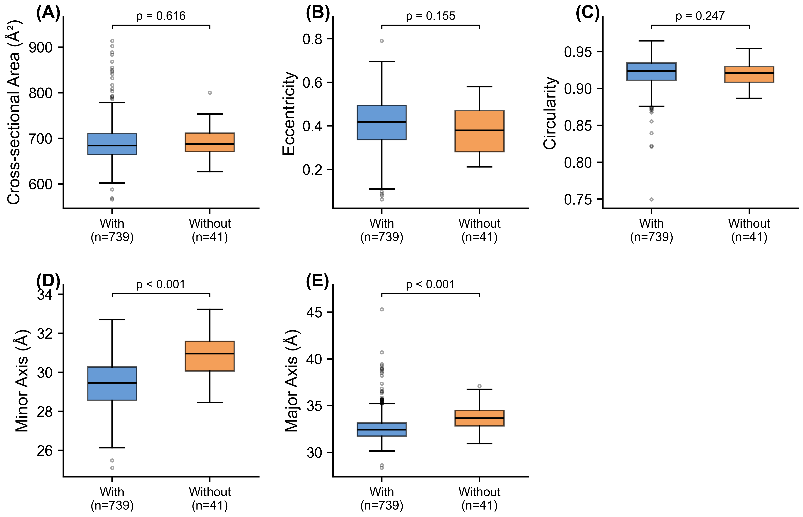
S1. Effect of chromophore maturation on barrel geometry within the canonical cohort (n = 780). Boxplots compare structures with (n = 739, blue) and without (n = 41, orange) a validated mature chromophore. (A) Cross-sectional area, (B) eccentricity, and (C) circularity do not differ between the two groups. (D) Minor axis and (E) major axis are both narrower in chromophore-containing structures at the structure level (p < 10⁻⁷ for both); these axis differences do not survive pseudoreplication collapse to one highest-resolution structure per unique protein (Table S2), reflecting the small number of unique chromophore-absent proteins (n = 6) and the unbalanced group sizes. See main-text Chromophore Maturation section for interpretation.

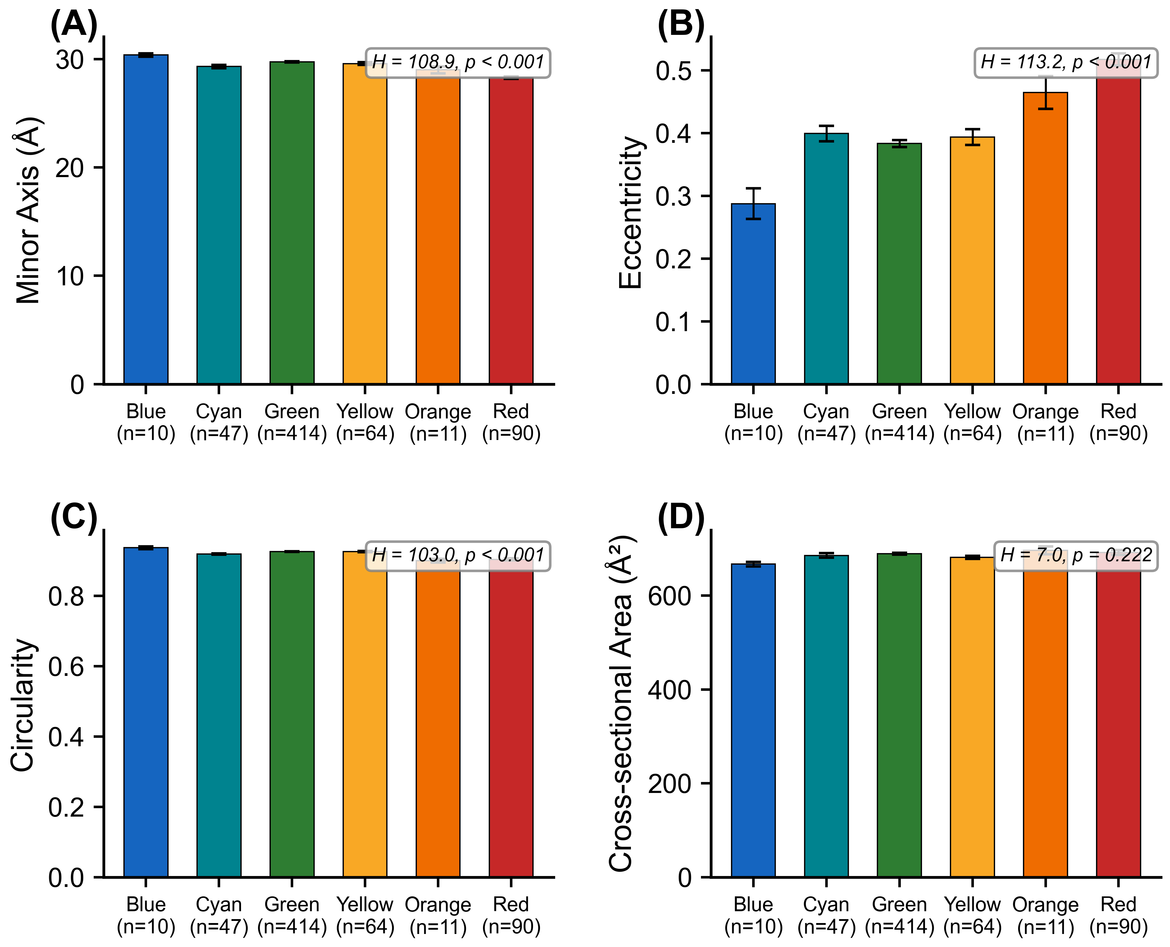
S2. Barrel geometry by emission color class within the canonical cohort. Mean (± SEM) minor axis, eccentricity, circularity, and cross-sectional area by color class, with Kruskal–Wallis H and p-values annotated. This is the categorical summary of the continuous relationships shown in Figure 1.

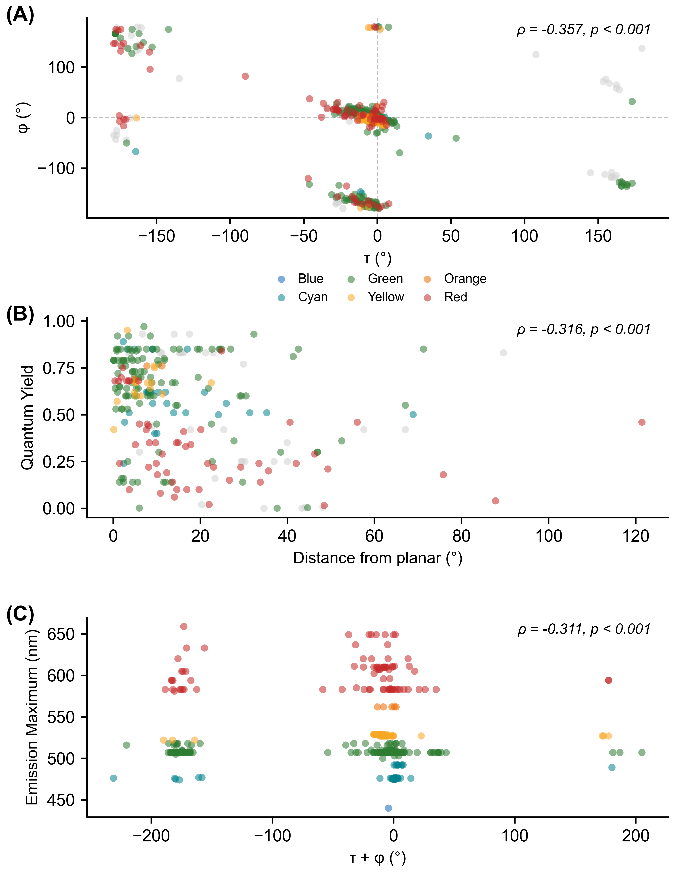
S3. Chromophore dihedral analysis. (A) τ vs φ plot colored by emission class. (B) Ground-state planarity (distance from the nearest planar reference, folding the phenol symmetry) vs quantum yield; the panel shows all canonical structures (per-structure ρ = –0.32), while the per-unique-FP value is ρ = –0.42 (Table S6). (C) Dihedral sum (τ + φ) vs emission wavelength.

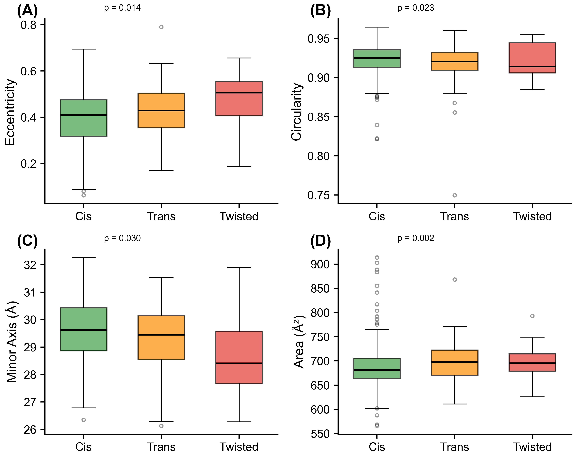
S4. Barrel geometry by chromophore configuration (cis, trans, and twisted).

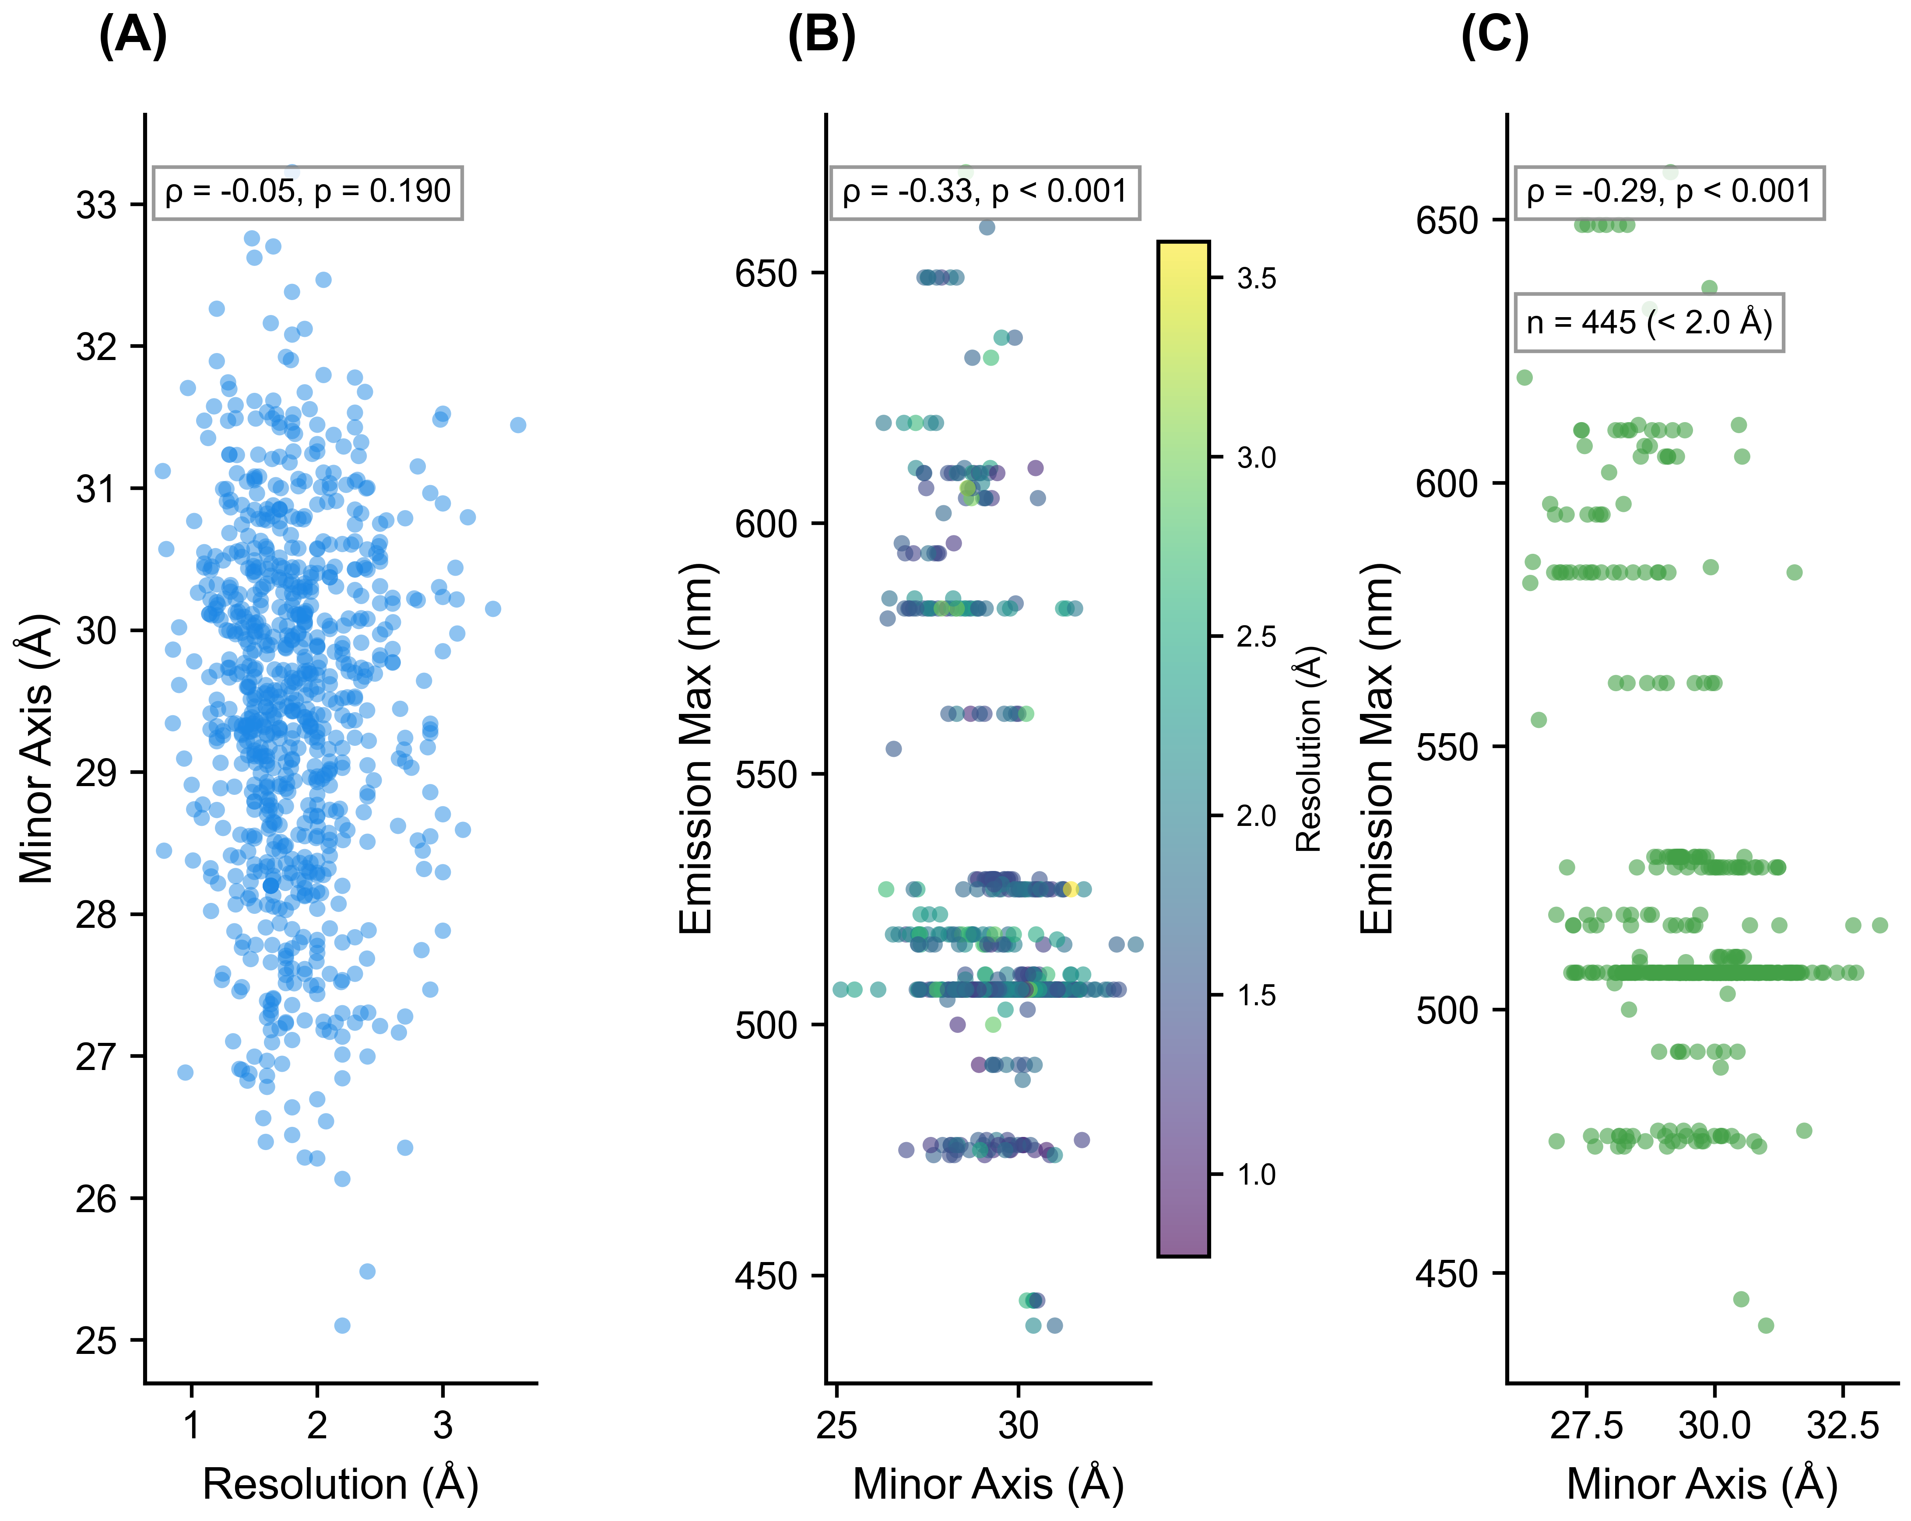
S5. Resolution control. (A) Resolution vs minor axis. (B) Emission vs minor axis colored by resolution. (C) High-resolution subset (<2.0 Å) only.

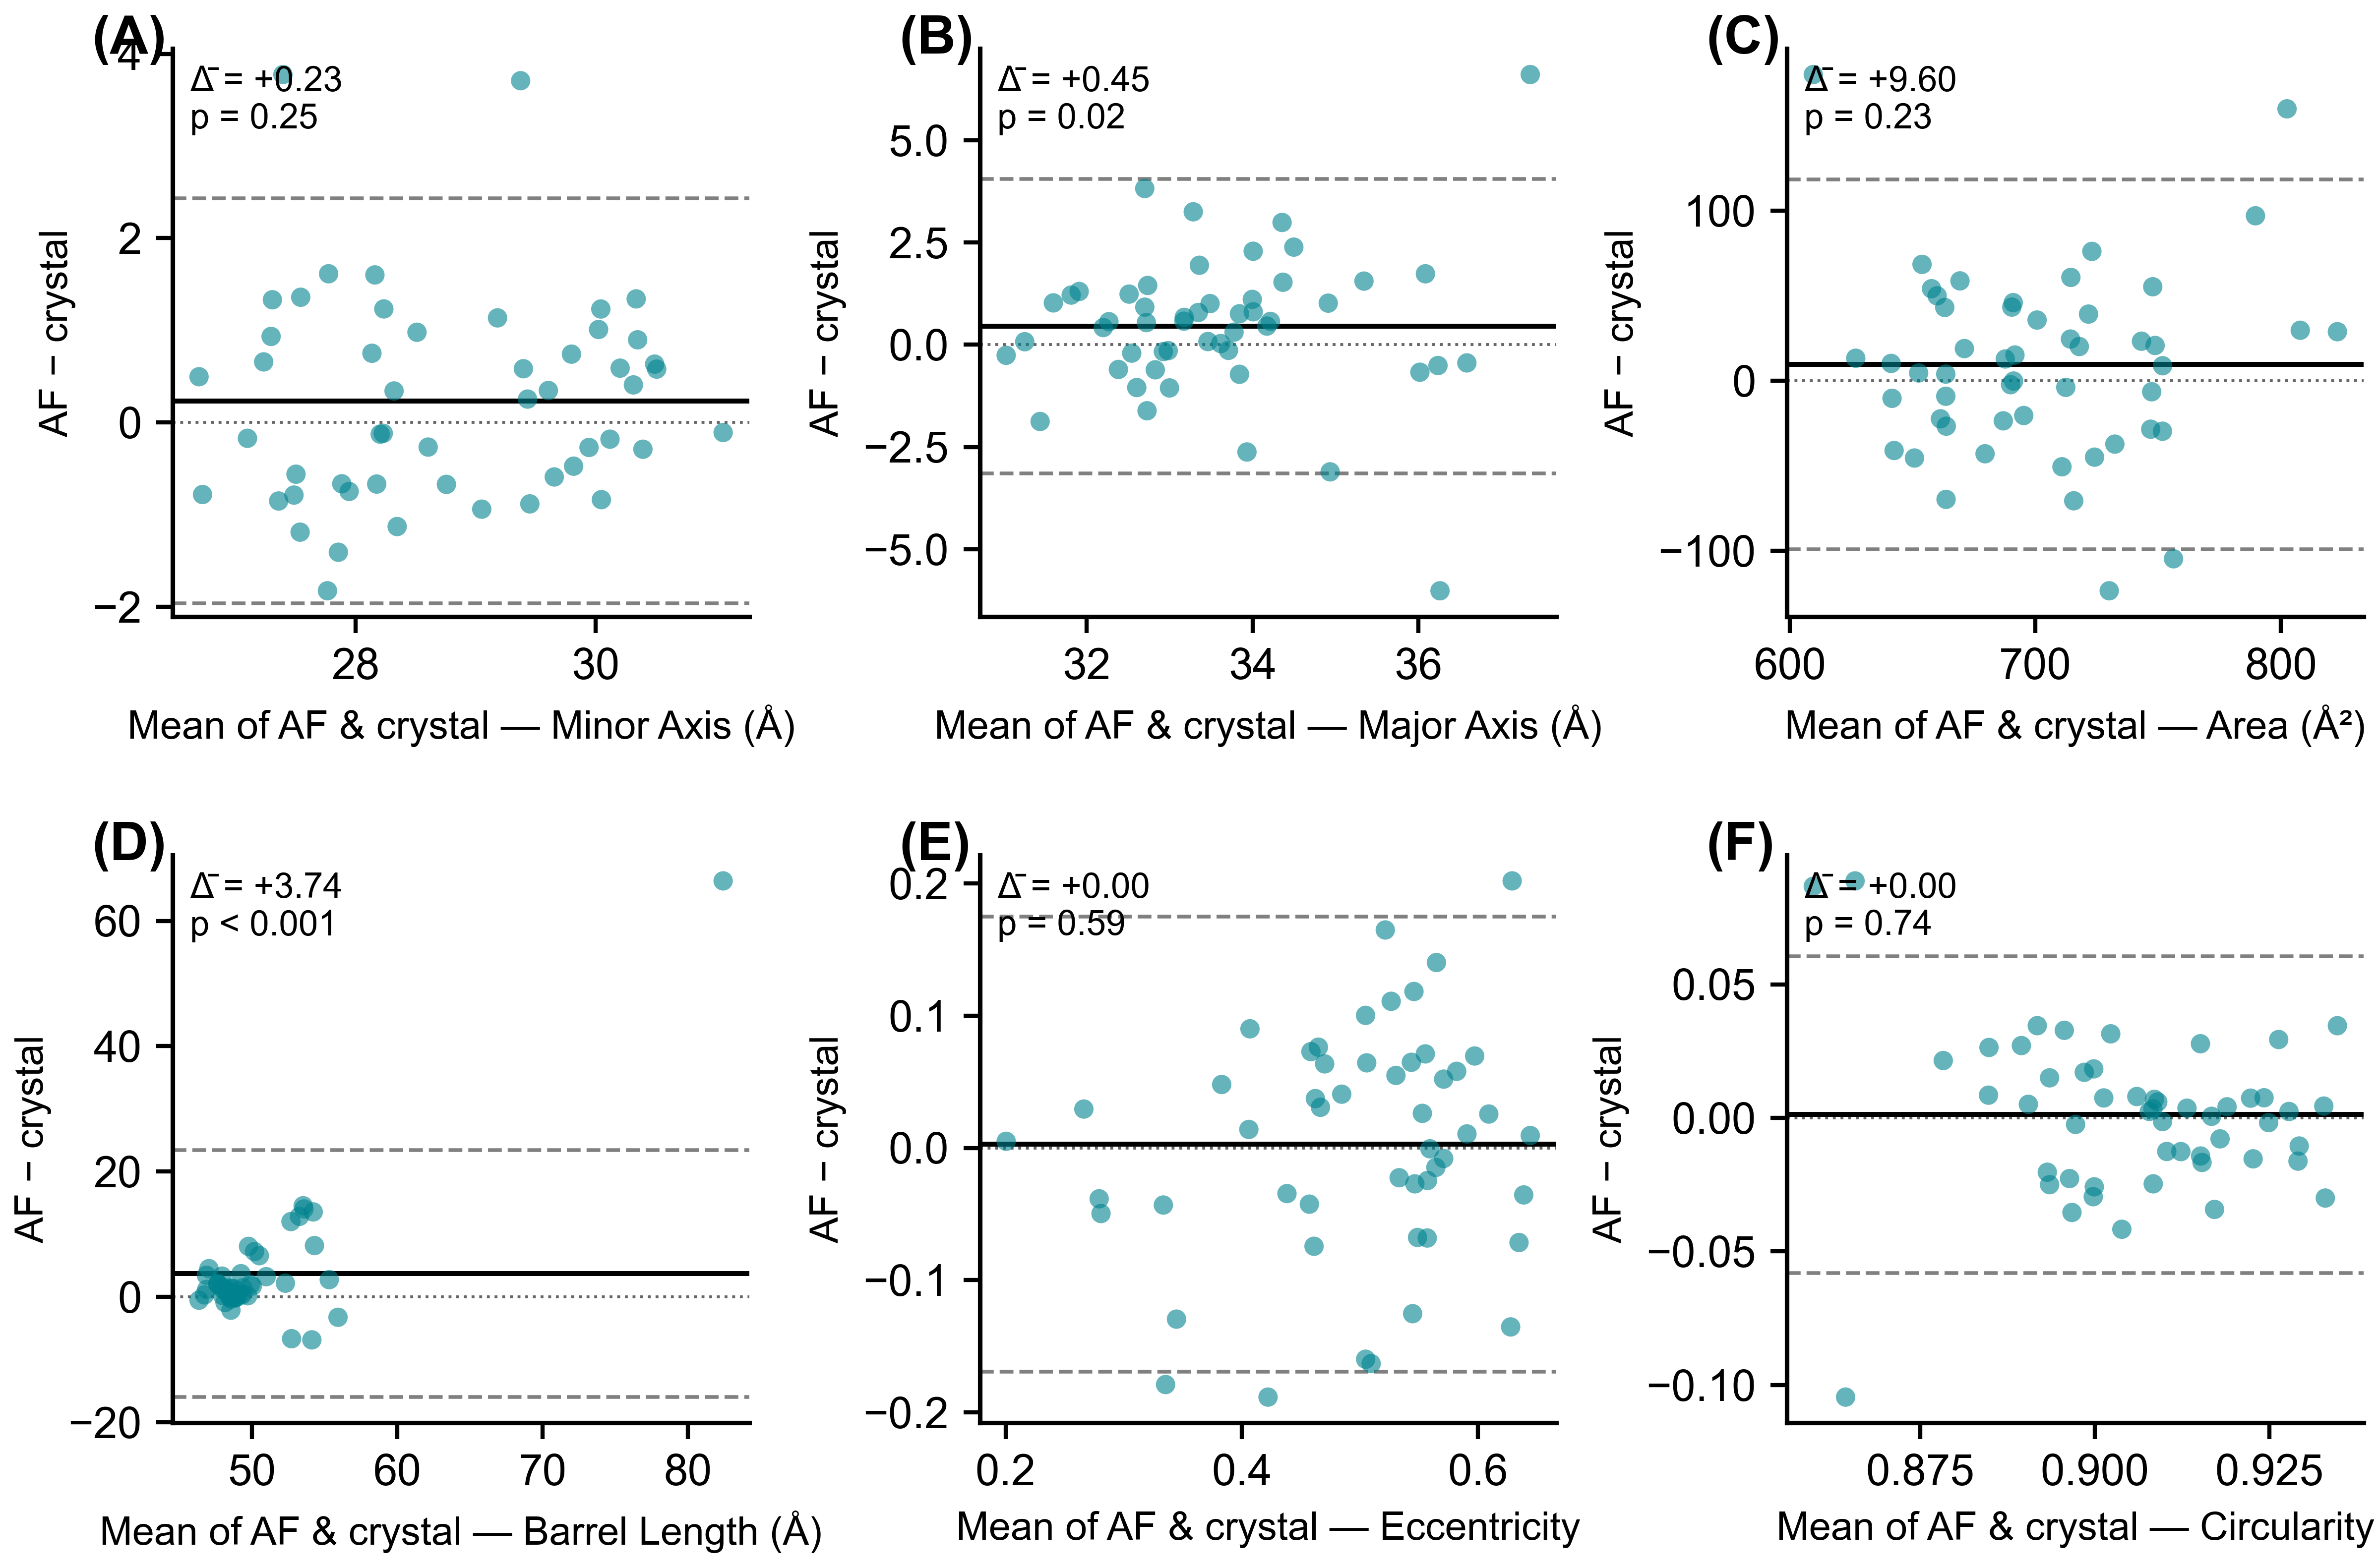
S6. Bland–Altman plots of the paired AlphaFold–crystal comparison (n = 51 wild-type FPs, one paired observation per protein). Each point is one protein; the x-axis is the mean of the AlphaFold and crystal values and the y-axis is AlphaFold minus crystal. The solid horizontal line marks the mean difference (Δ̄); dashed lines mark the 95% limits of agreement (Δ̄ ± 1.96 SD); the dotted line at zero marks perfect agreement. p-values are from two-sided Wilcoxon signed-rank tests. With crystal slices restricted to protein heavy atoms (no ordered solvent), AlphaFold and crystal barrels are statistically indistinguishable on minor axis (Δ̄ = +0.23 Å, p = 0.25), eccentricity (Δ̄ = 0.00, p = 0.59), circularity (Δ̄ = 0.00, p = 0.74), and area (Δ̄ = +9.6 Å², p = 0.23). AlphaFold predicts slightly wider major axes (Δ̄ = +0.45 Å, p = 0.02) and longer barrels (Δ̄ = +3.7 Å, p < 10⁻⁴).

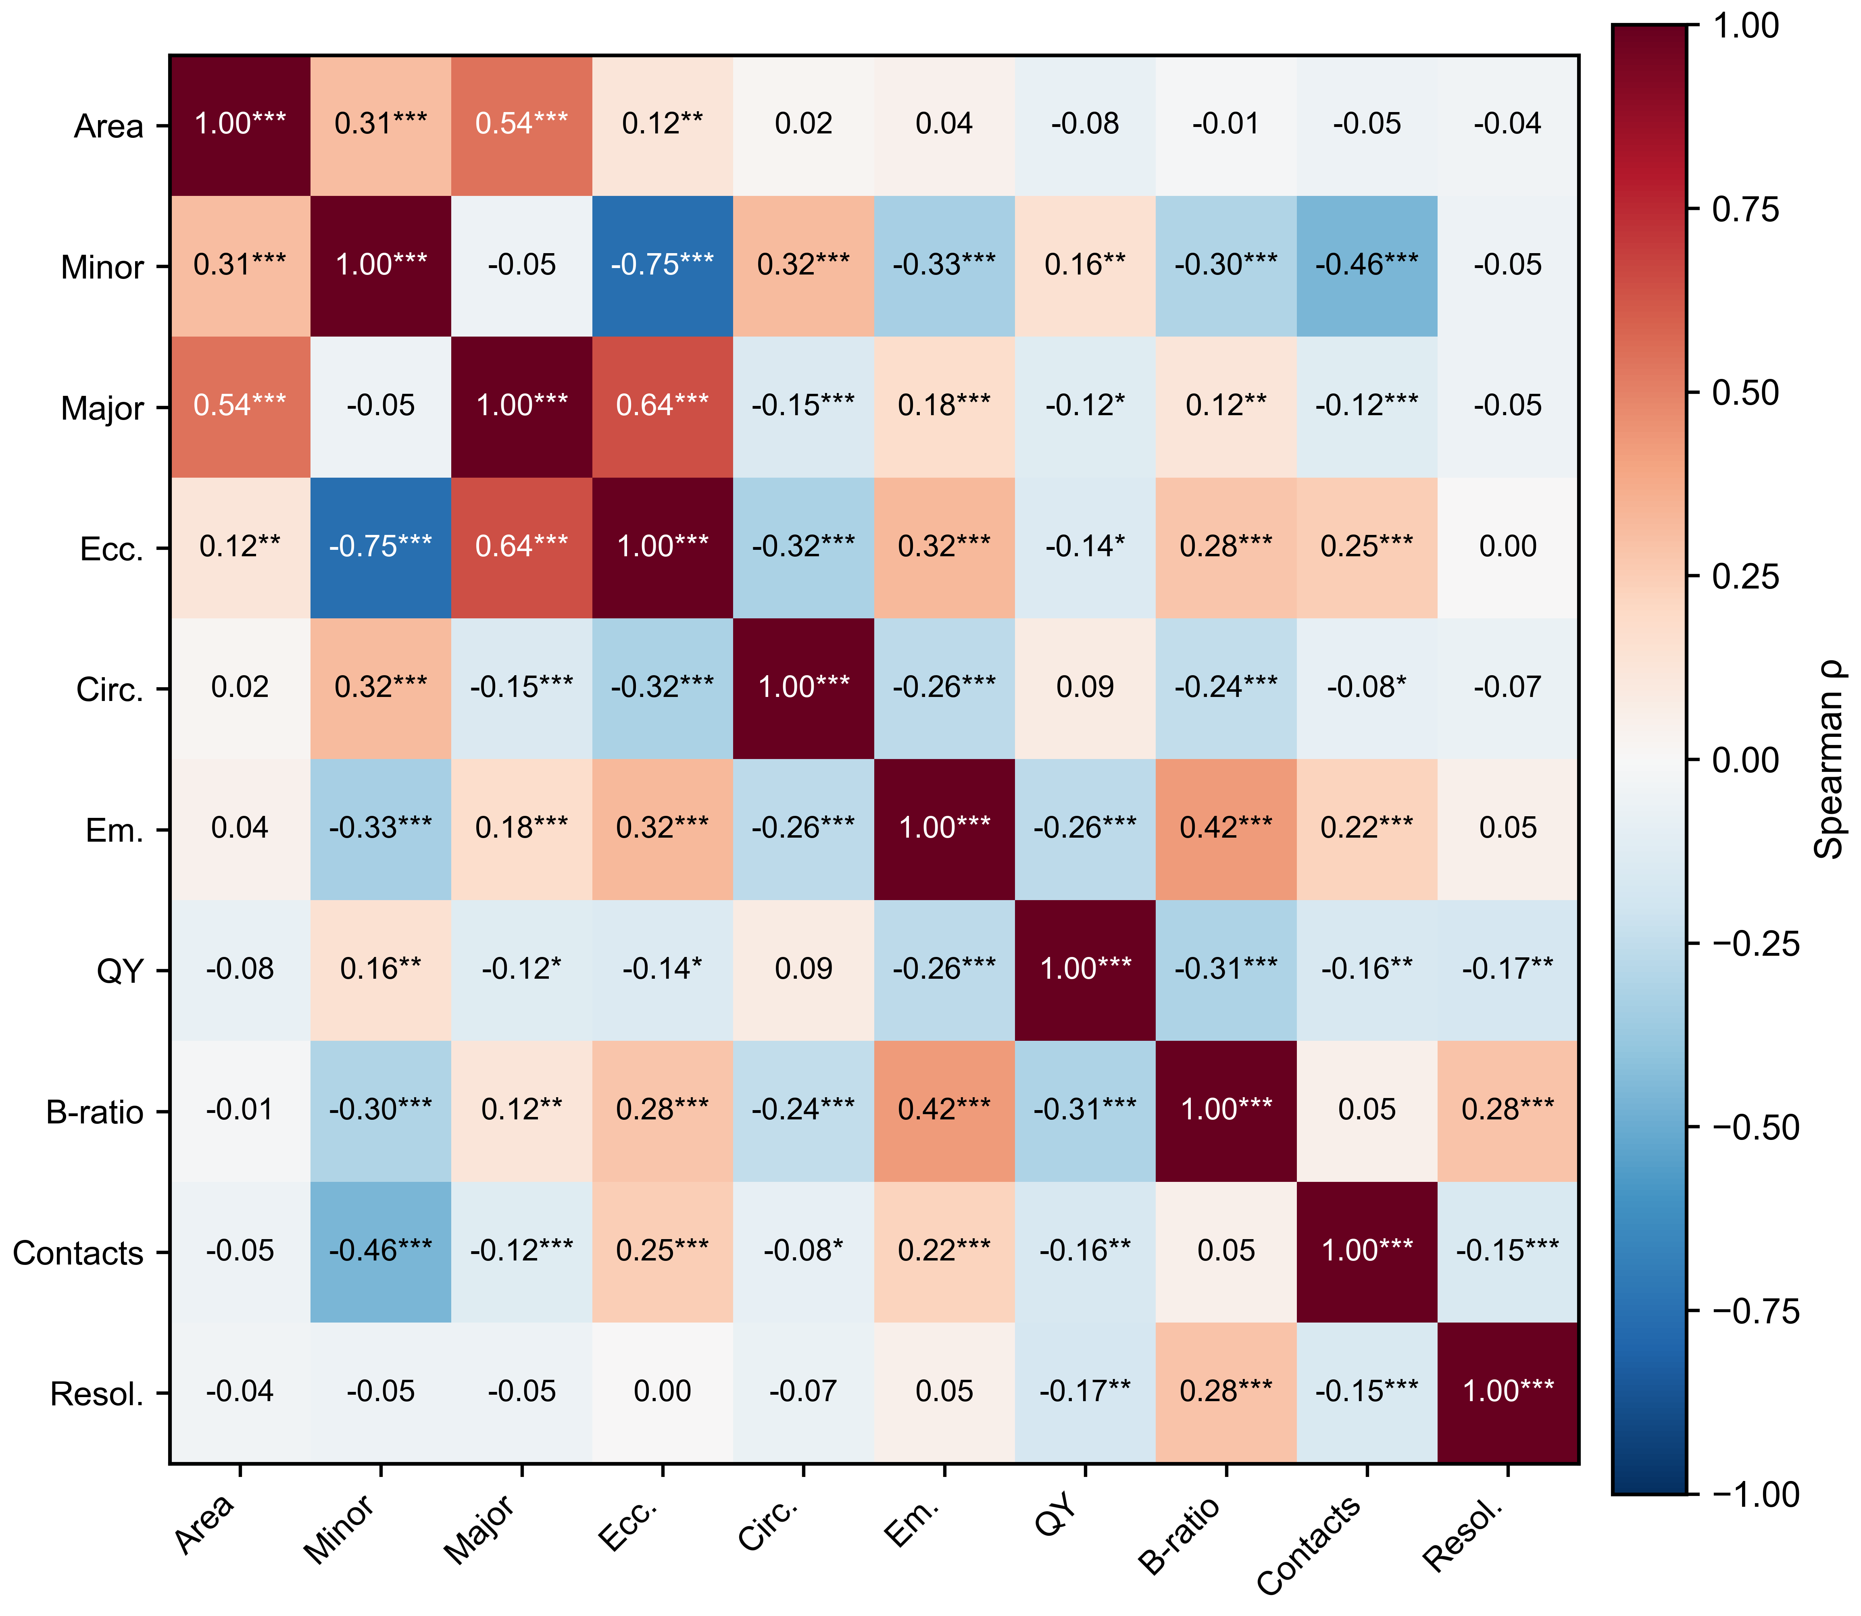
S7. Spearman correlation matrix for all variables. Asterisks indicate * p < 0.05, ** p < 0.01, *** p < 0.001.

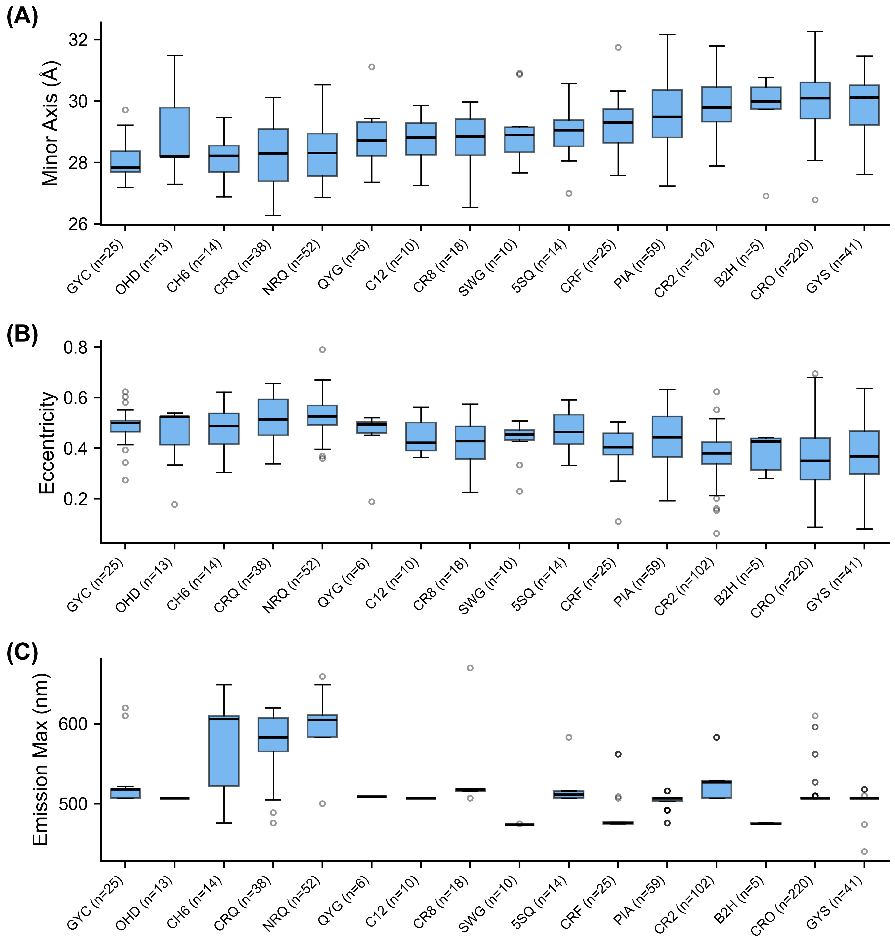
S8. Barrel geometry by chromophore residue type. Chromophore codes with n < 5 are omitted for legibility; this excludes the four His66-derived (blue) codes (IIC, CRG, CSH, XXY; n = 1, 3, 4, and 1 respectively).

