Barrel Shape and Chromophore Rigidity Predict Fluorescent-Protein Photophysics

Luke P. Begg, Madeline L. Mason, Marc Zimmer*
Chemistry Department, Connecticut College, New London, CT 06320

Keywords: fluorescent proteins; beta-barrel geometry; chromophore rigidity; photophysical properties; Protein Data Bank; AlphaFold; computational structural biology; agentic AI

Abstract
The 11-stranded β-barrel of fluorescent proteins (FPs) is universally conserved, yet its quantitative geometry has not been systematically characterized. We analyzed cross-sectional barrel geometry across 908 FP crystal structures in the RCSB PDB by PCA-based axis determination and convex hull analysis of protein-atom slices at the chromophore plane; 780 structures (210–245 residues, with the chromophore-containing chain selected in FP-complex co-crystals) form the canonical analysis cohort. Barrel shape, but not size, correlates with emission wavelength: red-shifted proteins have narrower, more elliptical barrels (ρ = –0.328 for minor axis, p = 2.2 × 10⁻¹⁷). The chromophore-to-scaffold B-factor ratio is the strongest predictor of quantum yield (ρ = –0.446, p < 10⁻¹³). Chromophore dihedral angles correlate with both barrel eccentricity and photophysical performance. Principal correlations survive Benjamini–Hochberg correction and partial correlation controlling for resolution. The barrel is not a passive scaffold: it constrains chromophore rigidity and thereby shapes photophysical output. The pipeline was developed with Claude (Anthropic) via Claude Code.

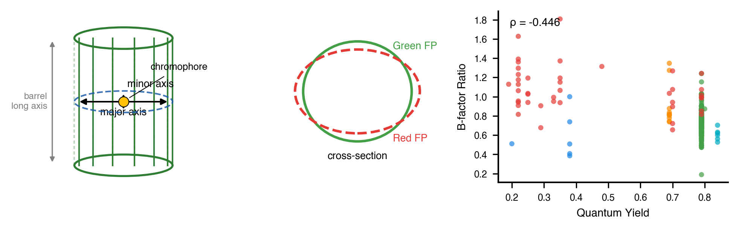

Introduction
Green fluorescent protein (GFP), first observed in the jellyfish Aequorea victoria by Shimomura et al. in 1962,¹ has fundamentally transformed biological research by enabling the direct visualization of proteins, organelles, and cellular processes in living systems.² The subsequent cloning and heterologous expression of GFP by Chalfie et al.³ demonstrated that the protein fluoresces without requiring cofactors or external enzymes, establishing GFP as a genetically encodable marker. The significance of this discovery was recognized with the 2008 Nobel Prize in Chemistry, awarded to Shimomura, Chalfie, and Tsien.⁴ In the decades since, fluorescent proteins have become indispensable tools across cell biology, neuroscience, and biotechnology, serving as reporters, biosensors, and partners in FRET⁵ and, more recently, super-resolution microscopy.⁶ˉ⁷
The three-dimensional structure of GFP, resolved by X-ray crystallography in 1996, revealed a distinctive 11-stranded beta-barrel fold approximately 42 Å in length and 24 Å in diameter.⁸ˉ⁹ This barrel encases a central alpha-helix, with the chromophore, formed by autocatalytic post-translational cyclization of residues Ser65–Tyr66–Gly67, is positioned at the geometric center and shielded from solvent.¹⁰ˉ¹¹ The rigid encapsulation minimizes non-radiative decay, enabling high quantum yields. The same 11-stranded topology is conserved across all known fluorescent protein families, including GFP-derived variants and fluorescent proteins from anthozoan organisms such as DsRed, despite sequence identities as low as 25%.¹²ˉ¹³
Protein engineering has produced a palette of fluorescent protein variants spanning the visible spectrum. Substitution of Tyr66 with tryptophan or histidine yields cyan or blue variants, respectively.¹⁴ The Thr203Tyr mutation introduces a π-stacking interaction that red-shifts emission by ~20 nm.¹⁵ In the DsRed family, an additional oxidation extends the conjugated π-system, producing red emission.¹⁶ Structure-guided engineering has achieved notable results: Goedhart et al. obtained a quantum yield of 0.93 in mTurquoise2 through a single packing mutation (I146F) identified by structure-guided saturation mutagenesis,¹⁷ while Campbell and colleagues have systematically monomerized and optimized coral-derived variants.¹⁸,¹⁹ Hirano et al. developed StayGold, a green fluorescent protein from the jellyfish Cytaeis uchidae, which exhibits exceptional photostability.⁴¹ A persistent trend across this engineering is that quantum yield decreases with increasing emission wavelength.²⁰ This has been attributed to increased vibrational degrees of freedom in extended conjugation systems, which open additional non-radiative relaxation pathways.
Despite the wealth of structural data now available, over 800 crystal structures classified within the GFP-like superfamily by SCOP, CATH, and Pfam, the quantitative geometry of the beta-barrel itself has received little systematic attention. Previous studies have focused on chromophore chemistry, hydrogen bonding networks, and site-specific mutation effects on spectral properties.²¹⁻²³ Computational studies have shown that the barrel contracts upon chromophore maturation and that water permeability through the barrel wall varies between GFP variants.²⁴,²⁵ Analysis of conserved glycine residues at positions 31, 33, and 35 demonstrated that these residues are essential for proper barrel folding and assembly.²⁶ Megley et al. showed that the φ and τ dihedral angles of the chromophore differ between yellow, blue, and green variants and correlate with non-radiative decay.²⁷ Ahmed et al. used molecular dynamics to guide engineering of YuzuFP, identifying a mutation at residue 148 that increased brightness 1.5-fold.²⁸ However, the beta-barrel has generally been treated as a static scaffold. Whether barrel geometry varies systematically across fluorescent protein families, and whether such variation relates to photophysical properties, has not been addressed.
Here, we report a systematic analysis of beta-barrel cross-sectional geometry across 908 fluorescent protein crystal structures from the RCSB Protein Data Bank. For each structure, the barrel axis was determined by PCA of backbone Cα coordinates, the structure was rotated to align this axis with the z-axis, and a perpendicular cross-sectional slice was extracted at the chromophore level. Convex hull analysis yielded area, eccentricity, circularity, and axis lengths for each barrel. Chromophore τ and φ dihedral angles were extracted and incorporated into the analysis. These measurements were integrated with spectral data from FPbase,³⁴ crystallographic B-factors, and chromophore–barrel contact counts. The results show that emission wavelength varies with barrel shape, that chromophore rigidity relative to the barrel is a strong predictor of quantum yield (ρ = –0.446), and that dihedral twist correlates with both barrel eccentricity and photophysical performance.
Prior AI applications in FP research have used models trained on protein sequence or structural data for design: AlphaFold2 and RoseTTAFold to predict chromophore-related post-translational modifications,³¹ ESM3 to design the de novo FP esmGFP at 58% identity to known GFPs,³² and protein-specific transformers to predict fluorescence properties from sequence.³³ In contrast, the analysis presented here uses a general-purpose conversational LLM (Claude, Anthropic; via Claude Code²⁹) as a coding assistant for systematic crystallographic and statistical analysis of an existing structural database — a role following the disk-mediated multi-task pattern recently described for theoretical physics by Schwartz.³⁰ A short failure-mode case study (chromophore mis-detection) is provided in Note S1 to illustrate the human-validation discipline required. All scientific decisions, interpretation, and responsibility for the claims rest with the human authors.

Methods
Dataset Assembly.
The RCSB Protein Data Bank was queried for all X-ray crystal structures belonging to the GFP-like superfamily using annotations from SCOP (b.67.1), CATH (2.60.120.200), Pfam (PF01353), and InterPro (IPR011584, IPR000786). The union returned 885 entries. Coordinate files in mmCIF format were downloaded for all entries. Eight structures were removed after inspection (APOBEC3H complexes, a DNA co-crystal, and misannotated entries). Sequences were extracted and aligned using Clustal Omega³⁵ and inspected in Jalview³⁶ to confirm GFP/DsRed motifs. The initial dataset comprised 877 structures; cross-referencing against additional RCSB annotations identified 31 confirmed FP barrels deposited after the last SCOP update, yielding a final dataset of 908 structures (Table S1).
Chromophore Detection.
Each structure was classified by scanning non-standard residues for known chromophore residue names. The detection list encompasses all major fluorescent chromophore variants, requiring two criteria: (i) an imidazolinone ring (atoms N2, C2, O2 in the PDB CONECT record), and (ii) a π-conjugated aromatic ring at position 66, irrespective of whether that ring carries a heteroatom donor. Phenol-based (Tyr66), indole-based (Trp66), imidazole-based (His66), and phenyl-based (Phe66) rings are all accepted; the detection logic checks for any of the standard aromatic-ring atom inventories associated with these four side chains as well as known non-standard naming conventions used in modified chromophore residues. Detection covered Tyr66-based GFP-type chromophores (CRO, CR2, CRQ, GYC, CRG, NYG, and others), Trp66-based CFP-type chromophores (PIA, CRF, CRK, CR7, CFY, CCY, and others), His66-based BFP-type chromophores (GYS, IIC, CSH, and others), Phe66-based variants where present, and red/orange-shifted variants (NRQ, CH6, CH7, SWG, OHD, RC7, B2H, C12, XYG, DYG, and others; 71 distinct residue codes in total, including CR8 whose aromatic ring uses non-standard PDB atom names). Residues with an intact imidazolinone ring but no aromatic ring at position 66 (CRX, MDO, C99, CLV, KWS, Q2K, NRP, and related synthetic analogs) were excluded as non-fluorescent. Structures in which the chromophore precursor is stored as standard residues SER65–TYR66–GLY67 (uncyclized/immature state) were likewise classified as lacking a mature chromophore. Of 908 structures, 861 contained a validated mature chromophore and 47 did not (Table S1). The chromophore detection step provides an instructive example of AI failure (Note S1).
Chromophore Torsion Angles.
Chromophore dihedral angles were defined following Megley et al.:²⁷ τ = N₁–C₁–C₂–C₃ (PDB atoms N2–CA2–CB2–CG2), describing rotation about the imidazolinone–bridge bond, and φ = C₁–C₂–C₃–C₄ (atoms CA2–CB2–CG2–CD1), describing rotation about the bridge–phenol bond. Structures with |τ| < 30° were classified as cis, |τ| > 150° as trans, and the remainder as twisted. Absolute magnitudes |τ| and |φ| are used in correlation analyzes as descriptive measures of out-of-plane chromophore distortion, irrespective of cis/trans configuration; the algebraic sum τ + φ is likewise treated as a descriptive composite of the two rotations and is not interpreted in the mechanistic sense of the hula-twist photoisomerization pathway. Valid angles were obtained for 690 structures (Table S1).
Barrel Axis Determination.
The barrel axis was determined independently for each structure by PCA of backbone Cα coordinates. The eigenvector corresponding to the largest eigenvalue (PC1) was taken as the barrel axis. The eigenvalue ratio λ₁/λ₂ averaged 2.18, confirming elongated barrel geometry. A rotation matrix mapping PC1 onto [0, 0, 1] was applied to all non-hydrogen coordinates. The cross-sectional slice was centered on the chromophore (mean z of chromophore atoms = 0) and defined as the protein heavy atoms (standard amino-acid + chromophore residues) with |z| ≤ 2.0 Å; see Geometry Quantification below.
Geometry Quantification.
All non-hydrogen atoms of the standard amino-acid and chromophore residues of the analyzed chain (i.e., protein heavy atoms) in each slice were projected onto the xy-plane (i.e., the plane perpendicular to the barrel axis). Ordered solvent molecules, crystallization additives, and ions were excluded from the slice so that the convex hull represents the protein barrel itself rather than the crystallographic solvent shell. The convex hull was computed using scipy.spatial.ConvexHull.³⁷ Cross-sectional area, perimeter, and an ellipse fit (via the 2D covariance matrix) yielded major and minor axis lengths. Eccentricity was calculated as e = √(1 – b²/a²). Circularity was defined as 4πA/P². A ring-shape test confirmed that slices captured the barrel wall (peripheral:central density ratios of 5.4–7.0). These measurements describe the outer envelope of the beta-barrel including the wall atoms; they are therefore larger than the inner channel diameter (~24 Å in avGFP⁸) reported in the original crystallographic papers, which refers to the solvent-accessible cavity through which the central alpha-helix passes. The beta-sheet walls add approximately 2–3 Å on each side, consistent with the mean minor axis of 29.5 Å reported here.
Canonical FP-Barrel Cohort.
Inspection of the 908 structures revealed that the extremes of the cross-sectional area distribution are dominated by entries whose PCA-derived barrel axis and chromophore-plane slice do not isolate a single 11-stranded barrel. Sequence-length outliers fall into two classes: (i) short constructs (< 210 residues, e.g., PDB 6LOF at 163 residues) corresponding to fragments, split-GFPs, or partial barrels, and (ii) long constructs (> 245 residues, e.g., GCaMP calcium sensors at ≈ 390 residues fused to calmodulin and the M13 peptide) in which the PC1 axis is tilted by fused domains so that the chromophore-level slice intersects non-barrel coordinates. The monomeric FP barrel has a sequence length of approximately 220–240 residues; we therefore restrict the geometric analysis to structures with seq_length between 210 and 245 (inclusive). A secondary chain-selection audit (Note S1(b)) identified 15 FP-complex co-crystals in which the original pipeline analyzed the binding partner rather than the FP chain; these entries were reprocessed using the chromophore-containing chain, which placed 13 of them into the canonical cohort and reclassified one (4XL5) from chromophore-absent to chromophore-positive. Two entries are excluded by name because their geometry is dominated by non-standard quaternary structure: 6H01 (domain-swapped sfGFP) and 3U0K (RCaMP, a circularly permuted red FP fused to calmodulin). The final canonical cohort comprises 780 structures. This canonical cohort eliminates major-axis outliers exceeding 50 Å while retaining all monomeric FPs identified by name-matching against FPbase. All reported barrel-geometry statistics, color-class comparisons, B-factor and dihedral correlations, and multivariate models in this paper refer to this 780-structure cohort. Section-level sample sizes (e.g., n = 633 for spectral correlations, n = 265 for quantum-yield correlations) reflect the further availability of FPbase spectral data within the canonical cohort. The full 908-structure dataset, including the seq-length outliers, is retained in Table S1 and is used only for the population-level descriptive statistics in the Dataset Composition subsection.
Spectral and Photophysical Data.
Spectral data were obtained from FPbase³⁴ using a hierarchical four-strategy matching protocol. (1) A manually curated dictionary mapped 176 PDB entries to known FPbase proteins. (2) The FPbase GraphQL API was queried by PDB identifier for entries with registered structures. (3) PDB titles were searched against a dictionary of over 150 fluorescent protein variant names (e.g., EGFP, mCherry, Venus, Dronpa) using case-insensitive keyword matching. (4) Remaining structures were assigned spectral properties by chromophore residue type where unambiguous. When multiple strategies returned matches, the highest-priority match was retained; each PDB identifier was mapped to at most one FPbase entry. Of 908 structures, 694 (76.4%) were matched to 74 unique FPbase protein names; 214 remained unmatched (predominantly structures with abbreviated or novel variant names not registered in FPbase). Quantum yield and extinction coefficient values from published sources²⁰,³⁴,³⁸ were available for 321 structures. Color classes were assigned by emission wavelength: blue (<460 nm), cyan (460–505 nm), green (505–545 nm), yellow (545–575 nm), orange (575–610 nm), red (>610 nm). The complete mapping is provided in Table S1.
B-Factor and Contact Analysis.
For each structure, two atom sets in the analyzed chain were defined: the chromophore set (all non-hydrogen atoms of the non-standard residue identified as the chromophore — imidazolinone ring, methine bridge, and pendant aromatic ring, for Tyr66-, Trp66-, His66-, or Phe66-derived chromophores alike), and the scaffold set (all non-hydrogen atoms of the standard amino-acid residues in the same chain). The latter is referred to throughout this paper as the "barrel" set for brevity, but it is not restricted to the eleven β-strands of the barrel wall — it also includes the central α-helix that bears the chromophore-forming tripeptide and the capping loops at both ends of the barrel. Mean B-factors were computed for each set, and the B-factor ratio (chromophore / scaffold) quantifies chromophore rigidity relative to the rest of the chain. Chromophore–barrel contacts were counted as the number of (chromophore-atom, scaffold-atom) pairs within 4.0 Å of one another (i.e., pair count, not unique scaffold-atom count).
Statistical Analysis.
Analyses were performed in Python 3.14 using SciPy³⁹ and scikit-learn.⁴⁰ Spearman rank correlations assessed monotonic relationships between continuous variables. Mann–Whitney U tests compared two groups; Kruskal–Wallis H tests compared multiple groups. All reported p-values were corrected for multiple testing using the Benjamini–Hochberg false discovery rate (FDR) procedure; the family comprised 63 pre-specified hypothesis tests covering all meaningful pairwise Spearman correlations among the six geometry metrics, four photophysical variables (em_max, lit_qy, stokes_shift, b_factor_ratio), and crystallographic resolution; eleven dihedral correlations involving τ, φ, |τ|, |φ|, and τ + φ; plus the five Mann–Whitney chromophore-present vs absent tests, the three cis-vs-trans tests, and the three Kruskal–Wallis by color class tests. The complete list with raw and BH-corrected p-values is provided in Table S4; 46 of 63 tests survive the FDR threshold at q < 0.05. Partial Spearman correlations controlling for crystallographic resolution were computed by the rank-residual method: all three variables were rank-transformed, the rank-transformed dependent and independent variables were each regressed on rank-transformed resolution by ordinary least squares, and the Pearson correlation of the residuals was reported (equivalent to the partial Spearman correlation).
AI-Assisted Computation.
All scripts were generated by Claude (Anthropic, Opus 4) via Claude Code and reviewed by the authors before execution. Each computational task was specified in plain language; the model produced code, results were written to disk, and intermediate files were used for cross-checking against known structures. Observed failure modes (steps reported as validated without performing checks, simplification based on unrelated patterns, premature halting on first error) were mitigated by mandatory intermediate output files and repeated verification prompts; the chromophore-detection failure is documented in Note S1. All scientific questions, methodology choices, and interpretations were made by the human authors.
AlphaFold Structure Analysis.
AlphaFold DB v6 coordinate files were downloaded for FP sequences via the EBI AlphaFold API and matched to crystal structures via the UniProt REST API. Two analyzes were performed: a paired comparison between 51 wild-type FPs for which both an AlphaFold model and the highest-resolution crystal structure exist (mean crystal resolution 1.63 ± 0.37 Å, mean pLDDT 96.7 ± 1.3); and a population-level analysis of the 309 successfully predicted AlphaFold structures whose sequence length falls within the canonical 210–245 residue window (327 successful predictions in total; 18 fell outside the window). Because AlphaFold structures lack the cyclized chromophore, the slice was centered on the barrel centroid (z = 0 in the PCA frame) rather than the chromophore z; the rest of the geometric pipeline matched the crystal-structure pipeline exactly. The pLDDT confidence scores in the AlphaFold B-factor field were not used in cross-structure comparisons with crystallographic B-factor ratios. Paired comparisons used two-sided Wilcoxon signed-rank tests; the 95% confidence intervals reported in Results are normal-approximation intervals on the mean paired difference (Δ̄ ± 1.96 SE), while Figure S8 plots the 95% limits of agreement (Δ̄ ± 1.96 SD).

Results and Discussion
Dataset Composition.
The dataset comprises 908 fluorescent protein crystal structures: 861 with a validated mature chromophore and 47 without. The 861 chromophore-containing structures span 69 distinct residue types (CRO, CR2, NRQ, CRQ, GYS, PIA, and others). Spectral data from FPbase were matched to 694 structures. Quantum yield data were available for 321. The color class distribution was green (n = 465), red (n = 94), yellow (n = 69), cyan (n = 48), orange (n = 11), and blue (n = 10). The ten blue entries comprise nine Y66H variants identified from their His66-derived chromophore residue codes (IIC, CRG, CSH, XXY; including PDB 1BFP, 1KYP/R/S, 1EMF, 2EMD/N/O, 2FWQ) plus one Tyr-based blue variant (PDB 4ORN, ex/em 380/440 nm). The Y66H entries had been mis-assigned em_max = 507 nm by FPbase keyword matching to generic "green fluorescent" titles and were re-classified directly from their chromophore residue identities. BFPs remain underrepresented in the PDB because His66-derived variants typically exhibit lower brightness and photostability than Tyr66-based counterparts, and their near-UV excitation overlaps with cellular autofluorescence; most modern applications requiring short-wavelength emission use cyan variants such as mCerulean or mTurquoise2 instead. Resolution ranged from 0.77 to 3.60 Å (mean 1.86 ± 0.47 Å). Because the PDB contains multiple entries for the same or closely related proteins, the 694 spectrally matched structures correspond to only 74 unique FPbase protein names. The effective sample size for cross-protein comparisons is therefore substantially smaller than the total structure count, and robustness to pseudoreplication is assessed in Table S2.
After applying the canonical sequence-length filter (210 ≤ residues ≤ 245) and the chain-selection audit described in Methods, the geometric analysis cohort comprises 780 structures: 739 with a validated mature chromophore and 41 without. Within this cohort the color class distribution is green (n = 415), red (n = 89), yellow (n = 64), cyan (n = 47), orange (n = 11), and blue (n = 10), and FPbase spectral matches are available for 633 structures (293 with quantum yield data). All subsequent results refer to this canonical cohort unless explicitly stated otherwise.
Barrel Geometry.
Cross-sectional geometry was computed for the 780 structures in the canonical cohort. Mean cross-sectional area was 689 ± 40 Å² (range 566–914 Å²). Mean eccentricity was 0.41 ± 0.12, indicating moderately elliptical cross-sections. Circularity averaged 0.92 ± 0.02. Major and minor axes averaged 32.7 ± 1.4 Å and 29.5 ± 1.3 Å, respectively. Barrel length averaged 49.3 ± 3.6 Å. Area and eccentricity were weakly positively correlated (ρ = +0.117, p = 0.001), reflecting the slightly larger major axis of more elliptical barrels. For comparison, when the same pipeline is applied to the full 908-structure dataset with crystallographic solvent included in the slice and no chain-selection audit, the area distribution is much wider (818 ± 194 Å², range 330–1975 Å²); the residual variance in the present canonical cohort is approximately 4.7-fold smaller, demonstrating that both the cohort definition and the exclusion of crystallographic solvent from the slice remove major methodological artifacts without altering the qualitative shape of the distribution.
Chromophore Maturation and Barrel Shape.
Within the canonical cohort, structures with a validated mature chromophore (n = 739) were compared to those without (n = 41). Cross-sectional area did not differ (689 ± 41 vs 691 ± 34 Å², p = 0.62), nor did circularity (0.922 ± 0.020 vs 0.919 ± 0.016, p = 0.25) or eccentricity (0.41 ± 0.12 vs 0.39 ± 0.11, p = 0.15). At the structure level, both axes were narrower in the chromophore-containing group: minor axis 29.4 ± 1.2 Å vs 30.9 ± 1.1 Å (p = 3.9 × 10⁻¹¹) and major axis 32.6 ± 1.4 Å vs 33.8 ± 1.4 Å (p = 3.1 × 10⁻⁸), while the convex-hull area was preserved (Figure S6). However, the two groups in this comparison are highly unbalanced both in size (739 vs 41) and in protein diversity (210 unique chromophore-positive proteins, six unique chromophore-absent proteins, mostly avGFP precursor variants), and the structure-level axis differences should be interpreted with this imbalance in mind. After pseudoreplication collapse to one highest-resolution structure per unique protein, the minor- and major-axis differences and the eccentricity trend do not survive (Table S2); only the circularity difference reaches significance (p = 4.6 × 10⁻⁴), and that effect is small in absolute terms (0.922 vs 0.919). The paired AlphaFold–crystal comparison provides only weak, partial support for the maturation hypothesis: AlphaFold, which lacks the cyclized chromophore, yields axes shifted in the direction expected if AlphaFold barrels resembled the chromophore-absent (uncyclized) crystals, but the shifts are much smaller than the within-crystal contraction. The minor-axis shift is not significant (Δ_minor = +0.23 Å, p = 0.25); the major-axis shift is significant but small (Δ_major = +0.45 Å, p = 0.02), both ≪ 1.2–1.5 Å within-crystal effect (Figure S8). We therefore conclude only that the gross barrel cross-section is largely established at the pre-cyclization stage and that any geometric imprint of chromophore maturation, if real, is too small to detect cleanly in this dataset.
Barrel Geometry by Emission Color Class.
Barrel geometry varied with emission color class. Eccentricity (Kruskal–Wallis H = 112.2, p = 1.4 × 10⁻²²), minor axis (H = 107.8, p = 1.2 × 10⁻²¹), and circularity (H = 104.2, p = 7.0 × 10⁻²¹) all differed across groups. Red fluorescent proteins had the most elliptical barrels and narrowest minor axes; green had the most circular. Emission wavelength correlated with eccentricity (ρ = +0.320, p = 1.6 × 10⁻¹⁶), minor axis (ρ = –0.328, p = 2.2 × 10⁻¹⁷), and circularity (ρ = –0.258, p = 4.2 × 10⁻¹¹). Emission was weakly correlated with the major axis (ρ = +0.176, p = 8.8 × 10⁻⁶) and uncorrelated with barrel length (ρ = –0.027, p = 0.50). All reported p-values were corrected for multiple testing using the Benjamini–Hochberg procedure (q < 0.05); the key correlations remain significant after correction. These associations also strengthen after collapse to one highest-resolution structure per unique FPbase protein (n = 69 unique proteins): minor axis ρ = –0.54, p = 1.6 × 10⁻⁶; eccentricity ρ = +0.49, p = 1.3 × 10⁻⁵; circularity ρ = –0.43, p = 2.0 × 10⁻⁴ (Table S2), ruling out pseudoreplication of related variants as a driver. The correlations of emission with eccentricity, minor axis, and circularity also survive partial correlation analysis controlling for resolution. The major axis and barrel length are uninformative. These data are consistent with a red-shift associated with narrowing of the barrel in one dimension, rather than a general contraction. In DsRed-type red chromophores, an additional oxidation step extends the π-conjugated system by forming an acylimine group at the peptide bond N-terminal to the chromophore-forming tripeptide.¹⁶ The resulting larger chromophore occupies a different steric volume within the barrel pocket, which may contribute to the observed asymmetric narrowing; however, the causal direction of this relationship cannot be established from static crystal structures alone.

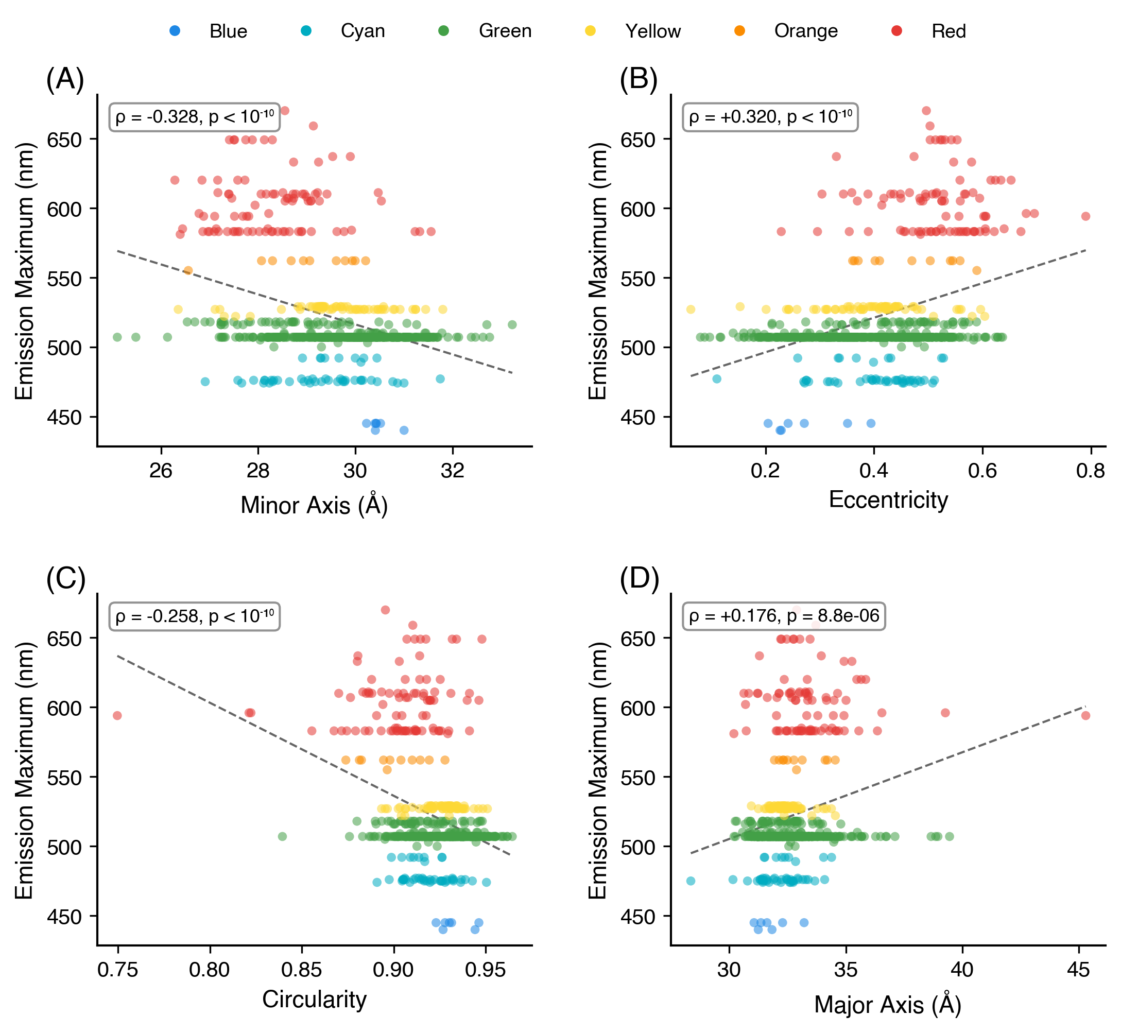
Figure 1. Continuous relationships between barrel geometry and emission wavelength in the canonical cohort (n = 633 structures with FPbase em_max). Each point is one structure, colored by emission class. (A) Minor axis (ρ = –0.328). (B) Eccentricity (ρ = +0.320). (C) Circularity (ρ = –0.258). (D) Major axis (ρ = +0.176). Dashed lines are least-squares fits, included as visual guides; Spearman ρ and p-values are reported in the panels. Red-shifted variants populate the narrower, more elliptical tail of each distribution. The same data summarized by emission color class are shown as bar charts in Figure S1.

B-Factor Ratio and Quantum Yield.
The B-factor ratio (chromophore/barrel) was computed for 739 structures in the canonical cohort. The mean ratio was 0.81 ± 0.22; in 86.3% of structures the chromophore was more rigid than the barrel (ratio < 1). The B-factor ratio was the strongest predictor of quantum yield: ρ = –0.446, p = 2.4 × 10⁻¹⁴, n = 265. This correlation survived partial correlation controlling for resolution (partial ρ = –0.481). After collapse to one highest-resolution structure per unique FPbase protein, the same effect size persists (ρ = –0.43) but the small remaining sample loses statistical significance (p = 0.08, n = 18; Table S2); the correlation should therefore be regarded as quantitatively supported by the full canonical cohort but limited by the sparse availability of quantum-yield measurements across unique proteins. The ratio varied by color class: blue 0.66 ± 0.19, cyan 0.70 ± 0.15, green 0.76 ± 0.17, yellow 0.79 ± 0.16, orange 0.88 ± 0.22, red 1.02 ± 0.24. In red fluorescent proteins, the chromophore is on average no more rigid than the barrel.
The correlation between B-factor ratio and quantum yield is not simply a proxy for emission wavelength. Although emission correlates with the B-factor ratio (ρ = +0.422), the B-factor ratio carries information about quantum yield beyond emission wavelength alone. The physical interpretation is direct: quantum yield depends on the competition between radiative and non-radiative decay. Non-radiative decay requires conformational motion, particularly rotation about the methine bridge. A chromophore that is rigid relative to its barrel has fewer accessible conformational states and therefore fewer decay pathways. This interpretation is consistent with the engineering examples discussed in the Implications section below. The extended conjugation that produces red emission introduces torsional degrees of freedom that the barrel does not fully constrain, explaining the mean B-factor ratio of 1.02 ± 0.24 for red variants compared to 0.70 ± 0.15 for cyan.

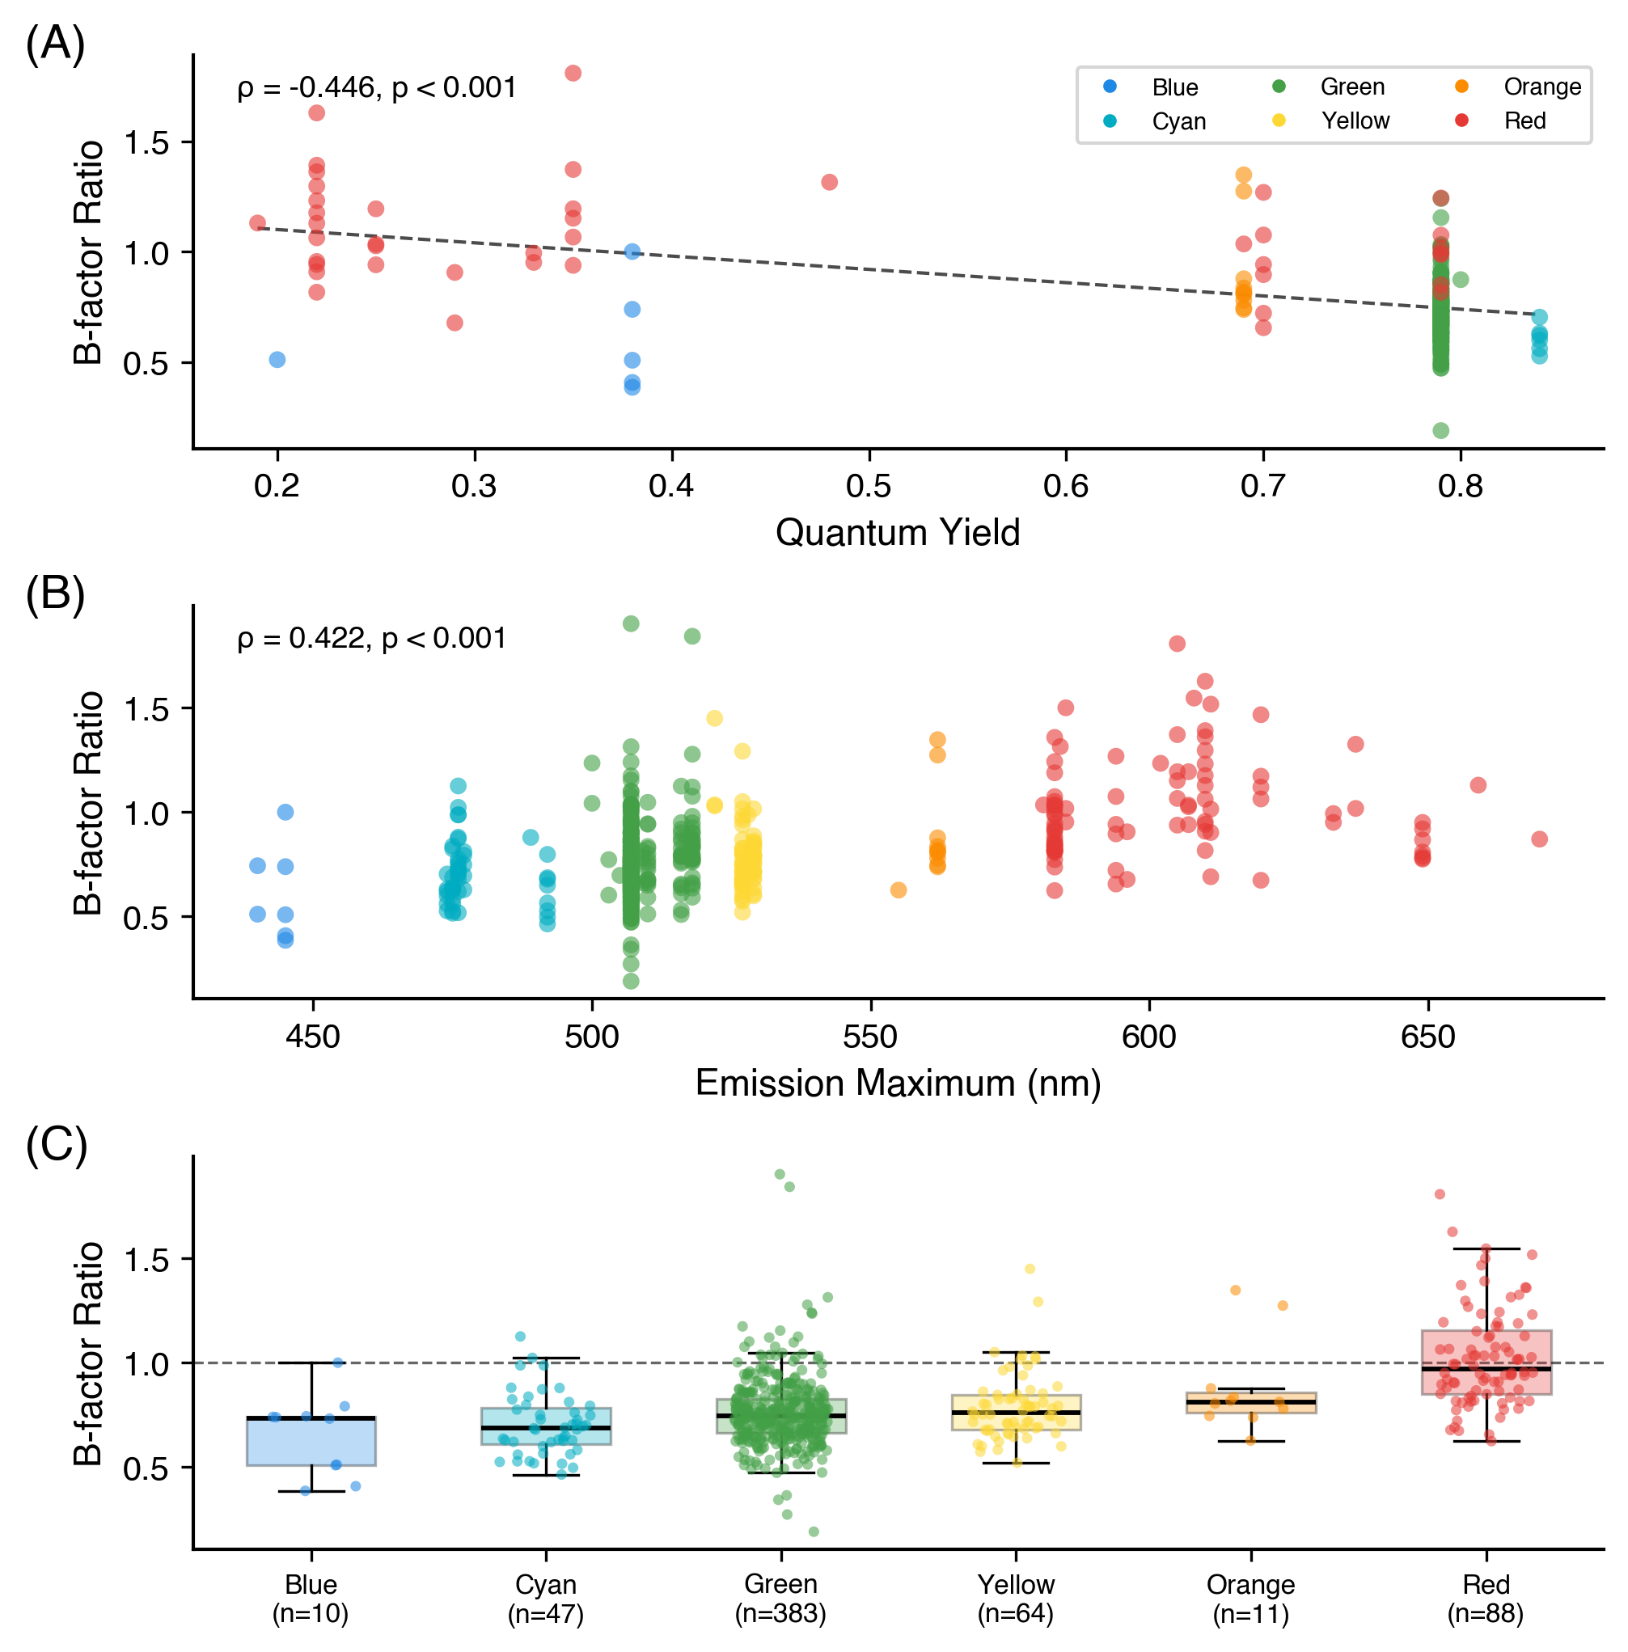
Figure 2. B-factor ratio analysis (canonical cohort, n = 780). (A) B-factor ratio vs quantum yield (ρ = –0.446). (B) B-factor ratio vs emission wavelength. (C) B-factor ratio by color class: box shows median and IQR with whiskers at 1.5 × IQR; individual structures are overlaid as jittered points; the dashed line at 1.0 indicates equal chromophore and barrel rigidity.

Chromophore–Barrel Contacts.
Restricting to the 739 chromophore-containing canonical structures, the mean number of (chromophore-atom, scaffold-atom) pairs within 4.0 Å was 133 ± 63 (pair count, not unique scaffold-atom count; see Methods). Pair count correlated with emission wavelength (ρ = +0.202, p = 5.9 × 10⁻⁷, n = 600).
Chromophore Dihedral Angles.
τ and φ dihedral angles were computed for 603 canonical-cohort structures (590 of which were classifiable as cis, trans, or twisted). Cis configurations predominated (441, 74.7%), with 111 trans (18.8%) and 38 twisted (6.4%). The τ angle correlated with eccentricity (ρ = –0.197, p = 1.1 × 10⁻⁶). Absolute twist magnitudes correlated with eccentricity (|τ|: ρ = +0.167; |φ|: ρ = +0.197), quantum yield (|τ|: ρ = –0.246, p = 1.9 × 10⁻⁴; |φ|: ρ = –0.204, p = 0.002), and B-factor ratio (|τ|: ρ = +0.158; |φ|: ρ = +0.155). The sum τ + φ was the strongest dihedral predictor of emission (ρ = –0.312, p = 1.0 × 10⁻¹²) and quantum yield (ρ = +0.281, p = 1.9 × 10⁻⁵). We note that τ + φ is used here as a descriptive algebraic sum of two static crystallographic dihedral angles, not in the mechanistic sense of the hula-twist photoisomerization pathway. This extends the findings of Megley et al.²⁷ from a small set of structures to 603. Within this dataset, τ and φ are negatively correlated across all structures (ρ = –0.357, p < 0.001; Figure S7A), forming two parallel bands in the τ–φ plane corresponding to cis and trans configurations. This anticorrelation primarily reflects the bimodal distribution of configurational states: cis structures (τ ≈ 0°) and trans structures (τ ≈ ±180°) each occupy distinct, non-overlapping regions of the τ–φ plane, such that the negative population-level correlation is a geometric consequence of the discrete classification rather than evidence for dynamic coupling between the two bonds in individual structures. Nevertheless, the relative positioning of τ and φ within each class may influence effective conjugation length. Twisted chromophores reside in more eccentric barrels with narrower minor axes. These observations are consistent with a model in which extended conjugation is associated with an asymmetric barrel that provides less symmetric constraint on torsional freedom, potentially allowing greater non-planar distortion and increased non-radiative decay. Trans-configured chromophores had higher eccentricity than cis (0.44 vs 0.40, p < 0.001), lower circularity (0.918 vs 0.923, p = 0.019), and narrower minor axes (29.2 vs 29.6 Å, p = 0.003; Figure S2). The full dihedral analysis is shown in Figure S7.
Resolution Confound and Barrel Size.
If crystallographic water and other ordered solvent atoms are included in the slice, a strong negative correlation appears between resolution and cross-sectional area (ρ ≈ –0.5), because higher-resolution structures resolve more ordered water molecules and these pad the convex hull. With the slice restricted to protein heavy atoms only (Methods), the resolution dependence of area essentially vanishes (ρ = –0.037, p = 0.30); the same holds for minor axis (ρ = –0.047, p = 0.19) and eccentricity (ρ = +0.003, p = 0.93). Partial correlations controlling for resolution are therefore nearly identical to the zero-order correlations: emission vs eccentricity (partial ρ = +0.321), emission vs minor axis (partial ρ = –0.327), and QY vs B-factor ratio (partial ρ = –0.481). Cross-sectional area is uncorrelated with emission (ρ = +0.039, p = 0.33), and barrel length is similarly uninformative (ρ = –0.027, p = 0.50). Resolution-vs-minor-axis and emission-vs-minor-axis scatters, with resolution color-coded, are shown in Figure S3. The photophysically relevant variation is in barrel shape, not size. This suggests that optimization of quantum yield should target the symmetry and tightness of chromophore packing in the minor-axis direction, not overall barrel volume.
Stokes Shift and Barrel Geometry.
The Stokes shift, which is the difference between excitation and emission maxima, was available for 633 canonical-cohort structures (mean 23.7 ± 18.6 nm, range 9–180 nm). Stokes shift varied by color class, with rankings dominated by a small long-Stokes-shift (LSS) subset of the blue class: blue 62.9 ± 2.0 nm (n = 7; all LSS variants), red 41.0 ± 36.4 nm (n = 89, very high variance reflecting a mix of standard and large-Stokes-shift red FPs), cyan 37.9 ± 4.4 nm (n = 47), green 19.5 ± 9.6 nm (n = 415), orange 16.6 ± 8.7 nm (n = 11), and yellow 13.3 ± 1.3 nm (n = 64). Stokes shift correlated negatively with quantum yield (ρ = –0.436, p = 5.2 × 10⁻¹⁵, n = 293), consistent with the interpretation that greater excited-state reorganization energy competes with radiative decay.
Stokes shift correlated significantly with barrel shape: proteins with larger Stokes shifts reside in more elliptical barrels (eccentricity: ρ = +0.123, p = 0.002), with narrower minor axes (minor axis: ρ = –0.128, p = 0.001), lower circularity (ρ = –0.142, p < 0.001), and shorter barrel length (ρ = –0.122, p = 0.002). Cross-sectional area was uninformative (ρ = –0.018, p = 0.66). Partial correlations controlling for emission wavelength confirmed that these associations are not simply driven by the color-class dependence of Stokes shift: eccentricity (partial ρ = +0.179), minor axis (partial ρ = –0.186), circularity (partial ρ = –0.186), and barrel length (partial ρ = –0.127) each remained significant. The barrel length association is notable given that barrel length was uninformative for emission wavelength (ρ = –0.027, p = 0.50), suggesting it captures variation relevant to excited-state reorganization independently of ground-state spectral tuning.
Multivariate Analysis.
To disentangle the contributions of correlated predictors, multiple linear regression was performed with quantum yield as the response variable. A model including eccentricity, minor axis, B-factor ratio, and |τ| yielded R² = 0.41 (n = 225). Standardized regression coefficients show that the B-factor ratio is the dominant — and only — independently significant geometric predictor (β = –0.563, p = 2 × 10⁻²⁰); eccentricity (β = –0.093, p = 0.24), minor axis (β = +0.082, p = 0.32), and |τ| (β = –0.020, p = 0.71) were not significant after controlling for the other predictors. This indicates that the bivariate correlations between barrel shape and quantum yield are mediated almost entirely through chromophore rigidity.
For emission wavelength, a model including minor axis, circularity, B-factor ratio, and resolution yielded R² = 0.33 (n = 600). Standardized regression coefficients again identified the B-factor ratio as the largest contributor (β = +0.394, p = 1.4 × 10⁻²⁵), with circularity (β = –0.225, p = 6.3 × 10⁻¹⁰) and minor axis (β = –0.177, p = 1.8 × 10⁻⁶) each making smaller but independently significant contributions; resolution was marginal (β = –0.063, p = 0.07). Barrel shape and chromophore rigidity thus contribute to emission wavelength through partially independent pathways.
A Random Forest model (500 trees, bootstrap aggregation) predicting quantum yield achieved out-of-bag R² = 0.42, with B-factor ratio as the dominant feature (importance = 0.499). The nonlinear model’s improved performance suggests that interactions among predictors contribute to quantum yield determination beyond what linear models capture.
Implications for Engineering.
These correlations do not establish causation, and the hypotheses below remain to be tested experimentally. Nevertheless, the observed trends suggest candidate strategies. If the B-factor ratio–quantum yield correlation reflects an underlying causal relationship, then mutations that rigidify the chromophore relative to the barrel would be expected to increase quantum yield. Similarly, barrel eccentricity in a crystal structure might serve as a coarse diagnostic: high eccentricity could flag variants that are candidates for improvement, though other factors (chromophore chemistry, protonation state, excited-state dynamics) will also be important. The engineering successes of mTurquoise2,¹⁷ StayGold,⁴¹ and YuzuFP²⁸—each achieved through mutations altering chromophore–barrel packing—are consistent with these hypotheses but do not constitute a prospective test of them.
AlphaFold Structural Predictions.
To assess whether AlphaFold-predicted structures recapitulate crystallographic barrel geometry, a paired analysis was performed for all 51 wild-type FP sequences for which both an AlphaFold model and a matched crystal structure exist in the dataset (UniProt–PDB cross-references from the UniProt REST API; highest-resolution crystal structure selected per protein; mean crystal resolution 1.63 ± 0.37 Å; mean AlphaFold pLDDT 96.7 ± 1.3). Wilcoxon signed-rank tests showed that barrel shape metrics were indistinguishable between AlphaFold and crystal structures: eccentricity (Δ = 0.00, p = 0.59) and circularity (Δ = 0.00, p = 0.74) did not differ. The minor axis also did not differ (Δ = +0.23 Å, p = 0.25, 95% CI [−0.07, +0.54]), and cross-sectional area was statistically indistinguishable (Δ = +9.6 Å², p = 0.23, 95% CI [−5.6, +24.8]). Two metrics did show small but significant offsets: AlphaFold predicted a marginally wider major axis (Δ = +0.45 Å, p = 0.02, 95% CI [−0.05, +0.96]) and a longer barrel (Δ = +3.74 Å, p < 10⁻⁴, 95% CI [+0.98, +6.49]). Bland–Altman plots for all six metrics are shown in Figure S8. The barrel-length excess likely reflects AlphaFold modeling of flexible terminal regions that are disordered and excluded from electron density in crystal structures. The lack of a measurable cross-sectional offset is notable given that AlphaFold DB models are sequence-based and do not explicitly include the cyclized chromophore (or any post-translational modification) in the predicted structure: the chromophore-forming residues are output as the uncyclized Ser–Tyr–Gly precursor. The barrel cross-section is therefore reproduced from sequence information alone.
Second, a population-level comparison was performed between the 309 AlphaFold structures and the 739 chromophore-containing crystal structures in the canonical cohort. With crystallographic solvent excluded from the crystal slice, the size of the AlphaFold and crystal barrels is similar — AlphaFold area is only 11 Å² larger than the crystal mean (700 ± 49 vs 689 ± 41 Å², p = 1.5 × 10⁻⁴) — but the *shape* of the predicted barrel differs systematically. AlphaFold barrels have a narrower minor axis (28.7 ± 1.3 vs 29.4 ± 1.2 Å, Δ = –0.7 Å, p < 10⁻¹⁵), a wider major axis (33.8 ± 1.6 vs 32.6 ± 1.4 Å, Δ = +1.1 Å, p < 10⁻²⁸), higher eccentricity (0.51 ± 0.11 vs 0.41 ± 0.12, p < 10⁻³²), and lower circularity (0.91 ± 0.02 vs 0.92 ± 0.02, p < 10⁻³²). These population differences partly reflect the distinct protein compositions of the two datasets: the AlphaFold set includes many uncrystallized FPs that may be enriched in red-shifted, more eccentric variants, while the crystal set is dominated by well-studied green FPs. Notably, the correlation between emission maximum and minor axis length prominent in crystal structures (ρ = −0.33, p < 10⁻¹⁶) was absent in the AlphaFold ensemble (ρ = −0.018, p = 0.85). Instead, sequence length remained a structural correlate even within the canonical filter window (ρ = −0.42 with eccentricity, p < 0.0001). This pattern indicates that the barrel distortions correlated with emission wavelength in crystal structures are driven by the mature chromophore, which is absent in AlphaFold models, rather than by primary sequence alone. AlphaFold therefore provides a useful geometric baseline for uncrystallized FPs, but reproducing the spectral correlations requires experimentally determined or computationally modeled chromophore geometry.
Limitations.
The canonical cohort is unevenly distributed (green n = 415, blue and orange ≤ 11), the 780 entries are not fully independent (633 spectrally matched entries correspond to only 70 unique FPbase names), and the PDB itself is not a random sample of all FPs — heavily studied variants such as GFP and mCherry are overrepresented while many natural and engineered FPs have no deposited structure. These pseudoreplication and selection issues are partially addressed by the unique-protein collapse (Table S2), which preserves the principal correlations, but the generalizability to FPs outside the crystallized subset remains to be established. Crystal-lattice contacts impose non-physiological forces that can distort eccentricity, particularly for proteins crystallized in multiple space groups.
Crystallographic B-factors are influenced by resolution, refinement protocol, occupancy, TLS treatment, and packing as well as genuine mobility. The B-factor ratio normalizes within each structure and survives partial correlation controlling for resolution (partial ρ = –0.481), but should be regarded as a proxy for relative chromophore mobility rather than a direct measure of dynamics. The geometry pipeline itself is robust: sensitivity tests across slice thicknesses (1.5–2.5 Å) and atom selections (protein heavy atoms vs backbone only) preserve the rank order of structures by eccentricity, circularity, and minor axis (Table S3). Quantum-yield values were available for only 293 canonical-cohort structures, from measurements under heterogeneous conditions. The full Spearman correlation matrix (Figure S4) and barrel geometry by chromophore type (Figure S5) are provided in Supporting Information.

Conclusions
Across a canonical cohort of 780 fluorescent protein crystal structures (drawn from 908 total deposits by an FP-barrel sequence-length filter of 210–245 residues, a chain-selection audit that recovered 14 FP-complex co-crystals analyzed on the binding-partner chain, and exclusion of two entries whose topology is not a standard monomeric β-can; see Note S1(b)), and using protein heavy atoms only (no crystallographic solvent) for the chromophore-plane slice, beta-barrel geometry varies systematically with photophysical output. Barrel shape, not size, tracks emission wavelength: red-shifted variants are narrower and more elliptical, while cross-sectional area and barrel length are largely uninformative. The chromophore-to-barrel B-factor ratio is the strongest single predictor of quantum yield (ρ = –0.446, partial ρ = –0.481 controlling for resolution) and multivariate analysis indicates that it mediates most of the bivariate correlations between barrel shape and quantum yield. Chromophore dihedral twist correlates with both barrel eccentricity and quantum yield, extending the observations of Megley et al.²⁷ from a handful of structures to 603 (canonical cohort). AlphaFold reproduces both the size and shape of the FP barrel; in the paired comparison against high-resolution crystal structures, only the major axis (+0.5 Å) and barrel length (+3.7 Å) differ measurably, while minor axis, area, eccentricity, and circularity are statistically indistinguishable from the crystallographic ground truth. Together these results argue that the barrel is not a passive scaffold: it constrains chromophore rigidity and, through that constraint, shapes photophysical output. The B-factor ratio offers a candidate structural diagnostic for variants amenable to quantum-yield improvement, particularly among red-shifted FPs where the chromophore is on average no more rigid than its barrel.
The structural patterns identified here motivate prospective experimental work, particularly mutations targeting the minor-axis-defining strands of red FPs aimed at restoring the rigidity differential that characterizes brighter green and cyan variants. On the methodological side, the entire pipeline was generated with AI assistance (Claude Code); the chromophore-detection failure documented in Note S1 illustrates that intermediate output files and explicit cross-checks against known structures remain essential when LLMs are used as coding agents on scientific data.

Author Information
Corresponding Author.
Marc Zimmer — Chemistry Department, Connecticut College, New London, CT 06320, United States. ORCID: 0000-0000-0000-0000. *E-mail: mzim@conncoll.edu.
Authors.
Luke P. Begg — Chemistry Department, Connecticut College, New London, CT 06320, United States. ORCID: 0000-0000-0000-0000.
Madeline L. Mason — Chemistry Department, Connecticut College, New London, CT 06320, United States. ORCID: 0000-0000-0000-0000.
Author Contributions.
L.P.B. conceived the project, designed and implemented the computational pipeline (CIF parsing, PCA-based barrel axis determination, cross-sectional slicing, convex-hull and ellipse-fit geometry, B-factor and contact analysis, dihedral computation, AlphaFold comparison, and statistical analysis), curated the dataset, generated the figures, and wrote the original draft. M.L.M. compiled the FPbase UniProt sequence list used for the AlphaFold comparison, performed independent validation of the geometric pipeline, and contributed to manuscript revision. M.Z. supervised the project, contributed to its conception and interpretation, and revised the manuscript. All authors have given approval to the final version of the manuscript.
Notes.
The authors declare no competing financial interest.

References
(1) Shimomura, O.; Johnson, F. H.; Saiga, Y. Extraction, Purification and Properties of Aequorin, a Bioluminescent Protein from the Luminous Hydromedusan, Aequorea. J. Cell. Comp. Physiol. 1962, 59, 223–239.
(2) Stepanenko, O. V.; Verkhusha, V. V.; Kuznetsova, I. M.; Uversky, V. N.; Turoverov, K. K. Fluorescent Proteins as Biomarkers and Biosensors: Throwing Color Lights on Molecular and Cellular Processes. Curr. Protein Pept. Sci. 2008, 9, 338–369.
(3) Chalfie, M.; Tu, Y.; Euskirchen, G.; Ward, W. W.; Prasher, D. C. Green Fluorescent Protein as a Marker for Gene Expression. Science 1994, 263, 802–805.
(4) The Nobel Foundation. The Nobel Prize in Chemistry 2008. https://www.nobelprize.org/prizes/chemistry/2008/ (accessed 2026-04-07).
(5) Tsien, R. Y. The Green Fluorescent Protein. Annu. Rev. Biochem. 1998, 67, 509–544.
(6) Day, R. N.; Davidson, M. W. The Fluorescent Protein Palette: Tools for Cellular Imaging. Chem. Soc. Rev. 2009, 38, 2887–2921.
(7) Rodriguez, E. A.; Campbell, R. E.; Lin, J. Y.; Lin, M. Z.; Miyawaki, A.; Palmer, A. E.; Shu, X.; Zhang, J.; Tsien, R. Y. The Growing and Glowing Toolbox of Fluorescent and Photoactive Proteins. Trends Biochem. Sci. 2017, 42, 111–129.
(8) Ormö, M.; Cubitt, A. B.; Kallio, K.; Gross, L. A.; Tsien, R. Y.; Remington, S. J. Crystal Structure of the Aequorea victoria Green Fluorescent Protein. Science 1996, 273, 1392–1395.
(9) Yang, F.; Moss, L. G.; Phillips, G. N., Jr. The Molecular Structure of Green Fluorescent Protein. Nat. Biotechnol. 1996, 14, 1246–1251.
(10) Heim, R.; Cubitt, A. B.; Tsien, R. Y. Improved Green Fluorescence. Nature 1995, 373, 663–664.
(11) Cubitt, A. B.; Heim, R.; Adams, S. R.; Boyd, A. E.; Gross, L. A.; Tsien, R. Y. Understanding, Improving and Using Green Fluorescent Proteins. Trends Biochem. Sci. 1995, 20, 448–455.
(12) Matz, M. V.; Fradkov, A. F.; Labas, Y. A.; Savitsky, A. P.; Zaraisky, A. G.; Markelov, M. L.; Lukyanov, S. A. Fluorescent Proteins from Nonbioluminescent Anthozoa Species. Nat. Biotechnol. 1999, 17, 969–973.
(13) Stepanenko, O. V.; Kuznetsova, I. M.; Verkhusha, V. V.; Turoverov, K. K. Beta-Barrel Scaffold of Fluorescent Proteins: Folding, Stability and Role in Chromophore Formation. Int. Rev. Cell Mol. Biol. 2013, 302, 221–278.
(14) Heim, R.; Tsien, R. Y. Engineering Green Fluorescent Protein for Improved Brightness, Longer Wavelengths and Fluorescence Resonance Energy Transfer. Curr. Biol. 1996, 6, 178–182.
(15) Wachter, R. M.; Elsliger, M. A.; Kallio, K.; Hanson, G. T.; Remington, S. J. Structural Basis of Spectral Shifts in the Yellow-Emission Variants of Green Fluorescent Protein. Structure 1998, 6, 1267–1277.
(16) Gross, L. A.; Baird, G. S.; Hoffman, R. C.; Baldridge, K. K.; Tsien, R. Y. The Structure of the Chromophore within DsRed, a Red Fluorescent Protein from Coral. Proc. Natl. Acad. Sci. U.S.A. 2000, 97, 11990–11995.
(17) Goedhart, J.; von Stetten, D.; Noirclerc-Savoye, M.; Lelimousin, M.; Joosen, L.; Hink, M. A.; van Weeren, L.; Gadella, T. W. J., Jr.; Royant, A. Structure-Guided Evolution of Cyan Fluorescent Proteins towards a Quantum Yield of 93%. Nat. Commun. 2012, 3, 751.
(18) Ai, H. W.; Henderson, J. N.; Remington, S. J.; Campbell, R. E. Directed Evolution of a Monomeric, Bright and Photostable Version of Clavularia Cyan Fluorescent Protein. Biochem. J. 2006, 400, 531–540.
(19) Davidson, M. W.; Campbell, R. E. Engineered Fluorescent Proteins: Innovations and Applications. Nat. Methods 2009, 6, 713–717.
(20) Shaner, N. C.; Steinbach, P. A.; Tsien, R. Y. A Guide to Choosing Fluorescent Proteins. Nat. Methods 2005, 2, 905–909.
(21) Remington, S. J. Fluorescent Proteins: Maturation, Photochemistry and Photophysics. Curr. Opin. Struct. Biol. 2006, 16, 714–721.
(22) Craggs, T. D. Green Fluorescent Protein: Structure, Folding and Chromophore Maturation. Chem. Soc. Rev. 2009, 38, 2865–2875.
(23) Zimmer, M. Green Fluorescent Protein (GFP): Applications, Structure, and Related Photophysical Behavior. Chem. Rev. 2002, 102, 759–781.
(24) Li, B.; Shahid, R.; Peshkepija, P.; Zimmer, M. Water Diffusion In and Out of the Beta-Barrel of GFP and the Fast Maturing Fluorescent Protein, TurboGFP. Chem. Phys. 2012, 392, 143–148.
(25) Zimmer, M. H.; Li, B.; Shahid, R. S.; Peshkepija, P.; Zimmer, M. Structural Consequences of Chromophore Formation and Exploration of Conserved Lid Residues amongst Naturally Occurring Fluorescent Proteins. Chem. Phys. 2014, 429, 5–11.
(26) Nwafor, J.; Salguero, C.; Welcome, F.; Durmus, S.; Glasser, R. N.; Zimmer, M.; Schneider, T. L. Why Are Gly31, Gly33, and Gly35 Highly Conserved in All Fluorescent Proteins? Biochemistry 2021, 60, 3762–3770.
(27) Megley, C. M.; Dickson, L. A.; Maddalo, S. L.; Chandler, G. J.; Zimmer, M. Photophysics and Dihedral Freedom of the Chromophore in Yellow, Blue, and Green Fluorescent Protein. J. Phys. Chem. B 2009, 113, 302–308.
(28) Ahmed, R. D.; Jamieson, W. D.; Vitsupakorn, D.; Zitti, A.; Pawson, K. A.; Castell, O. K.; Watson, P. D.; Jones, D. D. Molecular Dynamics Guided Identification of a Brighter Variant of Superfolder Green Fluorescent Protein with Increased Photobleaching Resistance. Commun. Chem. 2025, 8, 174.
(29) Anthropic. Claude Code. https://docs.anthropic.com/en/docs/claude-code (accessed 2026-04-07).
(30) Schwartz, M. D. Vibe Physics: The AI Grad Student. Anthropic 2026. https://www.anthropic.com/research/vibe-physics (accessed 2026-04-07).
(31) Hartley, S. M.; Tiernan, K. A.; Ahmetaj, G.; Cretu, A.; Zhuang, Y.; Zimmer, M. AlphaFold2 and RoseTTAFold Predict Posttranslational Modifications. Chromophore Formation in GFP-like Proteins. PLoS One 2022, 17, e0267560.
(32) Hayes, T.; et al. Simulating 500 Million Years of Evolution with a Language Model. Science 2025, 387, 850–858.
(33) Gelman, S.; Johnson, B.; Freschlin, C. R.; Sharma, A.; D’Costa, S.; Peters, J.; Gitter, A.; Romero, P. A. Biophysics-Based Protein Language Models for Protein Engineering. Nat. Methods 2025, 22, 1868–1879.
(34) Lambert, T. J. FPbase: A Community-Editable Fluorescent Protein Database. Nat. Methods 2019, 16, 277–278.
(35) Sievers, F.; et al. Fast, Scalable Generation of High-Quality Protein Multiple Sequence Alignments Using Clustal Omega. Mol. Syst. Biol. 2011, 7, 539.
(36) Waterhouse, A. M.; Procter, J. B.; Martin, D. M. A.; Clamp, M.; Barton, G. J. Jalview Version 2—A Multiple Sequence Alignment Editor and Analysis Workbench. Bioinformatics 2009, 25, 1189–1191.
(37) Barber, C. B.; Dobkin, D. P.; Huhdanpaa, H. The Quickhull Algorithm for Convex Hulls. ACM Trans. Math. Softw. 1996, 22, 469–483.
(38) Cranfill, P. J.; et al. Quantitative Assessment of Fluorescent Proteins. Nat. Methods 2016, 13, 557–562.
(39) Virtanen, P.; et al. SciPy 1.0: Fundamental Algorithms for Scientific Computing in Python. Nat. Methods 2020, 17, 261–272.
(40) Pedregosa, F.; et al. Scikit-learn: Machine Learning in Python. J. Mach. Learn. Res. 2011, 12, 2825–2830.
(41) Hirano, M.; Ando, R.; Shimozono, S.; Sugiyama, M.; Takeda, N.; Kurokawa, H.; Deguchi, R.; Endo, K.; Haga, K.; Takai-Todaka, R.; et al. A Highly Photostable and Bright Green Fluorescent Protein. Nat. Biotechnol. 2022, 40, 1132–1142.

