Term Project: Final Report

In-Flight Cultural Companion

Sarthak Poshattiwar and Nathan Walker

CSCI 6561 – Design of Human Computer Interface

**Project Selection**

We selected the in-flight cultural companion topic. We selected this project because we were both already familiar with a variety of different in-flight entertainment systems and were interested in how we could extend these systems.

We divided the work for the project evenly. Here are the components that were worked on by each team member:

|  |  |
| --- | --- |
| **Nathan** | **Sarthak** |
| Developed initial structure for the application | Worked on designing part of the application |
| Finished final working designed application | Suggested and implemented changes in the design |
| Worked on task part in user profile writeup | Worked on user profile part in user profile writeup |
| Designed initial prototype presentation slides | Completed remaining prototype presentation slides |
| Did user testing and interface evaluation | Did task analysis |
| Finished final project prototype | Made the project presentation |
| Compiled components into final report |  |

**Design Process and Guidelines**

In building this project, we did not rely on a particular design model. We did utilize Nielsen’s usability guidelines while we were developing the prototypes. Additionally, we kept in mind a number of other design rules taught in class, such as the rules regarding how to group elements and how to utilize white space. Overall, we tried to keep a minimalist design to build an interface that emphasized content over interface elements.

**User Profile**

Inflight entertainment is the entertainment system available in the passenger aircraft. In earlier years, the entertainment was offered as a piano player, lounge or a smoking room to the passengers. After few years, occasional projector movies became common part of the entertainment system. Now, the technological advancement allowed every passenger to have his own personal inflight entertainment system. In this report, we will be discussing adding functionality to this system to include cultural information about a destination – in this case, Spain.

The general demographics could be divided in many categories such as culture, age, gender, physical abilities etc. User interface needs to be modified for certain group according to the specific requirement to provide a better compatibility. User expectations for different demographics are explained below.

**Age:**

Age group is very important factor while designing user interface for any system. Age groups can be divided in 3 general categories i.e. kids, adults and seniors. Kids under the age of 17 will tends towards animated design or gaming interface. Adult will be expecting the fast interface with multiple shortcuts. Design must be elegant to sooth the viewer of this categories. It needs to be more responsive as most of the adults are already exposed to different interfaces. Seniors above age of 60 would require a simple and easy design as cognitive abilities reduces with age.

**Gender:**

We need to consider all three types of gender i.e. male, female and others while designing the UI. Men and women identify different element of UI as important. We need to go beyond the stereotype of pink color for women and think about the structure of the bars and buttons which would interest a specific gender class. Men are more likely to attract to sophisticated designs; however, women will tend towards fashionable designs.

**Physical abilities:**

There are many travelers who could be suffering from different physical disabilities. We first need to collect the data for different types of disabilities. Comprehensive study about different physically challenged people would be useful in determining the overall design. A customized software with aids and tools for disables people can be included in the design. Disable people are less attractive as a target audience when it comes to commercial market. However, our focus should be making every individual comfortable while using the application.

**Cognitive abilities:**

Cognitive abilities are referred to how a person understand and react to different situations. Recognition and interpretation play vital role where person tries to apply his previous knowledge and experience while interacting with user interface. We need to consider the regular standards which would result in better compatibility. User should not be required to remember data from one screen to use on another. Hence load should be minimal on user with proper labels.

**Attitude and motivation:**

Attitude is an enduring organization of beliefs around an object or a situation which allows one to respond in some specific manner. Whereas, motivation can be referred to as an extent to which an individual will strive to learn something to achieve satisfaction. Some user will not pay attention to the instructions provided on the screen and ends up in a situation where they want to revert the changes or steps taken. In such situation implementing feedback system and designing smooth way of reverting the changes is all expected from the user. We can take necessary measure to attract inattentive users by using red colored design which possess highest wavelength amongst all other colors. Due to high wavelength red color attract human eyes.

**Language skills:**

While designing the system for passenger the most important consideration is nothing but language. People from different ethnicity, country and background would be able to use the system efficiently irrespective the languages they speak or understand. English is globally known language but still there are many people from different places of the world who are not comfortable in English. We need to include a button which will allow user to choose from many globally known languages. However, it is impossible to include all the languages in the world as there are more than 6000 different languages spoken around the world. We can do some research on the background and languages known by the frequent travelers for the airline or specific route in order to include maximum languages.

**Tasks:**

*Learn About the People of Spain*

The first task available to users will be accessing some content about the Spanish people, their culture, and their customs. The content will be primarily videos, although some text-based content and photos could also be available.

*Spanish Language Tutor*

Another task that users can perform while using the app will be taking some basic Spanish language lessons. If the language is available in the system, users will be able to take language lessons in their native language. If headphones are available, audio lessons will be provided, but written lessons will also be available.

*Places to Visit*

The last task that the users will be able to perform in the app is to view a map with different activities to do and tourist attractions to visit in Spain. Users will be able to zoom in and out of different regions of Spain to see the points of interest in different cities. A user can click on a given place marked on the map to see more information.

**Duration:**

We expect that most people will not spend a particularly long amount of time interacting with our system, given the large number of alternative activities available during a flight, such as watching a movie, having a conversation with someone you are traveling with, or using a personal electronic device.

However, since our target audience is people who are unfamiliar with Spain, these people are more likely to be traveling on longer flights, and we should try to accommodate them with enough content if they choose to use our app during the whole flight.

**Familiarity with the Hardware:**

We plan to integrate with the existing touchscreens built into many airplane seats already for the in-flight entertainment systems. Many of our users will likely be familiar with these systems already from other flights that they have taken in the past.

Even if a user has not been exposed to an in-flight entertainment screen before, we expect that most users will be familiar with this type of interface through other touchscreen devices like smartphones and tablets. A Zenith Media study found that 63% of people worldwide owned smartphones in 2017. In just the United States, the Pew Research Center found that 77% of adults owned smartphones in 2018. Given these high ownership rates, we expect an even higher percentage of people have are at least familiar with smartphones, even if they do not own one.

**Environment:**

Some aspects of the in-flight environment can be challenging for the type of interactive experience this app will offer, so we must be considerate of them during the design process.

One aspect to consider on a flight is noise. Since playing any sort of sound would be disruptive to other passengers, headphones are a must for any part of the app that requires audio. Since not all passengers may have brought headphones with them, we must offer a good experience when audio is not available. For example, closed captioning can be added to any video content, which would also be helpful for hearing-impaired passengers.

Another aspect to keep in mind is distraction. While on the flight, a person could experience a wide variety of different situations that could cause them to stop using the app for a while. For example, they could get up to use the bathroom or stop to order beverage service from a flight attendant. The app should allow users to easily pick up where they left off, so they are not frustrated by losing their place.

**Sources:**

We have taken survey within our friends (group of 4) and asked them about their expectation from inflight entertainment. As age group of all the 4 people are same hence expectation from them was similar. They demanded fast responsive interface with multiple shortcuts. We have asked one senior couple about the problem they face while interacting with different user interface. Surprisingly, they were comfortable using the different devices. However, they expected much simpler version of the existing user design.

Secondly, we did research and found various articles talking about user expectations from interface designs. Most of the articles talked about how to develop soothing UI with minimal load. Also, keeping a consistency is very important part of design. We also checked few airline websites to get information about the inflight entertainment system they provide.

**References:**

1]<https://apex.aero/2017/11/17/how-to-design-modern-in-flight-entertainment-graphical-user-interface>

2] <https://www.aa.com/i18n/travel-info/experience/entertainment/inflight-entertainment.jsp>?

3] <https://www.lufthansa-inflightentertainment.com/en/>

4] <https://www.creativebloq.com/web-design/how-design-sites-match-user-expectations-51514868>

5] <https://www.zenithmedia.com/smartphone-penetration-reach-66-2018/>

6] <http://www.pewinternet.org/fact-sheet/mobile/>

**Task Analysis**

In this project user will be able to perform following 3 task successfully without little or no help from anyone just by following the steps provided:

1. **First Task: Learn about people of Spain**
2. The application will be launched in the default format and it will show the home page
3. Select or touch the tab “Learn About Spain” which will launch a section where cultural details about the Spain can be seen
4. The first tab is “People of Spain” which needs to be selected to know more about Spanish culture
5. This will land a page with list of videos which gives more details about Spain, select “Interesting facts about Spain”
6. After the selection video will start where we can simply close the tab to end the running video
7. We can click “Home” tab anytime to go back to home menu
8. **Second Task: Learn Spanish**
9. The application will be launched in the default format and it will show the home page
10. Select or touch the tab “Learn About Spain” which will launch a section where cultural details about the Spain can be seen
11. Select second tab, “Learn Spanish” which will launch a wizard where we can select each Flashcard
12. Click or touch the flashcard with the name “hola” which will reveal the meaning of that word
13. We can select other flashcards as well to learn different Spanish words
14. **Third task: Choose places to visit in Spain**
15. The application will be launched in the default format and it will show the home page
16. Select or touch the tab “Learn About Spain” which will launch a section where cultural details about the Spain can be seen
17. Select the tab “Places to visit” which will launch a screen with map with details section
18. Touch on one of the red markers, let say rightmost marker which is a location of Barcelona
19. This will show image of the city with the details which a user can refer to choose the destination
20. Touch the “Home” button to go back to home page
21. **Fourth Task: Choosing the appropriate language**
22. Firstly, the application will be launched in the default format and it will show the home page
23. Various details can be seen on the home page where we need to select the “English” tab for changing the language
24. By default, the language selected will be English and after touching the “English” tab we can see options for different languages
25. Flags of the country and languages are written its own language for better understanding, choose “Spanish” tab or any other language to select the appropriate language which will land you with the home screen and language will be changed

**Initial Prototype**

This initial prototype showed all of our major screens in a low-fidelity paper format. We went for a minimalistic design style when building this prototype. This interface has a hierarchical conceptual model, since users go through different layers of menus to navigate to different parts of the application.

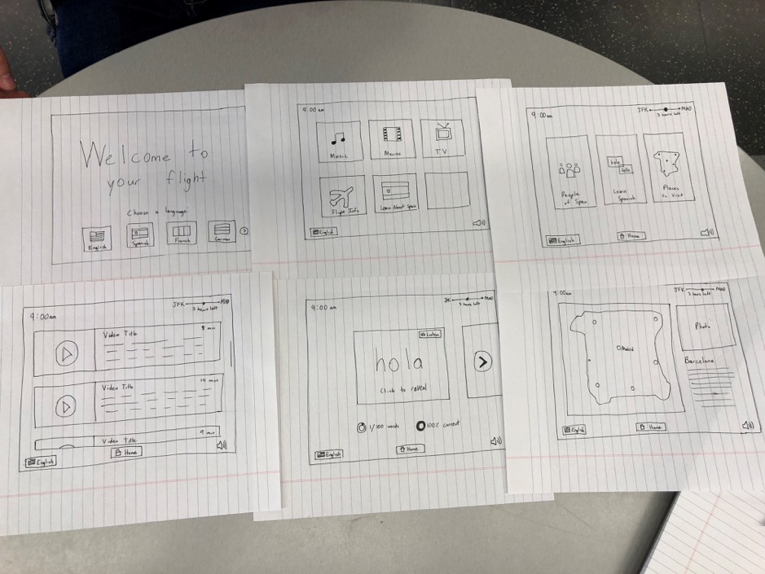

**Additional Refined Prototypes**

This next prototype addresses some comments about navigation, such as including a back button in addition to the home button. It also upgrades from paper to PowerPoint slides, allowing us to start working with colors and fonts.

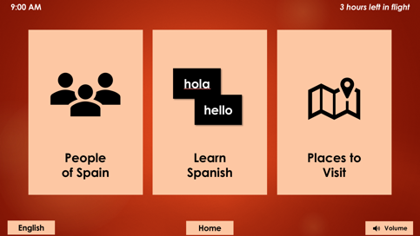 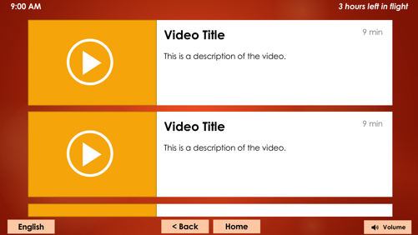

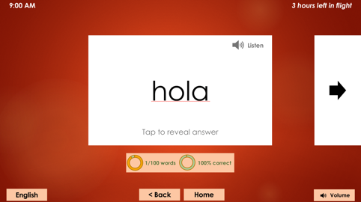 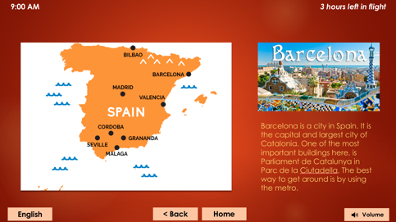

This was the final iteration of our prototype which included final colors, content, and full interactivity.

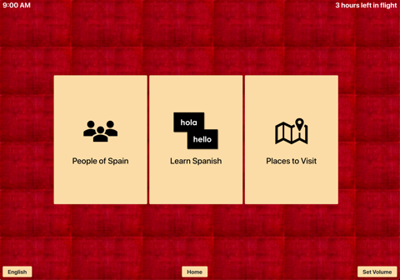 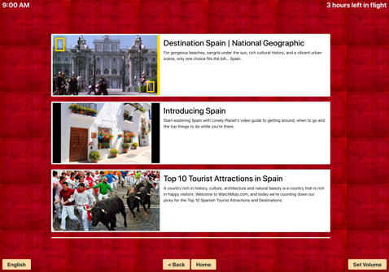

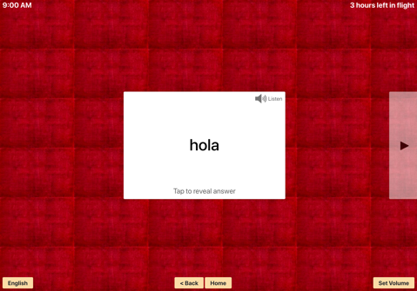 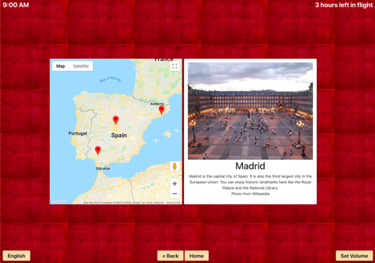

**Interface Evaluation**

In order to evaluate our prototype, we showed a near-final version to four subjects and allowed them to interact with it. We used a cognitive walkthrough method of evaluation, getting their feedback on every part of the interface as they walked through it. In order to provide some structure for the walkthrough, we assigned each user a few tasks to complete using the interface (see the Task Analysis earlier in this report). We also asked each user a few questions after the interface test, including following up on issues previous users had.

Here is a summary of the results of the user testing:

|  |  |
| --- | --- |
| Subject 1 | * Navigated quickly through the menus to get to the various tasks * Noted that the text was hard to read on some screens, especially the one with the map over Learn Spanish * Always hit Home, did not use back button * Noted an interest in having a next button to go from place to place in Places to Visit (like in Learn Spanish section) |
| Subject 2 | * When asked to find some videos about Spanish culture, tried to go to the Movies section (unimplemented) instead of the Learn About Spain section * Thought red background was a bit overpowering * Found the time left in flight at top right helpful * Struggled to read text on navigation buttons |
| Subject 3 | * Did not like that big play button blocked most of the image thumbnails in People of Spain * Did use back button frequently, never hit home button * Only user to try to listen to flashcard words (audio not implemented in prototype) * Noticed that color scheme was Spanish flag-based |
| Subject 4 | * Zoomed in People of Spain map to look for more markers * Hit next button on flashcards before revealing answer, had to go back * Thought images were overpowering in the navigation, preferred the idea of a simpler solid color |

Based on this testing, we made a few changes to the interface for the final version:

* Originally, the Places to Visit section started out with a location by default, but some users were not sure how to get to the next place at first. To correct for this, we replaced the default place with a message instructing people to click on the pins to pick a place.
* The large play button over the thumbnail in People of Spain was found to be unnecessary and blocked the thumbnails, so it was removed.
* The image backgrounds in the navigation menus made the text difficult to read, so we replaced those with a simpler, solid color background.
* There was some concern about users getting discouraged in the Learn Spanish section if it kept track of all the wrong answers. We decided to remove that and allow users to just move through the flashcards unguided.

**Documentation**

After choosing our topic, we first did some brainstorming and built out a user profile in order to understand what our functionality our users would need and what the best way to bring it to them was.

We then created a paper prototype to show our ideas to the class. After that, we created a PowerPoint slide-based prototype to explore our interface idea in a higher fidelity way, with real colors, fonts, and icons. Finally, we built a webpage-based prototype for the final version. This webpage-based prototype allowed us to have full functionality in our interface.

We used the Bootstrap framework as a way to develop the basic structure of our webpage prototype. Some images in the prototype are from Wikipedia (noted in the prototype as needed). Thumbnails and descriptions for videos in the “People of Spain” section were taken from YouTube videos, which are linked in the prototype. Some icons were taken from the PowerPoint clip art library.