ResaPermis Project Documentation
Generated on: 2026-02-19

1. Project Overview
This platform is a SaaS solution integrated with RDVPermis to manage driving school exams, automate synchronization, and provide operational control tools.

2. System Architecture
The system consists of an external RDVPermis API, backend synchronization layer, local database, and frontend dashboard.
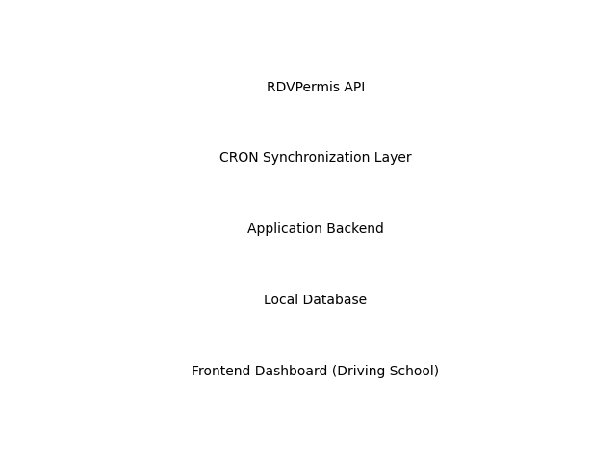

3. Core Modules
• Exams Dashboard (Flat, Grouped, Calendar Views)
• Swap & Replace Management
• Skills Assessment & CEPC Download
• Repeat Candidates Automation
• Profile & GDPR Lifecycle Management
• CRON Automation System

4. Database Schema
Key Tables: Users, Candidates, Exams, Centers, Repeat Candidates, FTE Records, Audit Logs.

5. CRON Architecture
Daily and Monthly scheduled jobs handle synchronization of exams, results, centers, FTE data, and account maintenance.

6. Development Roadmap
Sprint 1: Foundation & Auth
Sprint 2: Planning Dashboard
Sprint 3: Operational Actions
Sprint 4: Results & Repeaters
Sprint 5: Automation & Security

7. Risks & Considerations
Includes API rate limits, synchronization conflicts, race conditions, data reconciliation, and GDPR compliance.

8. Open Questions for Client
Clarification needed on architecture, penalty enforcement, audit logging, billing logic, and data retention policies.

