ResaPermis – Complete Project Master Document
Generated on: 2026-02-19
Version: 1.0

1. Executive Summary
ResaPermis is a SaaS platform designed to integrate with the RDVPermis API to manage the full lifecycle of driving school exam operations.
The system provides synchronized exam planning, operational control (Swap, Replace, Cancel), automated result ingestion, repeat candidate management,
FTE billing synchronization, and GDPR-compliant account lifecycle management.

2. Project Objective
The objective is to build a centralized operational management platform that reduces manual work for driving schools by:
• Mirroring RDVPermis planning locally
• Automating synchronization using CRON jobs
• Enabling operational management tools
• Providing KPI visibility
• Managing repeat candidates automatically
• Ensuring compliance and auditability

3. System Architecture
The system consists of four major layers:
1. RDVPermis API (External Source of Truth)
2. Backend Synchronization & Business Logic Layer
3. Local Database Storage Layer
4. Frontend Dashboard Layer
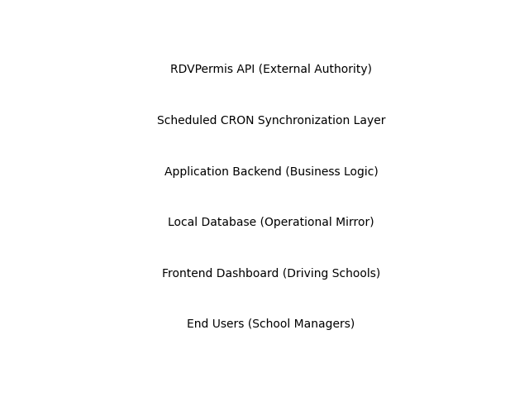

4. Functional Modules Overview
Core Modules:
• Exams Dashboard (Flat, Grouped, Calendar Views)
• Swap Exams Module
• Replace Candidate Module
• Cancel Exam Module
• Skills Assessment (Official Result + CEPC)
• Repeat Candidates Management
• Profile & Security Management
• CRON Automation System

5. Detailed Functional Specifications

5.1 Exams Dashboard
Provides full exam planning visibility including:
- Flat List View
- Grouped View by Session
- Calendar View (Month/Week/Day)
- Status Toggle (In Progress / Completed)
- Filters (Center, Date, License Category)
- KPIs (Total, Active, Cancelled)
- Operational Actions (Swap, Replace, Cancel)

5.2 Swap Workflow
Step 1: Open Swap Modal
Step 2: Fetch eligible exams
Step 3: Select target exam
Step 4: Confirmation screen
Step 5: Execute API call
Step 6: Handle success or error
Includes race-condition and deadline validation handling.

5.3 Replace Workflow
Allows replacement of a candidate within a scheduled slot.
Includes mandate validation, API execution, and database update.

5.4 Skills Assessment
Displays official practical exam result including:
- Candidate information
- Score (/31)
- Pass/Fail badge
- Evaluation grid with valid/invalid scoring rules
- CEPC PDF download (if available)

5.5 Repeat Candidates Management
Automatically populated via Results CRON.
Stores penalty reason and end date.
Allows user to add candidate to waiting list with warning modal if penalty active.

5.6 Profile & Security
Features include:
- Email change with verification
- Password update
- 72-hour scheduled deletion
- Cancel deletion
Deletion handled via soft delete + scheduled CRON job.

6. CRON Automation Architecture
Daily Jobs:
- 00:00 → Sync Scheduled & Cancelled Exams
- 01:00 → Sync Results & Feed Repeaters
- 04:00 → Process Scheduled Account Deletions
Monthly Jobs:
- 26th 02:00 → Sync FTE Data
- 1st 03:00 → Sync Exam Centers

7. Database Schema (High-Level)
Core Tables:
- users
- candidates
- exams
- centers
- repeat_candidates
- fte_records
- audit_logs
Relationships enforce referential integrity and support multi-tenant architecture.

8. Non-Functional Requirements
• Secure authentication
• Rate-limit handling
• Idempotent CRON execution
• Logging and monitoring
• GDPR compliance
• Audit trail for critical operations

9. Risk Assessment
Major Risks:
- API rate limits
- Swap race conditions
- Data inconsistency between local DB and RDVPermis
- CRON failure recovery
- Performance impact of iterative result fetching

10. Development Roadmap
Sprint 1: Foundation & Authentication
Sprint 2: Planning Dashboard
Sprint 3: Operational Actions (Swap/Replace/Cancel)
Sprint 4: Results & Repeaters Automation
Sprint 5: Automation, FTE, Centers, Profile Security

11. Open Questions for Client
• What is the approved tech stack?
• Is this multi-tenant SaaS?
• How should penalties be enforced?
• Is audit logging mandatory?
• What is the billing logic based on FTE?
• What is the data retention policy?
• Should CEPC be cached locally?
• What is the retry strategy for failed CRON jobs?

12. Conclusion
This project represents a large-scale SaaS application integrating deeply with RDVPermis.
It requires careful architecture, phased development, robust synchronization logic,
and clear validation from the client before development begins.

