MSDK-Seq
(MSDK adapted for Illumina platform)
1. Cleavage with methylation sensitive mapping enzyme BssHII
- Cleave genomic DNA with BssHII.
  - Recognition site: G^CGCGC (same overhang as AscI); total sites in human genome: 59447 (AscI: 4675); number of sites in CGI: 30353, 51.1% (AscI: 3028, 64.8%); CGI with recognition site: 13255/27801, 47.7% (AscI: 2631/27801, 9.5%).
  - Optimal working temp 50ºC. Activity at 37°C: 75%.
  - Conditions of low ionic strength [< 25 mM], high enzyme concentration [varies with each enzyme, usually >100 units/µg of DNA], glycerol concentration [> 5% v/v], or high pH [> pH 8.0] may result in star activity.
10x NEB Buffer 3 | 20 μl
Genomic DNA | 1-5 μg
BssHII (4U/μl) | 15 μl
dH₂O | to total 200 μl

- Incubate @ 50ºC for 1.5 hrs.
- Extract with equal volume PC8 in phase lock gel tube. Transfer aqueous phase to a new tube and ethanol precipitate:
200 μl sample
20 μl 3M NaOAc
3 μl glycogen
600 μl 100% EtOH (ice-cold)

- Spin @ 14K, RT for 15 min.
- Wash 2x 1 ml 70% EtOH.
- Resuspend in 5 μl LoTE.
2. Ligate biotinylated linkers to digested DNA
- Ligate biotinylated linkers (same linker used for AscI) to the BssHII-digested genomic DNA.
Biotinylated linker:
5’-biotin-TTTGCAGAGGTTCGTAATCGAGTTGGGTGG-3’
3’-CGTCTCCAAGCATTAGCTCAACCCACCGCGC-phos-5’

Annealed biotinylated linker (1:5 – 2 μM) | 2.5 μl
BssHII-digested DNA | 5 μl
dH₂O | 1.1 μl
5x ligation buffer | 2.4 μl
T4 ligase H.C. | 1 μl

- Before adding T4 DNA ligase, heat samples at 50ºC for 2 min, let it sit at room temperature for 10 min, then add ligase.
- Incubate @ 16ºC for 3 hrs.
- Add 188 μl LoTE to bring volume to 200 μl.
- Isopropanol precipitate:
200 μl sample
66 μl 2M sodium perchlorate
152 μl isopropanol

- Spin for @ 14K, RT for 15 min.
- Wash 2x 1 ml 70% EtOH.
- Resuspend in 12 μl LoTE.
----------------------------------------PAUSE POINTS-----------------------------------------------

3. Cleave with fragmenting enzyme NlaIII
- Store NlaIII at –80ºC.
DNA | 12 μl
dH₂O | 160 μl
100x BSA | 2 μl
10x NEB buffer 4 | 20 μl
NlaIII (10U/μl) | 6 μl

- Incubate @ 37ºC for 1 hr.
- Add 400 μl wash buffer D.
4. Isolate DNA fragment with streptavidin-magnetic beads
- Add 200 μl Dynabead M-280 Streptavidin slurry to each 1.5 ml siliconized microcentrifuge tube.
- Use magnet to immobilize beads and remove supernatant.
- Wash beads with 400 μl wash buffer D, mix, magnet, remove supernatant.
- Add the 600 μl DNA digest/wash buffer D mix to the tube containing beads.
- Incubate @ RT for 20 min. Mix every 5 min.
- Wash 3x 400 μl wash buffer D, 1x 300 μl 1x ligation buffer.
- Resuspend beads in 300 μl 1x ligation buffer, transfer to a new siliconized tube.
5. Ligate Gex Adapter 1 to bound genomic DNA
Gex Adapter 1:
5'-ACAGGTTCAGAGTTCTACAGTCCGACATG-3’
3’-CAAGTCTCAAGATGTCAGGCT-phos-5’

- Remove the 1x ligation buffer, and add:
dH₂O | 24.5 μl
Gex Adapter 1 (10 μM) | 1* μl
5x ligation buffer | 7 μl
T4 ligase H.C. | 2.5 μl

- Before adding T4 DNA ligase, heat samples at 50ºC for 2 min, let sit at room temperature for 15 min, then add ligase. *The amount of linker should be adjusted according to the amount of genomic DNA and expected degree of methylation.
- Incubate @ 16ºC for 2 hrs, mix every 15 min.
- Preheat wash buffer C to 37ºC. Wash 2x 400 μl wash buffer C.
- Wash 4x 400 μl wash buffer D+2x BSA. Transfer contents to a new siliconized tube.
- Wash 1x 400 μl wash buffer D+2x BSA and 1x 200 μl 1x NEB buffer 4+2x BSA.
- Resuspend beads in 200 μl 1x NEB buffer 4+2x BSA.
6. Release genomic tags using tagging enzyme MmeI
- Remove the 1x NEB buffer 4, and add:
dH₂O | 150 μl
10x NEB buffer 4 | 20 μl
500 μM SAM (1:64) | 20 μl
MmeI (2 U/μl) | 10 μl

- Incubate @ 37ºC for 1 hr and 10 min. Mix every 10 min.
- Centrifuge at 14 K for 2 min then transfer supernatant to a phase lock gel tube. Wash beads with 40 ml of LoTE, pull these together. Add 240 ml PC8, vortex and spin @ 14 K for 2 min.
- Transfer aqueous layer to a new microcentrifuge tube. Take out 1/10 for no ligase negative control (if have multiple samples, ligase minus reactions can be pooled together) and add LoTE to 216 μl final volume. Ethanol precipitate:
216 μl sample
22 μl 3M NaOAc
4 μl glycogen
650 μl 100% EtOH (ice cold)

- Spin @ 14K for 15 min.
- Wash 2x 1 ml ice cold 70% EtOH.
- Resuspend in 5 μl LoTE. The final volume is ~5.5 μl.
7. Ligate Gex Adapter 2
Gex Adapter 2:
5'-CAAGCAGAAGACGGCATACGANN-3’
3’-GTTCGTCTTCTGCCGTATGCT-phos-5’

- add:
 | Ligase plus | ligase minus
Gex Adapter 2 (1.5 μM) | 1 μl | 1 μl
3 mM Tris-HCl (pH 7.5) | 2 μl | 3 μl
5x ligation buffer | 2.4 μl | 2.4 μl
T4 ligase H.C. | 1 μl | 0

- Incubate @16ºC overnight.
- Proceed to PCR amplification below or store at -20ºC.
8. PCR amplification of tags
Gex PCR Primer 1:
5'-CAAGCAGAAGACGGCATACGA-3’
Gex PCR Primer 2:
5'–AATGATACGGCGACCACCGACAGGTTCAGAGTTCTACAGTCCGA-3’

5x Phusion HF buffer | 10 μl
DMSO | 1.5 μl
10 mM dNTPs | 1 μl
Gex PCR Primer 1+2 mix (1:5 – 5 μM) | 1 μl
Phusion Hot Start DNA Polymerase (2 U/μl) | 0.5 μl
Ligation product (undiluted) | 3 μl
dH₂O | 33 μl

- Perform PCR at following temperatures:
Cycles | Temp/time
1 cycle | 98ºC, 2 min
9 cycles | 98ºC, 15 sec; 60ºC, 30 sec; 72ºC, 15 sec

- Remove 9 μl and perform PCR with the remaining reaction at following temperatures:
Cycles | Temp/time
3 cycles | 98ºC, 15 sec; 60ºC, 30 sec; 72ºC, 15 sec

- Repeat the above step 3x. Run the product from each cycle number (9, 12, 15, 18, 21 cycles) on 12% polyacrylamide gel using 10 bp marker @ 250 V, 1 hr. Amplified tags should be ~85 bp. The cycle number that gives the optimal amplification varies with samples. Negative control (No ligase sample) should not contain any amplified product of the size of the tags.
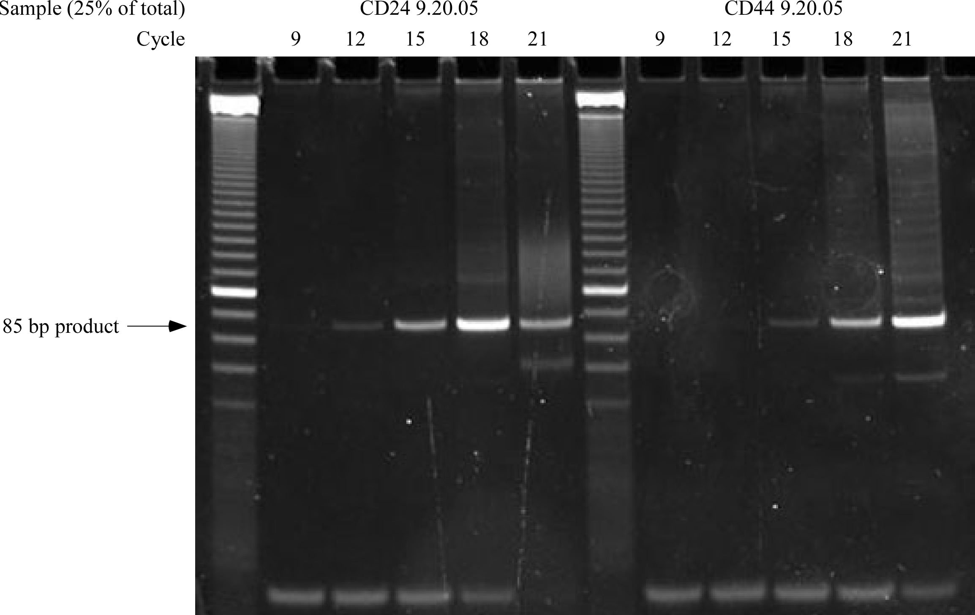
9. Gel purification of PCR product
- After determining the optimal cycle number, repeat PCR (it is suggested to use the sub-peak cycle number and do 2x 50 ml reactions then pool together). Add 10 μl 5x FSB to 50 ml reaction and load into 1 well of a 10-well 12% polyacrylamide gel. Run 180 V for ~2.5 hr.
- Cut out the 85 bp band and crush the gel (puncture the bottom of a 0.5-ml tube with a 18G needle, place it into a 2-ml tube, put gel into the 0.5 ml tube then cf @14K for 3 min). Elute fragment in 500 ml LoTE+acetate mix (9:1 of LoTE and 10 M NH₄OAc) overnight @ 65ºC.
- Place the gel/LoTE mix (cut the pipette tip) into a spinX tube and cf @14K for 2x 5 min, switch the direction of tubes in between.
- Extract with equal amount of PC8, transfer aqueous phase to a 1.5 ml tube and isopropanol precipitate:
500 μl sample
4 μl glycogen
167 μl 2 M sodium perchlorate
500 μl isopropanol

- Vortex to mix, and cf @ 14K, 4ºC, 30 min.
- Wash 3x 1 ml 70% ethanol. Resuspend the pellet in 10 μl LoTE.
- Measure with picogreen or nanodrop.
- Submit for sequencing.
Gex Sequencing Primer:
5'-CCGACAGGTTCAGAGTTCTACAGTCCGACATG

