In Press, Nicotine and Tobacco Research
Patterns of Tobacco Use in a Sample of American Indians in Minneapolis-St. Paul

Jean L. Forster, PhD, MPH, University of Minnesota
Kristine L. Rhodes, MPH, University of Minnesota
John Poupart, MPA, American Indian Policy Center
Lannesse O. Baker, BA, University of Minnesota
Cynthia Davey, MS, University of Minnesota
for the American Indian Community Tobacco Project Steering Council

Corresponding Author:
Jean L. Forster, PhD, MPH
University of Minnesota
Division of Epidemiology and Community Health
1300 South Second St., Ste. 300
Minneapolis, MN 55454
USA
612-626-8864 (phone)
612-624-0315 (fax)
Email: forster@epi.umn.edu

All work was conducted at the University of Minnesota, Minneapolis, MN

Abstract
The purpose of this study is to identify patterns of tobacco initiation, current use, and smoking cessation and their correlates in the adult American Indian population in the Twin Cities, using community-based participatory research methods. Three hundred American Indians 18 years and older participated in in-person interviews. Participants were recruited to fill age-gender quotas that reflect the demographic distribution of American Indians in Minnesota. Almost everyone in this sample has smoked cigarettes recreationally: only 12% have smoked fewer than 100 cigarettes, and nearly two-thirds (62%) reported that they are current smokers. Only 29% of ever smokers have quit smoking. Over two-thirds (68%) of current smokers would like to quit, and most of these (53% of all smokers) have tried unsuccessfully to quit in the previous 12 months. Our results show a level of current smoking and low cessation rates among American Indians in the Twin Cities area that reflects a crisis for public health and for the Indian community.

Introduction
Compared to other American ethnic/racial groups, American Indians in the Upper Midwest smoke cigarettes earlier, at higher rates (Levin et al., 2002), and with more severe health consequences (Indian Health Service, 2004; Levin et al., 2002; Seaverson et al., 2005; The Great Lakes EpiCenter, 2005). Smoking prevalence among American Indians varies by geographic and cultural factors, but is highest in the Northern Plains area that includes Minnesota. According to the Behavioral Risk Factor Surveillance Survey 48% of Indian men and 40% of Indian women in this area report current cigarette smoking (defined as having smoked ≥100 cigarettes and smoking currently) (Denny et al., 2003).

American Indians in this area have disproportionately higher rates of health problems associated with tobacco misuse as well. In Minnesota four of the five leading causes of death among American Indians are related to tobacco misuse: cancer, coronary heart disease, diabetes, and chronic lung disease (The Great Lakes EpiCenter, 2005). American Indians in Minnesota have higher rates of cancer compared to other racial/ethnic groups in the state, and higher rates than American Indians in other parts of the U.S.; most of the excess is due to the dramatically higher lung cancer prevalence (Indian Health Service, 2004; Seaverson et al., 2005) (CDC, 2003). Men and especially women in the Northern Plains region have a high prevalence of diabetes (Denny et al., 2003; Gohdes et al., 2002), and 44% of American Indians in this region diagnosed with diabetes smoke cigarettes (Rith-Najarian et al., 2002). American Indians from this region have the highest cardiovascular disease mortality rates among American Indians in the US (Casper et al., 2005; Gohdes et al., 2002).

American Indians in the Upper Midwest grew, used and revered tobacco for many centuries before the arrival of and colonization by Europeans (Johnston, 1982; Winter, 2000). Ceremonial tobacco use varies greatly among tribes, and each tribe has a unique term for tobacco grown specifically for spiritual use (Winter, 2000). Each tribe has specific traditional practices for growing, cultivating and sharing Indian tobacco. A combination of barks and plants is used for spiritual purposes by some tribes, and sometimes is referred to as tobacco as well even though it may not contain any tobacco (Struthers & Hodge, 2004; Winter, 2000). Traditional or ceremonial tobacco use occurs in a variety of forms: tobacco can be offered as a gift to the Creator by placing it on the ground, or as a gift to honor someone. It may be placed on the ground, or burned in a pipe, dish, shell or fire, with the smoke believed to carry prayers to the Creator. Some Indian people use tobacco in this way several times a day and others use it only on special occasions.

Commercial tobacco also is used by American Indians for ceremonial or traditional purposes (Struthers & Hodge, 2004). Nineteenth and twentieth century federal policies and institutional practices promoted extermination or assimilation of Indian people, making it dangerous for American Indians to practice traditional ceremonies openly or speak native languages. It wasn’t until the Indian Religious Freedom Act of 1978 (Pub. L. 95-341) that the American right to freedom of religion was guaranteed to Indian people. Thus commercial tobacco came to be used for traditional purposes as a way to “hide in plain sight”, and was substituted for Indian tobacco that was more difficult to grow and harvest under these repressive conditions. It is believed that this substitution is a factor in the historically high prevalence of recreational use of commercial tobacco by American Indians in this region.

The Twin Cities (Minneapolis-St. Paul) area is home to a large population of urban, off-reservation American Indians, estimated at about 33,000 by the US Census, or about 41% of all American Indians in Minnesota (US Census Bureau, 2000). The majority of urban American Indians in this area are Ojibwe (Chippewa), Lakota, Dakota (Sioux) or Ho-Chunk (Winnebago) reflecting the indigenous peoples of Minnesota and Wisconsin, but many are affiliated with other tribes.

Methodological problems limit the validity and generalizability of much of the research findings on American Indians. The Behavioral Risk Factor Surveillance Survey, for example, is administered by telephone (Health Risks in the United States: Behavioral Risk Factor Surveillance System. At A Glance 2005, 2006), thus excluding many urban American Indians who are homeless, live with extended family on a temporary basis, or don’t have telephones. Most studies are based on rural and reservation populations. Very little information exists about tobacco use of any kind in urban American Indian populations, which are more diverse in tribal affiliation and identification and may be more diverse in traditional tobacco use practices (Burhansstipanov, 2000; Forquera, 2001). Standard research methods used may not reflect Indian cultural values and meaningful language and concepts, particularly in distinguishing ceremonial use of tobacco from addictive use, and Indian people may be less likely to agree to participate or to report accurately their experience and knowledge in projects using standard research methods. The urban Indian population is not systematically listed on any rolls, cannot be identified by location or neighborhood, and is too diffuse for random selection, making it a difficult population to study systematically (Forquera, 2001). Furthermore, American Indians have learned to look with suspicion and disfavor on research done by white researchers for their own purposes (Burhansstipanov et al., 2005; Oberly & Macedo, 2004). A partnership approach overcomes some of these methodological, logistical and ethical issues. This approach is more likely to produce results that more accurately reflect lived Indian experience and information of use to Indian people in this area.

The purpose of this study is to identify patterns of tobacco initiation, current use, and smoking cessation and their correlates in the adult American Indian population in the Twin Cities. This study is part of the American Indian Community Tobacco Project (AICTP), the goal of which is to address youth tobacco misuse by developing strategies that are grounded in the culture and values of the Indian people in the Twin Cities.

Methods
Conceptual Framework. This research is driven by a conceptual model rooted in community-based participatory research (CBPR), but focused on the cultural traditions of information sharing and learning in American Indian communities. CBPR acknowledges the different ways of knowing, giving equal weight to scientific expressions of knowledge and traditional or cultural expressions of knowledge (Israel et al., 1998; Leung et al., 2004). In the past, researchers have assumed that traditional knowledge was less important than scientific knowledge. CBPR emphasizes the importance and value of different ways of knowing according to context. Because each way of knowing has value, each must be included (Fletcher, 2003). CBPR is also oriented to action - applying practical knowledge to locally defined issues in a way that provides long-term improvement in the quality of life of a group of people, rather than generating knowledge for its own sake (Fletcher, 2003; Leung et al., 2004). Accordingly this project is guided by the need for practical knowledge rooted in the urban Native American community that can be applied to improving the tobacco-related health of the community.

The project also follows a model of research called reality-based research, developed specifically for use within a framework of Native American culture and traditions (Poupart et al., 2000). This framework reflects the reality of American Indians and tells their stories from an Indian oral tradition, intrinsic to their history and contemporary lifestyle. It preserves the "sacred past" of Indian traditions that are still used to guide Indian attitudes and behavior. The reality-based model involves Indian people in every aspect of research, including identifying key topics or issues; defining terms, strategies, outcomes, and goals; designing data collection instruments; analyzing information and data; developing strategies and activities for returning the information to the community; and evaluating the outcomes of those activities (Poupart et al., 2000).

These two complementary models of research help overcome the negative experiences with and distrust of research in Indian communities that does not benefit community members and may have resulted in demonstrable harm to Indian communities (Burhansstipanov et al., 2005).

Steering Council. The AICTP is guided by a steering council whose members, except one academic researcher, are all American Indian. Members were invited to participate because of their interest in addressing the issue of tobacco misuse in the Indian community.

Study Participants. No lists of American Indian residents of the Twin Cities are available. In an attempt to make the study sample as broadly representative of the urban Indian community as possible, study participants were recruited in several ways: a paid notice was placed in a widely read Indian community newspaper and fliers were posted in prominent locations in the community, stating “Not another survey!?! (Yes, but this one is different-it is by Indians for Indians!) If you are an Indian adult, we want to talk to you about how you do or don’t use tobacco. It takes about 30 minutes. You will get a $25 Target gift card!” Also, participants were asked to tell others about the study. As stated in the flyer/notice, participants were given a $25 gift card as an incentive for completing the interview.

Men and women who self-identified as American Indian (only or in part) and were at least age 18 were eligible for the study. Age by gender quotas were established to match the age by gender distribution of American Indians in Minnesota in the 2000 U.S. Census. A total of 300 participants were interviewed from February-April, 2005.

Interviews. Members of the steering council and staff of the AICTP, all American Indians, collected the data via face-to-face interviews. Steering council members participated in an 8-hour training on study protocol and human subjects protection, and were paid for their work.

The interview questions were developed by the AICTP steering council by modifying and adding to existing survey instruments, particularly the tobacco survey of urban American Indians and Alaska Natives developed by the Urban Indian Health Institute (www.uihi.org). The interview was pilot-tested with ten men and women of varying ages before it was finalized, and interviews lasted 20 minutes on average. The interview included questions about general health, participant and household demographics, spiritual or ceremonial tobacco use, perceptions of smoking in the urban Indian community, cigarette smoking patterns, secondhand smoke exposure and attitudes, smoking cessation, and prevention of tobacco addiction in the Indian community.

Measures. An important feature of the interview questions was an acknowledgement of tobacco use for spiritual or ceremonial reasons along with a clear distinction between spiritual or ceremonial tobacco use and recreational or addictive tobacco use. Patterns of recreational use of tobacco were determined by two questions: “Not including ceremonial or sacred smoking, have you smoked at least 100 cigarettes in your entire life?” and “Not including ceremonial or sacred smoking, do you smoke cigarettes now at all?” Current (recreational) smokers are those who answered yes to both questions, former (recreational) smokers answered yes to the first question and no to the second, and non-recreational smokers answered no to both questions. Age at smoking initiation was determined by the open-ended question, “How old were you the first time you smoked a cigarette, even one or two puffs, not for ceremonial or sacred purposes?” Participants were asked two open-ended questions to determine smoking intensity: “During the past 30 days, on approximately how many days did you smoke cigarettes?” and “On the days when you smoked in the past 7 days, about how many cigarettes did you smoke per day?”

Characteristics of quitting cigarette smoking were determined by a series of open and close-ended questions. Number of quit attempts was assessed by asking current smokers, “How many times, if any, have you tried to quit smoking?” with categorical responses of none, 1 time, 2 times, 3-5 times, 6-9 times, 10 times. Thus quit attempt was self-defined. Length of last quit attempt was determined by asking both current and former smokers, “The last time you tried to quit, how long did you stay off cigarettes?” with response categories <1 day, 1-7 days, more than 7 days but less than 30 days, more than 30 days but less than 6 months, more than 6 months but less than a year, and more than a year. Participants were also asked an open-ended question, “The last time you tried to quit, what helped you to not smoke cigarettes for that long?” Up to three responses were coded for each participant. Current and former smokers were asked, “What is [was] your main reason for wanting to quit?” Current smokers were asked, “If you were going to try to quit smoking, would you try any of the following?” and then were read a list of 10 strategies that included asking for help from a friend, family member, or spiritual leader; trying various programs or quit-smoking aids; or quitting on my own.

Analysis. Chi-square tests of association were used to evaluate the relationships between gender, age, smoking status and tobacco use patterns of study participants. Two-factor ANOVA was used to evaluate the effects of age and gender on average number of cigarettes smoked per day by current smokers. Statistically significant associations and effects were identified by p-values for test statistics <0.05. Data were analyzed using SAS Software Version 8, 1999, SAS Institute, Cary, NC.

Results
Demographics. The distribution of respondents by age and gender is shown in Table 1. Most of the participants identified themselves as American Indian alone, but 14% named one or more race/ethnicity in addition. The survey participants are primarily members of Ojibwe (70%) or Lakota/Dakota (19%) tribes, who have traditionally lived in the Upper Midwest. Other tribal affiliations reflect a broad geographic area and included Ho-chunk, Menomonie, Seneca, Navajo, Arapaho, Blackfeet, Chickasaw, Omaha, Oneida, Ponca, Southern Cheyenne, and the Three Affiliated Tribes. Most participants reside in Minneapolis (71%) or St. Paul (21%).
<Insert Table 1 about here>
Traditional Use of Tobacco. Participants were asked, “Have you used tobacco for ceremonial, prayer or traditional reasons in the past 12 months?” About 72% responded “yes”, including significantly more females than males, and significantly fewer current smokers compared to former or never smokers. There were no differences in traditional use of tobacco by age or tribal affiliation.

Recreational Use of Cigarettes. Almost everyone in this sample has smoked cigarettes recreationally - 2% have never smoked even a single cigarette, and 12% have smoked fewer than 100 cigarettes. Nearly two-thirds (62%) reported that they are current smokers, and 26% have smoked previously but are not now smokers. Table 2 shows that smoking status differed by age group: young adults are more likely to be never smokers than any other age group, and those 55 years and older are more likely to be former smokers and less likely to be current smokers compared to other age groups. The current smoking prevalence is highest among those 35-44 years of age at 73%. Smoking status does not vary significantly by gender, though 34% of women who have ever smoked have quit, while 24% of men who have ever smoked have quit.
<Insert Table 2 about here>
While almost all current smokers smoke every day, on average they smoke about a half a pack of cigarettes per day. As shown in Figure 1, there is an interaction between age and gender, with the highest daily average at 16 cigarettes for men age 45-54, and the lowest average at 7 cigarettes for men age 18-24. Middle-aged women smoke significantly fewer cigarettes than men.
<Insert Figure 1 about here>
The average age at smoking initiation among all who have smoked at least once (98% of sample) is 12.9 years. Current smokers on average had their first cigarette at age 12.3, former smokers at age 13.2, and never smokers at age 15.9. The data show no differences by gender, but do show a general trend toward earlier age of initiation among younger participants.

Quitting Smoking. Despite the high prevalence of smoking among the urban Indian community, 68% of current smokers would like to quit, and most of these (53% of all smokers) have tried to quit in the previous 12 months. These findings do not differ by age or gender. More than 80% of current smokers have tried to quit more than once, and more than a quarter have tried to quit six or more times. As shown in Figure 2, those ≥ age 25 have tried to quit many times. Even though the same proportion of female as male current smokers have made quit attempts, women report relapsing more quickly than men, as shown in Table 3. Over half of women report that their last quit attempt lasted less than 1 week compared to 29% of men, and 16% were able to quit for more than 6 months, compared to 29% of men. Smokers used a number of strategies in their last quit attempt; women were most likely to mention an oral substitution, staying away from smoky places or people who smoke, or being confined where they could not smoke. Men were less likely to mention avoidance of places or smokers, and more likely to mention will power.
<Insert Figure 2 about here>
<Insert Table 3 about here>
Current smokers are willing to consider a variety of strategies for quitting smoking. From a list of strategies provided to participants, the most popular strategy is “quit on my own” (78% of all current smokers, 85% of men). The most favored form of external assistance is talking to a health care provider (61%) and trying medications (59%). Women are more willing than men to call a quit-smoking help line (32% vs. 13%), and to try acupuncture (50% vs. 26%). Young adults (age 18-24 years) are less willing to talk to a healthcare provider (35% vs. 61% overall) compared to older smokers. Elders are less willing to talk to family or friends (20% vs. 42% overall) or try to quit on their own (56% vs. 78% overall), and more interested in attending a program or group (52% vs. 32% overall). Just under half of all current smokers (45%) report that they know where to find resources in the Indian community to help people quit smoking. About 9% said they had relied on some form of pharmacotherapy. One person said they had tried a smoking cessation class or program.

Seventy-seven participants in this study (26%) were classified as former smokers. Their own health was the motivation for more than half of them to quit smoking. Other important reasons to quit were because they did not like some aspect of smoking (taste, smell), and for family members or children. When asked what helped them to stay off cigarettes, former smokers listed the same issues that motivated them to quit in the first place; one mentioned buproprion and none mentioned nicotine replacement therapy or any form of professional assistance or advice.

Discussion
Our results show a level of current smoking (62.0%) among American Indians in the Twin Cities area that reflects a crisis for public health and for Native people. This prevalence is higher than reported for American Indians in Minnesota overall (51.7%), 56% higher than the prevalence reported for American Indians in the U.S. (39.7%%), and about three times the smoking prevalence in the general population of Minnesotans (21.1%), (2002 and 2003 BRFSS data) (CDC, 2005a and b). Only one study, from the early 1990s, of American Indians from reservations in Minnesota and Wisconsin reported a smoking prevalence this high (Levin et al., 2002). Almost three-quarters of those age 35-44 report smoking, but the prevalence is lower among younger adults. Only 12.3% of study participants overall report not having smoked 100 cigarettes in their lifetime.

American Indian smokers in this study smoke almost everyday, but smoke fewer cigarettes per day than the general population – only 39% smoked more than 10 cigarettes per day, compared to 42%- 62% of the general Minnesota population of smokers (Minnesota Department of Health 2004a). These results are consistent with those reported elsewhere for American Indians (American Lung Association, 2004).

A cause for encouragement is the youngest age group, adults age 18-24 – 26% of them have never been regular smokers, more than twice the proportion of the older participants, and they smoke fewer cigarettes on average than older smokers. This is in contrast to the general population in Minnesota, where 18-24 year olds have the highest smoking prevalence among all adults (Minnesota Department of Health, 2004a). There is reason to be optimistic that this low smoking prevalence will persist as they get older, since the average age of becoming a regular smoker is 16.6 years for the entire group of study participants.

The data with regard to smoking cessation further elucidate the disparity in smoking between American Indians and the general Minnesota population . Twenty-nine percent of ever smokers have quit, just over half the proportion (56%) for ever-smokers in Minnesota overall (National Center For Chronic Disease Prevention and Health Promotion, 2005). That proportion is substantially lower among men (24%) compared to women (34%), and among younger smokers (20%).

The low rate of quitting is not for lack of trying. Most smokers have tried, and often many times. The proportion who have made at least one quit attempt in the past year (53%) is similar to the general population of smokers in Minnesota (56%) (Minnesota Department of Health, 2004b). Women who are current smokers report a shorter time off cigarettes at their last attempt and report having made more attempts compared to men. Women’s apparent willingness to continue to try to quit may account for their higher overall quit ratio. The strategies used to quit may be one reason for lack of success. Few current and former smokers report using pharmacotherapy or smoking cessation programs.

It is encouraging that current smokers indicated their interest in trying a variety of types of assistance when presented with a list of options for quitting. However, few of these strategies were mentioned by current or former smokers as helping them to stay off cigarettes the last time they quit smoking. According to the Minnesota Department of Health, assistance in quitting smoking is available to everyone in Minnesota (Minnesota Department of Health, 2004b). This assistance includes telephone help lines that offer counseling and nicotine replacement therapy to insured and uninsured smokers, an internet-based cessation program, worksite based programs, and programs offered in community centers (Minnesota Department of Health, 2004b; Minnesota Partnership for Action Against Tobacco, 2005). Appropriate marketing and increased accessibility of quit methods in the urban American Indian community might result in more successful quit attempts.

Special note should be taken of the preferences and needs of elders in the American Indian community who want to quit. They are least willing to ask family and friends for help in this study, perhaps because they are accustomed to the traditional position of providing advice to others in the community. Elders are more interested in organized programs or groups than others, and less interested in trying to quit on their own, suggesting that offering programs specifically for them may be fruitful.

Almost three quarters of American Indians in this study report using tobacco for ceremonial or spiritual reasons, as is the tradition among American Indians who originated in this part of North America. This is a high figure, given the well-documented effort during the past century by the federal government to eliminate Indian culture and promote assimilation by making traditional spiritual practices illegal, disrupting intergenerational transmission of these traditions by taking children away from their extended families, and by relocating Indian people away from their communities of origin (Burhansstipanov, 2000; Halverson et al., 2002). One unfortunate result of banning the practice of traditional Indian ceremonies is that commercial tobacco often was, and still is, substituted for traditional plants and herbs in these ceremonies. It isn’t clear to what extent use of commercial tobacco in ceremonies has led to the very high prevalence of recreational tobacco use in this urban Indian community. It seems clear however that the sacred role of tobacco in traditional Native spirituality is a strength that can be used to reduce the harms caused by recreational use of tobacco in this community.

These data should be interpreted with caution. The sample, while reflecting the age and gender distribution of the American Indian population in Minnesota, is not necessarily representative of the American Indian population in Minneapolis-St. Paul because the recruitment process was not systematic. However because the sampling strategy cast a wide net, the participants do include traditionally underrepresented groups, e.g. young men and those without a stable address. The higher smoking prevalence estimates in this study compared to BRFSS estimates for the Minnesota American Indian population raise the possibility that we over-sampled smokers. While we used definitions of smoking outcomes consistent with BRFSS, that survey includes American Indians from rural and reservation locations, administers the survey via telephone, and is not identified with the American Indian community, so the methods are quite different between the two data sets. Furthermore the BRFSS estimates are based on very small samples, e.g. a total of 85 American Indian respondents from Minnesota in the combined 2001-2003 BRFSS surveys (Casper et al., 2005). However the BRFSS provides the only standardized state-level estimates for American Indians.

In summary, this study reports a very high prevalence of smoking among American Indians in the Minneapolis-St. Paul area, and low success at quitting smoking. Concerted efforts are needed to provide culturally appropriate smoking cessation information and assistance for this population.

Acknowledgements
This work was supported (or supported in part) by grant RC 2004-0032 from the Minnesota Partnership for Action Against Tobacco (MPAAT). Its contents are solely the responsibility of the authors and do not necessarily represent the official views of MPAAT. We acknowledge the contributions of the AICTP Steering Council: Linda Azure, Hope Flanagan, Julie Green, Jennifer Irving, Julia Littlewolf, Loretta Rivera and Patty Thunder Hawk, and we thank the study participants for sharing their information and insights.

Table 1. Distribution of Survey Participants by Age and Gender
 | Women | Men | Total
18-24 yr | 31 | 31 | 62 (21%)
25-34 yr | 34 | 26 | 60 (20%)
35-44 yr | 40 | 37 | 77 (26%)
45-54 yr | 22 | 23 | 45 (15%)
55-64 yr | 21 | 14 | 35 (12%)
65+ yr | 10 | 11 | 21 (7%)
Total | 158 (53%) | 142 (47%) | 300

Table 2. Correlates of Recreational Cigarette Smoking Status and Quit Ratio
 | Never Smoker  N=37 | Former Smoker  N=77 | Current Smoker  N=186 | Quit Ratio¹
Gender χ²=2.94, 2 df, p=0.23
Women (N=158) | 11.4% | 29.8% | 58.9% | 0.34
Men (N=142) | 13.4% | 21.1% | 65.5% | 0.24
Age χ² =35.02, 8 df, p<.0001
18-24 yr (N=62) | 25.8% | 14.5% | 59.7% | 0.20
25-34 yr (N=60) | 11.7% | 21.7% | 66.7% | 0.25
35-44 yr (N=77) | 9.1% | 18.2% | 72.7% | 0.20
45-54 yr (N=45) | 8.9% | 28.9% | 62.2% | 0.32
≥ 55 yr (N=56) | 5.4% | 50.0% | 44.6% | 0.53
Mean age at smoking initiation² | 15.9 yr | 13.2 yr | 12.3 yr
Total | 12.3% | 25.7% | 62.0% | 0.29
¹%former smoker÷(%former smoker + %current smoker)
²Age at initiation can be calculated for never smokers who have smoked at least one cigarette, but <100 in their lifetime

Table 3. Characteristics of Last Quit Attempt Among Current Smokers *
 | Female  N=84 | Male  N=80 | Total  N=164
Length of last quit attempt χ²=10.07, 2 df, p=.0065
≤ 1 week | 52.4% | 28.8% | 40.9%
> 1 week, ≤6 months | 32.1% | 42.5% | 37.2%
> 6 months | 15.5% | 28.8% | 22.0%
What helped you not to smoke?
Oral substitution | 17.9% | 11.3% | 14.6%
Confined/unable to smoke | 13.1% | 15.0% | 14.0%
Stay away from smokers | 17.9% | 8.8% | 13.4%
Willpower | 7.1% | 16.3% | 11.6%
Distraction | 9.5% | 8.8% | 9.1%
Nicotine patch, bupropion | 10.7% | 7.5% | 9.1%
Didn’t buy cigarettes | 3.6% | 8.8% | 6.1%
Children’s health concerns | 8.3% | 2.5% | 5.5%
Lost urge to smoke | 2.4% | 5.0% | 3.7%
Sports, exercise | 2.4% | 5.0% | 3.7%
Personal health | 4.8% | 1.3% | 3.1%
Nothing | 0 | 3.8% | 1.8%
Support of family/friends | 1.2% | 2.5% | 1.8%
Other | 0 | 3.8% | 1.8%
Class/program | 1.2% | 0 | 0.6%
*N excludes 22 current smokers who have never tried to quit
Figure 1. Average Cigarettes Smoked per Day Among Current Smokers by Age and Gender (N=186) p=0.042 for age by gender interaction
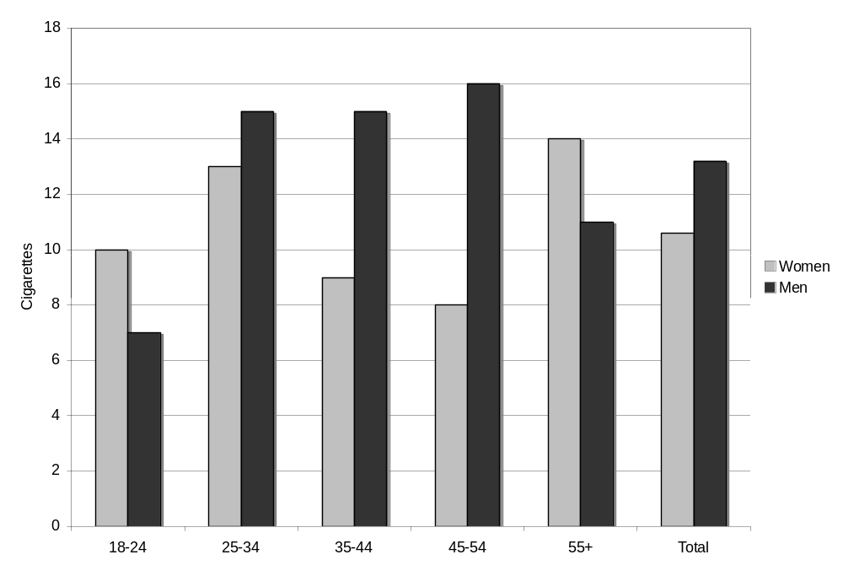
Age

Figure 2. Quit Attempts among Current Smokers by Age (N=186)
χ²=19.52, 8 df, p=0.0123
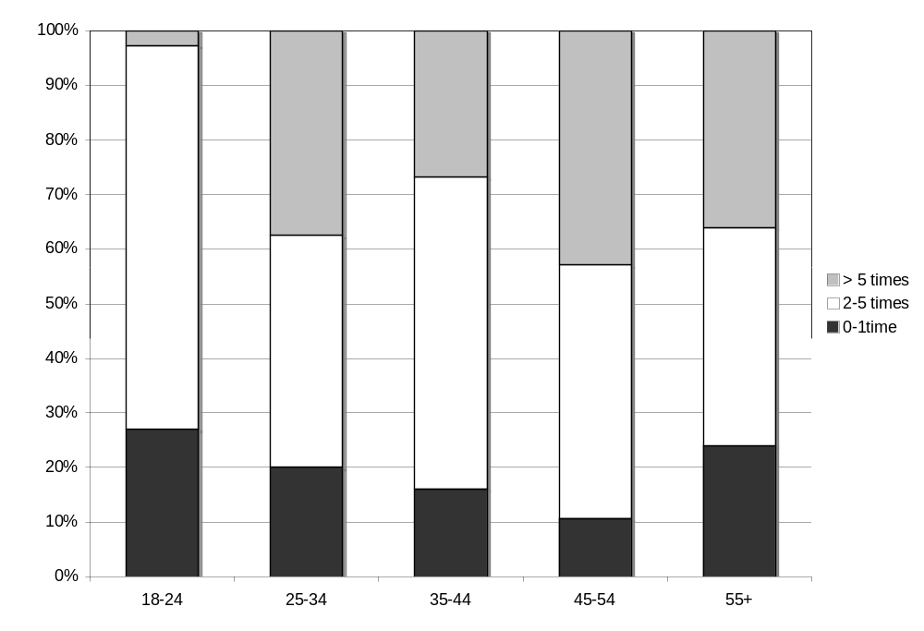
Age

