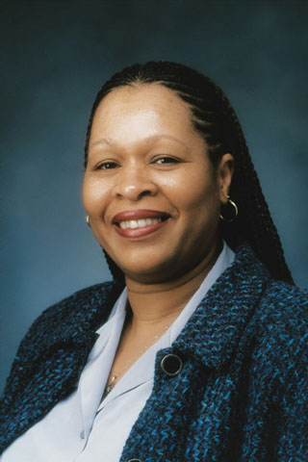
Vickie L. Shavers, Ph.D.
Epidemiologist
Health Services and Economics Branch
Applied Research Program
Division of Cancer Control and Population Sciences
The National Cancer Institute
Bethesda, MD

BIOSKETCH

Dr. Shavers is an epidemiologist at the National Cancer Institute where she focuses on health disparities and health services research. She received her BBA in Marketing from the University of Iowa in 1990, a MS in Preventive Medicine in 1993 and a PhD in Preventive Medicine/Epidemiology in 1999 also from the University of Iowa. While at the University of Iowa, Dr. Shavers participated as a research assistant or principle investigator on a number of studies including studies that examined residential radon exposure and female lung cancer, familial aggregation of prostate cancer, pesticide contamination of rural well water, urban/rural differences in the detection and treatment of breast cancer and a study that examined factors that impede African American participation in medical research studies. While a doctoral candidate in 1997 she accepted a position as a chronic disease epidemiologist with the Eugene DuPont Preventive Medicine and Rehabilitation Institute of the Christiana Care Hospital Systems in Wilmington, DE where she focused on community health risk assessment, survey research design and program evaluation. She left Christiana Care in 1999 to complete postdoctoral training at Johns Hopkins where she focused on cancer prevention and control. Since joining NCI in 2000 Dr. Shavers has had several peer reviewed publications in the area of health disparities including studies that examine racial/ethnic differences in the receipt of treatment for breast, prostate, and head and neck cancers, perceived access to care and the prevalence of behavioral risks, and the prevalence of overweight and obesity among African Americans. Her current research interests include, the role of discrimination in the receipt of health care, racial/ethnic variation in cancer risk factors, racial/ethnic differences in receipt of appropriate care, factors that influence racial/ethnic variation in cancer incidence and outcomes, minority access to health care services, and health disparities. Other interests include mentoring and increasing the representation of minority scientists among NIH funded investigators.

Peer-Reviewed Publications

Shavers VL, Fagan P, Lawrence D, McCaskill-Stevens W, Browne D, McClinden D, Christian M, Trimble T, Kerner J. Barriers to minority investigator application and successful competition for NIH funding. J Natl Med Assoc 2005;97:1063-1077.

Shavers VL, Fagan P, Lawrence D. Racial/ethnic variation in cigarette smoking among the civilian US population by occupation and employment status, CPS-TUS, 1998-1999. Prev Med 2005;41:597-606.

Shavers VL, Brown ML, Klabunde C, Potosky A, Moul J. Race/ethnicity and the receipt of watchful waiting for the initial management of prostate cancer. Journal of General Internal Medicine 2004:19:146-155.

Shavers VL, Potosky A, Brown ML, Klabunde C, Moul J. Race/ethnicity and the intensity of medical monitoring under watchful waiting for prostate cancer. Med Care;2004:42: 239-250.

Shavers VL, Harlan LC. Racial/ethnic patterns of care for cancers of the oral cavity, pharynx, larynx, sinuses, and salivary glands. Cancer Metastasis and Review 2003;22:25-38.

Shavers VL, Harlan LC. Racial/ethnic variation in clinical presentation, treatment and survival among breast cancer patients under age 35. Cancer 2003;97:134-147.

Shavers VL, Shankar S, Alberg A. Perceived access to health care and its influence on the prevalence of behavioral cancer risks among urban African Americans. J Natl Med Assoc 2002 ;94:952-962.

Shavers VL and Shankar S. Prevalence of overweight and obesity among urban African-American hospital workers and public housing residents. Journal of the National Medical Association 2002;94:566-576.

Shavers VL, Lynch CF, Burmeister LF. Racial differences in factors that influence the willingness to participate in medical research studies. Annals of Epidemiology 2002;12:4:248-256.

Shavers VL, Brown ML. Racial/ethnic disparities in the receipt of cancer treatment. Journal of the National Cancer Institute 2002;94:334-357.

Shavers VL, Lynch CF, Burmeister LF. Factors that influence African-American willingness to participate in medical research studies. Erratum Cancer 2001;91:1187.

Shavers VL, Lynch CF, Burmeister LF. Factors that influence African-American willingness to participate in medical research studies. Cancer 2001;91:1(Suppl):233-236.

Alavanja MCR, Field W, Sinha R, Brus C, Shavers V, Curtain J, Lynch CF. Lung cancer risk and red meat consumption among Iowa women. Lung Cancer;2001:34 (1) :37-46.

Shavers VL, Lynch CF, Burmeister LF. Knowledge of the Tuskegee Study and its impact on the willingness to participate in medical research studies. Journal of the National Medical Association 2000;92:12:563-572.

Shavers-Hornaday V, Lynch CF, Burmeister LF, Torner JC. Why are African-Americans Underrepresented in Medical Research Studies? Impediments to medical research participation. Ethnicity and Health 1997:2(1/2) 31-45.

