**HealthGenic-- Online Doctor Consultation and E-Health Commerce platform**

**Patient Use Case Diagram:**

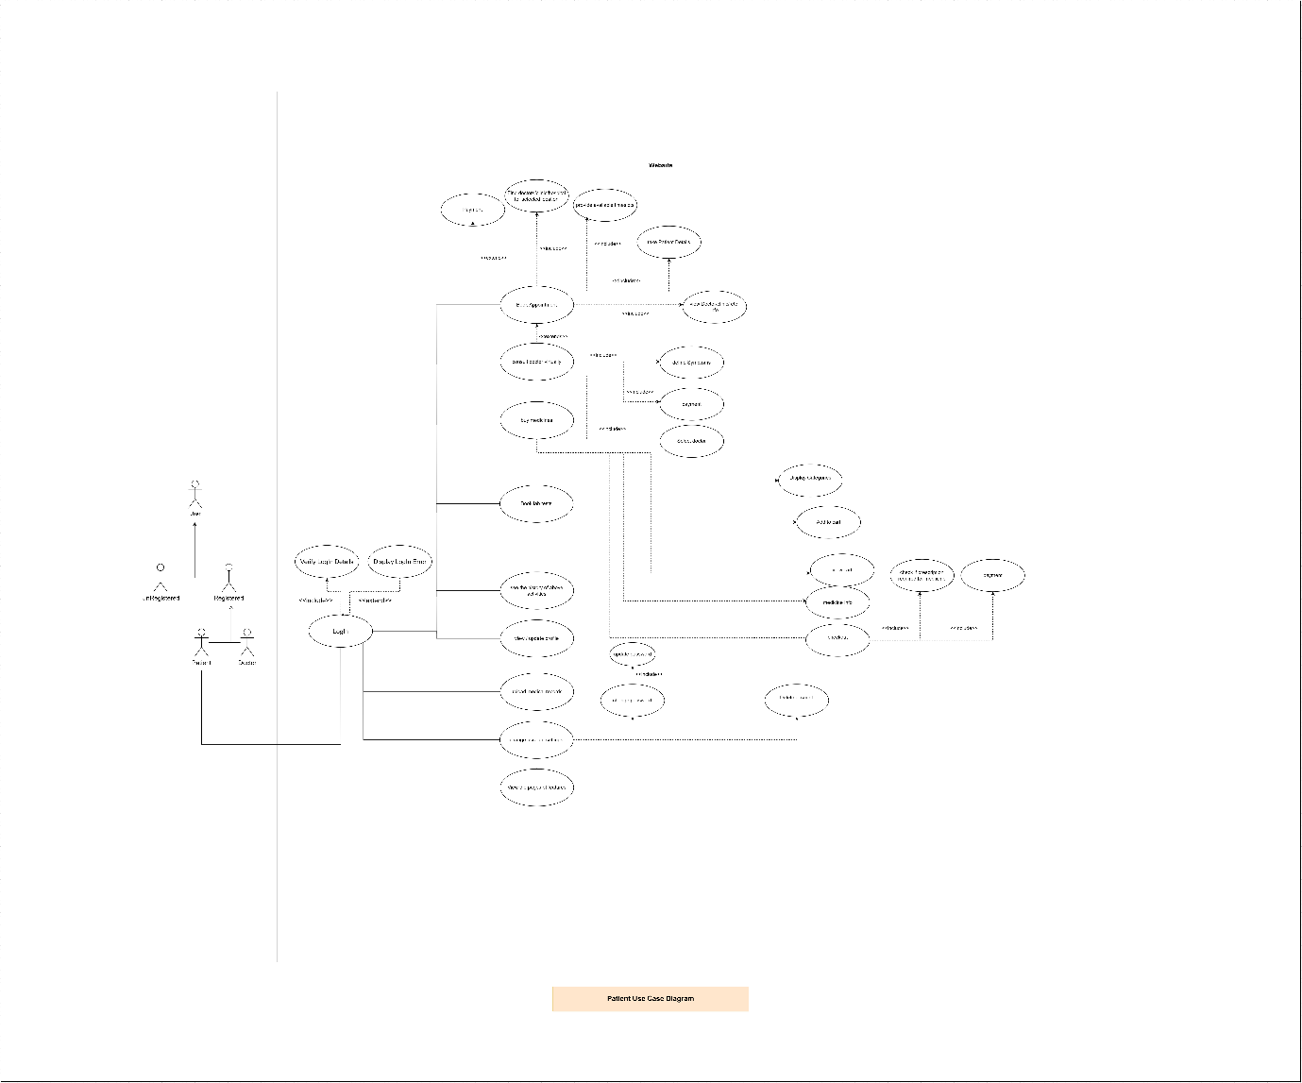

**Login Activity Diagram:**

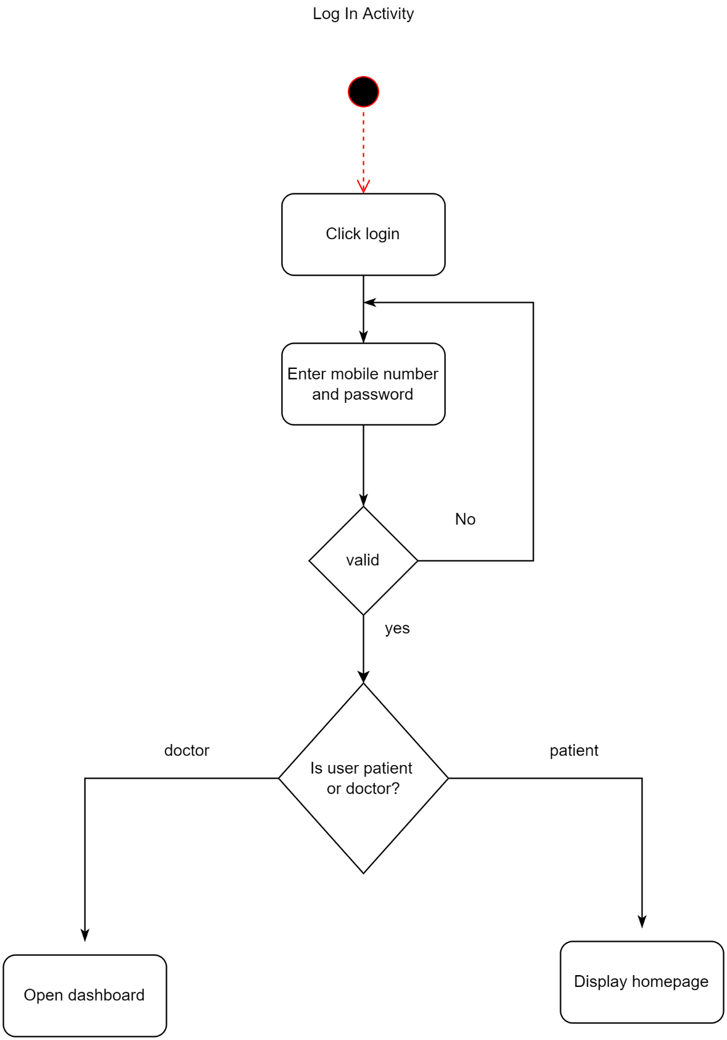

**Book Appointment Activity Diagram:**

