README
- Building
- All files required to run the program are included in the Paxos zip file.
- Unzip the Paxos zip file.
- cd to the path of your Paxos folder.
- cd to src.
- compile all the java files in the src folder (See image below).
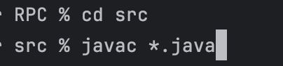
- Running
  - Start the server before running the client. The server will default to port 1099 if no specific port number is provided. Then, the server will select the next 4 ports for its replicas automatically.
Usage: “java Server <port>”
e.g.
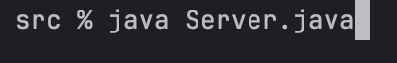
Or
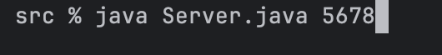
When ready, your Server terminal will look like the below image. The server comes with some prepopulated key-value pairs. The replicas will be shown as well in the same terminal for this project.
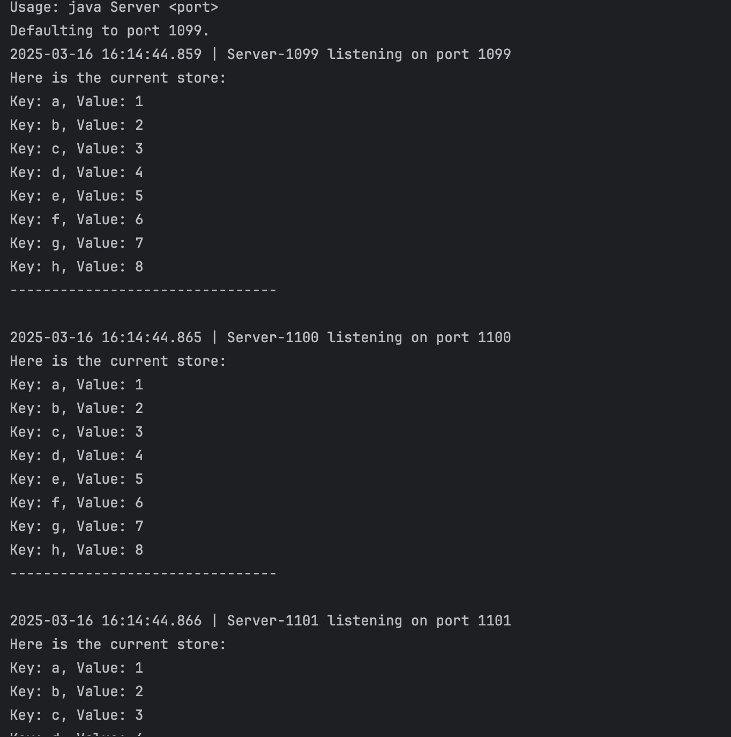
The server terminal will also show the log of each Paxos and client operation and the latest store information.
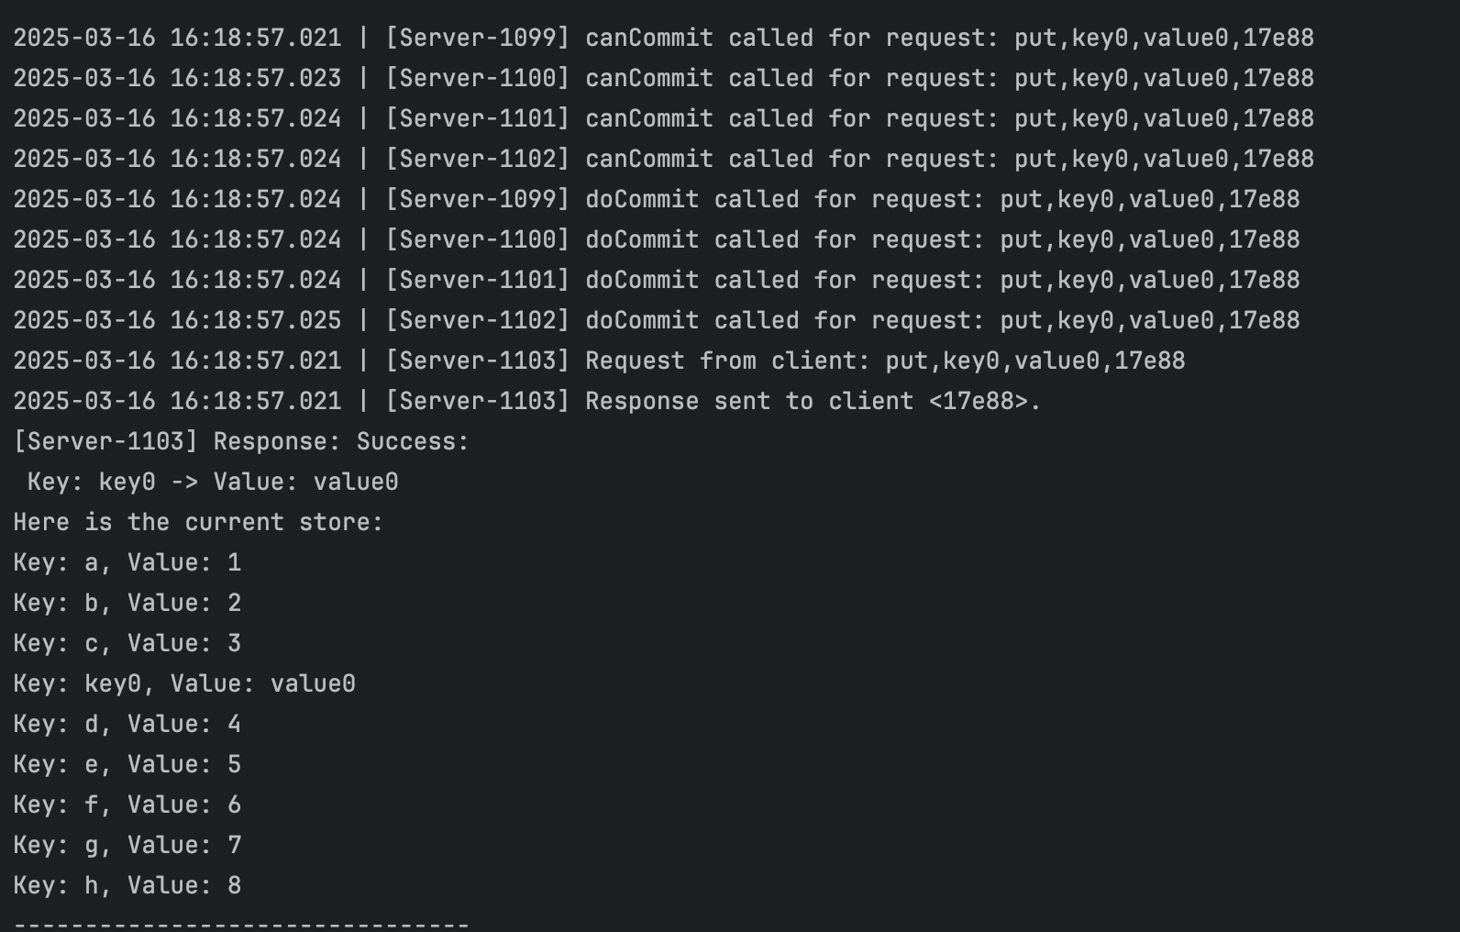
  - Start the client.
Usage: “Java Client <serverAddressList>”
e.g.
If the connection is successful, your Client terminal will look like the below image. A client ID will be provided to every client.
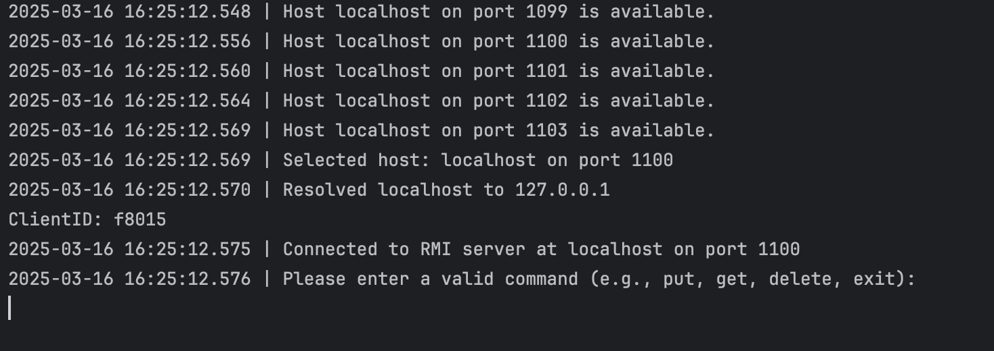
Follow read and follow the prompt instructions to operate on the Client. If an input is malformed, the terminal will inform you and ask you again.
- If you want to end the program, simply type in exit.
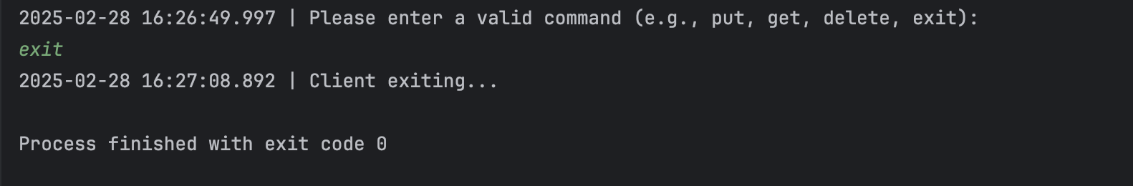
- Get Request Example: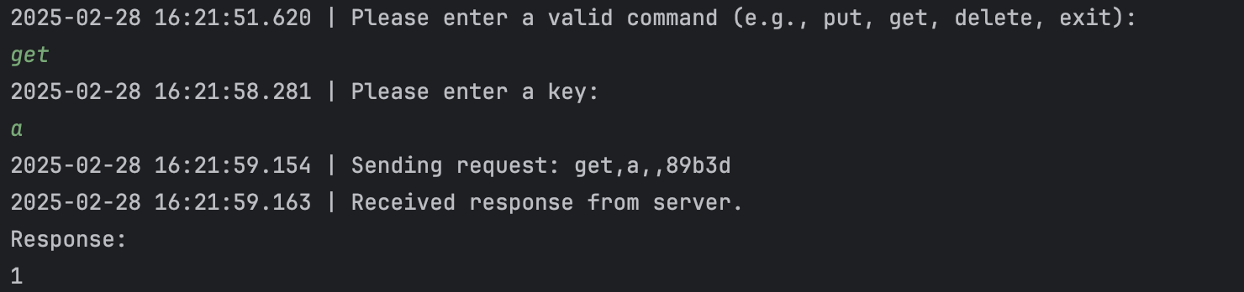
- Put Request Example:
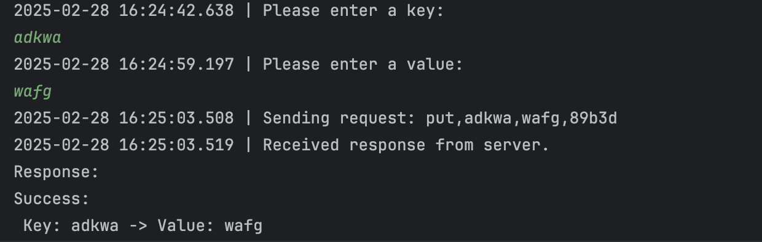
- Delete Request Example:
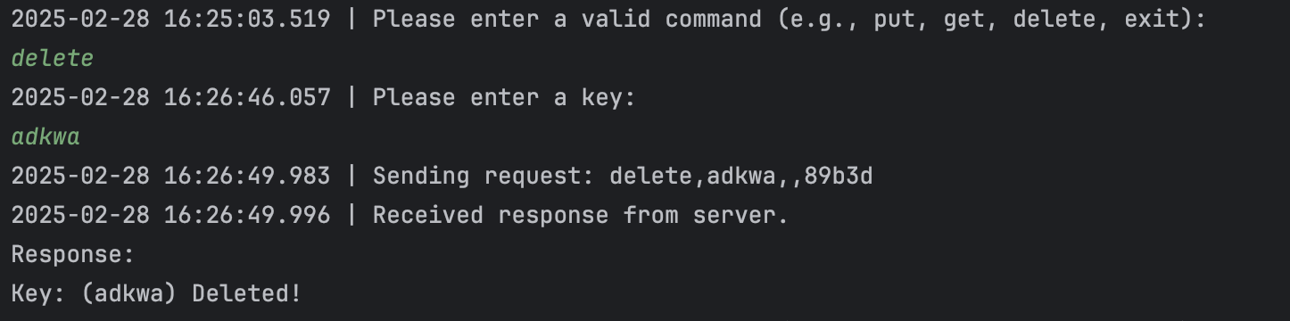
- Testing
The ClientTest class is a single client that uses a list of addresses for the 5 concurrent servers to perform 5 PUTs, 5 GETs and 5 DELETEs operations. The result of the requests will be logged and shown on the terminal.
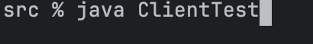
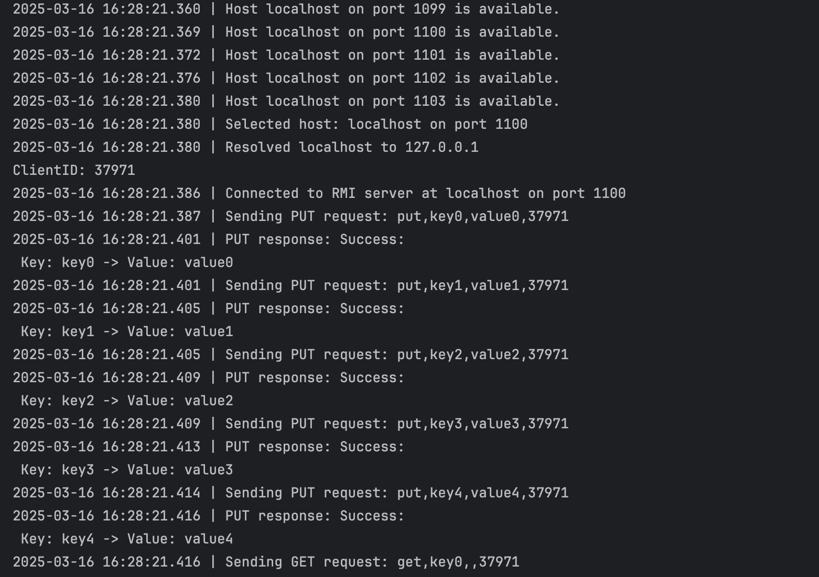

After the operation tests, the server terminal will log the final states of the stores of all 5 servers. They should be the same as the original preconfigured stores.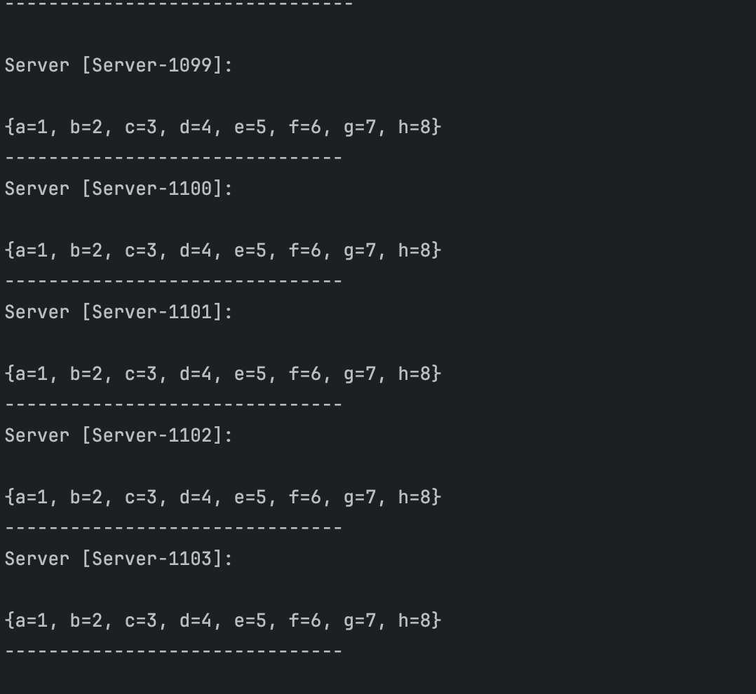
Executive Summary (Project 4)
Assignment Overview
This project extends the previous key-value store implementations into a robust, replicated, multi-threaded distributed system using Java RMI. While retaining the fundamental client operations (PUT, GET, DELETE) from prior implementations, the central objective of Project 4 was to enhance system availability and consistency by transitioning from the Two-Phase Commit (2PC) protocol to the Paxos consensus algorithm. The key-value store is now replicated across five independent servers, allowing clients to seamlessly interact with any replica while maintaining data consistency through Paxos. In alignment with the project requirements, I introduced simulated random failures in Paxos acceptors using threads to realistically mimic server crashes and subsequent recoveries. Additionally, a leader election mechanism employing the Bully algorithm was integrated to streamline proposal coordination and mitigate conflicts. An operation log was implemented to facilitate state recovery, ensuring that servers catching up after failures remain consistent with the system's state. The client remains the same, which continues to pre-populate the store and execute concurrent operations, validating the system’s resilience and data integrity under various failure scenarios. For the clientTest, while adding some delays to allow for simulated failures and recoveries, everything else remains the same like the previous assignment. After the operation tests, the server terminal will log the final states of the stores of all 5 servers. They should be the same as the original preconfigured stores.

Technical Impression
This project provided significant exposure to advanced replication strategies and distributed consensus mechanisms, specifically transitioning from 2PC to the Paxos protocol. Implementing Paxos required meticulous handling of majority quorum decisions, proposal ordering, and management of transient node failures. A particularly challenging and insightful component was simulating random acceptor thread failures and ensuring graceful state recovery through the integration of an operation log and dynamic state recovery mechanism. The addition of the Bully algorithm further enhanced system efficiency by centralizing proposal management through elected leaders, thus significantly reducing operational contention. Debugging under these complex, multi-threaded RPC conditions reinforced the critical balance between consistency, performance, and fault tolerance in distributed environments. Overall, this project enriched my practical understanding of distributed system principles and reinforced skills necessary for developing highly resilient and scalable data management systems.

