Kyle Healy
CPSC62700 Week 6 Assignment Write Up
2/27/2019
PHP Exfiltration Using POST

The PHP Exfilitraiton Using Post that was coded during this project relies on two vulnerabilities. The first is within the server side code, and the second is human vulnerability. The second one, human vulnerability, exists because humans in nature are not perfect and prone to error. One example, a spear phishing attack may be conducted to get a user to click on a hyperlink. That second vulnerability is step one in executing this attack. The attacker must get the victim to click a bait link somehow. The attack is than executed and the victim loses the cookie required, giving the attacker access to the victims session, and the passwd file on the server.
The attack works in the following manner and can be seen in the figure on the beginning of the next page. Step 1: the attacker “sends” the bait link to the victim. This can be through an email, through a separate web page or by some other means. Step 2: the bait link includes a call to the attackers machine, to access postinfo, embedded in the actual call to the server. Step 3: the call to the server executes on the actual server and due to an include vulnerability attempts to access the “postinfo” file which only exists on the remote attackers machine. Step 4: the postinfo file is remotely included into the server and now runs on the server. Step 5: executing postinfo makes a call back to the attackers server (which was set up on the attackers computer) to call saveinfo.php and posts the PHPSESSID and contents of the /etc/passwd file. Step 6: saveinfo.php receives cookies from the actual server and writes them to the attackers machine.
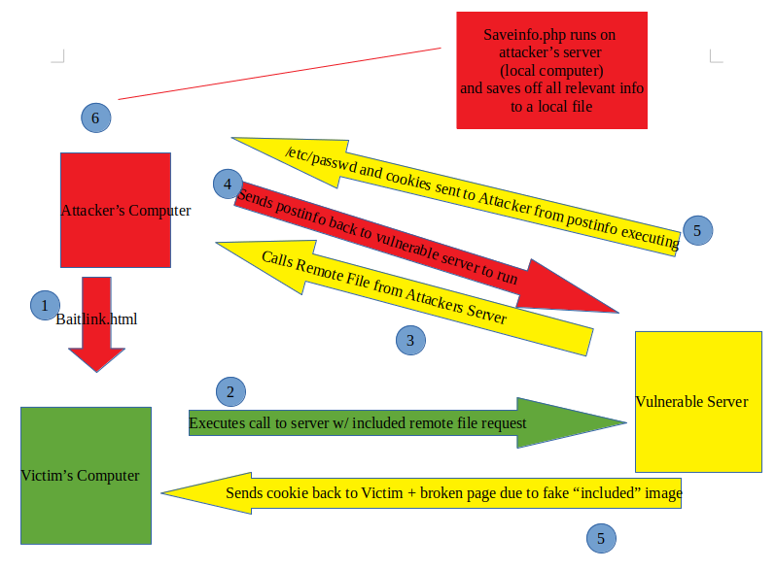

The postinfo and saveinfo.php file live on the attackers machine. The baitlink.html file can exist anywhere (attackers machine, email, anywhere that has access to the internet and gives the victim the ability to click the link). Postinfo is a remote file inclusion into the server and is run on the vulnerable server. Saveinfo.php is run on the attackers machine and waits to receive info from the postinfo call by the vulnerable server. Baitlink.html sends the victim to the server. The server runs postinfo, and grabs the cookies that were intended for the victim, and sends the cookie and /etc/passwd file from the server to the attacker’s computer and saveinfo.php receives them. Saveinfo.php runs on the attackers machine and writes the data out to a file on the attackers machine.
All of this is available due to an remote file inclusion (RFI) vulnerability within PHP. A RFI vulnerability is caused by the PHP program attempting to include a file that doesn’t exist on the local server, therefore it includes the file from a remote location and executes that file without scrubbing the input. Not scrubbing the input allows the attacker to overload the input and execute extra commands, that the php program is not expecting. Scrubbing the input is necessary to ensure no extra code is injected into the code to cause the program to do something it was unintended to do. RFI vulnerabilities are caused due to poor coding practices and developers not thinking through the security side of the application. RFIs allow attackers to include a file from a remote server (the attackers machine) to run with root or admin permissions. This gives the attacker access to the entire file system and be able to execute a program with elevated permissions.

