Kyle Healy
CPSC62700 Week 7 Assignment Write Up
3/6/2019
Exploiting the FreeFloat FTP Server on Windows XP

The attack on the FreeFloat FTP Server on a Windows XP machine is accomplished in a methodical step by step manner by taking advantage of how the stack works and the pointer registers. The stack is a place in memory where code and data exist. Both (code and data) are accessed by calling the memory addresses. The stack works down the memory addresses, but buffer overflows in program read the memory from the lowest memory location to the highest. Due to the stack is set up being inverse to how it is utilized, buffer overflow vulnerabilities exist and can be exploited to gain access to a system. If a local variable isn’t properly protecting the memory, the input can overwrite data it shouldn’t have access to. Due to the design of the stack, overwriting this data goes up the stack, towards the return address of previous calls. If an attacker can correctly gain access to the return address and point it towards attacker inserted shell code, the attacker can gain access to the entire system. A few steps are laid out below on how this was implemented to gain access to the Freefloat FTP server on a Windows XP machine.
The first step is to get a local copy of the program (Freefloat FTP Server) running inside Immunity Debugger, start up Freefloat FTP Server, and determine the IP address (seen in the left figure below). The second step is to confirm the Kali machine can connect to the Windows XP Server by attempting to FTP to the IP address (seen in the right figure below).
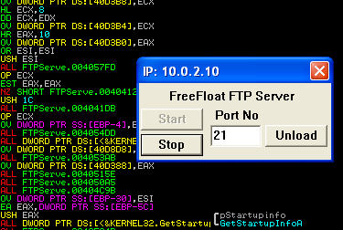
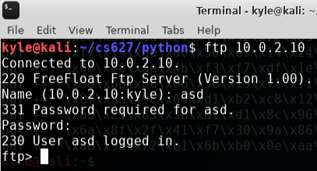

The next step is to completely disrupt the program by smashing the stack and overloading it with the “A” character. Python was used to easily create a program that can send 768 A’s in a row to the FTPServer executable as the username. Due to the vulnerability, the 768 A’s overwrites the stack all the way through the EIP. Following this initial check, the next step is to determine the offset from the entry point at the “user” input to the EIP. This is accomplished by generating a very unique string of characters that isn’t repeating and determining the location of the offset. 768 alpha-numeric characters were again submitted overwriting the stack and the EIP showed x41326941. Due to Microsoft using little endian, the specific hex characters x41 (A), x32 (2), x69 (i), x41 (A) need to be reversed. Therefore, the offset we are looking for is really at Ai2A, which corresponds to the EIP offset starting at 246. Reset and run the exploit again with the username having 246 As, 4 Bs followed C’s to confirm the offset was properly found. This was run and confirmed that 4x Bs or (0x42424242) ended up in the EIP register.
After finding the EIP instruction, the next step is to find the JMP ESP instruction inside the shell32.dll file. Reset Immunity Debugger and reload the FTPServer executable. View the “Executable modules” and find the Shell32.dll. Search for the ‘JMP ESP’ instruction and copy the address (0x 7CB41020). Add the JMP ESP memory address to the exploit to replace the 4 consecutive B’s that go into the EIP register. Confirm the JMP ESP memory address is correct by adding interrupts at the end (0xCC). This will execute the code, run it through the jump esp command and interrupt the program after and return it to the debugger. This is a good inspection to confirm the steps up to now.
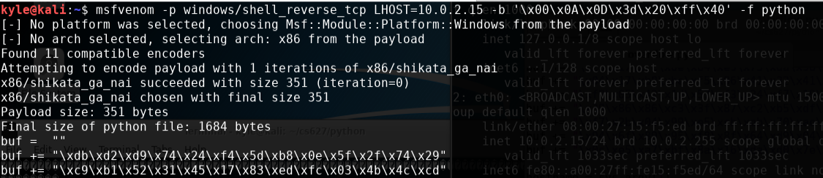
The last step is to generate and insert shellcode into the exploit to be able to access the shell of the vulnerable machine after. A program called msfvenom will be used to generate the shellcode. A few parameters are passed into msfvenom to ensure it works properly. The command in its entirety can be seen below. The local host of the attackers machine is passed in, as well as the output format (python in this case). The last piece of information required is the bad bytes. Bad bytes are specific bytes that will cause the program to stop reading the input, prior to reading in the entire exploit. Add a 16 character nop sled before buffer and execute the program. The username now looks like 246 A’s in a row, followed by the jump esp address (0x2010b47c), a 16 byte nop sled, the buffer built from msfvenom and closed out with interrupts following.
Start a separate terminal to listen using the command “nc -vvv -l -p 4444” for the reverse connection. The exploit is opening a connection on port 4444 with the attackers machine. The successful results can be seen in the image below.
