Continuous Integration: Processes and APIs

1. Abstract
2. Intro
   1. High level overview of CI.
3. Continuous Integration: What it is?
   1. What is continuous integrations?
   2. What is the purpose
   3. Current usages
      1. continuous integration in industry
         1. Raytheon
         2. Northrop Grumman
      2. continuous integration in academia
      3. Servers vs standalone PCs
   4. Benefits of continuous integration
   5. Limitations of continuous integration
4. Continuous Integration Processes
5. Continuous Integration Tools and APIs
   1. Jenkins
   2. Buildbot
   3. Travis CI
   4. Strider
   5. Go
   6. Integrity
6. **Best Practices**
   1. **Master – resource management**
   2. **Slaves – Different baselines on different OSs**
7. **New uses of Continuous Integration**
   1. **Auto test generation**
      1. **History of tests**
      2. **Create test stubs**
      3. **Known tests that cause problems – highlight**
   2. **Continuous Delivery**
   3. **Continuous Deployment**
   4. **Parallelization of build and tests**
8. References

<https://opensource.com/business/15/7/six-continuous-integration-tools>

<https://www.thoughtworks.com/continuous-integration>

<https://aws.amazon.com/devops/continuous-integration/>

<https://jenkins.io/index.html>

<https://insights.sei.cmu.edu/devops/2015/01/continuous-integration-in-devops-1.html>

<http://www.360logica.com/blog/2015/08/the-existing-challenges-of-continuous-integration-ci.html>

<https://cloudacademy.com/cloud-computing/introduction-to-continuous-integration-course/>

<http://ieeexplore.ieee.org/document/7284593/>

<https://www.java.net//blog/kohsuke/archive/20070514/Hudson%20J1.pdf>

<http://sourceforge.net/project/shownotes.php?release_id=155929>

<http://buildbot.net/index.html#/basics>

<https://www.ibm.com/developerworks/library/l-buildbot/>

Continuous Integration/Deployment is a huge piece in the current Computer Science field. This is a topic I believe I will want to write about for my course project. The topic is still relatively new in the computer science field and has a lot of growing information. Considering that the topic is newer, it leaves a great opportunity to conduct research on it to determine the best way to use it. This research can be done by analyzing its current uses in industry and by applying new uses if applicable.

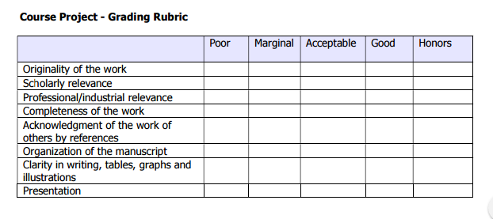

15 minute presentation

10 minute Q and A