**Software Engineering: GitHub Interrogation**

Made use of user “phadej”’s information.

**Graph 1:** Number of users’ followers plotted against their number of repositories.

**Graph 2:** Number of users’ followers plotted against their number of repositories, coloured by date created.

**Graph 3** Number of users’ followers plotted against the number of users they follow.

**Graph 4:** Number of followers my followers have.

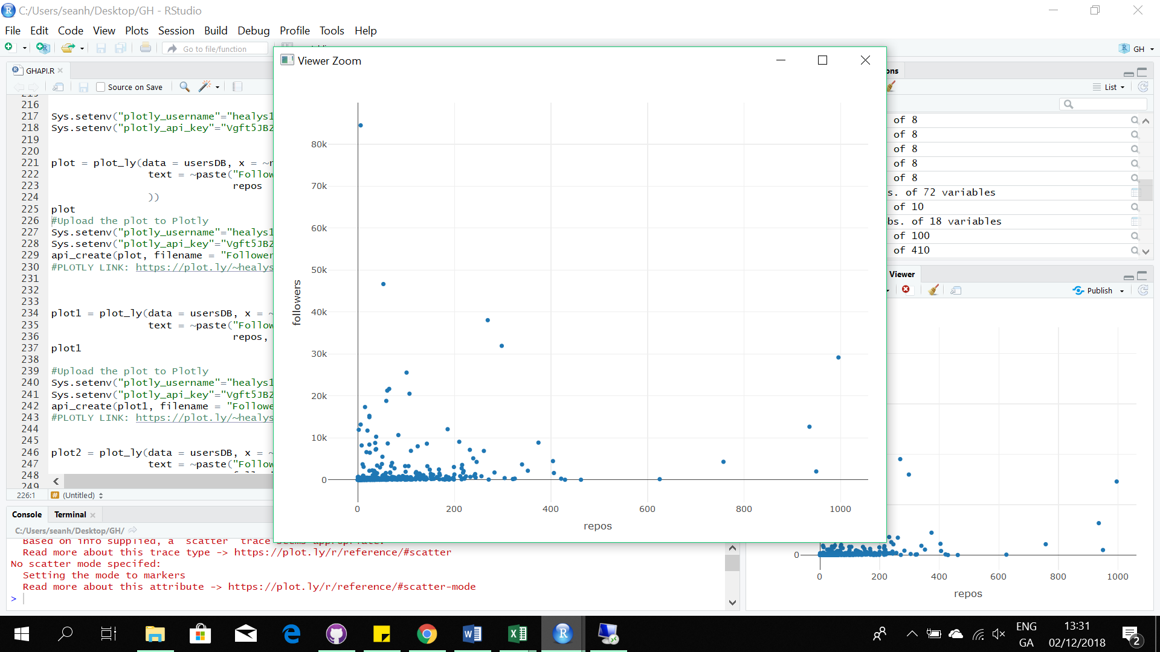**Graph 1**

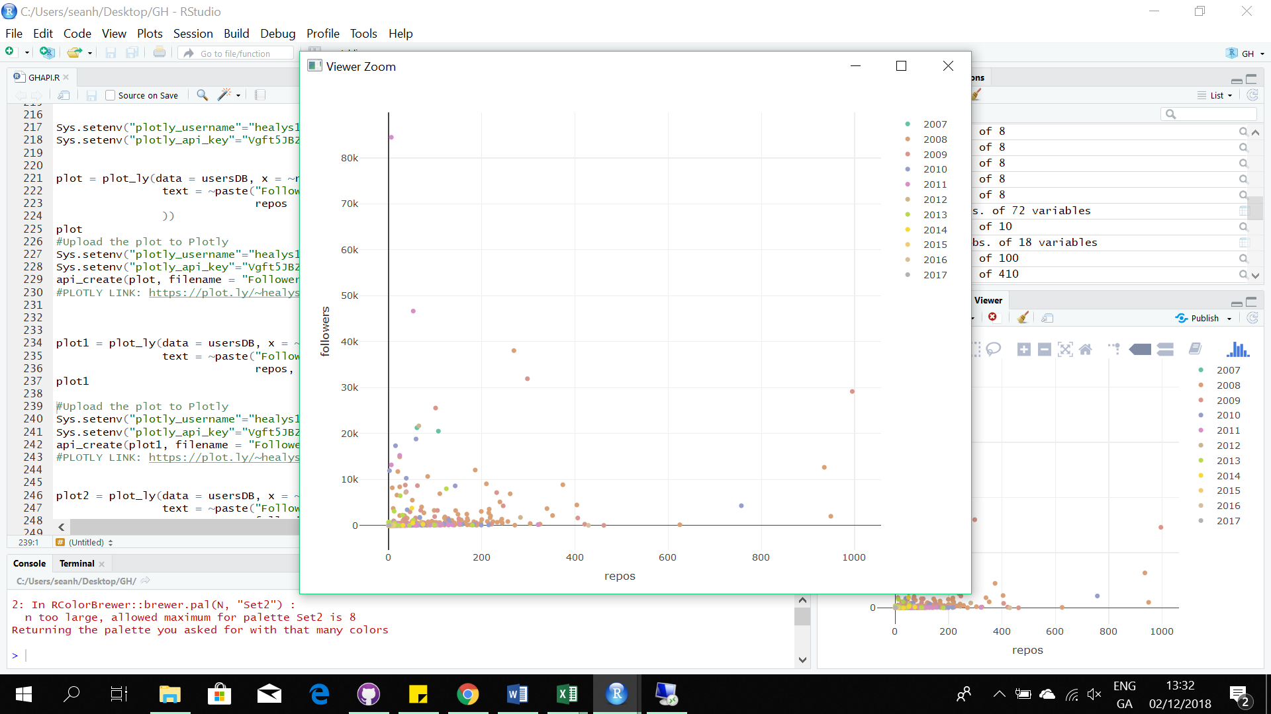  
  
  
  
  
  
  
  
  
  
  
  
  
  
  
**Graph 2  
  
  
  
  
  
  
  
  
  
  
  
  
  
  
  
  
  
Graph 3  
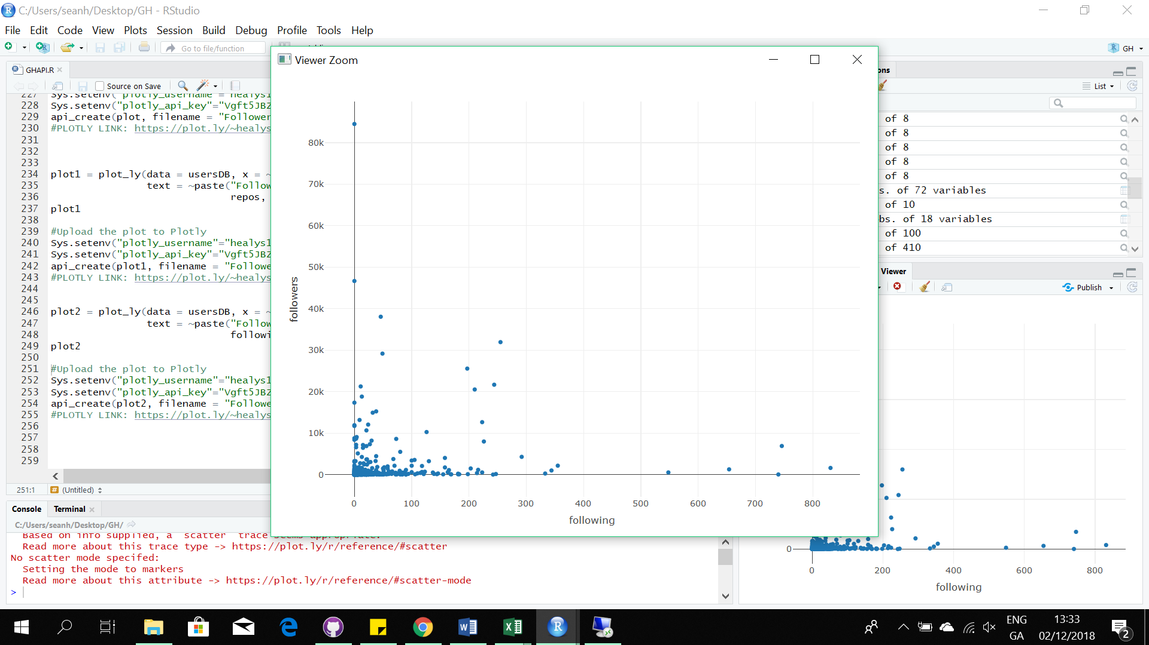**

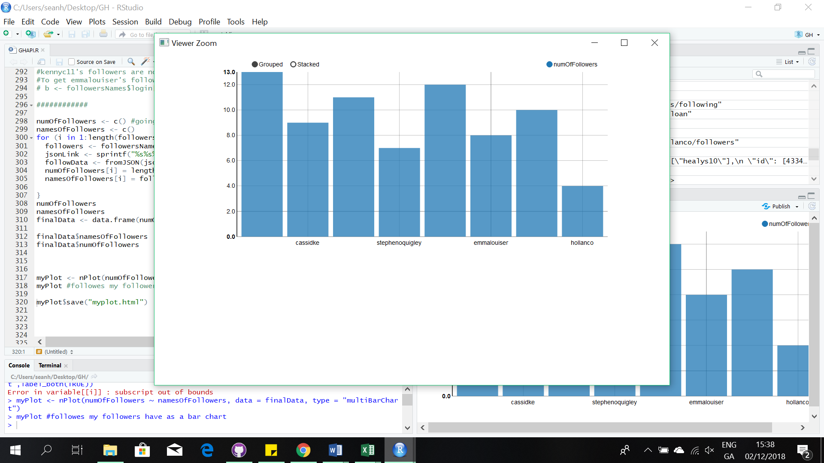**Graph 4**