SYNOPSIS

Project Title: Distributed Clock Synchronization System Using UDP

1. Abstract (Problem Statement and Scope)
In distributed computer networks, each machine maintains its own internal clock. Due to hardware imperfections and environmental factors, clocks drift over time, causing inconsistencies in timestamps across systems. Even small time differences can affect distributed applications such as logging systems, transaction ordering, and real-time coordination systems.
This project aims to implement a UDP-based clock synchronization protocol where multiple clients synchronize their clocks with a centralized time server using a time request-reply mechanism. The system will calculate network delay and clock offset, perform drift correction, and evaluate synchronization accuracy.

2. Architecture Design
Architecture Type:
- Client–Server Architecture
- Multi-client Distributed System
- UDP-based Communication
Components:
- Time Server (Maintains reference time)
- Multiple Clients (Synchronize with server)
- UDP Communication Layer

3. Architectural Workflow
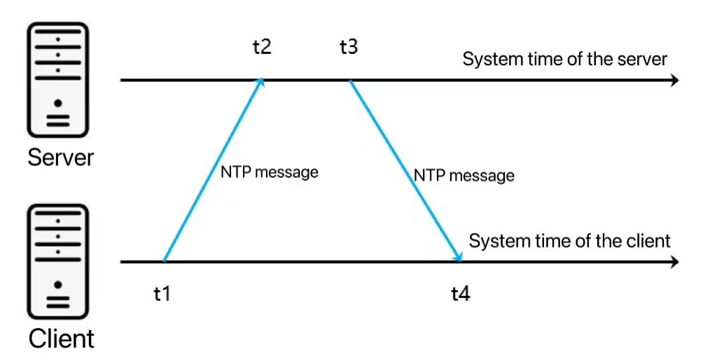
1. Client sends request at time T1
2. Server receives request at T2
3. Server replies at T3
4. Client receives reply at T4
Round-Trip Delay = (T4 - T1) - (T3 - T2)
Clock Offset = ((T2 - T1) + (T3 - T4)) / 2
Client adjusts logical clock using calculated offset.

4. Drift Correction
Clock drift refers to gradual deviation in local clock time. Drift correction is implemented using periodic synchronization and incremental logical clock adjustment to avoid sudden jumps in time.

5. Objectives
1. Design a UDP-based synchronization protocol.
2. Calculate network delay and clock offset.
3. Implement drift correction.
4. Evaluate synchronization accuracy.

6. Functional Requirements
- Accept time requests from multiple clients.
- Record timestamps accurately.
- Compute delay and offset.
- Adjust logical client clocks.
- Handle packet loss.
- Perform periodic synchronization.
- Log synchronization statistics.

7. Software and Hardware Requirements
Software:
- Programming Language: C / Python
- OS: Windows / Linux
- Libraries: socket, time, threading
Hardware:
- Minimum 4 GB RAM
- Modern processor
- Network connectivity (LAN/Wi-Fi)

8. Performance Evaluation Parameters
- Clock Offset Accuracy
- Round-Trip Delay
- Jitter
- Packet Loss Rate
- Synchronization Stability
- Scalability with increasing clients

9. Expected Outcome
- Clients synchronize with server time.
- Offset reduces over multiple iterations.
- Clock drift is minimized.
- Performance metrics are generated and analyzed.

