**Information Hiding**

**Introduction**

This activity involves finding the average age of a group of students, without anyone having to reveal what their age is. Alternatively, one could work out the average income (allowance) of the students in the group, or some similar personal detail. Calculating these statistics works particularly well with adults, because older people can be more sensitive about details like age and income.

You will need at least three students in the group.

**Discussion**

1. Explain to the group that you would like to work out their average age, without anyone telling anyone else what their age is. Ask for suggestions about how this might be done, or even whether they believe it can be done.
2. Select about six to ten students to work with. Give the pad and pen to the first student, and ask them to secretly write down a randomly chosen three- digit number on the top sheet of paper. In this example, 613 has been chosen as the random number.

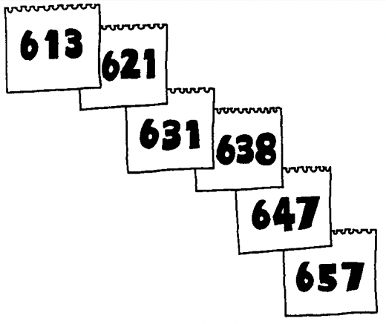

1. Have the first student tear off the first page, add their age to the random number, and write it on the second sheet on the pad. The first student's age is 8, so the second sheet shows 621. They should keep the page that was torn off (and not show it to anyone.)
2. The pad is then passed to the second student, who adds their age to the number on the top, tears off the page, and writes the total on the next page. In the example, the second student is 10 years old.
3. Continue this process having a student tear off the top page and add their age to the number on it, until all the students have had the pad.
4. Return the pad to the first student. Have that student subtract their original random number from the number on the pad. In the example, the pad has been around five students, and the final number, 657, has the original number, 613, subtracted from it, giving the number 44. This number is the sum of the students' ages, and the average can be calculated by dividing by the number of students; thus the average age of our example group is 8.8 years old.
5. Point out to the students that so long as everyone destroys their piece of paper, no-one can work out an individual’s age unless two people decide to cooperate.