Jessica Hall

Intro to Python Programming

Assignment 05

4/30/18

Organize a to do list with List and Dictionaries

1.Created a file called Todo.txt and entered in default values.

2.Opened and read Todo.txt file into memory

3. Created “for” “in” loop to arrange the data into a list of dictionaries

4. Created a “while” loop to run through each option until user chose to Exit

5. Within the While loop I used the Input function to ask the user to enter their choices.

6. “if” the user entered 1 “print” tasks in list

7.Provided Elif options until user selected 4 or 5. Using Continue to continue to read menu options.

8.Opened File to write everything to it. I used ‘w’ to re write everything so there would not be any duplicates.

9. open_file.close()

I struggled with understanding reading the data from the file and putting that data into dictionaries. With a lot of trial an error and debugging my code and going back through the book I was able to get it to work properly. Learning that the data is all stored in the variable to the left of the data is starting to sync in. As well as how and when to use dictionaries and list.

Tested work by adding and removing data and checking Todo.txt file until it eventually looked right.

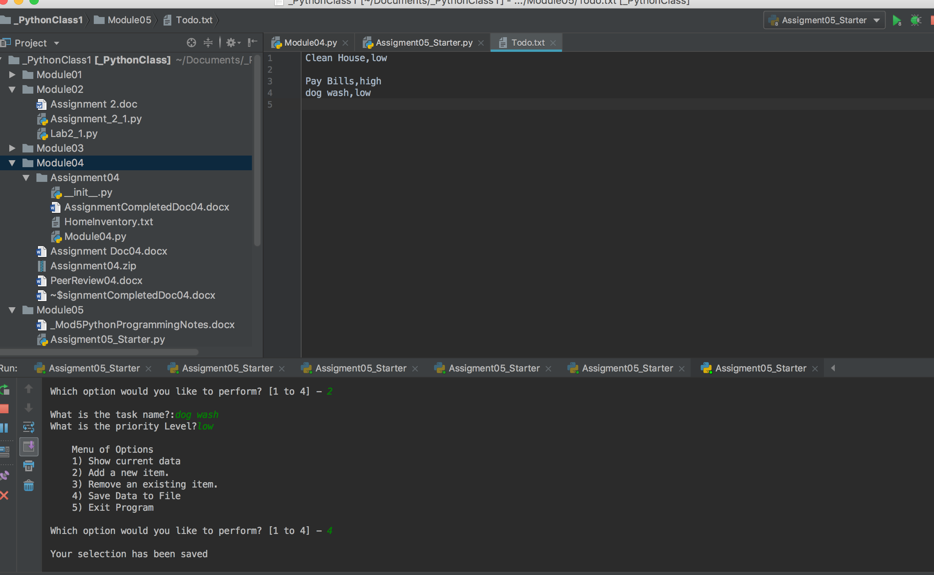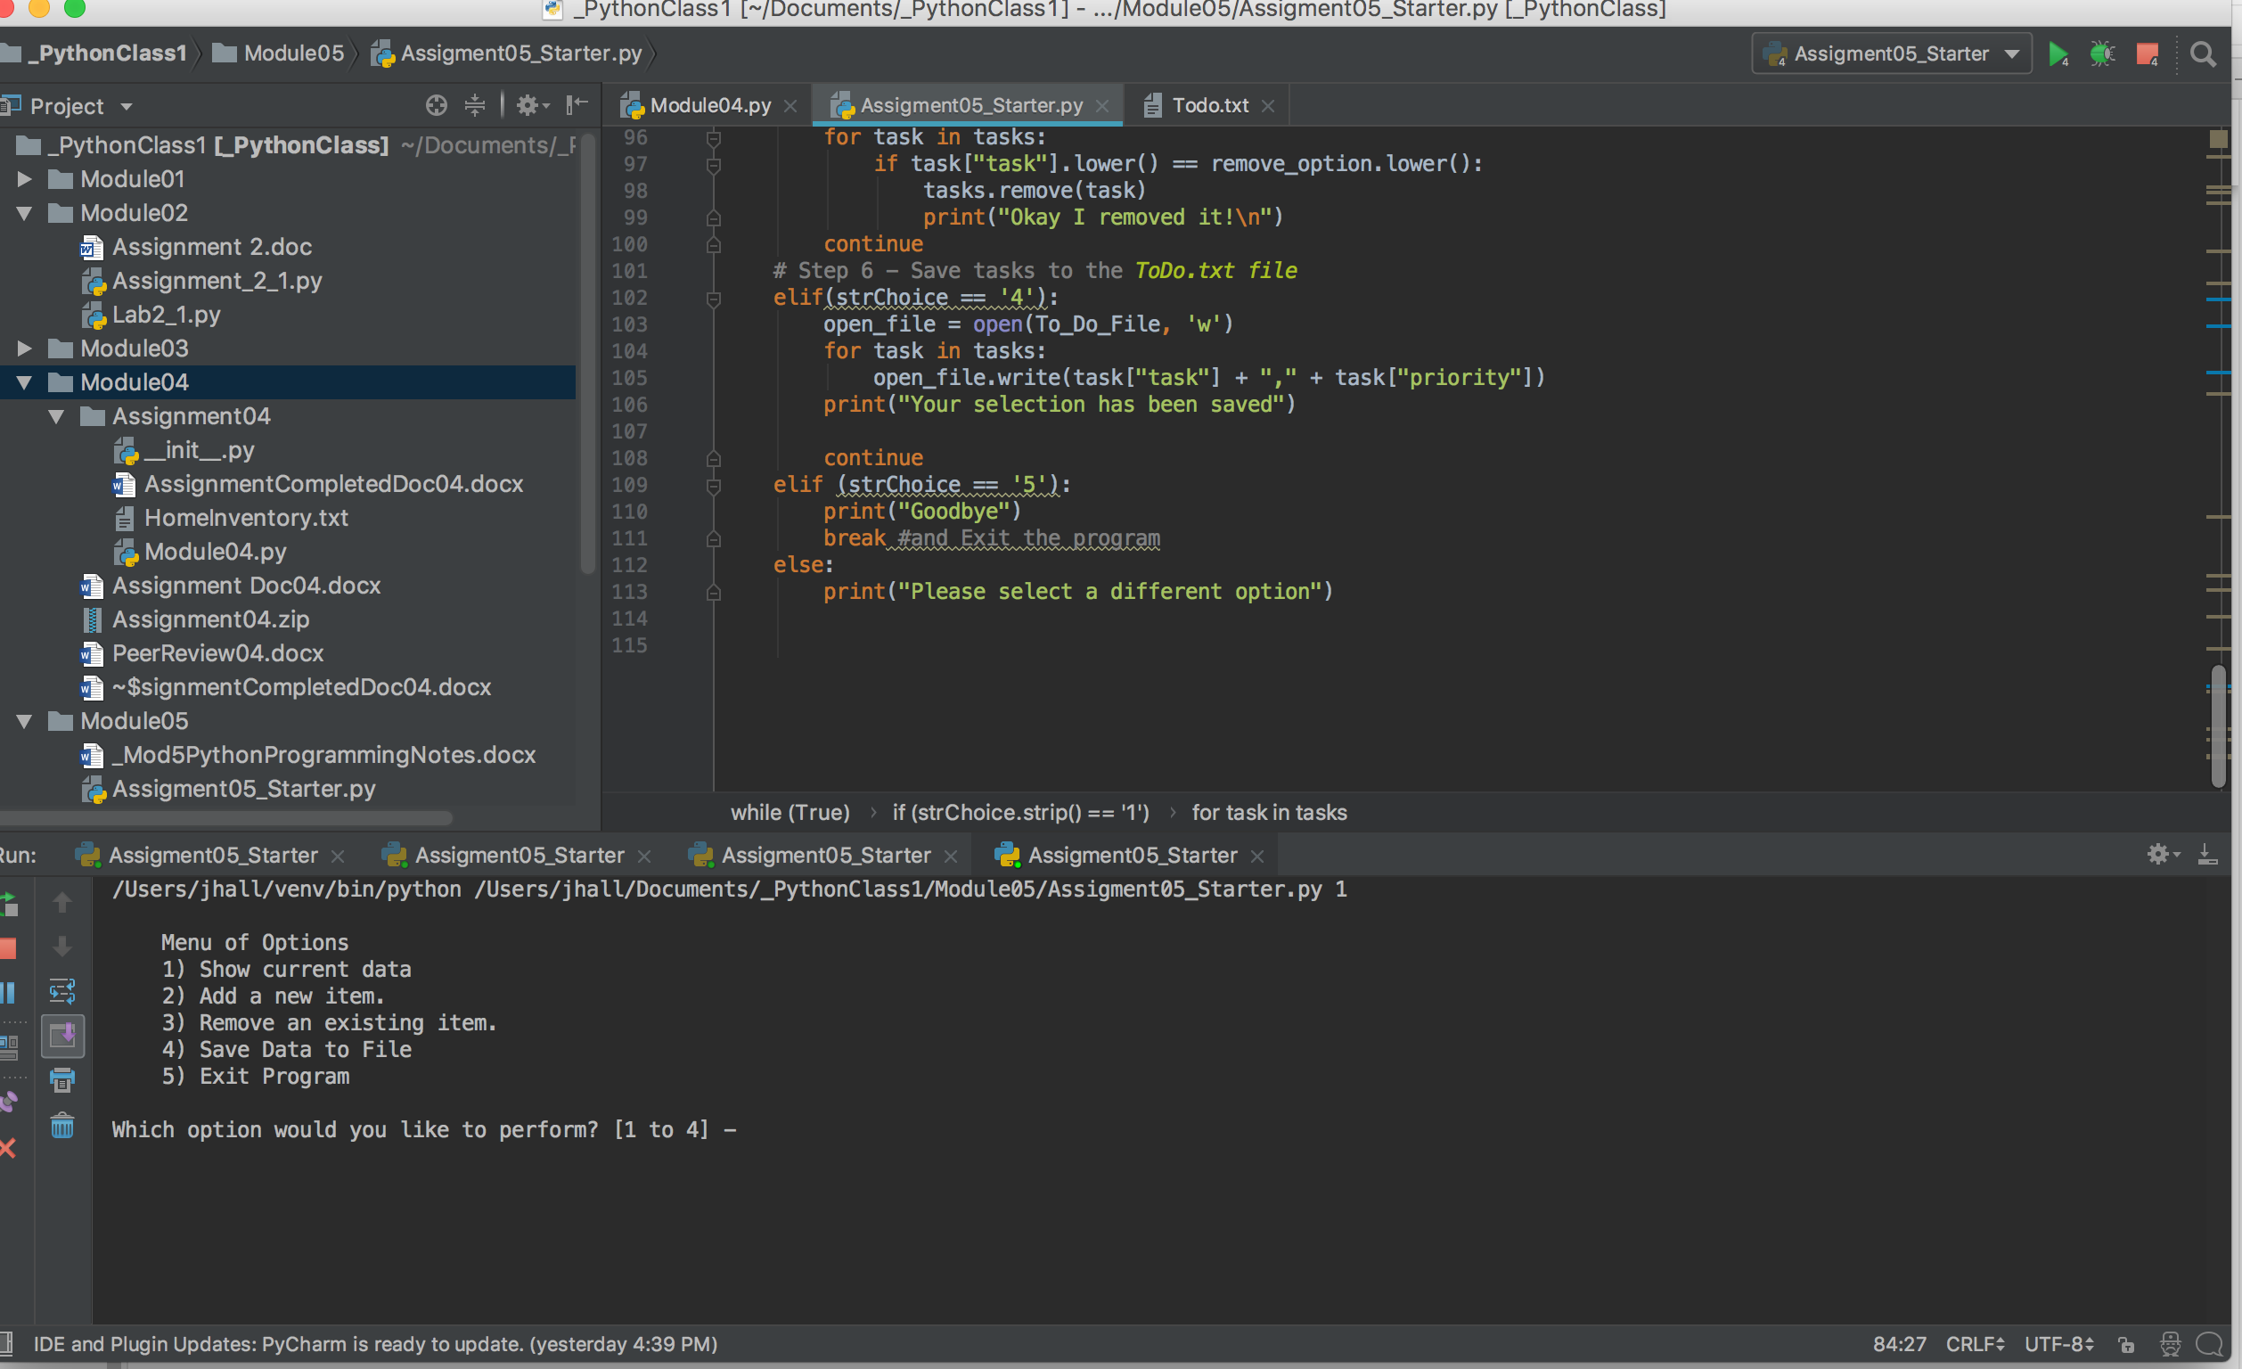

Tested code over an over till I was sure it was running and saving correctly.