AE学习开发

****一 主要功能****

1.用户管理：添加用户、更改用户、删除用户功能。

2.地图导航：拉框放大、拉框缩小、漫游小手功能。（实现）

3.文件：打开、保存、退出。（实现）

4.查询：SQL查询功能。

**二窗体界面**

主界面

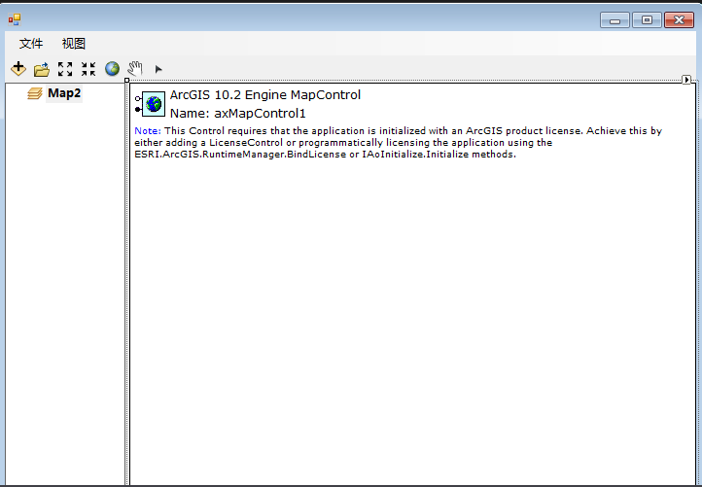

放大缩小

private void inoutToolStripMenuItem_Click(object sender, EventArgs e)

{

ICommand inout = new ControlsMapZoomPanToolClass();

inout.OnCreate(axMapControl1.Object);

axMapControl1.CurrentTool = inout as ITool;

}

打开文件

private void openToolStripMenuItem_Click(object sender, EventArgs e)

{

ICommand openfile = new ControlsAddDataCommandClass();

openfile.OnCreate(axMapControl1.Object);

openfile.OnClick();

}

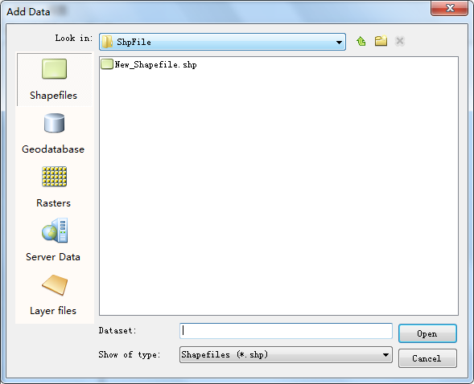

保存文件

private void saveastoolStripMenuItem3_Click(object sender, EventArgs e)

{

ICommand saveas = new ControlsSaveAsDocCommandClass();

saveas.OnCreate(axMapControl1.Object);

saveas.OnClick();

}

缩放至图层：

private IFeatureLayer player = null;

private void zoomtotheplayerToolStripMenuItem_Click(object sender, EventArgs e)

{

if (player != null)

{

(axMapControl1.Map as IActiveView).Extent = player.AreaOfInterest;

(axMapControl1.Map as IActiveView).PartialRefresh(esriViewDrawPhase.esriViewGeography, null, null);

}

}

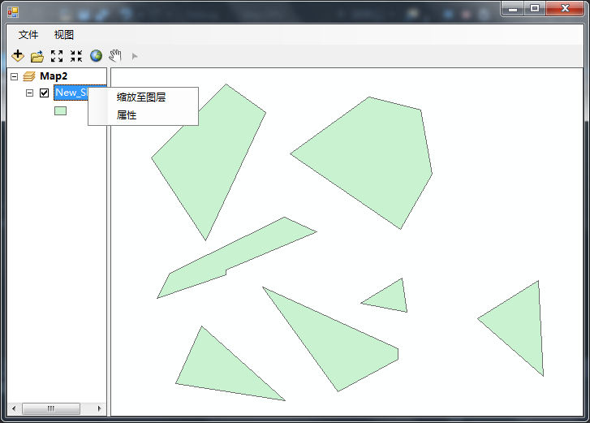

打开属性表

public IMap currentmap;

private IFeatureLayer currentlayer;

public IFeatureLayer getlayer

{

set { currentlayer = value; }

get { return currentlayer; }

}

public void start()

{

if (currentlayer == null)

{

return;

}

DataTable datadt = new DataTable();

DataRow rrow = null;

DataColumn ccol = null;

IField ifield = null;

for (int i = 0; i < currentlayer.FeatureClass.Fields.FieldCount; i++)

{

ifield = currentlayer.FeatureClass.Fields.get_Field(i);

ccol = new DataColumn();

ccol.ColumnName = ifield.AliasName;

datadt.Columns.Add(ccol);

}

IFeatureCursor fcursor = currentlayer.Search(null, true);

IFeature pfeature = fcursor.NextFeature();

while (pfeature != null)

{

rrow = datadt.NewRow();

for (int i = 0; i < datadt.Columns.Count; i++)

{

rrow[i] = pfeature.get_Value(i);

}

datadt.Rows.Add(rrow);

pfeature = fcursor.NextFeature();

}

System.Runtime.InteropServices.Marshal.ReleaseComObject(fcursor);

gridControl1.DataSource = datadt;

gridView1.OptionsView.ShowGroupPanel = false;

double total = datadt.AsEnumerable().Select(d => Convert.ToDouble(d.Field<string>("Area"))).Sum();

}

private Form3 att = null;

private void attributeToolStripMenuItem_Click(object sender, EventArgs e)

{

if(att == null || att.IsDisposed)

{

att = new Form3();

}

att.currentmap = axMapControl1.Map;

att.getlayer = player;

att.start();

att.Show();

}

