# 服务端

新建一个web工程，工程目录如下：

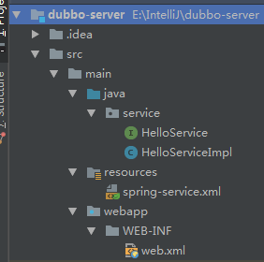

pom.xml配置

<dependencies>  
 <dependency>  
 <groupId>org.springframework</groupId>  
 <artifactId>spring-context</artifactId>  
 <version>4.3.11.RELEASE</version>  
 </dependency>  
 <dependency>  
 <groupId>com.alibaba</groupId>  
 <artifactId>dubbo</artifactId>  
 <version>2.5.7</version>  
 </dependency>  
 <dependency>  
 <groupId>org.apache.zookeeper</groupId>  
 <artifactId>zookeeper</artifactId>  
 <version>3.4.10</version>  
 </dependency>  
 <dependency>  
 <groupId>com.github.sgroschupf</groupId>  
 <artifactId>zkclient</artifactId>  
 <version>0.1</version>  
 </dependency>  
</dependencies>  
<build>  
 <finalName>dubbo-server</finalName>  
 <plugins>  
 <plugin>  
 <groupId>org.apache.tomcat.maven</groupId>  
 <artifactId>tomcat7-maven-plugin</artifactId>  
 <version>2.2</version>  
 <configuration>  
 <port>8080</port>  
 <path>/</path>  
 </configuration>  
 </plugin>  
 </plugins>  
</build>

## 编写要发布的接口

**package service**;  
**//要发布的接口  
public interface** HelloService **{  
 //要发布的方法  
 String** sayHello();  
**}**

## 实现接口功能

**package service**;  
  
**public class HelloServiceImpl implements** HelloService **{  
  
 @Override  
 public String** sayHello() **{  
 return "HELLO DUBBO"**;  
 **}  
}**

## 发布服务

*<?*xml version="1.0" encoding="UTF-8"*?>*<beans xmlns="http://www.springframework.org/schema/beans"  
 xmlns:xsi="http://www.w3.org/2001/XMLSchema-instance"  
 xmlns:dubbo="http://code.alibabatech.com/schema/dubbo"  
 xsi:schemaLocation="http://www.springframework.org/schema/beans  
 http://www.springframework.org/schema/beans/spring-beans.xsd  
 http://code.alibabatech.com/schema/dubbo  
 http://code.alibabatech.com/schema/dubbo/dubbo.xsd">  
  
 <bean id="helloServiceImpl" class="service.HelloServiceImpl"/>  
 <!-- 发布dubbo服务 -->  
 <!-- 提供方应用信息，用于计算依赖关系 -->  
 <dubbo:application name="dubbo-server-test"/>  
 <!-- 注册中心的地址 -->  
 <dubbo:registry protocol="zookeeper" address="10.0.31.98:2181"/>  
 <!-- 用dubbo协议在20880端口暴露服务 -->  
 <dubbo:protocol name="dubbo" port="20880"/>  
 <!-- 声明需要暴露的服务接口 -->  
 <dubbo:service interface="service.HelloService" ref="helloServiceImpl" timeout="300000"/>  
</beans>

## web.xml配置

*<?*xml version="1.0" encoding="UTF-8"*?>*<web-app xmlns="http://java.sun.com/xml/ns/javaee"  
 xmlns:xsi="http://www.w3.org/2001/XMLSchema-instance"  
 xsi:schemaLocation="http://java.sun.com/xml/ns/javaee  
 http://java.sun.com/xml/ns/javaee/web-app_3_0.xsd"  
 version="3.0">  
  
 <!--加载spring配置文件-->  
 <context-param>  
 <param-name>contextConfigLocation</param-name>  
 <param-value>classpath:spring-service.xml</param-value>  
 </context-param>  
 <listener>  
 <listener-class>org.springframework.web.context.ContextLoaderListener</listener-class>  
 </listener>  
</web-app>

配置maven的tomcat插件，发布：

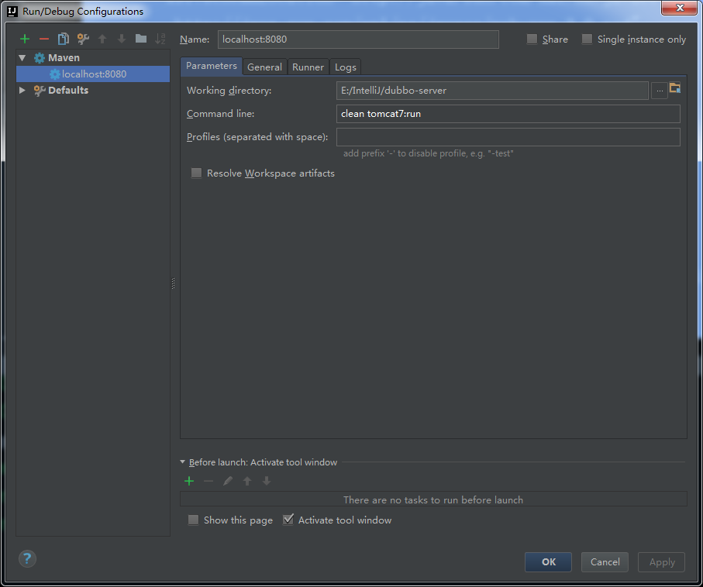

# Dubbo管理后台

是dubbo的管理后台。

先关掉服务器的tomcat

上传到服务器的tomcat的wabapp目录下

启动tomcat。

http://服务器ip:8080/dubbo-admin-2.8.4/

登录的用户名密码都是root

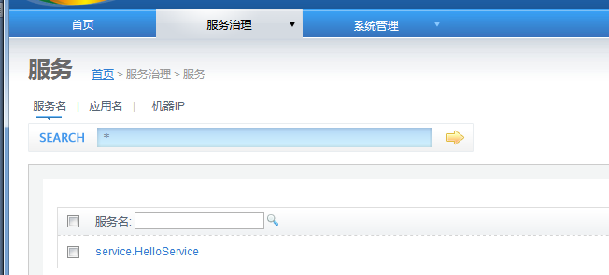

# 客户端

普通的java工程即可，使用main方法测试：

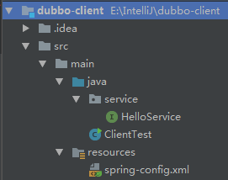

pom.xml配置：

<dependencies>  
 <dependency>  
 <groupId>org.springframework</groupId>  
 <artifactId>spring-context</artifactId>  
 <version>4.3.11.RELEASE</version>  
 </dependency>  
 <dependency>  
 <groupId>com.alibaba</groupId>  
 <artifactId>dubbo</artifactId>  
 <version>2.5.7</version>  
 </dependency>  
 <dependency>  
 <groupId>org.apache.zookeeper</groupId>  
 <artifactId>zookeeper</artifactId>  
 <version>3.4.10</version>  
 </dependency>  
 <dependency>  
 <groupId>com.github.sgroschupf</groupId>  
 <artifactId>zkclient</artifactId>  
 <version>0.1</version>  
 </dependency>  
</dependencies>

## 编写接口

HelloService同1.1中的一样。

## spring调用服务

spring-config.xml

*<?*xml version="1.0" encoding="UTF-8"*?>*<beans xmlns="http://www.springframework.org/schema/beans"  
 xmlns:xsi="http://www.w3.org/2001/XMLSchema-instance"  
 xmlns:dubbo="http://code.alibabatech.com/schema/dubbo"  
 xsi:schemaLocation="http://www.springframework.org/schema/beans http://www.springframework.org/schema/beans/spring-beans.xsd  
 http://code.alibabatech.com/schema/dubbo http://code.alibabatech.com/schema/dubbo/dubbo.xsd">  
 <!-- 引用dubbo服务 -->  
 <dubbo:application name="dubbo-client-test"/>  
 <dubbo:registry protocol="zookeeper" address="10.0.31.98:2181"/>  
 <dubbo:reference interface="service.HelloService" id="helloService"/>  
</beans>

## 测试

**import org.springframework.context.**ApplicationContext;  
**import org.springframework.context.support.ClassPathXmlApplicationContext**;  
**import service.**HelloService;  
  
**public class ClientTest {  
 public static void** main(**String**[] **args**) **{** ApplicationContext **ac = new** ClassPathXmlApplicationContext(**"spring-config.xml"**);  
 HelloService **helloService =** (HelloService) **ac**.**getBean**(**"helloService"**);  
 **System**.***out***.println(**helloService**.**sayHello**());  
 **}  
}**