CHAPTER -1
INTRODUCTION

1.1 ABOUT THE PROJECT
"Neural Vault" is a sophisticated, data-centric Student Information System (SIS) engineered to redefine the interaction between academic performance and professional development. In the current educational paradigm, students often manage their academic records in a fragmented manner, lacking a centralized platform that interprets their data into actionable career insights. This project serves as a comprehensive solution, utilizing a high-performance Python (Flask) framework and a structured MySQL database to create a secure, analytical, and visually immersive "Neural Vault" for academic management.
At its core, the project focuses on Visual Analytics and System Intelligence. Rather than presenting data in static tables, the platform employs dynamic Trajectory Charts that map a student’s progress across multiple semesters. These visualizations allow students to identify patterns in their GPA, monitor attendance trends, and recognize subject-specific strengths. The system is governed by an automated evaluation engine that processes raw academic scores against predefined benchmarks, ensuring that every data point contributes to a larger narrative of student growth.
Beyond simple record-keeping, Neural Vault acts as a strategic bridge. It analyzes a student’s technical aptitude and academic consistency to offer tailored career guidance. This transition from a traditional "Record System" to an "Insight System" is what defines the Neural Hub. It empowers administrators with streamlined tools for student record management (CRUD operations) while providing students with a digital roadmap to navigate their journey from the classroom to the professional world. The result is a robust, scalable, and intuitive ecosystem that makes academic success both measurable and predictable.

CHAPTER - 2
PROBLEM DEFINITION

EXISTING SYSTEM
The Existing System usually relies on traditional, manual methods or very basic digital spreadsheets to maintain student records, which often feels outdated and disconnected. In most cases, academic data is stored in static tables that don't offer much insight beyond just showing a final grade. Students have no way to visualize their progress over time, and there is no built-in logic to help them understand what those grades actually mean for their future. Because these systems are often not mobile-friendly and lack any kind of analytical tools, the data just sits there unused, leaving students to figure out their Neural Vaults and academic growth entirely on their own without any data-driven guidance.

  - DISADVANTAGE OF EXISTING SYSTEM
The Disadvantages of the Existing System mainly stem from the fact that it is passive and lacks any real interaction with the student’s data.
- Lack of Visualization: No charts or graphs to show academic progress over time.
- Manual Effort: High dependency on manual data entry and physical record-keeping.
- No Career Direction: No analytical features to suggest Neural Vaults based on student strengths.
- Poor Accessibility: Not mobile-responsive, making it difficult to use on different devices.

2.3 PROPOSED SYSTEM
The Proposed System, Neural Vault, is designed to turn static academic data into a dynamic and useful tool for students. Unlike the old way of doing things, this system introduces visual analytics through "Trajectory" charts, allowing students to see their GPA trends and academic growth at a glance. It bridges the gap between grades and goals by incorporating logic that suggests Neural Vaults based on a student’s strongest subjects. By using a modern, mobile-responsive "Neural" interface, the system ensures that both students and admins can access and manage information easily from any device. Essentially, it moves away from simple record-keeping and toward a mentor-like platform that helps students understand their potential and plan their future more effectively.

  - ADVANTAGES OF PROPOSED SYSTEM
The Advantages of the Proposed System lie in its ability to transform raw data into actionable insights for both students and administrators. By automating the calculation of GPA and results, it eliminates human error and provides an instant, accurate look at academic standing.
- Data Visualization: Uses "Trajectory" charts to make academic trends easy to understand.
- Career Guidance: Suggests professional paths based on actual subject performance.
- Mobile Accessibility: A fully responsive interface with a slide-in menu for easy use on phones.
- Efficiency: Automates GPA calculations and result tracking (with a 30-mark pass criteria).
- Enhanced UI/UX: A sleek "Neural" theme that is much more engaging than old, flat spreadsheets.

CHAPTER 3
SOFTWARE REQUIREMENT SPECIFICATION

3.1 INTRODUCTION
The Introduction to the Software Requirement Specification (SRS) serves as a roadmap for the technical foundation of the Neural Vault project. This section defines the scope, purpose, and the overall environment required to bring the "Neural Hub" to life. Instead of just listing tools, this introduction explains how the chosen technologies work together to create a secure, responsive, and intelligent platform for students. It outlines the specific expectations for the software, ensuring that the transition from a manual system to a digital, logic-driven mentor is handled efficiently. By establishing these requirements early on, we ensure that the system remains stable, scalable, and capable of handling complex tasks like GPA trajectory mapping and AI-based career analysis.

3.2 MODULE DESCRIPTION
- Authentication & Security Module: This is the entry point of the system, handling secure logins for both Administrators and Students. It uses session management to ensure that users can only access data relevant to their roles, protecting sensitive academic information and maintaining the integrity of the "Neural Vault."
- Administrative Management Module: This module acts as the control center where admins can manage the student database. It includes features for registering new students, updating existing profiles, and overseeing global metrics like total student counts and overall attendance averages to ensure the institution runs smoothly.
- Academic Transcript & Logic Module: This is the core engine of the platform that handles all grade-related data. It automatically calculates GPAs and determines pass/fail status based on the 30-mark criteria. It also maps marks to specific subjects across different semesters, ensuring the data is organized and accurate.
- Neural Analytics & Insight Module: This module is responsible for the "Trajectory" charts and career guidance features. It takes raw academic data and transforms it into visual growth trends. By analyzing performance patterns, it generates personalized career suggestions, helping students bridge the gap between their studies and their professional future

  - HARDWARE REQUIREMENTS:
PERIPHERAL | SPECIFICATION
PROCESSOR | Intel Core i3 or Higher
RAM | 4GB (Minimum) / 8GB (Recommended)
MONITOR | Standard LED/LCD Monitor
KEYBOARD | Standard QWERTY Keyboard
HARD DISK | 256GB SSD or 500GB HDD
MOUSE | Optical Mouse / Touchpad

  - SOFTWARE REQUIREMENTS
COMPONENT | TOOLS OR APPLICATION
FRONT-END TECHNOLOGY | HTML5, CSS3 (BOOTSTRAP 5), JAVASCRIPT
BACKEND DATABASE | PYTHON 3.X (FLASK FRAMEWORK)
DATABASE | MYSQL DATABASE
WEB SERVER | FLASK LOCALHOST SERVER
DESIGNING TOOLS | PHOTOSHOP / FIGMA

CHAPTER 4
SYSTEM ANALYSIS

4.1 INTRODUCTION
The System Analysis phase serves as the foundation for the "Neural Vault" project by identifying the specific needs of students and administrators. It involves a detailed study of the current manual processes to determine how digital logic can better manage academic records and career forecasting. By evaluating data flow and user requirements, this section ensures that the proposed "Neural Vault" is both technically feasible and practically effective. Ultimately, it defines the functional boundaries of the system to ensure the software solves real-world academic challenges efficiently.

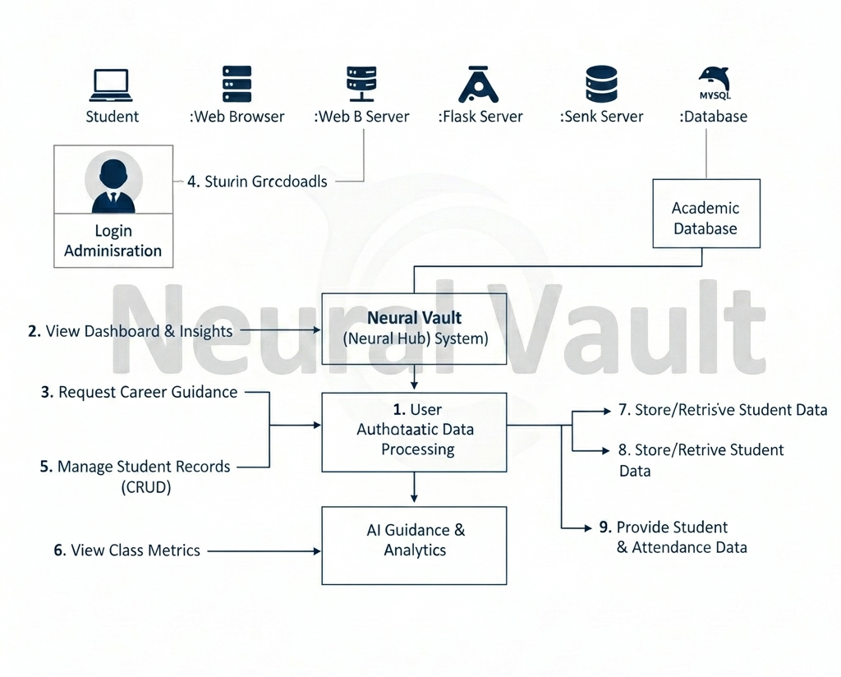

  - DATAFLOW DIAGRAM

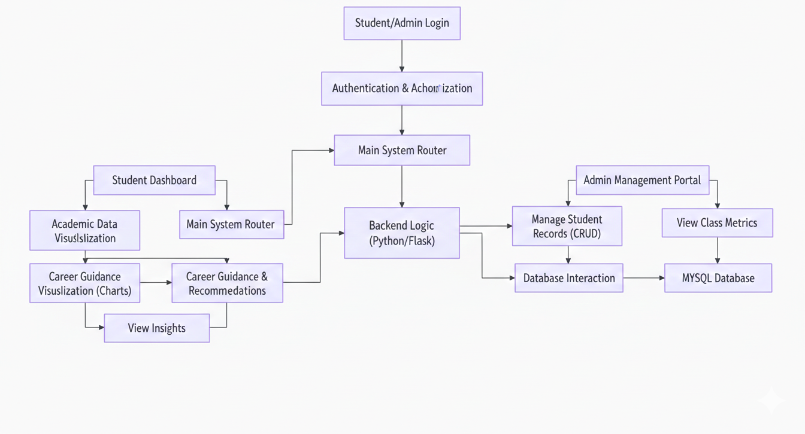

CHAPTER 5
SYSTEM DESIGN

  - INTRODUCTION
The Introduction to the System Design phase outlines the technical architecture and the structural blueprint of the Neural Vault platform. While the analysis phase focused on "what" the system should do, system design focuses on "how" it will be built. This chapter translates the requirements into detailed technical specifications, covering everything from the database schema and the flow of data to the user interface design. By defining the relationship between the Flask backend, the MySQL database, and the responsive frontend, we ensure that the system is not only functional but also scalable and easy to maintain. It serves as the bridge between the initial concept and the actual coding of the "Neural Hub."

5.2 USER INTERFACE DESIGN

The User Interface Design for the Neural Vault system focuses on a "Neural" aesthetic, combining a professional color palette with a clean, modern layout. It features a fully responsive design that adapts seamlessly from the index ERP login page to complex data dashboards on any device size. The interface utilizes glassmorphism cards and smooth micro-interactions to make academic data feel interactive rather than static. High-contrast typography and visual cues are used to highlight critical metrics like the 30-mark pass criteria and GPA trends. Navigation is simplified through a mobile-friendly burger menu, ensuring that students can access their career insights with minimal clicks. Overall, the design prioritizes a high-tech user experience that balances aesthetic appeal with functional clarity.

STATIC PAGE:

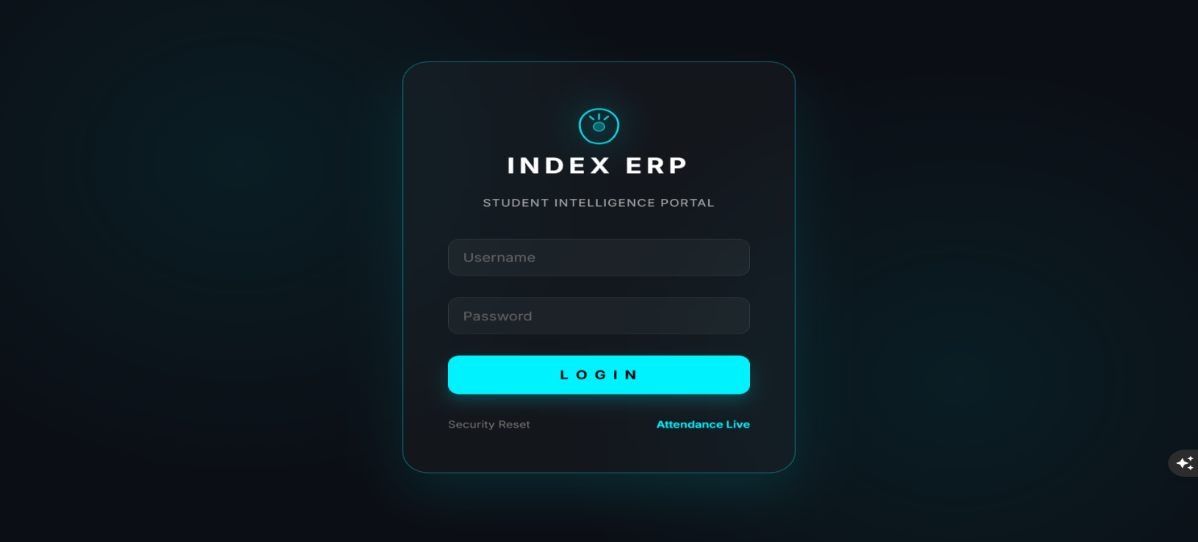

DYNAMIC PAGE:
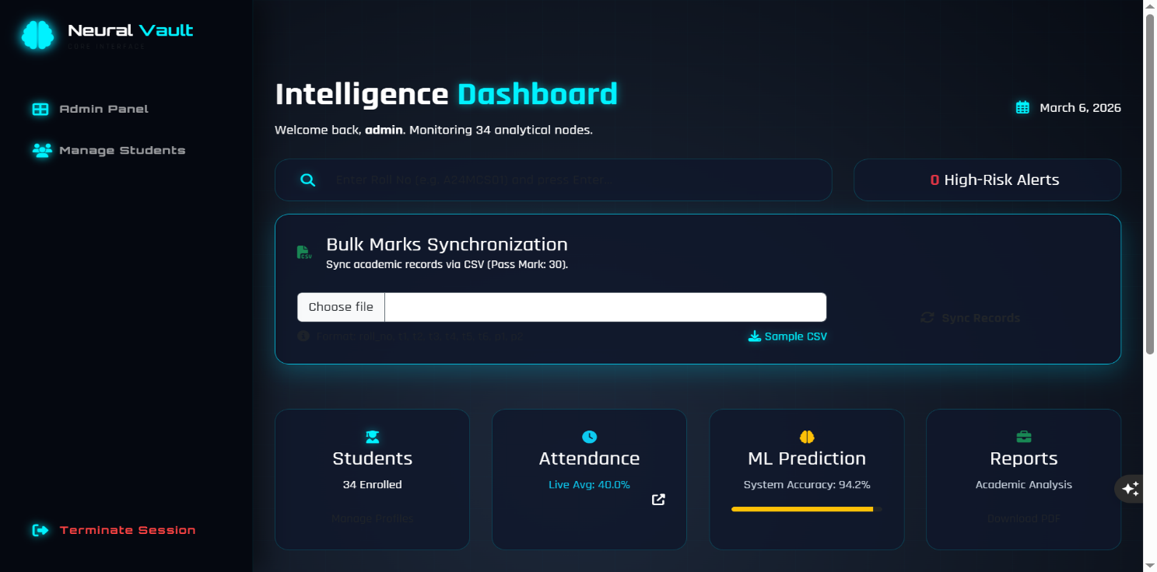

CHAPTER 6
SYSTEM TESTING
  - INTRODUCTION
The System Testing phase is a critical quality assurance process that ensures the Neural Vault platform functions reliably under various conditions. It involves verifying that every component, from the index login to the GPA calculation logic, meets the specified requirements and pass/fail criteria. By identifying and fixing bugs before deployment, this stage guarantees a secure, stable, and error-free experience for both students and administrators. Ultimately, it validates that the "Neural Hub" provides accurate career insights and maintains data integrity across all mobile and desktop devices.

6.2 UNIT TESTING
Unit Testing focuses on verifying each individual component of the Neural Vault system to ensure they work correctly in isolation. Every function, such as the 30-mark pass logic, the login authentication, and the GPA calculation, is tested separately for accuracy. This stage helps in identifying small logic errors early, preventing them from affecting the larger system. By isolating these units, we ensure the core "Neural Hub" engine is stable and mathematically sound before full integration.

6.3 INTEGRATION TESTING
Integration Testing focuses on verifying that the different modules of the Neural Vault system, such as the Login, Student Dashboard, and Database, communicate correctly with each other. It ensures that data entered by an admin in the management portal flows seamlessly into the student’s "Trajectory" charts without any loss or corruption. By testing these interfaces, we can identify issues in data transfer or connectivity between the Flask backend and the MySQL database. This phase is crucial to confirm that the entire "Neural Hub" works as a unified and stable platform.

6.4 REGRESSION TESTING
Regression Testing ensures that new updates or changes to the code do not break existing features in the "Neural Vault" system. For instance, when we update the career guidance logic, we perform regression tests to confirm that the index login page and the 30-mark pass calculation still function perfectly.

6.5 VALIDATION TESTING
Validation Testing confirms that the final "Neural Vault" software actually meets the user's requirements and solves the intended problem. It is the process of checking if the system does what it is supposed to do—like accurately predicting career trajectories and strictly enforcing the 30-mark pass criteria. While other tests focus on code, validation testing focuses on the user's needs to ensure the "Neural Hub" provides real value to both students and admins. It is the final "seal of approval" that the product is ready for real-world deployment.

6.6 ALPHA AND BETA TESTING
Testing is conducted in-house by the development team to identify bugs and logic errors before the system is shown to users. For the "Neural Vault" project, this involved stress-testing the 30-mark pass logic and ensuring the database accurately stores academic records. Beta Testing, on the other hand, is performed by a select group of actual students and administrators in a real-world environment. Their feedback on the "Neural Vault" UI and the career trajectory insights helps refine the user experience and ensures the system is truly ready for full-scale deployment.

6.7 SYSTEM TESTING
System Testing is the final stage of the testing process where the entire "Neural Vault" application is evaluated as a whole. The primary goal is to ensure that the integrated system meets all the functional and technical requirements specified during the analysis phase. In this stage, we verified that the Neural Hub flows correctly from the Index ERP Login to the final Career Trajectory Insights. Every path, including student data entry, GPA calculation, and responsive UI behaviour, was tested against the 30-mark pass criteria to ensure a 100% bug-free experience.

CHAPTER 7
CONCLUSION & FUTURE ENCHANCEMENTS

7.1 CONCLUSION
The "Neural Vault (Neural Hub)" system successfully bridges the gap between academic record management and career guidance. By implementing a modern, responsive web application using Python (Flask) and MySQL, the project provides a streamlined platform for students to track their progress and for admins to manage institutional data efficiently. The integration of the 30-mark pass criteria and automated GPA calculations ensures high accuracy and eliminates manual errors. Ultimately, the system transforms static academic data into a visual "Trajectory," empowering students with clear insights into their performance and future professional opportunities.

7.2 FUTURE ENHANCEMENTS
While the current system provides a strong foundation, the following features can be added in the future to make it even more powerful:
- AI-Powered Predictive Analytics: Implementing Machine Learning models to predict future student performance based on historical data patterns.
- Integrated Placement Cell Portal: A dedicated module for recruiters to view student profiles and for students to apply for jobs directly through the "Neural Hub."
- Automated Notification System: Adding WhatsApp or Email alerts for attendance updates, mark releases, and important academic deadlines.
- Mobile App Development: Expanding the platform into a native Android/iOS application using Flutter or React Native for better accessibility.
- Document Vault: A secure feature for students to store and share digital copies of their certificates and resumes within the portal.

CHAPTER 8

BIBLIOGRAPHY

BOOKS
- Python Machine Learning” by Sebastian Raschka and Vahid Mirjalili
- “Hands-On Machine Learning with Scikit-Learn, Keras, and TensorFlow” by Aurélien Géron
- “Introduction to Machine Learning with Python” by Andreas C. Müller and Sarah Guido
- “Deep Learning with Python” by François Chollet
- “Applied Machine Learning” by David Forsyth
- Goodfellow, Ian, Yoshua Bengio, and Aaron Courville. Deep Learning. MIT Press, 2016.
A foundational reference for understanding neural networks and advanced AI concepts.
- Bishop, Christopher M. Pattern Recognition and Machine Learning. Springer, 2006.
This book presents statistical techniques and algorithms widely used in predictive modeling.
- Han, Jiawei, Micheline Kamber, and Jian Pei. Data Mining: Concepts and Techniques. Morgan Kaufmann, 2011.
It explains data mining methodologies used for analyzing student performance data.
WEBSITES REFERENCES
- Python Official Documentation: https://www.python.org/doc/
- Scikit-Learn Documentation: https://scikit-learn.org/
- TensorFlow Documentation: https://www.tensorflow.org/
- Kaggle – Datasets and ML Resources: https://www.kaggle.com/
- Stack Overflow – Python: https://stackoverflow.com/questions/tagged/python
- Google Scholar.: https://scholar.google.com/
Used for accessing research papers and academic references.
- Towards Data Science.: https://towardsdatascience.com/
Offers articles and tutorials on AI, data science, and machine learning.
- GitHub.: https://github.com/
A repository hosting platform for open-source machine learning projects.
- UCI Machine Learning Repository.: https://archive.ics.uci.edu/

APPENDIX A
SOFTWARE DESCRIPTION
PYTHON TECHNOLOGY
Python is a high-level, interpreted programming language widely used for general-purpose programming. It is known for its simplicity, readability, and ease of learning, making it suitable for beginners and professionals. Python supports multiple programming paradigms, including objectoriented, procedural, and functional programming. It is extensively used in data science, machine learning, web development, automation, and scientific computing. Python programs run on an interpreter, allowing rapid development and testing. Its large community and extensive libraries make Python one of the most popular programming languages today.
THE PYTHON PLATFORM
A platform refers to the environment in which a program is executed. Python is a platformindependent language, meaning Python programs can run on different operating systems such as Windows, Linux, and macOS without modification. This is possible because Python code is interpreted by the Python interpreter available for various platforms. Unlike compiled languages, Python executes code line by line, which simplifies debugging and development. The Python platform provides a rich standard library that supports file handling, networking, database access, and graphical interfaces. This flexibility makes Python suitable for developing scalable and cross-platform applications.
PYTHON INTERPRETER AND LIBRARIES
The Python interpreter is the core component of the Python platform. It reads and executes Python code directly, eliminating the need for separate compilation. Python provides a vast collection of built-in and third-party libraries that extend its functionality. Popular libraries include NumPy for numerical operations, Pandas for data analysis, and Matplotlib for visualization. Machine learning libraries such as Scikit-learn, TensorFlow, and PyTorch are widely used for predictive modeling.
These libraries enable developers to build powerful applications with minimal code.
PERFORMANCE AND PORTABILITY
Python is generally slower than compiled languages because it is interpreted. However, optimized libraries and just-in-time compilation techniques help improve performance. Python’s simplicity reduces development time significantly. Programs written in Python are easy to maintain and modify. Its portability ensures that applications behave consistently across platforms. This balance of performance and ease of use makes Python highly practical.

WHAT CAN PYTHON TECHNOLOGY DO?
Python is used to develop a wide range of applications across different domains. It is widely used in machine learning and artificial intelligence for data analysis and prediction. Python supports web development using frameworks such as Django and Flask. It is also used for automation, scripting, and scientific research. Python applications can be standalone programs or server-based systems. Its flexibility makes it suitable for both small and large-scale projects.
PYTHON FEATURES SUPPORTING APPLICATION DEVELOPMENT
Python provides essential features required for modern software development.
- Core features include data types, control structures, file handling, and exception handling.
- Networking support allows communication using protocols such as HTTP and TCP/IP.
- Database connectivity enables interaction with databases like MySQL, PostgreSQL, and SQLite.
- Security libraries support encryption and authentication mechanisms.
- Machine learning frameworks allow efficient data processing and model training.
HOW WILL PYTHON TECHNOLOGY BENEFIT DEVELOPERS?
Python helps developers build applications faster and more efficiently. Its simple syntax reduces the amount of code required. Python encourages clean and readable coding practices. Automatic memory management helps avoid common programming errors. The availability of reusable libraries reduces development effort. Python’s wide adoption increases career opportunities for developers.
DATABASE CONNECTIVITY
Python supports database interaction through standard APIs and libraries. It provides modules such as sqlite3, mysql-connector, and psycopg2 for database access. These libraries allow developers to connect, query, and manage relational databases. Python database APIs provide consistent methods for executing SQL queries. This makes database integration flexible and efficient. Python-based applications can easily scale with growing data needs.

FRONT END
HTML (Hyper Text Markup Language) is used to structure web pages. It defines the layout and content such as text, images, and links. HTML uses tags like <div>, <p>, and <a> to organize content. It forms the foundation of all web applications. HTML works with CSS and JavaScript to create interactive interfaces. It is essential for frontend development.
JavaScript is used to add interactivity to web pages. It enables dynamic content such as form validation and animations. JavaScript runs in the browser and responds to user actions.
It enhances user experience by making applications interactive. JavaScript works alongside HTML and CSS. It is widely used in modern web development.
CSS (Cascading Style Sheets) is used to design and style web pages. It controls colors, fonts, layouts, and responsiveness. CSS separates presentation from content for better maintainability. It improves the visual appearance of applications. CSS works with HTML to build responsive designs. It is a key component of frontend development.

BACK END
WHAT IS A DATABASE?
A database is a structured collection of data stored electronically. It allows efficient storage, retrieval, and management of information. Databases use structured query languages for data manipulation. Relational databases organize data into tables with defined relationships.They ensure data consistency and integrity. Databases are essential for backend systems.

RELATIONAL DATABASE MANAGEMENT SYSTEM (RDBMS)
An RDBMS is software used to manage relational databases. It stores data in tables consisting of rows and columns. Relationships between tables are maintained using keys.
RDBMS ensures data integrity and security. It supports SQL for querying and managing data.
Popular RDBMS include MySQL, PostgreSQL, and Oracle.

RDBMS TERMINOLOGY
• Database: A collection of related tables.
• Table: A structure that stores data in rows and columns.
• Column: A single data field in a table.
• Row: A record representing related data.
• Primary Key: A unique identifier for table records.
• Foreign Key: A key used to link tables.
• Index: Improves data retrieval speed.
• Referential Integrity: Ensures valid relationships between tables.

MYSQL DATABASE:
MySQL is a fast, easy-to-use RDBMS being used for many small and big businesses. MySQL is developed, marketed and supported by MySQL AB, which is a Swedish company. MySQL is becoming so popular because of many good reasons:
    - MySQL is released under an open-source license. So, you have nothing to pay to use it.
    - MySQL is a very powerful program in its own right. It handles a large subset of the functionality of the most expensive and powerful database packages.
    - MySQL uses a standard form of the well-known SQL data language.
    - MySQL works on many operating systems and with many languages including HP, PERL, C, C++, JAVA, etc.
    - MySQL works very quickly and works well even with large data sets.
    - MySQL is very friendly to PHP, the most appreciated language for web development
- MySQL supports large databases, up to 50 million rows or more in a table. The default file size limit for a table is 4GB, but you can increase this (if your operating system can handle it) to a theoretical limit of 8 million terabytes (TB).
    - MySQL is customizable. The open-source GPL license allows programmers to modify the MySQL software to fit their own specific environments.

MYSQL INTRODUCTION:
MySQL (pronounced “My Ess Cue Ell”) is more than just “the world’s most popular opensource database,” as the developers at the MySQL AB corporation (http://www.mysql.com) claim. This modest-sized database has introduced millions of everyday computer users and amateur researchers to the world of powerful information systems. MySQL is a relatively recent entrant into the well-established area of relational database management systems (RDBMs), a concept invented by IBM researcher Edgar Frank Codd in 1970. Despite the arrival of newer types of data repositories over the past 35years, relational databases remain the workhorses of the information world.

They permit users to represent sophisticated relationships between items of data and to calculate these relationships with the speed needed to make decisions in modern organizations. It’s impressive how you can go from design to implementation in just a few hours, and how easily you can develop web applications to access terabytes of data and serve thousands of web users per second. Whether you’re offering products on a web site, conducting a scientific survey, or simply trying to provide useful data to your classroom, bike club, or religious organization, MySQL gets you started quickly and lets you scale up your services comfortably overtime. Its ease of installation and use led media analyst Clay Shirky to credit MySQL with driving a whole new type of information system he calls “situated software”—custom software that can be easily designed and built for niche applications. In this book, we provide detailed instructions to help you set up MySQL and related software. We’ll teach you Structured Query Language (SQL), which is used to insert, retrieve, and manipulate data

. We’ll also provide a tutorial on database design, explain how to configure MySQL for improved security, and offer you advanced hints on getting even more out of your data. In the last five chapters, we show how to interact with the database using the PHP and Perl programming languages, and how to allow interaction with your data over the medium most people prefer these days: the Web.

WHY IS MYSQL SO POPULAR?
The MySQL development process focuses on offering a very efficient implementation of the features most people need. This means that MySQL still has fewer features than its chief open source competitor, PostgreSQL, or the commercial database engines .Nevertheless, the skills you get from this book will serve you well on any platform .Many database management systems—even open source ones—preceded MySQL .Why has MySQL been the choice for so many beginners and small sites, and now for some heavyweight database users in government and industry? We can suggest a few factors:
Size and speed:
MySQL can run on very modest hardware and puts very little strain on system resources; many small users serve up information to their organizations by running MySQL on modest desktop systems. The speed with which it can retrieve information has made it a longstanding favourite of web administrators. Over the past few years, MySQL AB has addressed the need of larger sites by adding features that necessarily slow down retrieval, but its modular design lets you ignore ethe advanced features and maintain the suppleness and speed for which MySQL is famous.

EASE OF INSTALLATION:
Partly because MySQL is small and fast, it works the way most people want straight “out of the box.” It can be installed without a lot of difficult and sophisticated configuration. Now that many Linux distributions include MySQL, installation can be almost automatic.

RESPONSIVENESS TO COMMUNITY:
With a few hundred employees scattered around the globe, MySQL AB is a very flexible organization that keeps constant tabs on user needs. At its conferences, lead developers get out in front and make themselves available to everyone with a gripe or a new idea. There are also local MySQL user groups in almost every major city. This responsiveness is helped by the fact that MySQL is open and free; any sufficiently skilled programmer can look at the program code to find and perhaps help in fixing problems.
It is easy to use MySQL as part of a larger software system. For example, you can write programs that can interact directly with a MySQL database. Most major programming languages have libraries of functions for use with MySQL; these include C, PHP, Perl, Python, Ruby, and the Microsoft .NET languages. MySQL also supports the Open Database Connectivity (ODBC) standard, making it accessible even when MySQL-specific functionality isn’t available.
MySQL is a popular open-source database used to store and manage data. It’s part of the relational database management system (RDBMS) family, which helps organize and connect information efficiently. MySQL is known for being easy to install and use, making it great for beginners and professionals alike. It powers many web applications by handling large amounts of data quickly. Whether you're building a website, running a survey, or managing a club, MySQL can grow with your needs. This book will guide you through using MySQL, learning SQL, and connecting your database to web apps using PHP and Perl.
Apache Tomcat is an open-source web server and servlet container developed by the Apache Software Foundation. It is used to run Java-based web applications by supporting technologies like Java Servlets, JSP (Java Server Pages), and Web Sockets. Tomcat 9 and above provide better performance, security, and support for newer Java versions. It acts as a bridge between your Java code and the user's web browser. Tomcat is lightweight, easy to set up, and widely used in enterprise and educational projects. It’s a key tool for deploying dynamic Java web app.

APPENDIX B
SOURCE CODE

Index.html
<!DOCTYPE html>
<html lang="en">

<head>
<meta charset="UTF-8">
<meta name="viewport" content="width=device-width, initial-scale=1.0">
<title>Index ERP | Intelligence Login</title>
<link rel="icon" type="image/svg+xml" href="{{ url_for('static', filename='favicon.svg') }}">
<link href="https://fonts.googleapis.com/css2?family=Inter:wght@300;400;600;700&display=swap" rel="stylesheet">
<link rel="stylesheet" href="https://cdnjs.cloudflare.com/ajax/libs/font-awesome/6.4.0/css/all.min.css">
</head>

<style>
:root {
--obsidian: #0b0e14;
--cyan-primary: #00f2ff;
--cyan-glow: rgba(0, 242, 255, 0.3);
--glass: rgba(255, 255, 255, 0.03);
--glass-border: rgba(255, 255, 255, 0.1);
}

* {
margin: 0;
padding: 0;
box-sizing: border-box;
font-family: 'Inter', sans-serif;
}

body {
background-color: var(--obsidian);
background-image:
radial-gradient(circle at 20% 30%, rgba(0, 242, 255, 0.07) 0%, transparent 40%),
radial-gradient(circle at 80% 70%, rgba(0, 242, 255, 0.07) 0%, transparent 40%);
height: 100vh;
display: flex;
justify-content: center;
align-items: center;
overflow: hidden;
}

.login-container {
perspective: 1000px;
animation: fadeIn 1s ease-out;
}

.glass-card {
background: var(--glass);
backdrop-filter: blur(25px);
-webkit-backdrop-filter: blur(25px);
border: 1px solid var(--glass-border);
border-radius: 28px;
padding: 3.5rem 3rem;
width: 420px;
box-shadow: 0 25px 50px rgba(0, 0, 0, 0.6);
position: relative;
transition: all 0.4s cubic-bezier(0.175, 0.885, 0.32, 1.275);
}

.glass-card:hover {
border-color: rgba(0, 242, 255, 0.5);
transform: translateY(-5px);
box-shadow: 0 30px 60px rgba(0, 242, 255, 0.1);
}

/* New Brain Icon Styling */
.brain-icon-wrapper {
text-align: center;
margin-bottom: 1.5rem;
}

.brain-svg {
width: 60px;
height: 60px;
filter: drop-shadow(0 0 15px var(--cyan-primary));
animation: pulseBrain 2.5s infinite ease-in-out;
}

h1 {
color: #fff;
font-weight: 800;
letter-spacing: 5px;
font-size: 1.8rem;
margin-bottom: 0.2rem;
text-align: center;
}

.welcome-text {
color: #aaa;
font-size: 0.85rem;
text-align: center;
margin-bottom: 2.5rem;
letter-spacing: 1px;
}

.input-group {
position: relative;
margin-bottom: 1.8rem;
}

.input-group input {
width: 100%;
padding: 14px 16px;
background: rgba(255, 255, 255, 0.04);
border: 1px solid var(--glass-border);
border-radius: 12px;
outline: none;
color: #fff;
font-size: 1rem;
transition: all 0.3s ease;
}

.input-group label {
position: absolute;
left: 16px;
top: 50%;
transform: translateY(-50%);
color: #666;
pointer-events: none;
transition: all 0.3s ease;
}

.input-group input:focus,
.input-group input:valid {
border-color: var(--cyan-primary);
background: rgba(0, 242, 255, 0.01);
box-shadow: 0 0 10px rgba(0, 242, 255, 0.1);
}

.input-group input:focus~label,
.input-group input:valid~label {
top: -10px;
left: 12px;
font-size: 0.75rem;
color: var(--cyan-primary);
background: #0b0e14;
padding: 0 8px;
font-weight: 600;
}

.login-btn {
width: 100%;
padding: 16px;
background: var(--cyan-primary);
border: none;
border-radius: 12px;
color: #000;
font-weight: 700;
font-size: 1rem;
letter-spacing: 2px;
cursor: pointer;
transition: all 0.3s ease;
box-shadow: 0 10px 20px rgba(0, 242, 255, 0.2);
}

.login-btn:hover {
transform: scale(1.02);
box-shadow: 0 0 30px var(--cyan-primary);
filter: brightness(1.1);
}

.footer-links {
margin-top: 2rem;
display: flex;
justify-content: space-between;
font-size: 0.8rem;
}

.footer-links a {
color: #777;
text-decoration: none;
transition: color 0.3s;
}

.footer-links a:hover {
color: var(--cyan-primary);
}

.accent-link {
color: var(--cyan-primary) !important;
font-weight: 600;
}

/* Animations */
@keyframes pulseBrain {

0%,
100% {
transform: scale(1);
opacity: 0.9;
}

50% {
transform: scale(1.1);
opacity: 1;
filter: drop-shadow(0 0 25px var(--cyan-primary));
}
}

@keyframes fadeIn {
from {
opacity: 0;
transform: translateY(30px);
}

to {
opacity: 1;
transform: translateY(0);
}
}

@media (max-width: 480px) {
.glass-card {
width: 90%;
padding: 2.5rem 1.5rem;
}
}
</style>

<body>
<div class="login-container">
<div class="glass-card">
<div class="brain-icon-wrapper">
<svg class="brain-svg" viewBox="0 0 64 64" fill="none" xmlns="http://www.w3.org/2000/svg">
<path
d="M32 8C20.5 8 11 17.5 11 29C11 37.6 14.5 45.5 20.3 51C21.4 51.9 22.8 52.7 24.4 53.3C26.8 54.3 29.6 54.9 32 54.9C34.4 54.9 37.2 54.3 39.6 53.3C41.2 52.7 42.6 51.9 43.7 51C49.5 45.5 53 37.6 53 29C53 17.5 43.5 8 32 8Z"
stroke="#00f2ff" stroke-width="2" />
<path d="M32 15V22M22 18L26 22M42 18L38 22" stroke="#00f2ff" stroke-width="2"
stroke-linecap="round" />
<circle cx="32" cy="32" r="6" fill="#00f2ff" fill-opacity="0.3" stroke="#00f2ff" stroke-width="1" />
</svg>
<h1>INDEX ERP</h1>
</div>
<p class="welcome-text">STUDENT INTELLIGENCE PORTAL</p>

<form action="/login" method="POST">
<div class="input-group">
<input type="text" name="username" required autocomplete="off">
<label>Username</label>
</div>
<div class="input-group">
<input type="password" name="password" required>
<label>Password</label>
</div>

<button type="submit" class="login-btn">L O G I N</button>

<div class="footer-links">
<a href="#">Security Reset</a>
<a href="http://localhost/Clg_att/htdocs/index.php" target="_blank" class="accent-link">Attendance
Live</a>
</div>
</form>
</div>
</div>
</body>

</html>

Prediction.html
<!DOCTYPE html>
<html lang="en">
<head>
<meta charset="UTF-8">
<meta name="viewport" content="width=device-width, initial-scale=1.0">
<title>Index ERP | Neural Hub</title>

<link href="https://cdn.jsdelivr.net/npm/bootstrap@5.3.0/dist/css/bootstrap.min.css" rel="stylesheet">
<link rel="stylesheet" href="https://cdnjs.cloudflare.com/ajax/libs/animate.css/4.1.1/animate.min.css"/>
<link rel="stylesheet" href="https://cdnjs.cloudflare.com/ajax/libs/font-awesome/6.4.0/css/all.min.css">
<script src="https://cdn.jsdelivr.net/npm/sweetalert2@11"></script>
<link rel="stylesheet" href="{{ url_for('static', filename='css/style.css') }}">

<style>
.custom-input { background: rgba(255,255,255,0.03) !important; border: 1px solid rgba(0, 242, 255, 0.1) !important; color: white !important; }
.custom-input:focus { border-color: #00f2ff !important; box-shadow: 0 0 10px rgba(0, 242, 255, 0.3) !important; }
.upload-zone { cursor: pointer; transition: 0.3s; }
.upload-zone:hover { background: rgba(0, 242, 255, 0.05) !important; border-color: #00f2ff !important; }
</style>
</head>
<body class="bg-obsidian text-white">

{% include 'header.html' %}

<div class="dashboard-wrapper container mt-5 pt-5">
<div class="row mb-5 animate__animated animate__fadeInDown">
<div class="col-12 text-center">
<h1 class="fw-bold neural-text">Registration <span class="text-white">Neural Hub</span></h1>
<p class="text-muted">Onboard students and synchronize academic intelligence.</p>
</div>
</div>

<div class="row g-4">
<div class="col-lg-5 animate__animated animate__fadeInLeft">
<div class="glass-card-premium p-4 h-100 border-cyan-low">
<div class="d-flex justify-content-between align-items-center mb-4">
<h4 class="text-white fw-bold mb-0">Bulk Intel Sync</h4>
<span class="badge bg-info text-dark rounded-pill">AI Ready</span>
</div>
<p class="text-light-muted small">Upload CSV to register students and their marks history simultaneously.</p>

<form action="/upload_students" method="POST" enctype="multipart/form-data">
<div class="upload-zone p-5 text-center border-dashed rounded-4 mb-3 bg-dark">
<i class="fas fa-microchip fa-3x text-cyan mb-3 pulse-animation"></i>
<input type="file" name="student_csv" class="form-control custom-input mb-2" accept=".csv" required>
<small class="text-white-50">Drag & Drop or Click to Select</small>
</div>
<button type="submit" class="btn btn-cyan w-100 rounded-pill py-3 fw-bold shadow-glow mb-3">
<i class="fas fa-sync-alt me-2"></i>Start Intelligence Sync
</button>
</form>

<div class="p-3 rounded-4" style="background: rgba(0,242,255,0.05); border: 1px solid rgba(0,242,255,0.1);">
<p class="small text-cyan mb-2"><i class="fas fa-info-circle me-2"></i>Required CSV Columns:</p>
<code class="text-white-50 x-small" style="font-size: 0.7rem;">roll_no, name, email, department, batch, semester, attendance, t1, t2, t3, t4, p1, p2</code>
<div class="mt-3">
<a href="{{ url_for('static', filename='sample.csv') }}" class="text-cyan text-decoration-none small fw-bold">
<i class="fas fa-download me-2"></i>Download Master Template
</a>
</div>
</div>
</div>
</div>

<div class="col-lg-7 animate__animated animate__fadeInRight">
<div class="glass-card-premium p-4 border-cyan-low">
<h4 class="text-white fw-bold mb-4">Manual Node Creation</h4>
<form class="row g-3" action="/add_student_manual" method="POST">
<div class="col-md-6">
<label class="form-label text-white-50 small fw-bold">Full Name</label>
<input type="text" name="name" class="form-control custom-input" placeholder="Arun Kumar" required>
</div>
<div class="col-md-6">
<label class="form-label text-white-50 small fw-bold">Email Address</label>
<input type="email" name="email" class="form-control custom-input" placeholder="arun@email.com" required>
</div>
<div class="col-md-6">
<label class="form-label text-white-50 small fw-bold">Roll Number</label>
<input type="text" name="roll_no" class="form-control custom-input" placeholder="2026CS101" required>
</div>
<div class="col-md-6">
<label class="form-label text-white-50 small fw-bold">Batch</label>
<input type="text" name="batch" class="form-control custom-input" placeholder="2022-2026" required>
</div>
<div class="col-md-4">
<label class="form-label text-white-50 small fw-bold">Department</label>
<select name="department" class="form-select custom-input">
<option>Computer Science</option>
<option>Artificial Intelligence</option>
<option>Information Technology</option>
</select>
</div>
<div class="col-md-4">
<label class="form-label text-white-50 small fw-bold">Current GPA</label>
<input type="number" step="0.1" name="gpa" class="form-control custom-input" placeholder="0.0" required>
</div>
<div class="col-md-4">
<label class="form-label text-white-50 small fw-bold">Attendance %</label>
<input type="number" name="attendance" class="form-control custom-input" placeholder="0" required>
</div>
<div class="col-12 mt-4">
<button type="submit" class="btn btn-outline-info w-100 rounded-pill py-2 fw-bold" style="border-width: 2px;">
<i class="fas fa-user-plus me-2"></i>Register Student Node
</button>
</div>
</form>
</div>
</div>
</div>
</div>

{% include 'footer.html' %}

<script>
// SweetAlert Feedback
{% with messages = get_flashed_messages() %}
{% if messages %}
{% for message in messages %}
Swal.fire({
title: 'System Notification',
text: '{{ message }}',
icon: '{{ "success" if "✅" in message else "error" if "❌" in message else "info" }}',
background: '#0a0f1c',
color: '#fff',
confirmButtonColor: '#00f2ff',
timer: 4000
});
{% endfor %}
{% endif %}
{% endwith %}
</script>
</body>
</html>

Student_dashboard.html
<!DOCTYPE html>
<html lang="en">
<head>
<meta charset="UTF-8">
<meta name="viewport" content="width=device-width, initial-scale=1.0">
<title>Student Intelligence | Neural Dashboard</title>
<link rel="stylesheet" href="{{ url_for('static', filename='css/style.css') }}">
<link rel="stylesheet" href="https://cdnjs.cloudflare.com/ajax/libs/animate.css/4.1.1/animate.min.css"/>
<link rel="stylesheet" href="https://cdnjs.cloudflare.com/ajax/libs/font-awesome/6.0.0/all.min.css">
<script src="https://cdn.jsdelivr.net/npm/apexcharts"></script>

<style>
:root { --neon-cyan: #00f2ff; --obsidian-dark: #0a0f1c; }
body { background-color: var(--obsidian-dark); font-family: 'Inter', sans-serif; }

.neural-text {
color: var(--neon-cyan) !important;
text-shadow: 0 0 15px rgba(0, 242, 255, 0.7);
font-family: 'Orbitron', sans-serif;
}

.glass-card-premium {
background: rgba(15, 23, 42, 0.9) !important;
border: 1px solid rgba(0, 242, 255, 0.2);
border-radius: 24px;
backdrop-filter: blur(10px);
transition: 0.3s cubic-bezier(0.4, 0, 0.2, 1);
}

.glass-card-premium:hover {
border-color: var(--neon-cyan);
transform: translateY(-5px);
box-shadow: 0 10px 30px rgba(0, 242, 255, 0.15);
}

.card-label {
color: #94a3b8 !important;
font-weight: 600;
text-transform: uppercase;
font-size: 0.75rem;
letter-spacing: 1.5px;
}

.marks-box {
background: rgba(255,255,255,0.03);
border: 1px solid rgba(255,255,255,0.05);
border-radius: 18px;
padding: 20px;
text-align: center;
transition: 0.3s;
}

.marks-box:hover { background: rgba(0, 242, 255, 0.08); border-color: var(--neon-cyan); }
.subject-score { font-size: 1.8rem; font-weight: 800; color: #fff; }

.glow-icon { color: var(--neon-cyan); filter: drop-shadow(0 0 8px rgba(0, 242, 255, 0.8)); }

/* New Reasoning Style to match your theme */
.insight-reason {
background: rgba(0, 242, 255, 0.05);
border-left: 3px solid var(--neon-cyan);
padding: 10px 15px;
margin-top: 10px;
border-radius: 0 12px 12px 0;
font-size: 0.85rem;
color: #cbd5e1;
}
</style>
</head>

<body class="text-white">

{% include 'header.html' %}

<div class="dashboard-wrapper container mt-5 pt-5">
<div class="row mb-4 animate__animated animate__fadeIn">
<div class="col-12">
<div class="glass-card-premium p-4 d-flex align-items-center justify-content-between" style="background: linear-gradient(90deg, rgba(0, 242, 255, 0.08), transparent) !important;">
<div>
<h2 class="text-white fw-bold">Welcome, <span class="neural-text">{{ student.name }}</span>!</h2>
<p class="text-white mb-0 opacity-75">
Status: <span class="badge {% if status == 'Good Standing' %}bg-success{% else %}bg-danger animate__animated animate__flash animate__infinite{% endif %} rounded-pill px-3">{{ status }}</span>
</p>
</div>
<div class="date-chip px-4 py-2 glass-card-premium rounded-pill text-cyan">
<i class="far fa-calendar-alt me-2"></i>{{ current_date or 'Feb 05, 2026' }}
</div>
</div>
</div>
</div>

<div class="row g-4 mb-5">
<div class="col-md-4 animate__animated animate__zoomIn">
<div class="glass-card-premium p-4 text-center h-100">
<div class="mb-2"><i class="fas fa-fingerprint fa-2x glow-icon"></i></div>
<p class="card-label mb-1">Live Attendance</p>
<h1 class="text-white fw-bold mb-0" style="font-size: 3.5rem;">{{ attendance_percent }}%</h1>
<div class="progress mt-3" style="height: 8px; background: rgba(255,255,255,0.05); border-radius: 10px;">
<div class="progress-bar {% if attendance_percent < 75 %}bg-danger{% else %}bg-info{% endif %}" style="width: {{ attendance_percent }}%"></div>
</div>
</div>
</div>

<div class="col-md-4 animate__animated animate__zoomIn" style="animation-delay: 0.1s;">
<div class="glass-card-premium p-4 text-center h-100" style="border: 1px solid rgba(0, 242, 255, 0.3); position: relative; overflow: hidden;">
{% if status != 'Good Standing' %}
<div style="position: absolute; top: 0; left: 0; width: 100%; height: 5px; background: #ff4d4d; box-shadow: 0 0 15px #ff4d4d;"></div>
{% endif %}

<div class="mb-2"><i class="fas fa-brain fa-2x glow-icon"></i></div>
<p class="card-label mb-1">Neural Prediction</p>
<h1 class="neural-text fw-bold mb-0" style="font-size: 3.5rem;">{{ predicted_gpa }}</h1>
<p class="text-info small mt-2">AI Confidence: 94.2%</p>
</div>
</div>

<div class="col-md-4 animate__animated animate__zoomIn" style="animation-delay: 0.2s;">
<div class="glass-card-premium p-4 text-center h-100">
<div class="mb-2"><i class="fas fa-chart-bar fa-2x text-white-50"></i></div>
<p class="card-label mb-1">Current CGPA</p>
<h1 class="text-white fw-bold mb-0" style="font-size: 3.5rem;">{{ student.gpa }}</h1>
<p class="text-success small mt-2 fw-bold">▲ Global Academic Hub</p>
</div>
</div>
</div>

<div class="row mb-5 animate__animated animate__fadeInUp">
<div class="col-12">
<div class="glass-card-premium p-4">
<h4 class="text-white mb-4"><i class="fas fa-microchip text-cyan me-2"></i>Recent Semester Performance</h4>
<div class="row g-4">
{% set latest_sem = marks_history[-1] if marks_history else None %}
{% if latest_sem %}
{% for i in range(1, 7) %} <div class="col-md-2 col-6">
<div class="marks-box {% if latest_sem['t' ~ i] and latest_sem['t' ~ i]|float < 40 %}border-danger{% endif %}">
<small class="card-label">T{{ i }}</small>
<div class="subject-score">{{ latest_sem['t' ~ i] if latest_sem['t' ~ i] != None else '0' }}</div>
</div>
</div>
{% endfor %}
{% else %}
<div class="col-12 text-center text-muted py-4">No marks synchronized yet.</div>
{% endif %}
</div>
</div>
</div>
</div>

<div class="row mb-5">
<div class="col-lg-8">
<div class="glass-card-premium p-4 h-100">
<h4 class="mb-4 text-white"><i class="fas fa-chart-line text-cyan me-2"></i>Academic Trajectory</h4>
<div id="gpaChart"></div>
</div>
</div>
<div class="col-lg-4">
<div class="glass-card-premium p-4 h-100 d-flex flex-column justify-content-between">
<div>
<h4 class="mb-4 text-white"><i class="fas fa-lightbulb text-warning me-2"></i>AI Career Insight</h4>
<p class="text-muted small">Path Recommended by Profile:</p>
<h3 class="neural-text fw-bold mb-2">{{ career }}</h3>

<div class="insight-reason animate__animated animate__fadeIn">
<i class="fas fa-robot me-2 text-cyan"></i>{{ career_reason }}
</div>

<div class="roadmap-preview p-3 rounded-4 mt-4" style="background: rgba(255,255,255,0.02); border: 1px solid rgba(255,255,255,0.05);">
<small class="text-muted d-block mb-1">Status Check:</small>
{% if arrears > 0 %}
<p class="small text-warning mb-0"><i class="fas fa-exclamation-triangle me-2"></i>{{ arrears }} Arrears Detected. Clear them to unlock path.</p>
{% else %}
<p class="small text-white mb-0"><i class="fas fa-check-circle text-success me-2"></i>Profile Strategy Optimized</p>
{% endif %}
</div>
</div>
<button class="btn btn-outline-info rounded-pill w-100 py-2 mt-4">Full Career Roadmap</button>
</div>
</div>
</div>
</div>

<script>
const gpaTrend = [{% for m in marks_history %}{{ m.calculated_gpa }},{% endfor %}];
const semLabels = [{% for m in marks_history %}"Sem {{ m.semester }}",{% endfor %}];

var options = {
series: [{
name: 'GPA Progress',
data: gpaTrend.length > 0 ? gpaTrend : [0]
}],
chart: { height: 350, type: 'area', toolbar: {show: false}, background: 'transparent', foreColor: '#94a3b8' },
colors: ['#00f2ff'],
stroke: { curve: 'smooth', width: 3 },
fill: { type: 'gradient', gradient: { shadeIntensity: 1, opacityFrom: 0.4, opacityTo: 0 } },
grid: { borderColor: 'rgba(255,255,255,0.05)' },
xaxis: { categories: semLabels.length > 0 ? semLabels : ['No Data'] }
};

var chart = new ApexCharts(document.querySelector("#gpaChart"), options);
chart.render();
</script>

{% include 'footer.html' %}
</body>
</html>

App.py

from flask import Flask, render_template, request, redirect, url_for, session, flash
import mysql.connector
import joblib # <--- IDHU MUKKIYAM
import numpy as np # <--- IDHU MUKKIYAM
import os
import csv
import io
import secrets
from flask import make_response
app = Flask(__name__)
app.secret_key = 'your_secret_key'

# --- 🎓 Complete Subject Intelligence Mapping (Sem 1-6) ---
SUBJECT_MAP = {
1: {
't1': 'Tamil-I', 't2': 'English-I', 't3': 'Programming in C',
't4': 'Digital Logic', 't5': 'Allied Maths-I', 't6': 'Prof. English-I',
'p1': 'C Practical', 'p2': 'Value Education'
},
2: {
't1': 'Tamil-II', 't2': 'English-II', 't3': 'Object Oriented Programming',
't4': 'Microprocessor', 't5': 'Allied Maths-II', 't6': 'Environmental Studies',
'p1': 'OOP Practical', 'p2': 'Professional English-II'
},
3: {
't1': 'Tamil-III', 't2': 'English-III', 't3': 'Data Structures',
't4': 'Java Programming', 't5': 'Financial Accounting', 't6': 'Soft Skills',
'p1': 'Data Structures Practical', 'p2': 'Java Practical'
},
4: {
't1': 'Tamil-IV', 't2': 'English-IV', 't3': 'Internet Programming',
't4': 'Computer Architecture', 't5': 'Statistical Methods', 't6': 'Modern Banking',
'p1': 'IP Practical', 'p2': 'Statistics Practical'
},
5: {
't1': 'RDBMS', 't2': 'Web Graphics', 't3': 'Software Engineering',
't4': 'Computer Networks', 't5': 'Open Source Tech (PHP)', 't6': 'Python Programming',
'p1': 'Oracle Practical', 'p2': 'Web Graphics Practical'
},
6: {
't1': 'Operating Systems', 't2': 'Data Mining', 't3': 'Mobile Computing',
't4': 'Information Security', 't5': 'Software Testing', 't6': 'Cloud Computing',
'p1': 'OS Practical', 'p2': 'Project Work'
}
}

# 🗄️ MySQL Database Connection
def get_db_connection():
return mysql.connector.connect(
host="localhost",
user="root",
password="",
database="student_intelligence",
buffered=True # <--- Ippo indha line "Unread Result" error-ah fix pannidum
)
# --- ML Models Loading ---
# Model files correct-ana folder-la irukkanu check pannunga
try:
perf_model = joblib.load('student_model.pkl')
career_model = joblib.load('career_model.pkl')
print("✅ All AI Models Loaded Successfully")
except Exception as e:
perf_model = None
career_model = None
print(f"⚠️ Model Loading Error: {e}")

# 1. Route: Index ERP Login Page
@app.route('/')
def index():
return render_template('index.html')

# 2. Route: Login Logic
@app.route('/login', methods=['POST'])
def login():
username = request.form.get('username')
password = request.form.get('password')

db = get_db_connection()
cursor = db.cursor(dictionary=True)

# User-ah check panrom (Admin or Student)
cursor.execute("SELECT * FROM users WHERE username = %s AND password = %s", (username, password))
user = cursor.fetchone()

if user:
session['user_id'] = user['id']
session['username'] = user['username']
session['role'] = user['role'] # 'admin' or 'student'

cursor.close()
db.close()

# Role base panni redirect panrom
if user['role'] == 'admin':
return redirect(url_for('dashboard'))
else:
return redirect(url_for('student_dashboard'))
else:
flash('Invalid Username or Password!')
return redirect(url_for('index'))

# 3. Route: Admin Dashboard
# Dashboard-la Real Attendance Percentage kaatta indha logic-ah update pannunga
@app.route('/dashboard')
def dashboard():
if 'user_id' not in session or session.get('role') != 'admin':
return redirect(url_for('index'))

try:
db = get_db_connection()
cursor = db.cursor(dictionary=True)

cursor.execute("SELECT COUNT(*) as total FROM students")
result_count = cursor.fetchone()
student_count = result_count['total'] if result_count else 0

# Overall Institution Average Attendance
query = """
SELECT (COUNT(CASE WHEN status='Present' THEN 1 END) * 100.0 / NULLIF(COUNT(*), 0)) as avg_att
FROM attendance_db.attendance_log
"""
cursor.execute(query)
result_att = cursor.fetchone()
avg_attendance = round(result_att['avg_att'], 1) if result_att and result_att['avg_att'] else 0

cursor.close()
db.close()

return render_template('dashboard.html',
username=session['username'],
student_count=student_count,
avg_attendance=avg_attendance)

except Exception as e:
print(f"Admin Dashboard Error: {e}")
return render_template('dashboard.html', username=session['username'], student_count=0, avg_attendance=0)

# 4. Route: ML Performance Prediction
@app.route('/predict/<roll_no>')
def predict(roll_no):
if 'user_id' not in session: return redirect(url_for('index'))

# Inga logic-ah unga student_model requirements-ku thagapadi mathikkalam
result_text = "Analysis Pending"
if perf_model:
sample_input = np.array([[90, 8.5, 80, 9]]) # Format: Attendance, GPA, Skills, Behavior
prediction = perf_model.predict(sample_input)[0]
result_text = "Good Standing" if prediction == 1 else "Performance Alert"

return render_template('prediction.html', result=result_text, username=session['username'])
# 5. Route: Career Recommendation
@app.route('/career_recommendation/<roll_no>')
def career_recommendation(roll_no):
if 'user_id' not in session: return redirect(url_for('index'))

roles = {0: 'Data Scientist', 1: 'Project Manager', 2: 'Web Developer'}
try:
if career_model:
sample_input = np.array([[8.5, 90, 75, 95]])
prediction = career_model.predict(sample_input)[0]
suggested_role = roles.get(prediction, "Technology Analyst")
else:
suggested_role = "AI Model Offline"

return render_template('career_rec.html', role=suggested_role, username=session['username'])
except Exception as e:
return f"Prediction Error: {e}"

@app.route('/register_students')
def register_students():
if 'user_id' not in session: return redirect(url_for('index'))
return render_template('register_students.html', username=session['username'])

@app.route('/upload_students', methods=['POST'])
def upload_students():
if 'user_id' not in session or session.get('role') != 'admin':
return redirect(url_for('index'))

file = request.files.get('student_csv')
if not file:
flash('❌ No file uploaded!')
return redirect(url_for('register_students'))

db = get_db_connection()
cursor = db.cursor()

try:
stream = io.StringIO(file.stream.read().decode("UTF8"), newline=None)
csv_input = csv.DictReader(stream)
success_count = 0

for row in csv_input:
row = {k.strip().lower(): v.strip() for k, v in row.items() if k}
current_roll = row['roll_no']

# --- 💡 Step A: Logic for Dynamic Subjects & Absenteeism ---
t_raw = [row.get(f't{i}', '').strip().upper() for i in range(1, 7)]
p_raw = [row.get(f'p{i}', '').strip().upper() for i in range(1, 3)]
all_raw = t_raw + p_raw

# Absent check
is_absent = any(m in ['AAA', 'ABSENT', 'A'] for m in all_raw if m)

# Marks Conversion logic
active_marks = []
db_marks = [] # Database-ku poga vendiya values

for m in all_raw:
if m == '' or m is None:
db_marks.append(None)
elif m in ['AAA', 'ABSENT', 'A']:
active_marks.append(0.0) # Calculation-ku 0
db_marks.append(0) # DB-la 0 store aagum
else:
val = float(m)
active_marks.append(val)
db_marks.append(val)

# --- 💡 Step B: Status Determination ---
if is_absent:
final_status = 'ABSENT'
elif any(m < 40 for m in active_marks if m is not None): # Pass mark 40
final_status = 'FAIL'
else:
final_status = 'PASS'

# Semester and GPA Logic
semester = int(row.get('semester', 1))
year = (semester + 1) // 2

# GPA Calculation (Excluding NULL slots)
valid_marks = [m for m in active_marks if m is not None]
calculated_gpa = round((sum(valid_marks) / (len(valid_marks) * 100)) * 10, 2) if valid_marks else 0.0

# --- 💡 Step C: Database Sync ---
# Update Master Students Table
cursor.execute("""
INSERT INTO students (name, email, roll_no, department, batch, gpa, attendance)
VALUES (%s, %s, %s, %s, %s, %s, %s)
ON DUPLICATE KEY UPDATE gpa = %s, attendance = %s
""", (row['name'], row['email'], current_roll, row['department'],
row['batch'], calculated_gpa, row['attendance'], calculated_gpa, row['attendance']))

# Update Marks Register with Status
query_marks = """
INSERT INTO marks_register
(roll_no, semester, year, t1, t2, t3, t4, t5, t6, p1, p2, calculated_gpa, result)
VALUES (%s, %s, %s, %s, %s, %s, %s, %s, %s, %s, %s, %s, %s)
ON DUPLICATE KEY UPDATE
t1=%s, t2=%s, t3=%s, t4=%s, t5=%s, t6=%s, p1=%s, p2=%s, calculated_gpa=%s, result=%s
"""
cursor.execute(query_marks, (
current_roll, semester, year, *db_marks, calculated_gpa, final_status,
*db_marks, calculated_gpa, final_status
))

# Create User Login
cursor.execute("INSERT IGNORE INTO users (username, password, role) VALUES (%s, %s, 'student')",
(current_roll, current_roll))

success_count += 1

db.commit()
flash(f'✅ {success_count} Records Processed (Status: Pass/Fail/Absent synced)')

except Exception as e:
db.rollback()
flash(f'❌ Error: {e}')
finally:
cursor.close()
db.close()

return redirect(url_for('register_students'))

# --- 7. Route: Manual Student Registration ---
# 1. Manual Registration with Automatic User Account Creation
@app.route('/add_student_manual', methods=['POST'])
def add_student_manual():
if 'user_id' not in session or session.get('role') != 'admin':
return redirect(url_for('index'))

name = request.form.get('name')
roll_no = request.form.get('roll_no')
department = request.form.get('department')
gpa = request.form.get('gpa')
attendance = request.form.get('attendance')

db = get_db_connection()
cursor = db.cursor()

try:
# A. Students Table-la insert panrom
query_student = """INSERT INTO students (name, roll_no, department, gpa, attendance)
VALUES (%s, %s, %s, %s, %s)"""
cursor.execute(query_student, (name, roll_no, department, gpa, attendance))

# B. Users Table-la login account create panrom
# Default password: 'password123'
query_user = """INSERT INTO users (username, password, role)
VALUES (%s, %s, 'student')"""
cursor.execute(query_user, (roll_no, 'password123'))

db.commit() # Rendu table-layum success aana dhaan save aagum
flash(f'✅ Student {name} registered and Login account created!')
return redirect(url_for('dashboard'))

except Exception as e:
db.rollback() # Error vandha change-ah cancel pannidum
flash(f'❌ Manual Registration Error: {e}')
return redirect(url_for('register_students'))
finally:
cursor.close()
db.close()

# 2. Updated Student Profile with Database Sync
@app.route('/student_profile/<roll_no>')
def student_profile(roll_no):
if 'user_id' not in session:
return redirect(url_for('index'))

try:
db = get_db_connection()
cursor = db.cursor(dictionary=True)

# Step A: Fetch Student Info using JOIN to ensure they exist in both tables
query = """
SELECT s.*, u.role FROM students s
JOIN users u ON s.roll_no = u.username
WHERE s.roll_no = %s
"""
cursor.execute(query, (roll_no,))
student = cursor.fetchone()

if not student:
return "Student profile or login account not found!"

# Step B: Fetch Live Attendance Stats from attendance_db
cursor.execute("""
SELECT
COUNT(*) as total_days,
COUNT(CASE WHEN status='Present' THEN 1 END) as present_days
FROM attendance_db.attendance_log
WHERE student_id = %s
""", (roll_no,))

att_stats = cursor.fetchone()

# Attendance Percentage Calculation
calc_attendance = 0
if att_stats and att_stats['total_days'] > 0:
calc_attendance = round((att_stats['present_days'] / att_stats['total_days']) * 100, 1)

cursor.close()
db.close()

# Render Profile with Data
return render_template('student_profile.html',
student=student,
attendance=calc_attendance)

except Exception as e:
print(f"Profile Fetch Error: {e}")
return f"Error fetching profile: {e}"

@app.route('/student_dashboard')
def student_dashboard():
if 'user_id' not in session or session.get('role') != 'student':
return redirect(url_for('index'))

roll_no = session.get('username')
db = get_db_connection()
cursor = db.cursor(dictionary=True)

try:
# 1. Fetch Student Basic Info
cursor.execute("SELECT * FROM students WHERE roll_no = %s", (roll_no,))
student_record = cursor.fetchone()

# 2. Fetch Complete Marks History
cursor.execute("SELECT * FROM marks_register WHERE roll_no = %s ORDER BY semester ASC", (roll_no,))
all_marks = cursor.fetchall()

# 3. Calculate Arrears & Skills for AI Insight
arrears_count = 0
total_p = 0
top_skills = []

if all_marks:
for sem_data in all_marks:
# Arrear detection (Based on result column)
if sem_data.get('result') in ['FAIL', 'ABSENT', 'AAA']:
arrears_count += 1

# Practical marks sum for model input (Skills)
total_p += (float(sem_data.get('p1') or 0) + float(sem_data.get('p2') or 0))

# Identify strengths >= 75 for Career Reasoning
s_num = sem_data.get('semester')
if s_num in SUBJECT_MAP:
for col in ['t1','t2','t3','t4','t5','t6','p1','p2']:
mark = sem_data.get(col)
if mark and float(mark) >= 75:
sub_name = SUBJECT_MAP[s_num].get(col)
top_skills.append(sub_name)

# 4. Live Attendance Calculation
# Note: roll_no is used to match student_id in attendance logs
cursor.execute("""
SELECT COUNT(*) as total,
COUNT(CASE WHEN status='Present' THEN 1 END) as presents
FROM attendance_db.attendance_log WHERE student_id = %s
""", (roll_no,))
att_data = cursor.fetchone()
calc_attendance = round((att_data['presents'] / att_data['total'] * 100), 1) if att_data and att_data['total'] > 0 else 0

# 5. Advanced Neural Prediction (RandomForest Classifier Match)
current_gpa = float(student_record['gpa']) if student_record and student_record['gpa'] else 0.0
avg_practical = total_p / (len(all_marks) * 2) if (all_marks and len(all_marks) > 0) else 0

# Scaling GPA to 0-100 to match Trainer's 'marks' feature
gpa_as_marks = current_gpa * 10
# Behavior Score logic: Starts at 10, drops per arrear (min 2 for active students)
behavior_score = max(2, 10 - arrears_count)

status_text = "Good Standing"
if perf_model:
try:
# Features Order must match model_trainer.py: [attendance, marks, skills, behavior]
input_features = np.array([[
float(calc_attendance),
float(gpa_as_marks),
float(avg_practical),
float(behavior_score)
]])

# Model returns 0 (At Risk) or 1 (Good)
pred_class = perf_model.predict(input_features)[0]

if pred_class == 1:
# If model says 'Good', we predict a slight growth trend
predicted_gpa = round(current_gpa + 0.25, 2)
status_text = "Good Standing"
else:
# If model says 'At Risk', we predict a drop trend
predicted_gpa = round(current_gpa - 0.4, 2)
status_text = "Performance Alert"

# Cap the GPA at 10.0
predicted_gpa = min(10.0, predicted_gpa)

except Exception as model_err:
print(f"🤖 Model Error: {model_err}")
predicted_gpa = current_gpa
else:
predicted_gpa = round(current_gpa + 0.1, 2)

# 6. Intelligent Career Insight Reasoning
career_suggestion = "Technology Analyst"
career_reason = "Based on your overall academic trajectory."

web_skills = [s for s in top_skills if any(kw in s for kw in ['Web', 'Internet', 'PHP'])]
prog_skills = [s for s in top_skills if any(kw in s for kw in ['Python', 'Java', 'C', 'Data Structures'])]
data_skills = [s for s in top_skills if any(kw in s for kw in ['Statistics', 'Data Mining', 'RDBMS'])]

if web_skills:
career_suggestion = "Full-Stack Web Developer"
career_reason = f"Excellent proficiency in {', '.join(web_skills[:2])}."
elif prog_skills:
career_suggestion = "Software Engineer"
career_reason = f"Strong core programming foundation in {', '.join(prog_skills[:2])}."
elif data_skills:
career_suggestion = "Data Analyst"
career_reason = f"Highly analytical; excels in {data_skills[0]}."

except Exception as e:
print(f"🔥 Dashboard Error: {e}")
calc_attendance, predicted_gpa, career_suggestion, career_reason, status_text, arrears_count, all_marks = 0, 0, "Offline", "Error", "Error", 0, []
student_record = None
finally:
cursor.close()
db.close()

return render_template('student_dashboard.html',
student=student_record,
marks_history=all_marks,
attendance_percent=calc_attendance,
predicted_gpa=predicted_gpa,
career=career_suggestion,
career_reason=career_reason,
status=status_text,
arrears=arrears_count)

@app.route('/search_student', methods=['POST'])
def search_student():
roll_no = request.form.get('roll_no')
if roll_no:
# Student profile page-ku direct-ah redirect pannum
return redirect(url_for('view_student_profile', roll_no=roll_no))
return redirect(url_for('admin_dashboard'))

@app.route('/admin/search', methods=['POST'])
def admin_search():
roll_no = request.form.get('roll_no').strip()

db = get_db_connection()
cursor = db.cursor(dictionary=True)

# Student database-la irukkaangala-nu check pannuvom
cursor.execute("SELECT roll_no FROM students WHERE roll_no = %s", (roll_no,))
student = cursor.fetchone()
cursor.close()
db.close()

if student:
# Student irundha, avanga profile page-ku redirect pannunga
# Note: 'view_student' nu neenga enna function name vachirukingalo adhai kudunga
return redirect(url_for('view_student_profile', roll_no=roll_no))
else:
# Student illana, oru error message-oda dashboard-ke thiruppi anupunga
flash("Student Roll No not found!", "danger")
return redirect(url_for('admin_dashboard'))

@app.route('/view_student_profile/<roll_no>')
def view_student_profile(roll_no):
# Indha function name 'view_student_profile' nu irundha dhaan url_for work aagum
if 'user_id' not in session or session.get('role') != 'admin':
return redirect(url_for('index'))

db = get_db_connection()
cursor = db.cursor(dictionary=True)

try:
cursor.execute("SELECT * FROM students WHERE roll_no = %s", (roll_no,))
student = cursor.fetchone()

# Simple attendance calculation for admin view
cursor.execute("""
SELECT COUNT(*) as total,
COUNT(CASE WHEN status='Present' THEN 1 END) as presents
FROM attendance_db.attendance_log WHERE student_id = %s
""", (roll_no,))
att_data = cursor.fetchone()
calc_attendance = round((att_data['presents'] / att_data['total'] * 100), 1) if att_data and att_data['total'] > 0 else 0

return render_template('view_student_profile.html',
student=student,
attendance_percent=calc_attendance,
status="Good Standing" if calc_attendance >= 75 else "Performance Alert",
career="Technology Analyst",
career_reason="Based on academic records")
except Exception as e:
print(f"Error: {e}")
return redirect(url_for('admin_dashboard'))
finally:
cursor.close()
db.close()

@app.route('/edit_student/<roll_no>', methods=['GET', 'POST'])
def edit_student(roll_no):
db = get_db_connection()
cursor = db.cursor(dictionary=True)

if request.method == 'POST':
# Update logic (idhu neenga munnadiye vachirupinga)
name = request.form['name']
dept = request.form['department']
gpa = request.form['gpa']
cursor.execute("UPDATE students SET name=%s, department=%s, gpa=%s WHERE roll_no=%s",
(name, dept, gpa, roll_no))
db.commit()
db.close()
return redirect(url_for('view_student_profile', roll_no=roll_no))

# --- IDHU DHAAN MUKKIYAM ---
# GET request varumbodu, andha student data-va fetch panni HTML-ku anupuroam
cursor.execute("SELECT * FROM students WHERE roll_no = %s", (roll_no,))
student_data = cursor.fetchone()
cursor.close()
db.close()

if not student_data:
return "Student not found", 404

# 'student' nu dhaan HTML-la access pandroam, so same name use pannunga
return render_template('edit_student.html', student=student_data)

@app.route('/semester_marks')
def semester_marks():
if 'user_id' not in session or session.get('role') != 'student':
return redirect(url_for('index'))

roll_no = session.get('username')
db = get_db_connection()
cursor = db.cursor(dictionary=True)

try:
# Fetching all semester records for the logged-in student
cursor.execute("SELECT * FROM marks_register WHERE roll_no = %s ORDER BY semester ASC", (roll_no,))
all_sem_marks = cursor.fetchall()

# Student basic info (Name, Dept)
cursor.execute("SELECT name, department, roll_no FROM students WHERE roll_no = %s", (roll_no,))
student_info = cursor.fetchone()

except Exception as e:
print(f"Error fetching marks: {e}")
all_sem_marks = []
student_info = None
finally:
cursor.close()
db.close()

# Passing SUBJECT_MAP to HTML to convert t1, t2 to real names
return render_template('semester_marks.html',
marks=all_sem_marks,
student=student_info,
subject_map=SUBJECT_MAP)

@app.route('/academic_trajectory')
def academic_trajectory():
if 'user_id' not in session or session.get('role') != 'student':
return redirect(url_for('index'))

roll_no = session.get('username')
db = get_db_connection()
cursor = db.cursor(dictionary=True)

try:
# 1. Fetch Student Info (Idhu dhaan Header-ku romba mukkiyamaana data)
cursor.execute("SELECT * FROM students WHERE roll_no = %s", (roll_no,))
student_record = cursor.fetchone()

# 2. Fetching Semester and GPA for the graph
cursor.execute("SELECT semester, calculated_gpa FROM marks_register WHERE roll_no = %s ORDER BY semester ASC", (roll_no,))
data = cursor.fetchall()

# Formatting data for JavaScript (ApexCharts)
semesters = [f"Sem {row['semester']}" for row in data]
gpas = [float(row['calculated_gpa']) for row in data]

# 3. Render template with 'student' variable
return render_template('trajectory.html',
semesters=semesters,
gpas=gpas,
student=student_record) # 'student' nu pass panna dhaan header-la error varaadhu

except Exception as e:
print(f"Error in Academic Trajectory: {e}")
# Error vandha dashboard-ke thirumba anupuvom
return redirect(url_for('student_dashboard'))
finally:
cursor.close()
db.close()

@app.route('/career_insight')
def career_insight():
if 'user_id' not in session or session.get('role') != 'student':
return redirect(url_for('index'))

roll_no = session.get('username')
db = get_db_connection()
cursor = db.cursor(dictionary=True)

try:
# Fetch data for AI analysis
cursor.execute("SELECT * FROM students WHERE roll_no = %s", (roll_no,))
student = cursor.fetchone()

cursor.execute("SELECT * FROM marks_register WHERE roll_no = %s", (roll_no,))
marks = cursor.fetchall()

# Simple Logic to find Top Skills (Example: Marks > 80 in specific subjects)
skills = []
if marks:
for m in marks:
sem = m['semester']
for key in ['t1','t2','t3','t4','t5','t6','p1','p2']:
if m[key] and float(m[key]) >= 80:
skills.append(SUBJECT_MAP[sem].get(key))

# Unique skills only
skills = list(set(skills))[:5]

except Exception as e:
print(f"Error: {e}")
student, skills = None, []
finally:
cursor.close()
db.close()

return render_template('career_insight.html', student=student, skills=skills)
# 6. Route: Logout
@app.route('/logout')
def logout():
session.clear()
# Flash message kudutha innum nalla irukkum
flash('You have been logged out successfully.', 'info')

# Response-ah create panni cache-ah clear panroam
response = make_response(redirect(url_for('index')))
response.headers['Cache-Control'] = 'no-cache, no-store, must-revalidate'
response.headers['Pragma'] = 'no-cache'
response.headers['Expires'] = '0'
return response

if __name__ == '__main__':
app.run(debug=True)

Student mark.html
<!DOCTYPE html>
<html lang="en">
<head>
<meta charset="UTF-8">
<title>Neural Vault | Academic Records</title>
<link href="https://cdn.jsdelivr.net/npm/bootstrap@5.3.0/dist/css/bootstrap.min.css" rel="stylesheet">
<link rel="stylesheet" href="https://cdnjs.cloudflare.com/ajax/libs/animate.css/4.1.1/animate.min.css"/>
<link rel="stylesheet" href="https://cdnjs.cloudflare.com/ajax/libs/font-awesome/6.4.0/css/all.min.css">

<style>
@import url('https://fonts.googleapis.com/css2?family=Orbitron:wght@400;700&family=Rajdhani:wght@300;500;700&display=swap');

:root {
--cyber-black: #02040a;
--neon-cyan: #00f2ff;
--neon-purple: #bc13fe;
--glass-bg: rgba(2, 4, 10, 0.8);
--row-bg: rgba(255, 255, 255, 0.03);
}

body {
background-color: var(--cyber-black) !important;
color: #e2e8f0;
font-family: 'Rajdhani', sans-serif;
min-height: 100vh;
overflow-x: hidden;
}

/* Animated Cyber Grid Background */
body::before {
content: "";
position: fixed;
top: 0; left: 0; width: 100%; height: 100%;
background-image:
linear-gradient(rgba(0, 242, 255, 0.03) 1px, transparent 1px),
linear-gradient(90deg, rgba(0, 242, 255, 0.03) 1px, transparent 1px);
background-size: 50px 50px;
z-index: -1;
}

.main-content { margin-left: 280px; padding: 3rem; }

/* Header Neon Style */
.cyber-title {
font-family: 'Orbitron', sans-serif;
letter-spacing: 4px;
text-transform: uppercase;
background: linear-gradient(to right, #fff, var(--neon-cyan));
-webkit-background-clip: text;
-webkit-text-fill-color: transparent;
filter: drop-shadow(0 0 10px rgba(0, 242, 255, 0.5));
}

/* Semantic Card Re-imagined */
.sem-container {
margin-bottom: 4rem;
position: relative;
}

.sem-label {
font-family: 'Orbitron', sans-serif;
font-size: 0.8rem;
color: var(--neon-cyan);
border-left: 4px solid var(--neon-cyan);
padding-left: 15px;
margin-bottom: 20px;
text-transform: uppercase;
}

/* Floating Row Style (Instead of Table) */
.data-row {
background: var(--row-bg);
border: 1px solid rgba(255, 255, 255, 0.05);
border-radius: 12px;
padding: 15px 25px;
margin-bottom: 10px;
display: flex;
align-items: center;
transition: all 0.3s ease;
backdrop-filter: blur(10px);
}

.data-row:hover {
background: rgba(0, 242, 255, 0.05);
border-color: var(--neon-cyan);
transform: scale(1.01);
box-shadow: 0 0 20px rgba(0, 242, 255, 0.1);
}

.subject-code {
width: 80px;
font-family: 'Orbitron', sans-serif;
font-size: 0.7rem;
color: var(--neon-purple);
}

.subject-name { flex-grow: 1; font-weight: 500; font-size: 1.1rem; }

.mark-display {
width: 100px;
text-align: center;
font-family: 'Orbitron', sans-serif;
font-size: 1.2rem;
color: #fff;
}

.status-indicator { width: 120px; text-align: right; }

/* GPA Glow Pill */
.gpa-card {
background: linear-gradient(135deg, rgba(0, 242, 255, 0.1), transparent);
border: 1px solid var(--neon-cyan);
padding: 20px;
border-radius: 20px;
text-align: center;
position: sticky;
top: 20px;
}

.gpa-val {
font-size: 2.5rem;
font-family: 'Orbitron', sans-serif;
color: #fff;
text-shadow: 0 0 15px var(--neon-cyan);
}

.pass-tag { color: #00ff88; font-size: 0.8rem; text-transform: uppercase; letter-spacing: 1px; }
.fail-tag { color: #ff4d4d; font-size: 0.8rem; text-transform: uppercase; letter-spacing: 1px; }

</style>
</head>
<body>

{% include 'header.html' %}

<main class="main-content">
<div class="header-area mb-5 animate__animated animate__fadeIn">
<h1 class="cyber-title">Neural <span style="color: white;">Transcript</span></h1>
<p class="text-muted small letter-spacing-2">ACCESSING ENCRYPTED DATA: {{ student.roll_no }}</p>
</div>

{% if marks %}
{% for sem in marks %}
<div class="sem-container animate__animated animate__fadeInLeft" style="animation-delay: {{ loop.index0 * 0.1 }}s">

<div class="row align-items-end mb-3">
<div class="col">
<div class="sem-label">Sequence 0{{ sem.semester }} Analysis</div>
<h3 class="fw-bold m-0">Semester {{ sem.semester }}</h3>
</div>
<div class="col-auto text-end">
<span class="text-muted small">GPA Index:</span>
<span class="ms-2 fw-bold text-cyan" style="font-family: 'Orbitron'; font-size: 1.3rem;">{{ sem.calculated_gpa }}</span>
<div class="{{ 'pass-tag' if sem.result == 'PASS' else 'fail-tag' }} fw-bold">
<i class="fas fa-circle me-1" style="font-size: 8px;"></i> System Status: {{ sem.result }}
</div>
</div>
</div>

<div class="subjects-wrapper">
{% set subjects = ['t1', 't2', 't3', 't4', 't5', 't6', 'p1', 'p2'] %}
{% for key in subjects %}
{% if sem[key] is not none %}
<div class="data-row">
<div class="subject-code">{{ key | upper }}</div>
<div class="subject-name text-uppercase">{{ subject_map[sem.semester][key] }}</div>
<div class="mark-display">{{ sem[key] }}</div>
<div class="status-indicator">
{% if sem[key]|float >= 40 %}
<span class="pass-tag" style="font-size: 0.6rem;"><i class="fas fa-shield-check me-1"></i> VERIFIED</span>
{% else %}
<span class="fail-tag" style="font-size: 0.6rem;"><i class="fas fa-exclamation-triangle me-1"></i> CRITICAL</span>
{% endif %}
</div>
</div>
{% endif %}
{% endfor %}
</div>
</div>
{% endfor %}
{% else %}
<div class="text-center py-5">
<h2 class="text-muted opacity-25 italic">NO RECORDS DETECTED IN THE VAULT</h2>
</div>
{% endif %}
</main>

</body>
</html>

Admin Dashboard:

<!DOCTYPE html>
<html lang="en">
<head>
<meta charset="UTF-8">
<meta name="viewport" content="width=device-width, initial-scale=1.0">
<title>Index ERP | Intelligence Dashboard</title>

<link href="https://cdn.jsdelivr.net/npm/bootstrap@5.3.0/dist/css/bootstrap.min.css" rel="stylesheet">
<link rel="stylesheet" href="https://cdnjs.cloudflare.com/ajax/libs/animate.css/4.1.1/animate.min.css"/>
<link rel="stylesheet" href="https://cdnjs.cloudflare.com/ajax/libs/font-awesome/6.4.0/css/all.min.css">
<link rel="stylesheet" href="{{ url_for('static', filename='css/style.css') }}">
</head>

<body class="bg-obsidian text-white">

{% include 'header.html' %}

<div class="dashboard-wrapper container-fluid px-4 mt-5 pt-5">

<div class="row align-items-center mb-4 animate__animated animate__fadeInLeft">
<div class="col-md-8">
<h1 class="display-6 fw-bold">Intelligence <span class="text-cyan">Dashboard</span></h1>
<p class="mb-0 text-muted-custom">Welcome back, <strong>{{ username }}</strong>. Monitoring {{ student_count }} analytical nodes.</p>
</div>
<div class="col-md-4 text-md-end">
<div class="date-chip">
<i class="far fa-calendar-alt me-2 text-cyan"></i> <span id="currentDate">February 6, 2026</span>
</div>
</div>
</div>

<div class="row g-4 mb-4 animate__animated animate__fadeInUp" style="animation-delay: 0.2s;">
<div class="col-md-8">
<div class="glass-card-premium p-2 px-3 h-100 d-flex align-items-center">
<form action="/admin/search" method="POST" class="w-100 mb-0">
<div class="input-group">
<span class="input-group-text bg-transparent border-0 text-cyan">
<i class="fas fa-search"></i>
</span>
<input type="text" name="roll_no" id="studentSearch" class="form-control bg-transparent border-0 text-white shadow-none"
placeholder="Enter Roll No (e.g. A24MCS01) and press Enter..." required>
</div>
</form>
</div>
</div>

<div class="col-md-4">
<div class="glass-card-premium p-2 px-3 border-danger-low h-100 d-flex align-items-center justify-content-center text-center">
<div class="pulse-red me-3"></div>
<h5 class="mb-0 text-white">
<span class="text-danger fw-bold">{{ arrears_total if arrears_total else '0' }}</span> High-Risk Alerts
</h5>
</div>
</div>
</div>

<div class="row mb-5 animate__animated animate__fadeInUp" style="animation-delay: 0.4s;">
<div class="col-12">
<div class="glass-card-premium p-4 border-cyan-low">
<div class="d-flex align-items-center mb-4">
<div class="card-icon-box text-success me-3">
<i class="fas fa-file-csv"></i>
</div>
<div>
<h4 class="mb-0">Bulk Marks Synchronization</h4>
<p class="text-muted-custom mb-0 small">Sync academic records via CSV (Pass Mark: 30).</p>
</div>
</div>

<form action="/upload_marks" method="POST" enctype="multipart/form-data" class="row g-3 align-items-center">
<div class="col-md-8">
<input type="file" name="csv_file" class="form-control bg-obsidian text-white border-secondary" accept=".csv" required>
<div class="form-text text-muted-custom small mt-2 d-flex justify-content-between">
<span><i class="fas fa-info-circle me-1"></i> Format: roll_no, t1, t2, t3, t4, t5, t6, p1, p2</span>
<a href="#" class="text-cyan text-decoration-none"><i class="fas fa-download me-1"></i>Sample CSV</a>
</div>
</div>
<div class="col-md-4">
<button type="submit" class="btn btn-cyan w-100 py-2 fw-bold">
<i class="fas fa-sync-alt me-2"></i>Sync Records
</button>
</div>
</form>
</div>
</div>
</div>

<div class="row g-4 mb-5">
<div class="col-12 col-md-6 col-lg-3 animate__animated animate__zoomIn" style="animation-delay: 0.5s;">
<div class="glass-card-premium">
<div class="card-icon-box text-cyan"><i class="fas fa-user-graduate"></i></div>
<h4>Students</h4>
<div class="stat-text text-white">{{ student_count }} Enrolled</div>
<a href="/register_students" class="btn btn-cyan-outline btn-sm mt-3 w-100">Manage Profiles</a>
</div>
</div>

<div class="col-12 col-md-6 col-lg-3 animate__animated animate__zoomIn" style="animation-delay: 0.6s;">
<a href="http://stay-smart.great-site.net" target="_blank" class="text-decoration-none">
<div class="glass-card-premium h-100">
<div class="card-icon-box text-info"><i class="fas fa-clock"></i></div>
<h4>Attendance</h4>
<div class="stat-text text-info">Live Avg: {{ avg_attendance }}%</div>
<i class="fas fa-external-link-alt float-end small text-muted-custom"></i>
</div>
</a>
</div>

<div class="col-12 col-md-6 col-lg-3 animate__animated animate__zoomIn" style="animation-delay: 0.7s;">
<div class="glass-card-premium h-100">
<div class="card-icon-box text-warning"><i class="fas fa-brain"></i></div>
<h4>ML Prediction</h4>
<div class="stat-text">System Accuracy: 94.2%</div>
<div class="progress mt-3 bg-dark" style="height: 6px; border-radius: 10px;">
<div class="progress-bar bg-warning shadow-glow-warning" style="width: 94%"></div>
</div>
</div>
</div>

<div class="col-12 col-md-6 col-lg-3 animate__animated animate__zoomIn" style="animation-delay: 0.8s;">
<div class="glass-card-premium h-100">
<div class="card-icon-box text-success"><i class="fas fa-briefcase"></i></div>
<h4>Reports</h4>
<div class="stat-text">Academic Analysis</div>
<button class="btn btn-cyan btn-sm mt-3 w-100">Download PDF</button>
</div>
</div>
</div>

<div class="row mb-5 animate__animated animate__fadeInUp" style="animation-delay: 0.9s;">
<div class="col-12">
<div class="glass-card-premium p-4">
<h5 class="mb-4"><i class="fas fa-history me-2 text-cyan"></i>Recent Activity Logs</h5>
<div class="table-responsive">
<table class="table table-dark table-hover border-secondary">
<thead>
<tr class="text-muted-custom">
<th>Action</th>
<th>Performed By</th>
<th>Target Batch</th>
<th>Timestamp</th>
<th>Status</th>
</tr>
</thead>
<tbody class="small">
<tr>
<td>Bulk Marks Sync</td>
<td>Admin</td>
<td>MCS (A-Section)</td>
<td>Just Now</td>
<td><span class="badge bg-success-subtle text-success border border-success">Success</span></td>
</tr>
<tr>
<td>Profile Update</td>
<td>System</td>
<td>A24MCS01</td>
<td>10 mins ago</td>
<td><span class="badge bg-info-subtle text-info border border-info">Modified</span></td>
</tr>
</tbody>
</table>
</div>
</div>
</div>
</div>

</div>

{% include 'footer.html' %}

<script src="https://cdn.jsdelivr.net/npm/bootstrap@5.3.0/dist/js/bootstrap.bundle.min.js"></script>
<script>
// Dynamic Date Logic
const d = new Date();
const months = ["January", "February", "March", "April", "May", "June", "July", "August", "September", "October", "November", "December"];
document.getElementById("currentDate").innerHTML = `${months[d.getMonth()]} ${d.getDate()}, ${d.getFullYear()}`;
</script>
</body>
</html>

Model Train.py

import pandas as pd
from sklearn.ensemble import RandomForestClassifier
import joblib
import numpy as np

# --- SECTION 1: PERFORMANCE PREDICTION MODEL ---
# Updated Logic: Pass Mark is 30.
# Features Map: [Attendance%, Marks(GPA*10), Practical_Skills, Behavior_Score]
performance_data = {
# High Performers, Average (Pass > 30), and At-Risk (Fail < 30)
'attendance': [90, 85, 95, 88, 92, 75, 65, 40, 30, 20, 55],
'marks': [85, 90, 88, 82, 95, 70, 45, 25, 28, 15, 35], # 30 is the threshold
'skills': [80, 95, 85, 75, 90, 60, 50, 20, 15, 10, 40],
'behavior': [9, 10, 9, 8, 10, 7, 6, 3, 2, 1, 5],
# Result: 1 (Good/Pass), 0 (At Risk/Fail)
'result': [1, 1, 1, 1, 1, 1, 1, 0, 0, 0, 1]
}

df_perf = pd.DataFrame(performance_data)
X_perf = df_perf.drop('result', axis=1)
y_perf = df_perf['result']

# Random Forest Classifier with 100 Trees
perf_model = RandomForestClassifier(n_estimators=100, random_state=42)
perf_model.fit(X_perf, y_perf)

# Save Performance Model
joblib.dump(perf_model, 'student_model.pkl')
print("✅ Success: Performance Model (Pass Mark 30) saved as student_model.pkl")

# --- SECTION 2: CAREER RECOMMENDATION MODEL ---
# Features: [GPA, Coding_Score, Comm_Score, Attendance]
# Roles: 0: Data Scientist, 1: Project Manager, 2: Web Developer
career_data = {
'gpa': [9.0, 7.5, 8.5, 6.0, 9.5, 5.5, 8.0, 7.0, 9.2, 6.5, 8.8],
'coding': [95, 60, 85, 40, 90, 30, 80, 50, 98, 45, 92],
'comm': [70, 90, 80, 85, 60, 95, 75, 88, 65, 92, 72],
'attendance': [95, 80, 90, 75, 98, 70, 92, 85, 96, 78, 94],
'role': [0, 1, 0, 1, 2, 1, 2, 1, 0, 2, 0]
}

df_career = pd.DataFrame(career_data)
X_career = df_career.drop('role', axis=1)
y_career = df_career['role']

career_model = RandomForestClassifier(n_estimators=100, random_state=42)
career_model.fit(X_career, y_career)

# Save Career Model
joblib.dump(career_model, 'career_model.pkl')
print("✅ Success: Career Model saved as career_model.pkl")

trajectory.html
<!DOCTYPE html>
<html lang="en">
<head>
<meta charset="UTF-8">
<title>Academic Trajectory | Neural Path</title>
<link href="https://cdn.jsdelivr.net/npm/bootstrap@5.3.0/dist/css/bootstrap.min.css" rel="stylesheet">
<link rel="stylesheet" href="https://cdnjs.cloudflare.com/ajax/libs/animate.css/4.1.1/animate.min.css"/>
<link rel="stylesheet" href="https://cdnjs.cloudflare.com/ajax/libs/font-awesome/6.4.0/css/all.min.css">
<script src="https://cdn.jsdelivr.net/npm/apexcharts"></script>

<style>
:root {
--bg-obsidian: #050810;
--accent-cyan: #00f2ff;
--glass-card: rgba(15, 23, 42, 0.6);
--border-glow: rgba(0, 242, 255, 0.15);
}

body {
background-color: var(--bg-obsidian) !important;
color: #ffffff;
font-family: 'Inter', sans-serif;
min-height: 100vh;
}

/* Ambient Background Glow */
body::before {
content: "";
position: fixed;
top: 0; left: 0; width: 100%; height: 100%;
background: radial-gradient(circle at 80% 20%, rgba(0, 242, 255, 0.05) 0%, transparent 50%);
z-index: -1;
}

.main-content { margin-left: 280px; padding: 3rem; }

.chart-container {
background: var(--glass-card);
backdrop-filter: blur(20px);
border: 1px solid var(--border-glow);
border-radius: 30px;
padding: 2.5rem;
margin-top: 2rem;
box-shadow: 0 20px 40px rgba(0, 0, 0, 0.4);
}

/* Status Cards Polished */
.info-card {
background: rgba(255, 255, 255, 0.02);
border: 1px solid rgba(255, 255, 255, 0.05);
border-radius: 20px;
padding: 1.5rem;
transition: 0.3s;
}

.info-card:hover {
border-color: var(--accent-cyan);
background: rgba(0, 242, 255, 0.02);
}

.text-cyan {
color: var(--accent-cyan);
text-shadow: 0 0 10px rgba(0, 242, 255, 0.3);
}

.letter-spacing-2 { letter-spacing: 2px; }

/* Customizing ApexCharts Tooltip and Labels */
.apexcharts-tooltip {
background: #0f172a !important;
border: 1px solid var(--accent-cyan) !important;
color: white !important;
}
</style>
</head>
<body>

{% include 'header.html' %}

<main class="main-content">
<div class="animate__animated animate__fadeInDown">
<h1 class="fw-bold display-6 text-white">Performance <span class="text-cyan">Trajectory</span></h1>
<p class="text-white lead" style="font-size: 1rem;">Neural mapping of your academic GPA progression.</p>
</div>

<div class="chart-container animate__animated animate__zoomIn">
<div id="mainTrajectoryChart"></div>
</div>

<div class="row mt-4 g-4 animate__animated animate__fadeInUp animate__delay-1s">
<div class="col-md-6">
<div class="info-card d-flex align-items-center">
<div class="rounded-circle bg-success bg-opacity-10 p-3 me-3">
<i class="fas fa-chart-line text-success"></i>
</div>
<div>
<small class="text-muted text-uppercase letter-spacing-2 fw-bold" style="font-size: 0.65rem;">Current Trend</small>
<h4 class="mb-0 fw-bold text-success">Positive Growth</h4>
</div>
</div>
</div>
<div class="col-md-6">
<div class="info-card d-flex align-items-center">
<div class="rounded-circle bg-info bg-opacity-10 p-3 me-3">
<i class="fas fa-sync-alt text-cyan"></i>
</div>
<div>
<small class="text-muted text-uppercase letter-spacing-2 fw-bold" style="font-size: 0.65rem;">Data Integrity</small>
<p class="small mb-0 text-white-50">Synchronized with Marks Register Database</p>
</div>
</div>
</div>
</div>
</main>

<script>
var semLabels = {{ semesters | safe }};
var gpaValues = {{ gpas | safe }};

var options = {
series: [{
name: 'GPA',
data: gpaValues
}],
chart: {
type: 'area',
height: 400,
toolbar: { show: false },
zoom: { enabled: false },
fontFamily: 'Inter, sans-serif',
foreColor: '#64748b'
},
colors: ['#00f2ff'],
stroke: {
curve: 'smooth',
width: 3,
lineCap: 'round'
},
fill: {
type: 'gradient',
gradient: {
shadeIntensity: 1,
opacityFrom: 0.4,
opacityTo: 0.05,
stops: [0, 90, 100]
}
},
markers: {
size: 5,
colors: ['#050810'],
strokeColors: '#00f2ff',
strokeWidth: 2,
hover: { size: 7 }
},
grid: {
borderColor: 'rgba(255, 255, 255, 0.05)',
strokeDashArray: 4,
xaxis: { lines: { show: true } }
},
dataLabels: {
enabled: true,
style: {
fontSize: '12px',
colors: ['#00f2ff']
},
background: { enabled: false }
},
xaxis: {
categories: semLabels,
axisBorder: { show: false },
axisTicks: { show: false },
labels: { style: { fontWeight: 600 } }
},
yaxis: {
min: 0,
max: 10,
tickAmount: 5,
labels: {
style: { fontWeight: 600 },
formatter: (val) => val.toFixed(1)
}
},
tooltip: {
theme: 'dark',
x: { show: true },
y: { title: { formatter: () => 'GPA Score: ' } }
}
};

var chart = new ApexCharts(document.querySelector("#mainTrajectoryChart"), options);
chart.render();
</script>
</body>
</html>

APPENDIX C
SCREENSHOTS

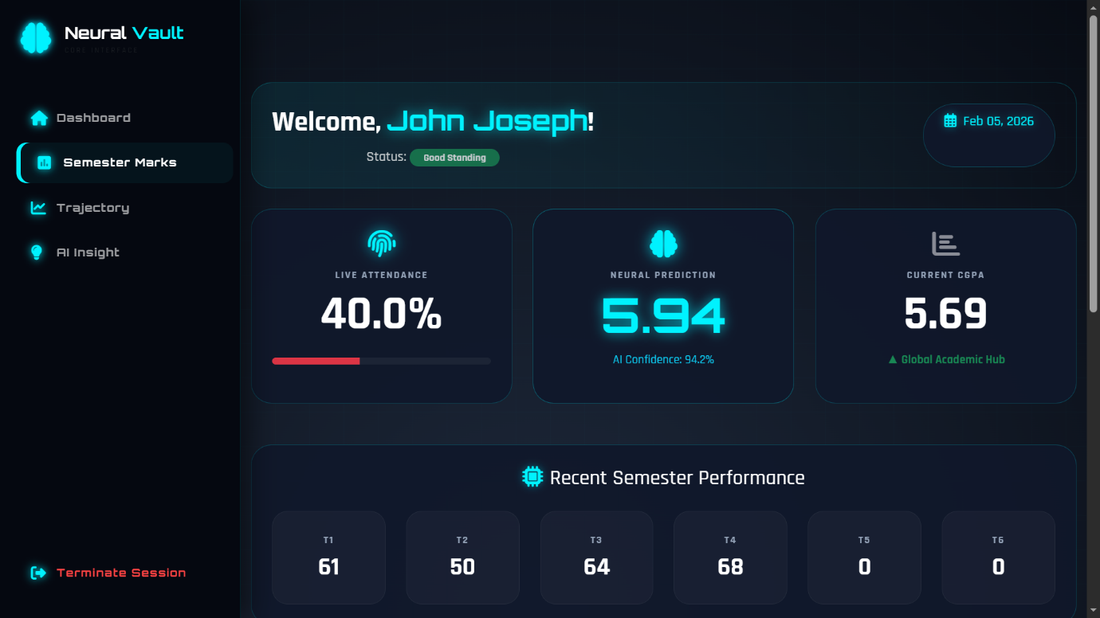

Student Dashboard

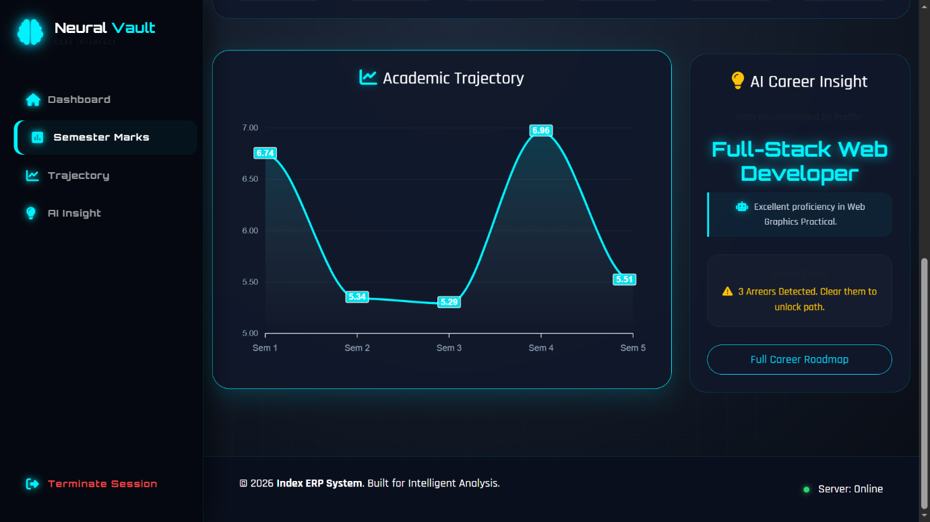

Student dashboard

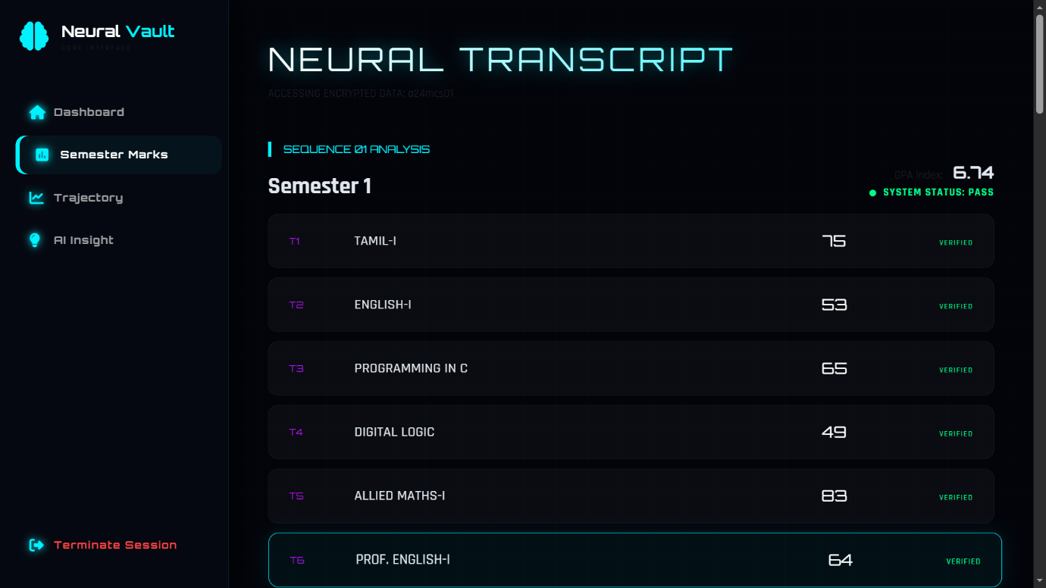

Student marks

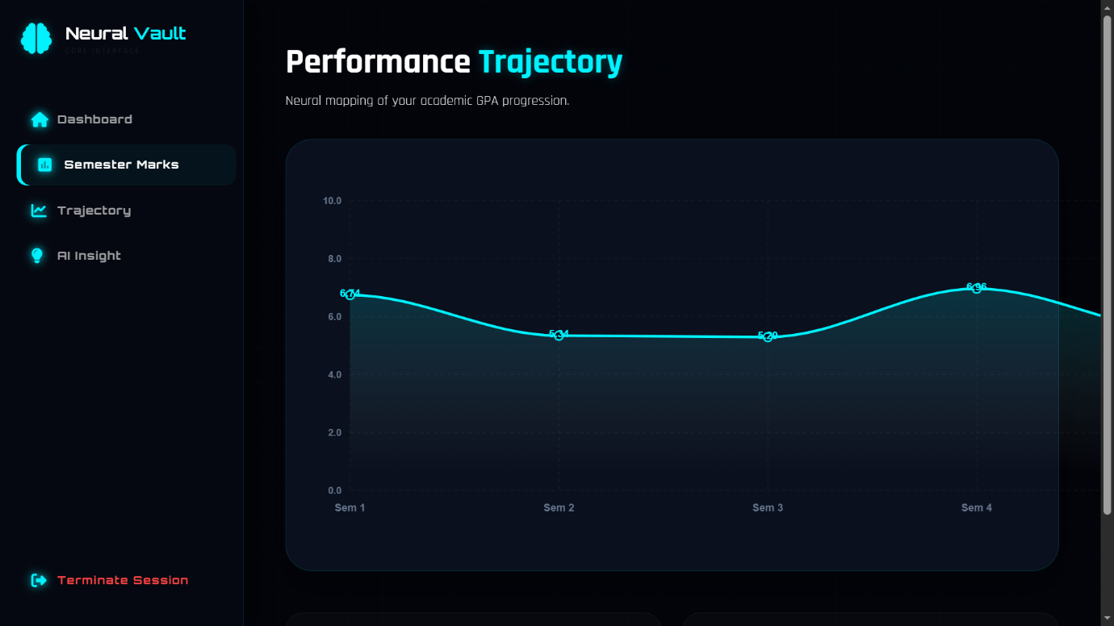

Mark Trajectory

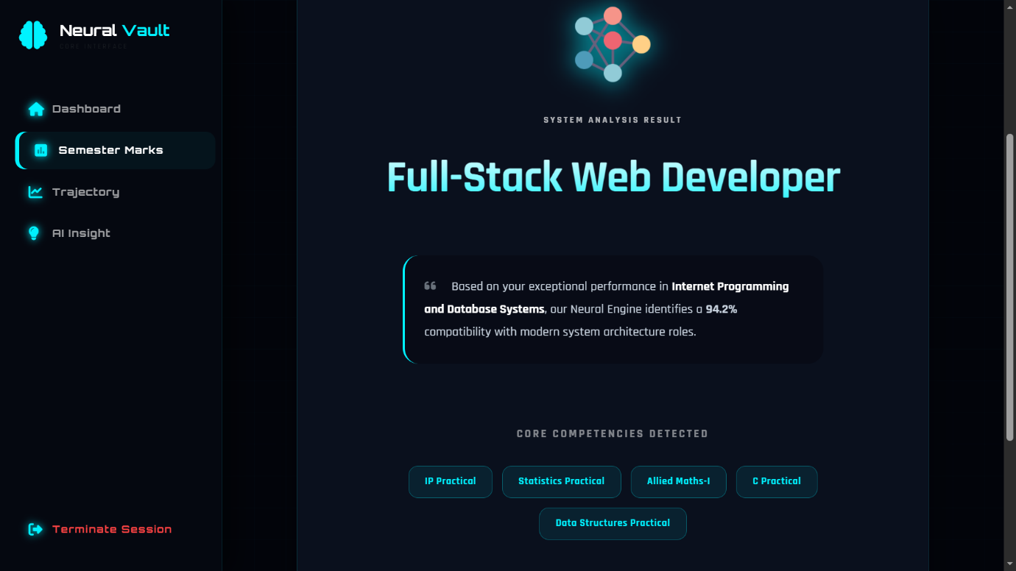

AI Insight



ERP Page

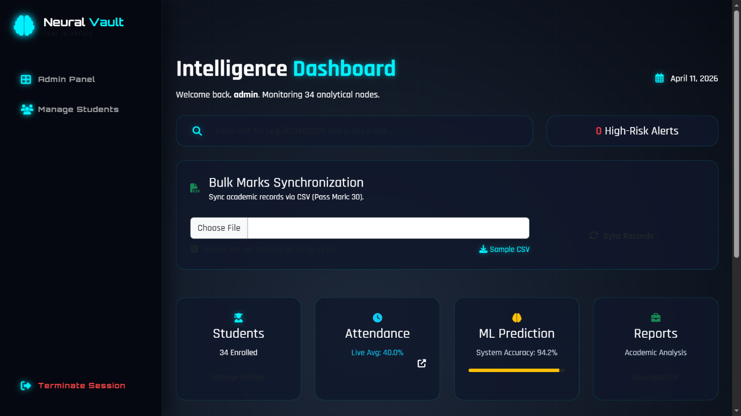

Admin Dashboard

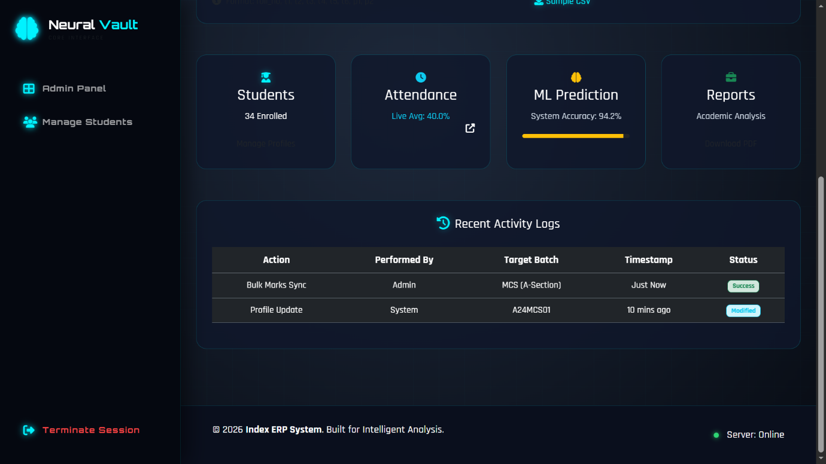

Admin Dashboard

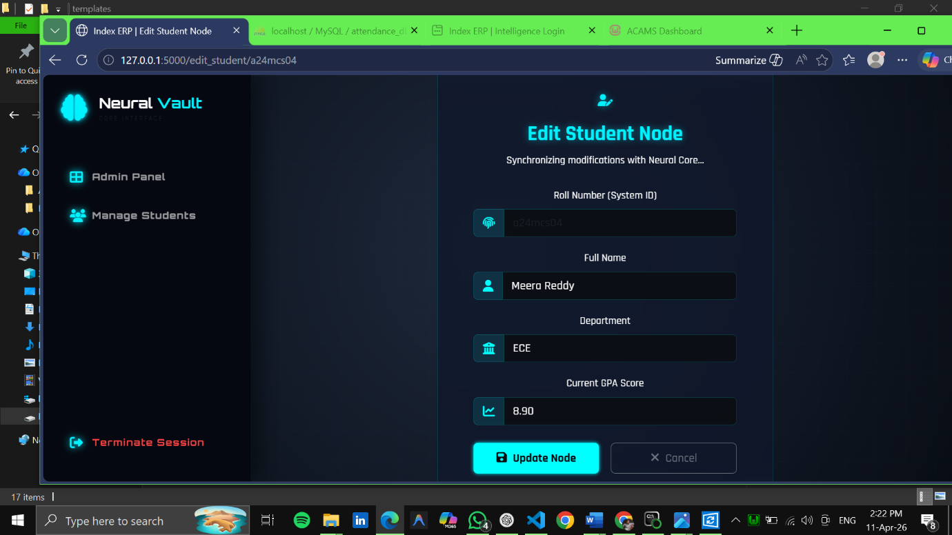

Manage Student page

