**Telemetry**

**Idea.** Application that will show information about selected lap from RaceRoom game. Base on this information user will be able to improve his driving abilities.

**Design.** Application will have two windows:

* General overview will contain information about current time, position, rpm, etc..
* Detailed information will contain information about selected values on graphs. You can also apply values from different laps.

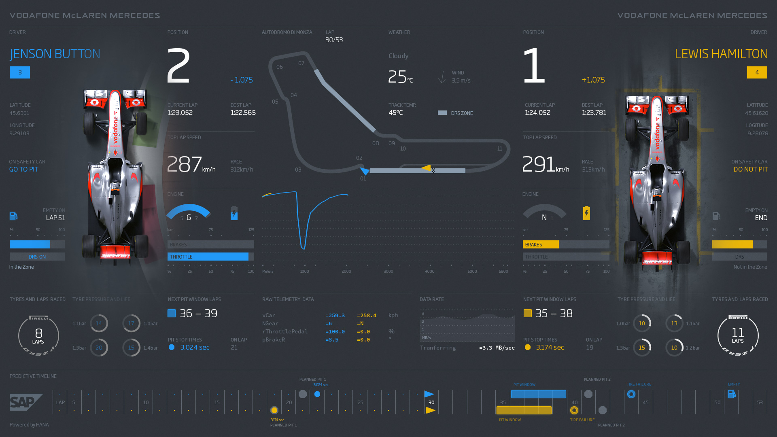

ScanCodes

https://www.millisecond.com/support/docs/v5/html/language/scancodes.htm