Heather Crowder

February 27, 2022

Foundations of Databases & SQL Programming

Assignment 06

SQL Views, Functions, and

Stored Procedures

# Introduction

Once a developer has created a database with tables, the developer or other users will need to utilize the database and tables. In order to allow for data extraction, a Structured Query Language (SQL) select statement can be utilized. These select statements can be saved as a SQL script or in the database file as a SQL view, function or stored procedure.

# Using SQL View

A SQL view is a fancy way to refer to data from a specific select statement. The data from a view is not stored on the hard drive; the select statement is the only aspect saved. Unfortunately, a user cannot prescribe how the data is ordered within a view. However, a top clause can be used to trick the system into determining the order of data results. If using a top clause, you should use an integer and not a percentage. Views can have public and private permissions in order to facilitate access to the appropriate data.

# SQL Views, Functions and Stored Procedures

At first glance, the SQL statements for views, functions and stored procedures look very similar but there are subtle differences in the statements. Figure 1 below shows the SQL statements for the same data but as a view, function and stored procedure. Views, functions and stored procedures are all used as a simpler way to extract data from a database. Views and functions contain select statements while a stored procedure has an execute statement. A function can evaluate into a table. A stored procedure is the most flexible of these three SQL statements. One stored procedure can include multiple update and insert statements.

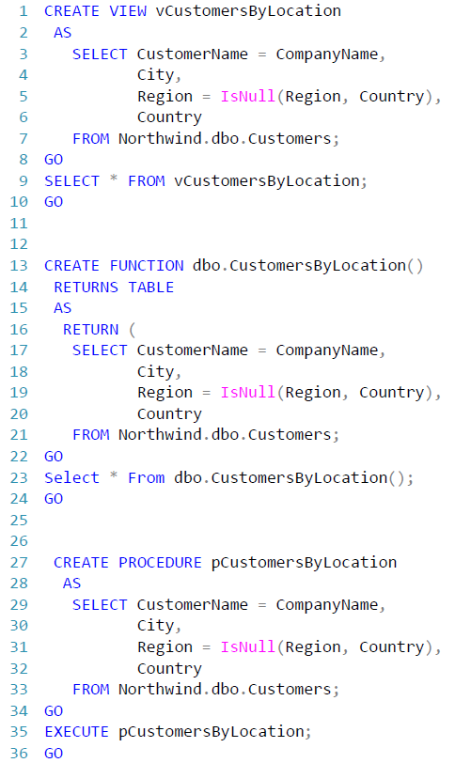

***Figure 1. Sample SQL for a View, Function and Stored Procedure***

# Summary

SQL views, functions and stored procedures are a simple version of complex select statements. A select statement is used in views and functions while a stored procedure has an execute statement. They all display data based on the SQL statements used. Multiple lines of SQL code can be simplified into one line of code.