**Transfers**

When sending items between branches we use P21’s transfers feature. There are three main modules used,

1. Transfer Entry – this is where the transfer is created. Notes regarding the transfer’s method can be changed or viewed from this window
2. Transfer Shipping – this will tell P21 the item is “in transit” to it’s destination
3. Transfer Receipts – finally, tell P21 the item has arrived and is ready to allocate to an order

Just like when items are allocated to an order, when items are put on a transfer, they become allocated for that transfer – which means there is a process to tell P21 where the items are at each step. Before an item can be used at its destination, it must be shipped from the source and received at the destination.

**Creating a Transfer**

1. Open the Transfer Entry module, enter the source and destination locations.
2. A carrier, or delivery method, must be chosen. There are only two used for transfers. One is UPS (Carrier ID 2001) and the other option is “Our Truck” (Carrier ID 2000). Large items or stock items are transferred on our truck once a week (Tuesday) and items needed immediately can be sent with UPS. Only UPS items when it is absolutely necessary. Fill in the method that will be used in “Carrier ID”
3. 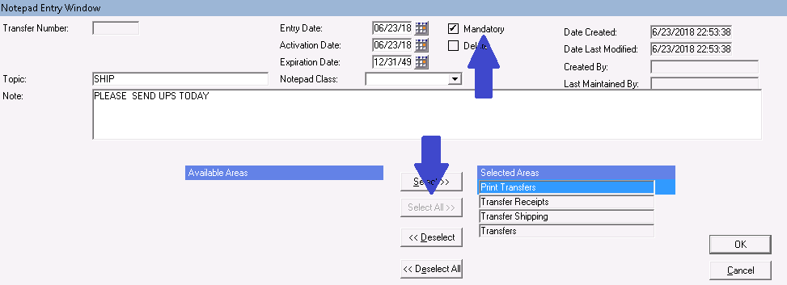 To guarantee your instructions and delivery method are followed you **must** put in a note on every transfer. This must be done for ALL transfers, especially for shipments that must ship the same day. Switch to the Transfer Notes tab and click add note, enter “ship” as the Topic of the note. In the body of the note, enter the method of transportation (UPS or Truck) and any additional instructions. By default, P21 will not make the note visible on printed forms, to correct this choose the “Select All” button below the note/message box. Finally, check the “Mandatory” checkbox and then click OK to save the note.
4. Enter the item and quantity to be transferred
5. 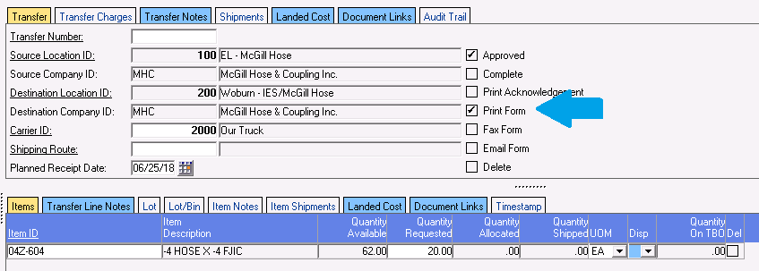Before saving, check the “Print Form” checkbox
6. Clicking Save will bring up a print dialog – this is for the Transfer Form. This needs to be printed at the source location. For East Lomgmeadow (100) the printer is “Shipping”, for Rhode Island (300) use “Broadway Office”

**Shipping a Transfer**

Note: Transfer being shipped UPS have an two additional steps: creating the UPS label and entering the tracking number into the Transfer Shipping module.

1. Pull items on transfer. Always bag and label each item – put as much care and attention into transfers as is done with orders. It is important to let the creator of the transfer know, immediately, if we do not have the stock they requested. The creator of the transfer can be found in the Timestamp tab of the Transfer Shipping module (See “Cancelling a Transfer” to complete the transfer by cancelling it)
   1. If the transfer’s note calls for the transfer to be shipped, bag and box the item – do not tape the box until the end of the day, this way an additional UPS transfer can be added easily. Write the weight and dimensions of the package on the transfer form.
2. In P21, open the Transfer Shipping module, enter the transfer number from the printed transfer form and hit enter.
3. Determine the shipping method and follow any notes for the item or transfer. The creator should have placed a note under the Transfer Notes tab indicating the method, in addition to entering the Carrier ID box. If both sections are empty the creator must be contacted to correct it. Find the creator in the Timestamp tab, next to “Created By”

**\*\*\*\*\*\*ADDITONAL STEPS FOR TRANSFERS SHIPPING VIA UPS CARRIER ID: 2001\*\*\*\*\***

1. If the item has not been packaged from the first step do so now. Do not tape the box until the end of the day, this way an additional UPS transfer can be added easily. Write the weight and dimensions of the package on the transfer form.
2. To reduce shipping costs multiple transfer can be shipped in one box – please verify the transfers have the same destination
3. When an order needs to be shipped UPS to another branch we create the shipping label outside of P21 using a program called UPS World Ship. Inside this program, both branch addresses are saved. If you start typing exactly what is listed in the Ship column on the transfer form, you will see an option to use a saved address. Choose the first one.
4. Some items need to be updated as World Ship saves the information from the last shipment, including old transfer numbers that must be removed before entering the new information:
   1. In the Attention box enter “TRANSFER # ******”
   2. On the right column under Reference #1, show the same information as the Attention box, “TRANSFER # ******”

MODIFIED AREA PIC

1. Now enter package specific information where indicated, dimensions and weight

DIMEMSIONS WEIGHT COLUMN PIC