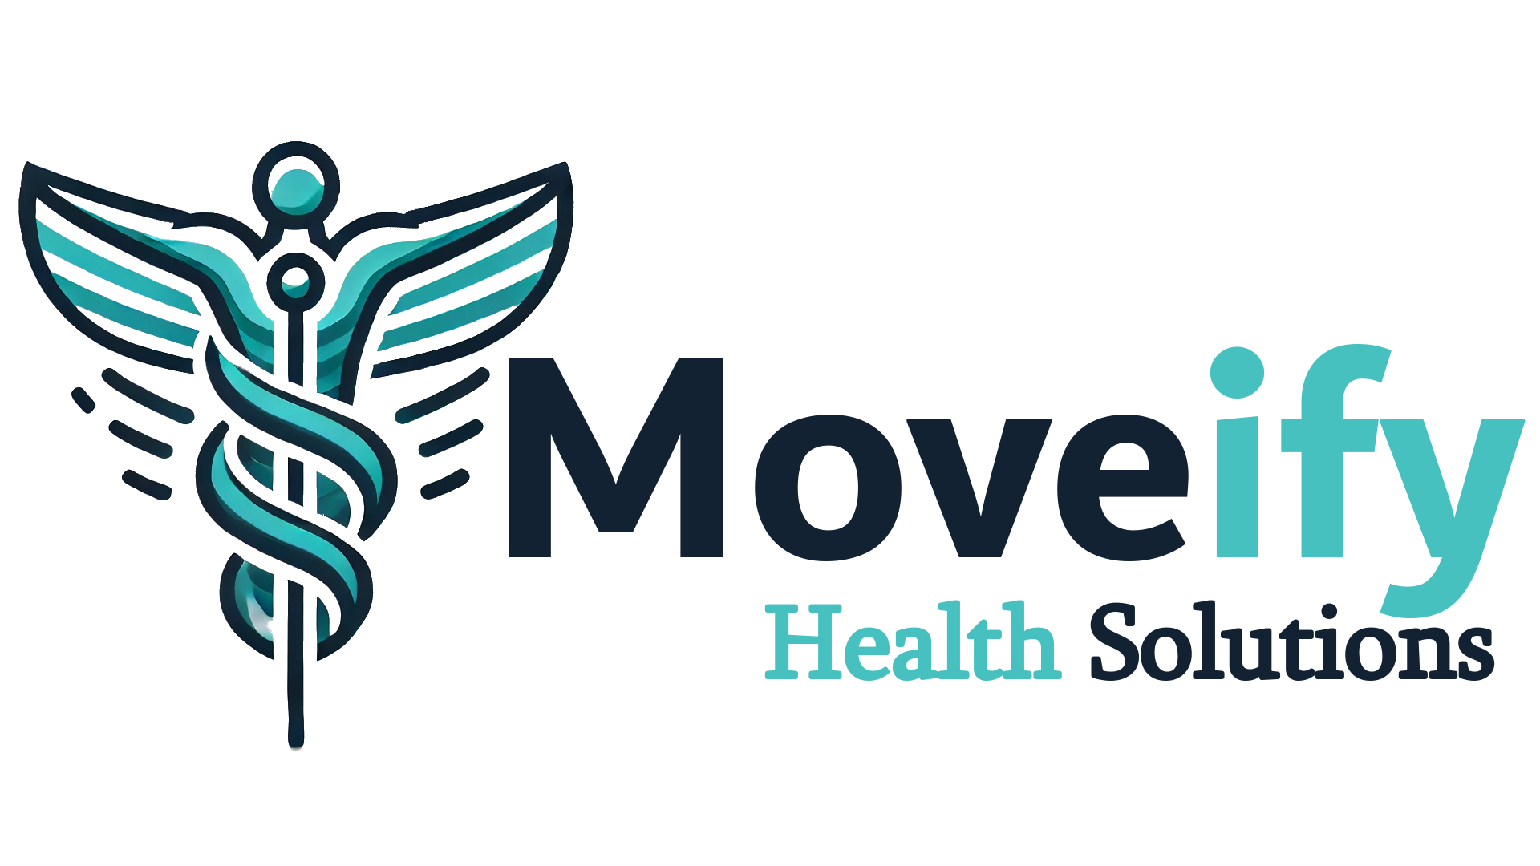 | Exercise Physiology Assessment Summary  {{patient_first_name}} · {{assessment_date}}

1 What We Found
{{what_we_found}}
Assessment Results
Test | Result | Interpretation
{{#oa_rows}}{{test}} | {{result}} | {{interpretation}}{{/oa_rows}}
2 What We'll Focus On
{{what_we_focus}}

Section 3 — Your Options
Treatment Blocks — 6 Weeks
Payment: weekly direct debit over 6 weeks, or pay in full with 5% discount. Includes: unlimited gym access + Moveify app.
Tier 1 — Foundation · $525 ($87.50/week)
60-min program design + 6 group sessions + 30-min reassessment + phone check-in. Medicare offset: up to $123.60 back · net cost from $401.40. Pay in full: $498.75 (5% discount). Best for: stable presentations, general deconditioning, independent patients.
Tier 2 — Progress · $695 ($115.83/week)
60-min program design + 5 × 30-min weekly 1:1s + 30-min reassessment. Medicare offset: up to $309 back · net cost from $386. Pay in full: $660.25 (5% discount). Best for: MSK and chronic disease, patients needing regular clinical oversight.
Tier 3 — Performance · $875 ($145.83/week)
60-min program design + 5 × 45-min weekly 1:1s + 30-min reassessment. Medicare offset: up to $309 back · net cost from $566. Pay in full: $831.25 (5% discount). Best for: complex neuro, cardiac, post-surgical, multi-morbidity.
Not Ready to Commit? Casual Options
If you'd prefer to try a session or two before committing to a block, that's completely fine.
Service | Fee | Details
1:1 Consultation (60 min) | $170 | Full program design or complex consultation
1:1 Consultation (45 min) | $130 | Standard clinical session
1:1 Consultation (30 min) | $85 | Follow-up or program adjustment
Group Session (45-60 min) | $30 | Supervised floor session with your program
Phone Check-in (10 min) | $50 | Brief clinical check-in
Note: if you decide to commit to a treatment block within 7 days of your casual sessions, the fees paid are credited toward your block price.
Section 4 — Medicare and Health Fund Offsets
Medicare CDM Rebates
If you have a Chronic Disease Management (CDM) plan from your GP, you are eligible for up to 5 Medicare-rebated allied health sessions per calendar year. Each eligible 1:1 session earns a rebate of $61.80.
Private Health Insurance
If you hold extras cover, you may be able to claim a rebate on Exercise Physiology sessions. You cannot claim both Medicare and PHI on the same session.
Section 5 — Next Steps
• Choose your program above and let Ryan know today
• If you'd like to take this home and think it over, that's completely fine
• Questions? Call or email: ryan@moveifyhealth.com
Moveify Health Solutions · ryan@moveifyhealth.com · 0435 524 991 · ABN 52 263 141 529 · 4 George St, Williamstown SA

