Create a folder named flask-server

In that create server.py

This will serve as our backend application

Go to the main folder directory

**npx create-react-app client**

* **Here “client” is the name of the app**

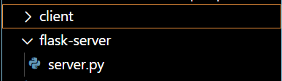

**cd flask-server**

**Create python virtual environment “venv”**

* **python -m venv ./venv**
* **here the second venv is the name of the virtual environment**
* **./venv/scripts/activate.ps1**
* **Command to activate the venv**

**Installing necessary Libraries in python**

* **pip install flask**

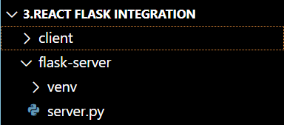

**Type the code in server.py**

from flask import Flask , redirect

app = Flask(__name__)

# Members API Route

@app.route("/")

def home():

    return redirect("/members")

@app.route("/members")

def members():

    return {"members" : ["Members1", "Members2","Member3"]}

if __name__ == "__main__":

    app.run(debug=True)

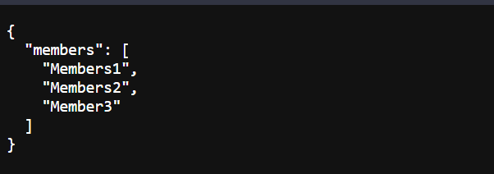

**Open the reactjs “client” folder and go under src**

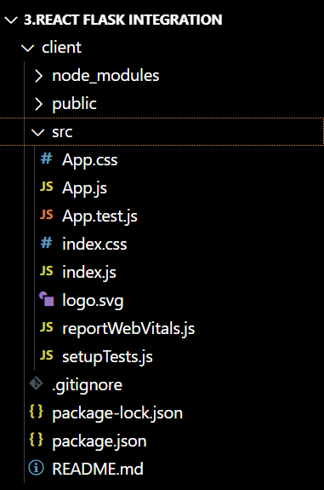

**Remove the following unnecessary files**

* **app.test.js**
* **index.css**
* **logo.svg**

**from index.css remove the following line**

import './index.css';

**MOST IMPORTANT PART**

* **go to package.json**

**you will see the following code**

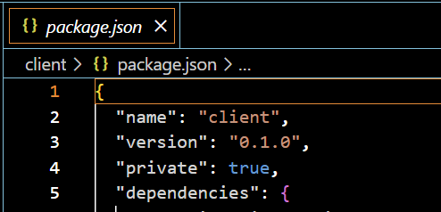

**Add this code**

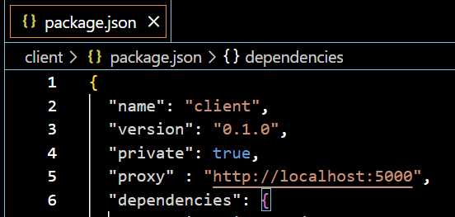

**Go to app.js delete all code**

* **use rfce shortcut**
* **to get this code**
* 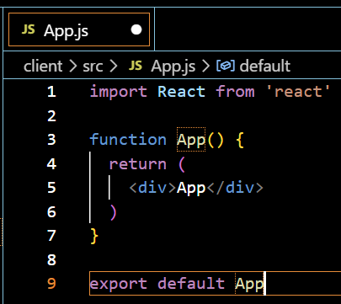
* **Just add 2 lines {useState,useEffect}**
* 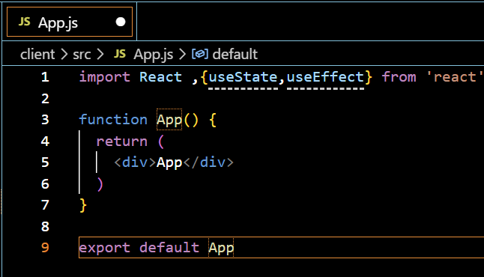

**Passing data from from flask backend to react frontend**

* const [data,setData] = useState([{}])
* using the setData function to pass the data from server api “/members”
* data variable
* This is the function I have used

**const [data,setData] = useState([{}])**

**useEffect(() => {**

**fetch("members").then(**

**res => res.json()**

**).then(**

**data => {**

**setData(data)**

**console.log(data)**

**}**

**)**

**}, [])**

**If you are still facing an issue change code in python server.py**

**app.run(debug=True , host = "0.0.0.0" , port = 5000)**

**Now check if localhost from flask is present by**

* **cd client**
* **npm start**
* **open a different terminal then cd flask-server**
* **python server.py**

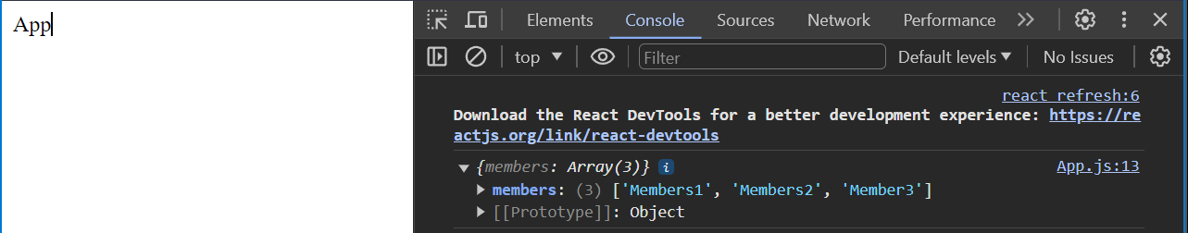

**Congrats task1 achieved rendering data from flask backing to react backend using api call**

**Now moving on to Task 2 ( Rendering elements from react Backend to frontend )**

**In the div section add this code**

**{(typeof data.members === "undefined") ? (**

**<p>Loading...</p>**

**) : (**

**data.members.map((member, i) => (**

**<p key={i}>{member}</p>**

**))**

**)}**

