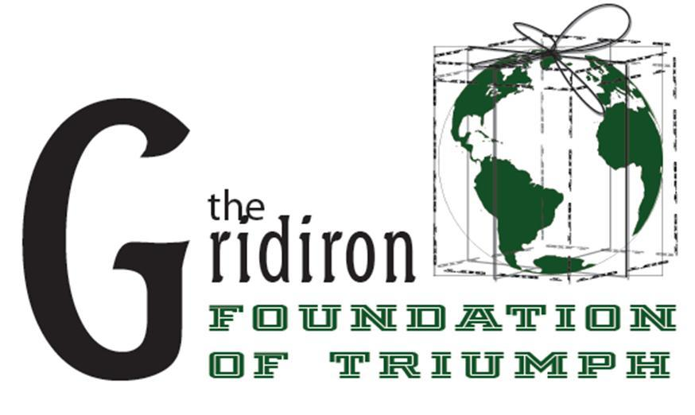

PO+COM

POLICE+COMMUNITY

Founded by former Miami Dolphin and CEO of The G.I.F.T., Alphonso Roundtree, Po+Com is a pro-active approach to addressing the void between law enforcement and the community. In Po+Com the police and community come together in an effort to build rapport and unite in light of the recent incidents involving both parties using sports as the means to bridge the gap.

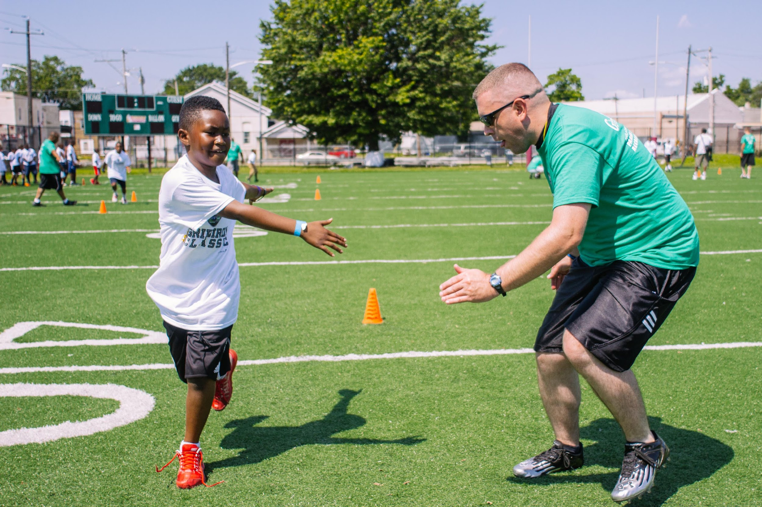

Po+Com give both groups an opportunity to meet where they are. Police officers will reach out to the community through the school system. Officers and their respective precincts from around the city will team up with a school and students to participate in a variety of fun sports and activities together. The officers will go to the schools regularly to practice with the selected students (at risk youth), learn about them and mentor them.

All of the practices and relationship building will culminate at the (Yet To Be Named) “Tournament of Champions” where all of the schools and police officers participating in Po+Com will compete in the sports and activities that they have been preparing for. The officers and the community is encouraged to bring their families for everyone to join together in this day of fun.

Alphonso Roundtree

Former Miami Dolphin

CEO, The G.I.F.T.

aroundtree@thegridironclassic.com

813.325.9719

Thank You!