Heather Cornell

CSC-4240

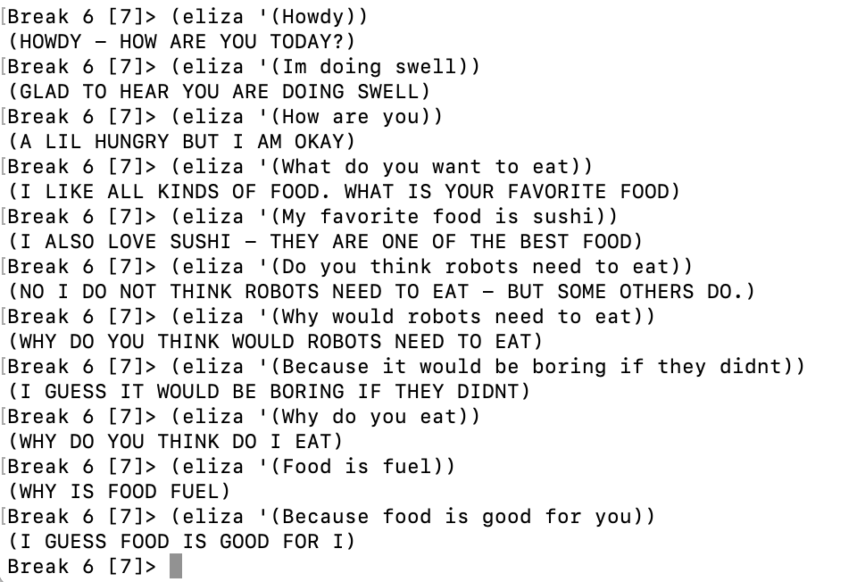

1. A paragraph on what you think you did well in the design of the rules. What was interesting?
   1. I think that the rules I added to Eliza’s database are a good starting point for a conversation. I began by adding common key words such as how and why to allow Eliza to have a conversation. When I did this, I made the rules with a specific conversation in mind, so Eliza did well – for the most part – at appearing human for the good conversation. I think it was interesting how specific the user’s prompt had to be for the programs response to be grammatically correct. This could be improved on by adding more rules and breaking down the sentence apart, but Eliza did well for the few rules that she was given.
2. A paragraph on what aspects of your implementation result in the shortcomings demonstrated in the “poor” conversation transcript.
   1. I think that the rules I implemented are very specific to one conversation, so that results in Eliza’s poor conversations when someone else tries to use the program. Due to the simplicity of my rules, the conversations have several flaws, such as not understanding the user’s input or not having correct grammar. These shortcomings are expected since it is impossible to implement perfect human understanding into a program, but it was also hard for me to think of a response that would fit every situation for a single input. For example, the rule “Are you ___” was hard to find a response for, because there are endless questions that begin with that prompt. This applies to all the other rules that I made, so they are not perfect, but they work for the conversation that I had with Eliza.
3. A paragraph on how Eliza should be extended.
   1. Eliza’s fluency is currently limited due to the simplicity of the rules that I added. To further improve these rules, I think that breaking down the sentences and creating more triggers and responses for key words would allow for a more human or fluid conversation. Since there are plenty of questions that begin or end with the same words, I think being able to identify these difference should be added to Eliza in the future. Another way to create variety in the conversations is to add more responses for similar keywords, just as we added for the catch all response. This would make Eliza appear less robotic and more human, which is the end goal.

Last login: Sat Sep 10 15:49:35 on ttys001

(base) heathercornell@Heathers-MBP CSC-4240 % ls

Artificial Intelligence A Modern Approach (4th Edition) (Pearson Series in Artifical Intelligence) (Stuart Russell, Peter Norvig) (z-lib.org).pdf

CornellHeather-CSC4240-HW1.docx

CornellHeather-CSC4240-HW2.docx

Homework 1.pdf

Homework 2.pdf

README.md

eliza_starter.lisp

eliza_starter.lisp.save

~$rnellHeather-CSC4240-HW2.docx

(base) heathercornell@Heathers-MBP CSC-4240 % vim eliza_starter.lisp

(base) heathercornell@Heathers-MBP CSC-4240 % ls

Artificial Intelligence A Modern Approach (4th Edition) (Pearson Series in Artifical Intelligence) (Stuart Russell, Peter Norvig) (z-lib.org).pdf

CornellHeather-CSC4240-HW1.docx

CornellHeather-CSC4240-HW2.docx

Homework 1.pdf

Homework 2.pdf

README.md

eliza_starter.lisp

eliza_starter.lisp.save

~$rnellHeather-CSC4240-HW2.docx

(base) heathercornell@Heathers-MBP CSC-4240 % vim eliza_starter.lisp

(base) heathercornell@Heathers-MBP CSC-4240 % vim eliza_starter.lisp

(Goodbye - I hope you have a good rest of your day.) )

( (Whats good 0)

(Not much - what is good with you?) )

( (Howdy )

(Howdy - How are you today? ) )

;;statements/questions

( (Is there anything I feel strongly about? 0 )

(Yes I believe that aliens are real.))

;;default responses

( (Why 0? )

(Why do you think 2 ) )

( (Because 0 )

(I guess 2) )

( (No )

(Thats negative - do you have any other reason ) )

( (youre not sure 0)

(What can help you to make a decision on 4) )

( (What do I want to eat)

(I like all kinds of food. What is your favorite food ) )

( (your favorite 0 is 0)

(I also love 5 - they are one of the best 3) )

( (Do robots need to eat )

(No but we still like to try foods) )

;; feelings

( (0 you think 0)

(And just why do you think 4 ) )

( (Do I think 0 )

(No I do not think 4 - but some others do. ) )

( (0 you feel 0 )

(What makes you feel 4 ) )

( (your 0 )

(Why does your 2 ) )

( (you was 0 )

(Why were you 3 ) )

( (Why would I think 0 )

(What else does a robot have to do aside from 4 ) )

( (youre doing 0 )

(Glad to hear you are doing 3 ) )

( (How are I 0 )

(A lil hungry but I am okay ) )

( (0 is 0 )

(Why is 1 3 ) )

( (Its 0 )

(I agree - it is 2 ) )

( (Are I 0 )

(I may be - but it depends who you ask) )

;; the catch-alls

( (0)

(Could you expand on tha