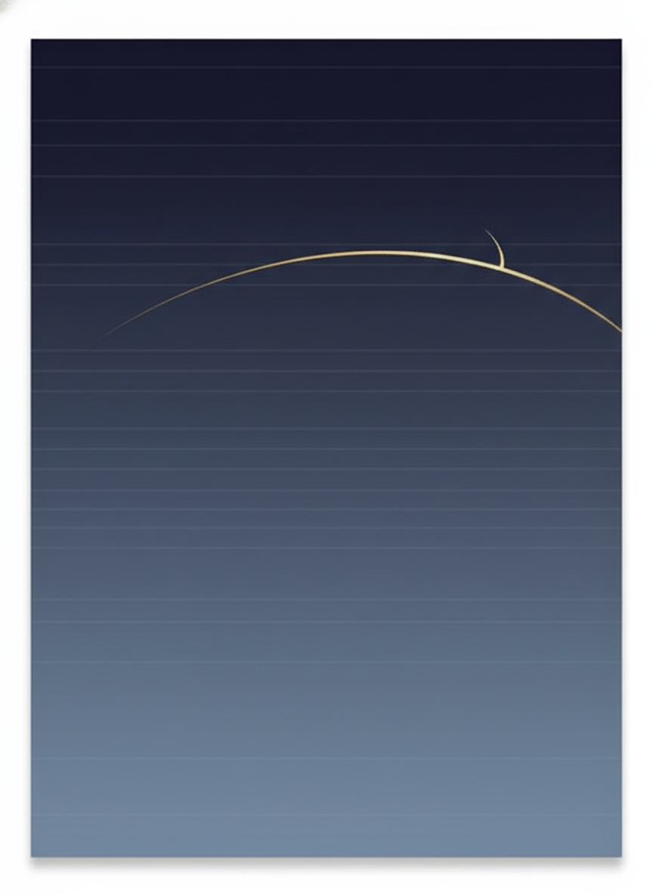

DIPLOMATIC WORKING DOCUMENT
Minimal Memorandum
of Understanding
Pertaining to PEACE
A Minimum-Viable Stabilization Instrument
United States - Islamic Republic of Iran
Version 1.0 | June 2026 | Immutable Present-Tense Edition
AUTHORIZED NEGOTIATORS ONLY - CONFIDENTIAL

Preamble
The United States of America and the Islamic Republic of Iran (each a "Party," together the "Parties"), convening under the auspices of the Islamic Republic of Pakistan as mediator and the Sultanate of Oman as co-facilitator, with verification by the International Atomic Energy Agency,
RECOGNIZING that the present stockpile of highly enriched uranium and the disruption of transit through the Strait of Hormuz together constitute the central risks to regional and global stability;
AFFIRMING Iran's sovereign right to peaceful nuclear energy under Article IV of the Nuclear Non-Proliferation Treaty;
PROCEEDING under the principle of Synchronized Reciprocal Motion, by which no Party moves first and every obligation pairs with a verified, proportional counterpart;
THE PARTIES AGREE as follows, intending to be bound by this Memorandum on signature.

Executive Summary
This Memorandum creates a 365-day stabilization framework between the United States and Iran. Iran caps its enrichment at 3.67%, places its HEU stockpile under IAEA dual-key custody, and opens the Strait of Hormuz to unrestricted transit. The United States deposits $500M in neutral escrow (released at Day 30 on verification), stages the release of frozen assets on a front-loaded schedule, allows oil exports up to 2.1 million barrels per day, and lifts its naval blockade starting Day 7. Nobody moves alone, nothing is unconditional, no cash changes hands on Day 1, and either Party walks an orderly exit ramp on 14 days' notice. Penalties are graduated and reversible - step-back on violation, earn-back on compliance. No automatic snapback. No automatic military escalation.

Article 1 - Key Definitions
Term | Meaning
HEU | Uranium enriched to 20% U-235 or above. Baseline: ~440-500 kg at ~60% U-235 per IAEA safeguards report, updating automatically.
Dual-key custody | Storage under two independent locks - one IAEA, one U.S.-designated - so neither Party opens the store unilaterally.
Step-back / earn-back | Graduated, reversible penalty: benefit reduces in proportion to a violation; restores fully on verified remediation and sustained compliance. Replaces snapback.
PRDD | Petroleum Revenue Direct Deposit: the Swiss-escrow channel crediting oil revenue to Iran's Central Bank on verified compliance.
Mirror Pairing | A Day-1 pair in which a U.S. action and an Iranian action of equal weight execute simultaneously.
JIG | Joint Implementation Group: the single compliance and dispute body in Geneva.
MSB | Maritime Stability Board: the advisory body in Muscat; no governing or revenue power.

1.8 No Misuse of Framework Data
No access, telemetry, monitoring feed, escrow record, or other data generated under this Memorandum serves intelligence collection, internal political disruption, or regime-change activity directed at either Party. A verified violation classifies as a Tier-3 deliberate hostile violation.

1.9 No Unilateral Reinterpretation
Neither Party unilaterally reinterprets any provision of this Memorandum in a manner that materially alters its obligations or the other Party's benefits.

1.10 Domestic Framing Autonomy
Each Party describes this Memorandum to its own public in its own terminology. Neither Party requires the other to adopt specific labels such as concession, surrender, or victory. Joint statements use only mutually agreed technical language.

Article 2 - Day-1 Mirror Pairings
On the hour of signature, four pairings execute together. No cash changes hands on Day 1. If any pairing fails, all suspend until the failure remedies - the non-severability rule that protects both Parties.
Pairing | United States | Iran
1 | $500M placed in Swiss-Omani escrow (released Day 30 on IAEA certification) | Enrichment cap posted at 3.67%; entire HEU stockpile under IAEA dual-lock
2 | OFAC General License for frozen-asset and escrow transfers | IAEA inspector access confirmed; border crossing open
3 | Oil-export normalization permits issued | IRGC-Navy small-craft withdrawal from commercial corridor
4 | SWIFT reconnection for two designated Iranian banks | 24/7 maritime deconfliction hotline staffed

Article 3 - Nuclear Stabilization Core

3.1 The Enrichment Cap and Moratorium
Enrichment caps at 3.67% U-235 from Day 1. No new centrifuge capacity installs during the moratorium. HEU production stops. The moratorium runs twelve years. A verified IAEA finding of enrichment above 3.67% extends the moratorium automatically by twenty-four months per incident, up to a cumulative cap of twenty-five years. A clean record shortens nothing below twelve years; a violation only lengthens.

3.2 Disposition of the HEU Stockpile
The 60% stockpile neutralizes under verified custody on Iranian soil. The default is in-country downblending: Pathway A activates automatically at Day 180. Pathway W (irreversible fertilizer conversion) activates automatically at Day 730 as the final back-stop. Iran retains the right to select Pathway W at any time as a unilateral decision, without U.S. concurrence, on 14-day advance notification to the JIG and IAEA clearance.
No U.S. custody, no U.S. soil: The United States never receives, stores, or exercises direct physical custody over Iranian uranium. The IAEA is the custodian; the U.S.-designated agent holds only the second key. A U.S. observer accesses an IAEA custody facility only on Iran's explicit, revocable, per-visit written consent. Each visit is a fresh sovereign permission.

3.3 Centrifuge Production Ban
Iran does not manufacture, assemble, or install any new centrifuge rotor or cascade component during the term of this Memorandum. The IAEA verifies compliance through quarterly inspections. A verified violation classifies as Tier-2 material disruption under Article 7.

Article 4 - Maritime Stabilization Core

4.1 Freedom of Navigation
The Strait of Hormuz reopens to unrestricted commercial transit. No vessel is halted, boarded, delayed, or denied passage for any reason related to fees, tolls, or management authority. No Party levies a toll, checkpoint, or transit charge.

4.2 Sovereign Coastal Statement
Nothing in this Article prejudices Iran's position as a coastal state under international law. This statement delegates no operational authority over the transit corridor to Iran; it records a sovereign position, not a management power.

4.3 Synchronized Blockade Lift
On Day 7, the dual blockade lifts in reciprocal choreography: as Iran clears mines and withdraws small craft, the United States and coalition forces stand down the naval blockade in proportion. Mine-clearing proceeds jointly or through Oman, verified by the MSB.

4.4 Non-Interdiction and Backdoor Closure
Commercial transit operates under an absolute non-interdiction protocol: no vessel is halted, boarded, or denied passage over a fee dispute. The Backdoor-Closure protocol classifies any pretextual safety inspection against a bright-line test, activates U.S. escort override, and imposes an automatic $10M penalty for a repeat interdiction. Humanitarian transits run zero-toll because no toll exists at all.

4.5 Service Reimbursement
A Multilateral Maritime Maintenance Fund, administered by Oman, reimburses Iran for verified services at audited rates: strait monitoring (per-vessel), mine-sweeping (per kilometer), environmental response (per incident), search-and-rescue (monthly retainer). These are service reimbursements, not tolls. No vessel is delayed for non-payment.

4.6 Force-Posture Stand-Off
The U.S. naval stand-off - no patrols within five nautical miles of the transit corridor - triggers only on IAEA confirmation that HEU consolidation has begun, not on signature alone. De-escalation is tied to verified action, not promises on paper.

Article 5 - Economic Normalization Core

5.1 The Escrow Principle
Value moves through a neutral Swiss escrow agent in Zurich, never as a direct U.S. transfer. Every release is reversible and compliance-gated. The escrow operates under sovereign immunity. Assets held in escrow are not subject to attachment, lien, or seizure by third parties.

5.2 Mutual Escrow Deposit and Frozen-Asset Release
$500M sits in the Swiss-Omani escrow on Day 1; it releases to Iran on Day 30 on IAEA certification of verified custody and the 3.67% cap. Frozen sovereign assets follow this front-loaded schedule:
Tranche | Day | Amount | Trigger
1 | Day 30 | 15% | 30 days of compliance + IAEA certificate
2 | Day 60 | 15% (cum. 30%) | 60-day compliance certified
3 | Day 180 | 15% (cum. 45%) | Disposition milestone certified
4 | Day 360 | 20% (cum. 65%) | Sustained compliance at one year
Final | Month 24 | 35% (cum. 100%) | 24 months sustained compliance
Every tranche before the final tranche is reversible under Article 7. Humanitarian-badged disbursements pass a one-way firewall and never reverse.

5.3 Oil-Export Normalization and PRDD
Iran exports up to 2.1 million barrels per day to whitelisted purchasers. Oil revenue flows to the Central Bank of Iran through the PRDD Swiss-escrow channel, weekly, beginning at downblending commencement. Revenue is graduated step-back governable - never an automatic cut-off.

5.4 Early Humanitarian Acceleration
As early as Day 7, the JIG issues a Humanitarian Acceleration Certificate releasing $250M into a restricted humanitarian-only sub-account, provided the IAEA confirms HEU is under dual-lock, the Strait is mine-free with commercial transit for 72 hours, and no Tier-2 violation has occurred. Funds serve only medicine, food, and medical equipment; they are non-reversible once disbursed.

5.5 SWIFT Reconnection
Two designated, non-IRGC-affiliated Iranian banks reconnect to SWIFT as early as Day 45, conditional on IAEA confirmation of dual-lock custody, no enrichment above 3.67%, and the Strait open for 30 consecutive days. The Central Bank and remaining major banks follow on later milestones. An OFAC General License covers escrow transfers and correspondent banking.

5.6 Political Discretion Fund
A $50M Political Discretion Fund sits outside the milestone schedule and outside step-back. It disburses only by unanimous heads-of-government decision for confidence-building. An early $10M tranche is available at Day 45 on foreign-minister concurrence.

5.7 Agricultural Green Lane
Iran exports agricultural products - pistachios, saffron, dates, caviar, dried fruits - without case-by-case OFAC licensing, through a dedicated green lane with no volume cap. Revenue flows through PRDD with 100% monthly release.

5.8 The Joint Disposition Fund
A $1B Joint Disposition Fund, contributed equally by both Parties, rewards verified progress on stockpile disposition. Iran draws on the Fund as milestones verify. The Fund makes a mutually acceptable disposition the financially advantaged choice for both sides.

Article 6 - Verification and Compliance

6.1 The IAEA Spine
The IAEA verifies the nuclear file end to end: baseline inventory by mass spectrometry, continuous dual-key camera monitoring, tamper-evident seals, real-time mass-flow verification, and independent isotopic sampling every 72 hours. The IAEA issues the certificates that gate each relief tranche. Batch telemetry from breakout-relevant facilities delivers on a mandatory 24-hour cycle.

6.2 Human-in-the-Loop
Automated detections route through human review before any escalation beyond an advisory log. A no-surprises notification protocol requires advance notice of anticipated deviations, converting potential breaches into managed corrections.

6.3 The Step-Back / Earn-Back Ladder
Enforcement runs through a graduated, reversible ladder. A violation reduces benefit in proportion to its severity; verified remediation and sustained compliance earn it back in full.
Tier | Classification | Benefit Effect | Remediation
1 | Technical dispute (de minimis) | No reduction; confidential handling | 14-day resolution; no penalty
2 | Material disruption (enrichment >0.5% above cap >48h; access denial <72h) | 10-25% reduction in non-humanitarian benefits; humanitarian protected | 30-day remediation; full restoration after 14 clean days + IAEA cert
3 | Deliberate hostile violation (enrichment >3.67%; inspector attack) | 25-50% reduction; non-humanitarian modules on hold | 90-day remediation; full restoration after 90 clean days + JIG confirmation
4 | Force majeure (natural disaster; third-party attack) | Protected; humanitarian and oil flows continue | Stabilization hold; no penalty
Tier 2: less than 7 days = 10% reduction; 7-14 days = 15%; 15-30 days = 25%. Tier 3: first 72 hours = 25%; after 72 hours = 35%; after 30 days = 50%. Earn-back: Tier 2 after 14 consecutive clean days post-remediation; Tier 3 after 90 clean days. A pattern of three occurrences of the same error type within 60 days graduates to the next tier.
No Tier consequence reaches already-released humanitarian funds, the humanitarian corridor, or medical-isotope shipments.

6.4 Human-in-the-Loop - No Automated Penalties
Every Tier-2 and Tier-3 determination requires prior consultation between senior officials at minister level or above, within a 48-hour cooling-off period. No penalty accrues during that period. For Tier-3, the cooling-off includes a direct foreign-minister consultation. No penalty takes effect until that consultation completes.

6.5 Automatic Suspension for Monitoring Failure
If IAEA telemetry from a breakout-relevant facility goes unavailable for 48 consecutive hours (other than scheduled, notified maintenance), all sanctions relief auto-suspends - no human veto, no consultation window. Releases resume in full the moment the IAEA certifies monitoring restored. Distinct from the step-back ladder, this clause addresses the verification blackout itself.

6.6 Over-Compliance Credit
When Iran completes a milestone ahead of schedule and sustains compliance, the corresponding tranche releases earlier, and unused credit banks for future acceleration. Credits never expire during the term of this Memorandum.

Article 7 - Safety Valves

7.1 The Learning Curve (Days 1-30)
Days 1-30 are a learning period. Tier-2 penalties halve; Tier-3 issues are advisory only. Expected errors - reporting delays up to 24 hours, positioning variances up to 20%, hotline delays up to 30 minutes - are protected and logged, not penalized. Normalization phases in over Days 31-44 with no cliff.

7.2 Safety-Valve Menu
Mechanism | Effect | Limit
Grace Day | Defers an obligation 24 hours | 3 per stage; 6h notice
Face-Saving Pause | 7-day deferral; auto-proceeds | 2 per 30 days; 24h notice
Quiet Correction Window | 72 hours to remedy a Tier-2/3 issue with no mark | Good-faith presumption
Crisis Pause | 30-90 day operational freeze without penalty | Once per 180 days; humanitarian and oil continue
Exit Ramp | Orderly 14-day withdrawal | Either Party; humanitarian and oil continue

7.3 Automatic Dampening
Any Tier-2 or Tier-3 event triggers a 48-hour dampening window: offensive operations suspend, the hotline goes to triple watch, the JIG convenes within eight hours. Humanitarian transit, released funds, oil in transit, IAEA access, and hotline operations are irreversible protections throughout.

7.4 Rolling Horizon and Clean-Break Withdrawal
Either Party withdraws on thirty days' written notice as a clean break: a capped exit payment of $500M settles outstanding obligations, and no clawback of already-released funds occurs. Withdrawal is an orderly door, not a trap.

7.5 No Automatic Military Escalation
Under no circumstances does a compliance dispute, Tier-2 or Tier-3 violation, step-back penalty, or framework suspension automatically authorize, trigger, or justify the use of military force by either Party. Military action requires a separate, explicit decision by the respective head of government under constitutional procedures. This separation is absolute and non-waivable.

7.6 Force Majeure
Either Party invokes force majeure where a regional conflict materially prevents compliance, suspending non-core obligations for up to sixty days. Core obligations never suspend: nuclear custody, freedom of navigation, and humanitarian flows continue.

7.7 Partial Success Doctrine
No single unresolved track invalidates the remainder. The nuclear, maritime, and economic tracks are independent. Progress banks where it is made, and a localized failure stays localized.

7.8 Crisis Contacts
Each Party designates primary and secondary around-the-clock crisis contacts. The JIG tests contacts monthly at 06:00 UTC; three consecutive failures to respond within 30 minutes constitute a Tier-1 technical dispute.

7.9 Wartime Protocol Sunset
Any wartime-entry provision sunsets automatically 180 days after entry into force, unless the JIG unanimously extends a specific provision for 90 additional days.

Article 8 - Governance
The Joint Implementation Group (JIG) in Geneva is the single compliance and dispute body. Both Parties sit; it operates by consensus. The IAEA in Vienna is the sole technical verification authority. The Maritime Stability Board in Muscat is advisory only - it coordinates traffic and safety but holds no governing, regulatory, or revenue power. The Swiss-Omani Escrow Agent (Zurich / Muscat) holds and releases all financial value on verified milestones.

Article 9 - What Each Side Concedes and Wins

9.1 The United States
Gains | Accepts
Default disposition neutralizes material in-country under joint dual-key, ending in downblending or irreversible fertilizer; 3.67% cap; 12-year moratorium | The material stays on Iranian soil under joint dual-key lock unless Iran elects the Oman lane
Unrestricted freedom of navigation; zero tolls; no Iranian checkpoints or management authority | Iran's coastal-state position acknowledged; reimbursement for verified strait services
No cash on Day 1; $500M escrowed and released only at Day 30; assets reversible until the end; 14-day exit ramp | Co-funding a $1B Joint Disposition Fund and a $50M discretionary fund
No reparations; no legal linkage of Hormuz to regional fronts; third-party action cannot breach the deal | A region-wide humanitarian ceasefire and a scheduled door to regional talks

9.2 Iran
Gains | Accepts
Oil at 2.1 mbpd; SWIFT restored; $500M at Day 30; assets to 100% by Month 24; $1B disposition fund; $50M discretionary fund | Binding 3.67% cap and 12-year moratorium effective Day 1; no cash on Day 1
Unilateral right to keep material in-country under dual-key custody with no U.S. veto | Continuous IAEA and U.S.-designated dual-key access
Coastal-state position acknowledged; reimbursement for verified strait services; framing autonomy | Unrestricted freedom of navigation; zero tolls; no management authority over the corridor
Step-back / earn-back instead of snapback; good-faith fast lane; safety valves | Front-loaded but reversible asset schedule; in-country default ends in dual-key downblending or irreversible fertilizer by Day 730

Article 10 - Duration and Review
This Memorandum remains in force for 365 days from signature. Either Party extends the term by mutual written consent. Either Party withdraws on thirty days' written notice. On withdrawal, the clean-break provisions of Article 7.4 apply.
Nothing in this Memorandum creates a presumption about any follow-on agreement. Both Parties retain full sovereign negotiating positions for any subsequent instruments.

Article 11 - Entry into Force, Depositary, and Signature
This Memorandum enters into force on signature by the authorized representative of each Party. Executive authority suffices. The Islamic Republic of Pakistan serves as depositary; the Sultanate of Oman as co-depositary.
The Annexes identified below enter by reference on the date each specifies. Where an Annex and this Memorandum differ, the more specific Annex provision governs.
The present-tense, mutual-architecture construction governs the interpretation of every clause: each obligation is a live operational reality of the shared framework, binding both Parties equally.

Annex Register
The Parties adopt the following Annexes as integral and operative parts of this Memorandum:
Annex | Title | Function
N | Non-Interdiction and Maritime Transit Integrity | Removes any authority to halt a vessel over a fee dispute
N.a | Maritime Backdoor Closure | Automatic classification, escort authority, financial penalties for pretextual interdiction
T | Adaptive Stabilization and Compliance Resilience Matrix | Sectoral firewalls, step-back mechanics, verified earn-back procedures
Y | Dual-Key Custody Protocol | Single sealed store, two independent locks (IAEA + U.S.-designated), live feeds, joint-supervised isotope use only
Z | In-Iran Transformation Pathways (A and W only) | Pathway A (in-country downblending) and Pathway W (fertilizer) - the two defaults

Signature
The undersigned, duly authorized, sign this Memorandum into force.
For the United States of America | For the Islamic Republic of Iran
Signature: _________________________ | Signature: _________________________
Name / Title: _____________________ | Name / Title: _____________________
Date: ____________________________ | Date: ____________________________
Depositary: Islamic Republic of Pakistan / Co-Facilitator: Sultanate of Oman
Depositary | Co-Facilitator
Signature: _________________________ | Signature: _________________________
Date: ____________________________ | Date: ____________________________
Verification participation acknowledged: International Atomic Energy Agency

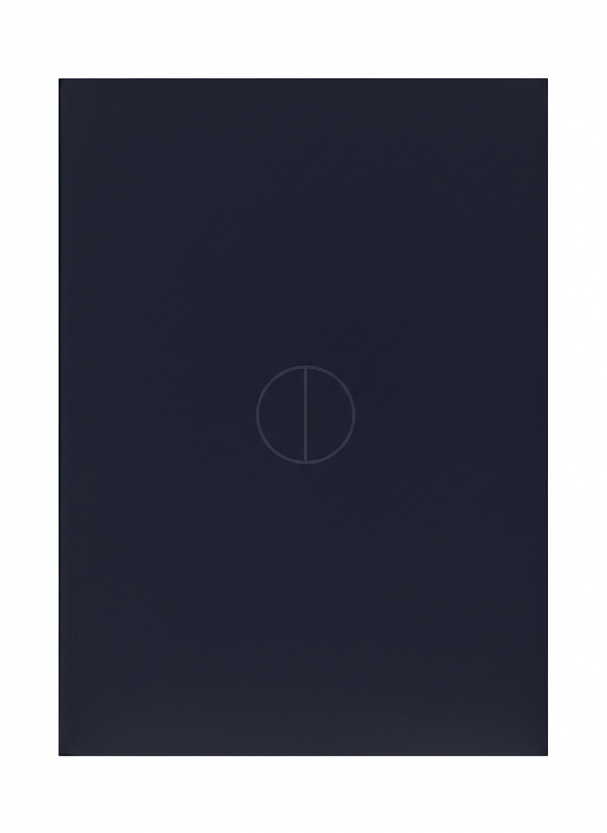

Minimum Viable Peace.
Everything else is optional.

Minimal MOU Pertaining to PEACE - v1.0 | June 2026
End of Document

