AndroidManifest.xml
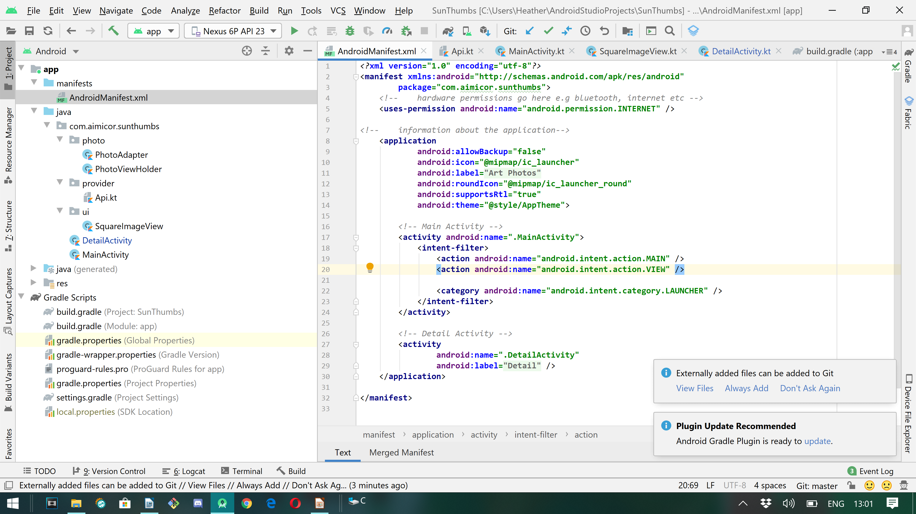

Gradle Scripts
Root Gradle: (Project SunThumbs)
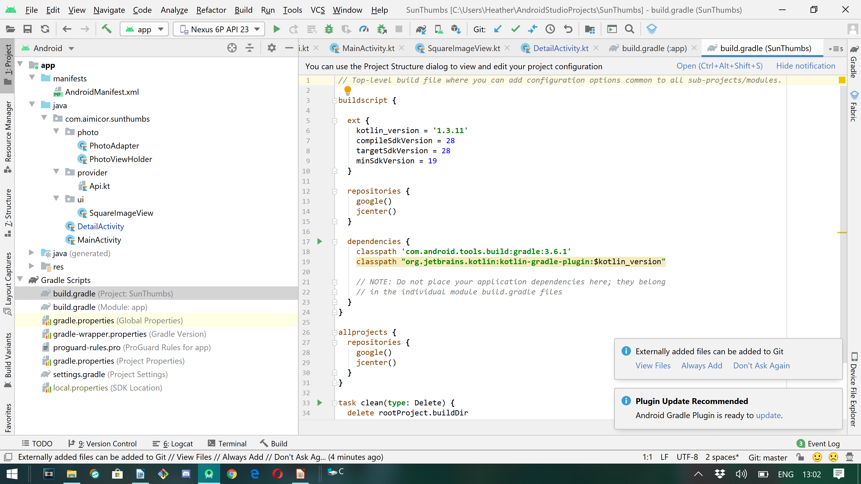

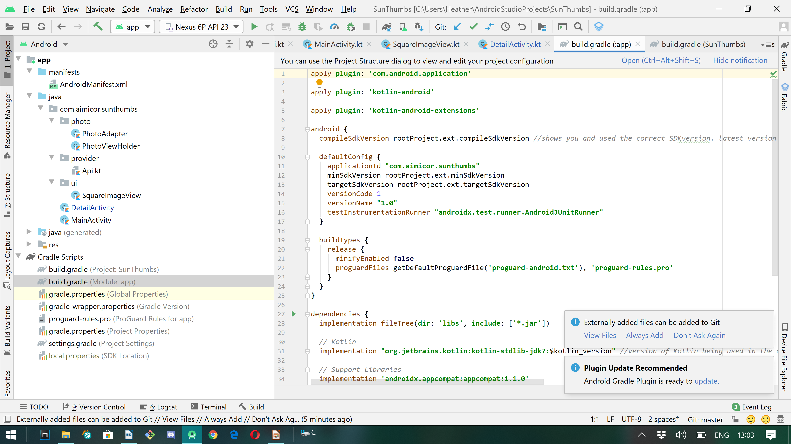
Gradle Script: (Module App)

Photos

