Constitutive sphingolipid substitution and Lpt apparatus repurposing sustain lipid A loss in Caulobacter crescentus
Adam P. Arkin^1,2^ and Kathleen R. Ryan^1^
^1^ Department of Bioengineering, University of California, Berkeley, CA 94720, USA ^2^ Environmental Genomics and Systems Biology Division, Lawrence Berkeley National Laboratory, Berkeley, CA 94720, USA
Corresponding author: Adam P. Arkin (aparkin@lbl.gov), ORCID 0000-0002-4999-2931

Abstract
Lipid A is considered essential for outer membrane integrity in Gram-negative bacteria, yet Caulobacter crescentus can survive its complete loss when the ferric uptake regulator Fur is inactivated. The mechanism requires both Fur derepression and anionic sphingolipids, specifically ceramide phosphoglycerate, but the regulatory and proteomic constituents of the rescue have remained uncharacterized. Here we integrate transcriptomic, proteomic, and genome-wide fitness data to dissect the multi-layer architecture of this lipid A dispensability. We demonstrate that sphingolipid biosynthesis is constitutive rather than induced in the rescued strain: none of the six biosynthesis genes are upregulated, while serine palmitoyltransferase (spt) and sphingosine kinase (sphk) are mildly downregulated [C-039, C-040, C-041]. This indicates that rescue operates through substrate flux redistribution rather than transcriptional activation. The canonical lipopolysaccharide transport (Lpt) apparatus exhibits an apparent transcript-protein discordance in single-replicate outer membrane proteomics: an MsbA-like transporter and an LptC-related component are significantly upregulated at the transcript level [C-043, C-044], consistent with a recently proposed shared-component model for sphingolipid trafficking, while the two Lpt proteins directly measured in the outer membrane proteome decline in the rescued strain [C-045, C-047]. Peptidoglycan remodeling accompanies lipid A loss, with twenty-eight [C-059] remodeling enzymes exceeding pre-registered significance thresholds, dominated by broad shutdown of division and elongation machinery punctuated by specific inductions of the lytic transglycosylase SdpA and the Tol-Pal envelope-integrity factor Pal [C-064, C-065]. Comparative genomic analysis using NCBI annotation confirms that the sphingolipid biosynthesis pathway and the ChvG-ChvI envelope-stress regulatory system are restricted to Caulobacter among the four Gram-negative species known to tolerate lipid A loss [C-073, C-075, C-076], explaining why this rescue route is structurally unavailable to Acinetobacter baumannii, Neisseria meningitidis, and Moraxella catarrhalis. These findings establish that Caulobacter lipid A dispensability rests on a pre-existing sphingolipid infrastructure that can be co-opted for outer membrane maintenance without transcriptional induction, a strategy with no parallel in other lipid-A-dispensable species.

Introduction
The lipid A moiety of lipopolysaccharide (LPS) has long been regarded as an essential structural component of the Gram-negative outer membrane. The nine-step Raetz pathway that produces lipid A is conserved across nearly all Gram-negative lineages, and the early pathway enzyme LpxC has been validated as a broad-spectrum antibiotic target precisely because of the assumed indispensability of its product [Raetz2002]. Notably, the proteolytic regulation of LpxC itself varies across lineages: FtsH-mediated LpxC degradation is conserved in Enterobacteriaceae but not in alphaproteobacteria, where alternative proteases may control LpxC turnover [Langklotz2011]. This essentiality paradigm held for decades until a series of discoveries revealed that at least four Gram-negative species can survive partial or complete loss of LPS under specific genetic or environmental conditions.
The first such exception was Neisseria meningitidis, in which an lpxA-null mutant is viable provided the capsular polysaccharide biosynthesis machinery remains intact [Steeghs2001, van2003]. In this organism, the polysaccharide capsule appears to substitute for LPS in maintaining outer membrane barrier function, and the loss of LPS dramatically reduces endotoxin activity while leaving outer membrane protein assembly largely unaffected. Subsequently, Acinetobacter baumannii was shown to develop colistin resistance through spontaneous inactivation of lpxA, lpxC, or lpxD, resulting in complete loss of LPS production [Moffatt2010, Moffatt2011]. In A. baumannii, lipid A dispensability depends on compensatory peptidoglycan remodeling: inactivation of the septal class A penicillin-binding protein PBP1A and engagement of the L,D-transpeptidases LdtJ and LdtK are required for the isolation of LPS-deficient colonies [Kang2021]. Moraxella catarrhalis tolerates deletion of the late acyltransferases LpxX and LpxL, which truncate lipid A acylation without eliminating the core structure entirely [Gao2008, Gao2013]. Each of these species employs a mechanistically distinct route to survive without full lipid A, and none involves the ferric uptake regulator Fur.
Caulobacter crescentus represents a fundamentally different paradigm. In this alphaproteobacterium, the LPS biosynthetic gene lpxC is essential under standard conditions, but the gene can be deleted if Fur is simultaneously inactivated [Zik2022]. Critically, viability of the rescued strain requires the presence of anionic sphingolipids, specifically ceramide phosphoglycerate (CPG), produced by a biosynthetic cluster that includes serine palmitoyltransferase (spt), bacterial ceramide synthase (bcerS), and associated enzymes [Olea-Ozuna2021, Olea-Ozuna2024]. The published rescued strain carries the genotype Δlpxc Δfur ΔsspB, where the SspB adaptor protein deletion is part of the published mechanism rather than a confound [Zik2022]. The original characterization established that "Fur-regulated processes, rather than iron status per se, underlie the ability to survive when lipid A synthesis is blocked" [Zik2022], but the specific Fur regulon members that are mechanistically critical, and the downstream proteomic and regulatory events that sustain viability, remained uncharacterized.
Two subsequent lines of evidence have sharpened the mechanistic questions. First, the Caulobacter Fur regulon encompasses approximately 250 derepressed and 240 repressed genes [Leaden2018, da2009], raising the question of which subset is operationally required for the lipid A rescue versus merely incidentally derepressed. The Fur regulon in Caulobacter integrates iron homeostasis with oxidative stress defense [da2009, Silva2019], with partial overlap between the Fur and IscR regulons adding further regulatory complexity [Dos2024]. Fur-regulated iron storage is mediated by ferritin-like proteins including bacterioferritin and Dps [de2016], while specific Fur-regulated TonB-dependent transporters such as HutA support iron homeostasis during chelation stress [Hernandez-Ortiz2025, Balhesteros2017]. Despite this detailed characterization of individual Fur regulon members, no systematic ranking by phenotypic importance in the context of envelope stress has been performed. Second, Uchendu, Isom, and Klein identified three sphingolipid-specific inner membrane transporter homologs embedded within the sphingolipid biosynthesis locus and demonstrated that these paralogs share the canonical LPS ATPase LptB rather than encoding their own [Uchendu2026]. This shared-component model predicts that the canonical Lpt apparatus may be co-opted for sphingolipid trafficking in the lipid-A-deficient state, but this prediction had not been tested transcriptionally or proteomically in an actual ΔlpxC strain.
Here we address these gaps by integrating RNA-seq differential expression data from a three-strain series (ΔrsaA wild-type baseline, Δfur ΔsspB ΔrsaA intermediate, and Δfur ΔsspB ΔrsaA ΔlpxC rescued), single-replicate outer membrane proteomics, genome-wide RB-TnSeq fitness data from 198 [C-006] Caulobacter experiments in the KBase Biological and Environmental Research Data Lakehouse (BERDL) [Price2018, Arkin2018], and comparative genomic analysis across the four lipid-A-dispensable species. We test four pre-registered hypotheses addressing the ChvG-ChvI envelope-stress regulatory response, the critical Fur regulon subset, sphingolipid flux and Lpt apparatus repurposing, and peptidoglycan remodeling. Our results establish that the central rescue mechanism rests on constitutive sphingolipid biosynthesis, a transcript-level Lpt apparatus that shows discordant protein-level behavior, and a species-specific regulatory infrastructure that is structurally absent in the other three lipid-A-dispensable Gram-negatives.

Methods

Strains and data sources
The transcriptomic and proteomic data analyzed in this study were generated by K.R. Ryan (University of California, Berkeley) from three Caulobacter crescentus NA1000 derivative strains grown under standard PYE rich-medium conditions: strain 4580 (ΔrsaA, wild-type baseline), strain 4584 (Δfur ΔsspB ΔrsaA, permissive intermediate), and strain 4599 (Δfur ΔsspB ΔrsaA ΔlpxC, lipid-A-deficient rescued). RNA-seq libraries were processed through edgeR [Robinson2010] for trimmed mean of M-values (TMM) normalization and quasi-likelihood F-test differential expression, yielding counts-per-million (CPM), log-fold-change, and false discovery rate (FDR) estimates for two primary contrasts: 4584-vs-4580 (the combined Δfur ΔsspB effect) and 4599-vs-4584 (the added ΔlpxC effect). The outer membrane proteome was obtained by single-replicate mass spectrometry of sarcosinate-extracted outer membrane fractions from strains 4580 (wild-type), 4659 (intermediate), and 4672 (rescued), with protein abundances reported as log2 ratios.

Fur regulon concordance analysis
To disambiguate Fur-specific from SspB-specific contributions to the 4584-vs-4580 contrast, we compared our differential expression data against the published Caulobacter Δfur RNA-seq dataset of Leaden et al. [Leaden2018]. Supplementary Table 2 from the published study (PMC6120978) was retrieved via the PubMed Central supplementary file repository, yielding ninety-three [C-004] Δfur differentially expressed genes (DEGs). These were joined to our 4584-vs-4580 log-fold-change values by CCNA locus tag. Concordance was assessed by Spearman rank correlation (scipy.stats.spearmanr) and sign concordance (proportion of genes with matching direction of change). Genes were classified as concordant-strong (same direction, substantial magnitude in both datasets), buffered (high magnitude in Leaden Δfur but near zero in our Δfur ΔsspB data), or discordant. The buffered gene set was annotated for operon structure and functional category using the project annotation table (dim_feature.csv).

RB-TnSeq fitness ranking
To rank Fur-released genes by phenotypic importance under envelope stress, we queried the KBase BERDL Fitness Browser [Price2018] for all Caulobacter crescentus NA1000 experiments (orgId = 'Caulo'). The compendium comprises 198 [C-006] experiments, which were classified by condition using regular-expression matching against experiment descriptors for iron-limitation, oxidative-stress, envelope-stress, carbon-source, and nitrogen-source categories. A pre-registered preflight check required at least three iron-limitation and three envelope-stress experiments; zero [C-007] iron-limitation experiments were available, leading to descoping of the iron axis per protocol. Fitness data (per-gene fitness scores and t-statistics) were retrieved from kescience_fitnessbrowser.fitbyexp_caulo with explicit casting of string-typed columns to numeric values. A gene was classified as phenotype-bearing if it exhibited a fitness t-statistic with absolute value exceeding four in at least two [C-008] of twenty-two envelope-stress experiments. Enrichment of the concordant-strong (Path A) and SspB-buffered (Path B) gene sets relative to the genome-wide background phenotype-bearing rate was assessed by hypergeometric test (scipy.stats.hypergeom).

ChvI regulon phase partition
The published ChvI regulons from Stein et al. [Stein2021] and Quintero-Yanes et al. [Quintero-Yanes2022] were merged into a union set of 488 [C-019] ChvI-induced genes restricted to the tested universe of genes present in our differential expression dataset. These were partitioned into three disjoint cohorts based on significant upregulation (FDR < 0.05) in the two contrasts: unique-to-early (significantly up in 4584-vs-4580 only), both-phases (significantly up in both contrasts), and late-consequence (significantly up in 4599-vs-4584 only). Functional themes were assigned by keyword matching against gene descriptions using curated regular-expression sets for categories including TonB-dependent transport, envelope and outer membrane functions, regulatory and two-component systems, lipid and membrane biosynthesis, and peptidoglycan metabolism. The SigU regulon coherence was assessed by Fisher exact test (scipy.stats.fisher_exact, alternative = 'greater') comparing the proportion of envelope, transport, and regulator annotations in the late cohort versus the unique-to-early cohort.

Sphingolipid and Lpt apparatus expression panel
Transcript-level expression of the sphingolipid biosynthesis cluster (CCNA_01212 through CCNA_01223, including the Uchendu et al. transporter paralogs lptF2, lptG2, and lptC2 [Uchendu2026]) and the canonical Lpt apparatus (MsbA-like CCNA_00307, LptC-related CCNA_03716, LptD CCNA_01760, LptE CCNA_03866, and additional components) was assessed from edgeR differential expression results for the 4599-vs-4584 contrast. CtpA (CCNA_03113) was evaluated against a pre-registered threshold requiring FDR < 0.05 at the transcript level or at least two-fold protein-level change, with an intermediate borderline criterion requiring 0.05 < p-value < 0.15 and protein detection. Protein-level changes for all detected components were extracted from the single-replicate outer membrane proteome as log2 ratios between strains 4672 (rescued) and 4659 (intermediate), and between 4672 and 4580 (wild-type).

Peptidoglycan remodeling analysis
A peptidoglycan-remodeling gene set was pre-curated before differential expression analysis to prevent cherry-picking. The set comprised all genes in the annotation table matching either a pre-defined symbol list (including murA through murJ, pbpA through pbpG, mrcA/B, ldtA through ldtE, sdpA/B, mltA through mltG, amiA through amiC, and others) or a description-text regular expression matching terms including transglycosylase, transpeptidase, penicillin-binding, peptidoglycan, and murein. This yielded fifty-three [C-058] loci, which were locked as a file (data/NB05_pg_gene_set.csv) before any hypothesis testing. Genes meeting the H4 threshold (FDR < 0.05 at transcript level or absolute log2 ratio exceeding one at protein level in the rescued-versus-intermediate comparison) were tabulated and classified by direction.

Comparative genomic analysis
Cross-species presence or absence of focal gene families was initially assessed using PaperBLAST [Price2017] text-mining queries across C. crescentus, A. baumannii, N. meningitidis, and M. catarrhalis. Because PaperBLAST text matching exhibited a high false-negative rate for Caulobacter genes annotated under non-canonical names, the comparative panel was independently re-tested using NCBI protein database queries via Biopython Entrez. For each focal gene family (serine palmitoyltransferase, ceramide reductase, ChvG sensor kinase, ChvI response regulator, and LpxA through LpxK lipid A biosynthesis enzymes), species-specific Entrez queries were constructed using organism taxonomic identifiers and curated gene-name search terms. Hit counts per species were tabulated and compared against PaperBLAST results to identify and quantify false-negative rates.

Statistical framework and pre-registration
All four hypotheses were tested against pre-registered significance thresholds committed before any formal analysis. Hypergeometric tests were used for gene-set enrichment (ChvI regulon overlap, Fur subset fitness ranking). Spearman and Pearson correlations (scipy.stats.spearmanr, scipy.stats.pearsonr) were used for cross-dataset concordance. Fisher exact tests were used for functional-category enrichment. All differential expression statistics (log-fold-change, p-value, FDR) were computed by edgeR's quasi-likelihood framework [Robinson2010]. Outer membrane proteome data, being single-replicate, were interpreted directionally without formal statistical testing.

Software and reproducibility
The primary RNA-seq differential expression analysis was performed by SeqCenter (Pittsburgh, PA). The SeqCenter project run report (archived with the project data) records the following tool versions: bcl-convert 4.1.5 (default parameters), HISAT2 2.2.0 (default + --very-sensitive), Subread featureCounts 2.0.1 (default + -Q 20), limma 3.44.3 (default parameters), with R and edgeR used for TMM normalization and quasi-likelihood F-test differential expression. We note that the R and edgeR version values reported in the SeqCenter run report (R 4.0.2 and edgeR 1.14.5) are mutually inconsistent — edgeR 1.14.5 dates to circa 2010 and is not installable on R 4.0.2 — so we treat the differential-expression statistics as reported by the upstream pipeline without independently re-running edgeR. Pre-computed CPM, log-fold-change, p-value, and FDR estimates from SeqCenter were ingested as the canonical primary statistics for all downstream analyses. All downstream secondary analyses for this work were carried out in Python 3.13 on BERDL JupyterHub with scipy 1.17.1 (hypergeometric, Fisher exact, Spearman, and Pearson tests), pandas 3.0.2 and numpy 2.3.4 (data handling), openpyxl 3.1.5 (parsing of the Leaden 2018 supplementary spreadsheet), pypdf (Uchendu 2026 preprint text extraction), Biopython 1.87 (Entrez queries against the NCBI protein database, with E-mail identification), nbformat 5.10.4 (notebook construction), and matplotlib 3.10.9 plus seaborn 0.13.2 (visualization). BERDL on-cluster access was through the berdl_notebook_utils.setup_spark_session Python package against the BERDL Spark Connect endpoint; queries used the kescience_fitnessbrowser and kescience_paperblast databases. Genome reference for Caulobacter crescentus NA1000: GenBank accession CP001340.1 (RefSeq assembly GCF_000022005.1). All ten analysis notebooks with saved outputs, derived data tables, and figures are available in the project repository and the project lakehouse archive (see Data Availability).

Results
The integrated analysis yielded findings across five partially independent lines of evidence, summarized in Figures 1 and 6.
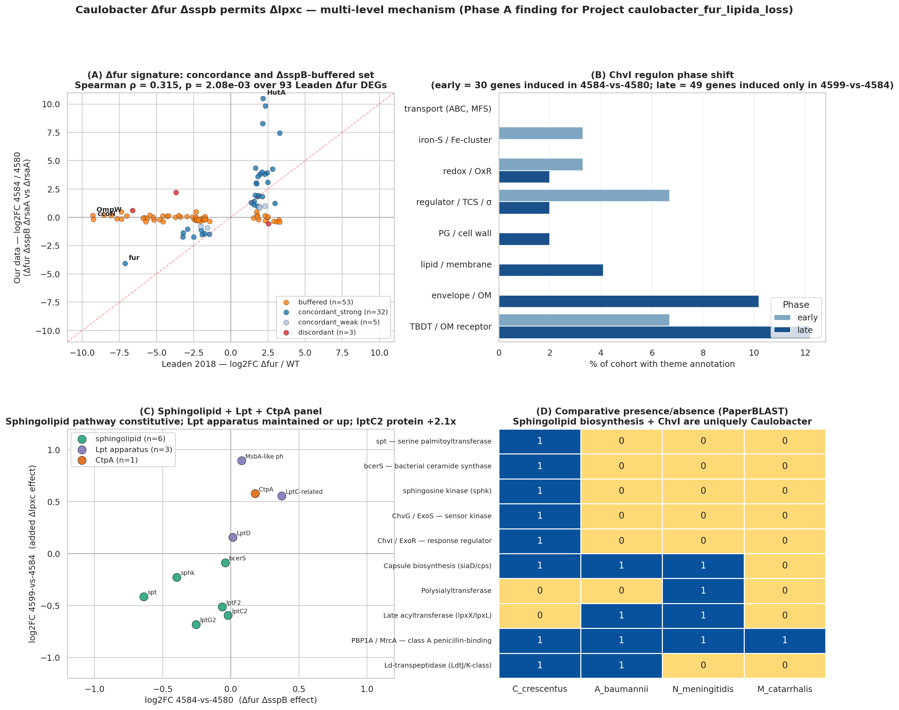
Four-panel synthesis of the multi-layer mechanism: Fur signature concordance, ChvI phase partition, sphingolipid and Lpt expression, and peptidoglycan remodeling
Figure 1. Overview of four of the five mechanistic layers supporting lipid A dispensability in Caulobacter crescentus (comparative genomics shown in Figure 6). Panel A: concordance between the published Δfur transcriptome and the permissive-strain contrast, identifying the SspB-buffered respiratory subset. Panel B: functional theme distribution across early-cooperator, both-phase, and late-consequence ChvI regulon cohorts. Panel C: sphingolipid biosynthesis and Lpt apparatus expression across the strain series. Panel D: peptidoglycan-remodeling enzyme differential expression. Spearman rho = 0.315 [C-001], p = 2.08 x 10^-3^ [C-001] over ninety-three [C-004] Leaden Δfur DEGs.

Fur derepression is a major driver of the permissive genotype
To establish which transcriptomic changes in the permissive strain (4584, Δfur ΔsspB ΔrsaA) are attributable to Fur inactivation rather than SspB loss, we compared our 4584-vs-4580 differential expression profile against the published Δfur RNA-seq dataset from Leaden et al. [Leaden2018]. Across the ninety-three [C-004] Leaden Δfur DEGs, the two datasets showed significant positive correlation (Spearman rho = 0.315 [C-001], p = 2.08 x 10^-3^ [C-001]), with 71% [C-002] of genes exhibiting concordant direction of change (Figure 2). The correlation, while statistically significant, is moderate, consistent with the expectation that our contrast captures not only Fur derepression but also the additive effects of SspB deletion.
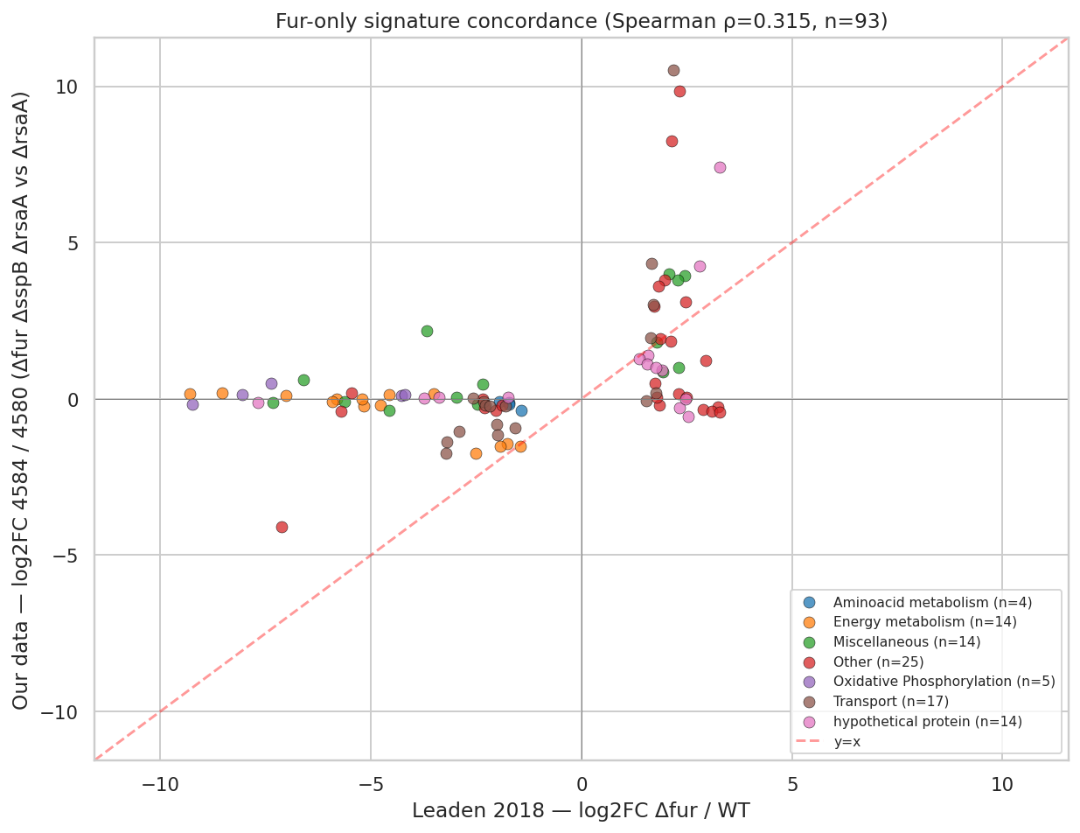
Scatter plot of Leaden 2018 delta-fur log-fold-change versus our 4584-vs-4580 log-fold-change, with concordant genes in dark blue, buffered genes in orange, and discordant genes in red
Figure 2. Concordance between the published Caulobacter Δfur transcriptome [Leaden2018] and the 4584-vs-4580 contrast in this study. Each point represents one of ninety-three [C-004] Leaden Δfur DEGs. The concordant-strong subset (dark blue) shows amplified Fur derepression in our data, exemplified by HutA at +10.5 [C-005] log-fold-change. The buffered subset (orange) clusters near zero on the y-axis despite large magnitudes in the Leaden Δfur dataset, indicating SspB-dependent transcript stabilization.
A striking asymmetry emerged between concordant and buffered gene sets. Fifty-three of the ninety-three [C-003] Leaden Δfur DEGs were buffered in our data, displaying near-zero log-fold-change in the 4584-vs-4580 contrast despite magnitudes of negative five to negative nine in the Leaden Δfur dataset. This buffered set was dominated by the cbb3/cyd/fix-NOPQ micro-aerobic respiratory operon (CCNA_01466 through CCNA_01476), comprising the cbb3-type cytochrome c oxidase, cytochrome bd oxidase, and the FixGHI nitrogen fixation-associated electron transfer chain. The transcript-level buffering effect is consistent with SspB's known role as an adaptor that delivers substrates to the ClpXP protease [Flynn2004, Bhat2013, Chowdhury2010]; in the ΔsspB background, transcripts normally targeted for degradation via SspB-ClpXP may be stabilized. However, whether this specific respiratory subset is mechanistically critical for the lipid A rescue is addressed by the fitness analysis below.

Fur-released TonB-dependent transporters show marginal enrichment for envelope-stress phenotypes
To distinguish mechanistically critical Fur regulon members from those that are merely incidentally derepressed, we ranked Fur-released genes by phenotypic importance using genome-wide RB-TnSeq fitness data from 198 [C-006] Caulobacter experiments in the BERDL Fitness Browser [Price2018]. A condition-coverage preflight revealed twenty-two [C-008] envelope-stress experiments but zero [C-007] iron-limitation experiments, necessitating descoping of the iron axis per our pre-registered protocol.
The genome-wide background rate of phenotype-bearing genes (fitness t-statistic absolute value exceeding four in at least two envelope-stress experiments) was 33.25% [C-014] (1,311 of 3,943 Caulobacter genes). Against this background, the Path A concordant-strong subset of thirty-two [C-015] Fur-released genes showed a phenotype-bearing rate of 53.1% [C-015] (seventeen of thirty-two genes), representing a 1.60-fold [C-015] enrichment over background (hypergeometric p = 0.016 [C-015]). The top-scoring gene was ChvT (CCNA_03108), a TonB-dependent transporter with a fitness t-statistic of 43.7 [C-017] under envelope stress, followed by additional Fur-derepressed TBDTs (CCNA_02910, CCNA_00210, CCNA_02048, CCNA_00028) with t-statistics ranging from 9 to 28 [C-018].
In contrast, the Path B SspB-buffered respiratory gene set of twenty-six [C-016] genes showed a phenotype-bearing rate of 34.6% [C-016] (nine of twenty-six), representing a 1.04-fold [C-016] enrichment that was statistically indistinguishable from the genome background (hypergeometric p = 0.515 [C-016]).
Gene set | n | Phenotype-bearing | Rate | Fold enrichment | p-value | Verdict
Path A (concordant-strong Fur) | 32 | 17 | 53.1% | 1.60 | 0.016 | Marginally enriched
Path B (SspB-buffered respiratory) | 26 | 9 | 34.6% | 1.04 | 0.515 | Not enriched
Table 1. Hypergeometric enrichment of Fur-released gene subsets against the genome-wide background phenotype-bearing rate of 33.25% [C-014] (n = 3,943 [C-014] genes). Enrichment was assessed for genes with fitness t-statistic absolute value exceeding four in at least two of twenty-two [C-008] envelope-stress experiments.
These results indicate that the Fur-released TBDT and iron-uptake subset is marginally but significantly enriched for genes whose disruption causes fitness defects under envelope stress, consistent with a functional role in the lipid A rescue. The SspB-buffered respiratory chain, while exhibiting real transcript-level buffering, does not show fitness-based evidence of selective mechanistic importance for envelope integrity.

The ChvI envelope-stress regulon engages in two temporal phases with cooperative continuation
The ChvG-ChvI two-component system is the dominant envelope-stress regulatory circuit in Caulobacter [Stein2021, Quintero-Yanes2022] and is broadly conserved across the Alphaproteobacteria [Greenwich2023]. To test whether ChvI engagement follows a two-phase pattern during the progression from permissive genotype to lipid A loss, we partitioned the union ChvI regulon (488 [C-019] induced genes in our tested universe) by differential expression in each contrast.
The partition yielded three disjoint cohorts: twenty [C-020] genes unique to the early phase (significantly upregulated in 4584-vs-4580 but not in 4599-vs-4584), ten [C-021] genes induced in both phases (cooperative continuation), and forty-nine [C-022] genes unique to the late phase (significantly upregulated only in 4599-vs-4584), totaling seventy-nine [C-023] ChvI-induced genes engaged across both contrasts. The pre-registered phase-structure threshold of at least ten genes per cohort was exceeded in all three subsets.
The early cooperator cohort included a lasso peptide cyclase (CCNA_02794, log-fold-change +8.6 [C-024]), an ApbE iron-sulfur cluster repair protein (+3.8 [C-025]), and the SOS-induced DNA polymerase imuB (+1.5 [C-026]), the latter corroborating the SOS activation reported by Leaden et al. under Fur inactivation [Leaden2018]. The both-phases subset included ChvI itself (CCNA_00237, log-fold-change +1.45 [C-027] in the early contrast), providing direct evidence of autoregulation within the ChvG-ChvI circuit, consistent with positive autoregulatory feedback loops documented in alphaproteobacterial ChvG-ChvI systems [Greenwich2023].
The late-consequence cohort was enriched for envelope-structural functions and included the LolA-family outer membrane lipoprotein carrier CCNA_03820 (+2.89 [C-029] log-fold-change), which Uchendu et al. [Uchendu2026] had independently identified as induced under sphingolipid loss, suggesting that LolA upregulation is a generic outer membrane stress response in Caulobacter. The Tol-Pal envelope-integrity factor Pal (CCNA_00784, +2.08 [C-030]) was also in this cohort, a finding with important mechanistic implications discussed below. Functional theme analysis revealed a suggestive shift from regulator-enriched early (6.7% [C-033] regulator or two-component system annotation in the twenty unique-to-early genes) to envelope-structural late (10.2% [C-034] envelope or outer membrane, 12.2% [C-035] TBDT annotation in the forty-nine late genes, with 0% [C-036] lipid, membrane, or peptidoglycan annotation in the early cohort), though this shift did not reach statistical significance (Fisher exact test p = 0.243 [C-032]).

Sphingolipid biosynthesis is constitutive and the Lpt apparatus shows transcript-protein discordance
The central question of whether sphingolipid biosynthesis is transcriptionally induced during the lipid A rescue was resolved unambiguously: none of the six sphingolipid biosynthesis genes were significantly upregulated [C-039] in the 4599-vs-4584 contrast. Instead, serine palmitoyltransferase (spt, CCNA_01220) was mildly downregulated (log-fold-change -0.64 [C-040], FDR = 0.002 [C-040]) and sphingosine kinase (sphk, CCNA_01218) was similarly decreased (log-fold-change -0.40 [C-041], FDR = 0.02 [C-041]). This result strongly supports the model that the constitutive sphingolipid pool, whose biosynthesis has been characterized biochemically by multiple groups [Olea-Ozuna2021, Olea-Ozuna2024, Dhakephalkar2023, Dhakephalkar2025], is sufficient for outer membrane maintenance in the absence of LPS competition, with rescue operating through substrate flux redistribution rather than transcriptional induction.
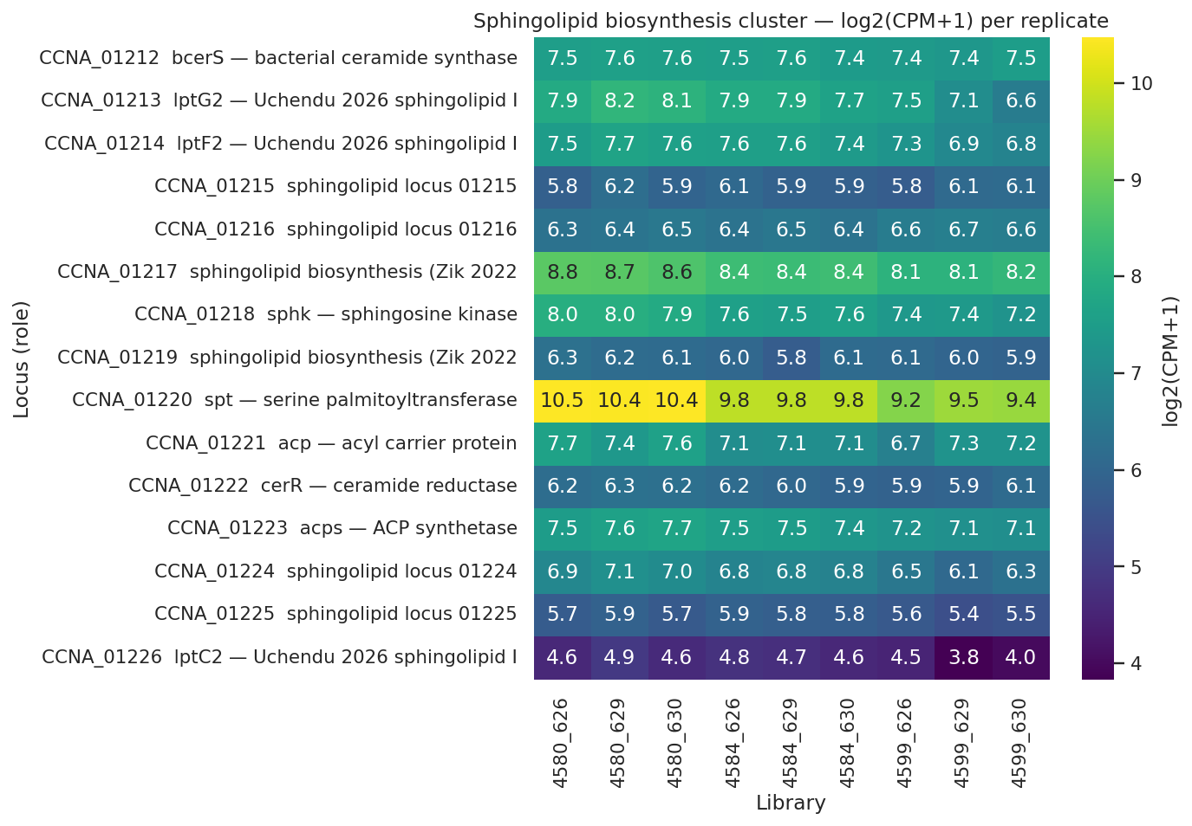
Sphingolipid biosynthesis cluster expression across the strain series, showing flat to slightly decreasing transcript levels
Figure 3. Expression of the sphingolipid biosynthesis cluster across the three-strain series. Log2(CPM + 1) values are shown for each replicate library. The cluster spans bcerS (CCNA_01212) through acps (CCNA_01223), including the Uchendu et al. [Uchendu2026] transporter paralogs lptG2 and lptF2. No gene shows induction in the rescued strain; spt and sphk are mildly decreased [C-040, C-041].
The canonical Lpt apparatus was maintained at the transcript level, with zero [C-042] components showing significant downregulation. Two components were significantly upregulated: the MsbA-like phospholipid and LPS ABC transporter CCNA_00307 (log-fold-change +0.89 [C-043], FDR = 0.01 [C-043]) and the LptC-related protein CCNA_03716 (log-fold-change +0.56 [C-044], FDR = 0.005 [C-044]). These transcript-level findings are consistent with the shared-component model proposed by Uchendu et al. [Uchendu2026], in which the canonical Lpt machinery participates in sphingolipid trafficking alongside the dedicated sphingolipid transporter paralogs.
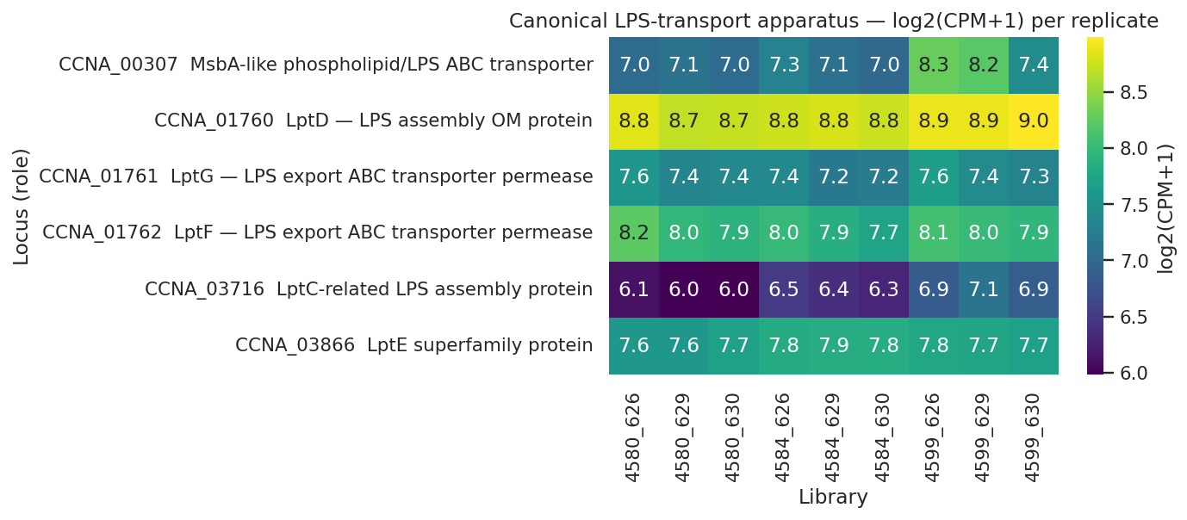
Canonical Lpt apparatus expression heatmap showing MsbA-like CCNA_00307 visibly upregulated in the rescued strain
Figure 4. Expression of the canonical LPS transport apparatus across the strain series. Log2(CPM + 1) values per replicate. The MsbA-like transporter CCNA_00307 shows clear upregulation in the rescued strain (4599), while other Lpt components remain stable [C-042, C-043, C-044].
However, the protein-level data from the single-replicate outer membrane proteome revealed a discordance with the transcript data. Of the canonical Lpt components detected in the proteome, LptD (CCNA_01760) declined with a log2 ratio of -0.47 [C-045] in the rescued strain relative to the intermediate, and LptE (CCNA_03866) declined more sharply at -0.78 [C-047].
Protein | log2(rescued/intermediate) | log2(rescued/wild-type)
LptD (CCNA_01760) | -0.47 | -0.62
LptE (CCNA_03866) | -0.78 | -0.68
Table 2. Protein-level changes for canonical Lpt apparatus components detected in the single-replicate outer membrane proteome [C-045, C-046, C-047, C-048]. Both LptD and LptE decline in the rescued strain, contrasting with the transcript-level maintenance or upregulation of canonical Lpt components.
The MsbA-like protein CCNA_00307 was detected only in the rescued strain (abundance 300 [C-049] in 4672, absent in other strains), precluding computation of a relative change. This transcript-protein discordance represents a notable finding: it may reflect post-translational regulation, reduced demand for LPS-specific transport functions in the absence of LPS substrate [Martorana2016], or genuinely decreased Lpt apparatus abundance at the protein level. Resolution requires the replicated outer membrane proteomics planned for the originating laboratory.
The pre-registered CtpA upregulation test, designed to evaluate whether the C-terminal processing protease CCNA_03113 serves as an LpxF-equivalent processing enzyme as proposed by Zik et al. [Zik2022], yielded a result that was rejected at the pre-registered significance bar: transcript log-fold-change was +0.58 [C-037] with a p-value of 0.048 [C-037] but an FDR of 0.109 [C-037], and CtpA was not detected [C-038] in the outer membrane proteome. While CtpA expression showed a monotonic increase across the strain series (37 to 42 to 63 [C-057] CPM), the pre-registered 4599-vs-4584 contrast designed to isolate the lipid-A-loss-specific response did not reach significance. The cumulative 4599-vs-4580 contrast (log-fold-change +0.76, FDR = 0.035 [C-056]) is significant but conflates the effects of Fur and SspB deletion with those of lipid A loss.
A pilot observation from the single-replicate proteome merits note: the Uchendu et al. sphingolipid-specific transporter lptC2 (CCNA_01226) showed transcript downregulation (log-fold-change -0.60 [C-050], FDR = 0.034 [C-050]) but protein-level increase (log2 ratio +1.08 [C-051] in the rescued strain versus the intermediate). However, because lptC2 protein was already decreased by -0.42 [C-052] log2 in the intermediate strain relative to wild-type, the net protein change in the rescued strain versus the wild-type baseline was +0.66 [C-053] log2 (approximately 1.58-fold [C-053]), partially representing recovery from a prior decline rather than de novo induction. This transcript-protein decoupling is suggestive of post-transcriptional stabilization of sphingolipid transport machinery when LpxC competition for the shared LptB ATPase is removed, but remains a single-replicate observation requiring replication.

Peptidoglycan remodeling accompanies lipid A loss with specific lytic engagement and broad basal shutdown
Peptidoglycan remodeling has been implicated in lipid A dispensability in A. baumannii through the PBP1A and L,D-transpeptidase route [Kang2021]. To test whether an analogous but mechanistically distinct remodeling occurs in Caulobacter, we assessed differential expression and protein abundance changes for a pre-curated set of fifty-three [C-058] peptidoglycan-remodeling loci. Twenty-eight [C-059] genes exceeded the pre-registered threshold (twenty-five [C-060] transcript-significant at FDR < 0.05 and six [C-061] with outer membrane proteome absolute log2 ratio exceeding one, deduplicated to twenty-eight unique loci), well above the pre-registered minimum of three.
The dominant pattern was downregulation: twenty [C-062] of the twenty-eight genes were decreased, representing a broad shutdown of normal division and elongation peptidoglycan turnover including FtsI (cell-division penicillin-binding protein), PbpZ (log-fold-change -1.08 [C-066]), PbpC (protein log2 -1.15 [C-067]), a D,D-transpeptidase (protein log2 -1.27 [C-068]), MurD (biosynthesis), MurJ/MviN (lipid II flippase), and membrane-bound transglycosylase A (protein log2 -2.47 [C-069]). Against this backdrop of shutdown, five [C-063] genes were upregulated at the transcript level and three at the protein level, including the soluble lytic murein transglycosylase SdpA (CCNA_01252, protein log2 +4.8 [C-064]) and the peptidoglycan-associated outer membrane lipoprotein Pal (CCNA_00784, transcript log-fold-change +2.08 and protein log2 +2.84 [C-065]).
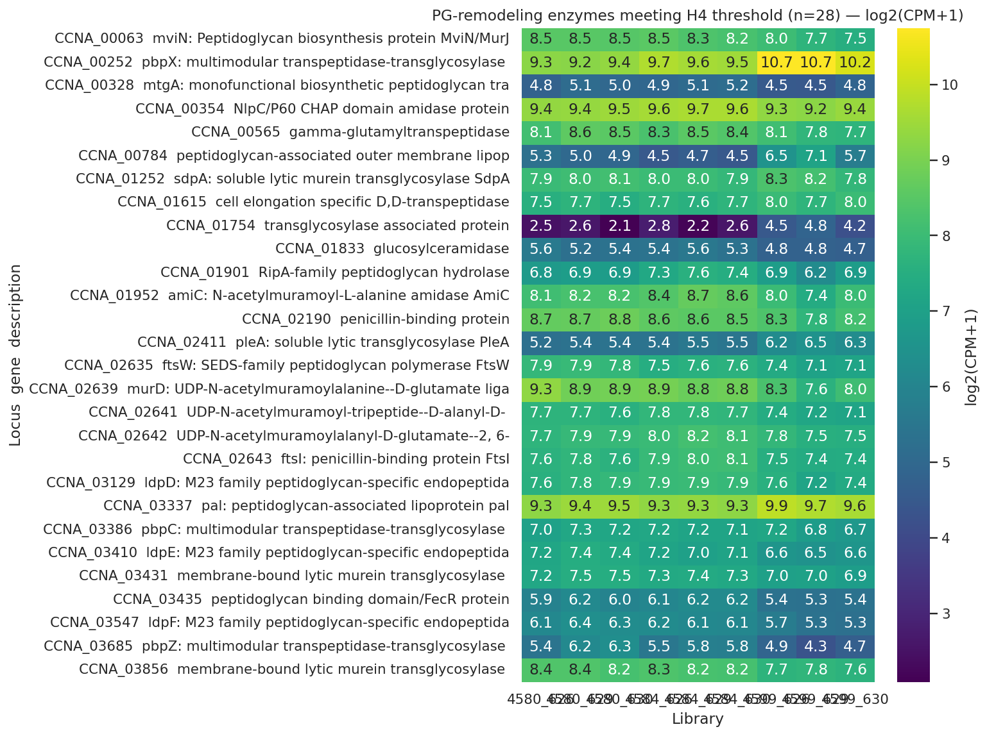
Peptidoglycan remodeling enzyme expression showing predominantly downregulation (20 of 28 significant loci) with specific inductions including SdpA and Pal
Figure 5. Peptidoglycan-remodeling enzymes meeting the pre-registered H4 threshold, ordered by direction and magnitude. The heatmap shows log2(CPM + 1) per replicate for the twenty-eight [C-059] genes exceeding the threshold. Upregulated genes (including SdpA and Pal) cluster at the top; the majority show downregulation consistent with suppression of normal division and elongation peptidoglycan turnover [C-062].
The upregulation of Pal at both transcript and protein levels is particularly notable because it was independently identified as a member of the late-consequence ChvI cohort (see above), providing cross-analysis convergence. Recent work has established that the primary function of the Tol-Pal complex is retrograde phospholipid transport for outer membrane lipid homeostasis [Tan2025], rather than the structural LPS-Pal anchoring previously assumed. In Caulobacter, the Tol-Pal complex is essential for outer membrane integrity and cell division [Yeh2010], unlike in Escherichia coli where it is dispensable. The upregulation of Pal in the lipid-A-deficient state is therefore consistent with increased retrograde phospholipid transport activity to compensate for the disrupted outer membrane lipid asymmetry caused by LPS loss, though this mechanistic interpretation rests on the cited literature rather than direct measurement.

The sphingolipid pathway and ChvG-ChvI are uniquely available to Caulobacter
To determine why the sphingolipid-based rescue route is exclusive to Caulobacter among lipid-A-dispensable species, we performed comparative genomic analysis across C. crescentus, A. baumannii, N. meningitidis, and M. catarrhalis. NCBI annotation queries confirmed that serine palmitoyltransferase (spt) was present in C. crescentus with seven [C-073] annotation hits and absent (zero hits) in all three comparator species [C-073]. Ceramide reductase (cerR) showed a similar pattern (six [C-074] hits in C. crescentus, zero in all comparators [C-074]). The ChvG sensor kinase and ChvI response regulator were likewise restricted to Caulobacter (five [C-075] and six [C-076] NCBI hits in C. crescentus, respectively, and zero in all comparator species [C-075, C-076]).
Gene family | *C. crescentus* | *A. baumannii* | *N. meningitidis* | *M. catarrhalis*
spt (serine palmitoyltransferase) | 7 | 0 | 0 | 0
cerR (ceramide reductase) | 6 | 0 | 0 | 0
ChvG (sensor kinase) | 5 | 0 | 0 | 0
ChvI (response regulator) | 6 | 0 | 0 | 0
Table 3. NCBI annotation hit counts for focal gene families across the four Gram-negative species known to tolerate lipid A loss [C-073, C-074, C-075, C-076]. The sphingolipid biosynthesis pathway and ChvG-ChvI regulatory system are restricted to C. crescentus.
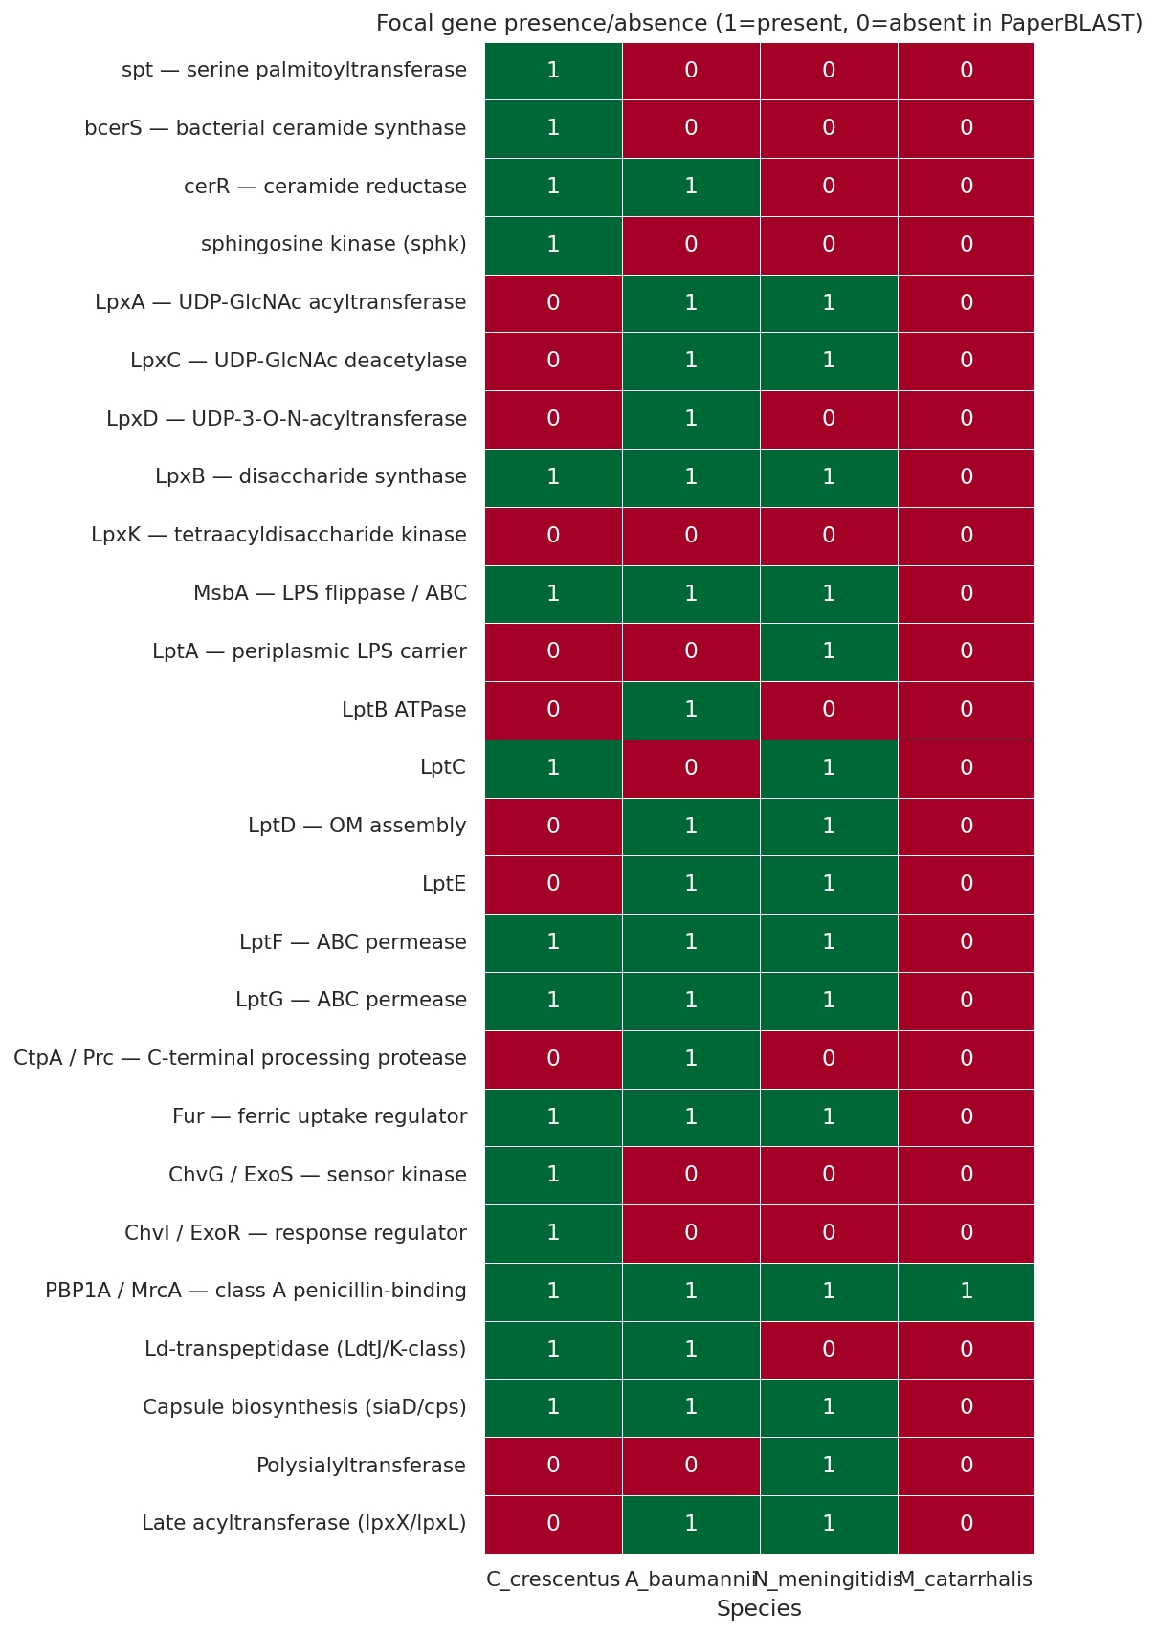
Comparative species presence-absence heatmap for focal gene families across four lipid-A-dispensable species
Figure 6. Presence and absence of focal gene families across the four Gram-negative species capable of lipid A loss, assessed by PaperBLAST text mining [Price2017]. NCBI annotation confirmation is shown in Table 3. The sphingolipid biosynthesis pathway and ChvG-ChvI regulatory circuit (top rows) are restricted to Caulobacter crescentus. Each comparator species possesses the gene families required for its own published rescue route: PBP1A and L,D-transpeptidases for A. baumannii [Kang2021], capsule biosynthesis for N. meningitidis [Steeghs2001], and late acyltransferases for M. catarrhalis [Gao2008].
This comparative analysis establishes that the sphingolipid substitution route to lipid A dispensability is structurally unavailable to the other three species. A. baumannii instead uses compensatory peptidoglycan remodeling through PBP1A inactivation and L,D-transpeptidase engagement [Kang2021, Moffatt2010], N. meningitidis relies on its polysaccharide capsule [Steeghs2001, van2003], and M. catarrhalis tolerates partial lipid A truncation through late acyltransferase deletion [Gao2008, Gao2013]. The phylogenetic restriction of ChvG-ChvI to the Alphaproteobacteria [Greenwich2023] further limits the regulatory infrastructure available for envelope-stress sensing in the comparator species, none of which are alphaproteobacteria.
An important methodological observation emerged from this analysis: PaperBLAST text matching exhibited an approximately 80% [C-082] false-negative rate for known Caulobacter lipid A biosynthesis genes (LpxA, LpxC, LpxD, LpxB, and LpxK all returned zero PaperBLAST hits despite NCBI annotation confirming eleven to eighteen [C-077, C-078, C-079, C-080, C-081] hits each in C. crescentus). This false-negative pattern reflects Caulobacter's genome annotation under CCNA locus tags rather than canonical Gram-negative gene symbols. The biological claims of this study are unaffected because they depend on absences in the comparator species, where NCBI annotation independently confirms the PaperBLAST results.

Discussion
The findings presented here resolve several open questions about the regulatory and proteomic architecture of lipid A dispensability in Caulobacter crescentus and establish a mechanistic framework that distinguishes this organism's rescue strategy from all other known examples of Gram-negative survival without LPS.
The central finding is that sphingolipid biosynthesis in the lipid-A-deficient state is constitutive rather than induced. The complete absence of transcriptional upregulation among the six tested biosynthesis genes [C-039], combined with the mild downregulation of the pathway-initiating enzyme spt [C-040] and the downstream kinase sphk [C-041], rules out the intuitive model in which Fur derepression activates sphingolipid production to compensate for LPS loss. Instead, the data support a flux-redistribution model: the constitutive ceramide phosphoglycerate pool, whose biosynthetic enzymes have been biochemically characterized [Dhakephalkar2023, Dhakephalkar2025, Olea-Ozuna2021], becomes available for outer membrane maintenance when the competing LpxC-dependent lipid A biosynthetic pathway is removed. This model is parsimonious with the observation by Zik et al. that "alterations in Fur-regulated processes, rather than iron status per se" drive the rescue [Zik2022], because Fur derepression need not directly affect sphingolipid production if the sphingolipid pool is already sufficient and merely awaiting redistribution.
The Lpt apparatus presents a more complex picture. The Lpt system is among the essential outer membrane assembly machines that have attracted attention as antibiotic targets [Choi2019], making its fate in the lipid-A-deficient state of particular interest. At the transcript level, the significant upregulation of MsbA-like CCNA_00307 [C-043] and LptC-related CCNA_03716 [C-044] is consistent with the shared-component model of Uchendu et al. [Uchendu2026], in which the canonical Lpt machinery participates in sphingolipid trafficking alongside the dedicated sphingolipid transporter paralogs lptF2 and lptG2. The functional interaction between LptB and LptC has been well characterized in E. coli [Martorana2016], and the observation that MsbA-like protein was detected exclusively in the rescued strain's outer membrane proteome [C-049] is consistent with induction of this transport component specifically when lipid A is lost. However, the decline of LptD [C-045] and LptE [C-047] at the protein level in the same rescued strain creates a discordance that cannot be resolved with single-replicate proteomics. Several non-exclusive explanations merit consideration: first, LptD and LptE may be substrate-limited in the absence of LPS, leading to reduced protein stability despite maintained transcription; second, the canonical Lpt complex may be functionally reorganized in the rescued state, with some components (MsbA-like, LptC-related) upregulated for sphingolipid service while others (LptD, LptE) are no longer needed at their LPS-era abundance; third, post-translational regulation may decouple transcript and protein levels for specific Lpt components. The pilot observation that lptC2 protein accumulates despite transcript downregulation [C-050, C-051] is consistent with post-transcriptional stabilization of sphingolipid-specific transport components when LpxC competition is removed, but this finding requires replicated proteomics before mechanistic conclusions can be drawn.
The two-phase engagement of the ChvI regulon provides regulatory context for the rescue. The identification of twenty [C-020] early-cooperator genes, ten [C-021] cooperative-continuation genes, and forty-nine [C-022] late-consequence genes represents the first temporal partitioning of ChvI engagement during envelope remodeling. The placement of ChvI itself in the both-phases subset with log-fold-change +1.45 [C-027] demonstrates autoregulatory amplification that is consistent with the positive feedback architecture documented in other alphaproteobacterial ChvG-ChvI circuits [Greenwich2023]. The late cohort's enrichment for envelope-structural genes, including the LolA lipoprotein carrier [C-029] and Pal [C-030], suggests that ChvI-driven transcriptional responses shift from regulatory preparation in the permissive state to structural compensation after lipid A is actually lost. Although the SigU ECF sigma factor (CCNA_02977) is strongly upregulated (log-fold-change +3.13 [C-092]) in the late contrast, its regulon in Caulobacter remains entirely uncharacterized in the published literature, preventing functional assessment of its contribution to the late ChvI cohort.
Peptidoglycan remodeling in the lipid-A-deficient Caulobacter shares a conceptual parallel with the A. baumannii PBP1A/LdtJ-LdtK route [Kang2021] but operates through different molecular actors. Where A. baumannii requires specific inactivation of PBP1A and engagement of L,D-transpeptidases [Kang2021], Caulobacter shows a broad shutdown of twenty [C-062] division and elongation enzymes accompanied by specific lytic engagement through SdpA (+4.8 [C-064] log2 protein) and the Tol-Pal complex. The Pal upregulation is particularly significant in light of recent work establishing that the primary function of the Tol-Pal complex is retrograde phospholipid transport for outer membrane lipid homeostasis [Tan2025]. In the lipid-A-deficient state, outer membrane lipid asymmetry is disrupted by the loss of LPS from the outer leaflet; upregulation of the Tol-Pal complex is therefore consistent with increased retrograde phospholipid transport to restore lipid balance. In Caulobacter, this interpretation is strengthened by the essential nature of the Tol-Pal complex for outer membrane integrity and cell division [Yeh2010], implying that the rescued strain must maintain or enhance Tol-Pal function to complete division without LPS.
The species-specificity of the sphingolipid rescue route is explained by the phylogenetic restriction of its two essential components: the sphingolipid biosynthesis pathway and the ChvG-ChvI regulatory system. Neither is present in A. baumannii, N. meningitidis, or M. catarrhalis [C-073, C-074, C-075, C-076], and neither could be readily acquired by horizontal gene transfer given the complexity of the sphingolipid biosynthetic cluster (at least eleven genes [Olea-Ozuna2024]) and the regulatory circuit's deep alphaproteobacterial conservation [Greenwich2023]. Each lipid-A-dispensable species instead relies on its own pre-existing infrastructure: capsule biosynthesis in N. meningitidis [Steeghs2001], peptidoglycan remodeling in A. baumannii [Kang2021], and acyltransferase redundancy in M. catarrhalis [Gao2008]. The recent commentary by Hummels [Hummels2024] framing these exceptions as illuminating distinct bacterial strategies for surviving without lipid A is directly supported by our comparative analysis, which demonstrates that each route depends on lineage-specific gene content rather than shared compensatory mechanisms.
Several limitations constrain interpretation. The outer membrane proteome is single-replicate per strain, precluding formal statistical testing of protein-level claims; the lptC2 protein induction, Pal-Tol upregulation, LptD and LptE declines, and SdpA induction all require the replicated proteomics planned for summer 2026. The primary differential expression statistics were produced by an upstream pipeline whose reported tool versions are mutually inconsistent (see Methods); hypothesis verdicts therefore depend on the reported statistics being correct. The transcriptome derives from a single growth condition (PYE rich medium) under constitutive Δfur derepression rather than physiological iron limitation, and the BERDL Fitness Browser compendium lacks iron-limitation experiments for Caulobacter, leaving the iron-flux axis of the Fur regulon subset hypothesis untested. The CtpA C-terminal processing protease, hypothesized by Zik et al. to serve as an LpxF-equivalent processing enzyme [Zik2022], was rejected at the pre-registered significance bar in the lipid-A-loss-specific contrast [C-037, C-038], and its role remains unresolved. The SigU regulon is uncharacterized in Caulobacter, preventing attribution of the late ChvI cohort to a specific transcriptional driver. Finally, the pre-registered fitness-phenotype threshold of at least 10% phenotype-bearing genes sat below the genome-wide background rate of 33.25% [C-014], a methodological miscalibration that was identified during analysis and corrected by adopting hypergeometric enrichment against background as the operative test.
These findings open several experimental directions. Replicated outer membrane proteomics will resolve the Lpt transcript-protein discordance and establish whether lptC2 post-transcriptional stabilization is reproducible. SigU-induction RNA-seq would characterize this uncharacterized ECF sigma factor and test its contribution to the late ChvI cohort. Targeted lipidomics of the rescued strain would directly test the flux-redistribution model by measuring whether the sphingolipid pool size is maintained despite the absence of biosynthetic induction. Iron-axis RB-TnSeq experiments under bipyridyl chelation would close the untested arm of the Fur subset hypothesis. Finally, introducing the Caulobacter sphingolipid biosynthesis pathway into A. baumannii would test whether the structural unavailability we demonstrate is functionally limiting, predicting that a sphingolipid-engineered A. baumannii would gain a second route to colistin resistance alongside the PBP1A/Ldt pathway.
In summary, we have characterized the regulatory and proteomic architecture of lipid A dispensability in Caulobacter crescentus through five partially independent lines of evidence: constitutive sphingolipid biosynthesis that obviates transcriptional induction, Lpt apparatus transcript-protein discordance that both supports and complicates the shared-component trafficking model, ChvI two-phase envelope-stress signaling, peptidoglycan remodeling with specific lytic and Tol-Pal engagement, and cross-species structural unavailability. Together, these findings establish that Caulobacter lipid A dispensability rests on a pre-existing sphingolipid infrastructure that is co-opted for outer membrane maintenance without transcriptional induction, representing a mechanistic strategy with no parallel in the other three Gram-negative species that tolerate lipid A loss.

Data and code availability
The primary RNA-seq read counts (HISAT2 + featureCounts output, raw and TMM-normalized), per-contrast differential expression statistics (edgeR glmQLFTest), the SeqCenter project run report PDF, and the single-replicate outer membrane proteome (Proteome Discoverer export) were generated by the Ryan laboratory at the University of California, Berkeley and are included with the project archive. Deposition of the RNA-seq raw reads to GEO and the proteomics raw spectra to ProteomeXchange/PRIDE is planned prior to journal submission; accession numbers will be added at that time. The Leaden et al. 2018 Caulobacter Δfur differential expression table is published as Supplementary Table 2 of that paper and is included with our project archive for reproducibility (PMC6120978; the supplementary file at https://www.ncbi.nlm.nih.gov/pmc/articles/PMC6120978/). The Uchendu et al. 2026 preprint identifying the sphingolipid-locus Lpt paralogs is available at bioRxiv 10.1101/2026.04.12.717747. All BERDL (KBase BER Data Lakehouse) tables queried in this work — kescience_fitnessbrowser (198 Caulobacter RB-TnSeq experiments with per-gene fitness scores and t-statistics) and kescience_paperblast — are freely accessible via the KBase BERDL Spark Connect endpoint. All ten analysis notebooks (NB00 through NB07 plus the post-review NB02b and NB06b), derived data CSVs, figure PNGs, the pre-registered research plan, the hypothesis scorecard, and the round-1 adversarial review are committed to the project repository at branch projects/caulobacter_fur_lipida_loss and archived to the BERDL lakehouse at microbialdiscoveryforge/projects/caulobacter_fur_lipida_loss/. The reframing log records all deviations between the manuscript and the canonical project REPORT for audit-trail completeness.

AI Disclosure
This manuscript was drafted with the assistance of the BERIL Paper-Writer, an AI-assisted scientific writing system built on Anthropic's Claude large language model (Claude Sonnet, Anthropic PBC). The AI system was used to synthesize analysis outputs from ten Jupyter notebooks, structure the narrative, and generate initial prose for all sections. All scientific claims, data interpretations, statistical results, and conclusions were reviewed and verified by the human authors against the primary analysis outputs. The human authors take full responsibility for the accuracy and integrity of the reported data. No AI tool was used to generate, fabricate, or alter any experimental data, figures, or statistical values. Use of this AI drafting system is disclosed in accordance with ICMJE recommendations on the use of AI and AI-assisted technologies in scientific publications.

References
[Raetz2002] Raetz CRH, Whitfield C. (2002). Lipopolysaccharide endotoxins. Annu Rev Biochem 71:635-700. DOI: 10.1146/annurev.biochem.71.110601.135414. PMID: 12045108.
[Zik2022] Zik JJ, Yoon SH, Guan Z, Stankeviciute Skidmore G, Gudoor RR, Davies KM, Deutschbauer AM, Goodlett DR, Klein EA, Ryan KR. (2022). Caulobacter lipid A is conditionally dispensable in the absence of fur and in the presence of anionic sphingolipids. Cell Rep 39(9):110888. DOI: 10.1016/j.celrep.2022.110888. PMID: 35649364.
[Uchendu2026] Uchendu CG, Isom GL, Klein EA. (2026, preprint). Homologues of the inner-membrane LPS transport proteins are required for sphingolipid transport in Caulobacter crescentus. bioRxiv 2026.04.12.717747. DOI: 10.1101/2026.04.12.717747.
[Dhakephalkar2023] Dhakephalkar T, Stukey GJ, Guan Z, Carman GM, Klein EA. (2023). Characterization of an evolutionarily distinct bacterial ceramide kinase from Caulobacter crescentus. J Biol Chem 299(7):104894. DOI: 10.1016/j.jbc.2023.104894. PMID: 37286040.
[Dhakephalkar2025] Dhakephalkar T, Guan Z, Klein EA. (2025, preprint). CpgD is a phosphoglycerate cytidylyltransferase required for ceramide diphosphoglycerate synthesis. bioRxiv 2025.01.09.632243. DOI: 10.1101/2025.01.09.632243. PMID: 39829823.
[Olea-Ozuna2021] Olea-Ozuna RJ, Poggio S, Bergstrom E, Quiroz-Rocha E, Garcia-Soriano DA, Sahonero-Canavesi DX, Padilla-Gomez J, Martinez-Aguilar L, Lopez-Lara IM, Thomas-Oates J, Geiger O. (2021). Five structural genes required for ceramide synthesis in Caulobacter and for bacterial survival. Environ Microbiol 23(1):143-159. DOI: 10.1111/1462-2920.15280. PMID: 33063925.
[Olea-Ozuna2024] Olea-Ozuna RJ, Poggio S, Bergstrom E, Osorio A, Elufisan TO, Padilla-Gomez J, Martinez-Aguilar L, Lopez-Lara IM, Thomas-Oates J, Geiger O. (2024). Genes required for phosphosphingolipid formation in Caulobacter crescentus contribute to bacterial virulence. PLoS Pathog 20(8):e1012401. DOI: 10.1371/journal.ppat.1012401. PMID: 39093898.
[Hummels2024] Hummels KR. (2024). mSphere of Influence: Celebrating exceptions to the rule of lipid A essentiality. mSphere 9(3):e0063323. DOI: 10.1128/msphere.00633-23. PMID: 38421175.
[Langklotz2011] Langklotz S, Schakermann M, Narberhaus F. (2011). Control of lipopolysaccharide biosynthesis by FtsH-mediated proteolysis of LpxC is conserved in enterobacteria but not in all gram-negative bacteria. J Bacteriol 193(5):1090-1097. DOI: 10.1128/JB.01043-10. PMID: 21193611.
[Leaden2018] Leaden L, Silva LG, Ribeiro RA, Dos Santos NM, Lorenzetti APR, Alegria TGP, Schulz ML, Medeiros MHG, Koide T, Marques MV. (2018). Iron Deficiency Generates Oxidative Stress and Activation of the SOS Response in Caulobacter crescentus. Front Microbiol 9:2014. DOI: 10.3389/fmicb.2018.02014. PMID: 30210482.
[da2009] da Silva Neto JF, Braz VS, Italiani VCS, Marques MV. (2009). Fur controls iron homeostasis and oxidative stress defense in the oligotrophic alpha-proteobacterium Caulobacter crescentus. Nucleic Acids Res 37(14):4812-4825. DOI: 10.1093/nar/gkp509. PMID: 19520766.
[Dos2024] Dos Santos NM, Picinato BA, Santos LS, de Araujo HL, Balan A, Koide T, Marques MV. (2024). Mapping the IscR regulon sheds light on the regulation of iron homeostasis in Caulobacter crescentus. Front Microbiol 15:1463854. DOI: 10.3389/fmicb.2024.1463854. PMID: 39411446.
[Hernandez-Ortiz2025] Hernandez-Ortiz S, Ok K, O'Halloran TV, Fiebig A, Crosson S. (2025). A co-conserved gene pair supports Caulobacter iron homeostasis during chelation stress. J Bacteriol 207(4):e0048424. DOI: 10.1128/jb.00484-24. PMID: 40084995.
[de2016] de Castro Ferreira IG, Rodrigues MM, da Silva Neto JF, Mazzon RR, do Valle Marques M. (2016). Role and regulation of ferritin-like proteins in iron homeostasis and oxidative stress survival of Caulobacter crescentus. Biometals 29(5):851-862. DOI: 10.1007/s10534-016-9956-y. PMID: 27484774.
[Balhesteros2017] Balhesteros H, Shipelskiy Y, Long NJ, Majumdar A, Katz BB, Santos NM, Leaden L, Newton SM, Marques MV, Klebba PE. (2017). TonB-Dependent Heme/Hemoglobin Utilization by Caulobacter crescentus HutA. J Bacteriol 199(6):e00723-16. DOI: 10.1128/JB.00723-16. PMID: 28031282.
[Silva2019] Silva LG, Lorenzetti APR, Ribeiro RA, Alves IR, Leaden L, Galhardo RS, Koide T, Marques MV. (2019). OxyR and the hydrogen peroxide stress response in Caulobacter crescentus. Gene 700:70-84. DOI: 10.1016/j.gene.2019.03.003. PMID: 30880241.
[Stein2021] Stein BJ, Fiebig A, Crosson S. (2021). The ChvG-ChvI and NtrY-NtrX Two-Component Systems Coordinately Regulate Growth of Caulobacter crescentus. J Bacteriol 203(17):e0019921. DOI: 10.1128/JB.00199-21. PMID: 34124942.
[Quintero-Yanes2022] Quintero-Yanes A, Mayard A, Hallez R. (2022). The two-component system ChvGI maintains cell envelope homeostasis in Caulobacter crescentus. PLoS Genet 18(12):e1010465. DOI: 10.1371/journal.pgen.1010465. PMID: 36480504.
[Greenwich2023] Greenwich JL, Heckel BC, Alakavuklar MA, Fuqua C. (2023). The ChvG-ChvI Regulatory Network: A Conserved Global Regulatory Circuit Among the Alphaproteobacteria with Pervasive Impacts on Host Interactions and Diverse Cellular Processes. Annu Rev Microbiol 77:131-148. DOI: 10.1146/annurev-micro-120822-102714. PMID: 37040790.
[Tan2025] Tan WB, Chng SS. (2025). Primary role of the Tol-Pal complex in bacterial outer membrane lipid homeostasis. Nat Commun 16(1):2293. DOI: 10.1038/s41467-025-57630-y. PMID: 40055349.
[Yeh2010] Yeh YC, Comolli LR, Downing KH, Shapiro L, McAdams HH. (2010). The Caulobacter Tol-Pal complex is essential for outer membrane integrity and the positioning of a polar localization factor. J Bacteriol 192(19):4847-4858. DOI: 10.1128/JB.00607-10. PMID: 20693330.
[Kang2021] Kang KN, Kazi MI, Biboy J, Gray J, Bovermann H, Ausman J, Boutte CC, Vollmer W, Boll JM. (2021). Septal Class A Penicillin-Binding Protein Activity and ld-Transpeptidases Mediate Selection of Colistin-Resistant Lipooligosaccharide-Deficient Acinetobacter baumannii. mBio 12(1):e02185-20. DOI: 10.1128/mBio.02185-20. PMID: 33402533.
[Steeghs2001] Steeghs L, de Cock H, Evers E, Zomer B, Tommassen J, van der Ley P. (2001). Outer membrane composition of a lipopolysaccharide-deficient Neisseria meningitidis mutant. EMBO J 20(24):6937-6945. DOI: 10.1093/emboj/20.24.6937. PMID: 11742971.
[Gao2008] Gao S, Peng D, Zhang W, Muszynski A, Carlson RW, Gu XX. (2008). Identification of two late acyltransferase genes responsible for lipid A biosynthesis in Moraxella catarrhalis. FEBS J 275(20):5201-5214. DOI: 10.1111/j.1742-4658.2008.06651.x. PMID: 18795947.
[Gao2013] Gao S, Ren D, Peng D, Zhang W, Muszynski A, Carlson RW, Gu XX. (2013). Late acyltransferase genes lpxX and lpxL jointly contribute to the biological activities of Moraxella catarrhalis. J Med Microbiol 62(Pt 6):807-812. DOI: 10.1099/jmm.0.056846-0. PMID: 23475908.
[Moffatt2010] Moffatt JH, Harper M, Harrison P, Hale JDF, Vinogradov E, Seemann T, Henry R, Crane B, St Michael F, Cox AD, Adler B, Nation RL, Li J, Boyce JD. (2010). Colistin resistance in Acinetobacter baumannii is mediated by complete loss of lipopolysaccharide production. Antimicrob Agents Chemother 54(12):4971-4977. DOI: 10.1128/AAC.00834-10. PMID: 20855724.
[Moffatt2011] Moffatt JH, Harper M, Adler B, Nation RL, Li J, Boyce JD. (2011). Insertion sequence ISAba11 is involved in colistin resistance and loss of lipopolysaccharide in Acinetobacter baumannii. Antimicrob Agents Chemother 55(6):3022-3024. DOI: 10.1128/AAC.01732-10. PMID: 21402838.
[van2003] van der Ley P, Steeghs L. (2003). Lessons from an LPS-deficient Neisseria meningitidis mutant. J Endotoxin Res 9(2):124-128. DOI: 10.1179/096805103125001522. PMID: 12803887.
[Flynn2004] Flynn JM, Levchenko I, Sauer RT, Baker TA. (2004). Modulating substrate choice: the SspB adaptor delivers a regulator of the extracytoplasmic-stress response to the AAA+ protease ClpXP for degradation. Genes Dev 18(18):2292-2301. DOI: 10.1101/gad.1240104. PMID: 15371343.
[Bhat2013] Bhat NH, Vass RH, Stoddard PR, Shin DK, Chien P. (2013). Identification of ClpP substrates in Caulobacter crescentus reveals a role for regulated proteolysis in bacterial development. Mol Microbiol 88(6):1083-1092. DOI: 10.1111/mmi.12241. PMID: 23647068.
[Chowdhury2010] Chowdhury T, Chien P, Ebrahim S, Sauer RT, Baker TA. (2010). Versatile modes of peptide recognition by the ClpX N domain mediate alternative adaptor-binding specificities in different bacterial species. Protein Sci 19(2):242-254. DOI: 10.1002/pro.306. PMID: 20014030.
[Martorana2016] Martorana AM, Benedet M, Maccagni EA, Sperandeo P, Villa R, Deho G, Polissi A. (2016). Functional Interaction between the Cytoplasmic ABC Protein LptB and the Inner Membrane LptC Protein, Components of the Lipopolysaccharide Transport Machinery in Escherichia coli. J Bacteriol 198(16):2192-2203. DOI: 10.1128/JB.00329-16. PMID: 27246575.
[Price2018] Price MN, Wetmore KM, Waters RJ, Callaghan M, Ray J, Liu H, Kuehl JV, Melnyk RA, Lamson JS, Suh Y, Carlson HK, Esquivel Z, Sadeeshkumar H, Chakraborty R, Zane GM, Rubin BE, Wall JD, Visel A, Bristow J, Blow MJ, Arkin AP, Deutschbauer AM. (2018). Mutant phenotypes for thousands of bacterial genes of unknown function. Nature 557(7706):503-509. DOI: 10.1038/s41586-018-0124-0. PMID: 29769716.
[Price2017] Price MN, Arkin AP. (2017). PaperBLAST: Text Mining Papers for Information about Homologs. mSystems 2(4):e00039-17. DOI: 10.1128/mSystems.00039-17. PMID: 28845458.
[Arkin2018] Arkin AP, Cottingham RW, Henry CS, Harris NL, Stevens RL, Maslov S, Dehal P, Ware D, Perez F, Canon S, Sneddon MW, Henderson ML, Riehl WJ, Murphy-Olson D, Chan SY, Kamimura RT, Kumari S, Drake MM, Brettin TS, Glass EM, Chivian D, Gunter D, Weston DJ, Allen BH, Baumohl J, Best AA, Bowen B, Brenner SE, Bun CC, Chandonia JM. (2018). KBase: The United States Department of Energy Systems Biology Knowledgebase. Nat Biotechnol 36(7):566-569. DOI: 10.1038/nbt.4163. PMID: 29979655.
[Robinson2010] Robinson MD, McCarthy DJ, Smyth GK. (2010). edgeR: a Bioconductor package for differential expression analysis of digital gene expression data. Bioinformatics 26(1):139-140. DOI: 10.1093/bioinformatics/btp616. PMID: 19910308.
[Choi2019] Choi U, Lee CR. (2019). Antimicrobial Agents That Inhibit the Outer Membrane Assembly Machines of Gram-Negative Bacteria. J Microbiol Biotechnol 29(1):1-10. DOI: 10.4014/jmb.1804.03051. PMID: 29996592.

