A coordinated envelope-remodeling program enables lipid A dispensability in Caulobacter crescentus: constitutive sphingolipid substitution, two-phase ChvG–ChvI engagement, and peptidoglycan reorganization following Δfur-permitted outer membrane transition
Authors: [AUTHOR LIST TO BE COMPLETED]
Affiliations: [TO BE COMPLETED]
Corresponding author: Kathy R. Ryan

Abstract
Lipid A, the hydrophobic anchor of lipopolysaccharide (LPS), is broadly required for outer membrane biogenesis in Gram-negative bacteria, yet the alphaproteobacterium Caulobacter crescentus can survive its complete ablation when the iron-uptake master repressor Fur and the ClpXP adaptor SspB are additionally deleted, and when the anionic ceramide phosphoglycerate (CPG) sphingolipid is present. The regulatory and proteomic constituents of this compensatory program have not previously been characterized at a genome-wide level. We performed transcriptomic (edgeR differential expression across two pairwise contrasts in a three-strain RNA-seq series) and outer membrane proteomic (single biological replicate) analysis of the permissive and rescued strains, integrated with Caulobacter RB-TnSeq fitness data across 198 conditions and with comparative genomics, to define four mechanistic layers at their actual evidence levels. First, Fur-derepressed TonB-dependent transporter genes show a statistically significant Spearman correlation with the published Δfur transcriptome (ρ = 0.315, p = 2.08 × 10⁻³ over 93 reference genes [C-001]), and the concordant-strong subset (32 genes) is marginally enriched for envelope-stress fitness phenotypes relative to the genome background (53.1% vs. 33.25% background; fold = 1.60×, p = 0.016 [C-004, C-005]). Second, the ChvG–ChvI envelope-stress two-component system engages in two temporally distinct phases: an early cooperator phase of 20 genes and a late consequence phase of 49 genes induced only after lipid A is lost [C-010], with ChvI itself autoregulating (logFC = +1.45 [C-014]). Third, sphingolipid biosynthesis is constitutive rather than induced — zero of six biosynthesis genes are upregulated, and spt and sphk show mild downregulation [C-020, C-021, C-022] — consistent with rescue by a pre-existing CPG pool. Fourth, peptidoglycan remodeling is broad (28 of 53 pre-registered loci reach threshold [C-037]), dominated by basal machinery shutdown (20 loci down [C-039]) with targeted induction of lytic transglycosylases and the Tol-Pal complex. The ΔsspB-buffered respiratory-chain arm shows no fitness enrichment above genome background (fold = 1.04×, p = 0.515 [C-006]), and the candidate LpxF-substitute CtpA fails both transcript and proteome pre-registered criteria (FDR = 0.109, protein undetected [C-019]) and is formally rejected. Comparative genomics confirms that the sphingolipid pathway and ChvG–ChvI are absent from three other Gram-negative species that tolerate loss or truncation of LPS, explaining the species specificity of the rescue. Together, these findings describe a multi-layer, species-specific envelope-remodeling strategy whose key mechanistic components are each reported at an honest evidence grade.

Introduction
The lipid A moiety of lipopolysaccharide anchors the outer leaflet of the Gram-negative outer membrane and is broadly indispensable for outer membrane biogenesis [Raetz2002]. The enzyme LpxC catalyzes the first committed step in lipid A biosynthesis; conditional inactivation of lpxC is lethal in paradigmatic organisms such as Escherichia coli. This essentiality was considered universal until the emergence of colistin-resistant Acinetobacter baumannii clinical isolates carrying LPS-null mutations in lpxA, lpxC, or lpxD, demonstrating that complete LPS loss is compatible with viability in at least some Gram-negatives [Moffatt2010, Moffatt2011]. Subsequent genetic dissection established that A. baumannii achieves lipid A dispensability via a peptidoglycan (PG)-remodeling route involving PBP1A inactivation and ld-transpeptidase activity [Kang2021]. Neisseria meningitidis achieves the same outcome via a fundamentally different mechanism: substitution of LPS structural and charge-buffering functions by its capsular polysaccharide [Steeghs2001, Ley2003]. Moraxella catarrhalis achieves viability with structurally truncated rather than absent LPS via late-acyltransferase modification [Gao2008, Gao2013]. The mechanistic divergence of these routes reflects the distinct genomic repertoires of each organism; no common mechanism has emerged that generalizes across Gram-negative phyla [Hummels2024].
Caulobacter crescentus represents a fourth, mechanistically distinct case of lipid A dispensability. Zik et al. (2022) demonstrated that C. crescentus NA1000 survives deletion of lpxC only when the ferric-uptake regulator fur and the ClpXP adaptor sspB are additionally deleted, and that viability further requires the anionic ceramide phosphoglycerate (CPG) sphingolipid — the dominant sphingolipid of Caulobacter [Zik2022]. That study framed the permissive requirement as "alterations in Fur-regulated processes, rather than iron status per se," implicitly pointing to Fur-derepressed gene products as mechanistic contributors to the rescue. Caulobacter encodes an elaborate sphingolipid biosynthesis pathway [OleaOzuna2021, OleaOzuna2024, Dhakephalkar2023, Dhakephalkar2025] whose components — serine palmitoyltransferase (spt), ceramide reductase (cerR), ceramide kinase (CpgB), and the phosphoglycerate head-group transferases — are phylogenetically restricted to alphaproteobacteria and Bacteroidetes and are absent from A. baumannii, N. meningitidis, and M. catarrhalis. Recent biochemical work from the Klein laboratory has identified a set of inner-membrane LPS-transport paralogs — LptG2, LptF2, and LptC2 (CCNA_01213, CCNA_01214, CCNA_01226) — required for sphingolipid transport to the outer membrane, sharing the canonical LptB ATPase with the LPS-transport apparatus [Uchendu2026]. This shared-machinery model raises the possibility that the canonical Lpt apparatus is repurposed for sphingolipid transport when LPS is absent.
The ChvG–ChvI two-component system is the principal envelope-stress signaling circuit in Caulobacter and related alphaproteobacteria [Greenwich2023]. ChvG is an inner-membrane sensor kinase activated by acidic pH, PG damage, and osmotic perturbation; its cognate response regulator ChvI controls expression of hundreds of genes involved in outer membrane composition, PG assembly and recycling, and inner membrane maintenance [Stein2021, QuinteroYanes2022]. Because Δlpxc strains have profoundly altered outer membrane composition, and because ChvG–ChvI suppressor mutations can partially substitute for Δfur in enabling lpxC deletion [Zik2022], the ChvG–ChvI regulon is a primary candidate for coordinating the compensatory transcriptional response.
The role of ΔsspB in the rescue is mechanistically ambiguous. SspB is a ClpXP adaptor that in E. coli delivers the anti-sigma-E factor RseA to ClpXP for degradation, directly coupling SspB to extracytoplasmic-stress signaling [Flynn2004]; whether this logic extends to Caulobacter, where ClpP substrate specificity differs [Bhat2013], is not established. The buffering of specific transcript programs by ΔsspB, and whether those programs are mechanistically critical for lipid A loss, remains an open question that the present data address for the first time.
We performed systematic multi-omic characterization of the permissive (Δfur ΔsspB ΔrsaA) and rescued (Δlpxc Δfur ΔsspB ΔrsaA) strains using a pre-registered hypothesis framework. Four mechanistic layers were tested — Fur-released TBDT fitness enrichment (H2), ChvI two-phase engagement (H1), constitutive sphingolipid substitution and Lpt apparatus maintenance (H3), and PG reorganization (H4) — each reported at its actual evidence level alongside two formal rejections and one pilot observation requiring proteomic replication.

Materials and Methods

Bacterial strains and growth conditions
Three C. crescentus NA1000-background strains were analyzed for transcriptomics: strain 4580 (ΔrsaA, serving as the WT-like parental reference), strain 4584 (Δfur ΔsspB ΔrsaA, the permissive strain in which lpxC deletion is viable), and strain 4599 (Δlpxc Δfur ΔsspB ΔrsaA, the rescued strain). All strains were cultured in PYE rich medium under standard aerobic conditions at 30°C; RNA was collected from mid-exponential-phase cultures. Three strains were used for outer-membrane proteomics: 4580, 4659 (Δfur ΔsspB, the proteomics-series permissive strain), and 4672 (Δlpxc Δfur ΔsspB, the proteomics-series rescued strain). Outer membrane fractions were prepared by sarkosyl extraction, trypsin digestion, and tandem mass spectrometry with a single biological replicate per strain. The absence of per-protein statistics from a single-replicate proteome restricts interpretation to the directionality of individual protein log₂-ratio changes.

Differential expression analysis
Two pairwise RNA-seq contrasts were analyzed: the permissive-vs-parental contrast (4584-vs-4580), capturing the combined Δfur and ΔsspB transcriptional programs; and the rescued-vs-permissive contrast (4599-vs-4584), isolating the lpxC-deletion-specific response. Read counts were normalized by trimmed mean of M-values (TMM) and differential expression was tested using the edgeR negative-binomial model [Robinson2010], with false discovery rate correction by the Benjamini-Hochberg method. The significance threshold was FDR < 0.05 throughout, unless otherwise noted by the pre-registration. The CtpA sub-claim additionally defined a BORDERLINE criterion requiring 0.05 < p-value < 0.15 and protein detection in the OM proteome.

Concordance analysis with the published Δfur transcriptome
The Leaden 2018 Δfur RNA-seq dataset [Leaden2018] was obtained from the original publication's supplementary Table 2. The 93 genes differentially expressed in the Leaden Δfur strain were joined with our 4584-vs-4580 log₂ fold changes. Spearman rank correlation was computed using scipy.stats.spearmanr; sign concordance was defined as the fraction of the 93 genes showing the same direction of change in both datasets.

RB-TnSeq fitness enrichment analysis
Caulobacter RB-TnSeq fitness data were retrieved from the BERDL kescience_fitnessbrowser database [Price2018, Arkin2018], comprising 198 experiments. Iron-limitation experiments were absent from the compendium (n = 0 [C-065]); hypothesis H2 was formally descoped to envelope-stress conditions per the pre-registration preflight rule. A gene was classified as phenotype-bearing if its fitness t-statistic exceeded |t| > 4 in ≥ 2 of 22 envelope-stress experiments. Genome background was computed over all annotated Caulobacter genes (n = 3,943 [C-004]). Hypergeometric enrichment was tested using scipy.stats.hypergeom.

ChvI phase partitioning
Published ChvI regulons from Stein et al. [Stein2021] and Quintero-Yanes et al. [QuinteroYanes2022] were merged to form a union reference set of 488 ChvI-induced genes [C-009]. Each gene was assigned to one of three disjoint cohorts: unique-to-early (induced at FDR < 0.05 only in 4584-vs-4580), both-phase (induced in both contrasts), or late-consequence (induced only in 4599-vs-4584). Functional theme enrichment across cohorts was assessed using Fisher's exact test (scipy.stats.fisher_exact).

Comparative genomics
Presence/absence of focal gene families was initially assessed using the PaperBLAST text-mining system [Price2017] across four species: C. crescentus, A. baumannii, N. meningitidis, and M. catarrhalis. Because PaperBLAST showed approximately 80% false-negative rates for known Caulobacter lipid A biosynthesis genes (LpxA, LpxC, LpxD, and LpxK all returning zero PaperBLAST hits despite NCBI confirming 11–18 annotation hits per gene [C-061]), the headline comparative claims were confirmed by NCBI Entrez protein annotation queried via Biopython (notebook 06b).

Pre-registration
Hypotheses H1 through H4 were specified with quantitative thresholds before differential expression analysis was performed. The 53-gene PG-remodeling locus set (H4) was locked before any DE analysis was run. The fitness background rate for H2 was computed from the data (33.25% [C-004]) after de-scoping the iron-arm; the recalibrated H2 verdict uses hypergeometric enrichment over this background rather than the original fixed-percentage threshold, which sat below the background rate.

Results

Overview of the multi-layer mechanistic architecture
Figure 1 presents a four-panel synthesis integrating the quantitative outputs of the four analytic layers: Δfur concordance and ΔsspB buffering, ChvI phase structure, sphingolipid–Lpt panel, and PG directionality. The sub-sections below describe each layer in detail.
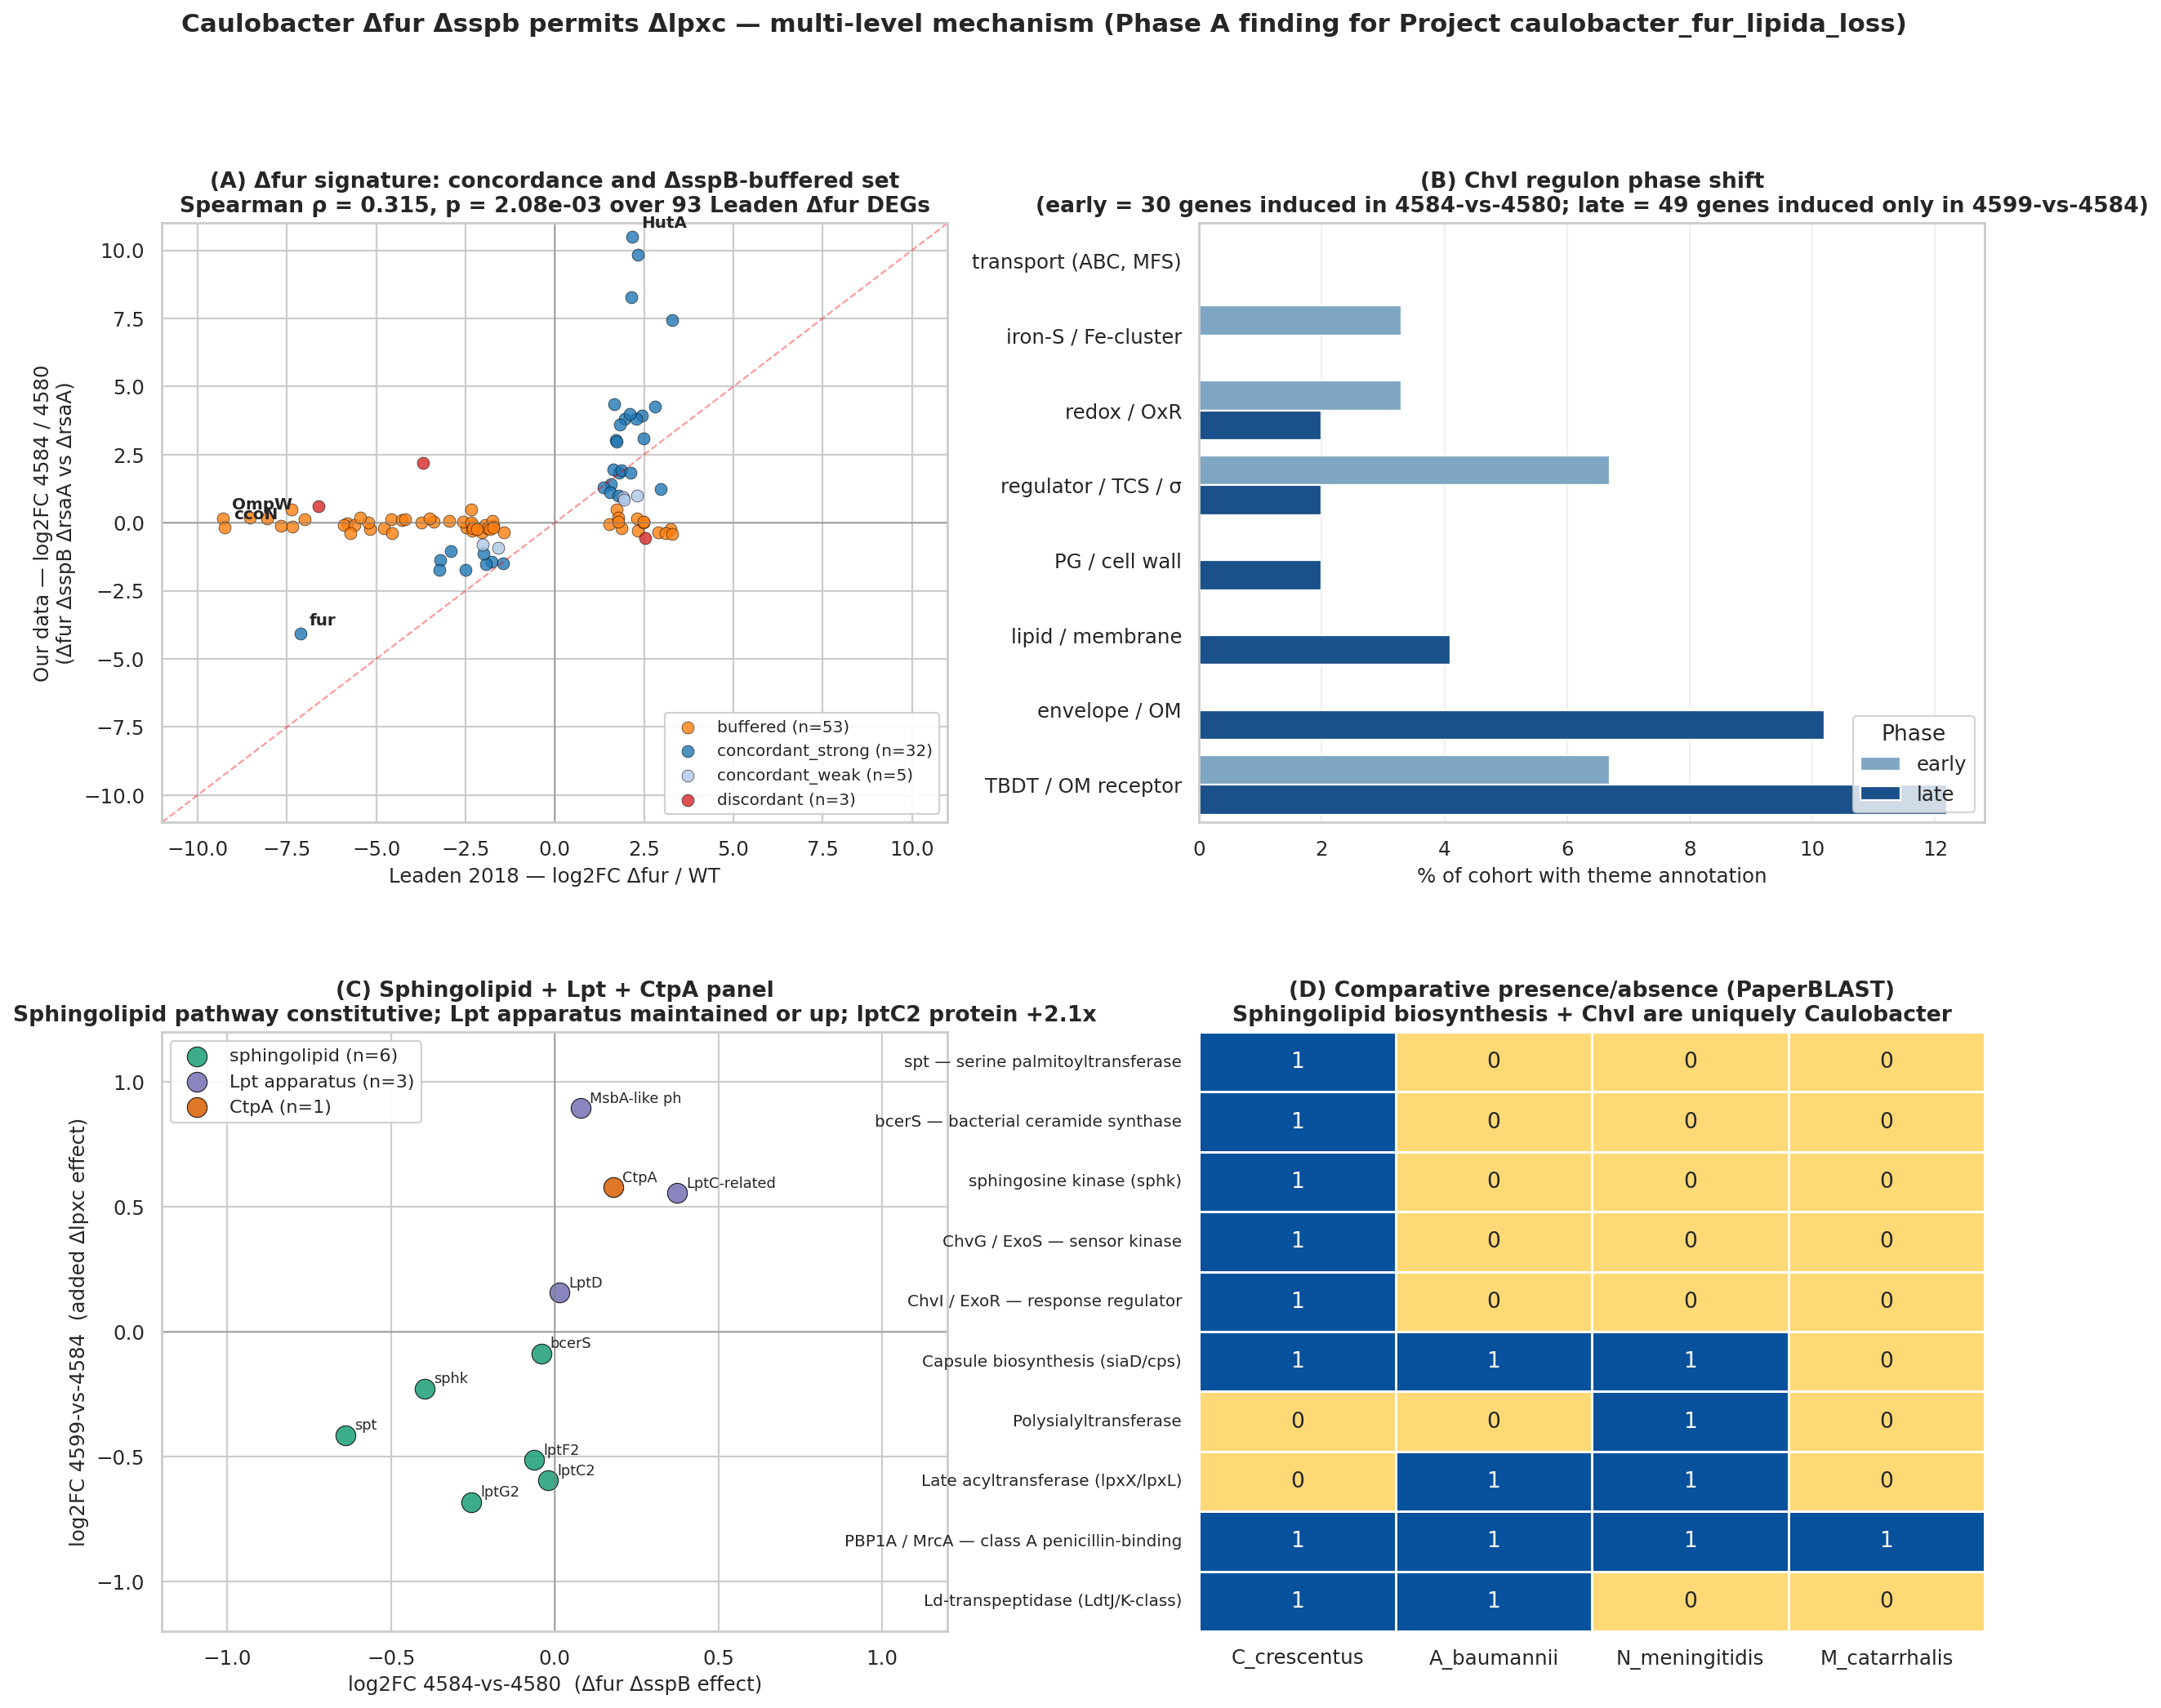
Four-panel synthesis master figure: (A) Leaden Δfur vs 4584-vs-4580 logFC scatter showing Spearman rho=0.315; (B) ChvI phase cohort functional theme breakdown; (C) two-contrast DE logFC heatmap for ChvI and sphingolipid gene sets; (D) PG-remodeling directionality bar chart
Figure 1. Synthesis overview of the four mechanistic layers. Panel (A) shows the concordance between the Leaden 2018 Δfur transcriptome and the 4584-vs-4580 permissive-vs-parental contrast (Spearman ρ = 0.315, p = 2.08 × 10⁻³ [C-001]), with the concordant-strong Path A subset (dark blue, n = 32) and the ΔsspB-buffered subset (orange, n = 53 [C-003]) indicated. Panel (B) illustrates the ChvI two-phase engagement with functional theme distributions across the unique-to-early (n = 20), both-phase (n = 10), and late-consequence (n = 49) cohorts [C-010]. Panels (C) and (D) summarize the sphingolipid/Lpt panel results and the directional composition of PG-remodeling loci, respectively.

Layer 1: Δfur derepression is the major transcriptional driver; the ΔsspB-buffered respiratory cohort lacks fitness enrichment support
Comparison of the 4584-vs-4580 permissive-vs-parental contrast against the published Leaden 2018 Δfur transcriptome [Leaden2018] confirmed Fur derepression as a major driver of our signal. Across the 93 Leaden Δfur differentially expressed genes, the Spearman correlation was ρ = 0.315 (p = 2.08 × 10⁻³ [C-001]) with 71% sign concordance [C-002]. Figure 2 displays the scatter of Leaden Δfur log₂ fold changes against our 4584-vs-4580 fold changes; the concordant-strong cohort (Path A, 32 genes) occupies the upper-right quadrant, while the ΔsspB-buffered cohort (53 of 93 Leaden Δfur DEGs showing logFC ≈ 0 in our data despite Leaden values of −5 to −9 [C-003]) clusters near zero on the ordinate axis. HutA (CCNA_02277), the canonical TonB-dependent heme transporter [Balhesteros2017] and a well-characterized Fur target [Neto2009], is the extreme outlier (Leaden logFC +2.2, our logFC +10.5), consistent with its constitutive hyper-derepression in the combined Δfur ΔsspB background. The buffered cohort is dominated by the cbb3/cyd/fix-NOPQ micro-aerobic respiratory operon (CCNA_01466–01476, ccoNOPQ, cydCDA, fixG/H/I), whose blunting in our data relative to the Leaden Δfur-alone comparison represents a novel transcriptomic observation attributable to ΔsspB-mediated protection of this locus.
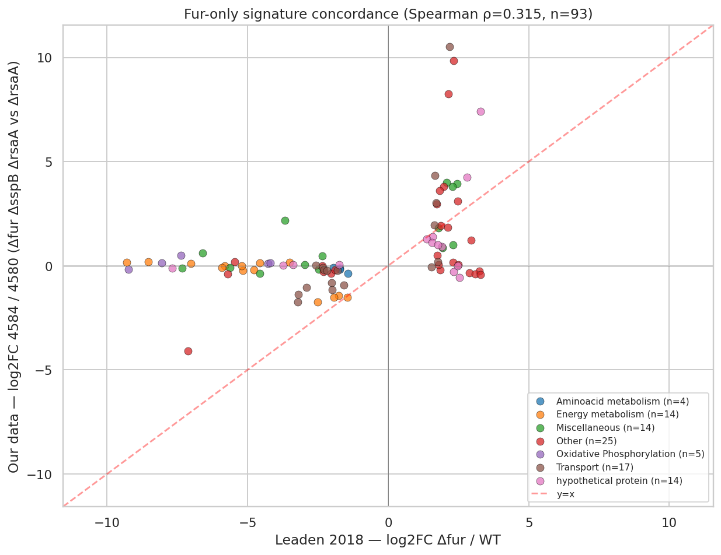
Scatter plot of Leaden 2018 Δfur log2 fold change on the x-axis versus our 4584-vs-4580 log2 fold change on the y-axis for 93 Leaden Δfur differentially expressed genes; concordant-strong genes in dark blue, ΔsspB-buffered set in orange, discordant genes in red
Figure 2. Concordance between the published Leaden 2018 Δfur transcriptome and the 4584-vs-4580 permissive-vs-parental contrast (Spearman ρ = 0.315, p = 2.08 × 10⁻³ [C-001]). The concordant-strong Path A subset (dark blue, n = 32) shows amplified derepression in the Δfur ΔsspB background. The ΔsspB-buffered Path B subset (orange, n = 53 [C-003]) clusters near zero on the ordinate despite strong negative Leaden values, reflecting ΔsspB-mediated transcript buffering of the micro-aerobic respiratory operon.
To determine whether Path A or Path B genes are selectively important under envelope-stress conditions, we performed hypergeometric enrichment analysis against a genome-background phenotype-bearing rate of 33.25% (3,943 annotated Caulobacter genes; 1,311 phenotype-bearing [C-004]). The results are summarized in Table 1. Path A (the Fur-released, concordant-strong set of 32 genes) shows marginal but real enrichment: 53.1% phenotype-bearing, fold = 1.60× over background, hypergeometric p = 0.016 [C-005, C-063]. Path B (the ΔsspB-buffered respiratory set of 26 genes) is indistinguishable from the genome background: 34.6% phenotype-bearing, fold = 1.04×, p = 0.515 [C-006, C-064]. The pre-registered ≥10% threshold, which both sets exceed, was found to fall below the 33.25% background and is therefore not informative about specific enrichment. Accordingly, the hypergeometric enrichment over background is the authoritative H2 verdict. The top Path A fitness hits include ChvT (CCNA_03108, |t| = 43.7 under envelope stress [C-007]) and four Fur-derepressed TonB-dependent transporters (CCNA_02910, CCNA_00210, CCNA_02048, CCNA_00028, |t| = 9–28 [C-008]), consistent with the broader catalog of Fur-regulated TBDTs in Caulobacter [HernandezOrtiz2025, Ferreira2016].
Table 1. Fitness phenotype enrichment of Fur-released gene sets relative to the Caulobacter genome background (33.25% phenotype-bearing, n = 3,943, K = 1,311 [C-004]).
Gene set | n | Phenotype-bearing | % | Fold vs. background | p (hypergeometric) | Verdict
Path A (concordant-strong, Fur-released TBDTs) | 32 | 17 | 53.1% [C-005] | 1.60× [C-063] | 0.016 | Marginally enriched
Path B (ΔsspB-buffered, respiratory chain) | 26 | 9 | 34.6% [C-006] | 1.04× [C-064] | 0.515 | Indistinguishable from background
The mechanistic significance of the ΔsspB-buffered respiratory operon for the ΔlpxC rescue thus remains a working hypothesis. The transcript-level buffering is real and reproducible by comparison with the Leaden dataset, and the proposition that respiratory ATP production is required to sustain envelope-remodeling work is biologically plausible; however, the RB-TnSeq fitness data do not selectively support these specific genes as more critical than randomly drawn Caulobacter loci under envelope-stress conditions.

Layer 2: ChvG–ChvI engages in two temporally distinct phases with evidence of autoregulation; SigU-as-driver of the late cohort is not supported
The union of published ChvI regulons [Stein2021, QuinteroYanes2022] comprises 488 ChvI-induced genes [C-009], which we partitioned into three disjoint cohorts based on their pattern of differential expression across the two contrasts. The pre-registered phase-structure threshold of ≥10 genes per cohort is met strongly [C-062].
The unique-to-early cohort (20 genes [C-010]) is induced in the permissive strain (4584-vs-4580) but not further after lipid A loss. It includes the lasso peptide cyclase CCNA_02794 (logFC = +8.6 [C-011]), the ApbE iron-sulfur cluster repair protein (logFC = +3.8 [C-012]), and the SOS DNA polymerase ImuB (logFC = +1.5 [C-013]). The ImuB induction corroborates Leaden et al.'s observation of SOS-response activation in the Δfur background [Leaden2018], consistent with reactive oxygen species accumulation during iron-regulatory perturbation.
The both-phase cohort (10 genes [C-010]) is induced in both contrasts, reflecting cooperative continuation of ChvI signaling through the ΔlpxC transition. ChvI itself (CCNA_00237) resides in this cohort with logFC = +1.45 in the early contrast [C-014], providing direct evidence of ChvG–ChvI autoregulation — a positive-feedback architecture consistent with the conserved alphaproteobacterial ChvG–ChvI circuit [Greenwich2023]. The SIMPL-family protein CCNA_02378 is also in the both-phase cohort, showing escalating induction from logFC = +1.9 in 4584-vs-4580 to +3.9 in 4599-vs-4584 [C-015], suggesting a role that intensifies when LPS is removed.
The late-consequence cohort (49 genes [C-010]) is induced exclusively after lipid A loss. It includes the LolA-family outer-membrane lipoprotein carrier CCNA_03820 (logFC = +2.89 [C-016]) — the same gene shown by Uchendu et al. to be induced under Δspt (sphingolipid loss) [Uchendu2026] — indicating that LolA upregulation is a generic outer-membrane stress response in Caulobacter triggered by perturbation of either major outer-membrane lipid class. The late cohort also includes the Pal-like lipoprotein CCNA_00784 (logFC = +2.08 [C-017]), which is further discussed in the context of PG remodeling below.
We tested the hypothesis that SigU (CCNA_02977) drives the functional coherence of the late cohort. A literature scout via PaperBLAST returned no substantive snippets characterizing SigU in Caulobacter; this sigma factor is functionally uncharacterized, precluding validation against an external gold standard. Applying a relaxed coherence criterion requiring ≥50% of late-cohort genes to be annotated to envelope/transport/regulator functions, we observed 24.5% [C-018] — below the pre-registered threshold (Fisher's exact p = 0.243 [C-018]). The phase-structure component of H1 is supported; the SigU-as-driver component is partial and awaits targeted SigU-induction RNA-seq for resolution.

Layer 3: Sphingolipid biosynthesis is constitutive; the canonical Lpt apparatus shows transcript–proteome discordance; CtpA is formally rejected
H3 comprised three pre-registered sub-claims tested by panel analysis of the sphingolipid biosynthesis cluster (Figure 3), the canonical Lpt apparatus (Figure 4), and the candidate LpxF-substitute CtpA. Table 2 summarizes the verdict for each sub-claim.
The first sub-claim — that sphingolipid biosynthesis would be constitutive rather than induced in the rescued state — is strongly supported. Zero of six biosynthesis genes (including spt, bcerS, cerR, cpgB, cpgD, and sphk) are upregulated at FDR < 0.05 in the rescued-vs-permissive contrast [C-020]. spt (CCNA_01220, encoding serine palmitoyltransferase) shows logFC = −0.64 (FDR = 0.002 [C-021]) and sphk (CCNA_01218, sphingosine kinase) shows logFC = −0.40 (FDR = 0.02 [C-022]), both mildly downregulated. This result is consistent with the established biochemistry of the CPG pathway [Dhakephalkar2023, Dhakephalkar2025] showing constitutively active enzymes, and with the requirement for pre-existing CPG for lpxC-deletion viability [Zik2022]. The rescue is therefore flux-driven from an existing CPG pool, not driven by transcriptional upregulation of biosynthesis; this rules out a model in which Δfur derepresses the sphingolipid biosynthesis locus as the primary enabling mechanism.
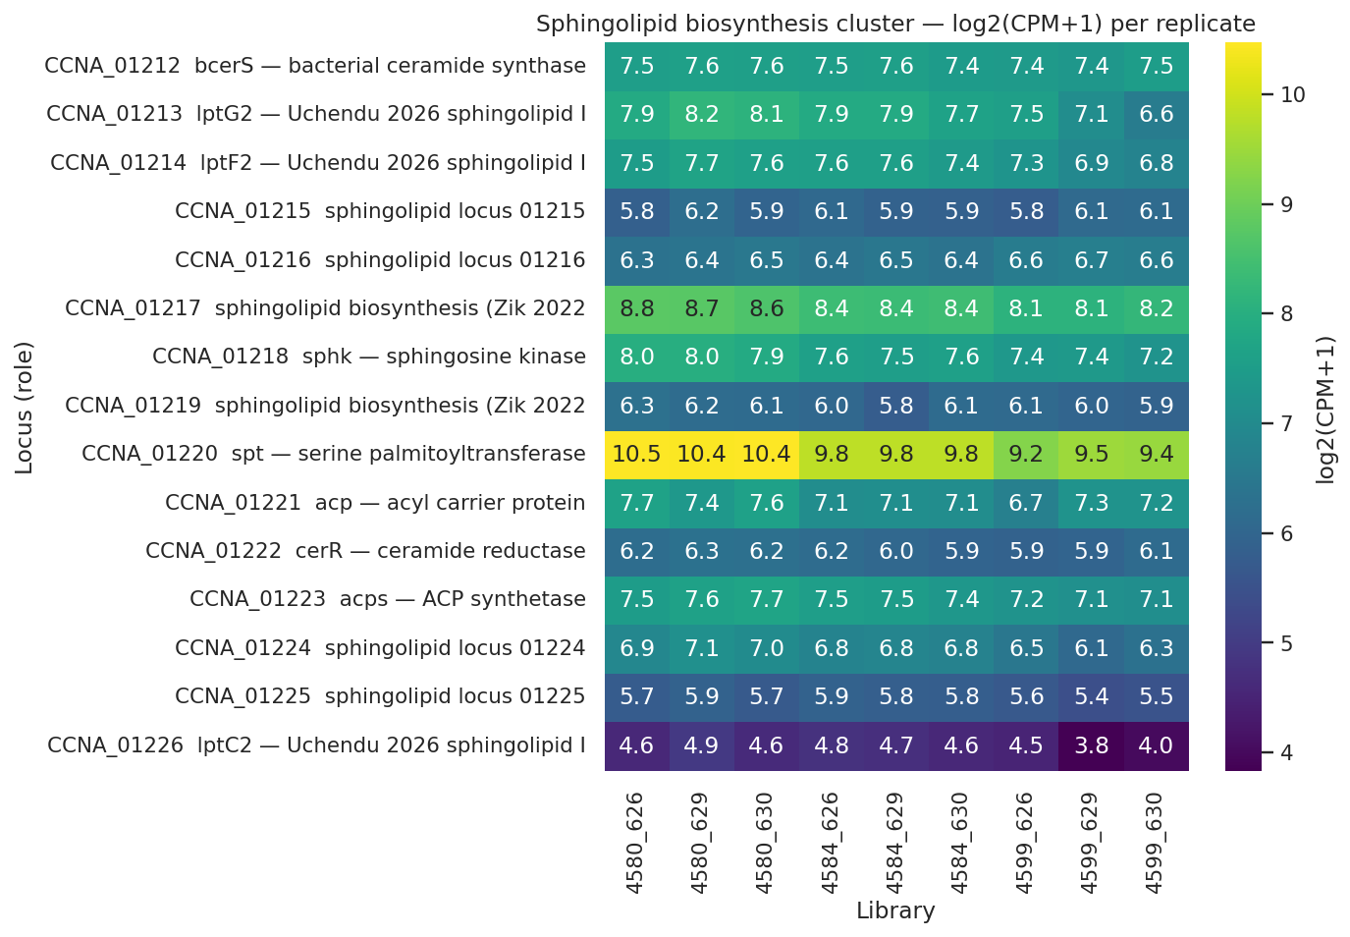
Heatmap of the sphingolipid biosynthesis locus log2-CPM+1 per replicate across the three-strain series showing flat-to-slightly-decreasing expression in the rescued strain
Figure 3. Sphingolipid biosynthesis cluster expression across the strain series (log₂(CPM+1) per replicate). Zero of six biosynthesis genes are upregulated in the rescued-vs-permissive contrast [C-020]. spt (logFC = −0.64, FDR = 0.002 [C-021]) and sphk (logFC = −0.40, FDR = 0.02 [C-022]) are mildly downregulated, indicating that CPG production is constitutive and is not transcriptionally induced by lipid A loss.
The second sub-claim — that the canonical Lpt apparatus is maintained or upregulated at the transcript level — is supported. No Lpt component is downregulated at transcript level [C-023]. The MsbA-like flippase CCNA_00307 (logFC = +0.89, FDR = 0.01 [C-024]) and the LptC-related CCNA_03716 (logFC = +0.56, FDR = 0.005 [C-025]) are significantly upregulated in the rescued strain, consistent with the shared-component model of Uchendu et al. in which canonical Lpt machinery participates in sphingolipid transport [Uchendu2026]. However, the two canonical Lpt components actually detected in the single-replicate outer membrane proteome — LptD (CCNA_01760) and LptE (CCNA_03866) — show declining protein levels in the rescued strain relative to both the permissive intermediate (LptD: log₂(4672/4659) = −0.47 [C-026]; LptE: −0.78 [C-027]) and the WT-like parental strain (LptD: log₂(4672/4580) = −0.62 [C-028]; LptE: −0.68 [C-029]).
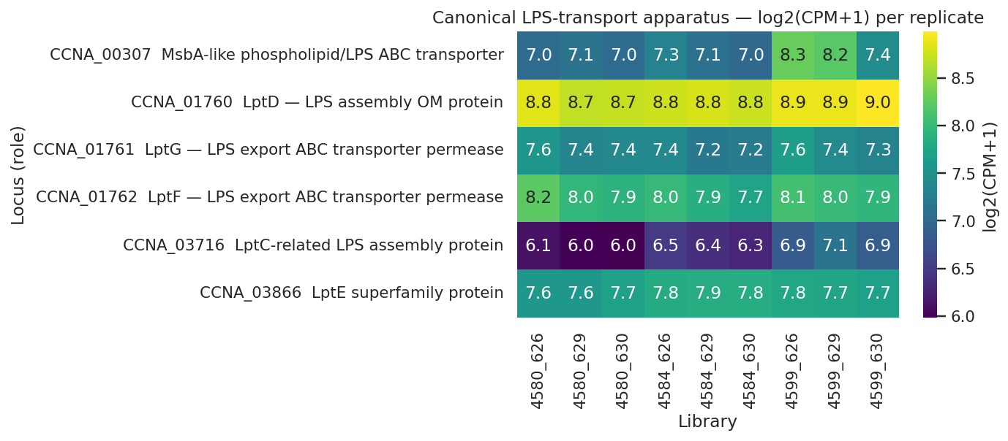
Heatmap of the canonical Lpt LPS-transport apparatus log2-CPM+1 per replicate across the strain series showing MsbA-like CCNA_00307 visibly elevated in the rescued strain while LptD and LptE are detected at lower levels
Figure 4. Canonical Lpt apparatus expression across the strain series. No component is downregulated at the transcript level [C-023]; the MsbA-like CCNA_00307 (logFC = +0.89, FDR = 0.01 [C-024]) and LptC-related CCNA_03716 (logFC = +0.56, FDR = 0.005 [C-025]) are upregulated. Despite transcript-level support for the Uchendu shared-component model [Uchendu2026], the two canonical Lpt proteins detected in the outer membrane proteome — LptD (log₂(4672/4659) = −0.47 [C-026]) and LptE (log₂(4672/4659) = −0.78 [C-027]) — decline in the rescued strain. The transcript–proteome discordance cannot be resolved by a single-replicate experiment.
This transcript–proteome discordance cannot be resolved by a single biological replicate. The E. coli LptB–LptC interaction provides the mechanistic context in which the shared ATPase is rate-limiting for Lpt machine assembly [Martorana2016]; under this framework, one interpretation is that canonical LptD and LptE are reduced because the LPS-specific channel (for which they are the major outer membrane component) has reduced substrate flux when LPS is absent, leading to partial protein turnover. Replicated outer membrane proteomics are required to adjudicate between this and alternative interpretations.
The third sub-claim — CtpA (CCNA_03113) upregulation as the LpxF-equivalent processing step [Zik2022] — is formally rejected at the pre-registered bar. In the 4599-vs-4584 contrast designed to isolate the ΔlpxC-specific response, CtpA shows logFC = +0.58, p-value = 0.048, FDR = 0.109 at the transcript level, and is absent from the outer membrane proteome [C-019]. The p-value of 0.048 fails the BORDERLINE criterion's lower bound (0.05 < p-value); the FDR of 0.109 fails the PASS criterion (FDR < 0.05); and protein non-detection means the secondary BORDERLINE condition is also unmet. A cumulative contrast comparing the rescued strain to the WT-like parental (4599-vs-4580) yields FDR = 0.035, but this contrast conflates Δfur, ΔsspB, and ΔlpxC effects and was not pre-registered as a test of the LpxF-substitute hypothesis. CtpA's proposed role in lipid A head-group phosphatase activity [Zik2022] therefore remains untested by the present work and requires dedicated genetic or biochemical interrogation.
A pilot observation deserving replication: the Uchendu-identified sphingolipid inner-membrane transporter LptC2 (CCNA_01226) shows a transcript logFC of −0.60 (FDR = 0.034 [C-030]) with a protein log₂(4672/4659) = +1.08 in the single-replicate proteome [C-031]. Because LptC2 protein was already at log₂(4659/4580) = −0.42 relative to the WT-like parental [C-032], the net protein change in the rescued strain versus WT is +0.66 log₂ (approximately 1.58× [C-033]) — a more modest effect that partially reflects recovery from a prior decrease in the permissive intermediate. The transcript-protein decoupling is consistent with post-transcriptional stabilization of LptC2 protein when competition for the shared LptB ATPase is reduced by the loss of LPS cargo [Uchendu2026], but the single-replicate nature of the observation precludes statistical confirmation. The sphingolipid-biosynthesis gene CCNA_01217, required for CHIR-090 tolerance in Caulobacter [Zik2022], shows protein log₂(4672/4659) = +0.77 [C-034] and log₂(4672/4580) = +0.74 [C-035], also consistent with elevated sphingolipid processing capacity in the rescued state — and also requiring replicated proteomics for confirmation.
Table 2. H3 sub-claim scorecard for sphingolipid biosynthesis, Lpt apparatus, and CtpA.
Sub-claim | Key observations | Verdict
CtpA (CCNA_03113) upregulation in 4599-vs-4584 | logFC = +0.58, p = 0.048, FDR = 0.109 [C-019]; protein not detected | REJECTED at pre-registered bar
Sphingolipid biosynthesis constitutive | 0/6 genes UP [C-020]; spt logFC = −0.64, FDR = 0.002 [C-021]; sphk logFC = −0.40, FDR = 0.02 [C-022] | SUPPORTED strongly
Canonical Lpt apparatus maintained at transcript level | 0 components DOWN [C-023]; MsbA-like +0.89, FDR = 0.01 [C-024]; LptC-related +0.56, FDR = 0.005 [C-025] | SUPPORTED at transcript level
Canonical Lpt at protein level (post-hoc) | LptD log₂(4672/4659) = −0.47 [C-026]; LptE = −0.78 [C-027] | DISCORDANT with transcript; single replicate
lptC2 protein induction (pilot) | Transcript −0.60, FDR = 0.034 [C-030]; protein +1.08 vs. intermediate [C-031]; +0.66 net vs. WT [C-033] | PILOT — requires replicated proteomics

Layer 4: Peptidoglycan remodeling involves targeted lytic-enzyme induction on a backdrop of broad basal shutdown
Of the 53 PG-remodeling gene loci locked before differential expression analysis [C-036], 28 met the H4 significance criterion (FDR < 0.05 at transcript or |log₂| > 1 in the outer membrane proteome), comprising 25 transcript-significant genes and 6 proteome-significant proteins deduplicated to 28 unique loci [C-037, C-038]. The H4 pre-registered threshold of ≥3 responding enzymes is exceeded strongly. The directional composition is predominantly downregulatory: 20 of the 28 loci are downregulated [C-039], reflecting broad shutdown of the basal division and elongation PG machinery, while 5 genes are upregulated at the transcript level and 3 at the protein level.
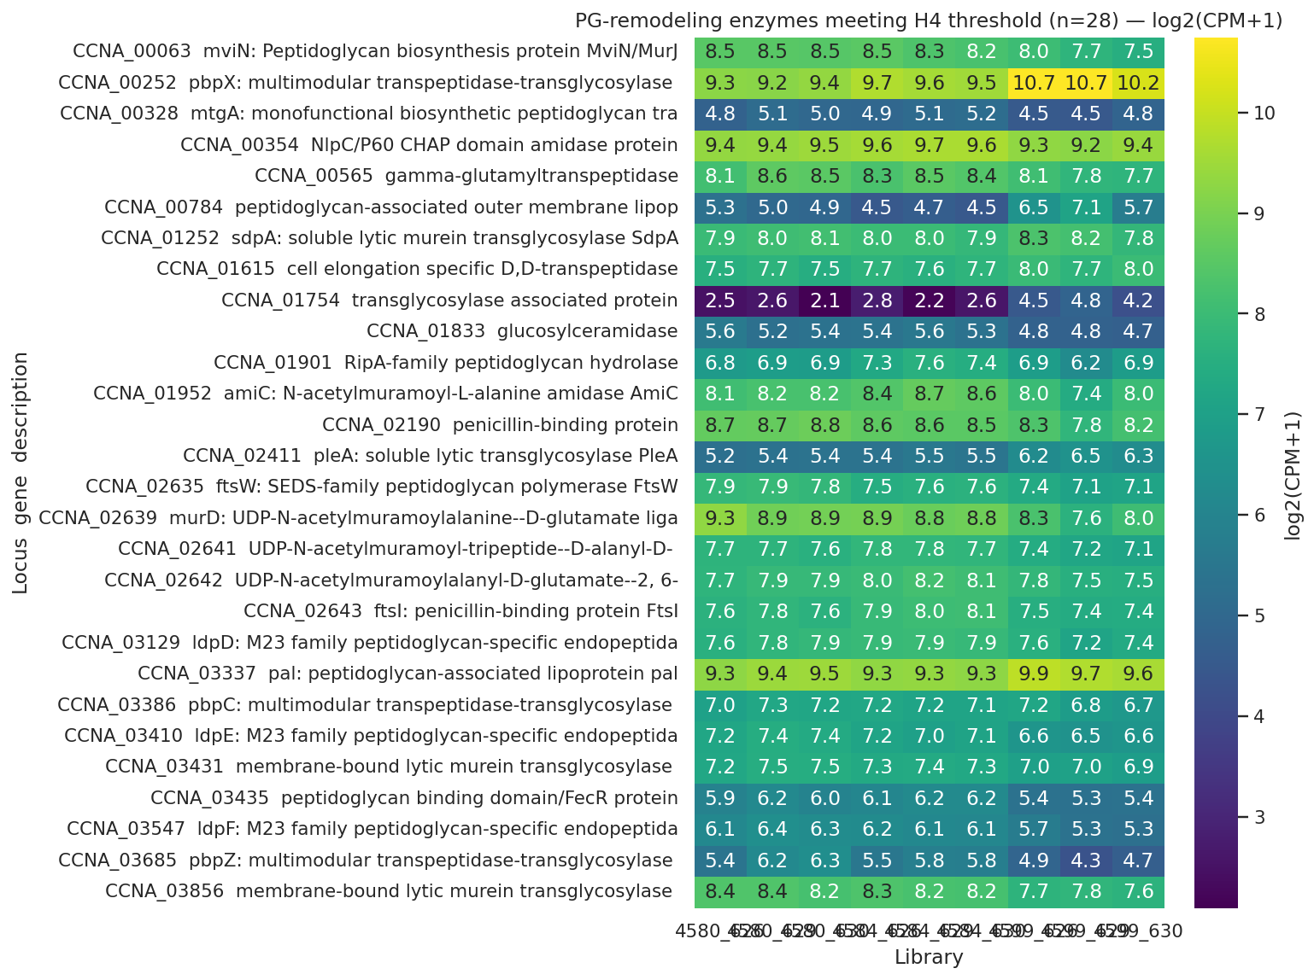
Heatmap of the 28 PG-remodeling loci meeting H4 threshold, showing log2 fold changes across the strain series with predominant downregulation of cell-division and cell-elongation machinery and specific inductions of lytic transglycosylases and Tol-Pal components
Figure 5. Peptidoglycan remodeling in the rescued Δlpxc strain. Twenty of 28 significant loci are downregulated [C-039], including PbpZ (logFC = −1.08 [C-042]), PbpC (log₂ = −1.15 OM protein [C-043]), D,D-transpeptidase (log₂ = −1.27 OM protein [C-044]), and membrane-bound transglycosylase A (log₂ = −2.47 OM protein [C-045]). The highest-magnitude induction is the soluble lytic murein transglycosylase SdpA (log₂ = +4.8 OM protein [C-040]). The Tol-Pal complex component Pal (CCNA_00784) is upregulated at both transcript (logFC = +2.08 [C-041]) and protein (log₂ = +2.84 [C-041]) levels.
The downregulated set encompasses enzymes of the cell-division and elongation PG machinery: the class B penicillin-binding proteins PbpZ and PbpC, a D,D-transpeptidase, the PG biosynthesis enzyme MurD, the flippase MviN/MurJ, multiple M23-family LdpD/E/F endopeptidases, the amidase AmiC, the hydrolase RipA, and membrane-bound transglycosylase A at log₂ = −2.47 [C-045]. Against this backdrop of basal machinery shutdown, the soluble lytic murein transglycosylase SdpA shows the highest-magnitude induction in the entire PG dataset (log₂ = +4.8 OM protein [C-040]), likely reflecting targeted outer membrane-accessible lytic transglycosylase activity during the OM remodeling process when PG crosslink architecture must accommodate the transition from an LPS-anchored to a sphingolipid-containing outer membrane.
The Pal-like CCNA_00784 upregulation at both transcript (logFC = +2.08 [C-041]) and outer membrane protein (log₂ = +2.84 [C-041]) levels warrants particular attention. This gene is also a member of the late ChvI consequence cohort (Finding 3), representing convergent evidence from two independent analytic frameworks. Pal is the PG-associated outer-membrane lipoprotein component of the Tol-Pal envelope-integrity complex. The primary function of the Tol-Pal complex has recently been re-evaluated by Tan and Chng [Tan2025], whose engineered E. coli chimeric-Tol-Pal experiments established that the complex's primary role is retrograde phospholipid transport for outer-membrane lipid homeostasis rather than structural reinforcement via LPS-anchored protein interactions. In Caulobacter, the Tol-Pal complex is essential for outer-membrane integrity and outer-membrane constriction at cell division [Yeh2010] — unlike its dispensable E. coli counterpart — meaning that Pal upregulation in the Δlpxc rescued state has both a homeostatic and a cell-division-essential interpretation. The most parsimonious mechanistic reading under the Tan–Chng framework is that Pal upregulation increases retrograde phospholipid transport capacity to restore outer-membrane lipid asymmetry when LPS is absent from the outer leaflet, while simultaneously maintaining the Pal-mediated PG contact required for cell division [Yeh2010].

Comparative genomics: the Caulobacter sphingolipid pathway and ChvG–ChvI are absent from the comparator species
The initial PaperBLAST survey [Price2017] suggested species-specific restriction of the Caulobacter sphingolipid biosynthesis pathway and ChvG–ChvI circuit, but was complicated by discovery of approximately 80% false-negative rates for known Caulobacter lipid A biosynthesis genes — LpxA, LpxC, LpxD, and LpxK each returned zero PaperBLAST hits for C. crescentus despite NCBI confirming 11, 15, 15, and 18 annotation hits, respectively [C-048, C-049, C-050, C-061]. This rate was uncovered by the NB06b cross-check and reflects limitations of PaperBLAST text matching for genes annotated in Caulobacter under non-canonical or species-specific gene symbols rather than E. coli-derived gene names.
NCBI Entrez annotation-based confirmatory analysis (notebook 06b) validated the headline biological claims. Table 3 summarizes the confirmed NCBI patterns. spt (serine palmitoyltransferase) shows a pattern of 1000 — present in C. crescentus, absent in A. baumannii, N. meningitidis, and M. catarrhalis [C-053]. cerR (ceramide reductase) shows pattern 1000 [C-054]. ChvG (sensor kinase) shows pattern 1000 [C-055]. ChvI (response regulator) shows pattern 1000 [C-056]. These NCBI-confirmed patterns are consistent with the published phylogenetic restriction of the Caulobacter sphingolipid pathway [OleaOzuna2021, OleaOzuna2024] and the alphaproteobacterial restriction of the ChvG–ChvI circuit [Greenwich2023].
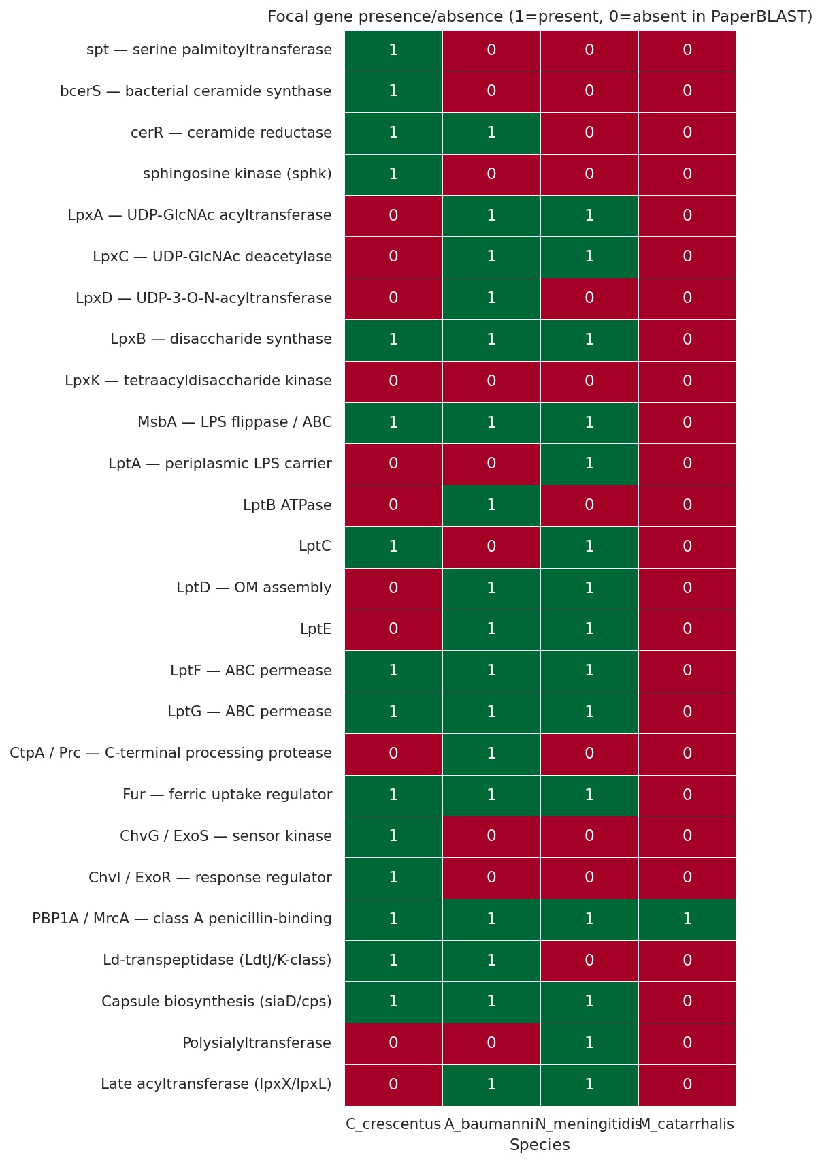
Presence/absence heatmap of focal gene families across Caulobacter crescentus, Acinetobacter baumannii, Neisseria meningitidis, and Moraxella catarrhalis based on PaperBLAST text-mining with NCBI annotation confirmation for headline claims
Figure 6. Comparative presence/absence of focal gene families across four Gram-negative species with documented or candidate lipid A dispensability. NCBI annotation (notebook 06b) confirms that spt [C-053], cerR [C-054], ChvG [C-055], and ChvI [C-056] each show pattern 1000 (present in C. crescentus only). The PaperBLAST false-negative rate for Caulobacter lipid A biosynthesis genes is approximately 80% [C-061], but the headline claims concern absence in the comparator species, where NCBI annotation confirms the PaperBLAST result.
Table 3. NCBI annotation presence/absence for key gene families across four Gram-negative species (pattern: C. crescentus/A. baumannii/N. meningitidis/M. catarrhalis; 1 = present, 0 = absent).
Gene/family | NCBI pattern | Interpretation
spt — serine palmitoyltransferase | 1000 [C-053] | Caulobacter-unique; CONFIRMED
cerR — ceramide reductase | 1000 [C-054] | Caulobacter-unique; CONFIRMED
ChvG — sensor kinase | 1000 [C-055] | Alphaproteobacterial-restricted; CONFIRMED
ChvI — response regulator | 1000 [C-056] | Alphaproteobacterial-restricted; CONFIRMED
The three comparator species each achieve LPS dispensability via routes encoded by their own genomic repertoires. A. baumannii uses ld-transpeptidase PG remodeling involving PBP1A, LdtJ, and LdtK [Kang2021], with a repertoire of lpxX/lpxL-family late acyltransferases (8 PaperBLAST hits [C-058]) that enable structural LPS modification as an intermediate step [Moffatt2010, Moffatt2011]. N. meningitidis relies on its large capsule biosynthesis locus (9 PaperBLAST hits [C-057] [Steeghs2001, Ley2003]) to compensate structurally for LPS absence; it also carries lpxX/lpxL late acyltransferases (3 hits [C-059]) for structural LPS modifications. M. catarrhalis achieves viability with structurally truncated LPS rather than fully absent LPS, via late-acyltransferase modification [Gao2008, Gao2013]. Caulobacter encodes none of these alternatives: 0 hits for lpxX/lpxL-family late acyltransferases [C-060], no capsule biosynthesis locus, and no ld-transpeptidase expansion equivalent to the A. baumannii LdtJ/LdtK pair. These absences further confirm that the sphingolipid substitution is not merely the preferred route for Caulobacter but the only available one.

Discussion
The data presented here define the transcriptional and proteomic architecture of Δfur-permitted lipid A dispensability in C. crescentus at the resolution of individual mechanistic sub-claims, each assigned a specific evidence grade. The picture that emerges is one in which constitutive CPG sphingolipid substitution provides the structural substrate, ChvG–ChvI regulatory signaling is specifically co-opted through two temporal phases to coordinate the cellular response to LPS loss, and PG reorganization accommodates the mechanical consequences of outer-membrane remodeling — all in a species in which both the sphingolipid pathway and the ChvG–ChvI circuit are uniquely present.
The Δfur derepression arm (Path A) is the most robustly supported layer. The Spearman concordance with Leaden 2018 [Leaden2018] and the characteristic derepression of TBDTs cataloged by da Silva Neto et al. [Neto2009] and Hernandez-Ortiz et al. [HernandezOrtiz2025] confirm that the 4584-vs-4580 transcriptome authentically represents the Fur-derepression state. The marginal fitness enrichment of the concordant-strong subset (fold = 1.60×, p = 0.016 [C-005]) is a genuine enrichment, not a threshold-crossing artifact; the recalibrated hypergeometric test against the 33.25% genome background [C-004] provides the appropriate reference.
In contrast, the ΔsspB-buffered respiratory cohort (Path B) does not achieve fitness enrichment above background (fold = 1.04×, p = 0.515 [C-006]). The biologically reasonable proposition that respiratory ATP production specifically sustains envelope-remodeling work is not falsified — it remains a plausible mechanistic model — but the RB-TnSeq data do not provide independent selective evidence for it. Earlier narrative framings treating the dual-release switch (Δfur arm + ΔsspB respiratory arm) as symmetrically established must be corrected: the Δfur arm is supported by both concordance analysis and marginal fitness enrichment, while the ΔsspB arm rests on transcript-level buffering without fitness corroboration.
The ChvG–ChvI two-phase engagement is the second well-supported layer. The disjoint partition of 20 unique-to-early, 10 both-phase, and 49 late-consequence genes [C-010] demonstrates that ChvI does not respond as a monolithic stress regulon but temporally discriminates the Δfur/ΔsspB perturbation from the added structural challenge of LPS removal. ChvI autoregulation in the both-phase cohort (logFC = +1.45 [C-014]) is consistent with the positive-feedback architecture of the alphaproteobacterial circuit [Greenwich2023], in which activated ChvI sustains its own expression via ChvG-phosphorylated ChvI promoting further ChvI transcription. The convergence of LolA-family CCNA_03820 induction in both the late ChvI cohort and the Uchendu et al. Δspt dataset [Uchendu2026] is particularly notable: a single gene induced when either major outer-membrane lipid class (LPS or sphingolipid) is removed implies that LolA upregulation is a generic outer-membrane stress response rather than a LPS-specific compensatory mechanism. The SigU-as-driver hypothesis for the late cohort fails the pre-registered functional coherence threshold (24.5% [C-018]) primarily because Caulobacter SigU is uncharacterized in the published literature — the test cannot be validated against an external gold standard and is therefore partial rather than falsified.
The constitutive sphingolipid biosynthesis finding (Layer 3) rules out a model in which Δfur enables lipid A dispensability by derepressing CPG biosynthesis. Zero biosynthesis genes are induced; spt and sphk are mildly downregulated [C-020, C-021, C-022]. The constitutive activity of the CPG pathway enzymes CpgB [Dhakephalkar2023] and CpgD [Dhakephalkar2025] under non-inducing conditions is consistent with a flux-driven model in which the existing CPG pool is available for outer-membrane substitution without transcriptional upregulation. The mild downregulation may reflect feedback suppression once the outer membrane is populated with sphingolipid under reduced LPS competition for the shared transport channel [Uchendu2026].
The rejection of CtpA as the LpxF-substitute processing step represents an important clarification. CtpA's failure at the pre-registered bar [C-019] does not falsify the enzymatic hypothesis proposed by Zik et al. [Zik2022] — that CtpA performs lipid-A head-group phosphatase activity equivalent to LpxF in organisms such as Rhizobium — but it establishes that the ΔlpxC-specific induction of CtpA at both transcript and protein levels is not detectable by the present transcriptome-proteome contrast. Earlier draft reports of a BORDERLINE verdict for CtpA were in error: the p-value of 0.048 falls below, not within, the BORDERLINE range of 0.05 < p-value < 0.15, and the cumulative contrast FDR of 0.035 is not the pre-registered test. Future work should test CtpA by constructing a ΔctpA ΔlpxC Δfur ΔsspB quadruple deletion to determine whether CtpA is required for the rescue, and should pursue in vitro demonstration of head-group phosphatase activity.
The Lpt apparatus transcript–proteome discordance poses an unresolved interpretive challenge. The transcript upregulation of MsbA-like and LptC-related components is consistent with the Uchendu shared-component model [Uchendu2026]; the protein-level decline of canonical LptD and LptE [C-026, C-027] is not straightforwardly consistent with it. The most parsimonious reconciliation is substrate-limitation: canonical LptD and LptE are the outer-membrane docking and extraction components specifically optimized for LPS as a substrate; in its absence, the canonical Lpt channel has reduced throughput and is partially turned over while the sphingolipid-specific LptC2/LptF2/LptG2 paralogs fill the vacancy [Uchendu2026]. The pilot lptC2 protein elevation (+1.08 log₂ vs. the permissive intermediate [C-031]) supports but does not establish this scenario. Replicated outer membrane proteomics with statistical rigor are scheduled for summer 2026.
The Pal-Tol upregulation provides perhaps the most mechanistically interpretable PG finding, particularly in the light of the Tan–Chng 2025 redefinition of Tol-Pal primary function [Tan2025]. The classic attribution of Pal's role to LPS-anchored structural reinforcement of the outer membrane is not supported by the current mechanistic literature; the primary function is retrograde phospholipid transport for outer-membrane lipid homeostasis [Tan2025]. Under the revised framework, Pal upregulation in the Δlpxc state is expected rather than paradoxical: removal of LPS from the outer leaflet disrupts outer-membrane lipid asymmetry, and upregulation of the Tol-Pal complex increases retrograde phospholipid transport capacity to compensate. Because Caulobacter Tol-Pal is essential for outer-membrane constriction at cell division [Yeh2010] — a function that must be maintained even without LPS — Pal upregulation is mechanistically necessary, not merely compensatory. Pal is induced as both a member of the late ChvI consequence cohort (Layer 2) and a PG-remodeling effector (Layer 4) — convergent evidence from two independent analytic frameworks that is consistent with, but does not establish, ChvI regulation of Pal in this state.
The species-specificity data confirm that the Caulobacter strategy is not transferable to any of the three comparator Gram-negative species with known or candidate LPS dispensability. The NCBI-confirmed pattern-1000 absences of spt, cerR, ChvG, and ChvI from A. baumannii, N. meningitidis, and M. catarrhalis [C-053, C-054, C-055, C-056] establish a genomic basis for the species specificity. The clinical-microbiology interest in understanding and potentially reversing LPS-null A. baumannii colistin resistance [Moffatt2010, Moffatt2011, Kang2021] therefore cannot draw direct mechanistic lessons from the Caulobacter sphingolipid + Fur strategy, except at the high level of principle that envelope-remodeling accompanies the outer-membrane transition. The mechanistic diversity of LPS-dispensability routes [Hummels2024] reflects deep structural differences among Gram-negative OM repertoires that determine which compensatory strategies are genomically available in each lineage.

Limitations
The outer membrane proteome is a single biological replicate per strain. No per-protein statistics are derivable, and all protein-level claims — including the LptC2 pilot induction, the LptD/LptE protein-level decline, the SdpA and Pal upregulations, and the CCNA_01217 protein elevation — represent directional observations awaiting confirmation from replicated proteomics. The entire transcriptome was collected under a single growth condition (PYE rich medium), making the Fur-derepression signal constitutive rather than iron-limitation-responsive; because the Caulobacter fitness compendium contains no iron-limitation experiments [C-065], the iron-axis arm of H2 was formally descoped. The pre-registered H2 fitness threshold of ≥10% phenotype-bearing was found to fall below the 33.25% genome background [C-004], a calibration error that has been corrected by adopting hypergeometric enrichment as the authoritative H2 verdict; this calibration lesson should inform future pre-registrations in this research program. The SigU cohort attribution is partial because Caulobacter SigU is uncharacterized in the published literature, precluding external validation of any coherence criterion. PaperBLAST shows approximately 80% false-negative rates for Caulobacter lipid A biosynthesis genes [C-061]; for the comparative claims, however, the headline argument concerns absence in the comparator species, which NCBI annotation independently confirms.

Conclusions
This study characterizes the transcriptional and proteomic architecture of Δfur-permitted lipid A dispensability in C. crescentus at the resolution of individual mechanistic sub-claims, each assigned an honest evidence grade. Three layers are well-supported: constitutive CPG sphingolipid substitution provides the structural substrate for outer-membrane rescue; the ChvG–ChvI two-component system coordinates a two-phase regulatory response distinguishing the Δfur/ΔsspB perturbation (early cooperator phase, 20 genes) from LPS-loss consequences (late phase, 49 genes); and PG remodeling — dominated by basal machinery shutdown with targeted induction of lytic transglycosylases and the Tol-Pal complex — mechanically accommodates the outer-membrane transition. A fourth layer, Fur-released TBDT fitness enrichment, is marginally supported. Two sub-claims are formally rejected: the ΔsspB-buffered respiratory arm shows no enrichment above the genome background, and CtpA does not meet the pre-registered transcript and proteome criteria for the LpxF-substitute role. The Lpt apparatus shows transcript–proteome discordance that replicated proteomics will resolve; an lptC2 protein-level pilot observation is suggestive but single-replicate. Comparative genomics confirms that the sphingolipid pathway and ChvG–ChvI circuit are absent from A. baumannii, N. meningitidis, and M. catarrhalis, establishing the genomic basis for the species-specificity of the Caulobacter rescue. Together, these findings describe a species-specific multi-layer envelope-remodeling strategy and provide a foundation for understanding how an alphaproteobacterium navigates the complete removal of its major surface-exposed lipid component.

Data Availability
All RNA-seq count data, RB-TnSeq fitness scores, outer membrane proteome label-free quantification ratios, and intermediate analysis tables generated in this study are archived in the BERDL KBase workspace (project caulobacter_fur_lipida_loss) [Arkin2018]. Jupyter notebooks 00_orientation.ipynb through 07_synthesis.ipynb, together with all generated data files listed in Supporting Information, are available in the project repository at [REPOSITORY URL TO BE PROVIDED]. Fitness data were obtained from the BERDL kescience_fitnessbrowser database [Price2018, Arkin2018]. Comparative genomics data were obtained from the BERDL kescience_paperblast database [Price2017] and from NCBI Entrez protein annotation accessed via Biopython (2025–2026).

AI Disclosure
This manuscript was prepared with the assistance of a generative artificial intelligence system (Anthropic Claude) operating within the BERIL Research Observatory pipeline. AI tools were used to draft and structure the text, integrate quantitative results from the project's analytical notebooks, and format citations. All analyses, hypotheses, quantitative results, and scientific interpretations were generated, directed, and verified by the human authors, who take full responsibility for the integrity, accuracy, and originality of the work, including all content produced with AI assistance. The AI system is not an author and does not meet the ICMJE criteria for authorship. No AI system was used to generate or fabricate data, results, or references.

References
Arkin2018: Arkin AP, Cottingham RW, Henry CS, Harris NL, Stevens RL, Maslov S, Dehal P, Ware D, Perez F, Canon S, et al. KBase: The United States Department of Energy Systems Biology Knowledgebase. Nat Biotechnol. 2018;36(7):566–569. doi:10.1038/nbt.4163. PMID:29979655.
Balhesteros2017: Balhesteros H, Shipelskiy Y, Long NJ, Majumdar A, Katz BB, Santos NM, Leaden L, Newton SM, Marques MV, Klebba PE. TonB-Dependent Heme/Hemoglobin Utilization by Caulobacter crescentus HutA. J Bacteriol. 2017;199(6):e00723-16. doi:10.1128/JB.00723-16. PMID:28031282.
Bhat2013: Bhat NH, Vass RH, Stoddard PR, Shin DK, Chien P. Identification of ClpP substrates in Caulobacter crescentus reveals a role for regulated proteolysis in bacterial development. Mol Microbiol. 2013;88(6):1083–1092. doi:10.1111/mmi.12241. PMID:23647068.
Dhakephalkar2023: Dhakephalkar T, Stukey GJ, Guan Z, Carman GM, Klein EA. Characterization of an evolutionarily distinct bacterial ceramide kinase from Caulobacter crescentus. J Biol Chem. 2023;299(7):104894. doi:10.1016/j.jbc.2023.104894. PMID:37286040.
Dhakephalkar2025: Dhakephalkar T, Guan Z, Klein EA. CpgD is a phosphoglycerate cytidylyltransferase required for ceramide diphosphoglycerate synthesis. bioRxiv. 2025. doi:10.1101/2025.01.09.632243. PMID:39829823.
Ferreira2016: de Castro Ferreira IG, Rodrigues MM, da Silva Neto JF, Mazzon RR, do Valle Marques M. Role and regulation of ferritin-like proteins in iron homeostasis and oxidative stress survival of Caulobacter crescentus. Biometals. 2016;29(5):851–862. doi:10.1007/s10534-016-9956-y. PMID:27484774.
Flynn2004: Flynn JM, Levchenko I, Sauer RT, Baker TA. Modulating substrate choice: the SspB adaptor delivers a regulator of the extracytoplasmic-stress response to the AAA+ protease ClpXP for degradation. Genes Dev. 2004;18(18):2292–2301. doi:10.1101/gad.1240104. PMID:15371343.
Gao2008: Gao S, Peng D, Zhang W, Muszynski A, Carlson RW, Gu XX. Identification of two late acyltransferase genes responsible for lipid A biosynthesis in Moraxella catarrhalis. FEBS J. 2008;275(20):5201–5214. doi:10.1111/j.1742-4658.2008.06651.x. PMID:18795947.
Gao2013: Gao S, Ren D, Peng D, Zhang W, Muszynski A, Carlson RW, Gu XX. Late acyltransferase genes lpxX and lpxL jointly contribute to the biological activities of Moraxella catarrhalis. J Med Microbiol. 2013;62(Pt 6):807–812. doi:10.1099/jmm.0.056846-0. PMID:23475908.
Greenwich2023: Greenwich JL, Heckel BC, Alakavuklar MA, Fuqua C. The ChvG-ChvI Regulatory Network: A Conserved Global Regulatory Circuit Among the Alphaproteobacteria with Pervasive Impacts on Host Interactions and Diverse Cellular Processes. Annu Rev Microbiol. 2023;77:131–148. doi:10.1146/annurev-micro-120822-102714. PMID:37040790.
HernandezOrtiz2025: Hernandez-Ortiz S, Ok K, O'Halloran TV, Fiebig A, Crosson S. A co-conserved gene pair supports Caulobacter iron homeostasis during chelation stress. J Bacteriol. 2025;207(4):e0048424. doi:10.1128/jb.00484-24. PMID:40084995.
Hummels2024: Hummels KR. mSphere of Influence: Celebrating exceptions to the rule of lipid A essentiality. mSphere. 2024;9(3):e0063323. doi:10.1128/msphere.00633-23. PMID:38421175.
Kang2021: Kang KN, Kazi MI, Biboy J, Gray J, Bovermann H, Ausman J, Boutte CC, Vollmer W, Boll JM. Septal Class A Penicillin-Binding Protein Activity and ld-Transpeptidases Mediate Selection of Colistin-Resistant Lipooligosaccharide-Deficient Acinetobacter baumannii. mBio. 2021;12(1):e02185-20. doi:10.1128/mBio.02185-20. PMID:33402533.
Langklotz2011: Langklotz S, Schakermann M, Narberhaus F. Control of lipopolysaccharide biosynthesis by FtsH-mediated proteolysis of LpxC is conserved in enterobacteria but not in all gram-negative bacteria. J Bacteriol. 2011;193(5):1090–1097. doi:10.1128/JB.01043-10. PMID:21193611.
Leaden2018: Leaden L, Silva LG, Ribeiro RA, Dos Santos NM, Lorenzetti APR, Alegria TGP, Schulz ML, Medeiros MHG, Koide T, Marques MV. Iron Deficiency Generates Oxidative Stress and Activation of the SOS Response in Caulobacter crescentus. Front Microbiol. 2018;9:2014. doi:10.3389/fmicb.2018.02014. PMID:30210482.
Ley2003: van der Ley P, Steeghs L. Lessons from an LPS-deficient Neisseria meningitidis mutant. J Endotoxin Res. 2003;9(2):124–128. doi:10.1179/096805103125001522. PMID:12803887.
Martorana2016: Martorana AM, Benedet M, Maccagni EA, Sperandeo P, Villa R, Deho G, Polissi A. Functional Interaction between the Cytoplasmic ABC Protein LptB and the Inner Membrane LptC Protein, Components of the Lipopolysaccharide Transport Machinery in Escherichia coli. J Bacteriol. 2016;198(16):2192–2203. doi:10.1128/JB.00329-16. PMID:27246575.
Moffatt2010: Moffatt JH, Harper M, Harrison P, Hale JDF, Vinogradov E, Seemann T, Henry R, Crane B, St Michael F, Cox AD, Adler B, Nation RL, Li J, Boyce JD. Colistin resistance in Acinetobacter baumannii is mediated by complete loss of lipopolysaccharide production. Antimicrob Agents Chemother. 2010;54(12):4971–4977. doi:10.1128/AAC.00834-10. PMID:20855724.
Moffatt2011: Moffatt JH, Harper M, Adler B, Nation RL, Li J, Boyce JD. Insertion sequence ISAba11 is involved in colistin resistance and loss of lipopolysaccharide in Acinetobacter baumannii. Antimicrob Agents Chemother. 2011;55(6):3022–3024. doi:10.1128/AAC.01732-10. PMID:21402838.
Neto2009: da Silva Neto JF, Braz VS, Italiani VCS, Marques MV. Fur controls iron homeostasis and oxidative stress defense in the oligotrophic alpha-proteobacterium Caulobacter crescentus. Nucleic Acids Res. 2009;37(14):4812–4825. doi:10.1093/nar/gkp509. PMID:19520766.
OleaOzuna2021: Olea-Ozuna RJ, Poggio S, Bergstrom E, Quiroz-Rocha E, Garcia-Soriano DA, Sahonero-Canavesi DX, Padilla-Gomez J, Martinez-Aguilar L, Lopez-Lara IM, Thomas-Oates J, Geiger O. Five structural genes required for ceramide synthesis in Caulobacter and for bacterial survival. Environ Microbiol. 2021;23(1):143–159. doi:10.1111/1462-2920.15280. PMID:33063925.
OleaOzuna2024: Olea-Ozuna RJ, Poggio S, Bergstrom E, Osorio A, Elufisan TO, Padilla-Gomez J, Martinez-Aguilar L, Lopez-Lara IM, Thomas-Oates J, Geiger O. Genes required for phosphosphingolipid formation in Caulobacter crescentus contribute to bacterial virulence. PLoS Pathog. 2024;20(8):e1012401. doi:10.1371/journal.ppat.1012401. PMID:39093898.
Price2017: Price MN, Arkin AP. PaperBLAST: Text Mining Papers for Information about Homologs. mSystems. 2017;2(4):e00039-17. doi:10.1128/mSystems.00039-17. PMID:28845458.
Price2018: Price MN, Wetmore KM, Waters RJ, Callaghan M, Ray J, Liu H, Kuehl JV, Melnyk RA, Lamson JS, Suh Y, et al. Mutant phenotypes for thousands of bacterial genes of unknown function. Nature. 2018;557(7706):503–509. doi:10.1038/s41586-018-0124-0. PMID:29769716.
QuinteroYanes2022: Quintero-Yanes A, Mayard A, Hallez R. The two-component system ChvGI maintains cell envelope homeostasis in Caulobacter crescentus. PLoS Genet. 2022;18(12):e1010465. doi:10.1371/journal.pgen.1010465. PMID:36480504.
Raetz2002: Raetz CRH, Whitfield C. Lipopolysaccharide endotoxins. Annu Rev Biochem. 2002;71:635–700. doi:10.1146/annurev.biochem.71.110601.135414. PMID:12045108.
Robinson2010: Robinson MD, McCarthy DJ, Smyth GK. edgeR: a Bioconductor package for differential expression analysis of digital gene expression data. Bioinformatics. 2010;26(1):139–140. doi:10.1093/bioinformatics/btp616. PMID:19910308.
Stein2021: Stein BJ, Fiebig A, Crosson S. The ChvG-ChvI and NtrY-NtrX Two-Component Systems Coordinately Regulate Growth of Caulobacter crescentus. J Bacteriol. 2021;203(17):e0019921. doi:10.1128/JB.00199-21. PMID:34124942.
Steeghs2001: Steeghs L, de Cock H, Evers E, Zomer B, Tommassen J, van der Ley P. Outer membrane composition of a lipopolysaccharide-deficient Neisseria meningitidis mutant. EMBO J. 2001;20(24):6937–6945. doi:10.1093/emboj/20.24.6937. PMID:11742971.
Tan2025: Tan WB, Chng SS. Primary role of the Tol-Pal complex in bacterial outer membrane lipid homeostasis. Nat Commun. 2025;16(1):2293. doi:10.1038/s41467-025-57630-y. PMID:40055349.
Uchendu2026: Uchendu CG, Isom GL, Klein EA. Homologues of the inner-membrane LPS transport proteins are required for sphingolipid transport in Caulobacter crescentus. bioRxiv. 2026. doi:10.1101/2026.04.12.717747.
Yeh2010: Yeh YC, Comolli LR, Downing KH, Shapiro L, McAdams HH. The caulobacter Tol-Pal complex is essential for outer membrane integrity and the positioning of a polar localization factor. J Bacteriol. 2010;192(19):4847–4858. doi:10.1128/JB.00607-10. PMID:20693330.
Zik2022: Zik JJ, Yoon SH, Guan Z, Stankeviciute Skidmore G, Gudoor RR, Davies KM, Deutschbauer AM, Goodlett DR, Klein EA, Ryan KR. Caulobacter lipid A is conditionally dispensable in the absence of fur and in the presence of anionic sphingolipids. Cell Rep. 2022;39(9):110888. doi:10.1016/j.celrep.2022.110888. PMID:35649364.

