Main Manuscript for:

Pitfalls of using negative control outcomes in environmental epidemiology

Heather McBrien^{1*}, Kara E. Rudolph², Joan A. Casey^{3,4}, Shodai Inose², Marianthi- Anna Kioumourtzoglou^{1,6,7}

¹ Columbia Mailman School of Public Health, Department of Environmental Health Sciences
² Columbia Mailman School of Public Health, Department of Epidemiology
³ University of Washington School of Public Health, Department of Environmental and Occupational Health Sciences
⁴ University of Washington School of Public Health, Department of Epidemiology
⁵ Brown University School of Public Health, Department of Epidemiology
⁶ Institute at Brown University for Environment and Society

* Corresponding author email: hm2913@cumc.columbia.edu

Competing Interest Statement: The authors declare no competing interests.

Keywords: negative control, negative control outcome, environmental epidemiology, observational studies

All code and data is publicly available and can be found at https://github.com/heathermcb/bad_negative_control_outcomes.

Human and Animal Rights and Informed Consent
This article does not contain any studies with human or animal subjects performed by any of the authors.

Funding
Canadian Institutes of Health Research, Doctoral Foreign Study Award (HM)
National Institute of Environmental Health Sciences, P30ES007033 (JAC)
National Institute of Environmental Health Sciences, P30 ES009089 (MAK)
National Institutes of Health, R01 ES030616 (MAK)
National Institutes of Health, R01 ES029943 (MAK)
National Institute on Aging, P20 AG093975 (MAK)

Abstract

Purpose: Environmental epidemiologists often use observational studies to identify environmental causes of disease that, if intervened upon, could improve health outcomes. One of the central challenges of observational studies is distinguishing between causal and non-causal relationships: researchers must rule out non-causal explanations for exposure-outcome associations. Negative control outcomes can be a helpful tool for assessing whether residual confounding bias may explain observed exposure-outcome associations. However, in practice, negative control analyses may mislead researchers, giving them false confidence that the observed associations are unbiased. In this paper, we review the potential benefits and limitations of negative control outcome analyses.

Findings: First, we define negative control outcomes and explain how they can be used to detect residual confounding bias. Next, we describe scenarios where such analyses may incorrectly reassure researchers that their findings are not subject to residual confounding bias when, in fact, they are exclusively a result of confounding. Finally, we present results from simulations demonstrating that negative control outcome analyses can be useful under certain conditions and not others.

Summary: When the chosen negative control outcome is known not to be caused by the exposure and shares all the same unobserved common causes with the exposure and primary outcome, all variables are measured adequately, and both primary and negative control health models are correctly specified, negative control outcome analyses can help detect residual confounding bias. In other scenarios, negative control outcome analyses may imbue a false sense of security.

Main Text
Background

Why are negative controls useful?
Environmental epidemiological studies aim to identify environmental causes of disease to inform policy to limit harmful environmental exposures and inform other preventive actions. Many environmental exposures are impossible to randomize, meaning most studies are observational. Ruling out non-causal explanations for observed associations is both essential and challenging. Negative control analyses can help researchers evaluate the possibility of residual confounding bias as an explanation for observed exposure-outcome associations in such studies [1], [2].
A negative control outcome is a variable satisfying two conditions [3]:

- It is not causally affected by the exposure of interest.
- It shares the same confounding mechanism with the primary outcome of interest.

Briefly, to conduct a negative control analysis, researchers replace the primary outcome of interest with the negative control outcome in their analysis. If all confounders are adequately measured and controlled for, there should be no association between the exposure and negative control outcome, since the negative control outcome is known to not be affected by the exposure of interest [4]. If an association is detected between the exposure and negative control outcome, this can indicate residual confounding bias in the original analysis induced by an inadequately controlled for confounder shared by the exposure, negative control outcome, and primary outcome of interest (Figure 1).

Theory underlying the negative control outcome
In a hypothetical observational environmental epidemiologic study, let the exposure of interest be A, the primary outcome of interest be Y, and the negative control outcome be N. For N to serve as a negative control outcome, the set of variables that d-separate A and Y, i.e., that block all backdoor paths between A and Y, must be identical to the set of variables that d-separate A and N. When this is true, N and Y are called ‘u-comparable’. When N and Y are u-comparable, a null association between the exposure of interest and negative control outcome implies no residual confounding in the association between the exposure and primary outcome of interest. The shared common causes of the exposure, outcome, and negative control outcome must also be measured and modeled adequately for this implication to hold, meaning that any models used in estimation of the relationship between Y and N need to be correctly specified [5], [6]. Negative control outcomes can also be useful in detecting residual bias due to confounder measurement error. When a negative control outcome shares all common causes with the primary outcome, including observed confounders, residual bias due to confounder measurement error can induce an association between the exposure and negative control outcome. In this case, a negative control analysis could help detect this residual confounding due to measurement error.

Negative control outcomes in practice
In practice, negative control outcomes are never perfect. Consequently, an association between the exposure and negative control outcome does not always indicate residual confounding, and the absence of association between the exposure and negative control outcome does not always indicate absence of residual confounding. First, A and N may have an unobserved common cause, but A and Y may not. In this case, an association between A and N would not indicate residual confounding in the association between A and Y. Negative control outcomes are rarely perfectly u-comparable to the primary outcomes of interest, meaning that they may not share the same unobserved confounding structure as with A and Y. This makes interpreting the results of negative control analyses challenging. Observing no association between A and N can suggest adequate confounding adjustment in the A – Y association, but when N and Y are not perfectly u-comparable, a null association between A and N does not imply that all A – Y confounding has been controlled for adequately. There are many cases when a researcher may observe a null association between A and N, yet confounding bias is still present in the A – Y association. In these cases, the negative control analysis results may give a researcher false confidence that they have adequately controlled for confounding bias, when they have not.
In some instances, researchers may choose to identify an imperfect negative control outcome that is known to be very weakly associated with the exposure of interest. If a much larger association than expected is detected between A and N, then that can also indicate residual confounding bias in the primary outcome analysis. In those cases, the researchers should explicitly acknowledge the use of the imperfect negative control outcome, state the expected association between A and N before any analysis, and very carefully interpret the results from the negative control outcome analysis.
Additionally, for a negative control analysis to be helpful, the relationships between exposure, outcome, and confounders must be measured and modelled correctly. Even if a primary outcome and negative control outcome are perfectly u-comparable, it is possible that the relationships between the exposure, confounders, and primary outcome are different than those relationships with the negative control outcome. In these cases, analysis procedures need to be flexible enough to model those relationships adequately in both the primary outcome analysis and negative control analysis, or residual confounding bias can remain in either the primary or negative control analyses.

Example: Inappropriate negative control analysis
While negative control outcome analysis has been adopted by some environmental epidemiologists, it is often applied in ways that may not align with its underlying assumptions. For example, one of the authors of the present manuscript has misapplied a negative control outcome analysis [7]. In our experience, negative control outcome analyses where the negative control outcome does not share a confounding structure with the primary outcome of interest are common in the environmental epidemiology literature. While epidemiologists may receive training on how to implement and interpret negative control outcome analyses, environmental health scientists may be less familiar with these methods and nuances in their application and interpretation. In our case, this gap in understanding contributed to our misapplication of this approach, and motivated us to write this paper.
To illustrate the potential pitfalls of negative control outcomes, we present a hypothetical example followed by simulations that highlight the implications of such misapplication.
Consider a hypothetical time-series analysis of daily fine particle (PM_{2.5}) exposure and daily ZIP-code-level emergency adult respiratory hospitalizations. In this analysis, researchers might control for temperature, day of week, and long-term and seasonal trends in PM_{2.5} exposure and hospitalizations. A researcher might conduct a negative control analysis, aiming to detect residual confounding, and select hospitalizations for scheduled hip replacement surgery as the negative control outcome.
To our knowledge, scheduled hip surgery hospitalizations cannot be caused by or be associated with PM_{2.5} exposure, so they meet the first criterion for a negative control outcome: they are known to not be caused by the exposure of interest. However, scheduled hip surgery hospitalizations are also not u-comparable with the primary outcome of interest. Temperature and seasonality likely do not predict scheduled hip surgery hospitalizations as they do respiratory hospitalizations, and they may not share unobserved confounders with respiratory hospitalizations either. For example, if temperature or seasonality are not adequately controlled for in the primary outcome model, a null association in the negative control outcome analysis should not alleviate concerns of residual confounding, since these factors are likely not associated with scheduled hip surgery hospitalization.

Methods: Simulations
In the remainder of this paper, we present simulated negative control outcome analyses to demonstrate cases when such analyses are sensitive to residual confounding and may give researchers false confidence in their primary outcome results.

Simulation set up
We selected a simple set-up for all simulation scenarios. A continuous exposure A was hypothesized to cause a continuous outcome Y, while N was a negative control outcome not caused by A. Depending on the scenario, A, Y, and N could each be caused by unmeasured confounder(s) U and measured confounder(s) L.
All variables were simulated normally distributed with some arbitrary means and variances, and we assumed linear relationships between variables for simplicity in most simulation scenarios unless otherwise specified in the detailed simulation scenario descriptions below. In each simulation, we estimated the exposure – outcome association 100 times, each time using n=100 observations.
Across all scenarios, the primary association of interest—between A and Y—was consistently subject to upward confounding bias. Across nearly all simulated scenarios, the association between A and the negative control outcome N appeared null, even in the presence of residual confounding in the A–Y model. Thus, in all but one scenario, the negative control analysis failed to reveal the presence of confounding, despite such bias being present in the primary outcome analysis.

Description of simulation scenarios
Details on all simulation scenarios are presented in Tables 1 and 2.

Simulation Scenario 1: Correct scenario
In this correct scenario, the exposure and outcome are both caused by an unmeasured confounder U, as well as measured confounders L. The exposure – primary outcome association is biased upward by confounding, and the negative control outcome is perfectly u-comparable to the primary outcome.

Simulation Scenario 2: Different unobserved confounding mechanisms
In this scenario, the exposure and primary outcome are both caused by an unmeasured confounder U and measured confounders L. The exposure – primary outcome association is biased upward by confounding, and the negative control outcome shares all confounders with A and Y except U. Therefore, N is not u-comparable with Y.

Simulation Scenario 3: Confounder measurement error
Here, the exposure, primary outcome, and negative control outcome are all influenced by a confounder L with integer values between 1 and 10, making Y and N u-comparable. However, this confounder is assessed with error as a binary variable L*: L*=0 when L=1 and L*=1 when L>1. Assuming a step function for simplicity, the relative dichotomization for the L – N relationship is at L=1, thus adequately captured with L*, but the relative dichotomization for the L-Y relationship is at L=9, not adequately captured with L*. This means that L is misclassified in the primary outcome analysis, but the effect of L on N is captured fully in the negative control analysis.

Simulation Scenario 4: Model misspecification
In this scenario, the exposure, primary outcome, and negative control outcome are all caused by the measured confounder L, making the primary and negative control outcomes u-comparable. However, L has a cubic relationship with the exposure and primary outcome but a linear relationship with the negative control outcome. The effects of L on A and L on Y are incorrectly modelled as linear, while the relationship between L and N is correctly modeled as linear. This means the L – N relationship is modelled correctly in the negative control outcome analysis but the L – Y relationship is modelled incorrectly in the primary outcome analysis.

Simulation Scenario 5: Weaker confounding in negative control outcome
Here, the exposure, outcome, and negative control outcome are all influenced by an unmeasured confounder U. The association between U and Y is positive and strong, while the association between U and N is positive but very weak. They are u-comparable since they share all common causes.

Simulation Scenario 6: Unobserved confounder negatively associated with negative control outcome
In this final scenario, the exposure, outcome, and negative control outcome are all influenced by an unmeasured confounder U. N and Y therefore share the same common causes, but U and N are negatively associated, while U and Y are positively associated.

Results and discussion
All results are presented in Figure 2 and Table 3.

Simulation Scenario 1: Correct case
In this scenario’s primary outcome analysis, the effect of A and Y was biased upwards due to confounding bias by U. The association between A and N was also biased upwards. Therefore, using a negative outcome control correctly indicated presence of residual confounding. More investigation is warranted to identify the missing U in this best-case scenario. This analysis worked as intended because Y and N were perfectly u-comparable.

Simulation Scenario 2: Different unobserved confounding mechanisms
In contrast, here, even though the effect estimate for the primary outcome was biased upward, the negative control outcome analysis detected no association between A and N (Figure 2, panel 2). This could give a researcher false confidence, as there is in fact residual confounding in the primary outcome analysis. In practice, this scenario could arise if a researcher lacks adequate background knowledge about the common causes of the exposure, outcome, and negative control, or if they choose a negative control outcome that does not exactly share the same unmeasured confounding mechanism with the primary outcome.

Simulation Scenario 3: Confounder measurement error
Here, there was upward residual confounding bias in the primary outcome analysis due to confounder measurement error. Still, the negative control analysis detected no association between the exposure and negative control outcome, since the confounder was only misclassified in the primary outcome analysis and not in the negative control analysis (Figure 2, panel 3). In the presence of confounder measurement error, including error from dichotomizing/classifying potential confounders when they are integers or continuous, such as education (e.g., L: total years in school vs. L*: graduated from high school), a negative control analysis may not always detect residual confounding.

Simulation Scenario 4: Model misspecification
As in scenario 3, this negative control analysis showed no association between the exposure and negative control outcome, despite the primary outcome analysis being biased by residual confounding (Figure 2, panel 4). Again, this may yield a misleading sense of confidence in the primary outcome analysis. If the relationships between confounder(s) (e.g., age), exposure, outcome, and negative control are not modelled correctly, it is possible that residual bias only remains in the primary outcome analysis. Use of flexible or nonparametric estimators that do not make assumptions on the shape of the confounder-outcome curve could help researchers avoid residual bias due to misspecification of the functional form in covariate adjustment in both primary and negative control analyses [8], [9], [10].

Simulation Scenario 5: Weaker confounding in negative control outcome
In this scenario, the unobserved confounder U was only weakly associated with the negative control outcome but strongly associated with Y. The association between the exposure and negative control outcome appeared to be null even though the effect estimate for the primary outcome was biased upward (Figure 2, panel 5). Depending on study sample size and power, the observed association between the exposure and negative control outcome could have been either very weak or null. This may lead to unwarranted confidence in the primary outcome analysis.

Simulation Scenario 6: Unobserved confounder negatively associated with negative control outcome
In this scenario, the unobserved confounder was negatively associated with the negative control outcome; the association between A and N was therefore biased downward (Figure 2, panel 6). Depending on the strength of association between A, U, and Y, the association between A and N could have been either positive, null, or negative. Although in this scenario we specifically simulated a positive relationship between U and Y and a negative relationship between U and N, we expect our results would generalize to any situation in which the direction of confounding bias differs for Y and N. If the direction of the relationship between an unobserved confounder and the negative control outcome is not known, the negative control analysis does not necessarily provide useful information about whether there is residual confounding in the original analysis.
For example, in a hypothetical study using electronic health record data to test the relationship between week-long traffic-related air pollution exposure and outpatient visits for hypertension, individual-level income could be positively associated with both the exposure and outcome. Weekly breast cancer diagnoses could serve as a negative control outcome to test for unmeasured confounding by income. However, lower income may be associated with lower rates of breast cancer diagnosis [11], [12]. Without understanding the direction of the relationship between income and breast cancer diagnosis, this negative control outcome analysis would not be helpful. Interpreting negative control analyses relies on assumptions about the relationship between the unmeasured confounder(s) and the primary and negative control outcomes, which are especially difficult to justify when the confounders are not only unmeasured but entirely unknown.

Conclusion
Negative control outcome analyses must be conducted with caution, as they may not always correctly indicate presence of residual confounding in the primary outcome analysis and can lead to false confidence in results. For a negative control analysis to be valid, the chosen negative control outcome must be known not to be caused by the exposure, and it must share the same unobserved confounding mechanism with the exposure as the primary outcome does (i.e., be u-comparable). Accurate assessment of confounders, exposure, and outcomes is also essential, as is proper modeling of these relationships—particularly the functional form of confounders in both the A – Y and A – N models. Researchers must also have a clear understanding of how exposure and confounder variables relate to one another and to both outcomes. Although negative control analyses have not been used as much to address other sources of bias, such as selection bias and measurement error in the exposure and outcome, similar application concerns would remain [13].
Even if a negative control outcome analysis is conducted appropriately, if a positive association is observed between the exposure of interest and negative control outcome, it is not always clear what may be biasing results. Bias could be due to an unobserved confounder, or from an observed confounder assessed or modelled inadequately. In any case, sensitivity analyses on the functional form of all included potential confounders can help.
Our simulations used simple linear models with continuous exposure and outcome; the core concerns we illustrated likely persist in more complicated analyses. Furthermore, we only included a few illustrative examples and not an exhaustive list of situations when a negative control outcome analysis may not be helpful. When relationships between exposure, outcome, confounders, and negative control outcome are complex, as they are in real-world studies, negative control analyses may be more likely to yield a false sense of confidence about the absence of confounding bias in an estimated effect.
In some cases, instead of negative control outcomes, negative control exposures can be used to evaluate if there is residual confounding in a primary analysis [14], [15]. In negative control exposure analysis, another exposure known to not cause the outcome and share an unobserved confounding structure with the primary exposure of interest is used (for example, an exposure that happened after the outcome of interest [16]). In this paper, we only explored some limitations of negative control outcome analyses. Negative control exposures have been applied more successfully and are often more realistic than negative control outcomes in environmental epidemiology studies [17], [18].
Negative control outcome analyses can be a powerful tool if applied correctly [1], [3], [19], [20]. However, researchers should pay close attention to the confounding structure of the exposure, primary outcome of interest, and negative control outcome, and take care to measure and model all variables and relationship between them adequately.

Key references:

M. Lipsitch, E. Tchetgen Tchetgen, and T. Cohen, “Negative Controls: A Tool for Detecting Confounding and Bias in Observational Studies,” Epidemiology, vol. 21, no. 3, pp. 383–388, May 2010, doi: 10.1097/ede.0b013e3181d61eeb. A description of how to use negative controls to identify confounding and bias in observational research.

Shi, W. Miao, and E. T. Tchetgen, “A Selective Review of Negative Control Methods in Epidemiology,” Curr Epidemiol Rep, vol. 7, no. 4, pp. 190–202, Dec. 2020, doi: 10.1007/s40471-020-00243-4. An overview of key negative control techniques in epidemiologic research.

B. F. Arnold, A. Ercumen, J. Benjamin-Chung, and J. M. Colford, “Brief Report: Negative Controls to Detect Selection Bias and Measurement Bias in Epidemiologic Studies,” Epidemiology, vol. 27, no. 5, pp. 637–641, Sep. 2016, doi: 10.1097/EDE.0000000000000504. A description of how to apply negative controls to detect selection and measurement bias in epidemiology.

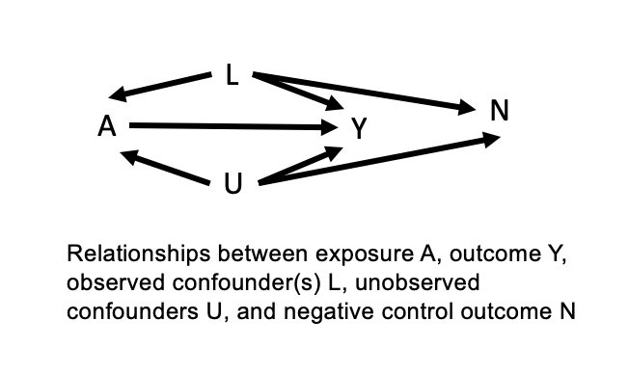
Figure 1: Relationships between exposure A, outcome Y, observed confounder(s) L, unobserved confounder(s) U, and a negative control outcome N necessary for a successful negative control outcome analysis.

Table 1: Equations and directed acyclic graphs (DAGs) describing the relationships between exposure, primary outcome, confounders, and negative control outcomes for each of the six simulation scenarios. $N$(1,10) represents a random normal distribution with mean of 1 and standard deviation of 10. All simulations assumed n=100 observations, and we ran each simulation 100 times.

Simulation Scenarios | Equations describing relationships between variables in simulation | Simulation DAG
1. Correct case | U = $N$(1, 10)  L = $N$(1, 10)  A = $N$(1, 10) + U + L  Y = $N$(1, 10) + A + U + L  N = $N$(1, 10) + U + L | 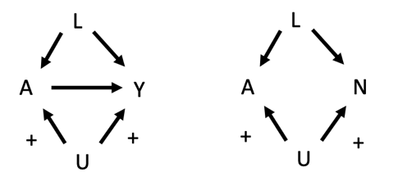
2. Different unobserved confounding mechanisms | U = $N$(1, 10)  L = $N$(1, 10)  A = $N$(1, 10) + U + L  Y = $N$(1, 10) + A + U + L  N = $N$(1, 10) + L | 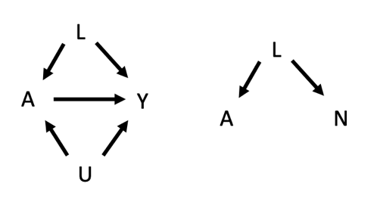
3. Confounder measurement error | L = $Unif$(1, 10)  A = $N$(1, 10) + $I$(L > 9)*20  Y = $N$(1, 10) + A + $I$(L > 9)*20  N = $N$(1, 10) + $I$(L > 1)*20 | 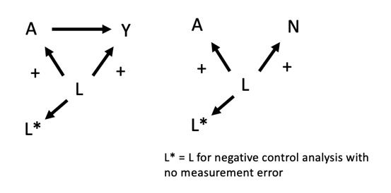
4. Model misspecification | U = $N$(1, 10)  L = $N$(1, 10)  A = $N$(1, 10) + L³  Y = $N$(1, 10) + A + L³  N = $N$(1, 10) + L | 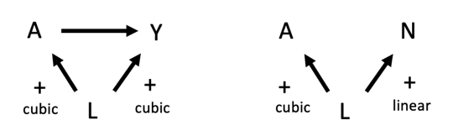
5. Weak negative control | U = $N$(1, 10)  A = $N$(1, 10) + U  Y = $N$(1, 10) + A + U  N = $N$(1, 10) + 0.001*U | 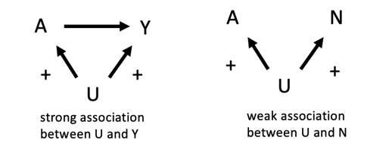
6. Negative association | U = $N$(1, 10)  A = $N$(1, 10) + U  Y = $N$(1, 10) + A + U  N = $N$(1, 10) – U | 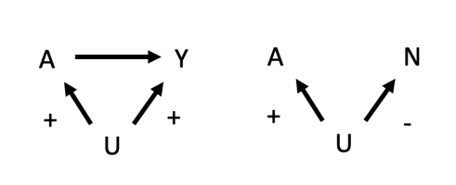

Table 2: Summary of how a negative control analysis was applied in each simulation scenario. Columns 2-4 describe if the analysis was conducted correctly. Columns 5 and 6 show the results and likely conclusion from the negative control analysis. Column 7, “Problem,” identifies why the negative control analysis failed.

Simulation Scenarios | Y and N  u-comparable? | All relationships modelled correctly? | All variables assessed correctly? | Observed  A – N association | Likely conclusion | Likely conclusion  correct? | Problem
1. Correct case | Yes | Yes | Yes | Positive | Primary analysis biased by residual confounding | Yes | Nothing – this is the correct scenario
2. Different unobserved confounding mechanisms | No | Yes | Yes | Null | Primary analysis unbiased | No | Y and N not u-comparable
3. Confounder measurement error | Yes | Yes | No | Null | Primary analysis unbiased | No | Residual bias due to confounder measurement error
4. Model misspecification | Yes | No | Yes | Null | Primary analysis unbiased | No | Residual bias due to model misspecification
5. Weak negative control | Yes | Yes | Yes | Null | Primary analysis unbiased | No | Unmeasured confounder not associated strongly enough with negative control outcome
6. Negative association | Yes | Yes | Yes | Negative | Wut. | Likely no conclusion | Relationship between confounder and negative control outcome not clear

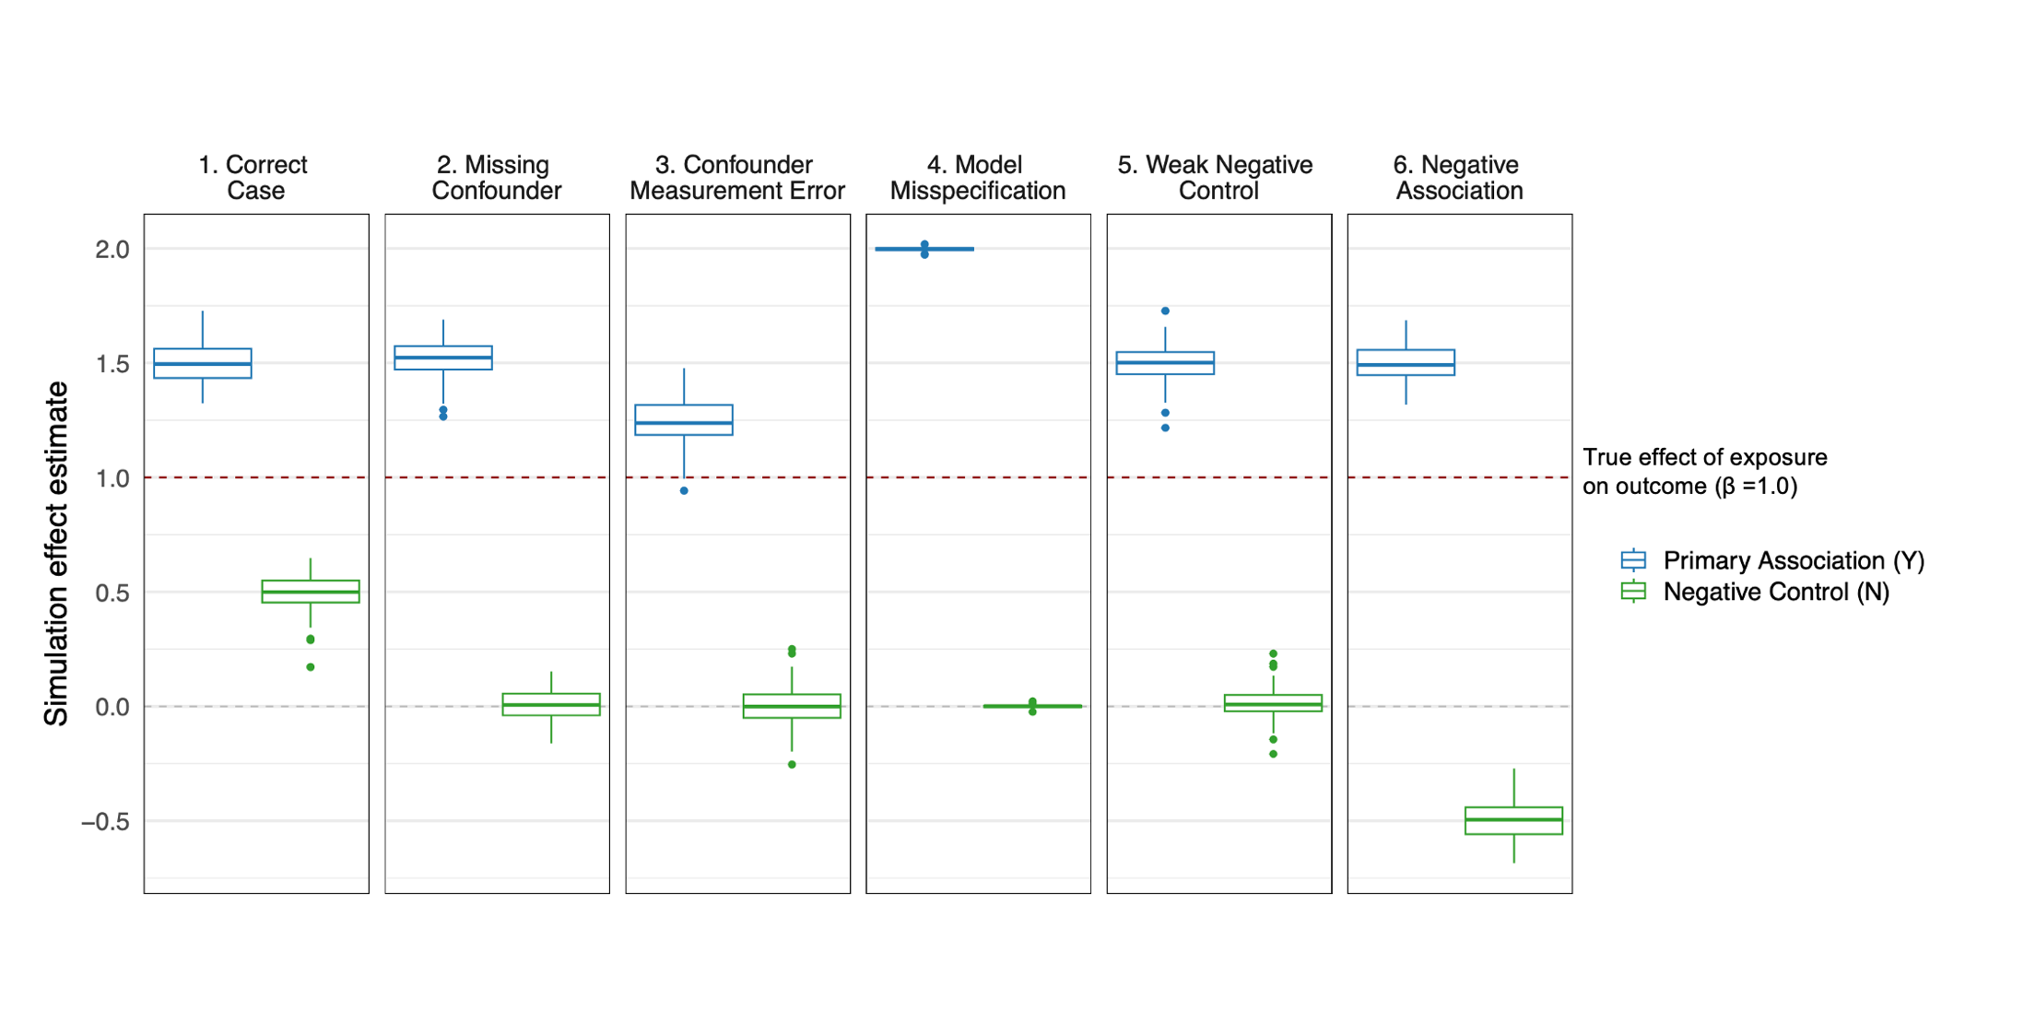
Figure 2: Distribution of the estimated effects across 100 simulations in six scenarios, using n=100 observations for each simulation and continuous exposure A, primary outcome Y, negative control outcome N, and measured and unmeasured confounders. Simulation scenarios are presented in Table 1. The horizontal, maroon dashed line at 1 represents the “true” effect of exposure A on Y, and the horizontal, gray dashed line at 0 represents a null effect.

Table 3: Summary of the distribution of the estimated effects across 100 simulations in six scenarios, using n=100 observations for each simulation and continuous exposure A, primary outcome Y, negative control outcome N, and measured and unmeasured confounders. Simulation scenarios are presented in Table 1.

Simulation scenario | 1. Correct case | 2. Different unobserved confounding mechanisms | 3. Confounder Measurement Error | 4. Model misspecification | 5. Weak negative control | 6. Negative association
Mean effect estimate for primary analysis | 1.50 | 1.51 | 1.25 | 2.00 | 1.50 | 1.50
Mean effect estimate for negative control | 0.49 | 0.00 | 0.00 | 0.00 | 0.01 | -0.50
% of negative control 95% confidence intervals that included 0 | 1 | 97 | 94 | 94 | 94 | 0

References

[1] M. Lipsitch, E. Tchetgen Tchetgen, and T. Cohen, “Negative Controls: A Tool for Detecting Confounding and Bias in Observational Studies,” Epidemiology, vol. 21, no. 3, pp. 383–388, May 2010, doi: 10.1097/ede.0b013e3181d61eeb.
[2] Timothy Lash, Tyler J. VanderWeele, Sebastien Haneuse, Kenneth J. Rothman, Modern Epidemiology.
[3] X. Shi, W. Miao, and E. T. Tchetgen, “A Selective Review of Negative Control Methods in Epidemiology,” Curr Epidemiol Rep, vol. 7, no. 4, pp. 190–202, Dec. 2020, doi: 10.1007/s40471-020-00243-4.
[4] J. K. Hu, E. J. Tchetgen Tchetgen, and F. Dominici, “Using negative controls to adjust for unmeasured confounding bias in time series studies,” Nat Rev Methods Primers, vol. 3, no. 1, p. 66, Aug. 2023, doi: 10.1038/s43586-023-00249-4.
[5] M. G. Weisskopf, E. J. Tchetgen Tchetgen, and R. Raz, “Commentary: On the Use of Imperfect Negative Control Exposures in Epidemiologic Studies,” Epidemiology, vol. 27, no. 3, pp. 365–367, May 2016, doi: 10.1097/ede.0000000000000454.
[6] M. G. Weisskopf, M.-A. Kioumourtzoglou, and A. L. Roberts, “Air Pollution and Autism Spectrum Disorders: Causal or Confounded?,” Curr Envir Health Rpt, vol. 2, no. 4, pp. 430–439, Dec. 2015, doi: 10.1007/s40572-015-0073-9.
[7] H. Elser et al., “Anomalously warm weather and acute care visits in patients with multiple sclerosis: A retrospective study of privately insured individuals in the US,” PLoS Med, vol. 18, no. 4, p. e1003580, Apr. 2021, doi: 10.1371/journal.pmed.1003580.
[8] X. Wu, F. Mealli, M.-A. Kioumourtzoglou, F. Dominici, and D. Braun, “Matching on Generalized Propensity Scores with Continuous Exposures,” Journal of the American Statistical Association, vol. 119, no. 545, pp. 757–772, Jan. 2024, doi: 10.1080/01621459.2022.2144737.
[9] K. E. Rudolph, N. T. Williams, C. H. Miles, J. Antonelli, and I. Diaz, “All models are wrong, but which are useful? Comparing parametric and nonparametric estimation of causal effects in finite samples,” Journal of Causal Inference, vol. 11, no. 1, p. 20230022, Nov. 2023, doi: 10.1515/jci-2023-0022.
[10] M. J. Van Der Laan and D. Rubin, “Targeted Maximum Likelihood Learning,” The International Journal of Biostatistics, vol. 2, no. 1, Jan. 2006, doi: 10.2202/1557-4679.1043.
[11] S. Lehrer, S. Green, and K. E. Rosenzweig, “Affluence and Breast Cancer,” Breast J, vol. 22, no. 5, pp. 564–567, Sep. 2016, doi: 10.1111/tbj.12630.
[12] W. J. Mackillop, J. Zhang-Salomons, C. J. Boyd, and P. A. Groome, “Associations between community income and cancer incidence in Canada and the United States,” Cancer, vol. 89, no. 4, pp. 901–912, Aug. 2000, doi: 10.1002/1097-0142(20000815)89:4<901::AID-CNCR25>3.0.CO;2-I.
[13] B. F. Arnold, A. Ercumen, J. Benjamin-Chung, and J. M. Colford, “Brief Report: Negative Controls to Detect Selection Bias and Measurement Bias in Epidemiologic Studies,” Epidemiology, vol. 27, no. 5, pp. 637–641, Sep. 2016, doi: 10.1097/EDE.0000000000000504.
[14] W. D. Flanders, “Negative-Control Exposures: Adjusting for Unmeasured and Measured Confounders With Bounds for Remaining Bias,” Epidemiology, vol. 34, no. 6, pp. 850–853, Nov. 2023, doi: 10.1097/EDE.0000000000001650.
[15] W. D. Flanders et al., “A Method for Detection of Residual Confounding in Time-series and Other Observational Studies,” Epidemiology, vol. 22, no. 1, pp. 59–67, Jan. 2011, doi: 10.1097/EDE.0b013e3181fdcabe.
[16] J. Schwartz, K. Fong, and A. Zanobetti, “A National Multicity Analysis of the Causal Effect of Local Pollution, NO2, and PM2.5 on Mortality,” Environ Health Perspect, vol. 126, no. 8, p. 087004, Aug. 2018, doi: 10.1289/EHP2732.
[17] J. Schwartz, M.-A. Bind, and P. Koutrakis, “Estimating Causal Effects of Local Air Pollution on Daily Deaths: Effect of Low Levels,” Environ Health Perspect, vol. 125, no. 1, pp. 23–29, Jan. 2017, doi: 10.1289/EHP232.
[18] R. A. Liu, Y. Wei, X. Qiu, A. Kosheleva, and J. D. Schwartz, “Short term exposure to air pollution and mortality in the US: a double negative control analysis,” Environ Health, vol. 21, no. 1, p. 81, Sep. 2022, doi: 10.1186/s12940-022-00886-4.
[19] H. Elser et al., “Wildfire smoke exposure and emergency department visits for headache: A case‐crossover analysis in California, 2006–2020,” Headache, vol. 63, no. 1, pp. 94–103, Jan. 2023, doi: 10.1111/head.14442.
[20] K. L. Hoffman et al., “Independent and joint contributions of physical disability and chronic pain to incident opioid use disorder and opioid overdose among Medicaid patients,” Psychol. Med., vol. 54, no. 7, pp. 1419–1430, May 2024, doi: 10.1017/S003329172300332X.

