Analysis plan: When not to use negative control outcomes in environmental epidemiology
Authors:
- Heather (lead author, main completer of tasks, booker of meetings, preparer of the manuscript)
- Joan, Kara, Marianthi: advisors and providers of ideas, feedback, planning, and suggestions
- Marianthi senior author?
- Maybe want to add a code reviewer or additional second author to support with task completion

Target journal:
- Current environmental health reports
- Needs to be done by June ideally (before SER?), can be pushed to august if necessary

Goal of the paper:
- Negative controls can be super helpful in trying to detect residual confounding in obv epi studies
- Good examples in epi and environmental epi (using negative control exposures of next-day air pollution for example)
- BUT people are using them wrong
- Goal of paper is to teach people how to use em right.
- Use some simple simulations to show that when people use them wrong (for example, when the confounding structures are different between the primary outcome of interest and the negative control outcome) they are not helpful!

Background outline:
Section 1: why do we like negative controls and what do they do
- We conduct observational environmental epidemiology studies with the goal of understanding how exposures cause negative health outcomes
- Want to direct policy and resources towards intervening on the causes of bad health outcomes that actually matter for health
- We can’t randomize exposures in observational env epi studies, so it’s very hard to rule out noncausal explanations of observed associations between exposure and outcome
- Need additional tools to do this
- Negative controls can help with this project
- Briefly, (more detail later) a negative control outcome is a variable that satisfies two conditions.
  - it is known to not be causally affected by the treatment of interest
  - It shares a confounding mechanism with a study’s primary outcome of interest (i.e. If exposure of interest is A, primary outcome of interest is Y, negative control outcome N, “the set of common causes of the exposure A and outcome Y should be as identical as possible to the set of common causes of A and N”).
  - Called being ‘u-comparable’ if confounding structure is identical
  - Should include DAG here showing this

- Negative controls used in epidemiology to test for residual confounding bias
- Ideally negative control outcome should be perfectly u-comparable to primary outcome
- This means that it has the same common causes.
- Theoretically, if negative control outcome is perfectly u-comparable to primary outcome of interest, then the absence of an association between the exposure of interest and negative control outcome when modelled with adequate control for confounding implies that there is no residual confounding bias
- Example of successful negative control here (influenza?? Something else)
- Joel schwartz injury hosp?

- In theory, for a negative control outcome analysis to give you evidence that you’ve successfully controlled for confounding, you only need the unobserved confounders to be the same between A and N
- If you’ve perfectly controlled for all other confounders, then if just unobserved confounders are different, you can still conclude that no association => no residual confounding
- However in practice it’s better to have all confounders be the same
- This usually just happens to be true anyway in real life because outcomes that you hypothesize to share unobserved confounders likely share measured confounders too
- But in any analysis you can have residual confounding bias due to inadequate measurement of your observed confounders
- If you do have inadequate measurement, then when you use a negative control you might see that there is still an association between A and N due to residual confounding from the inadequate measurement.
- Negative control outcomes sometimes also used for bias correction on p-value calibration (kara Marianthi how would they be used for p val correction?) but we’ll focus on residual confounding bias here

- In practice using negative control outcomes is slightly more nuanced than in theory.
- In practice negative control outcomes are only approximately u-comparable, never perfectly u-comparable
- Relationships between confounders and outcome and negative control outcome are likely not identical
- Additionally, there could always be another unobserved confounder that is a common cause of A and N, but not of A and Y
- If so, this means that if you do see an association between A and N when you model them as you modelled A and Y, it doesn’t mean for sure that there is residual confounding whether from an unobserved variable or from inadequate measurement. Could be another confounder. But it does mean that residual confounding is LIKELY depending on how u-comparable your Y and N are.
- On the flip side, if you DON’T observe an association between you A and N, this can provide evidence that you’ve controlled for confounding adequately.
- But sometimes it doesn’t
- Sometimes can give you false confidence
Section 2: but environmental epidemiologists are being silly
- If A and Y are not u-comparable or approximately U-comparable with A and N, if A and Y do not share the same common causes as A and N, then if A and N are not associated, it doesn’t provide evidence that there is no residual confounding
- Several environmental epi papers have attempted to use negative control outcomes to provide evidence that the association they’ve observed is causal
- But the negative control outcomes they’ve chosen have not been u-comparable with the primary outcomes of interest in the study
- If the set of common causes of A and N is different than the set of common causes of A and Y, then when you model A and N as you would A and Y, they will not be associated
- This does not provide any evidence that you’ve adequately controlled for confounding
- They wouldn’t be associated anyway if they don’t share common causes
Example:
- For example, in a time series study looking at daily zcta level PM2.5 exposure and daily zcta level respiratory hospitalizations among older adults, where you’re controlling for temperature, week day and seasonal effects in PM2.5 and hospitalizations, and other observed confounders, you might be interested in choosing a negative control outcome to see if u have residual confounding
- If you selected hospitalizations for hip surgery as a negative control outcome, this would not satisfy the conditions of being a good negative control
- The negative control outcome needs to be a) known to not be causally related to the exposure of interest
- And b) u-comparable. The common causes of the exposure and outcome need to be the same as the common causes of the exposure and negative control and they need to have similar relationships.
- Hip surgery hospitalizations are not caused by or associated with PM2.5 exposure, so that criterion is met
- but they are also not u-comparable with the PM2.5 -> respiratory hospitalization relationship
- Temperature, seasonality, and week day effects do not predict hip surgery hospitalizations in the same way they predict respiratory hospitalizations.
- So, in this case, observing a null association between the exposure and negative control would not provide evidence that there is no residual confounding.

Section 3: goals of this paper
- In this paper we want to help environmental epidemiologists understand when a null association between A and N provides evidence that confounding has been controlled for adequately, and when it does not
- We’ll conduct simulations that show how you could incorrectly select a negative control outcome or incorrectly conduct a negative control analysis such that even though there actually is residual confounding of your exposure and primary outcome of interest, the negative control analysis shows that there is no relationship between the exposure of interest and negative control outcome.
- Could lead the researcher to have false confidence that they’re adequately controlled for residual confounding.
- When confounders are more similar/more u-comparable between A and Y and A and N, a null association between the exposure and negative control outcome provides more evidence that you’ve controlled for residual confounding
- Differences between the confounding structures between A -> Y and A -> N mean that a null association between A -> N may not imply that there is no residual confounding.
- when a negative control does not share a confounding structure with the primary outcome of interest/when it is not u-comparable, a null association between the exposure and negative control does not imply that confounding has been controlled for adequately.
- As well, for negative control analyses to work, the relationships between all variables involved need to be adequately measured and modelled.
- We’ll give four examples of how you could have residual confounding in your analysis but have a negative control analysis show no relationship between the exposure and negative control outcome

I think that it makes sense to present the methods and results together – like, the simulation set up and then the results of that simulation right after.
Then have a discussion section.
Methods and results outline:
Simulation set up:
- Again goal is to show when a negative control outcome can provide evidence that there is no residual confounding, and when a null association between the exposure of interest and a negative control outcome doesn’t mean there isn’t confounding, and might give a researcher false confidence
- Will run simulated studies where there are different relationships between the exposure, outcome, unmeasured confounders, and negative control outcome
- See when negative control analysis is sensitive to detecting residual confounding

- All simulations will represent a time series study where a daily exposure is hypothesized to be related to a daily count outcome.
- Let A be an exposure measured as a continuous numeric value between 0 and 10.
- Y is primary outcome of interest, measured as a continuous numeric var between 1 and 15
- N is the negative control outcome, continuous numeric var 1 and 15
- U_1 unmeasured confounder 1
- U_2 unmeasured confounder 2
- L measured confounder(s)
- Generally assume linear relationships between variables for simplicity and clarity unless otherwise specified.
- Will use a linear model to test association between exposure, confounders, and outcome

Simulation 1: correct use of a negative control outcome.
Method:
- In this correct scenario, the exposure and outcome are both influenced by an unmeasured confounder that’s uncontrolled for
- They could also be influenced by well measured and controlled for confounders L
- So there is residual confounding in the analysis
- The researcher is trying to use a negative control outcome to test if there is residual confounding
- They pick a negative control outcome that is perfectly u-comparable to the primary outcome of interest
- Exposure not related to NCO
- Exposure has a linear relationship with primary outcome
- Unobserved confounder has a linear relationship with negative control outcome
- Observed and measured confounders L are adequately controlled for.
Setup:
U = rnorm(1, 5)
A = rnorm(1, 5) + B_0*U
Y = rnorm(1, 5) + B_1*A + B_2*U
N = rnorm(1, 10) + B_2*U
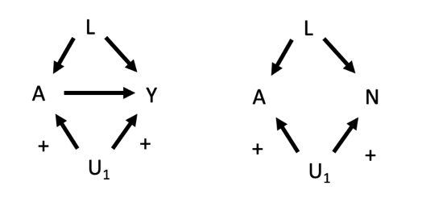
- Model relationship between exposure and outcome with simple linear model
Result:
- Results will be that there is an association between the exposure and negative control outcome
- Provides evidence of residual confounding
- This is what a negative control outcome should do when it’s working

Simulation 2: Inadequately modelled observed confounder
Method:
- In this scenario, the exposure and outcome are both influenced by a measured confounder that’s inadequately controlled for in the model testing the association between the exposure and primary outcome of interest
- Confounder has a cubic relationship with the primary outcome Y = B_1*A + B_2 * U*3 + e
- There is residual confounding in the analysis because the researcher modelled the relationship between the confounder and outcome as linear, and so the confounder hasn’t been adequately controlled for
- Researcher runs a negative control analysis hoping to test if there is residual confounding
- However, there is a linear relationship between the inadequately controlled for confounder and negative control outcome
- They are still u-comparable because they share common causes, but the relationships between the confounder and primary outcome of interest is different from the relationship between the confounder and negative control outcome
- Researcher models relationship between confounder and negative control outcome as linear, which is correct
- This means relationships are modelled correctly in the negative control outcome analysis but incorrectly in the primary analysis
Setup:
- U = rnorm(1, 5)
- A = rnorm(1, 5) + B_0*U
- Y = rnorm(1, 5) + B_1*A + B_2*U*3
- N = rnorm(1, 10) + B_3*U
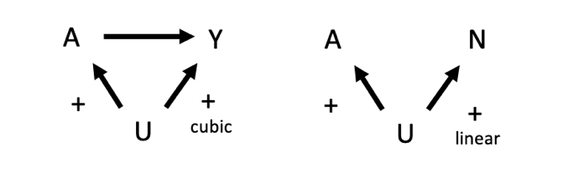
Results:
- Result of negative control outcome analysis will show that there is no association between the exposure and negative control outcome
- Could give researcher false confidence because there IS residual confounding in the original analysis

Simulation 3: Inadequate measurement of observed confounders
- Exposure and outcome both influenced by a measured confounder that is actually a continuous variable (continuous with values between 1 and 3 inclusive) but is only available to the researcher as a categorical variable (L < 3 is binary 0, and L = 3 means binary 1)
- Confounder influences primary outcome of interest. If confounder is > 1, increases value of outcome
- If not, no change
- This means that the confounder is inadequately controlled for because it’s inadequately measured, and there is residual confounding in the analysis
- Researcher runs a negative control analysis hoping to test if there is residual confounding
- Unluckily, the confounder has a different relationship with the negative control outcome than it does with the primary outcome of interest
- Confounder influences negative control outcome: if confounder is > 2, increases value of outcome
- If not, no change
- So model is able to fully capture the influence of the confounder on the negative control outcome
Setup:
- U = runif(1, 3)
- A = rnorm(1, 5) + B_0*(indicator U higher than 2)
- Y = rnorm(1, 5) + B_1*A + B_2*(indicator U higher than 2)
- N = rnorm(1, 10) + B_2*(indicator U higher than 2)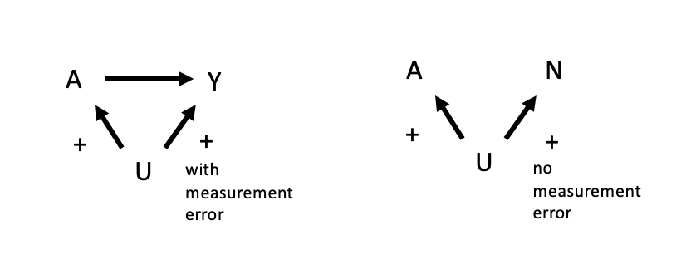
Results:
- There is residual confounding in the analysis of exposure and primary outcome due to measurement error
- In negative control analysis, there is no confounding and a null association between the exposure and negative control outcome
- Theoretically provides evidence that there is no residual confounding but because of measurement error that’s not what’s happening
- Could give researcher false confidence because there IS residual confounding in the original analysis

Simulation 4: association between unobserved confounder and negative control outcome is weak, but association between confounder and primary outcome of interest is strong
- Unobserved confounder U is shared between A -> Y and A -> N.
- Association between U and Y is really strong and not controlled for in the analysis
- However association between U and N is positive but weak
- Researcher conducts negative control analysis to test for residual confounding which there definitely is
- U-comparable because they have the same common causes
Setup:
- U = rnorm(1, 5)
- A = rnorm(1, 5) + B_0*U
- Y = rnorm(1, 5) + B_1*A + 100*U
- N = rnorm(1, 10) + 0.1*U
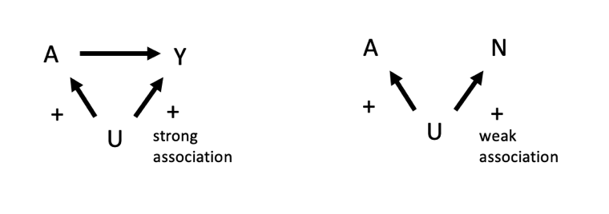
Results:
- Depending on sample size and power, the association between the exposure and negative control outcome is either very weak or null.
- From the negative control analysis it looks like there is either no residual confounding or almost no residual confounding in the original analysis
- However there is actually a lot of residual confounding
- Could give researcher false confidence

Simulation 5: missed confounder
- There is unmeasured confounding by U between A -> Y.
- A -> N shares all measured confounders with A -> Y but is not confounded by U
- Not u-comparable
Setup:
- U = rnorm(1, 5)
- A = rnorm(1, 5) + B_0*U
- Y = rnorm(1, 5) + B_1*A + 100*U
- N = rnorm(1, 10)
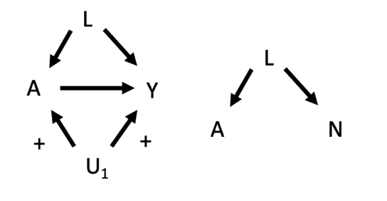
Results:
- Negative control shows null association between A and N.
- False confidence.

Bonus simulation 6: when you could be extra confused
- Unmeasured confounding by U between A and Y
- A and Y u-comparable to A and N, so unmeasured confounding by U for A->N as well
- But relationship between U and N is opposite direction than relationship between U and Y
Setup:
- U = rnorm(1, 5)
- A = rnorm(1, 5) + B_0*U
- Y = rnorm(1, 5) + B_1*A + B_2*U
- N = rnorm(1, 10) + -B_2*U
- B_2 negative in equation with N
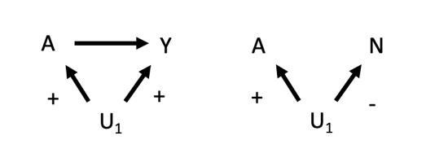
Result:
- Association between A and N will be biased downward by the negative association between U and N.
- Depending on the strength of association between A, U, and Y, this could mean that there is either a positive, null, or negative association between A and N.
- The negative control analysis gives us no information about whether there is residual confounding in the original analysis

Some incomplete points for the discussion:
Summary of results:
- important to be really careful when setting up negative control outcomes to try to test for residual confounding
- a lot of scenarios where the negative control outcome analysis is not sensitive to residual confounding
- negative control outcome must be known to not be caused by the exposure
- negative control outcome and exposure must share all the same common causes that the exposure and primary outcome do
- all confounders, exposure, and outcome must be measured adequately
- analysis must correctly model the relationships between exposure, outcome (as you must in any analysis) but especially confounders in exposure -> primary analysis and exposure -> negative control outcome

- there are lots of scenarios where NCO analysis will not be sensitive to detecting residual confounding

- inadequate measurement of confounders, inadequate modelling of confounders, different strengths of association between confounder and primary outcome of interest and NCO, if primary outcome and NCO are not u-comparable and confusion about the direction of associations can all mean that the results of an NCO analysis are not helpful and may confuse researchers or lead to false confidence about the causal nature of the association in a study
- in reality these relationships are really complex. Important to consider nuances and knowledge about all the variables at play in your analysis

need to flesh out discussion and conclusions.

Couple of notes to consider:
- I’m aware that I should take the Ls out of the first example and or include them in all the other examples
- I think reordering the examples might make sense so the missing confounder (example 5) is first
- Not sure whether to include final example.

