Main Manuscript for:

Pitfalls of negative control outcomes in environmental epidemiology

Heather McBrien^{1*}, Kara Rudolph², Joan Casey^{3,4}, Marianthi- Anna Kioumourtzoglou¹

¹ Columbia Mailman School of Public Health, Department of Environmental Health Sciences
² Columbia Mailman School of Public Health, Department of Epidemiology
³ University of Washington Department of Environmental and Occupational Health Sciences
⁴ University of Washington Department of Epidemiology

* Corresponding author email: hm2913@cumc.columbia.edu

Competing Interest Statement: The authors declare no competing interests.
Keywords: negative control, negative control outcome, environmental epidemiology

Abstract

Main Text
Background
Why are negative controls useful?
Observational environmental epidemiology studies aim to understand how exposures cause adverse health outcomes. Ideally, these studies identify environmental causes of disease and inform policy and preventative interventions. However, since exposures can’t be randomized in observational environmental epidemiology studies, it is both essential and extremely difficult to rule out non-causal explanations of observed associations between exposures and outcomes.
Negative control analyses can help researchers rule out non-causal explanations for observed exposure-outcome associations. They can help us find out if unmeasured confounding explains an observed association between the exposure and outcome. A negative control outcome is a variable which must satisfy two conditions:
1. It is known to not be causally affected by the treatment of interest.
2. It shares a confounding mechanism with a study’s primary outcome of interest.
If a variable meets these two conditions, it can be used as a negative control outcome to evaluate if there is residual confounding bias in the primary association of interest in a study.
Briefly, to conduct a negative control analysis, researchers replace the primary outcome of interest with the negative control outcome in their analysis. If all confounders are adequately measured and controlled for, there should be no association between the exposure and negative control outcome, since the negative control outcome is known to not be affected by the treatment of interest. If there is an association between the exposure and negative control outcome, this can indicate residual confounding bias in the original analysis induced by an inadequately controlled for confounder shared by the exposure, negative control outcome, and primary outcome of interest (Figure 1).
Formal definition of negative control outcome
In a hypothetical observational environmental epidemiology study, let the exposure of interest be A, the primary outcome of interest be Y, and the negative control outcome be N. For N to serve as a negative control outcome, the set of common causes of A and Y must be identical to the set of common causes of A and N. When this is true, N and Y are called ‘u-comparable’. When N and Y are u-comparable, a null association between the exposure of interest and negative control outcome implies no residual confounding of the association between the exposure and primary outcome of interest. The shared common causes of the exposure, outcome, and negative control outcome must also be measured and modelled adequately for this implication to hold.
In theory, a negative control outcome need only share unobserved common causes with the exposure and outcome to help detect residual confounding. If all observed confounders are controlled for, then a null association between the exposure of interest and negative control outcome still implies no residual confounding, as long as all confounders are measured and modelled correctly. However, negative controls can also be useful in detecting residual bias due to measurement error. Measurement error in confounders in always possible, so when a negative control outcome shares all common causes with the primary outcome, including observed confounders, residual bias due to measurement error can induce an association between the exposure and negative control outcome. In this case, a negative control analysis could help detect this residual confounding due to measurement error.
Negative control outcomes in practice
In practice, negative control outcomes are never perfect. An association between the exposure and negative control outcome does not always indicate residual confounding. First, there may be an unobserved confounder which is a common cause of A and N, but not a cause of Y. Here, an association between A and N would not indicate residual confounding of the association between A and Y.
Conversely, a null association between A and N does not always imply no residual confounding. In practice, negative control outcomes are never perfectly u-comparable to primary outcomes of interest – they may share most confounders or almost all confounders with the primary outcome, but not all. This makes interpreting the results of negative control analyses nuanced. Observing a null association can suggest that you’ve controlled for confounding adequately, but when N and Y are not perfectly u-comparable, observing a null association between A and N doesn’t imply that all confounding is controlled for adequately. There are many cases where a researcher may observe a null association and there is still confounding. In these cases, doing a negative control analysis may give a researcher false confidence that they have adequately controlled for confounding when they have not.
Additionally, for a negative control analysis to be effective, the relationships between exposure, outcome, and confounders must be modelled correctly. Even if a primary outcome and negative control outcome are perfectly u-comparable, it’s possible that the relationships between the exposure, confounders, and primary outcome are different than those relationships with the negative control outcome. In these cases, analysis procedures need to be flexible enough that those relationships are modelled adequately in both the primary analysis and negative control analysis, or this can induce residual confounding bias in either the primary analysis or negative control analysis. This residual confounding bias can make the results of the negative control analysis very difficult to interpret.
Example: Inappropriate negative control analysis
When A and Y are not u-comparable or approximately u-comparable with A and N (in other words, if A and Y do not share the same common causes as A and N) then even if A and N are not associated in a negative control analysis, there may still be confounding of the association between A and Y. If the set of common causes of A and N is different than the set of common causes of A and Y, when A and N are modelled like A and Y, they will not be associated, regardless of how confounding was handled in the original analysis.
Consider an analysis of daily county-level PM_{2.5} exposure and daily county-level emergency adult respiratory hospitalizations. Here, researchers might control for temperature, week day and seasonal trends in PM_{2.5} exposure and hospitalizations, and other observed confounders. A researcher might conduct a negative control analysis with the aim of detecting residual confounding, and select hospitalizations for hip surgery as a negative control outcome.
Hip surgery hospitalizations are not caused by or associated with PM_{2.5} exposure, so they meet the first criterion for a negative control: they are known to not be caused by the exposure of interest. However, hip surgery hospitalizations are not u-comparable with the primary outcome of interest. Temperature and seasonality not predict hip surgery hospitalizations as they do respiratory hospitalizations. In this case, observing a null association between the exposure and negative control would not provide evidence that confounding has been controlled for adequately.
Simulations
Negative control analyses can be useful when the negative control outcome is u-comparable to the primary outcome of interest, and when they are conducted with adequate measurement of all variables and modelling of all relationships between variables. However, in practice, these analyses can be difficult to implement. In the remainder of this paper, we will present simulated negative control analyses to show when this analysis can be sensitive to residual confounding, and when it may give researchers false confidence in their results.

Methods
Simulation set up
All simulations will represent a cross-sectional study where a researcher is attempting to use a negative control outcome to test if the estimated association between A and Y is biased by residual confounding. The continuous exposure A is hypothesized to cause a continuous outcome Y. N is a negative control outcome not caused by A. Both A, Y, and N may be caused by unmeasured confounder(s) U and measured confounder(s) L depending on the simulation scenario.
All these variables will be normally distributed with some arbitrary mean and variance. The relationships between these variables will be linear for simplicity unless otherwise specified, and vary slightly across simulation scenarios. We’ll model the relationship between exposure and outcome using a linear model sometimes including confounders U and L, depending on the simulation scenario. In each simulation we’ll estimate the exposure outcome association 100 times, each time using a dataset of 100 observations of the exposure and outcome or exposure and negative control outcome.
In each simulation, the primary association of interest in the study is confounded, but the researcher often observes a null association between the exposure and negative control outcome – in these cases, the negative control analysis does not help detect residual confounding.
Simulation cases description (Table 1):
Simulation 1: Correct case
In this correct scenario, the exposure and outcome are both caused by an unmeasured confounder, as well as measured confounders L. The researcher picks a negative control outcome perfectly u-comparable to the primary outcome.
Simulation 2: Missing confounder
In this scenario, the exposure and outcome are both caused by an unmeasured confounder U and measured confounders L. The exposure-outcome association is biased, and the researcher picks a negative control outcome that shares all confounders with A and Y except U. It is not u-comparable to the primary outcome.
Simulation 3: Modelling error
Here, the exposure and outcome are both caused by a measured confounder L which is inadequately controlled for in the model testing the association between the exposure and primary outcome of interest, but controlled for correctly in the negative control analysis. This confounder has a cubic relationship with the primary outcome, and a linear relationship with the negative control outcome. These outcomes are u-comparable, but researcher incorrectly models relationship between L and Y as linear, while relationship between L and N is correctly modeled as linear. This means the confounder-outcome relationships are modelled correctly in the negative control outcome analysis but incorrectly in the primary analysis.
Simulation 4: Measurement error
Here, the exposure, primary outcome, and negative control outcome are all influenced by a measured continuous confounder L with values between 1 and 3 inclusive measured as a categorical variable by the researcher (L < 3 is binary 0, and L = 3 means binary 1). L influences the both the primary and negative control outcomes. If L > 1, the value of the primary outcome increases by 1. If L > 2, this value of the negative control outcome by 1.
Simulation 5: Weak negative control
Here, the exposure, outcome, and negative control outcome are all influenced by an unmeasured confounder U. The association between U and Y is positive and strong, while the association between U and N is positive but weak. They are u-comparable since they share all common causes.
Simulation 6: Negative control negatively associated with outcome
In this final scenario the exposure, outcome, and negative control outcome are all influenced by an unmeasured confounder U. N and Y are therefore U-comparable, but U and N are negatively associated, while U and Y are positively associated.

Results and discussion
Simulation 1: Correct case
Here, the negative control analysis showed a positive association between the exposure and negative control outcome. This provides evidence of residual confounding, and the researcher could investigate and try to find the missing U in this best-case scenario. This analysis worked because Y and N were perfectly u-comparable.
Simulation 2: Missing confounder
In contrast, here, the negative control outcome analysis shows that there is no association between the exposure and negative control outcome. This could give the researcher false confidence, since there in fact is residual confounding in the primary analysis. In practice, this scenario could arise if the researcher does not have adequate background knowledge about the common causes of the exposure, outcome, and negative control, or if the researcher chooses a negative control outcome that does not share the same confounding structure as the primary outcome.
Simulation 3: Modelling error
As in scenario 2, this negative control analysis shows no association between the exposure and negative control outcome, even though the primary analysis is biased by residual confounding. Again, this may give a researcher false confidence in their primary analysis. If the relationships between confounders, exposure, outcome, and negative control are not modelled correctly, there may be a null association between the exposure and negative control outcome even in the primary analysis is confounded.
Simulation 4: Measurement error
Here, there was residual confounding in the primary analysis due to measurement error. Still, the negative control analysis shows no association between the exposure and negative control outcome. In the presence of measurement error, including error from binarizing confounders when they’re continuous, a negative control analysis may not always be sensitive to detecting residual confounding.
Simulation 5: Weak negative control
In this scenario, where the unobserved confounder U was only weakly associated with the negative control outcome, the association between the exposure and negative control outcome was null. Depending on study sample size and power, the observed association between the exposure and negative control outcome could have been either very weak or null. Again, this may give a researcher false confidence in their primary analysis.
Simulation 6: Negative control negatively associated with outcome
In this scenario, since the unobserved confounder was negatively associated with the negative control outcome, the association between A and N was biased downward. Depending on the strength of association between A, U, and Y, the association between A and N could have been either a positive, null, or negative. If a researcher does not know the direction of the relationship between the unobserved confounder and the negative control outcome, the negative control analysis does not provide useful information about whether there is residual confounding in the original analysis. Researchers must have prior knowledge about relationships between confounders and the negative control outcome to interpret negative control analyses.
Conclusion
Negative control outcome analyses must be conducted with care, as they may not always detect residual confounding. For a negative control analysis to be valid, the chosen negative control outcome must be known not to be caused by the exposure, and it must share all the same common causes with the exposure as the primary outcome does (be u-comparable).
Accurate measurement of confounders, exposure, and outcomes is essential, as is proper modeling of these relationships—particularly the role of confounders in both the exposure-to-primary outcome and exposure-to-negative control pathways. Researchers must also have a clear understanding of how variables relate to one another and to both outcomes. While the simulations discussed here were based on a simple linear model with continuous exposure and outcome, and the results could change across study designs or with different kinds of exposures or outcomes, the core principles demonstrated in these simulations apply across different study designs, exposures, and outcomes. When relationships between exposure, outcome, confounders, and negative control outcomes are complex, as they are in real studies, negative control analyses can be misleading and may falsely reassure researchers about the causal nature of an observed effect.

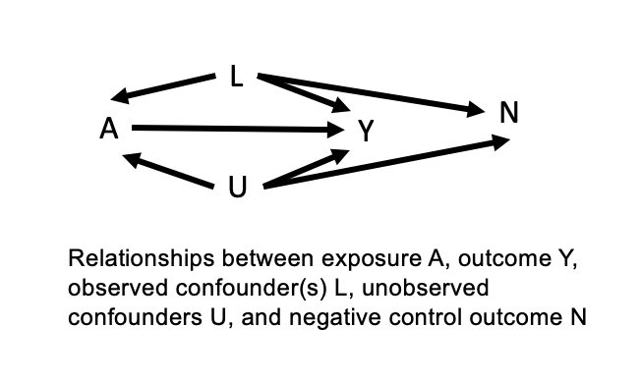
Figure 1: Relationships between exposure A, outcome Y, observed confounder(s) L, unobserved confounder(s) U, and a variable N which can serve as a negative control outcome.

Table 1: Simulation cases
Simulation name | Equations describing relationships between variables in simulation | Simulation DAG
1. Correct case | U = N(1, 10)  L = N(1, 10)  A = N(1, 10) + U + L  Y = N(1, 10) + A + U + L  N = N(1, 10) + U + L | 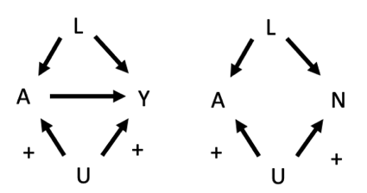
2. Missing confounder | U = N(1, 10)  L = N(1, 10)  A = N(1, 10) + U + L  Y = N(1, 10) + A + U + L  N = N(1, 10) + L | 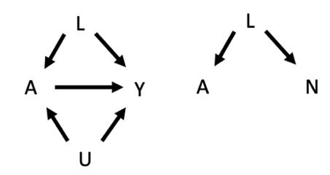
3. Modelling error | L = N(1, 10)  A = N(1, 10) + L  Y = N(1, 10) + A + 0.03*(L + L² + L³)  N = N(1, 10) + L | 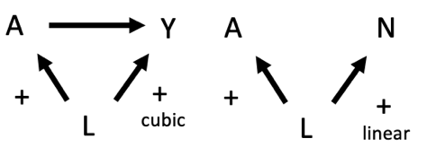
4. Measurement error | L = Uniform(1, 10)  A = N(1, 10) + Indicator(L < 5)*10  Y = N(1, 10) + A + Indicator(L < 5)*10  N = N(1, 10) + Indicator(L < 1) | 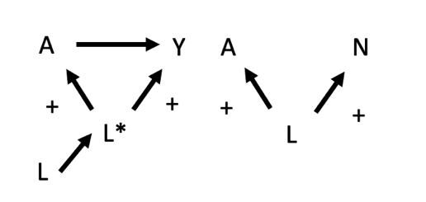
5. Weak negative control | U = N(1, 10)  A = N(1, 10) + U  Y = N(1, 10) + A + U  N = N(1, 10) + 0.001*U | 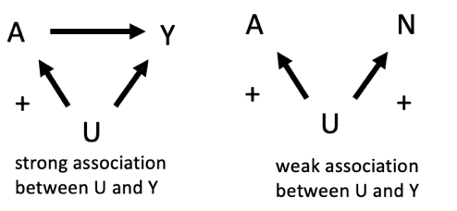
6. Negative association | U = N(1, 10)  A = N(1, 10) + U  Y = N(1, 10) + A + U  N = N(1, 10) – U | 