Pitfalls of negative control outcomes in environmental epi
Heather, Joan, Kara, Marianthi

Background outline:
Section 1: why do we like negative controls and what do they do
- We conduct observational environmental epidemiology studies with the goal of understanding how exposures cause negative health outcomes
- Want to direct policy and resources towards intervening on causes that will prevent those bad health outcomes
- We can’t randomize exposures in observational env epi studies, so it’s very hard to rule out noncausal explanations of observed associations between exposure and outcome
- Need additional tools to do this
- Negative controls can help with this project
- Briefly, (more detail later) a negative control outcome is a variable that satisfies two conditions.
  - it is known to not be causally affected by the treatment of interest
  - It shares a confounding mechanism with a study’s primary outcome of interest (i.e. If exposure of interest is A, primary outcome of interest is Y, negative control outcome N, “the set of common causes of the exposure A and outcome Y should be as identical as possible to the set of common causes of A and N”).
  - Called being ‘u-comparable’ if confounders/common causes are all the same
  - Should include DAG here showing this
  - For the rest of this paper let A be the primary exposure of interest, Y the outcome, L observed confounder(s), U unobserved confounders, and N the negative control outcome.
Figure 1: this is the negative control setup
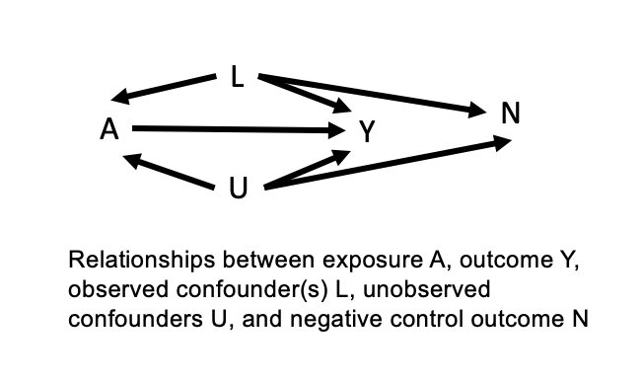
- Negative controls used in epidemiology as one way to evaluate if there’s residual confounding bias
- Ideally negative control outcome should have all the same common causes with the exposure of interest as the primary outcome of interest. This is called being “perfectly u-comparable” to the primary outcome
- Theoretically, if negative control outcome is perfectly u-comparable to primary outcome of interest, then the absence of an association between the exposure of interest and negative control outcome when modelled with adequate control for confounding implies that there is no residual confounding bias
- Example of successful negative control here (influenza?? Something else)
- Joel schwartz injury hosp?

- In theory, for a negative control outcome analysis to give you evidence that you’ve successfully controlled for confounding, you only need the unobserved confounders to be the same between the exposure and negative control
- If you’ve perfectly controlled for all other confounders, and if just unobserved confounders are the same between the primary outcome of interest and the negative control outcome, you can still conclude that no association => no residual confounding, even if measured confounders are not the same between the primary outcome and negative control outcome
- However in practice it’s better to have all confounders be the same
- This usually just happens to be true anyway in real life because outcomes that you hypothesize to share unobserved confounders likely share measured confounders too
- But in any analysis you can have residual confounding bias due to inadequate measurement of your observed confounders
- If you do have inadequate measurement, then when you use a negative control you might see that there is still an association between A and N due to residual confounding from the inadequate measurement, which can be helpful
- Negative control outcomes sometimes also used for bias correction but we’ll focus on their use to detect residual confounding bias in this paper

- In practice using negative control outcomes is slightly more nuanced than in theory.
- In practice negative control outcomes are only approximately u-comparable, never perfectly u-comparable
- Additionally, there could always be another unobserved confounder that is a common cause of A and N, but not of A and Y
- If so, this means that if you do see an association between A and N when you model them as you modelled A and Y, it doesn’t mean for sure that there is residual confounding whether from an unobserved variable or from inadequate measurement. Could be another confounder. But it does mean that residual confounding is LIKELY depending on how u-comparable your Y and N are.
- On the flip side, if you DON’T observe an association between you A and N, this can provide evidence that you’ve controlled for confounding adequately.
- But sometimes it doesn’t
- Sometimes can give you false confidence

Section 2: but environmental epidemiologists are being silly
- If A and Y are not u-comparable or approximately U-comparable with A and N, if A and Y do not share the same common causes as A and N, then if A and N are not associated, it doesn’t provide evidence that there is no residual confounding
- Several environmental epi papers have attempted to use negative control outcomes to provide evidence that the association they’ve observed is causal
- But the negative control outcomes they’ve chosen have not been u-comparable with the primary outcomes of interest in the study
- If the set of common causes of A and N is different than the set of common causes of A and Y, then when you model A and N as you would A and Y, they will not be associated
- This does not provide any evidence that you’ve adequately controlled for confounding
- They wouldn’t be associated anyway if they don’t share common causes

Example:
- For example, in a time series study looking at daily zcta level PM2.5 exposure and daily zcta level emergency respiratory hospitalizations among older adults, where you’re controlling for temperature, week day and seasonal effects in PM2.5 and hospitalizations, and other observed confounders, you might be interested in choosing a negative control outcome to see if u have residual confounding
- If you selected hospitalizations for hip surgery as a negative control outcome, this would not satisfy the conditions of being a good negative control
- The negative control outcome needs to be a) known to not be causally related to the exposure of interest
- And b) u-comparable. The common causes of the exposure and outcome need to be the same as the common causes of the exposure and negative control and they need to have similar relationships.
- Hip surgery hospitalizations are not caused by or associated with PM2.5 exposure, so that criterion is met
- but they are also not u-comparable with the PM2.5 -> respiratory hospitalization relationship
- Temperature and seasonality not predict hip surgery hospitalizations, but they do predict respiratory hospitalizations.
- So, in this case, observing a null association between the exposure and negative control would not provide evidence that there is no residual confounding.
Note/last paragraph:
- Keep in mind for any of this environmental epi analysis stuff to work at all, you need to model things correctly.
- Relationships between confounders and outcome and negative control outcome are likely not identical
- The models you use to model the exposure outcome and confounder relationship as well as the relationship between exposure, outcome, and negative control may be different
- And they must be flexible enough to capture the true relationships between these vars
- Otherwise you might have residual confounding because your model is wrong.
- We’ll touch on that more in one of the simulation cases

Methods and results together outline:
Simulation set up:
- Again goal is to show when analyzing the relationship between exposure and a negative control outcome can provide evidence that there is no residual confounding in the original analysis, and when a null association between the exposure of interest and a negative control outcome doesn’t mean there isn’t confounding, and might give a researcher false confidence
- Will run simulations where there are different relationships between the exposure, outcome, unmeasured confounders, and negative control outcome
- See when negative control analysis is sensitive to detecting residual confounding

- We’re going to do things in the simplest way possible so that the concepts are as clear as possible to the reader.
- All simulations will represent a cross-sectional study where a continuous exposure is hypothesized to be related to a continuous outcome.
- Let A be an exposure with a random normal distribution with mean 1 and SD 10.
- Y is primary outcome of interest, also a normally distributed continuous variable influenced by the values of the exposure and confounders according to the case-specific equations written below
- N is the negative control outcome, also a normally distributed continuous variable influenced by the values of confounders but not the exposure
- U unmeasured confounders N(1, 10)
- L measured confounder(s) N(1, 10)
- All the choices here of distribution and later the choices of coefficients describing the relationships between vars are completely arbitrary
- Generally assume linear relationships between variables for simplicity and clarity unless otherwise specified in the specific cases below
- Will use a linear model to test association between exposure, confounders, and outcome
- And specify those at the beginning of each simulation
- In each simulation we’ll run 100 models with a dataset of 100 exposures and outcomes.
- Calculate estimate of association between A and Y as well as A and N 100 times and look at average
Simulation 1: correct use of a negative control outcome. “Correct case”
Method:
- In this correct scenario, the exposure and outcome are both influenced by an unmeasured confounder that’s uncontrolled for
- They could also be influenced by well measured and controlled for confounders L
- So there is residual confounding in the analysis
- The researcher is trying to use a negative control outcome to test if there is residual confounding
- They pick a negative control outcome that is perfectly u-comparable to the primary outcome of interest
- Exposure not related to N
- Exposure has a linear relationship with primary outcome
- Unobserved confounder has a linear relationship with negative control outcome
- Observed and measured confounders L are adequately controlled for.
- Model relationship between exposure and outcome with simple linear model
Setup:
- U = N(1, 10)
- L = N(1, 10)
- A = N(1, 10) + U + L
- Y = N(1, 10) + A + U + L
- N = N(1, 10) + U + L
(Will TeX these for the final paper).
See figure 2:
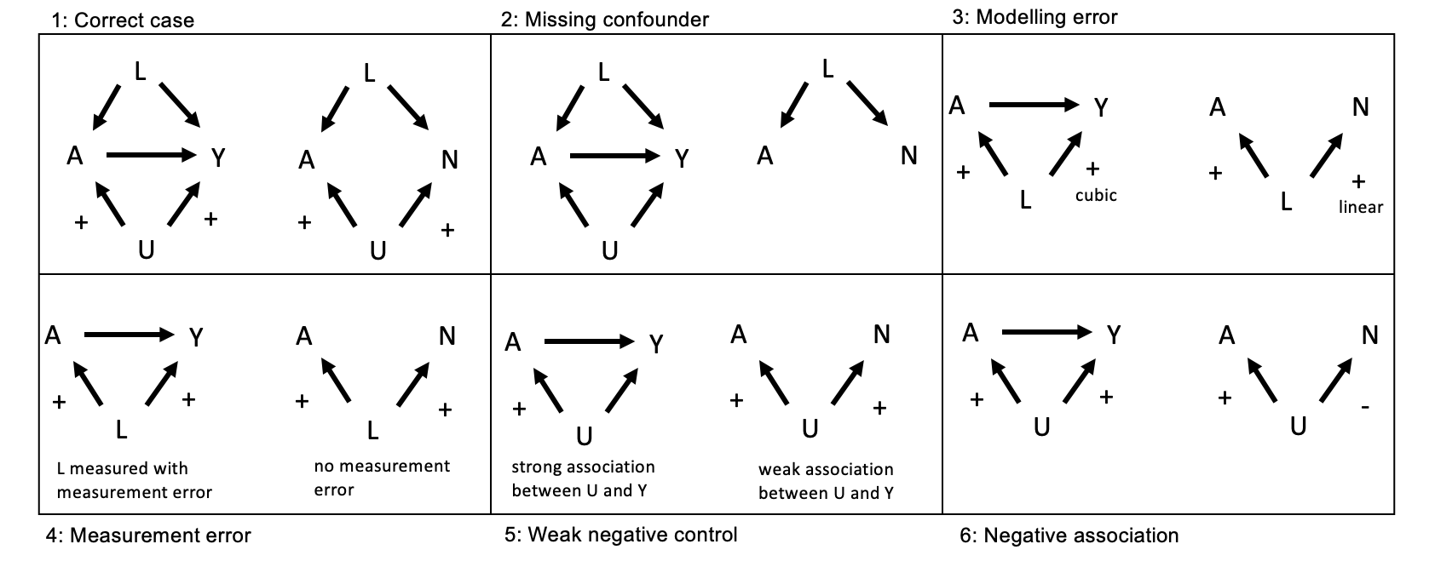
Result:
- There is an association between the exposure and negative control outcome
- Provides evidence of residual confounding
- This is what a negative control outcome should do when it’s working
See figure 3 case 1: ‘correct case’.
Figure 3:
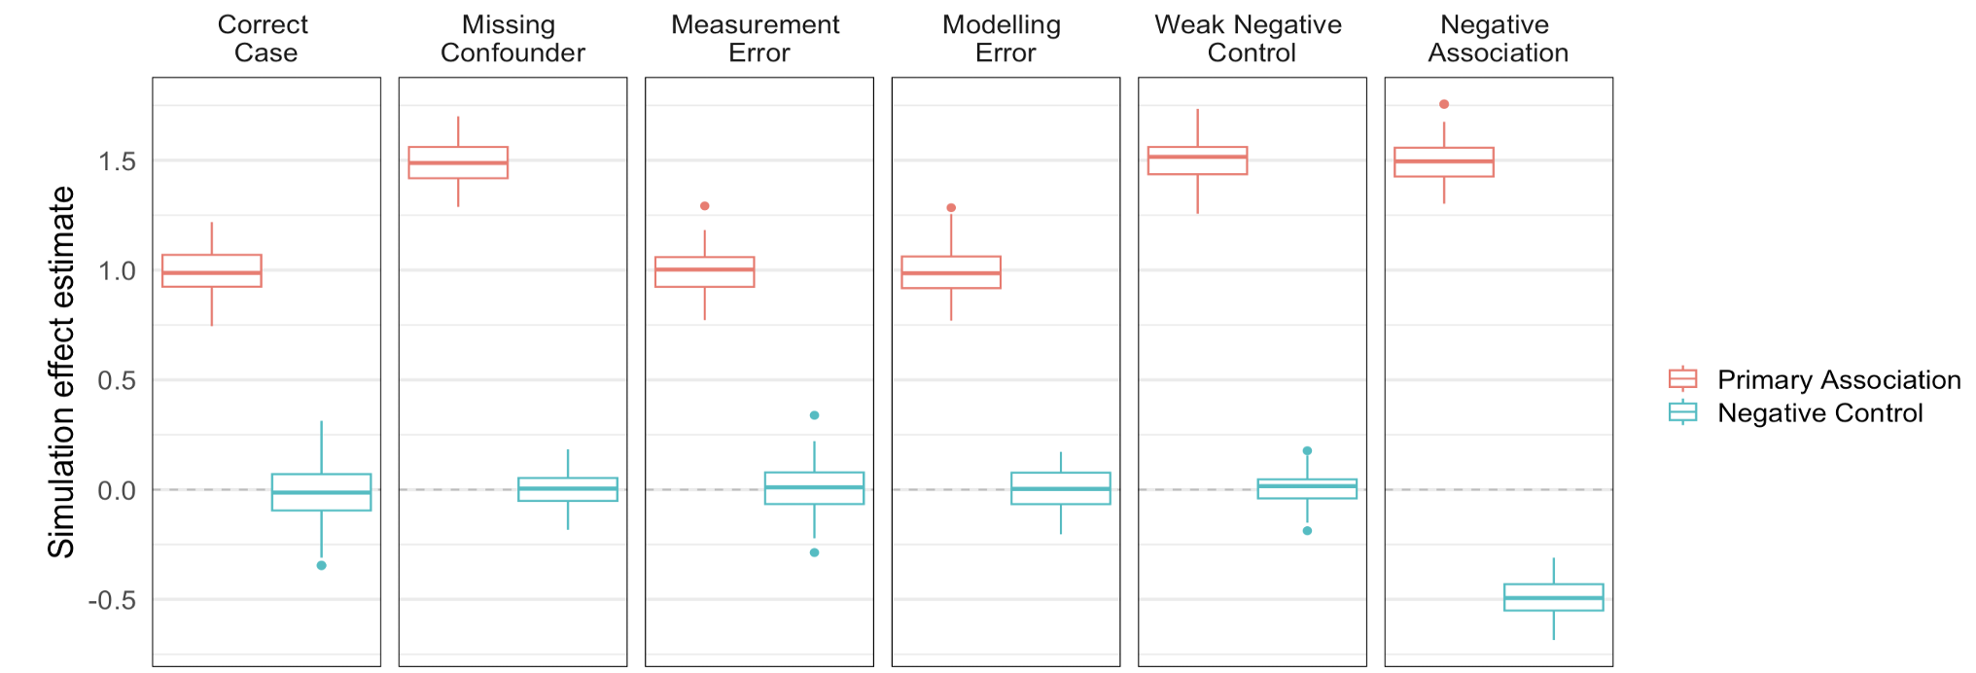
Table 1:
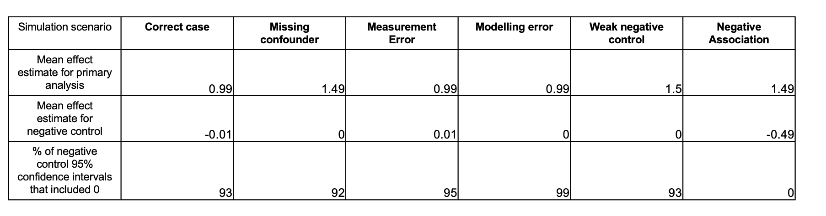
Simulation 2: negative control is missing a confounder of the exposure and primary outcome this sim is called “missing confounder”
- There is unmeasured confounding by U between A -> Y.
- A -> N shares all measured confounders with A -> Y but is not confounded by U
- Not u-comparable
- For setup again see figure 2
Setup:
- U = N(1, 10)
- L = N(1, 10)
- A = N(1, 10) + U + L
- Y = N(1, 10) + A + U + L
- N = N(1, 10) + L
Results:
- Negative control shows null association between A and N.
- False confidence.
- Figure 3
Simulation 3: Inadequately modelled observed confounder
“modelling error”
Method:
- In this scenario, the exposure and outcome are both influenced by a measured confounder that’s inadequately controlled for in the model testing the association between the exposure and primary outcome of interest
- Confounder has a cubic relationship with the primary outcome
- There is residual confounding in the analysis because the researcher modelled the relationship between the confounder and outcome as linear, and so the confounder hasn’t been adequately controlled for
- Researcher runs a negative control analysis hoping to test if there is residual confounding
- However, there is a linear relationship between the inadequately controlled for confounder and negative control outcome
- They are still u-comparable because they share common causes, but the relationships between the confounder and primary outcome of interest is different from the relationship between the confounder and negative control outcome
- Researcher models relationship between confounder and negative control outcome as linear, which is correct
- This means relationships are modelled correctly in the negative control outcome analysis but incorrectly in the primary analysis
- Case 3 in figure 2 (measurement error)
Setup:
- L = N(1, 10)
- A = N(1, 10) + L
- Y = N(1, 10) + A + 0.0003*L^3
- N = N(1, 10) + L
Results:
- Result of negative control outcome analysis shows that there is no association between the exposure and negative control outcome
- Could give researcher false confidence because there IS residual confounding in the original analysis
- Figure 3 case 3

Simulation 4: Inadequate measurement of observed confounders
“measurement error”
- Exposure and outcome both influenced by a measured continuous confounder that is actually a continuous variable (continuous with values between 1 and 3 inclusive) but is only available to the researcher as a categorical variable (L < 3 is binary 0, and L = 3 means binary 1)
- Confounder influences primary outcome of interest. If confounder is > 1, increases value of outcome
- If not, no change
- This means that the confounder is inadequately controlled for because it’s inadequately measured, and there is residual confounding in the analysis
- Researcher runs a negative control analysis hoping to test if there is residual confounding
- Unluckily, the confounder has a different relationship with the negative control outcome than it does with the primary outcome of interest
- Confounder influences negative control outcome: if confounder is > 2, increases value of outcome
- If not, no change
- So model is able to fully capture the influence of the confounder on the negative control outcome
- Case four in figure 2
Setup:
- L = Uniform(1, 3)
- A = N(1, 10) + Indicator(L < 2)
- Y = N(1, 10) + A + Indicator(L < 2)
- N = N(1, 10) + Indicator(L < 2)
Results:
- There is residual confounding in the analysis of exposure and primary outcome due to measurement error
- In negative control analysis, there is no confounding and a null association between the exposure and negative control outcome
- Theoretically provides evidence that there is no residual confounding but because of measurement error that’s not what’s happening
- Could give researcher false confidence because there IS residual confounding in the original analysis
- Case 4 in figure 3

Simulation 5: association between unobserved confounder and negative control outcome is weak, but association between confounder and primary outcome of interest is strong
“weak negative control”
- Unobserved confounder U is shared between A -> Y and A -> N.
- Association between U and Y is really strong and not controlled for in the analysis
- However association between U and N is positive but weak
- Researcher conducts negative control analysis to test for residual confounding which there definitely is
- U-comparable because they have the same common causes
Setup:
- U = N(1, 10)
- A = N(1, 10) + U
- Y = N(1, 10) + A + U
- N = N(1, 10) + 0.001*U
Results:
- Depending on sample size and power, the association between the exposure and negative control outcome is either very weak or null.
- Here it was weak and often looked null for the simulation sample size and power
- From the negative control analysis it looks like there is either no residual confounding or almost no residual confounding in the original analysis
- However there is actually a lot of residual confounding
- Could give researcher false confidence
- Case 5 in figure 3

Bonus simulation 6: negative control negatively associated with outcome
“negative association”
- Unmeasured confounding by U between A and Y
- A and Y u-comparable to A and N, so unmeasured confounding by U for A->N as well
- But relationship between U and N is opposite direction than relationship between U and Y
Setup:
- U = N(1, 10)
- A = N(1, 10) + U
- Y = N(1, 10) + A + U
- N = N(1, 10) – U
Result:
- Association between A and N will be biased downward by the negative association between U and N.
- Depending on the strength of association between A, U, and Y, this could mean that there is either a positive, null, or negative association between A and N.
- If we don’t know the direction of the relationship between the unobserved confounder here and the negative control outcome, the negative control analysis gives us no information about whether there is residual confounding in the original analysis
- Case 6 in figure 3
- This is a bonus scenario because this paper was about when you could have residual confounding in your original analysis but the negative control analysis would show a null assoc, giving you false confidence
- This doesn’t necessarily show a null assoc, but could definitely give you false confidence.

Some incomplete points for the discussion:
Summary of results:
- important to be really careful when setting up negative control outcomes to look for residual confounding
- there are a lot of scenarios where the negative control outcome analysis is not sensitive to residual confounding
- negative control outcome must be known to not be caused by the exposure
- negative control outcome and exposure must share all the same common causes that the exposure and primary outcome do
- all confounders, exposure, and outcome must be measured adequately
- analysis must correctly model the relationships between exposure, outcome (as you must in any analysis) but especially confounders in exposure -> primary analysis and exposure -> negative control outcome

- inadequate measurement of confounders, exposure, outcome, inadequate modelling of confounders, different strengths of association between confounder and primary outcome of interest and NCO, if primary outcome and NCO are not u-comparable and confusion about the direction of associations can all mean that the results of an NCO analysis are not helpful and may confuse researchers or lead to false confidence about the causal nature of the association in a study
- in reality these relationships are really complex. Important to consider nuances and knowledge about all the variables at play in your analysis

Marianthi points to add to discussion/future directions:
- i would also briefly add the potential differences in outcome measurement error/misclassification. Not so much of an impact in linear models for continuous outcomes, but could be important for binary/count outcomes
- ok! either time series or just a linear model for this should work! (and in either case we do need to write in the discussion that our conclusions are based on our modeling choices for the simulations but there is no reason to expect that they would not qualitatively generalize to other study designs etc!)
- b/c i would assume that even if we did (generalized) propensity scores with matching, the unmeasured confounding situations (and possibly up to a point the residual one as well) should still hold! if we finish this early and we have time to play more we could potentially with PS as well! :D

