SDVC Final Report Descriptive Tables

Income, Gender and Ownership

John Kemp

2016-10-03

### 6a. Decision maker on how to spend money earned - (Treatment & Control) rounds 1 and 5

|  |  |  |  |  |
| --- | --- | --- | --- | --- |
| District | Round of Data Collection | Decision maker on how to spend money earned | Treatment/Control Group | Percent |
| Bogra | Jul 2014 | Self | Treatment | 0.49 |
| Bogra | Jul 2014 | Self | Control | 0.23 |
| Bogra | Jul 2014 | Husband | Treatment | 0.10 |
| Bogra | Jul 2014 | Husband | Control | 0.08 |
| Bogra | Jul 2014 | Jointly | Treatment | 0.36 |
| Bogra | Jul 2014 | Jointly | Control | 0.68 |
| Bogra | Jul 2014 | Other Male Member | Treatment | 0.05 |
| Bogra | Jul 2014 | Other Male Member | Control | 0.01 |
| Bogra | Jul 2016 | Self | Treatment | 0.16 |
| Bogra | Jul 2016 | Self | Control | 0.11 |
| Bogra | Jul 2016 | Husband | Treatment | 0.03 |
| Bogra | Jul 2016 | Husband | Control | 0.21 |
| Bogra | Jul 2016 | Jointly | Treatment | 0.80 |
| Bogra | Jul 2016 | Jointly | Control | 0.67 |
| Bogra | Jul 2016 | Other Male Member | Treatment | 0.00 |
| Joypurhat | Jul 2014 | Self | Treatment | 0.04 |
| Joypurhat | Jul 2014 | Self | Control | 0.09 |
| Joypurhat | Jul 2014 | Husband | Treatment | 0.01 |
| Joypurhat | Jul 2014 | Jointly | Treatment | 0.94 |
| Joypurhat | Jul 2014 | Jointly | Control | 0.91 |
| Joypurhat | Jul 2016 | Self | Treatment | 0.08 |
| Joypurhat | Jul 2016 | Self | Control | 0.12 |
| Joypurhat | Jul 2016 | Husband | Control | 0.13 |
| Joypurhat | Jul 2016 | Jointly | Treatment | 0.92 |
| Joypurhat | Jul 2016 | Jointly | Control | 0.75 |
| Kurigram | Jul 2014 | Self | Treatment | 0.10 |
| Kurigram | Jul 2014 | Self | Control | 0.12 |
| Kurigram | Jul 2014 | Husband | Treatment | 0.12 |
| Kurigram | Jul 2014 | Jointly | Treatment | 0.79 |
| Kurigram | Jul 2014 | Jointly | Control | 0.88 |
| Kurigram | Jul 2016 | Self | Treatment | 0.06 |
| Kurigram | Jul 2016 | Self | Control | 0.09 |
| Kurigram | Jul 2016 | Husband | Treatment | 0.13 |
| Kurigram | Jul 2016 | Husband | Control | 0.02 |
| Kurigram | Jul 2016 | Jointly | Treatment | 0.82 |
| Kurigram | Jul 2016 | Jointly | Control | 0.89 |
| Naogaon | Jul 2014 | Self | Control | 0.98 |
| Naogaon | Jul 2014 | Jointly | Control | 0.02 |
| Naogaon | Jul 2016 | Jointly | Control | 1.00 |
| Nator | Jul 2014 | Self | Treatment | 0.60 |
| Nator | Jul 2014 | Self | Control | 1.00 |
| Nator | Jul 2014 | Husband | Treatment | 0.17 |
| Nator | Jul 2014 | Jointly | Treatment | 0.23 |
| Nator | Jul 2016 | Self | Control | 0.86 |
| Nator | Jul 2016 | Jointly | Treatment | 1.00 |
| Nator | Jul 2016 | Jointly | Control | 0.14 |
| Pabna | Jul 2014 | Self | Treatment | 0.09 |
| Pabna | Jul 2014 | Self | Control | 0.26 |
| Pabna | Jul 2014 | Husband | Treatment | 0.22 |
| Pabna | Jul 2014 | Husband | Control | 0.28 |
| Pabna | Jul 2014 | Jointly | Treatment | 0.68 |
| Pabna | Jul 2014 | Jointly | Control | 0.46 |
| Pabna | Jul 2014 | Other Male Member | Treatment | 0.01 |
| Pabna | Jul 2014 | Other Male Member | Control | 0.00 |
| Pabna | Jul 2016 | Self | Treatment | 0.08 |
| Pabna | Jul 2016 | Self | Control | 0.06 |
| Pabna | Jul 2016 | Husband | Treatment | 0.25 |
| Pabna | Jul 2016 | Jointly | Treatment | 0.67 |
| Pabna | Jul 2016 | Jointly | Control | 0.92 |
| Pabna | Jul 2016 | Other Male Member | Control | 0.02 |
| Rangpur | Jul 2014 | Self | Treatment | 0.10 |
| Rangpur | Jul 2014 | Self | Control | 0.37 |
| Rangpur | Jul 2014 | Husband | Treatment | 0.07 |
| Rangpur | Jul 2014 | Husband | Control | 0.05 |
| Rangpur | Jul 2014 | Jointly | Treatment | 0.82 |
| Rangpur | Jul 2014 | Jointly | Control | 0.58 |
| Rangpur | Jul 2014 | Other Male Member | Treatment | 0.01 |
| Rangpur | Jul 2016 | Self | Treatment | 0.11 |
| Rangpur | Jul 2016 | Self | Control | 0.24 |
| Rangpur | Jul 2016 | Husband | Treatment | 0.34 |
| Rangpur | Jul 2016 | Husband | Control | 0.03 |
| Rangpur | Jul 2016 | Jointly | Treatment | 0.53 |
| Rangpur | Jul 2016 | Jointly | Control | 0.74 |
| Rangpur | Jul 2016 | Other Male Member | Treatment | 0.03 |
| Sirajgonj | Jul 2014 | Self | Treatment | 0.02 |
| Sirajgonj | Jul 2014 | Self | Control | 0.14 |
| Sirajgonj | Jul 2014 | Husband | Treatment | 0.29 |
| Sirajgonj | Jul 2014 | Husband | Control | 0.72 |
| Sirajgonj | Jul 2014 | Jointly | Treatment | 0.69 |
| Sirajgonj | Jul 2014 | Jointly | Control | 0.10 |
| Sirajgonj | Jul 2014 | Other Male Member | Control | 0.04 |
| Sirajgonj | Jul 2016 | Self | Treatment | 0.12 |
| Sirajgonj | Jul 2016 | Self | Control | 0.16 |
| Sirajgonj | Jul 2016 | Husband | Treatment | 0.05 |
| Sirajgonj | Jul 2016 | Husband | Control | 0.29 |
| Sirajgonj | Jul 2016 | Jointly | Treatment | 0.83 |
| Sirajgonj | Jul 2016 | Jointly | Control | 0.51 |
| Sirajgonj | Jul 2016 | Other Male Member | Control | 0.03 |

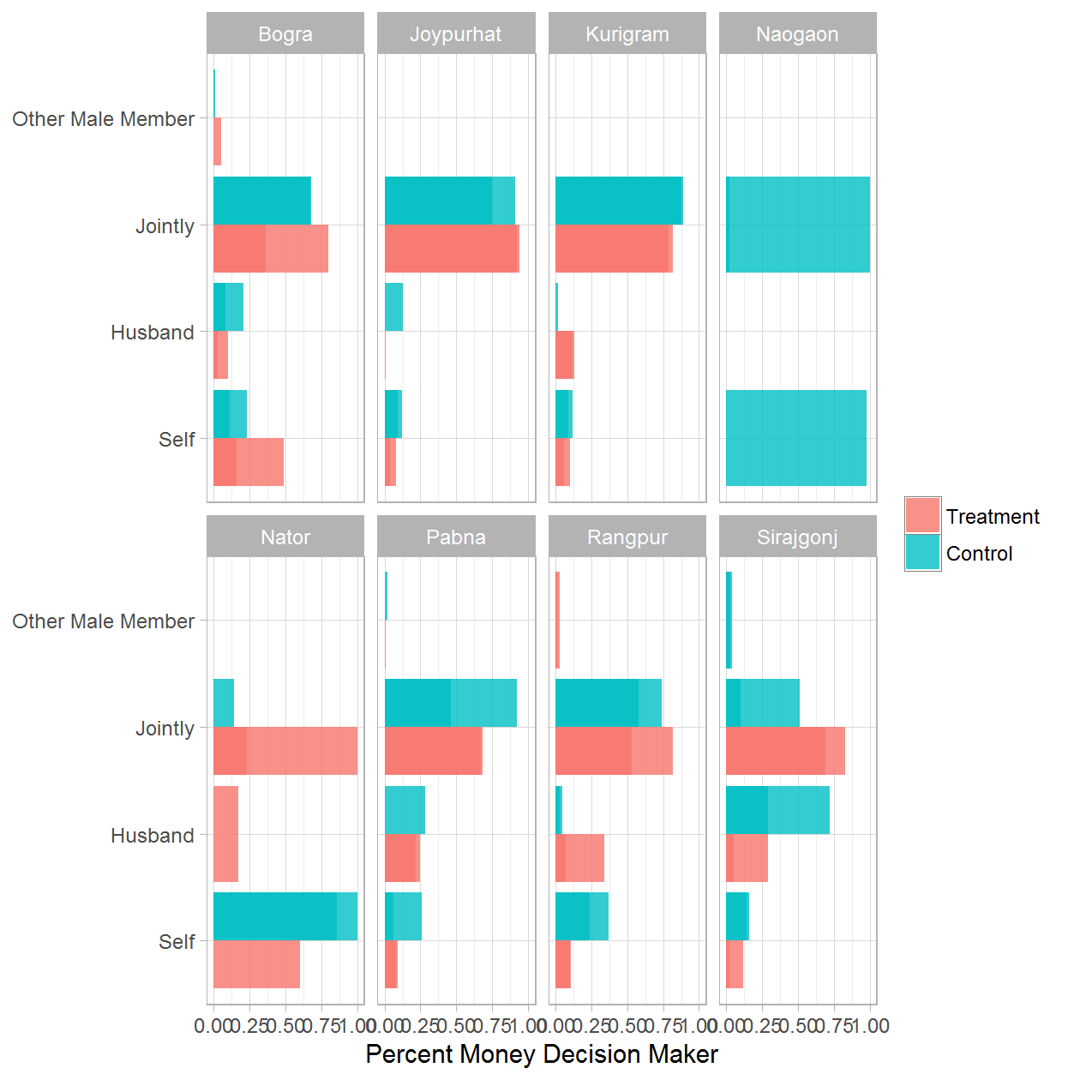

### 6b. Decision maker on how to spend money earned - Treatment Only

|  |  |  |  |
| --- | --- | --- | --- |
| District | Round of Data Collection | Decision maker on how to spend money earned | Percent |
| Bogra | Jul 2014 | Self | 0.49 |
| Bogra | Jul 2014 | Husband | 0.10 |
| Bogra | Jul 2014 | Jointly | 0.36 |
| Bogra | Jul 2014 | Other Male Member | 0.05 |
| Bogra | Dec 2014 | Self | 0.14 |
| Bogra | Dec 2014 | Husband | 0.21 |
| Bogra | Dec 2014 | Jointly | 0.63 |
| Bogra | Dec 2014 | Other Female Member | 0.02 |
| Bogra | Jul 2015 | Self | 0.35 |
| Bogra | Jul 2015 | Jointly | 0.65 |
| Bogra | Dec 2015 | Self | 0.09 |
| Bogra | Dec 2015 | Husband | 0.01 |
| Bogra | Dec 2015 | Jointly | 0.90 |
| Bogra | Dec 2015 | Other Male Member | 0.00 |
| Bogra | Jul 2016 | Self | 0.16 |
| Bogra | Jul 2016 | Husband | 0.03 |
| Bogra | Jul 2016 | Jointly | 0.80 |
| Bogra | Jul 2016 | Other Male Member | 0.00 |
| Joypurhat | Jul 2014 | Self | 0.04 |
| Joypurhat | Jul 2014 | Husband | 0.01 |
| Joypurhat | Jul 2014 | Jointly | 0.94 |
| Joypurhat | Dec 2014 | Self | 0.42 |
| Joypurhat | Dec 2014 | Jointly | 0.58 |
| Joypurhat | Jul 2015 | Self | 0.33 |
| Joypurhat | Jul 2015 | Husband | 0.13 |
| Joypurhat | Jul 2015 | Jointly | 0.54 |
| Joypurhat | Dec 2015 | Self | 0.23 |
| Joypurhat | Dec 2015 | Jointly | 0.77 |
| Joypurhat | Jul 2016 | Self | 0.08 |
| Joypurhat | Jul 2016 | Jointly | 0.92 |
| Kurigram | Jul 2014 | Self | 0.10 |
| Kurigram | Jul 2014 | Husband | 0.12 |
| Kurigram | Jul 2014 | Jointly | 0.79 |
| Kurigram | Dec 2014 | Self | 0.17 |
| Kurigram | Dec 2014 | Husband | 0.19 |
| Kurigram | Dec 2014 | Jointly | 0.64 |
| Kurigram | Jul 2015 | Self | 0.07 |
| Kurigram | Jul 2015 | Jointly | 0.93 |
| Kurigram | Dec 2015 | Self | 0.08 |
| Kurigram | Dec 2015 | Husband | 0.22 |
| Kurigram | Dec 2015 | Jointly | 0.70 |
| Kurigram | Jul 2016 | Self | 0.06 |
| Kurigram | Jul 2016 | Husband | 0.13 |
| Kurigram | Jul 2016 | Jointly | 0.82 |
| Nator | Jul 2014 | Self | 0.60 |
| Nator | Jul 2014 | Husband | 0.17 |
| Nator | Jul 2014 | Jointly | 0.23 |
| Nator | Dec 2014 | Self | 0.77 |
| Nator | Dec 2014 | Husband | 0.07 |
| Nator | Dec 2014 | Jointly | 0.16 |
| Nator | Dec 2015 | Self | 0.14 |
| Nator | Dec 2015 | Jointly | 0.86 |
| Nator | Jul 2016 | Jointly | 1.00 |
| Pabna | Jul 2014 | Self | 0.09 |
| Pabna | Jul 2014 | Husband | 0.22 |
| Pabna | Jul 2014 | Jointly | 0.68 |
| Pabna | Jul 2014 | Other Male Member | 0.01 |
| Pabna | Dec 2014 | Self | 0.34 |
| Pabna | Dec 2014 | Husband | 0.13 |
| Pabna | Dec 2014 | Jointly | 0.53 |
| Pabna | Jul 2015 | Self | 0.14 |
| Pabna | Jul 2015 | Husband | 0.18 |
| Pabna | Jul 2015 | Jointly | 0.67 |
| Pabna | Dec 2015 | Self | 0.02 |
| Pabna | Dec 2015 | Husband | 0.04 |
| Pabna | Dec 2015 | Jointly | 0.92 |
| Pabna | Dec 2015 | Other | 0.02 |
| Pabna | Jul 2016 | Self | 0.08 |
| Pabna | Jul 2016 | Husband | 0.25 |
| Pabna | Jul 2016 | Jointly | 0.67 |
| Rangpur | Jul 2014 | Self | 0.10 |
| Rangpur | Jul 2014 | Husband | 0.07 |
| Rangpur | Jul 2014 | Jointly | 0.82 |
| Rangpur | Jul 2014 | Other Male Member | 0.01 |
| Rangpur | Dec 2014 | Self | 0.28 |
| Rangpur | Dec 2014 | Husband | 0.03 |
| Rangpur | Dec 2014 | Jointly | 0.66 |
| Rangpur | Dec 2014 | Other Male Member | 0.03 |
| Rangpur | Jul 2015 | Self | 0.04 |
| Rangpur | Jul 2015 | Jointly | 0.96 |
| Rangpur | Dec 2015 | Self | 0.15 |
| Rangpur | Dec 2015 | Husband | 0.02 |
| Rangpur | Dec 2015 | Jointly | 0.82 |
| Rangpur | Dec 2015 | Other Male Member | 0.01 |
| Rangpur | Jul 2016 | Self | 0.11 |
| Rangpur | Jul 2016 | Husband | 0.34 |
| Rangpur | Jul 2016 | Jointly | 0.53 |
| Rangpur | Jul 2016 | Other Male Member | 0.03 |
| Sirajgonj | Jul 2014 | Self | 0.02 |
| Sirajgonj | Jul 2014 | Husband | 0.29 |
| Sirajgonj | Jul 2014 | Jointly | 0.69 |
| Sirajgonj | Dec 2014 | Self | 0.43 |
| Sirajgonj | Dec 2014 | Jointly | 0.52 |
| Sirajgonj | Dec 2014 | Other Male Member | 0.05 |
| Sirajgonj | Jul 2015 | Self | 0.02 |
| Sirajgonj | Jul 2015 | Jointly | 0.98 |
| Sirajgonj | Dec 2015 | Self | 0.00 |
| Sirajgonj | Dec 2015 | Husband | 0.16 |
| Sirajgonj | Dec 2015 | Jointly | 0.84 |
| Sirajgonj | Jul 2016 | Self | 0.12 |
| Sirajgonj | Jul 2016 | Husband | 0.05 |
| Sirajgonj | Jul 2016 | Jointly | 0.83 |

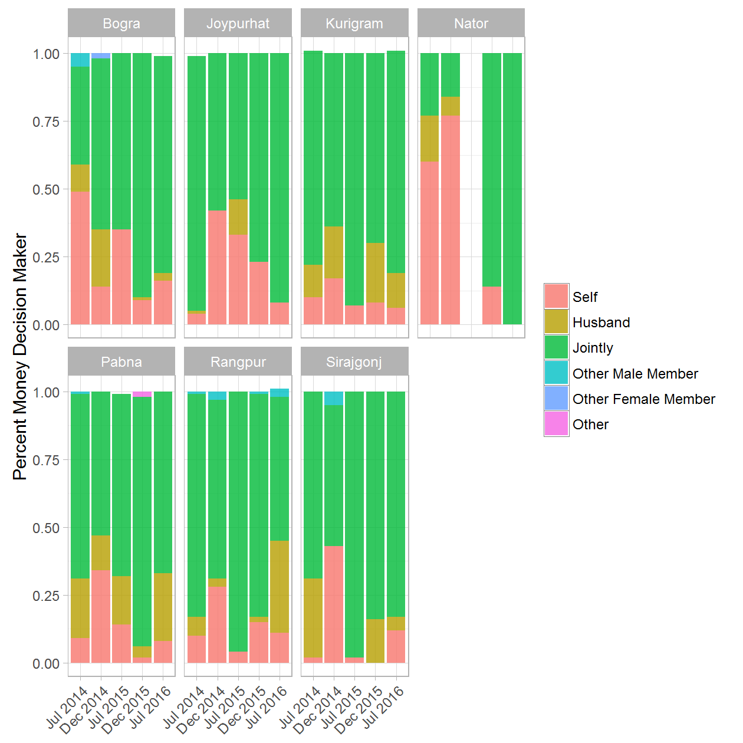

### 7a. Decision maker on how to use milk sales income - (Treatment & Control) rounds 1 and 5

|  |  |  |  |  |
| --- | --- | --- | --- | --- |
| District | Round of Data Collection | Decision maker on how to use milk sales income | Treatment/Control Group | Percent |
| Bogra | Jul 2014 | Self | Treatment | 0.17 |
| Bogra | Jul 2014 | Self | Control | 0.14 |
| Bogra | Jul 2014 | Husband | Treatment | 0.15 |
| Bogra | Jul 2014 | Husband | Control | 0.26 |
| Bogra | Jul 2014 | Jointly | Treatment | 0.65 |
| Bogra | Jul 2014 | Jointly | Control | 0.60 |
| Bogra | Jul 2014 | Other Male Member | Treatment | 0.02 |
| Bogra | Jul 2014 | Other Male Member | Control | 0.00 |
| Bogra | Jul 2014 | Other Female Member | Treatment | 0.00 |
| Bogra | Jul 2016 | Self | Treatment | 0.14 |
| Bogra | Jul 2016 | Self | Control | 0.14 |
| Bogra | Jul 2016 | Husband | Treatment | 0.09 |
| Bogra | Jul 2016 | Husband | Control | 0.26 |
| Bogra | Jul 2016 | Jointly | Treatment | 0.76 |
| Bogra | Jul 2016 | Jointly | Control | 0.60 |
| Bogra | Jul 2016 | Other Male Member | Treatment | 0.00 |
| Bogra | Jul 2016 | Other Female Member | Treatment | 0.00 |
| Joypurhat | Jul 2014 | Self | Treatment | 0.09 |
| Joypurhat | Jul 2014 | Self | Control | 0.08 |
| Joypurhat | Jul 2014 | Husband | Treatment | 0.02 |
| Joypurhat | Jul 2014 | Husband | Control | 0.23 |
| Joypurhat | Jul 2014 | Jointly | Treatment | 0.89 |
| Joypurhat | Jul 2014 | Jointly | Control | 0.69 |
| Joypurhat | Jul 2016 | Self | Treatment | 0.06 |
| Joypurhat | Jul 2016 | Self | Control | 0.10 |
| Joypurhat | Jul 2016 | Husband | Treatment | 0.32 |
| Joypurhat | Jul 2016 | Husband | Control | 0.18 |
| Joypurhat | Jul 2016 | Jointly | Treatment | 0.63 |
| Joypurhat | Jul 2016 | Jointly | Control | 0.72 |
| Kurigram | Jul 2014 | Self | Treatment | 0.16 |
| Kurigram | Jul 2014 | Self | Control | 0.15 |
| Kurigram | Jul 2014 | Husband | Treatment | 0.11 |
| Kurigram | Jul 2014 | Jointly | Treatment | 0.72 |
| Kurigram | Jul 2014 | Jointly | Control | 0.85 |
| Kurigram | Jul 2016 | Self | Treatment | 0.06 |
| Kurigram | Jul 2016 | Self | Control | 0.10 |
| Kurigram | Jul 2016 | Husband | Treatment | 0.13 |
| Kurigram | Jul 2016 | Husband | Control | 0.03 |
| Kurigram | Jul 2016 | Jointly | Treatment | 0.82 |
| Kurigram | Jul 2016 | Jointly | Control | 0.87 |
| Naogaon | Jul 2014 | Self | Control | 1.00 |
| Naogaon | Jul 2016 | Self | Control | 0.21 |
| Naogaon | Jul 2016 | Husband | Control | 0.14 |
| Naogaon | Jul 2016 | Jointly | Control | 0.64 |
| Nator | Jul 2014 | Self | Control | 0.99 |
| Nator | Jul 2014 | Husband | Treatment | 0.72 |
| Nator | Jul 2014 | Jointly | Treatment | 0.28 |
| Nator | Jul 2014 | Jointly | Control | 0.01 |
| Nator | Jul 2016 | Self | Control | 0.86 |
| Nator | Jul 2016 | Husband | Treatment | 0.19 |
| Nator | Jul 2016 | Jointly | Treatment | 0.81 |
| Nator | Jul 2016 | Jointly | Control | 0.14 |
| Pabna | Jul 2014 | Self | Treatment | 0.09 |
| Pabna | Jul 2014 | Self | Control | 0.04 |
| Pabna | Jul 2014 | Husband | Treatment | 0.57 |
| Pabna | Jul 2014 | Husband | Control | 0.70 |
| Pabna | Jul 2014 | Jointly | Treatment | 0.32 |
| Pabna | Jul 2014 | Jointly | Control | 0.26 |
| Pabna | Jul 2014 | Other Male Member | Treatment | 0.03 |
| Pabna | Jul 2016 | Self | Treatment | 0.01 |
| Pabna | Jul 2016 | Self | Control | 0.07 |
| Pabna | Jul 2016 | Husband | Treatment | 0.28 |
| Pabna | Jul 2016 | Husband | Control | 0.02 |
| Pabna | Jul 2016 | Jointly | Treatment | 0.71 |
| Pabna | Jul 2016 | Jointly | Control | 0.91 |
| Rangpur | Jul 2014 | Self | Treatment | 0.09 |
| Rangpur | Jul 2014 | Self | Control | 0.37 |
| Rangpur | Jul 2014 | Husband | Treatment | 0.19 |
| Rangpur | Jul 2014 | Husband | Control | 0.14 |
| Rangpur | Jul 2014 | Jointly | Treatment | 0.71 |
| Rangpur | Jul 2014 | Jointly | Control | 0.49 |
| Rangpur | Jul 2014 | Other Male Member | Treatment | 0.01 |
| Rangpur | Jul 2016 | Self | Treatment | 0.06 |
| Rangpur | Jul 2016 | Self | Control | 0.06 |
| Rangpur | Jul 2016 | Husband | Treatment | 0.30 |
| Rangpur | Jul 2016 | Husband | Control | 0.08 |
| Rangpur | Jul 2016 | Jointly | Treatment | 0.62 |
| Rangpur | Jul 2016 | Jointly | Control | 0.86 |
| Rangpur | Jul 2016 | Other Male Member | Treatment | 0.02 |
| Sirajgonj | Jul 2014 | Self | Treatment | 0.02 |
| Sirajgonj | Jul 2014 | Self | Control | 0.11 |
| Sirajgonj | Jul 2014 | Husband | Treatment | 0.34 |
| Sirajgonj | Jul 2014 | Husband | Control | 0.74 |
| Sirajgonj | Jul 2014 | Jointly | Treatment | 0.63 |
| Sirajgonj | Jul 2014 | Jointly | Control | 0.14 |
| Sirajgonj | Jul 2014 | Other Male Member | Treatment | 0.01 |
| Sirajgonj | Jul 2014 | Other Male Member | Control | 0.01 |
| Sirajgonj | Jul 2016 | Self | Treatment | 0.02 |
| Sirajgonj | Jul 2016 | Self | Control | 0.07 |
| Sirajgonj | Jul 2016 | Husband | Treatment | 0.11 |
| Sirajgonj | Jul 2016 | Husband | Control | 0.40 |
| Sirajgonj | Jul 2016 | Jointly | Treatment | 0.87 |
| Sirajgonj | Jul 2016 | Jointly | Control | 0.49 |
| Sirajgonj | Jul 2016 | Other Male Member | Control | 0.03 |

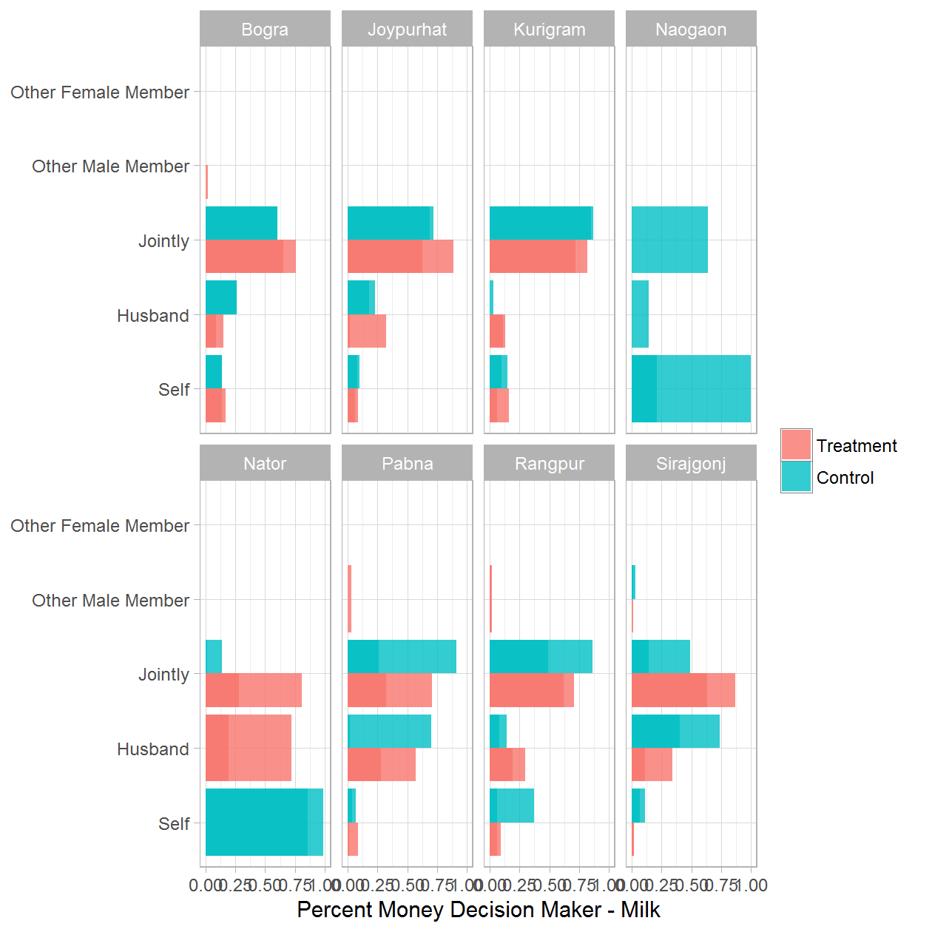

### 7b. Decision maker on how to use milk sales income - Treatment Only

|  |  |  |  |
| --- | --- | --- | --- |
| District | Round of Data Collection | Decision maker on how to use milk sales income | Percent |
| Bogra | Jul 2014 | Self | 0.17 |
| Bogra | Jul 2014 | Husband | 0.15 |
| Bogra | Jul 2014 | Jointly | 0.65 |
| Bogra | Jul 2014 | Other Male Member | 0.02 |
| Bogra | Jul 2014 | Other Female Member | 0.00 |
| Bogra | Dec 2014 | Self | 0.10 |
| Bogra | Dec 2014 | Husband | 0.23 |
| Bogra | Dec 2014 | Jointly | 0.66 |
| Bogra | Dec 2014 | Other Female Member | 0.02 |
| Bogra | Jul 2015 | Self | 0.34 |
| Bogra | Jul 2015 | Husband | 0.01 |
| Bogra | Jul 2015 | Jointly | 0.65 |
| Bogra | Dec 2015 | Self | 0.08 |
| Bogra | Dec 2015 | Husband | 0.01 |
| Bogra | Dec 2015 | Jointly | 0.91 |
| Bogra | Jul 2016 | Self | 0.14 |
| Bogra | Jul 2016 | Husband | 0.09 |
| Bogra | Jul 2016 | Jointly | 0.76 |
| Bogra | Jul 2016 | Other Male Member | 0.00 |
| Bogra | Jul 2016 | Other Female Member | 0.00 |
| Joypurhat | Jul 2014 | Self | 0.09 |
| Joypurhat | Jul 2014 | Husband | 0.02 |
| Joypurhat | Jul 2014 | Jointly | 0.89 |
| Joypurhat | Dec 2014 | Self | 0.05 |
| Joypurhat | Dec 2014 | Jointly | 0.95 |
| Joypurhat | Jul 2015 | Self | 0.21 |
| Joypurhat | Jul 2015 | Husband | 0.14 |
| Joypurhat | Jul 2015 | Jointly | 0.66 |
| Joypurhat | Dec 2015 | Self | 0.23 |
| Joypurhat | Dec 2015 | Jointly | 0.77 |
| Joypurhat | Jul 2016 | Self | 0.06 |
| Joypurhat | Jul 2016 | Husband | 0.32 |
| Joypurhat | Jul 2016 | Jointly | 0.63 |
| Kurigram | Jul 2014 | Self | 0.16 |
| Kurigram | Jul 2014 | Husband | 0.11 |
| Kurigram | Jul 2014 | Jointly | 0.72 |
| Kurigram | Dec 2014 | Self | 0.17 |
| Kurigram | Dec 2014 | Husband | 0.21 |
| Kurigram | Dec 2014 | Jointly | 0.62 |
| Kurigram | Jul 2015 | Self | 0.07 |
| Kurigram | Jul 2015 | Jointly | 0.93 |
| Kurigram | Dec 2015 | Self | 0.08 |
| Kurigram | Dec 2015 | Husband | 0.22 |
| Kurigram | Dec 2015 | Jointly | 0.70 |
| Kurigram | Jul 2016 | Self | 0.06 |
| Kurigram | Jul 2016 | Husband | 0.13 |
| Kurigram | Jul 2016 | Jointly | 0.82 |
| Nator | Jul 2014 | Husband | 0.72 |
| Nator | Jul 2014 | Jointly | 0.28 |
| Nator | Dec 2014 | Husband | 0.43 |
| Nator | Dec 2014 | Jointly | 0.57 |
| Nator | Dec 2015 | Jointly | 1.00 |
| Nator | Jul 2016 | Husband | 0.19 |
| Nator | Jul 2016 | Jointly | 0.81 |
| Pabna | Jul 2014 | Self | 0.09 |
| Pabna | Jul 2014 | Husband | 0.57 |
| Pabna | Jul 2014 | Jointly | 0.32 |
| Pabna | Jul 2014 | Other Male Member | 0.03 |
| Pabna | Dec 2014 | Self | 0.09 |
| Pabna | Dec 2014 | Husband | 0.14 |
| Pabna | Dec 2014 | Jointly | 0.77 |
| Pabna | Jul 2015 | Self | 0.18 |
| Pabna | Jul 2015 | Husband | 0.36 |
| Pabna | Jul 2015 | Jointly | 0.46 |
| Pabna | Dec 2015 | Self | 0.01 |
| Pabna | Dec 2015 | Husband | 0.05 |
| Pabna | Dec 2015 | Jointly | 0.92 |
| Pabna | Dec 2015 | Other | 0.02 |
| Pabna | Jul 2016 | Self | 0.01 |
| Pabna | Jul 2016 | Husband | 0.28 |
| Pabna | Jul 2016 | Jointly | 0.71 |
| Rangpur | Jul 2014 | Self | 0.09 |
| Rangpur | Jul 2014 | Husband | 0.19 |
| Rangpur | Jul 2014 | Jointly | 0.71 |
| Rangpur | Jul 2014 | Other Male Member | 0.01 |
| Rangpur | Dec 2014 | Self | 0.15 |
| Rangpur | Dec 2014 | Husband | 0.04 |
| Rangpur | Dec 2014 | Jointly | 0.77 |
| Rangpur | Dec 2014 | Other Male Member | 0.04 |
| Rangpur | Jul 2015 | Self | 0.04 |
| Rangpur | Jul 2015 | Jointly | 0.96 |
| Rangpur | Dec 2015 | Self | 0.16 |
| Rangpur | Dec 2015 | Husband | 0.03 |
| Rangpur | Dec 2015 | Jointly | 0.81 |
| Rangpur | Dec 2015 | Other Male Member | 0.01 |
| Rangpur | Jul 2016 | Self | 0.06 |
| Rangpur | Jul 2016 | Husband | 0.30 |
| Rangpur | Jul 2016 | Jointly | 0.62 |
| Rangpur | Jul 2016 | Other Male Member | 0.02 |
| Sirajgonj | Jul 2014 | Self | 0.02 |
| Sirajgonj | Jul 2014 | Husband | 0.34 |
| Sirajgonj | Jul 2014 | Jointly | 0.63 |
| Sirajgonj | Jul 2014 | Other Male Member | 0.01 |
| Sirajgonj | Dec 2014 | Self | 0.08 |
| Sirajgonj | Dec 2014 | Jointly | 0.92 |
| Sirajgonj | Jul 2015 | Self | 0.16 |
| Sirajgonj | Jul 2015 | Jointly | 0.84 |
| Sirajgonj | Dec 2015 | Husband | 0.12 |
| Sirajgonj | Dec 2015 | Jointly | 0.88 |
| Sirajgonj | Jul 2016 | Self | 0.02 |
| Sirajgonj | Jul 2016 | Husband | 0.11 |
| Sirajgonj | Jul 2016 | Jointly | 0.87 |

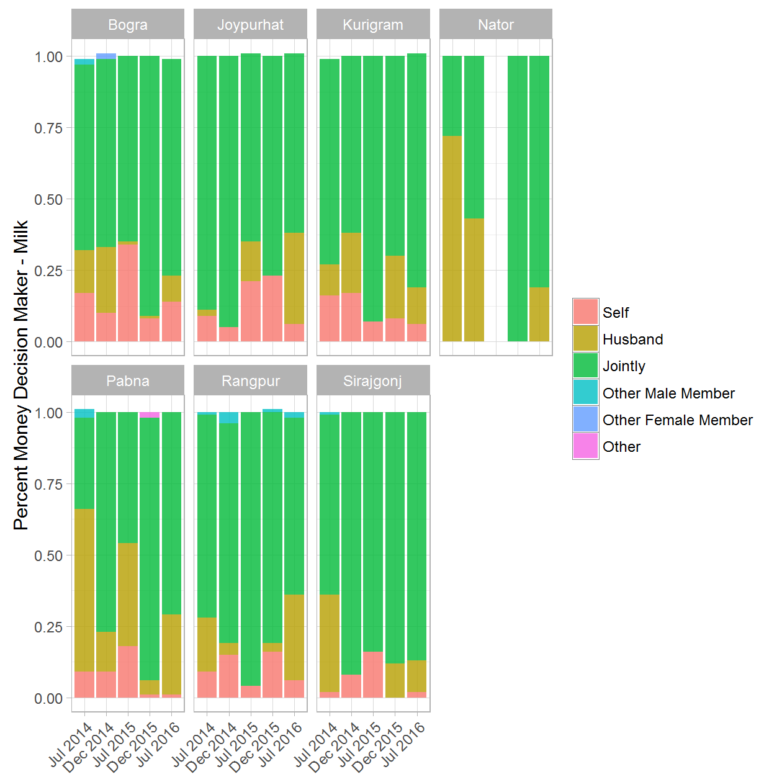

### 8a. Asset purchases - (Treatment & Control) rounds 1 and 5

|  |  |  |  |  |
| --- | --- | --- | --- | --- |
| District | Round of Data Collection | Asset purchases | Treatment/Control Group | Percent |
| Bogra | Jul 2014 | Husband | Treatment | 0.97 |
| Bogra | Jul 2014 | Husband | Control | 1.00 |
| Bogra | Jul 2014 | Son | Treatment | 0.03 |
| Bogra | Jul 2016 | Husband | Treatment | 0.98 |
| Bogra | Jul 2016 | Husband | Control | 0.95 |
| Bogra | Jul 2016 | Father-in-law | Treatment | 0.02 |
| Bogra | Jul 2016 | Father-in-law | Control | 0.05 |
| Joypurhat | Jul 2014 | Husband | Control | 1.00 |
| Joypurhat | Jul 2016 | Husband | Treatment | 1.00 |
| Joypurhat | Jul 2016 | Husband | Control | 1.00 |
| Kurigram | Jul 2014 | Husband | Treatment | 0.98 |
| Kurigram | Jul 2014 | Mother-in-law | Treatment | 0.01 |
| Kurigram | Jul 2014 | Son | Treatment | 0.01 |
| Kurigram | Jul 2016 | Husband | Control | 1.00 |
| Naogaon | Jul 2014 | Husband | Control | 1.00 |
| Naogaon | Jul 2016 | Husband | Control | 1.00 |
| Nator | Jul 2014 | Husband | Treatment | 1.00 |
| Nator | Jul 2014 | Husband | Control | 1.00 |
| Nator | Jul 2016 | Husband | Control | 1.00 |
| Pabna | Jul 2014 | Husband | Treatment | 0.75 |
| Pabna | Jul 2014 | Husband | Control | 1.00 |
| Pabna | Jul 2014 | Father-in-law | Treatment | 0.14 |
| Pabna | Jul 2014 | Mother-in-law | Treatment | 0.08 |
| Pabna | Jul 2014 | Other Male Member | Treatment | 0.04 |
| Pabna | Jul 2016 | Husband | Treatment | 0.95 |
| Pabna | Jul 2016 | Husband | Control | 1.00 |
| Pabna | Jul 2016 | Father-in-law | Treatment | 0.01 |
| Pabna | Jul 2016 | Son | Treatment | 0.02 |
| Pabna | Jul 2016 | Other Male Member | Treatment | 0.02 |
| Pabna | Jul 2016 | Other Male Member | Control | 0.00 |
| Rangpur | Jul 2014 | Husband | Treatment | 0.99 |
| Rangpur | Jul 2014 | Husband | Control | 1.00 |
| Rangpur | Jul 2014 | Son | Treatment | 0.01 |
| Rangpur | Jul 2014 | Other Male Member | Treatment | 0.00 |
| Rangpur | Jul 2016 | Husband | Treatment | 0.96 |
| Rangpur | Jul 2016 | Husband | Control | 0.97 |
| Rangpur | Jul 2016 | Father-in-law | Treatment | 0.01 |
| Rangpur | Jul 2016 | Mother-in-law | Treatment | 0.02 |
| Rangpur | Jul 2016 | Son | Treatment | 0.01 |
| Rangpur | Jul 2016 | Other Male Member | Treatment | 0.00 |
| Rangpur | Jul 2016 | Other Male Member | Control | 0.03 |
| Sirajgonj | Jul 2014 | Husband | Treatment | 1.00 |
| Sirajgonj | Jul 2014 | Husband | Control | 1.00 |
| Sirajgonj | Jul 2016 | Husband | Treatment | 0.98 |
| Sirajgonj | Jul 2016 | Husband | Control | 1.00 |
| Sirajgonj | Jul 2016 | Son | Treatment | 0.02 |

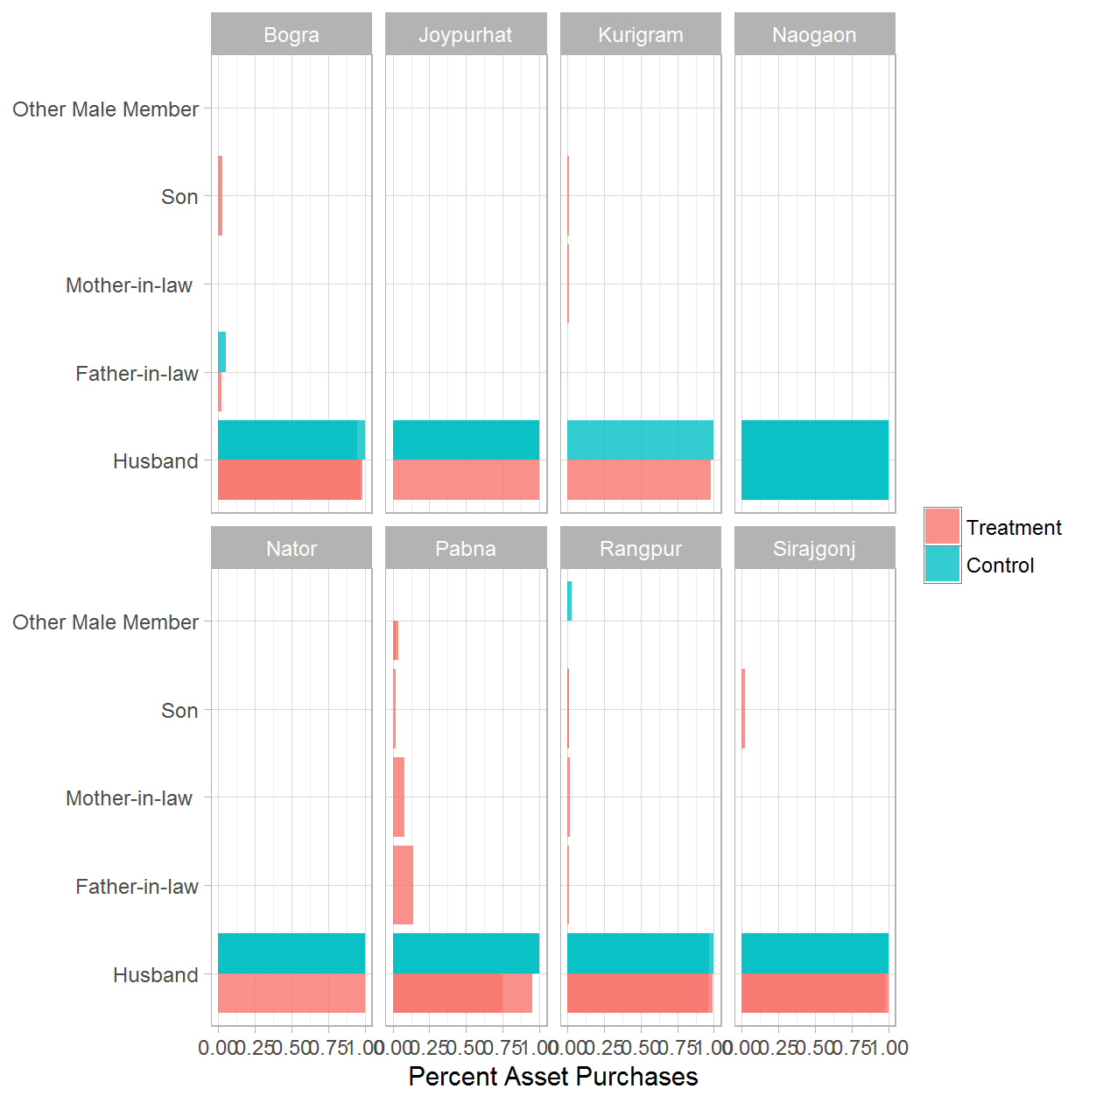

### 8b. Asset purchases - Treatment Only

|  |  |  |  |
| --- | --- | --- | --- |
| District | Round of Data Collection | Asset purchases | Percent |
| Bogra | Jul 2014 | Husband | 0.97 |
| Bogra | Jul 2014 | Son | 0.03 |
| Bogra | Dec 2014 | Husband | 0.40 |
| Bogra | Dec 2014 | Father-in-law | 0.20 |
| Bogra | Dec 2014 | Mother-in-law | 0.40 |
| Bogra | Jul 2015 | Husband | 1.00 |
| Bogra | Dec 2015 | Husband | 0.90 |
| Bogra | Dec 2015 | Father-in-law | 0.10 |
| Bogra | Jul 2016 | Husband | 0.98 |
| Bogra | Jul 2016 | Father-in-law | 0.02 |
| Joypurhat | Dec 2015 | Husband | 1.00 |
| Joypurhat | Jul 2016 | Husband | 1.00 |
| Kurigram | Jul 2014 | Husband | 0.98 |
| Kurigram | Jul 2014 | Mother-in-law | 0.01 |
| Kurigram | Jul 2014 | Son | 0.01 |
| Nator | Jul 2014 | Husband | 1.00 |
| Nator | Dec 2014 | Husband | 0.76 |
| Nator | Dec 2014 | Father-in-law | 0.12 |
| Nator | Dec 2014 | Mother-in-law | 0.12 |
| Pabna | Jul 2014 | Husband | 0.75 |
| Pabna | Jul 2014 | Father-in-law | 0.14 |
| Pabna | Jul 2014 | Mother-in-law | 0.08 |
| Pabna | Jul 2014 | Other Male Member | 0.04 |
| Pabna | Dec 2014 | Husband | 1.00 |
| Pabna | Jul 2015 | Husband | 1.00 |
| Pabna | Dec 2015 | Husband | 1.00 |
| Pabna | Jul 2016 | Husband | 0.95 |
| Pabna | Jul 2016 | Father-in-law | 0.01 |
| Pabna | Jul 2016 | Son | 0.02 |
| Pabna | Jul 2016 | Other Male Member | 0.02 |
| Rangpur | Jul 2014 | Husband | 0.99 |
| Rangpur | Jul 2014 | Son | 0.01 |
| Rangpur | Jul 2014 | Other Male Member | 0.00 |
| Rangpur | Dec 2014 | Husband | 1.00 |
| Rangpur | Jul 2015 | Husband | 1.00 |
| Rangpur | Dec 2015 | Husband | 1.00 |
| Rangpur | Jul 2016 | Husband | 0.96 |
| Rangpur | Jul 2016 | Father-in-law | 0.01 |
| Rangpur | Jul 2016 | Mother-in-law | 0.02 |
| Rangpur | Jul 2016 | Son | 0.01 |
| Rangpur | Jul 2016 | Other Male Member | 0.00 |
| Sirajgonj | Jul 2014 | Husband | 1.00 |
| Sirajgonj | Dec 2015 | Husband | 1.00 |
| Sirajgonj | Jul 2016 | Husband | 0.98 |
| Sirajgonj | Jul 2016 | Son | 0.02 |

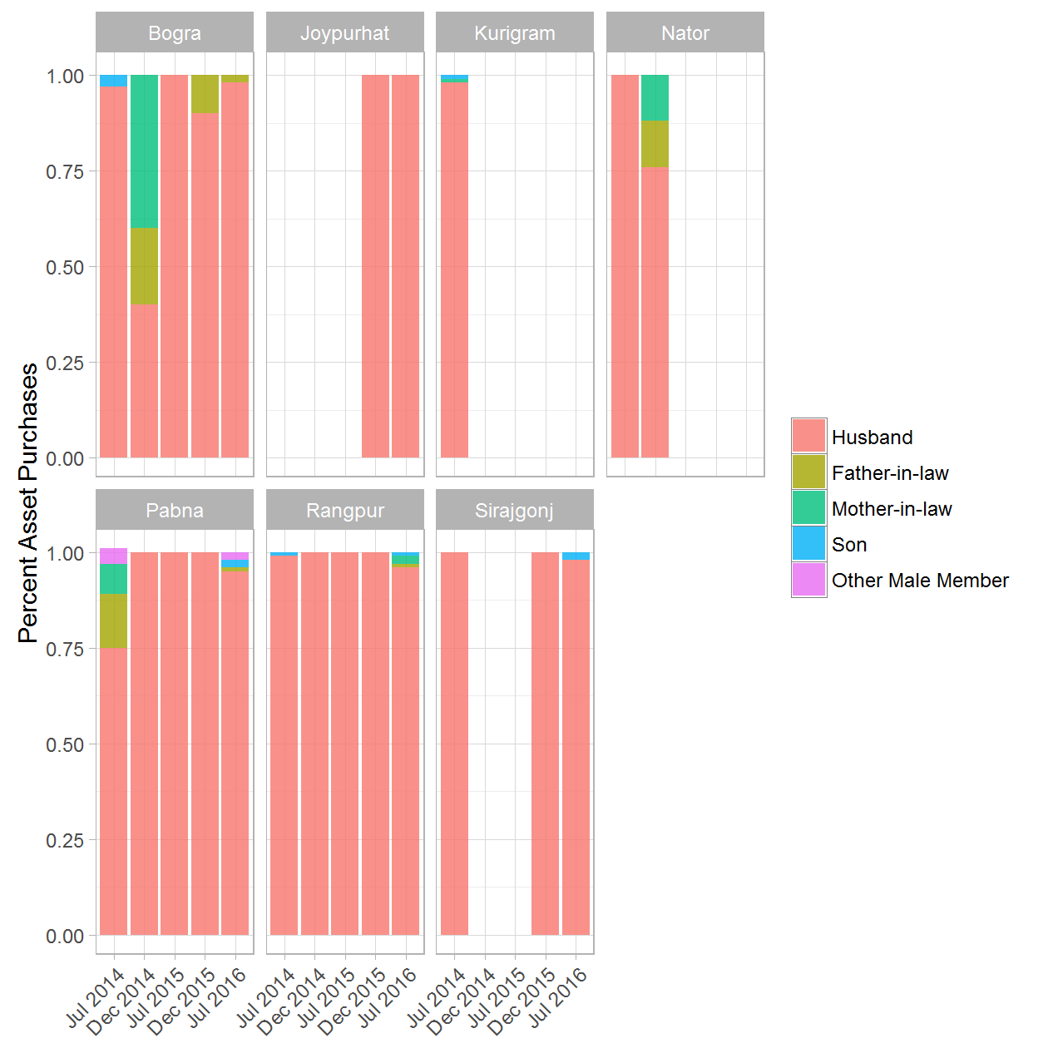

### 9a. Decision maker to purchase assets - (Treatment & Control) rounds 1 and 5

|  |  |  |  |  |
| --- | --- | --- | --- | --- |
| District | Round of Data Collection | Decision maker to purchase assets | Treatment/Control Group | Percent |
| Bogra | Jul 2014 | Self | Treatment | 0.29 |
| Bogra | Jul 2014 | Husband | Treatment | 0.07 |
| Bogra | Jul 2014 | Husband | Control | 0.83 |
| Bogra | Jul 2014 | Jointly | Treatment | 0.57 |
| Bogra | Jul 2014 | Jointly | Control | 0.17 |
| Bogra | Jul 2014 | Other Female Member | Treatment | 0.07 |
| Bogra | Jul 2016 | Self | Treatment | 0.18 |
| Bogra | Jul 2016 | Self | Control | 0.35 |
| Bogra | Jul 2016 | Husband | Treatment | 0.02 |
| Bogra | Jul 2016 | Husband | Control | 0.17 |
| Bogra | Jul 2016 | Jointly | Treatment | 0.72 |
| Bogra | Jul 2016 | Jointly | Control | 0.48 |
| Bogra | Jul 2016 | Other Male Member | Treatment | 0.02 |
| Bogra | Jul 2016 | Other Female Member | Treatment | 0.06 |
| Joypurhat | Jul 2014 | Jointly | Treatment | 1.00 |
| Joypurhat | Jul 2016 | Self | Treatment | 0.50 |
| Joypurhat | Jul 2016 | Self | Control | 0.79 |
| Joypurhat | Jul 2016 | Husband | Control | 0.21 |
| Joypurhat | Jul 2016 | Jointly | Treatment | 0.50 |
| Kurigram | Jul 2014 | Husband | Treatment | 0.20 |
| Kurigram | Jul 2014 | Jointly | Control | 1.00 |
| Kurigram | Jul 2014 | Other Male Member | Treatment | 0.13 |
| Kurigram | Jul 2014 | Other Female Member | Treatment | 0.67 |
| Naogaon | Jul 2016 | Jointly | Control | 1.00 |
| Nator | Jul 2014 | 0 | Treatment | 0.25 |
| Nator | Jul 2014 | Self | Treatment | 0.31 |
| Nator | Jul 2014 | Jointly | Treatment | 0.44 |
| Pabna | Jul 2014 | 0 | Control | 0.32 |
| Pabna | Jul 2014 | Self | Control | 0.40 |
| Pabna | Jul 2014 | Jointly | Control | 0.28 |
| Pabna | Jul 2016 | Self | Treatment | 0.08 |
| Pabna | Jul 2016 | Self | Control | 0.38 |
| Pabna | Jul 2016 | Jointly | Treatment | 0.92 |
| Pabna | Jul 2016 | Jointly | Control | 0.62 |
| Rangpur | Jul 2014 | 0 | Treatment | 0.12 |
| Rangpur | Jul 2014 | Self | Treatment | 0.16 |
| Rangpur | Jul 2014 | Self | Control | 0.90 |
| Rangpur | Jul 2014 | Jointly | Treatment | 0.72 |
| Rangpur | Jul 2014 | Jointly | Control | 0.10 |
| Rangpur | Jul 2016 | Self | Treatment | 0.15 |
| Rangpur | Jul 2016 | Husband | Treatment | 0.17 |
| Rangpur | Jul 2016 | Jointly | Treatment | 0.68 |
| Sirajgonj | Jul 2014 | 0 | Treatment | 0.42 |
| Sirajgonj | Jul 2014 | Self | Treatment | 0.17 |
| Sirajgonj | Jul 2014 | Self | Control | 0.42 |
| Sirajgonj | Jul 2014 | Husband | Treatment | 0.17 |
| Sirajgonj | Jul 2014 | Jointly | Treatment | 0.25 |
| Sirajgonj | Jul 2014 | Jointly | Control | 0.58 |
| Sirajgonj | Jul 2016 | Self | Treatment | 0.39 |
| Sirajgonj | Jul 2016 | Self | Control | 0.67 |
| Sirajgonj | Jul 2016 | Jointly | Treatment | 0.61 |
| Sirajgonj | Jul 2016 | Jointly | Control | 0.33 |

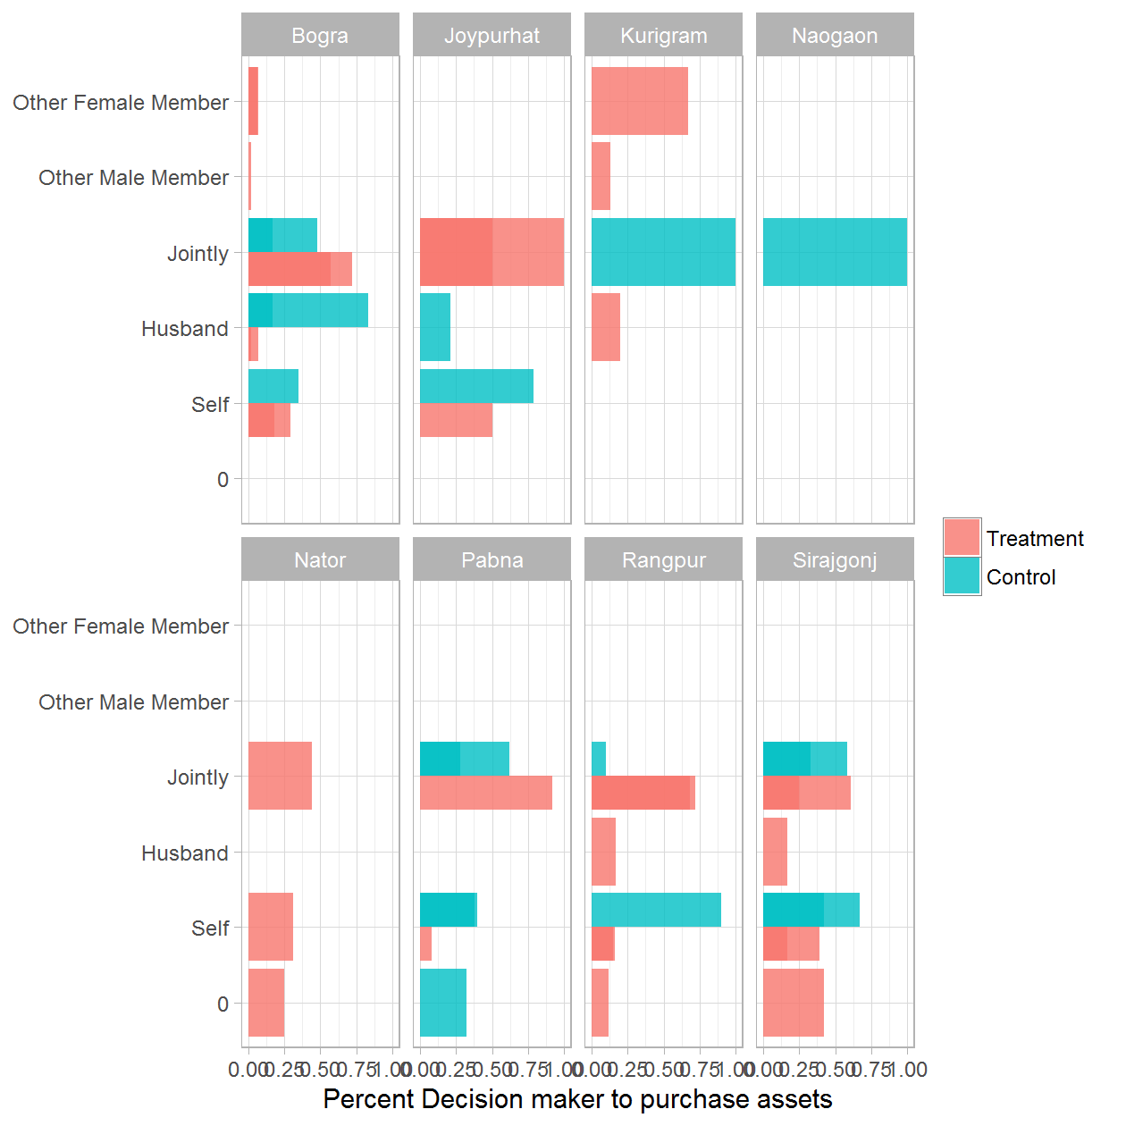

### 9b. Decision maker to purchase assets - Treatment Only

|  |  |  |  |
| --- | --- | --- | --- |
| District | Round of Data Collection | Decision maker to purchase assets | Percent |
| Bogra | Jul 2014 | Self | 0.29 |
| Bogra | Jul 2014 | Husband | 0.07 |
| Bogra | Jul 2014 | Jointly | 0.57 |
| Bogra | Jul 2014 | Other Female Member | 0.07 |
| Bogra | Dec 2014 | Self | 0.48 |
| Bogra | Dec 2014 | Husband | 0.02 |
| Bogra | Dec 2014 | Jointly | 0.50 |
| Bogra | Jul 2015 | Self | 0.41 |
| Bogra | Jul 2015 | Husband | 0.03 |
| Bogra | Jul 2015 | Jointly | 0.57 |
| Bogra | Dec 2015 | Self | 0.18 |
| Bogra | Dec 2015 | Jointly | 0.82 |
| Bogra | Jul 2016 | Self | 0.18 |
| Bogra | Jul 2016 | Husband | 0.02 |
| Bogra | Jul 2016 | Jointly | 0.72 |
| Bogra | Jul 2016 | Other Male Member | 0.02 |
| Bogra | Jul 2016 | Other Female Member | 0.06 |
| Joypurhat | Jul 2014 | Jointly | 1.00 |
| Joypurhat | Dec 2014 | Self | 0.67 |
| Joypurhat | Dec 2014 | Husband | 0.33 |
| Joypurhat | Jul 2015 | Self | 1.00 |
| Joypurhat | Jul 2016 | Self | 0.50 |
| Joypurhat | Jul 2016 | Jointly | 0.50 |
| Kurigram | Jul 2014 | Husband | 0.20 |
| Kurigram | Jul 2014 | Other Male Member | 0.13 |
| Kurigram | Jul 2014 | Other Female Member | 0.67 |
| Kurigram | Dec 2014 | Self | 0.32 |
| Kurigram | Dec 2014 | Jointly | 0.68 |
| Nator | Jul 2014 | 0 | 0.25 |
| Nator | Jul 2014 | Self | 0.31 |
| Nator | Jul 2014 | Jointly | 0.44 |
| Nator | Dec 2014 | Self | 1.00 |
| Nator | Dec 2015 | Self | 1.00 |
| Pabna | Dec 2014 | Jointly | 1.00 |
| Pabna | Jul 2015 | Self | 0.68 |
| Pabna | Jul 2015 | Jointly | 0.32 |
| Pabna | Dec 2015 | Self | 0.13 |
| Pabna | Dec 2015 | Jointly | 0.87 |
| Pabna | Jul 2016 | Self | 0.08 |
| Pabna | Jul 2016 | Jointly | 0.92 |
| Rangpur | Jul 2014 | 0 | 0.12 |
| Rangpur | Jul 2014 | Self | 0.16 |
| Rangpur | Jul 2014 | Jointly | 0.72 |
| Rangpur | Dec 2014 | Self | 0.75 |
| Rangpur | Dec 2014 | Jointly | 0.25 |
| Rangpur | Jul 2015 | Self | 0.67 |
| Rangpur | Jul 2015 | Husband | 0.06 |
| Rangpur | Jul 2015 | Jointly | 0.28 |
| Rangpur | Dec 2015 | Self | 0.75 |
| Rangpur | Dec 2015 | Jointly | 0.25 |
| Rangpur | Jul 2016 | Self | 0.15 |
| Rangpur | Jul 2016 | Husband | 0.17 |
| Rangpur | Jul 2016 | Jointly | 0.68 |
| Sirajgonj | Jul 2014 | 0 | 0.42 |
| Sirajgonj | Jul 2014 | Self | 0.17 |
| Sirajgonj | Jul 2014 | Husband | 0.17 |
| Sirajgonj | Jul 2014 | Jointly | 0.25 |
| Sirajgonj | Dec 2014 | Self | 0.80 |
| Sirajgonj | Dec 2014 | Jointly | 0.20 |
| Sirajgonj | Jul 2015 | Jointly | 1.00 |
| Sirajgonj | Dec 2015 | Jointly | 1.00 |
| Sirajgonj | Jul 2016 | Self | 0.39 |
| Sirajgonj | Jul 2016 | Jointly | 0.61 |

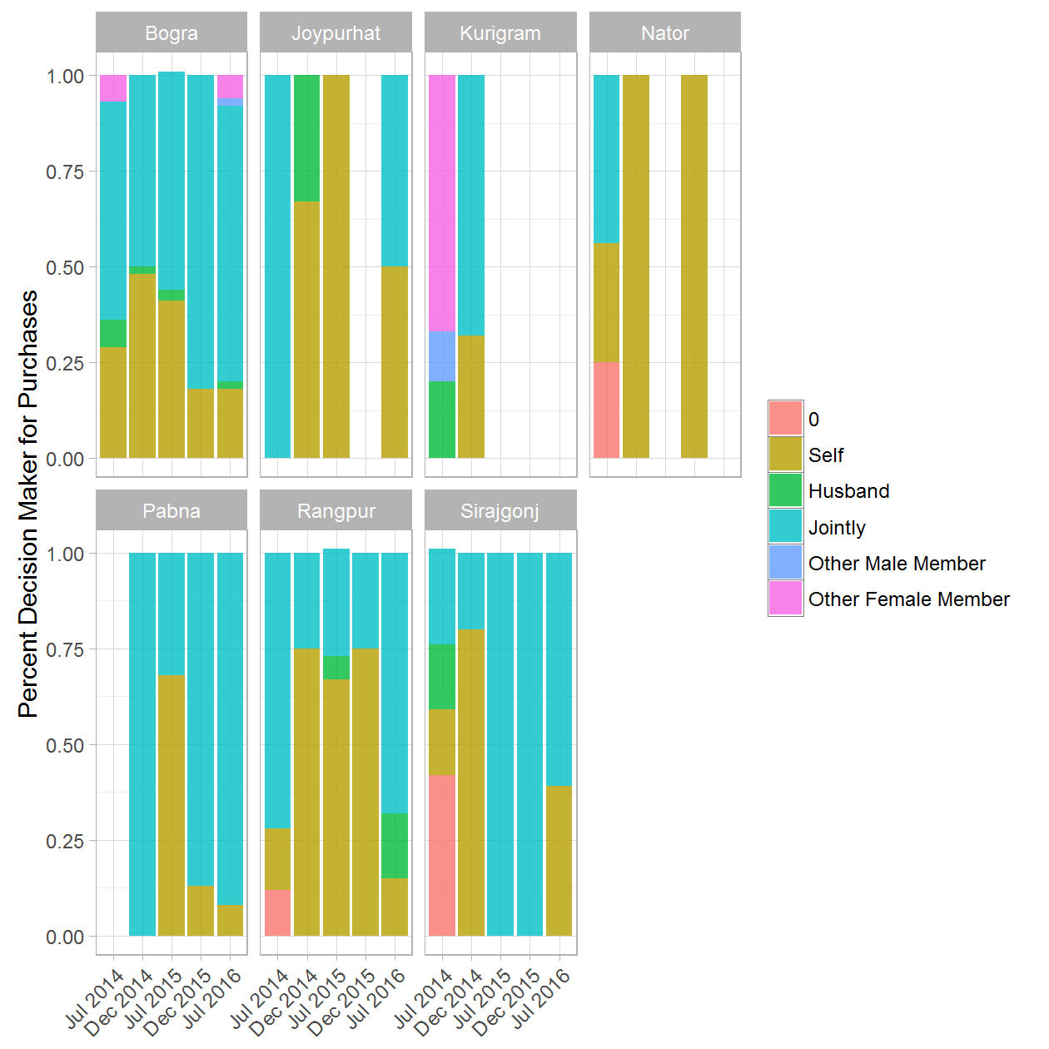

### 10a. Person in control of assets - (Treatment & Control) rounds 1 and 5

|  |  |  |  |  |
| --- | --- | --- | --- | --- |
| District | Round of Data Collection | Person in control of assets | Treatment/Control Group | Percent |
| Bogra | Jul 2014 | Self | Treatment | 0.49 |
| Bogra | Jul 2014 | Self | Control | 0.23 |
| Bogra | Jul 2014 | Husband | Treatment | 0.10 |
| Bogra | Jul 2014 | Husband | Control | 0.08 |
| Bogra | Jul 2014 | Jointly | Treatment | 0.36 |
| Bogra | Jul 2014 | Jointly | Control | 0.68 |
| Bogra | Jul 2014 | Other Male Member | Treatment | 0.05 |
| Bogra | Jul 2014 | Other Male Member | Control | 0.01 |
| Bogra | Jul 2016 | Self | Treatment | 0.16 |
| Bogra | Jul 2016 | Self | Control | 0.11 |
| Bogra | Jul 2016 | Husband | Treatment | 0.03 |
| Bogra | Jul 2016 | Husband | Control | 0.21 |
| Bogra | Jul 2016 | Jointly | Treatment | 0.80 |
| Bogra | Jul 2016 | Jointly | Control | 0.67 |
| Bogra | Jul 2016 | Other Male Member | Treatment | 0.00 |
| Joypurhat | Jul 2014 | Self | Treatment | 0.04 |
| Joypurhat | Jul 2014 | Self | Control | 0.09 |
| Joypurhat | Jul 2014 | Husband | Treatment | 0.01 |
| Joypurhat | Jul 2014 | Jointly | Treatment | 0.94 |
| Joypurhat | Jul 2014 | Jointly | Control | 0.91 |
| Joypurhat | Jul 2016 | Self | Treatment | 0.08 |
| Joypurhat | Jul 2016 | Self | Control | 0.12 |
| Joypurhat | Jul 2016 | Husband | Control | 0.13 |
| Joypurhat | Jul 2016 | Jointly | Treatment | 0.92 |
| Joypurhat | Jul 2016 | Jointly | Control | 0.75 |
| Kurigram | Jul 2014 | Self | Treatment | 0.10 |
| Kurigram | Jul 2014 | Self | Control | 0.12 |
| Kurigram | Jul 2014 | Husband | Treatment | 0.12 |
| Kurigram | Jul 2014 | Jointly | Treatment | 0.79 |
| Kurigram | Jul 2014 | Jointly | Control | 0.88 |
| Kurigram | Jul 2016 | Self | Treatment | 0.06 |
| Kurigram | Jul 2016 | Self | Control | 0.09 |
| Kurigram | Jul 2016 | Husband | Treatment | 0.13 |
| Kurigram | Jul 2016 | Husband | Control | 0.02 |
| Kurigram | Jul 2016 | Jointly | Treatment | 0.82 |
| Kurigram | Jul 2016 | Jointly | Control | 0.89 |
| Naogaon | Jul 2014 | Self | Control | 0.98 |
| Naogaon | Jul 2014 | Jointly | Control | 0.02 |
| Naogaon | Jul 2016 | Jointly | Control | 1.00 |
| Nator | Jul 2014 | Self | Treatment | 0.60 |
| Nator | Jul 2014 | Self | Control | 1.00 |
| Nator | Jul 2014 | Husband | Treatment | 0.17 |
| Nator | Jul 2014 | Jointly | Treatment | 0.23 |
| Nator | Jul 2016 | Self | Control | 0.86 |
| Nator | Jul 2016 | Jointly | Treatment | 1.00 |
| Nator | Jul 2016 | Jointly | Control | 0.14 |
| Pabna | Jul 2014 | Self | Treatment | 0.09 |
| Pabna | Jul 2014 | Self | Control | 0.26 |
| Pabna | Jul 2014 | Husband | Treatment | 0.22 |
| Pabna | Jul 2014 | Husband | Control | 0.28 |
| Pabna | Jul 2014 | Jointly | Treatment | 0.68 |
| Pabna | Jul 2014 | Jointly | Control | 0.46 |
| Pabna | Jul 2014 | Other Male Member | Treatment | 0.01 |
| Pabna | Jul 2014 | Other Male Member | Control | 0.00 |
| Pabna | Jul 2016 | Self | Treatment | 0.08 |
| Pabna | Jul 2016 | Self | Control | 0.06 |
| Pabna | Jul 2016 | Husband | Treatment | 0.25 |
| Pabna | Jul 2016 | Jointly | Treatment | 0.67 |
| Pabna | Jul 2016 | Jointly | Control | 0.92 |
| Pabna | Jul 2016 | Other Male Member | Control | 0.02 |
| Rangpur | Jul 2014 | Self | Treatment | 0.10 |
| Rangpur | Jul 2014 | Self | Control | 0.37 |
| Rangpur | Jul 2014 | Husband | Treatment | 0.07 |
| Rangpur | Jul 2014 | Husband | Control | 0.05 |
| Rangpur | Jul 2014 | Jointly | Treatment | 0.82 |
| Rangpur | Jul 2014 | Jointly | Control | 0.58 |
| Rangpur | Jul 2014 | Other Male Member | Treatment | 0.01 |
| Rangpur | Jul 2016 | Self | Treatment | 0.11 |
| Rangpur | Jul 2016 | Self | Control | 0.24 |
| Rangpur | Jul 2016 | Husband | Treatment | 0.34 |
| Rangpur | Jul 2016 | Husband | Control | 0.03 |
| Rangpur | Jul 2016 | Jointly | Treatment | 0.53 |
| Rangpur | Jul 2016 | Jointly | Control | 0.74 |
| Rangpur | Jul 2016 | Other Male Member | Treatment | 0.03 |
| Sirajgonj | Jul 2014 | Self | Treatment | 0.02 |
| Sirajgonj | Jul 2014 | Self | Control | 0.14 |
| Sirajgonj | Jul 2014 | Husband | Treatment | 0.29 |
| Sirajgonj | Jul 2014 | Husband | Control | 0.72 |
| Sirajgonj | Jul 2014 | Jointly | Treatment | 0.69 |
| Sirajgonj | Jul 2014 | Jointly | Control | 0.10 |
| Sirajgonj | Jul 2014 | Other Male Member | Control | 0.04 |
| Sirajgonj | Jul 2016 | Self | Treatment | 0.12 |
| Sirajgonj | Jul 2016 | Self | Control | 0.16 |
| Sirajgonj | Jul 2016 | Husband | Treatment | 0.05 |
| Sirajgonj | Jul 2016 | Husband | Control | 0.29 |
| Sirajgonj | Jul 2016 | Jointly | Treatment | 0.83 |
| Sirajgonj | Jul 2016 | Jointly | Control | 0.51 |
| Sirajgonj | Jul 2016 | Other Male Member | Control | 0.03 |

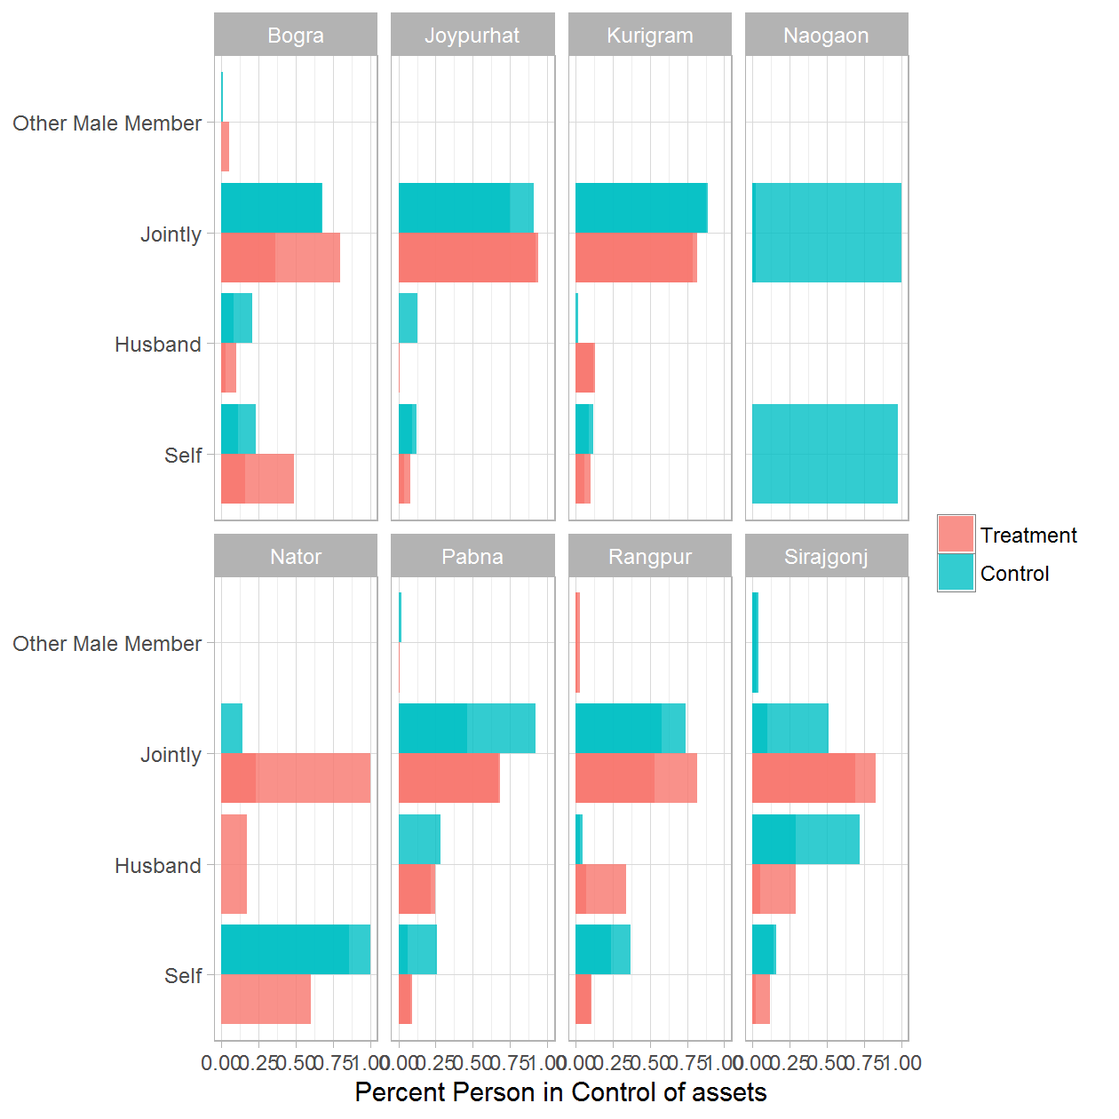

### 10b. Person in control of assets - Treatment Only

|  |  |  |  |
| --- | --- | --- | --- |
| District | Round of Data Collection | Person in control of assets | Percent |
| Bogra | Jul 2014 | Self | 0.49 |
| Bogra | Jul 2014 | Husband | 0.10 |
| Bogra | Jul 2014 | Jointly | 0.36 |
| Bogra | Jul 2014 | Other Male Member | 0.05 |
| Bogra | Dec 2014 | Self | 0.14 |
| Bogra | Dec 2014 | Husband | 0.21 |
| Bogra | Dec 2014 | Jointly | 0.63 |
| Bogra | Dec 2014 | Other Female Member | 0.02 |
| Bogra | Jul 2015 | Self | 0.35 |
| Bogra | Jul 2015 | Jointly | 0.65 |
| Bogra | Dec 2015 | Self | 0.09 |
| Bogra | Dec 2015 | Husband | 0.01 |
| Bogra | Dec 2015 | Jointly | 0.90 |
| Bogra | Dec 2015 | Other Male Member | 0.00 |
| Bogra | Jul 2016 | Self | 0.16 |
| Bogra | Jul 2016 | Husband | 0.03 |
| Bogra | Jul 2016 | Jointly | 0.80 |
| Bogra | Jul 2016 | Other Male Member | 0.00 |
| Joypurhat | Jul 2014 | Self | 0.04 |
| Joypurhat | Jul 2014 | Husband | 0.01 |
| Joypurhat | Jul 2014 | Jointly | 0.94 |
| Joypurhat | Dec 2014 | Self | 0.42 |
| Joypurhat | Dec 2014 | Jointly | 0.58 |
| Joypurhat | Jul 2015 | Self | 0.33 |
| Joypurhat | Jul 2015 | Husband | 0.13 |
| Joypurhat | Jul 2015 | Jointly | 0.54 |
| Joypurhat | Dec 2015 | Self | 0.23 |
| Joypurhat | Dec 2015 | Jointly | 0.77 |
| Joypurhat | Jul 2016 | Self | 0.08 |
| Joypurhat | Jul 2016 | Jointly | 0.92 |
| Kurigram | Jul 2014 | Self | 0.10 |
| Kurigram | Jul 2014 | Husband | 0.12 |
| Kurigram | Jul 2014 | Jointly | 0.79 |
| Kurigram | Dec 2014 | Self | 0.17 |
| Kurigram | Dec 2014 | Husband | 0.19 |
| Kurigram | Dec 2014 | Jointly | 0.64 |
| Kurigram | Jul 2015 | Self | 0.07 |
| Kurigram | Jul 2015 | Jointly | 0.93 |
| Kurigram | Dec 2015 | Self | 0.08 |
| Kurigram | Dec 2015 | Husband | 0.22 |
| Kurigram | Dec 2015 | Jointly | 0.70 |
| Kurigram | Jul 2016 | Self | 0.06 |
| Kurigram | Jul 2016 | Husband | 0.13 |
| Kurigram | Jul 2016 | Jointly | 0.82 |
| Nator | Jul 2014 | Self | 0.60 |
| Nator | Jul 2014 | Husband | 0.17 |
| Nator | Jul 2014 | Jointly | 0.23 |
| Nator | Dec 2014 | Self | 0.77 |
| Nator | Dec 2014 | Husband | 0.07 |
| Nator | Dec 2014 | Jointly | 0.16 |
| Nator | Dec 2015 | Self | 0.14 |
| Nator | Dec 2015 | Jointly | 0.86 |
| Nator | Jul 2016 | Jointly | 1.00 |
| Pabna | Jul 2014 | Self | 0.09 |
| Pabna | Jul 2014 | Husband | 0.22 |
| Pabna | Jul 2014 | Jointly | 0.68 |
| Pabna | Jul 2014 | Other Male Member | 0.01 |
| Pabna | Dec 2014 | Self | 0.34 |
| Pabna | Dec 2014 | Husband | 0.13 |
| Pabna | Dec 2014 | Jointly | 0.53 |
| Pabna | Jul 2015 | Self | 0.14 |
| Pabna | Jul 2015 | Husband | 0.18 |
| Pabna | Jul 2015 | Jointly | 0.67 |
| Pabna | Dec 2015 | Self | 0.02 |
| Pabna | Dec 2015 | Husband | 0.04 |
| Pabna | Dec 2015 | Jointly | 0.92 |
| Pabna | Dec 2015 | 7 | 0.02 |
| Pabna | Jul 2016 | Self | 0.08 |
| Pabna | Jul 2016 | Husband | 0.25 |
| Pabna | Jul 2016 | Jointly | 0.67 |
| Rangpur | Jul 2014 | Self | 0.10 |
| Rangpur | Jul 2014 | Husband | 0.07 |
| Rangpur | Jul 2014 | Jointly | 0.82 |
| Rangpur | Jul 2014 | Other Male Member | 0.01 |
| Rangpur | Dec 2014 | Self | 0.28 |
| Rangpur | Dec 2014 | Husband | 0.03 |
| Rangpur | Dec 2014 | Jointly | 0.66 |
| Rangpur | Dec 2014 | Other Male Member | 0.03 |
| Rangpur | Jul 2015 | Self | 0.04 |
| Rangpur | Jul 2015 | Jointly | 0.96 |
| Rangpur | Dec 2015 | Self | 0.15 |
| Rangpur | Dec 2015 | Husband | 0.02 |
| Rangpur | Dec 2015 | Jointly | 0.82 |
| Rangpur | Dec 2015 | Other Male Member | 0.01 |
| Rangpur | Jul 2016 | Self | 0.11 |
| Rangpur | Jul 2016 | Husband | 0.34 |
| Rangpur | Jul 2016 | Jointly | 0.53 |
| Rangpur | Jul 2016 | Other Male Member | 0.03 |
| Sirajgonj | Jul 2014 | Self | 0.02 |
| Sirajgonj | Jul 2014 | Husband | 0.29 |
| Sirajgonj | Jul 2014 | Jointly | 0.69 |
| Sirajgonj | Dec 2014 | Self | 0.43 |
| Sirajgonj | Dec 2014 | Jointly | 0.52 |
| Sirajgonj | Dec 2014 | Other Male Member | 0.05 |
| Sirajgonj | Jul 2015 | Self | 0.02 |
| Sirajgonj | Jul 2015 | Jointly | 0.98 |
| Sirajgonj | Dec 2015 | Self | 0.00 |
| Sirajgonj | Dec 2015 | Husband | 0.16 |
| Sirajgonj | Dec 2015 | Jointly | 0.84 |
| Sirajgonj | Jul 2016 | Self | 0.12 |
| Sirajgonj | Jul 2016 | Husband | 0.05 |
| Sirajgonj | Jul 2016 | Jointly | 0.83 |

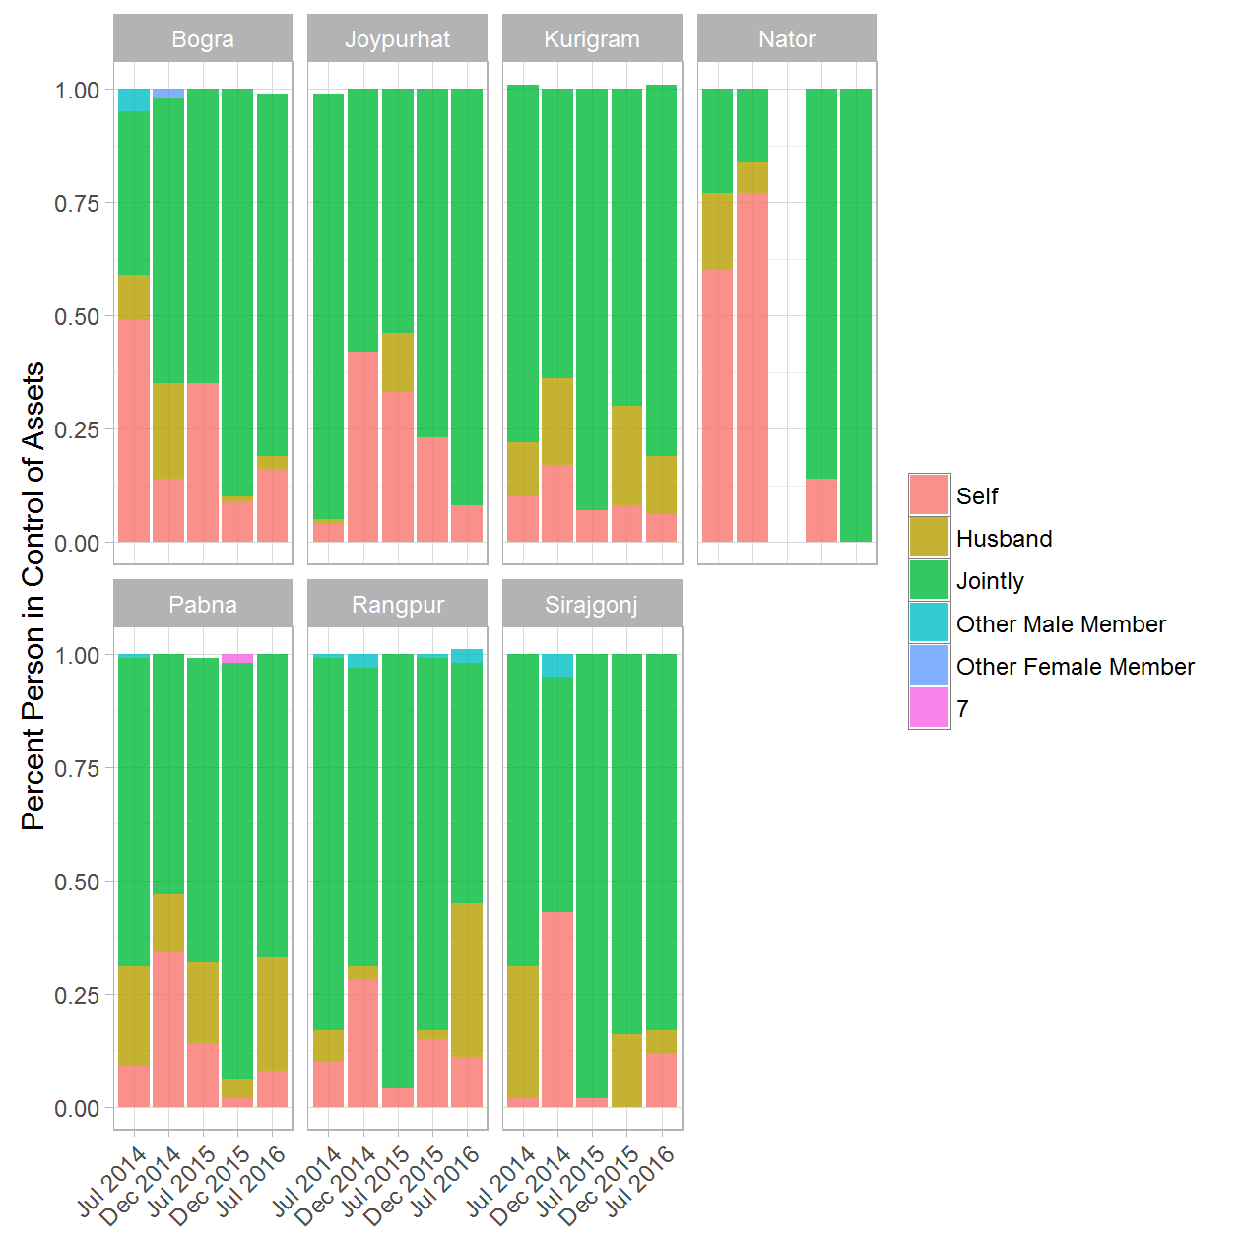

### GENDER: 2a. Gender of Person Rearing Cow - (Treatment & Control) rounds 1 and 5

|  |  |  |  |  |
| --- | --- | --- | --- | --- |
| District | Round of Data Collection | Person Rearing Cow | Treatment/Control Group | Percent |
| Bogra | Jul 2014 | Women | Treatment | 0.56 |
| Bogra | Jul 2014 | Women | Control | 0.50 |
| Bogra | Jul 2014 | Men | Treatment | 0.04 |
| Bogra | Jul 2014 | Men | Control | 0.04 |
| Bogra | Jul 2014 | Jointly | Treatment | 0.40 |
| Bogra | Jul 2014 | Jointly | Control | 0.45 |
| Bogra | Jul 2016 | Women | Treatment | 0.61 |
| Bogra | Jul 2016 | Women | Control | 0.39 |
| Bogra | Jul 2016 | Men | Treatment | 0.03 |
| Bogra | Jul 2016 | Men | Control | 0.06 |
| Bogra | Jul 2016 | Jointly | Treatment | 0.35 |
| Bogra | Jul 2016 | Jointly | Control | 0.55 |
| Bogra | Jul 2016 | Other Female Member | Treatment | 0.01 |
| Joypurhat | Jul 2014 | Women | Treatment | 0.37 |
| Joypurhat | Jul 2014 | Women | Control | 0.08 |
| Joypurhat | Jul 2014 | Men | Treatment | 0.22 |
| Joypurhat | Jul 2014 | Men | Control | 0.06 |
| Joypurhat | Jul 2014 | Jointly | Treatment | 0.41 |
| Joypurhat | Jul 2014 | Jointly | Control | 0.86 |
| Joypurhat | Jul 2016 | Women | Treatment | 0.14 |
| Joypurhat | Jul 2016 | Women | Control | 0.11 |
| Joypurhat | Jul 2016 | Men | Treatment | 0.00 |
| Joypurhat | Jul 2016 | Men | Control | 0.03 |
| Joypurhat | Jul 2016 | Jointly | Treatment | 0.85 |
| Joypurhat | Jul 2016 | Jointly | Control | 0.86 |
| Joypurhat | Jul 2016 | Other Female Member | Treatment | 0.00 |
| Kurigram | Jul 2014 | Women | Treatment | 0.08 |
| Kurigram | Jul 2014 | Women | Control | 0.56 |
| Kurigram | Jul 2014 | Men | Treatment | 0.21 |
| Kurigram | Jul 2014 | Men | Control | 0.07 |
| Kurigram | Jul 2014 | Jointly | Treatment | 0.71 |
| Kurigram | Jul 2014 | Jointly | Control | 0.37 |
| Kurigram | Jul 2016 | Women | Treatment | 0.51 |
| Kurigram | Jul 2016 | Women | Control | 0.28 |
| Kurigram | Jul 2016 | Men | Treatment | 0.30 |
| Kurigram | Jul 2016 | Men | Control | 0.07 |
| Kurigram | Jul 2016 | Jointly | Treatment | 0.18 |
| Kurigram | Jul 2016 | Jointly | Control | 0.66 |
| Naogaon | Jul 2014 | Women | Control | 0.14 |
| Naogaon | Jul 2014 | Jointly | Control | 0.86 |
| Naogaon | Jul 2016 | Women | Control | 0.13 |
| Naogaon | Jul 2016 | Men | Control | 0.06 |
| Naogaon | Jul 2016 | Jointly | Control | 0.81 |
| Nator | Jul 2014 | Women | Treatment | 0.86 |
| Nator | Jul 2014 | Women | Control | 0.68 |
| Nator | Jul 2014 | Men | Treatment | 0.11 |
| Nator | Jul 2014 | Men | Control | 0.22 |
| Nator | Jul 2014 | Jointly | Treatment | 0.02 |
| Nator | Jul 2014 | Jointly | Control | 0.10 |
| Nator | Jul 2016 | Women | Treatment | 0.79 |
| Nator | Jul 2016 | Women | Control | 0.28 |
| Nator | Jul 2016 | Men | Treatment | 0.12 |
| Nator | Jul 2016 | Men | Control | 0.01 |
| Nator | Jul 2016 | Jointly | Treatment | 0.10 |
| Nator | Jul 2016 | Jointly | Control | 0.71 |
| Pabna | Jul 2014 | Women | Treatment | 0.11 |
| Pabna | Jul 2014 | Women | Control | 0.20 |
| Pabna | Jul 2014 | Men | Treatment | 0.17 |
| Pabna | Jul 2014 | Men | Control | 0.04 |
| Pabna | Jul 2014 | Jointly | Treatment | 0.72 |
| Pabna | Jul 2014 | Jointly | Control | 0.76 |
| Pabna | Jul 2016 | Women | Treatment | 0.13 |
| Pabna | Jul 2016 | Women | Control | 0.11 |
| Pabna | Jul 2016 | Men | Treatment | 0.09 |
| Pabna | Jul 2016 | Men | Control | 0.07 |
| Pabna | Jul 2016 | Jointly | Treatment | 0.77 |
| Pabna | Jul 2016 | Jointly | Control | 0.82 |
| Pabna | Jul 2016 | Other Female Member | Treatment | 0.01 |
| Pabna | Jul 2016 | Other Female Member | Control | 0.00 |
| Rangpur | Jul 2014 | Women | Treatment | 0.35 |
| Rangpur | Jul 2014 | Women | Control | 0.48 |
| Rangpur | Jul 2014 | Men | Treatment | 0.09 |
| Rangpur | Jul 2014 | Men | Control | 0.07 |
| Rangpur | Jul 2014 | Jointly | Treatment | 0.56 |
| Rangpur | Jul 2014 | Jointly | Control | 0.46 |
| Rangpur | Jul 2016 | Women | Treatment | 0.49 |
| Rangpur | Jul 2016 | Women | Control | 0.52 |
| Rangpur | Jul 2016 | Men | Treatment | 0.04 |
| Rangpur | Jul 2016 | Men | Control | 0.03 |
| Rangpur | Jul 2016 | Jointly | Treatment | 0.44 |
| Rangpur | Jul 2016 | Jointly | Control | 0.41 |
| Rangpur | Jul 2016 | Other Male Member | Treatment | 0.03 |
| Rangpur | Jul 2016 | Other Male Member | Control | 0.03 |
| Rangpur | Jul 2016 | Other Female Member | Control | 0.02 |
| Sirajgonj | Jul 2014 | Women | Treatment | 0.27 |
| Sirajgonj | Jul 2014 | Women | Control | 0.32 |
| Sirajgonj | Jul 2014 | Men | Treatment | 0.11 |
| Sirajgonj | Jul 2014 | Men | Control | 0.12 |
| Sirajgonj | Jul 2014 | Jointly | Treatment | 0.62 |
| Sirajgonj | Jul 2014 | Jointly | Control | 0.56 |
| Sirajgonj | Jul 2016 | Women | Treatment | 0.18 |
| Sirajgonj | Jul 2016 | Women | Control | 0.27 |
| Sirajgonj | Jul 2016 | Men | Treatment | 0.06 |
| Sirajgonj | Jul 2016 | Men | Control | 0.11 |
| Sirajgonj | Jul 2016 | Jointly | Treatment | 0.75 |
| Sirajgonj | Jul 2016 | Jointly | Control | 0.59 |
| Sirajgonj | Jul 2016 | Other Male Member | Treatment | 0.01 |
| Sirajgonj | Jul 2016 | Other Male Member | Control | 0.03 |
| Sirajgonj | Jul 2016 | Other Female Member | Control | 0.01 |

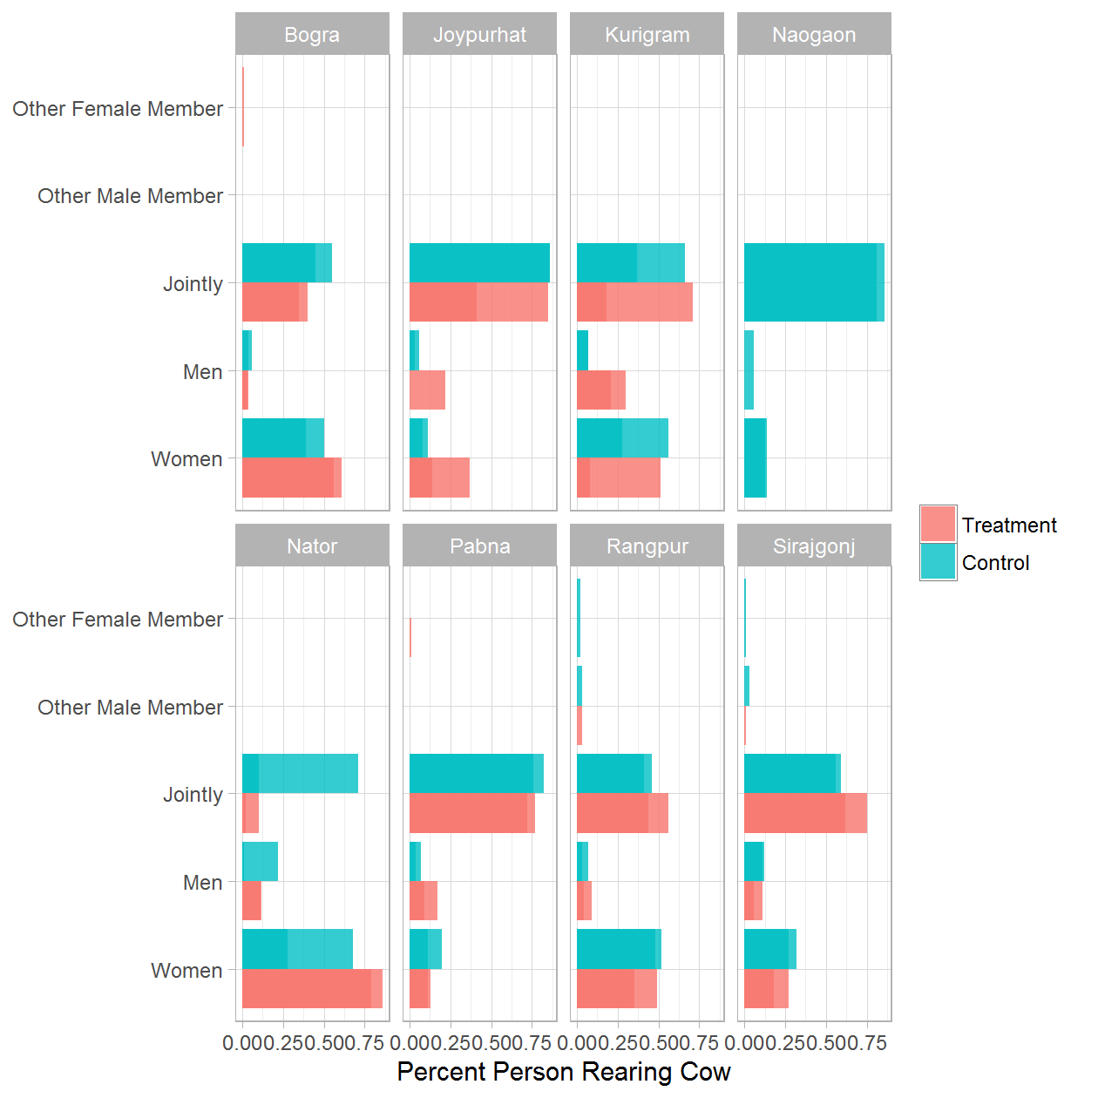

### GENDER: 2b. Gender of Person Rearing Cow - Treatment Only

|  |  |  |  |
| --- | --- | --- | --- |
| District | Round of Data Collection | Person Rearing Cow | Percent |
| Bogra | Jul 2014 | Women | 0.56 |
| Bogra | Jul 2014 | Men | 0.04 |
| Bogra | Jul 2014 | Jointly | 0.40 |
| Bogra | Dec 2014 | Women | 0.55 |
| Bogra | Dec 2014 | Men | 0.10 |
| Bogra | Dec 2014 | Jointly | 0.35 |
| Bogra | Jul 2015 | Women | 0.44 |
| Bogra | Jul 2015 | Men | 0.01 |
| Bogra | Jul 2015 | Jointly | 0.55 |
| Bogra | Dec 2015 | Women | 0.47 |
| Bogra | Dec 2015 | Men | 0.03 |
| Bogra | Dec 2015 | Jointly | 0.50 |
| Bogra | Jul 2016 | Women | 0.61 |
| Bogra | Jul 2016 | Men | 0.03 |
| Bogra | Jul 2016 | Jointly | 0.35 |
| Bogra | Jul 2016 | Other Female Member | 0.01 |
| Joypurhat | Jul 2014 | Women | 0.37 |
| Joypurhat | Jul 2014 | Men | 0.22 |
| Joypurhat | Jul 2014 | Jointly | 0.41 |
| Joypurhat | Dec 2014 | Women | 0.22 |
| Joypurhat | Dec 2014 | Jointly | 0.77 |
| Joypurhat | Dec 2014 | Other Male Member | 0.01 |
| Joypurhat | Jul 2015 | Women | 0.19 |
| Joypurhat | Jul 2015 | Jointly | 0.81 |
| Joypurhat | Dec 2015 | Women | 0.12 |
| Joypurhat | Dec 2015 | Men | 0.02 |
| Joypurhat | Dec 2015 | Jointly | 0.86 |
| Joypurhat | Jul 2016 | Women | 0.14 |
| Joypurhat | Jul 2016 | Men | 0.00 |
| Joypurhat | Jul 2016 | Jointly | 0.85 |
| Joypurhat | Jul 2016 | Other Female Member | 0.00 |
| Kurigram | Jul 2014 | Women | 0.08 |
| Kurigram | Jul 2014 | Men | 0.21 |
| Kurigram | Jul 2014 | Jointly | 0.71 |
| Kurigram | Dec 2014 | Women | 0.13 |
| Kurigram | Dec 2014 | Men | 0.15 |
| Kurigram | Dec 2014 | Jointly | 0.72 |
| Kurigram | Jul 2015 | Women | 1.00 |
| Kurigram | Dec 2015 | Women | 0.07 |
| Kurigram | Dec 2015 | Men | 0.17 |
| Kurigram | Dec 2015 | Jointly | 0.76 |
| Kurigram | Jul 2016 | Women | 0.51 |
| Kurigram | Jul 2016 | Men | 0.30 |
| Kurigram | Jul 2016 | Jointly | 0.18 |
| Nator | Jul 2014 | Women | 0.86 |
| Nator | Jul 2014 | Men | 0.11 |
| Nator | Jul 2014 | Jointly | 0.02 |
| Nator | Dec 2014 | Women | 0.31 |
| Nator | Dec 2014 | Men | 0.10 |
| Nator | Dec 2014 | Jointly | 0.59 |
| Nator | Dec 2015 | Women | 0.71 |
| Nator | Dec 2015 | Men | 0.29 |
| Nator | Jul 2016 | Women | 0.79 |
| Nator | Jul 2016 | Men | 0.12 |
| Nator | Jul 2016 | Jointly | 0.10 |
| Pabna | Jul 2014 | Women | 0.11 |
| Pabna | Jul 2014 | Men | 0.17 |
| Pabna | Jul 2014 | Jointly | 0.72 |
| Pabna | Dec 2014 | Women | 0.13 |
| Pabna | Dec 2014 | Men | 0.07 |
| Pabna | Dec 2014 | Jointly | 0.80 |
| Pabna | Jul 2015 | Women | 0.17 |
| Pabna | Jul 2015 | Men | 0.04 |
| Pabna | Jul 2015 | Jointly | 0.79 |
| Pabna | Dec 2015 | Women | 0.03 |
| Pabna | Dec 2015 | Men | 0.02 |
| Pabna | Dec 2015 | Jointly | 0.94 |
| Pabna | Dec 2015 | 6 | 0.01 |
| Pabna | Jul 2016 | Women | 0.13 |
| Pabna | Jul 2016 | Men | 0.09 |
| Pabna | Jul 2016 | Jointly | 0.77 |
| Pabna | Jul 2016 | Other Female Member | 0.01 |
| Rangpur | Jul 2014 | Women | 0.35 |
| Rangpur | Jul 2014 | Men | 0.09 |
| Rangpur | Jul 2014 | Jointly | 0.56 |
| Rangpur | Dec 2014 | Women | 0.27 |
| Rangpur | Dec 2014 | Jointly | 0.73 |
| Rangpur | Jul 2015 | Women | 0.30 |
| Rangpur | Jul 2015 | Men | 0.02 |
| Rangpur | Jul 2015 | Jointly | 0.68 |
| Rangpur | Dec 2015 | Women | 0.42 |
| Rangpur | Dec 2015 | Men | 0.04 |
| Rangpur | Dec 2015 | Jointly | 0.53 |
| Rangpur | Dec 2015 | Other Male Member | 0.01 |
| Rangpur | Jul 2016 | Women | 0.49 |
| Rangpur | Jul 2016 | Men | 0.04 |
| Rangpur | Jul 2016 | Jointly | 0.44 |
| Rangpur | Jul 2016 | Other Male Member | 0.03 |
| Sirajgonj | Jul 2014 | Women | 0.27 |
| Sirajgonj | Jul 2014 | Men | 0.11 |
| Sirajgonj | Jul 2014 | Jointly | 0.62 |
| Sirajgonj | Dec 2014 | Women | 0.07 |
| Sirajgonj | Dec 2014 | Jointly | 0.93 |
| Sirajgonj | Jul 2015 | Women | 0.02 |
| Sirajgonj | Jul 2015 | Men | 0.01 |
| Sirajgonj | Jul 2015 | Jointly | 0.96 |
| Sirajgonj | Dec 2015 | Women | 0.32 |
| Sirajgonj | Dec 2015 | Men | 0.09 |
| Sirajgonj | Dec 2015 | Jointly | 0.57 |
| Sirajgonj | Dec 2015 | Other Male Member | 0.00 |
| Sirajgonj | Dec 2015 | Other Female Member | 0.01 |
| Sirajgonj | Jul 2016 | Women | 0.18 |
| Sirajgonj | Jul 2016 | Men | 0.06 |
| Sirajgonj | Jul 2016 | Jointly | 0.75 |
| Sirajgonj | Jul 2016 | Other Male Member | 0.01 |

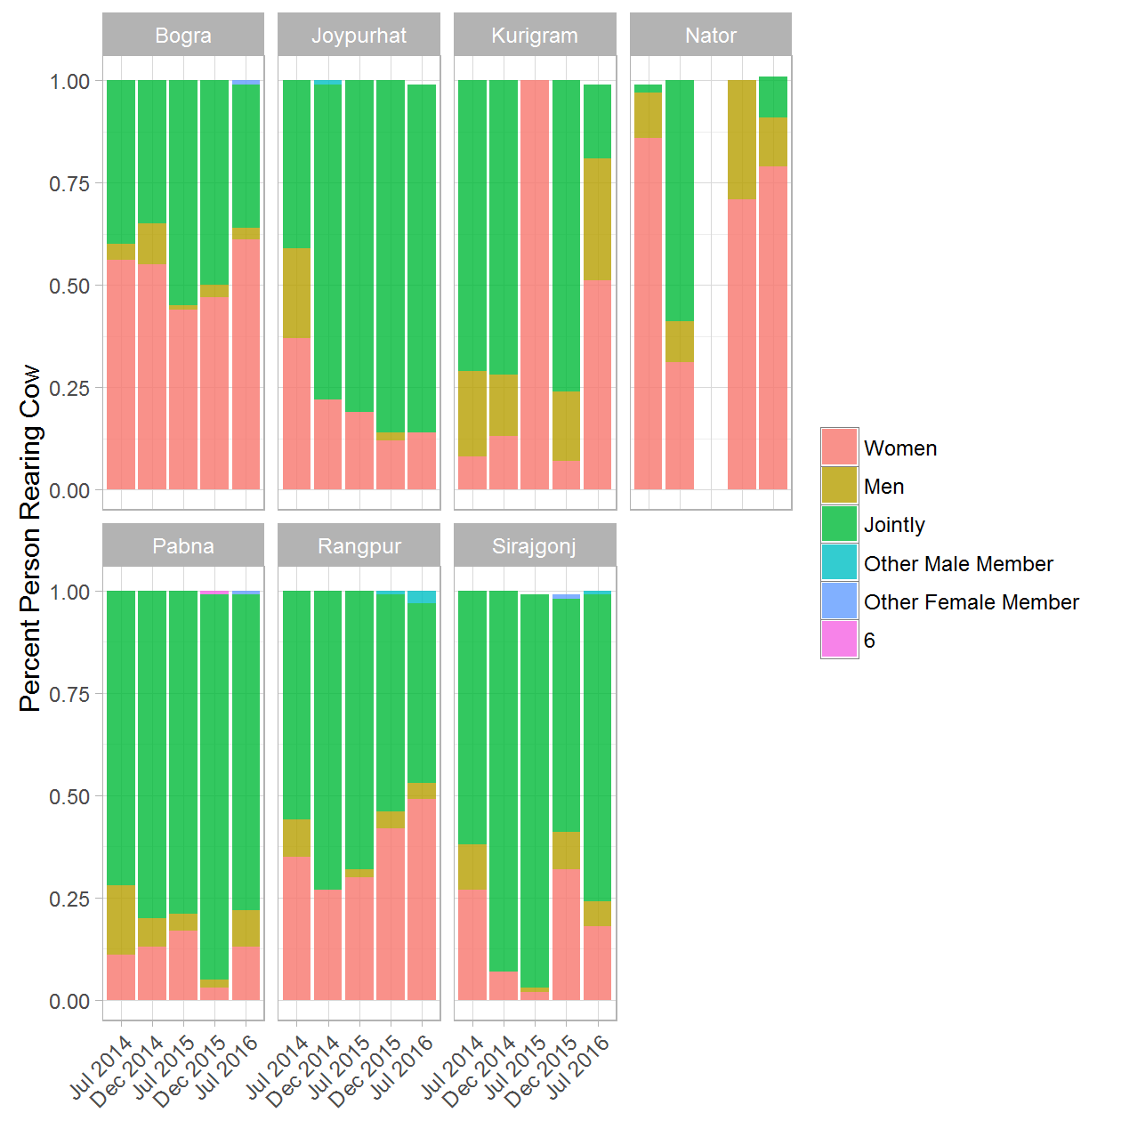

### GENDER: 3a. Person Purchasing Feed - (Treatment & Control) rounds 1 and 5

|  |  |  |  |  |
| --- | --- | --- | --- | --- |
| District | Round of Data Collection | Person Purchasing Feed | Treatment/Control Group | Percent |
| Bogra | Jul 2014 | Women | Treatment | 0.07 |
| Bogra | Jul 2014 | Women | Control | 0.02 |
| Bogra | Jul 2014 | Men | Treatment | 0.71 |
| Bogra | Jul 2014 | Men | Control | 0.77 |
| Bogra | Jul 2014 | Jointly | Treatment | 0.22 |
| Bogra | Jul 2014 | Jointly | Control | 0.21 |
| Bogra | Jul 2016 | Women | Treatment | 0.10 |
| Bogra | Jul 2016 | Women | Control | 0.09 |
| Bogra | Jul 2016 | Men | Treatment | 0.68 |
| Bogra | Jul 2016 | Men | Control | 0.50 |
| Bogra | Jul 2016 | Jointly | Treatment | 0.19 |
| Bogra | Jul 2016 | Jointly | Control | 0.41 |
| Bogra | Jul 2016 | Other Male Member | Treatment | 0.02 |
| Joypurhat | Jul 2014 | Women | Treatment | 0.04 |
| Joypurhat | Jul 2014 | Women | Control | 0.03 |
| Joypurhat | Jul 2014 | Men | Treatment | 0.93 |
| Joypurhat | Jul 2014 | Men | Control | 0.93 |
| Joypurhat | Jul 2014 | Jointly | Treatment | 0.04 |
| Joypurhat | Jul 2014 | Jointly | Control | 0.04 |
| Joypurhat | Jul 2016 | Women | Treatment | 0.01 |
| Joypurhat | Jul 2016 | Women | Control | 0.08 |
| Joypurhat | Jul 2016 | Men | Treatment | 0.59 |
| Joypurhat | Jul 2016 | Men | Control | 0.47 |
| Joypurhat | Jul 2016 | Jointly | Treatment | 0.40 |
| Joypurhat | Jul 2016 | Jointly | Control | 0.44 |
| Kurigram | Jul 2014 | Women | Treatment | 0.04 |
| Kurigram | Jul 2014 | Women | Control | 0.09 |
| Kurigram | Jul 2014 | Men | Treatment | 0.95 |
| Kurigram | Jul 2014 | Men | Control | 0.79 |
| Kurigram | Jul 2014 | Jointly | Treatment | 0.01 |
| Kurigram | Jul 2014 | Jointly | Control | 0.12 |
| Kurigram | Jul 2016 | Women | Treatment | 0.03 |
| Kurigram | Jul 2016 | Women | Control | 0.03 |
| Kurigram | Jul 2016 | Men | Treatment | 0.97 |
| Kurigram | Jul 2016 | Men | Control | 0.93 |
| Kurigram | Jul 2016 | Jointly | Control | 0.02 |
| Kurigram | Jul 2016 | Other Male Member | Control | 0.01 |
| Naogaon | Jul 2014 | Women | Control | 0.05 |
| Naogaon | Jul 2014 | Men | Control | 0.88 |
| Naogaon | Jul 2014 | Jointly | Control | 0.07 |
| Naogaon | Jul 2016 | Women | Control | 0.06 |
| Naogaon | Jul 2016 | Men | Control | 0.25 |
| Naogaon | Jul 2016 | Jointly | Control | 0.68 |
| Nator | Jul 2014 | Women | Treatment | 0.27 |
| Nator | Jul 2014 | Women | Control | 0.03 |
| Nator | Jul 2014 | Men | Treatment | 0.73 |
| Nator | Jul 2014 | Men | Control | 0.97 |
| Nator | Jul 2016 | Women | Treatment | 0.05 |
| Nator | Jul 2016 | Women | Control | 0.04 |
| Nator | Jul 2016 | Men | Treatment | 0.93 |
| Nator | Jul 2016 | Men | Control | 0.74 |
| Nator | Jul 2016 | Jointly | Treatment | 0.02 |
| Nator | Jul 2016 | Jointly | Control | 0.23 |
| Pabna | Jul 2014 | Women | Treatment | 0.04 |
| Pabna | Jul 2014 | Women | Control | 0.01 |
| Pabna | Jul 2014 | Men | Treatment | 0.96 |
| Pabna | Jul 2014 | Men | Control | 0.96 |
| Pabna | Jul 2014 | Jointly | Treatment | 0.00 |
| Pabna | Jul 2014 | Jointly | Control | 0.03 |
| Pabna | Jul 2016 | Women | Treatment | 0.03 |
| Pabna | Jul 2016 | Women | Control | 0.06 |
| Pabna | Jul 2016 | Men | Treatment | 0.84 |
| Pabna | Jul 2016 | Men | Control | 0.91 |
| Pabna | Jul 2016 | Jointly | Treatment | 0.12 |
| Pabna | Jul 2016 | Jointly | Control | 0.03 |
| Pabna | Jul 2016 | Other Male Member | Treatment | 0.00 |
| Pabna | Jul 2016 | Other Male Member | Control | 0.01 |
| Rangpur | Jul 2014 | Women | Treatment | 0.07 |
| Rangpur | Jul 2014 | Women | Control | 0.10 |
| Rangpur | Jul 2014 | Men | Treatment | 0.62 |
| Rangpur | Jul 2014 | Men | Control | 0.86 |
| Rangpur | Jul 2014 | Jointly | Treatment | 0.31 |
| Rangpur | Jul 2014 | Jointly | Control | 0.05 |
| Rangpur | Jul 2016 | Women | Treatment | 0.10 |
| Rangpur | Jul 2016 | Women | Control | 0.07 |
| Rangpur | Jul 2016 | Men | Treatment | 0.73 |
| Rangpur | Jul 2016 | Men | Control | 0.87 |
| Rangpur | Jul 2016 | Jointly | Treatment | 0.11 |
| Rangpur | Jul 2016 | Jointly | Control | 0.01 |
| Rangpur | Jul 2016 | Other Male Member | Treatment | 0.05 |
| Rangpur | Jul 2016 | Other Male Member | Control | 0.03 |
| Rangpur | Jul 2016 | Other Female Member | Control | 0.02 |
| Sirajgonj | Jul 2014 | Women | Treatment | 0.08 |
| Sirajgonj | Jul 2014 | Women | Control | 0.03 |
| Sirajgonj | Jul 2014 | Men | Treatment | 0.64 |
| Sirajgonj | Jul 2014 | Men | Control | 0.90 |
| Sirajgonj | Jul 2014 | Jointly | Treatment | 0.28 |
| Sirajgonj | Jul 2014 | Jointly | Control | 0.07 |
| Sirajgonj | Jul 2016 | Women | Treatment | 0.03 |
| Sirajgonj | Jul 2016 | Women | Control | 0.05 |
| Sirajgonj | Jul 2016 | Men | Treatment | 0.76 |
| Sirajgonj | Jul 2016 | Men | Control | 0.84 |
| Sirajgonj | Jul 2016 | Jointly | Treatment | 0.21 |
| Sirajgonj | Jul 2016 | Jointly | Control | 0.09 |
| Sirajgonj | Jul 2016 | Other Male Member | Treatment | 0.01 |
| Sirajgonj | Jul 2016 | Other Male Member | Control | 0.02 |

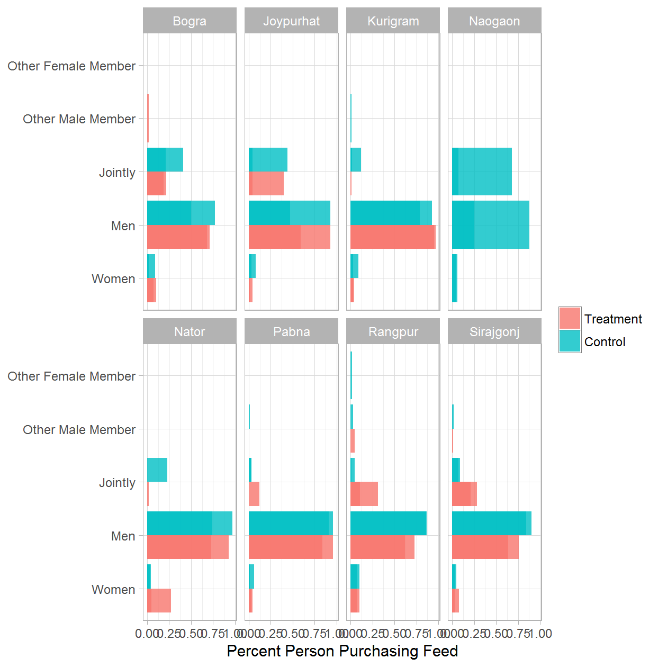

### GENDER: 3b. Person Purchasing Feed - Treatment Only

|  |  |  |  |
| --- | --- | --- | --- |
| District | Round of Data Collection | Person Purchasing Feed | Percent |
| Bogra | Jul 2014 | Women | 0.07 |
| Bogra | Jul 2014 | Men | 0.71 |
| Bogra | Jul 2014 | Jointly | 0.22 |
| Bogra | Dec 2014 | Women | 0.07 |
| Bogra | Dec 2014 | Men | 0.88 |
| Bogra | Dec 2014 | Jointly | 0.05 |
| Bogra | Jul 2015 | Women | 0.28 |
| Bogra | Jul 2015 | Men | 0.59 |
| Bogra | Jul 2015 | Jointly | 0.14 |
| Bogra | Dec 2015 | Women | 0.13 |
| Bogra | Dec 2015 | Men | 0.81 |
| Bogra | Dec 2015 | Jointly | 0.06 |
| Bogra | Jul 2016 | Women | 0.10 |
| Bogra | Jul 2016 | Men | 0.68 |
| Bogra | Jul 2016 | Jointly | 0.19 |
| Bogra | Jul 2016 | Other Male Member | 0.02 |
| Joypurhat | Jul 2014 | Women | 0.04 |
| Joypurhat | Jul 2014 | Men | 0.93 |
| Joypurhat | Jul 2014 | Jointly | 0.04 |
| Joypurhat | Dec 2014 | Women | 0.04 |
| Joypurhat | Dec 2014 | Men | 0.90 |
| Joypurhat | Dec 2014 | Jointly | 0.06 |
| Joypurhat | Jul 2015 | Women | 0.03 |
| Joypurhat | Jul 2015 | Men | 0.97 |
| Joypurhat | Dec 2015 | Women | 0.09 |
| Joypurhat | Dec 2015 | Men | 0.03 |
| Joypurhat | Dec 2015 | Jointly | 0.88 |
| Joypurhat | Jul 2016 | Women | 0.01 |
| Joypurhat | Jul 2016 | Men | 0.59 |
| Joypurhat | Jul 2016 | Jointly | 0.40 |
| Kurigram | Jul 2014 | Women | 0.04 |
| Kurigram | Jul 2014 | Men | 0.95 |
| Kurigram | Jul 2014 | Jointly | 0.01 |
| Kurigram | Dec 2014 | Women | 0.03 |
| Kurigram | Dec 2014 | Men | 0.62 |
| Kurigram | Dec 2014 | Jointly | 0.35 |
| Kurigram | Jul 2015 | Women | 0.07 |
| Kurigram | Jul 2015 | Men | 0.91 |
| Kurigram | Jul 2015 | Jointly | 0.02 |
| Kurigram | Dec 2015 | Women | 0.07 |
| Kurigram | Dec 2015 | Men | 0.93 |
| Kurigram | Jul 2016 | Women | 0.03 |
| Kurigram | Jul 2016 | Men | 0.97 |
| Nator | Jul 2014 | Women | 0.27 |
| Nator | Jul 2014 | Men | 0.73 |
| Nator | Dec 2014 | Women | 0.06 |
| Nator | Dec 2014 | Men | 0.94 |
| Nator | Dec 2015 | Men | 0.96 |
| Nator | Dec 2015 | Jointly | 0.04 |
| Nator | Jul 2016 | Women | 0.05 |
| Nator | Jul 2016 | Men | 0.93 |
| Nator | Jul 2016 | Jointly | 0.02 |
| Pabna | Jul 2014 | Women | 0.04 |
| Pabna | Jul 2014 | Men | 0.96 |
| Pabna | Jul 2014 | Jointly | 0.00 |
| Pabna | Dec 2014 | Women | 0.02 |
| Pabna | Dec 2014 | Men | 0.56 |
| Pabna | Dec 2014 | Jointly | 0.42 |
| Pabna | Jul 2015 | Men | 0.92 |
| Pabna | Jul 2015 | Jointly | 0.08 |
| Pabna | Dec 2015 | Men | 0.98 |
| Pabna | Dec 2015 | Jointly | 0.02 |
| Pabna | Jul 2016 | Women | 0.03 |
| Pabna | Jul 2016 | Men | 0.84 |
| Pabna | Jul 2016 | Jointly | 0.12 |
| Pabna | Jul 2016 | Other Male Member | 0.00 |
| Rangpur | Jul 2014 | Women | 0.07 |
| Rangpur | Jul 2014 | Men | 0.62 |
| Rangpur | Jul 2014 | Jointly | 0.31 |
| Rangpur | Dec 2014 | Women | 0.12 |
| Rangpur | Dec 2014 | Men | 0.73 |
| Rangpur | Dec 2014 | Jointly | 0.16 |
| Rangpur | Jul 2015 | Women | 0.03 |
| Rangpur | Jul 2015 | Men | 0.51 |
| Rangpur | Jul 2015 | Jointly | 0.46 |
| Rangpur | Jul 2015 | Other Male Member | 0.00 |
| Rangpur | Dec 2015 | Women | 0.11 |
| Rangpur | Dec 2015 | Men | 0.75 |
| Rangpur | Dec 2015 | Jointly | 0.14 |
| Rangpur | Jul 2016 | Women | 0.10 |
| Rangpur | Jul 2016 | Men | 0.73 |
| Rangpur | Jul 2016 | Jointly | 0.11 |
| Rangpur | Jul 2016 | Other Male Member | 0.05 |
| Sirajgonj | Jul 2014 | Women | 0.08 |
| Sirajgonj | Jul 2014 | Men | 0.64 |
| Sirajgonj | Jul 2014 | Jointly | 0.28 |
| Sirajgonj | Dec 2014 | Women | 0.04 |
| Sirajgonj | Dec 2014 | Men | 0.89 |
| Sirajgonj | Dec 2014 | Jointly | 0.07 |
| Sirajgonj | Jul 2015 | Women | 0.03 |
| Sirajgonj | Jul 2015 | Men | 0.78 |
| Sirajgonj | Jul 2015 | Jointly | 0.19 |
| Sirajgonj | Dec 2015 | Men | 0.96 |
| Sirajgonj | Dec 2015 | Jointly | 0.04 |
| Sirajgonj | Jul 2016 | Women | 0.03 |
| Sirajgonj | Jul 2016 | Men | 0.76 |
| Sirajgonj | Jul 2016 | Jointly | 0.21 |
| Sirajgonj | Jul 2016 | Other Male Member | 0.01 |

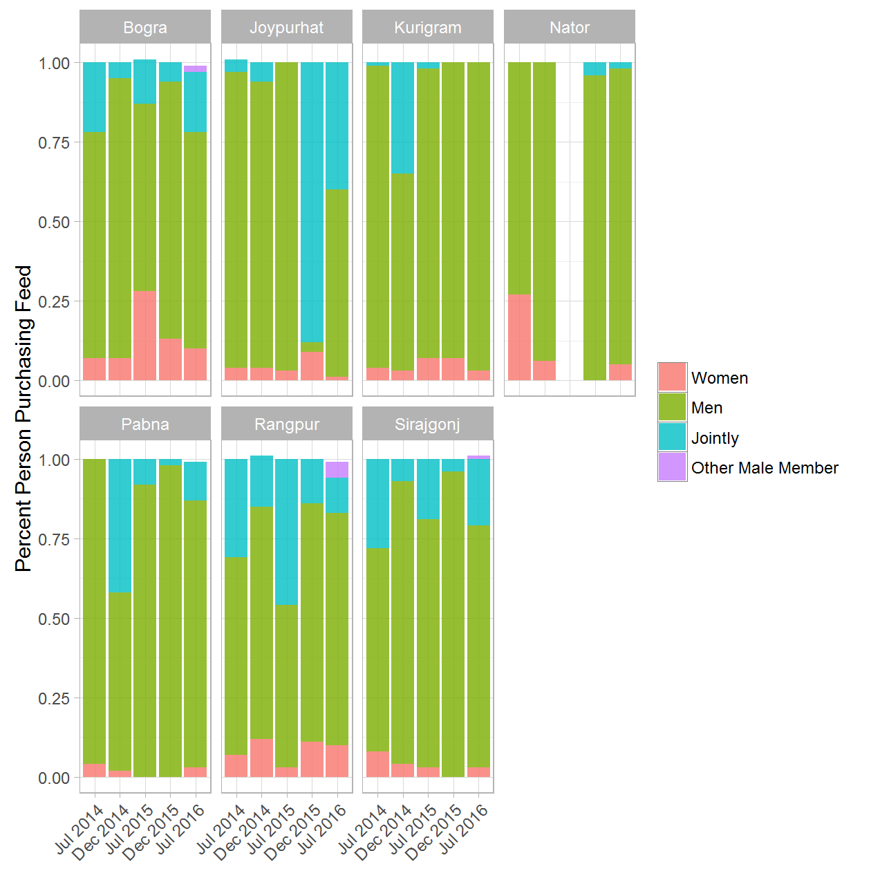

### GENDER: 4a. Person Selling Milk - (Treatment & Control) rounds 1 and 5

|  |  |  |  |  |
| --- | --- | --- | --- | --- |
| District | Round of Data Collection | Person Selling Milk | Treatment/Control Group | Percent |
| Bogra | Jul 2014 | Women | Treatment | 0.28 |
| Bogra | Jul 2014 | Women | Control | 0.10 |
| Bogra | Jul 2014 | Men | Treatment | 0.24 |
| Bogra | Jul 2014 | Men | Control | 0.24 |
| Bogra | Jul 2014 | Jointly | Treatment | 0.48 |
| Bogra | Jul 2014 | Jointly | Control | 0.66 |
| Bogra | Jul 2016 | Women | Treatment | 0.13 |
| Bogra | Jul 2016 | Women | Control | 0.20 |
| Bogra | Jul 2016 | Men | Treatment | 0.40 |
| Bogra | Jul 2016 | Men | Control | 0.15 |
| Bogra | Jul 2016 | Jointly | Treatment | 0.33 |
| Bogra | Jul 2016 | Jointly | Control | 0.44 |
| Bogra | Jul 2016 | Other Male Member | Treatment | 0.14 |
| Bogra | Jul 2016 | Other Male Member | Control | 0.21 |
| Joypurhat | Jul 2014 | Women | Treatment | 0.17 |
| Joypurhat | Jul 2014 | Women | Control | 0.14 |
| Joypurhat | Jul 2014 | Men | Treatment | 0.39 |
| Joypurhat | Jul 2014 | Men | Control | 0.62 |
| Joypurhat | Jul 2014 | Jointly | Treatment | 0.44 |
| Joypurhat | Jul 2014 | Jointly | Control | 0.24 |
| Joypurhat | Jul 2016 | Women | Treatment | 0.12 |
| Joypurhat | Jul 2016 | Women | Control | 0.17 |
| Joypurhat | Jul 2016 | Men | Treatment | 0.32 |
| Joypurhat | Jul 2016 | Men | Control | 0.34 |
| Joypurhat | Jul 2016 | Jointly | Treatment | 0.46 |
| Joypurhat | Jul 2016 | Jointly | Control | 0.49 |
| Joypurhat | Jul 2016 | Other Male Member | Treatment | 0.10 |
| Kurigram | Jul 2014 | Women | Treatment | 0.12 |
| Kurigram | Jul 2014 | Women | Control | 0.18 |
| Kurigram | Jul 2014 | Men | Treatment | 0.63 |
| Kurigram | Jul 2014 | Men | Control | 0.12 |
| Kurigram | Jul 2014 | Jointly | Treatment | 0.25 |
| Kurigram | Jul 2014 | Jointly | Control | 0.70 |
| Kurigram | Jul 2016 | Women | Treatment | 0.03 |
| Kurigram | Jul 2016 | Women | Control | 0.36 |
| Kurigram | Jul 2016 | Men | Treatment | 0.95 |
| Kurigram | Jul 2016 | Men | Control | 0.62 |
| Kurigram | Jul 2016 | Jointly | Treatment | 0.02 |
| Kurigram | Jul 2016 | Jointly | Control | 0.01 |
| Naogaon | Jul 2014 | Women | Control | 0.47 |
| Naogaon | Jul 2014 | Men | Control | 0.45 |
| Naogaon | Jul 2014 | Jointly | Control | 0.08 |
| Naogaon | Jul 2016 | Women | Control | 0.07 |
| Naogaon | Jul 2016 | Men | Control | 0.25 |
| Naogaon | Jul 2016 | Jointly | Control | 0.67 |
| Nator | Jul 2014 | Women | Treatment | 0.07 |
| Nator | Jul 2014 | Women | Control | 0.02 |
| Nator | Jul 2014 | Men | Treatment | 0.28 |
| Nator | Jul 2014 | Men | Control | 0.98 |
| Nator | Jul 2014 | Jointly | Treatment | 0.65 |
| Nator | Jul 2016 | Women | Treatment | 0.07 |
| Nator | Jul 2016 | Women | Control | 0.21 |
| Nator | Jul 2016 | Men | Treatment | 0.74 |
| Nator | Jul 2016 | Men | Control | 0.58 |
| Nator | Jul 2016 | Jointly | Treatment | 0.19 |
| Nator | Jul 2016 | Jointly | Control | 0.18 |
| Nator | Jul 2016 | Other Male Member | Control | 0.03 |
| Pabna | Jul 2014 | Women | Treatment | 0.05 |
| Pabna | Jul 2014 | Women | Control | 0.20 |
| Pabna | Jul 2014 | Men | Treatment | 0.88 |
| Pabna | Jul 2014 | Men | Control | 0.67 |
| Pabna | Jul 2014 | Jointly | Treatment | 0.07 |
| Pabna | Jul 2014 | Jointly | Control | 0.13 |
| Pabna | Jul 2016 | Women | Treatment | 0.07 |
| Pabna | Jul 2016 | Women | Control | 0.10 |
| Pabna | Jul 2016 | Men | Treatment | 0.79 |
| Pabna | Jul 2016 | Men | Control | 0.80 |
| Pabna | Jul 2016 | Jointly | Treatment | 0.14 |
| Pabna | Jul 2016 | Jointly | Control | 0.09 |
| Pabna | Jul 2016 | Other Male Member | Control | 0.02 |
| Rangpur | Jul 2014 | Women | Treatment | 0.15 |
| Rangpur | Jul 2014 | Women | Control | 0.69 |
| Rangpur | Jul 2014 | Men | Treatment | 0.37 |
| Rangpur | Jul 2014 | Men | Control | 0.07 |
| Rangpur | Jul 2014 | Jointly | Treatment | 0.48 |
| Rangpur | Jul 2014 | Jointly | Control | 0.24 |
| Rangpur | Jul 2016 | Women | Treatment | 0.14 |
| Rangpur | Jul 2016 | Women | Control | 0.19 |
| Rangpur | Jul 2016 | Men | Treatment | 0.53 |
| Rangpur | Jul 2016 | Men | Control | 0.53 |
| Rangpur | Jul 2016 | Jointly | Treatment | 0.18 |
| Rangpur | Jul 2016 | Jointly | Control | 0.22 |
| Rangpur | Jul 2016 | Other Male Member | Treatment | 0.14 |
| Rangpur | Jul 2016 | Other Male Member | Control | 0.05 |
| Rangpur | Jul 2016 | Other Female Member | Treatment | 0.01 |
| Rangpur | Jul 2016 | Other Female Member | Control | 0.02 |
| Sirajgonj | Jul 2014 | Women | Treatment | 0.12 |
| Sirajgonj | Jul 2014 | Women | Control | 0.19 |
| Sirajgonj | Jul 2014 | Men | Treatment | 0.39 |
| Sirajgonj | Jul 2014 | Men | Control | 0.63 |
| Sirajgonj | Jul 2014 | Jointly | Treatment | 0.48 |
| Sirajgonj | Jul 2014 | Jointly | Control | 0.19 |
| Sirajgonj | Jul 2016 | Women | Treatment | 0.04 |
| Sirajgonj | Jul 2016 | Women | Control | 0.15 |
| Sirajgonj | Jul 2016 | Men | Treatment | 0.38 |
| Sirajgonj | Jul 2016 | Men | Control | 0.58 |
| Sirajgonj | Jul 2016 | Jointly | Treatment | 0.54 |
| Sirajgonj | Jul 2016 | Jointly | Control | 0.22 |
| Sirajgonj | Jul 2016 | Other Male Member | Treatment | 0.04 |
| Sirajgonj | Jul 2016 | Other Male Member | Control | 0.05 |

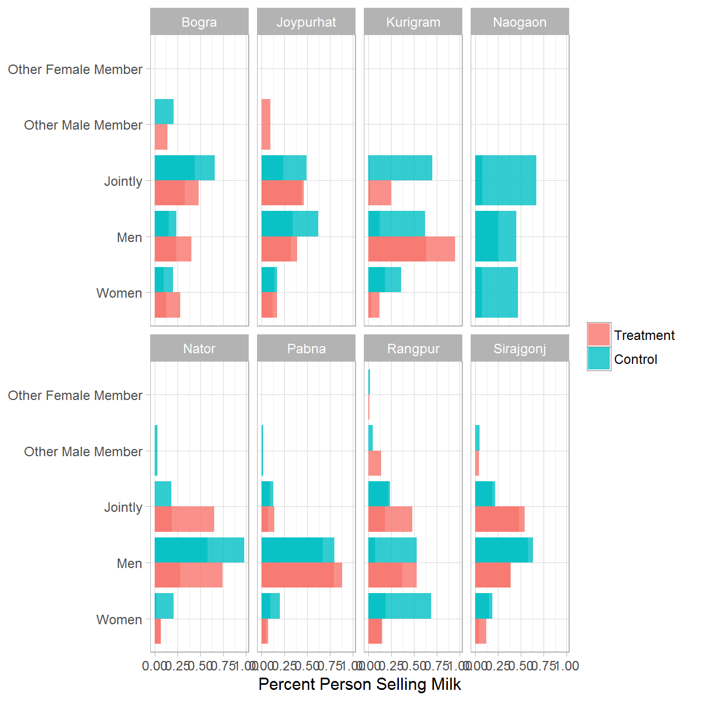

### GENDER: 4b. Person Selling Milk - Treatment Only

|  |  |  |  |
| --- | --- | --- | --- |
| District | Round of Data Collection | Person Selling Milk | Percent |
| Bogra | Jul 2014 | Women | 0.28 |
| Bogra | Jul 2014 | Men | 0.24 |
| Bogra | Jul 2014 | Jointly | 0.48 |
| Bogra | Dec 2014 | Women | 0.25 |
| Bogra | Dec 2014 | Men | 0.65 |
| Bogra | Dec 2014 | Jointly | 0.10 |
| Bogra | Jul 2015 | Women | 0.31 |
| Bogra | Jul 2015 | Men | 0.45 |
| Bogra | Jul 2015 | Jointly | 0.24 |
| Bogra | Dec 2015 | Women | 0.16 |
| Bogra | Dec 2015 | Men | 0.55 |
| Bogra | Dec 2015 | Jointly | 0.29 |
| Bogra | Jul 2016 | Women | 0.13 |
| Bogra | Jul 2016 | Men | 0.40 |
| Bogra | Jul 2016 | Jointly | 0.33 |
| Bogra | Jul 2016 | Other Male Member | 0.14 |
| Joypurhat | Jul 2014 | Women | 0.17 |
| Joypurhat | Jul 2014 | Men | 0.39 |
| Joypurhat | Jul 2014 | Jointly | 0.44 |
| Joypurhat | Dec 2014 | Women | 0.28 |
| Joypurhat | Dec 2014 | Men | 0.39 |
| Joypurhat | Dec 2014 | Jointly | 0.33 |
| Joypurhat | Jul 2015 | Women | 0.27 |
| Joypurhat | Jul 2015 | Men | 0.63 |
| Joypurhat | Jul 2015 | Jointly | 0.10 |
| Joypurhat | Dec 2015 | Women | 0.09 |
| Joypurhat | Dec 2015 | Men | 0.02 |
| Joypurhat | Dec 2015 | Jointly | 0.89 |
| Joypurhat | Jul 2016 | Women | 0.12 |
| Joypurhat | Jul 2016 | Men | 0.32 |
| Joypurhat | Jul 2016 | Jointly | 0.46 |
| Joypurhat | Jul 2016 | Other Male Member | 0.10 |
| Kurigram | Jul 2014 | Women | 0.12 |
| Kurigram | Jul 2014 | Men | 0.63 |
| Kurigram | Jul 2014 | Jointly | 0.25 |
| Kurigram | Dec 2014 | Women | 0.09 |
| Kurigram | Dec 2014 | Men | 0.58 |
| Kurigram | Dec 2014 | Jointly | 0.33 |
| Kurigram | Jul 2015 | Women | 0.02 |
| Kurigram | Jul 2015 | Men | 0.12 |
| Kurigram | Jul 2015 | Jointly | 0.85 |
| Kurigram | Dec 2015 | Women | 0.09 |
| Kurigram | Dec 2015 | Men | 0.78 |
| Kurigram | Dec 2015 | Jointly | 0.13 |
| Kurigram | Jul 2016 | Women | 0.03 |
| Kurigram | Jul 2016 | Men | 0.95 |
| Kurigram | Jul 2016 | Jointly | 0.02 |
| Nator | Jul 2014 | Women | 0.07 |
| Nator | Jul 2014 | Men | 0.28 |
| Nator | Jul 2014 | Jointly | 0.65 |
| Nator | Dec 2014 | Women | 0.05 |
| Nator | Dec 2014 | Men | 0.92 |
| Nator | Dec 2014 | Jointly | 0.03 |
| Nator | Dec 2015 | Men | 0.71 |
| Nator | Dec 2015 | Jointly | 0.29 |
| Nator | Jul 2016 | Women | 0.07 |
| Nator | Jul 2016 | Men | 0.74 |
| Nator | Jul 2016 | Jointly | 0.19 |
| Pabna | Jul 2014 | Women | 0.05 |
| Pabna | Jul 2014 | Men | 0.88 |
| Pabna | Jul 2014 | Jointly | 0.07 |
| Pabna | Dec 2014 | Women | 0.10 |
| Pabna | Dec 2014 | Men | 0.38 |
| Pabna | Dec 2014 | Jointly | 0.53 |
| Pabna | Jul 2015 | Men | 0.47 |
| Pabna | Jul 2015 | Jointly | 0.53 |
| Pabna | Dec 2015 | Women | 0.02 |
| Pabna | Dec 2015 | Men | 0.48 |
| Pabna | Dec 2015 | Jointly | 0.50 |
| Pabna | Jul 2016 | Women | 0.07 |
| Pabna | Jul 2016 | Men | 0.79 |
| Pabna | Jul 2016 | Jointly | 0.14 |
| Rangpur | Jul 2014 | Women | 0.15 |
| Rangpur | Jul 2014 | Men | 0.37 |
| Rangpur | Jul 2014 | Jointly | 0.48 |
| Rangpur | Dec 2014 | Women | 0.38 |
| Rangpur | Dec 2014 | Men | 0.46 |
| Rangpur | Dec 2014 | Jointly | 0.16 |
| Rangpur | Jul 2015 | Women | 0.09 |
| Rangpur | Jul 2015 | Men | 0.23 |
| Rangpur | Jul 2015 | Jointly | 0.69 |
| Rangpur | Dec 2015 | Women | 0.25 |
| Rangpur | Dec 2015 | Men | 0.57 |
| Rangpur | Dec 2015 | Jointly | 0.17 |
| Rangpur | Jul 2016 | Women | 0.14 |
| Rangpur | Jul 2016 | Men | 0.53 |
| Rangpur | Jul 2016 | Jointly | 0.18 |
| Rangpur | Jul 2016 | Other Male Member | 0.14 |
| Rangpur | Jul 2016 | Other Female Member | 0.01 |
| Sirajgonj | Jul 2014 | Women | 0.12 |
| Sirajgonj | Jul 2014 | Men | 0.39 |
| Sirajgonj | Jul 2014 | Jointly | 0.48 |
| Sirajgonj | Dec 2014 | Women | 0.08 |
| Sirajgonj | Dec 2014 | Men | 0.50 |
| Sirajgonj | Dec 2014 | Jointly | 0.42 |
| Sirajgonj | Jul 2015 | Women | 0.06 |
| Sirajgonj | Jul 2015 | Men | 0.22 |
| Sirajgonj | Jul 2015 | Jointly | 0.72 |
| Sirajgonj | Dec 2015 | Women | 0.11 |
| Sirajgonj | Dec 2015 | Men | 0.80 |
| Sirajgonj | Dec 2015 | Jointly | 0.09 |
| Sirajgonj | Jul 2016 | Women | 0.04 |
| Sirajgonj | Jul 2016 | Men | 0.38 |
| Sirajgonj | Jul 2016 | Jointly | 0.54 |
| Sirajgonj | Jul 2016 | Other Male Member | 0.04 |

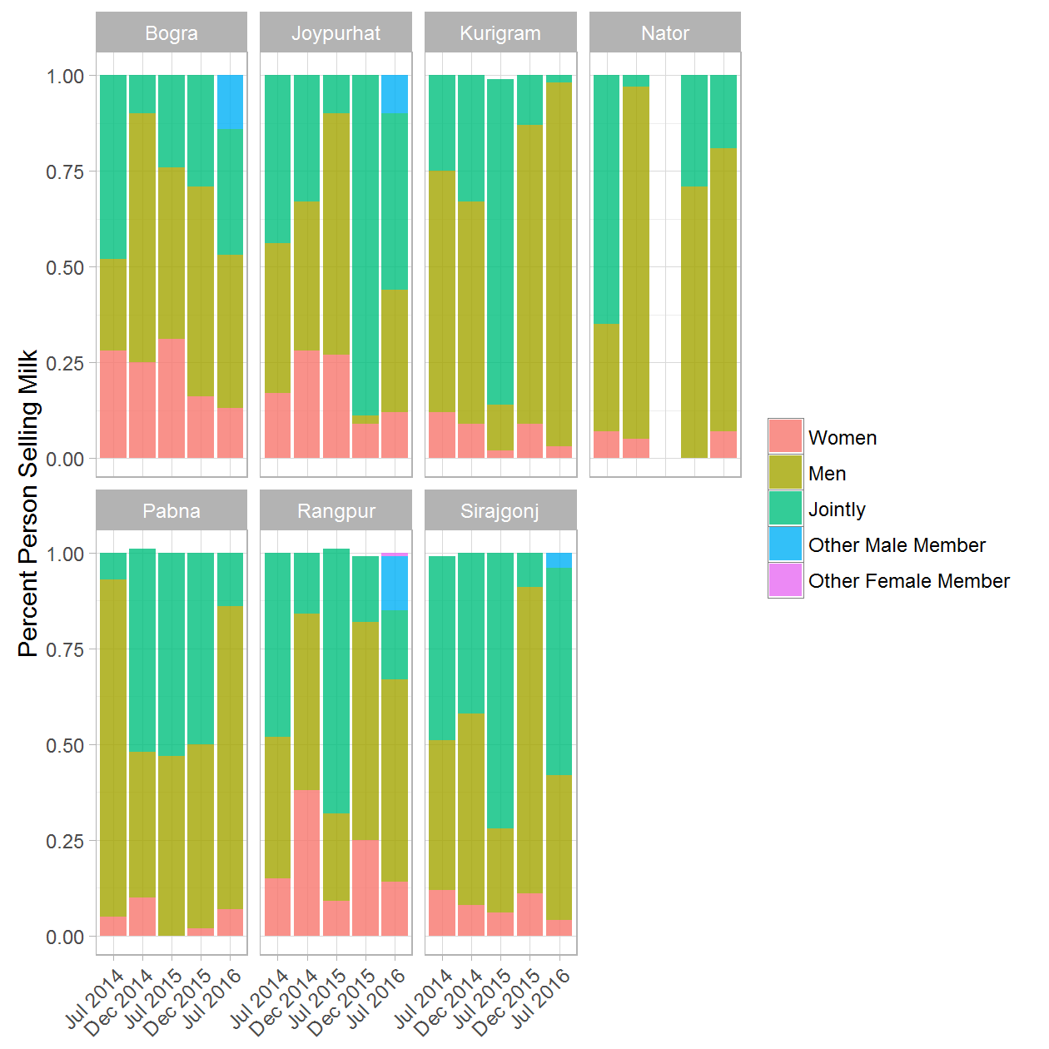

### GENDER: 5a. Person Purchasing Cow - (Treatment & Control) rounds 1 and 5

|  |  |  |  |  |
| --- | --- | --- | --- | --- |
| District | Round of Data Collection | Person Purchasing Cow | Treatment/Control Group | Percent |
| Bogra | Jul 2014 | Women | Treatment | 0.11 |
| Bogra | Jul 2014 | Women | Control | 0.06 |
| Bogra | Jul 2014 | Men | Treatment | 0.39 |
| Bogra | Jul 2014 | Men | Control | 0.09 |
| Bogra | Jul 2014 | Jointly | Treatment | 0.47 |
| Bogra | Jul 2014 | Jointly | Control | 0.84 |
| Bogra | Jul 2014 | Other Male Member | Treatment | 0.04 |
| Bogra | Jul 2014 | Other Male Member | Control | 0.01 |
| Bogra | Jul 2016 | Women | Treatment | 0.20 |
| Bogra | Jul 2016 | Women | Control | 0.24 |
| Bogra | Jul 2016 | Men | Treatment | 0.18 |
| Bogra | Jul 2016 | Men | Control | 0.34 |
| Bogra | Jul 2016 | Jointly | Treatment | 0.62 |
| Bogra | Jul 2016 | Jointly | Control | 0.42 |
| Bogra | Jul 2016 | Other Male Member | Treatment | 0.00 |
| Joypurhat | Jul 2014 | Women | Treatment | 0.32 |
| Joypurhat | Jul 2014 | Women | Control | 0.15 |
| Joypurhat | Jul 2014 | Men | Treatment | 0.57 |
| Joypurhat | Jul 2014 | Men | Control | 0.19 |
| Joypurhat | Jul 2014 | Jointly | Treatment | 0.05 |
| Joypurhat | Jul 2014 | Jointly | Control | 0.65 |
| Joypurhat | Jul 2014 | Other Male Member | Treatment | 0.06 |
| Joypurhat | Jul 2014 | Other Male Member | Control | 0.01 |
| Joypurhat | Jul 2016 | Women | Treatment | 0.11 |
| Joypurhat | Jul 2016 | Women | Control | 0.09 |
| Joypurhat | Jul 2016 | Men | Treatment | 0.06 |
| Joypurhat | Jul 2016 | Men | Control | 0.52 |
| Joypurhat | Jul 2016 | Jointly | Treatment | 0.83 |
| Joypurhat | Jul 2016 | Jointly | Control | 0.38 |
| Kurigram | Jul 2014 | Women | Treatment | 0.07 |
| Kurigram | Jul 2014 | Women | Control | 0.06 |
| Kurigram | Jul 2014 | Men | Control | 0.35 |
| Kurigram | Jul 2014 | Jointly | Treatment | 0.90 |
| Kurigram | Jul 2014 | Jointly | Control | 0.58 |
| Kurigram | Jul 2014 | Other Male Member | Treatment | 0.02 |
| Kurigram | Jul 2014 | Other Male Member | Control | 0.02 |
| Kurigram | Jul 2016 | Women | Treatment | 0.03 |
| Kurigram | Jul 2016 | Women | Control | 0.05 |
| Kurigram | Jul 2016 | Men | Treatment | 0.97 |
| Kurigram | Jul 2016 | Men | Control | 0.86 |
| Kurigram | Jul 2016 | Jointly | Control | 0.09 |
| Naogaon | Jul 2014 | Women | Control | 0.08 |
| Naogaon | Jul 2014 | Men | Control | 0.03 |
| Naogaon | Jul 2014 | Jointly | Control | 0.87 |
| Naogaon | Jul 2014 | Other Male Member | Control | 0.01 |
| Naogaon | Jul 2016 | Women | Control | 0.03 |
| Naogaon | Jul 2016 | Men | Control | 0.18 |
| Naogaon | Jul 2016 | Jointly | Control | 0.79 |
| Nator | Jul 2014 | Women | Treatment | 0.01 |
| Nator | Jul 2014 | Women | Control | 0.15 |
| Nator | Jul 2014 | Men | Treatment | 0.02 |
| Nator | Jul 2014 | Men | Control | 0.09 |
| Nator | Jul 2014 | Jointly | Treatment | 0.97 |
| Nator | Jul 2014 | Jointly | Control | 0.76 |
| Nator | Jul 2016 | Women | Control | 0.03 |
| Nator | Jul 2016 | Men | Control | 0.02 |
| Nator | Jul 2016 | Jointly | Treatment | 1.00 |
| Nator | Jul 2016 | Jointly | Control | 0.96 |
| Pabna | Jul 2014 | Women | Treatment | 0.20 |
| Pabna | Jul 2014 | Women | Control | 0.07 |
| Pabna | Jul 2014 | Men | Treatment | 0.29 |
| Pabna | Jul 2014 | Men | Control | 0.20 |
| Pabna | Jul 2014 | Jointly | Treatment | 0.49 |
| Pabna | Jul 2014 | Jointly | Control | 0.73 |
| Pabna | Jul 2014 | Other Male Member | Treatment | 0.02 |
| Pabna | Jul 2016 | Women | Treatment | 0.03 |
| Pabna | Jul 2016 | Women | Control | 0.02 |
| Pabna | Jul 2016 | Men | Treatment | 0.40 |
| Pabna | Jul 2016 | Men | Control | 0.10 |
| Pabna | Jul 2016 | Jointly | Treatment | 0.57 |
| Pabna | Jul 2016 | Jointly | Control | 0.89 |
| Rangpur | Jul 2014 | Women | Treatment | 0.10 |
| Rangpur | Jul 2014 | Women | Control | 0.18 |
| Rangpur | Jul 2014 | Men | Treatment | 0.12 |
| Rangpur | Jul 2014 | Men | Control | 0.38 |
| Rangpur | Jul 2014 | Jointly | Treatment | 0.77 |
| Rangpur | Jul 2014 | Jointly | Control | 0.42 |
| Rangpur | Jul 2014 | Other Male Member | Treatment | 0.02 |
| Rangpur | Jul 2014 | Other Male Member | Control | 0.03 |
| Rangpur | Jul 2016 | Women | Treatment | 0.07 |
| Rangpur | Jul 2016 | Women | Control | 0.05 |
| Rangpur | Jul 2016 | Men | Treatment | 0.51 |
| Rangpur | Jul 2016 | Men | Control | 0.93 |
| Rangpur | Jul 2016 | Jointly | Treatment | 0.39 |
| Rangpur | Jul 2016 | Jointly | Control | 0.00 |
| Rangpur | Jul 2016 | Other Male Member | Treatment | 0.03 |
| Rangpur | Jul 2016 | Other Male Member | Control | 0.01 |
| Sirajgonj | Jul 2014 | Women | Treatment | 0.19 |
| Sirajgonj | Jul 2014 | Women | Control | 0.45 |
| Sirajgonj | Jul 2014 | Men | Treatment | 0.19 |
| Sirajgonj | Jul 2014 | Men | Control | 0.19 |
| Sirajgonj | Jul 2014 | Jointly | Treatment | 0.62 |
| Sirajgonj | Jul 2014 | Jointly | Control | 0.35 |
| Sirajgonj | Jul 2014 | Other Male Member | Treatment | 0.00 |
| Sirajgonj | Jul 2014 | Other Male Member | Control | 0.02 |
| Sirajgonj | Jul 2016 | Women | Treatment | 0.01 |
| Sirajgonj | Jul 2016 | Women | Control | 0.03 |
| Sirajgonj | Jul 2016 | Men | Treatment | 0.09 |
| Sirajgonj | Jul 2016 | Men | Control | 0.51 |
| Sirajgonj | Jul 2016 | Jointly | Treatment | 0.90 |
| Sirajgonj | Jul 2016 | Jointly | Control | 0.46 |
| Sirajgonj | Jul 2016 | Other Male Member | Control | 0.01 |

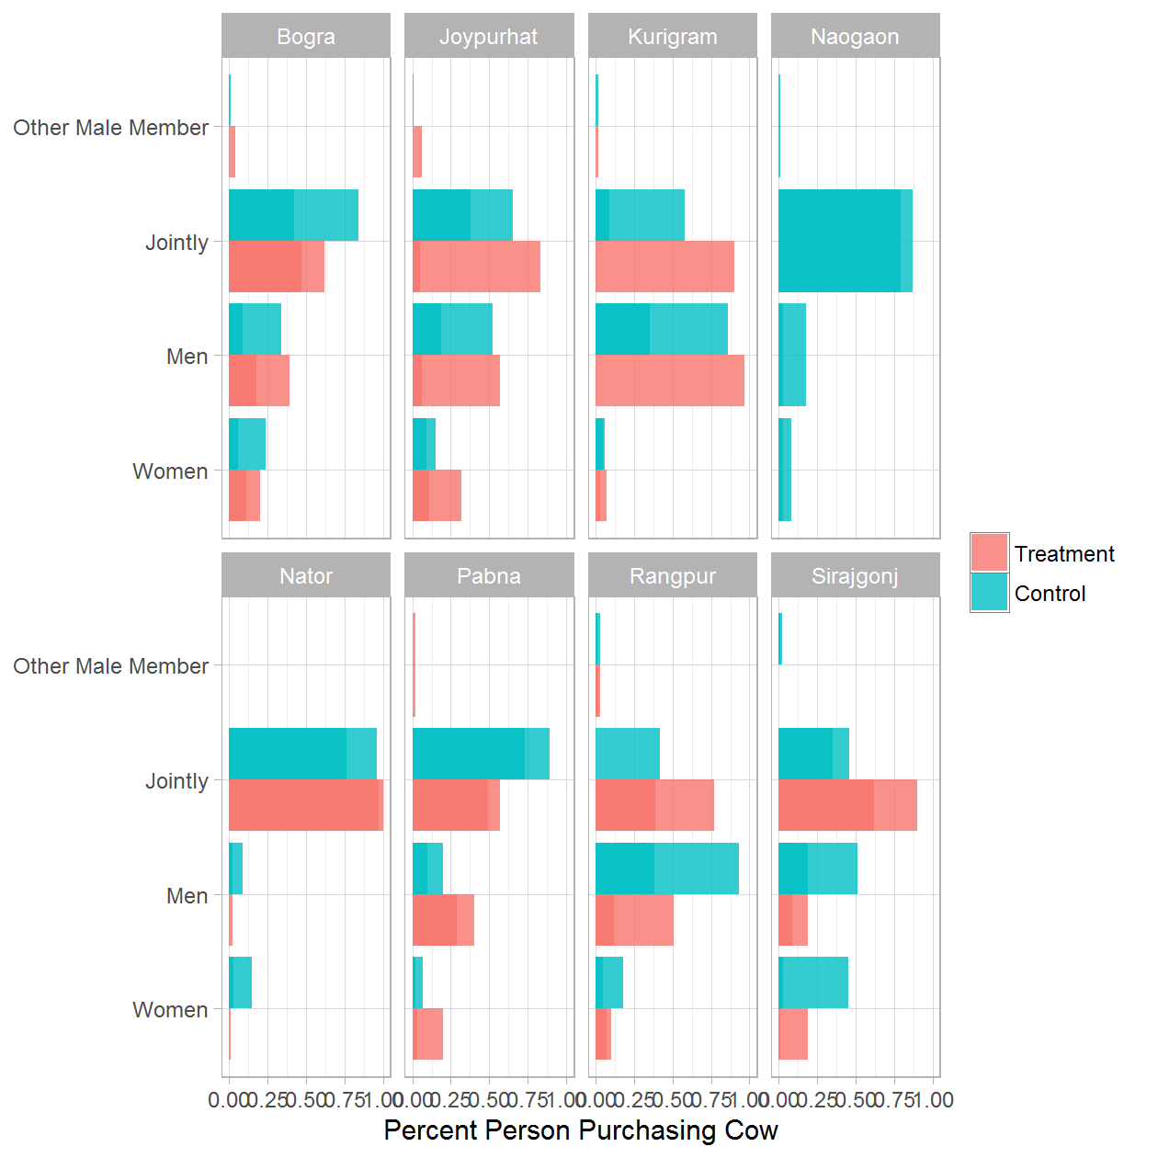

### GENDER: 5b. Person Purchasing Cow - Treatment Only

|  |  |  |  |
| --- | --- | --- | --- |
| District | Round of Data Collection | Person Purchasing Cow | Percent |
| Bogra | Jul 2014 | Women | 0.11 |
| Bogra | Jul 2014 | Men | 0.39 |
| Bogra | Jul 2014 | Jointly | 0.47 |
| Bogra | Jul 2014 | Other Male Member | 0.04 |
| Bogra | Dec 2014 | Women | 0.02 |
| Bogra | Dec 2014 | Men | 0.08 |
| Bogra | Dec 2014 | Jointly | 0.79 |
| Bogra | Dec 2014 | Other Male Member | 0.10 |
| Bogra | Dec 2014 | Other Female Member | 0.01 |
| Bogra | Jul 2015 | Women | 0.05 |
| Bogra | Jul 2015 | Jointly | 0.95 |
| Bogra | Dec 2015 | Women | 0.05 |
| Bogra | Dec 2015 | Men | 0.04 |
| Bogra | Dec 2015 | Jointly | 0.87 |
| Bogra | Dec 2015 | Other Male Member | 0.02 |
| Bogra | Dec 2015 | 6 | 0.01 |
| Bogra | Dec 2015 | 7 | 0.01 |
| Bogra | Dec 2015 | 12 | 0.01 |
| Bogra | Jul 2016 | Women | 0.20 |
| Bogra | Jul 2016 | Men | 0.18 |
| Bogra | Jul 2016 | Jointly | 0.62 |
| Bogra | Jul 2016 | Other Male Member | 0.00 |
| Joypurhat | Jul 2014 | Women | 0.32 |
| Joypurhat | Jul 2014 | Men | 0.57 |
| Joypurhat | Jul 2014 | Jointly | 0.05 |
| Joypurhat | Jul 2014 | Other Male Member | 0.06 |
| Joypurhat | Dec 2014 | Women | 0.00 |
| Joypurhat | Dec 2014 | Jointly | 1.00 |
| Joypurhat | Jul 2015 | Men | 0.03 |
| Joypurhat | Jul 2015 | Jointly | 0.97 |
| Joypurhat | Dec 2015 | Women | 0.29 |
| Joypurhat | Dec 2015 | Jointly | 0.71 |
| Joypurhat | Jul 2016 | Women | 0.11 |
| Joypurhat | Jul 2016 | Men | 0.06 |
| Joypurhat | Jul 2016 | Jointly | 0.83 |
| Kurigram | Jul 2014 | Women | 0.07 |
| Kurigram | Jul 2014 | Jointly | 0.90 |
| Kurigram | Jul 2014 | Other Male Member | 0.02 |
| Kurigram | Dec 2014 | Women | 0.31 |
| Kurigram | Dec 2014 | Men | 0.51 |
| Kurigram | Dec 2014 | Jointly | 0.18 |
| Kurigram | Dec 2014 | Other Male Member | 0.01 |
| Kurigram | Jul 2015 | Women | 0.07 |
| Kurigram | Jul 2015 | Men | 0.93 |
| Kurigram | Dec 2015 | Women | 0.31 |
| Kurigram | Dec 2015 | Men | 0.64 |
| Kurigram | Dec 2015 | Jointly | 0.05 |
| Kurigram | Jul 2016 | Women | 0.03 |
| Kurigram | Jul 2016 | Men | 0.97 |
| Nator | Jul 2014 | Women | 0.01 |
| Nator | Jul 2014 | Men | 0.02 |
| Nator | Jul 2014 | Jointly | 0.97 |
| Nator | Dec 2014 | Women | 0.32 |
| Nator | Dec 2014 | Men | 0.19 |
| Nator | Dec 2014 | Jointly | 0.47 |
| Nator | Dec 2014 | Other Female Member | 0.02 |
| Nator | Dec 2015 | Women | 0.46 |
| Nator | Dec 2015 | Men | 0.54 |
| Nator | Jul 2016 | Jointly | 1.00 |
| Pabna | Jul 2014 | Women | 0.20 |
| Pabna | Jul 2014 | Men | 0.29 |
| Pabna | Jul 2014 | Jointly | 0.49 |
| Pabna | Jul 2014 | Other Male Member | 0.02 |
| Pabna | Dec 2014 | Women | 0.00 |
| Pabna | Dec 2014 | Men | 0.20 |
| Pabna | Dec 2014 | Jointly | 0.78 |
| Pabna | Dec 2014 | Other Male Member | 0.01 |
| Pabna | Jul 2015 | Women | 0.02 |
| Pabna | Jul 2015 | Men | 0.30 |
| Pabna | Jul 2015 | Jointly | 0.68 |
| Pabna | Dec 2015 | Men | 0.10 |
| Pabna | Dec 2015 | Jointly | 0.90 |
| Pabna | Jul 2016 | Women | 0.03 |
| Pabna | Jul 2016 | Men | 0.40 |
| Pabna | Jul 2016 | Jointly | 0.57 |
| Rangpur | Jul 2014 | Women | 0.10 |
| Rangpur | Jul 2014 | Men | 0.12 |
| Rangpur | Jul 2014 | Jointly | 0.77 |
| Rangpur | Jul 2014 | Other Male Member | 0.02 |
| Rangpur | Dec 2014 | Women | 0.04 |
| Rangpur | Dec 2014 | Men | 0.29 |
| Rangpur | Dec 2014 | Jointly | 0.62 |
| Rangpur | Dec 2014 | Other Male Member | 0.04 |
| Rangpur | Dec 2014 | 6 | 0.01 |
| Rangpur | Jul 2015 | Women | 0.05 |
| Rangpur | Jul 2015 | Men | 0.20 |
| Rangpur | Jul 2015 | Jointly | 0.73 |
| Rangpur | Jul 2015 | Other Male Member | 0.02 |
| Rangpur | Dec 2015 | Women | 0.03 |
| Rangpur | Dec 2015 | Men | 0.38 |
| Rangpur | Dec 2015 | Jointly | 0.54 |
| Rangpur | Dec 2015 | Other Male Member | 0.04 |
| Rangpur | Jul 2016 | Women | 0.07 |
| Rangpur | Jul 2016 | Men | 0.51 |
| Rangpur | Jul 2016 | Jointly | 0.39 |
| Rangpur | Jul 2016 | Other Male Member | 0.03 |
| Sirajgonj | Jul 2014 | Women | 0.19 |
| Sirajgonj | Jul 2014 | Men | 0.19 |
| Sirajgonj | Jul 2014 | Jointly | 0.62 |
| Sirajgonj | Jul 2014 | Other Male Member | 0.00 |
| Sirajgonj | Dec 2014 | Women | 0.06 |
| Sirajgonj | Dec 2014 | Men | 0.02 |
| Sirajgonj | Dec 2014 | Jointly | 0.92 |
| Sirajgonj | Jul 2015 | Women | 0.13 |
| Sirajgonj | Jul 2015 | Men | 0.07 |
| Sirajgonj | Jul 2015 | Jointly | 0.80 |
| Sirajgonj | Jul 2015 | Other Female Member | 0.01 |
| Sirajgonj | Dec 2015 | Women | 0.10 |
| Sirajgonj | Dec 2015 | Men | 0.48 |
| Sirajgonj | Dec 2015 | Jointly | 0.42 |
| Sirajgonj | Jul 2016 | Women | 0.01 |
| Sirajgonj | Jul 2016 | Men | 0.09 |
| Sirajgonj | Jul 2016 | Jointly | 0.90 |

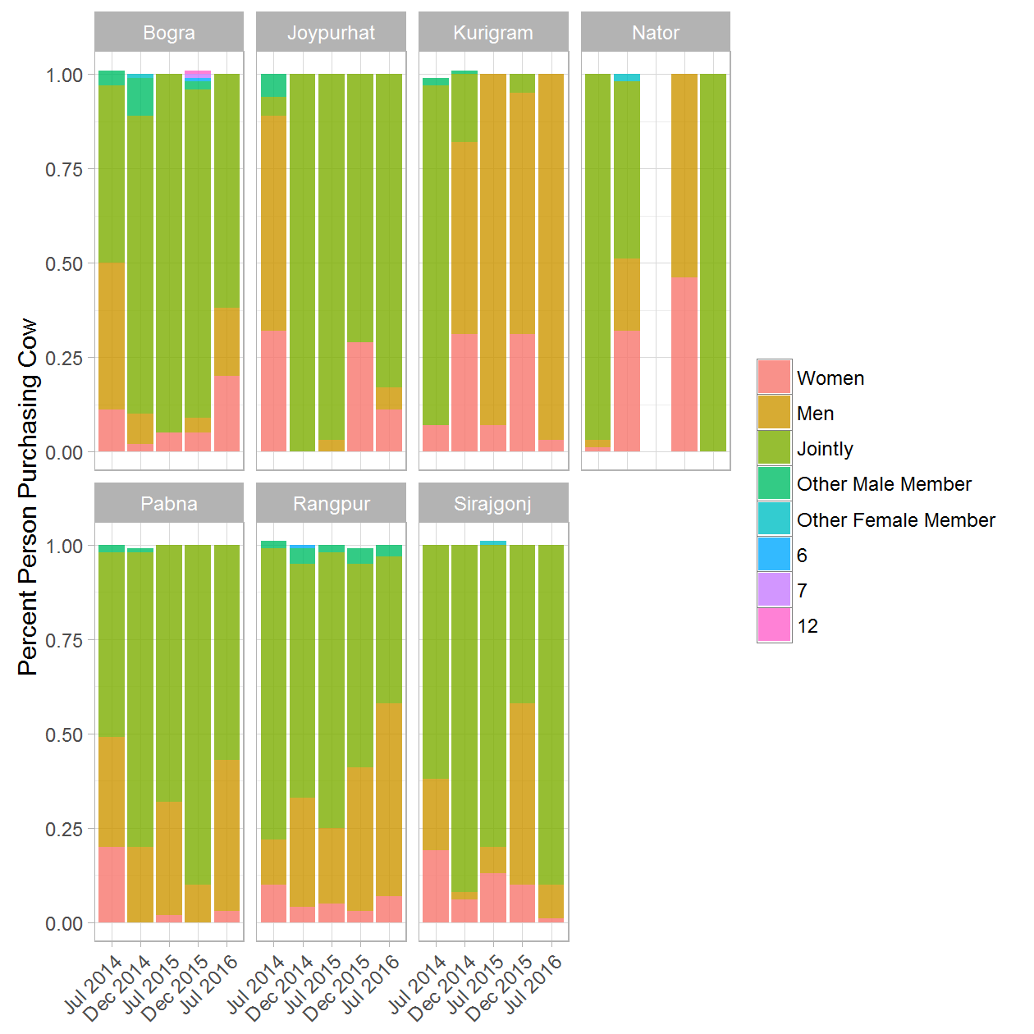

### GENDER: 6a. Person Selling Cow - (Treatment & Control) rounds 1 and 5

|  |  |  |  |  |
| --- | --- | --- | --- | --- |
| District | Round of Data Collection | Person Selling Cow | Treatment/Control Group | Percent |
| Bogra | Jul 2014 | Women | Treatment | 0.10 |
| Bogra | Jul 2014 | Women | Control | 0.05 |
| Bogra | Jul 2014 | Men | Treatment | 0.37 |
| Bogra | Jul 2014 | Men | Control | 0.09 |
| Bogra | Jul 2014 | Jointly | Treatment | 0.50 |
| Bogra | Jul 2014 | Jointly | Control | 0.84 |
| Bogra | Jul 2014 | Other Male Member | Treatment | 0.03 |
| Bogra | Jul 2014 | Other Male Member | Control | 0.02 |
| Bogra | Jul 2016 | Women | Treatment | 0.09 |
| Bogra | Jul 2016 | Women | Control | 0.04 |
| Bogra | Jul 2016 | Men | Treatment | 0.29 |
| Bogra | Jul 2016 | Men | Control | 0.54 |
| Bogra | Jul 2016 | Jointly | Treatment | 0.62 |
| Bogra | Jul 2016 | Jointly | Control | 0.42 |
| Bogra | Jul 2016 | Other Male Member | Treatment | 0.00 |
| Joypurhat | Jul 2014 | Women | Treatment | 0.32 |
| Joypurhat | Jul 2014 | Women | Control | 0.16 |
| Joypurhat | Jul 2014 | Men | Treatment | 0.57 |
| Joypurhat | Jul 2014 | Men | Control | 0.19 |
| Joypurhat | Jul 2014 | Jointly | Treatment | 0.05 |
| Joypurhat | Jul 2014 | Jointly | Control | 0.63 |
| Joypurhat | Jul 2014 | Other Male Member | Treatment | 0.06 |
| Joypurhat | Jul 2014 | Other Male Member | Control | 0.01 |
| Joypurhat | Jul 2016 | Women | Treatment | 0.01 |
| Joypurhat | Jul 2016 | Women | Control | 0.03 |
| Joypurhat | Jul 2016 | Men | Treatment | 0.17 |
| Joypurhat | Jul 2016 | Men | Control | 0.60 |
| Joypurhat | Jul 2016 | Jointly | Treatment | 0.83 |
| Joypurhat | Jul 2016 | Jointly | Control | 0.38 |
| Kurigram | Jul 2014 | Women | Treatment | 0.08 |
| Kurigram | Jul 2014 | Women | Control | 0.06 |
| Kurigram | Jul 2014 | Men | Control | 0.35 |
| Kurigram | Jul 2014 | Jointly | Treatment | 0.90 |
| Kurigram | Jul 2014 | Jointly | Control | 0.58 |
| Kurigram | Jul 2014 | Other Male Member | Treatment | 0.02 |
| Kurigram | Jul 2014 | Other Male Member | Control | 0.02 |
| Kurigram | Jul 2016 | Women | Treatment | 0.03 |
| Kurigram | Jul 2016 | Women | Control | 0.05 |
| Kurigram | Jul 2016 | Men | Treatment | 0.95 |
| Kurigram | Jul 2016 | Men | Control | 0.86 |
| Kurigram | Jul 2016 | Jointly | Treatment | 0.02 |
| Kurigram | Jul 2016 | Jointly | Control | 0.09 |
| Naogaon | Jul 2014 | Women | Control | 0.08 |
| Naogaon | Jul 2014 | Men | Control | 0.03 |
| Naogaon | Jul 2014 | Jointly | Control | 0.87 |
| Naogaon | Jul 2014 | Other Male Member | Control | 0.02 |
| Naogaon | Jul 2016 | Women | Control | 0.01 |
| Naogaon | Jul 2016 | Men | Control | 0.20 |
| Naogaon | Jul 2016 | Jointly | Control | 0.79 |
| Nator | Jul 2014 | Women | Treatment | 0.01 |
| Nator | Jul 2014 | Women | Control | 0.14 |
| Nator | Jul 2014 | Men | Treatment | 0.02 |
| Nator | Jul 2014 | Men | Control | 0.11 |
| Nator | Jul 2014 | Jointly | Treatment | 0.97 |
| Nator | Jul 2014 | Jointly | Control | 0.74 |
| Nator | Jul 2014 | Other Male Member | Control | 0.01 |
| Nator | Jul 2016 | Women | Control | 0.03 |
| Nator | Jul 2016 | Jointly | Treatment | 1.00 |
| Nator | Jul 2016 | Jointly | Control | 0.97 |
| Pabna | Jul 2014 | Women | Treatment | 0.20 |
| Pabna | Jul 2014 | Women | Control | 0.07 |
| Pabna | Jul 2014 | Men | Treatment | 0.22 |
| Pabna | Jul 2014 | Men | Control | 0.20 |
| Pabna | Jul 2014 | Jointly | Treatment | 0.58 |
| Pabna | Jul 2014 | Jointly | Control | 0.72 |
| Pabna | Jul 2014 | Other Male Member | Treatment | 0.00 |
| Pabna | Jul 2014 | Other Male Member | Control | 0.01 |
| Pabna | Jul 2016 | Women | Treatment | 0.03 |
| Pabna | Jul 2016 | Women | Control | 0.01 |
| Pabna | Jul 2016 | Men | Treatment | 0.39 |
| Pabna | Jul 2016 | Men | Control | 0.10 |
| Pabna | Jul 2016 | Jointly | Treatment | 0.58 |
| Pabna | Jul 2016 | Jointly | Control | 0.89 |
| Rangpur | Jul 2014 | Women | Treatment | 0.09 |
| Rangpur | Jul 2014 | Women | Control | 0.18 |
| Rangpur | Jul 2014 | Men | Treatment | 0.12 |
| Rangpur | Jul 2014 | Men | Control | 0.37 |
| Rangpur | Jul 2014 | Jointly | Treatment | 0.77 |
| Rangpur | Jul 2014 | Jointly | Control | 0.41 |
| Rangpur | Jul 2014 | Other Male Member | Treatment | 0.02 |
| Rangpur | Jul 2014 | Other Male Member | Control | 0.03 |
| Rangpur | Jul 2016 | Women | Treatment | 0.06 |
| Rangpur | Jul 2016 | Women | Control | 0.05 |
| Rangpur | Jul 2016 | Men | Treatment | 0.50 |
| Rangpur | Jul 2016 | Men | Control | 0.93 |
| Rangpur | Jul 2016 | Jointly | Treatment | 0.40 |
| Rangpur | Jul 2016 | Jointly | Control | 0.02 |
| Rangpur | Jul 2016 | Other Male Member | Treatment | 0.04 |
| Rangpur | Jul 2016 | Other Male Member | Control | 0.01 |
| Sirajgonj | Jul 2014 | Women | Treatment | 0.19 |
| Sirajgonj | Jul 2014 | Women | Control | 0.44 |
| Sirajgonj | Jul 2014 | Men | Treatment | 0.19 |
| Sirajgonj | Jul 2014 | Men | Control | 0.18 |
| Sirajgonj | Jul 2014 | Jointly | Treatment | 0.62 |
| Sirajgonj | Jul 2014 | Jointly | Control | 0.36 |
| Sirajgonj | Jul 2014 | Other Male Member | Treatment | 0.00 |
| Sirajgonj | Jul 2014 | Other Male Member | Control | 0.02 |
| Sirajgonj | Jul 2016 | Women | Treatment | 0.01 |
| Sirajgonj | Jul 2016 | Women | Control | 0.03 |
| Sirajgonj | Jul 2016 | Men | Treatment | 0.08 |
| Sirajgonj | Jul 2016 | Men | Control | 0.51 |
| Sirajgonj | Jul 2016 | Jointly | Treatment | 0.91 |
| Sirajgonj | Jul 2016 | Jointly | Control | 0.46 |
| Sirajgonj | Jul 2016 | Other Male Member | Control | 0.01 |

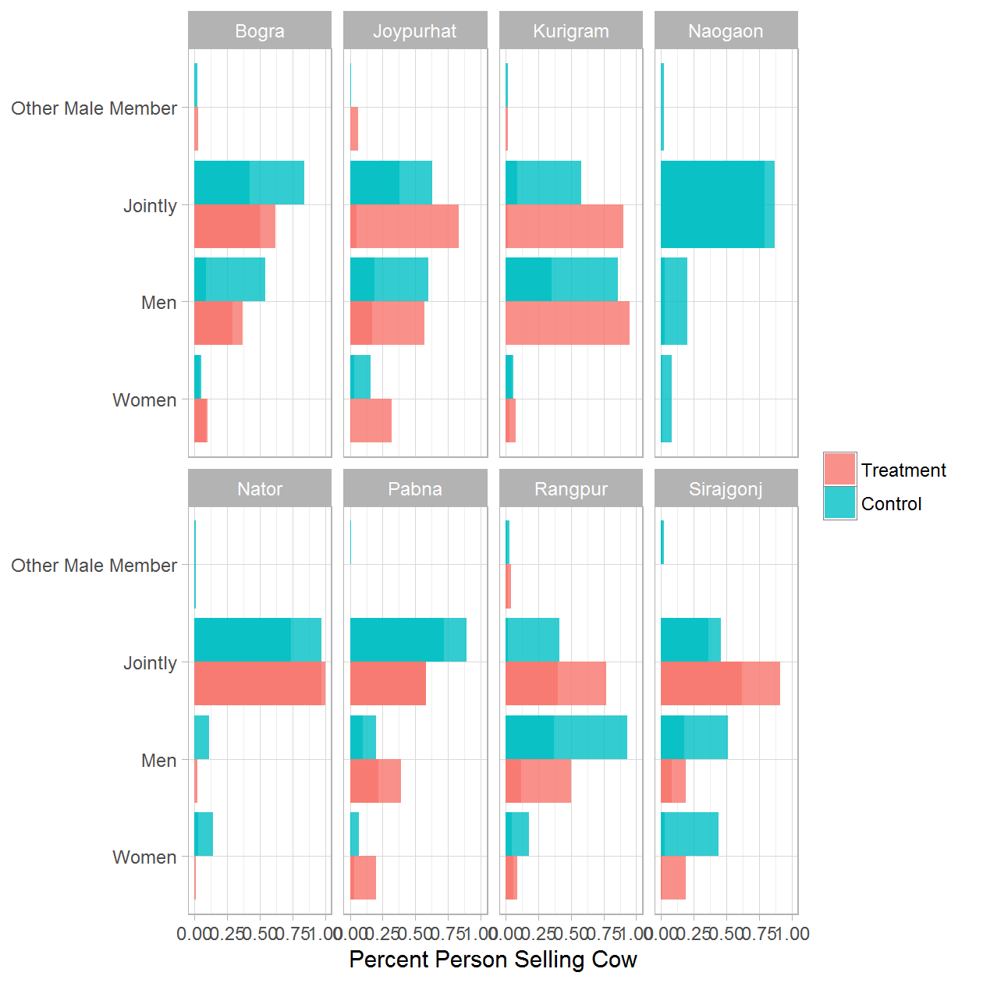

### GENDER: 6b. Person Selling Cow - Treatment Only

|  |  |  |  |
| --- | --- | --- | --- |
| District | Round of Data Collection | Person Selling Cow | Percent |
| Bogra | Jul 2014 | Women | 0.10 |
| Bogra | Jul 2014 | Men | 0.37 |
| Bogra | Jul 2014 | Jointly | 0.50 |
| Bogra | Jul 2014 | Other Male Member | 0.03 |
| Bogra | Dec 2014 | Women | 0.02 |
| Bogra | Dec 2014 | Men | 0.09 |
| Bogra | Dec 2014 | Jointly | 0.79 |
| Bogra | Dec 2014 | Other Male Member | 0.09 |
| Bogra | Dec 2014 | Other Female Member | 0.01 |
| Bogra | Jul 2015 | Women | 0.05 |
| Bogra | Jul 2015 | Men | 0.02 |
| Bogra | Jul 2015 | Jointly | 0.93 |
| Bogra | Dec 2015 | Women | 0.05 |
| Bogra | Dec 2015 | Men | 0.04 |
| Bogra | Dec 2015 | Jointly | 0.88 |
| Bogra | Dec 2015 | Other Male Member | 0.01 |
| Bogra | Dec 2015 | 7 | 0.01 |
| Bogra | Dec 2015 | 9 | 0.01 |
| Bogra | Dec 2015 | 12 | 0.01 |
| Bogra | Jul 2016 | Women | 0.09 |
| Bogra | Jul 2016 | Men | 0.29 |
| Bogra | Jul 2016 | Jointly | 0.62 |
| Bogra | Jul 2016 | Other Male Member | 0.00 |
| Joypurhat | Jul 2014 | Women | 0.32 |
| Joypurhat | Jul 2014 | Men | 0.57 |
| Joypurhat | Jul 2014 | Jointly | 0.05 |
| Joypurhat | Jul 2014 | Other Male Member | 0.06 |
| Joypurhat | Dec 2014 | Women | 0.00 |
| Joypurhat | Dec 2014 | Jointly | 1.00 |
| Joypurhat | Jul 2015 | Jointly | 1.00 |
| Joypurhat | Dec 2015 | Women | 0.26 |
| Joypurhat | Dec 2015 | Jointly | 0.74 |
| Joypurhat | Jul 2016 | Women | 0.01 |
| Joypurhat | Jul 2016 | Men | 0.17 |
| Joypurhat | Jul 2016 | Jointly | 0.83 |
| Kurigram | Jul 2014 | Women | 0.08 |
| Kurigram | Jul 2014 | Jointly | 0.90 |
| Kurigram | Jul 2014 | Other Male Member | 0.02 |
| Kurigram | Dec 2014 | Women | 0.32 |
| Kurigram | Dec 2014 | Men | 0.48 |
| Kurigram | Dec 2014 | Jointly | 0.21 |
| Kurigram | Jul 2015 | Women | 0.07 |
| Kurigram | Jul 2015 | Men | 0.93 |
| Kurigram | Dec 2015 | Women | 0.31 |
| Kurigram | Dec 2015 | Men | 0.61 |
| Kurigram | Dec 2015 | Jointly | 0.09 |
| Kurigram | Jul 2016 | Women | 0.03 |
| Kurigram | Jul 2016 | Men | 0.95 |
| Kurigram | Jul 2016 | Jointly | 0.02 |
| Nator | Jul 2014 | Women | 0.01 |
| Nator | Jul 2014 | Men | 0.02 |
| Nator | Jul 2014 | Jointly | 0.97 |
| Nator | Dec 2014 | Women | 0.32 |
| Nator | Dec 2014 | Men | 0.19 |
| Nator | Dec 2014 | Jointly | 0.47 |
| Nator | Dec 2014 | Other Female Member | 0.02 |
| Nator | Dec 2015 | Women | 0.46 |
| Nator | Dec 2015 | Men | 0.54 |
| Nator | Jul 2016 | Jointly | 1.00 |
| Pabna | Jul 2014 | Women | 0.20 |
| Pabna | Jul 2014 | Men | 0.22 |
| Pabna | Jul 2014 | Jointly | 0.58 |
| Pabna | Jul 2014 | Other Male Member | 0.00 |
| Pabna | Dec 2014 | Women | 0.00 |
| Pabna | Dec 2014 | Men | 0.20 |
| Pabna | Dec 2014 | Jointly | 0.78 |
| Pabna | Dec 2014 | Other Male Member | 0.01 |
| Pabna | Jul 2015 | Women | 0.02 |
| Pabna | Jul 2015 | Men | 0.30 |
| Pabna | Jul 2015 | Jointly | 0.68 |
| Pabna | Dec 2015 | Men | 0.13 |
| Pabna | Dec 2015 | Jointly | 0.87 |
| Pabna | Jul 2016 | Women | 0.03 |
| Pabna | Jul 2016 | Men | 0.39 |
| Pabna | Jul 2016 | Jointly | 0.58 |
| Rangpur | Jul 2014 | Women | 0.09 |
| Rangpur | Jul 2014 | Men | 0.12 |
| Rangpur | Jul 2014 | Jointly | 0.77 |
| Rangpur | Jul 2014 | Other Male Member | 0.02 |
| Rangpur | Dec 2014 | Women | 0.05 |
| Rangpur | Dec 2014 | Men | 0.29 |
| Rangpur | Dec 2014 | Jointly | 0.61 |
| Rangpur | Dec 2014 | Other Male Member | 0.03 |
| Rangpur | Dec 2014 | 6 | 0.01 |
| Rangpur | Jul 2015 | Women | 0.05 |
| Rangpur | Jul 2015 | Men | 0.22 |
| Rangpur | Jul 2015 | Jointly | 0.72 |
| Rangpur | Jul 2015 | Other Male Member | 0.02 |
| Rangpur | Dec 2015 | Women | 0.03 |
| Rangpur | Dec 2015 | Men | 0.39 |
| Rangpur | Dec 2015 | Jointly | 0.54 |
| Rangpur | Dec 2015 | Other Male Member | 0.05 |
| Rangpur | Jul 2016 | Women | 0.06 |
| Rangpur | Jul 2016 | Men | 0.50 |
| Rangpur | Jul 2016 | Jointly | 0.40 |
| Rangpur | Jul 2016 | Other Male Member | 0.04 |
| Sirajgonj | Jul 2014 | Women | 0.19 |
| Sirajgonj | Jul 2014 | Men | 0.19 |
| Sirajgonj | Jul 2014 | Jointly | 0.62 |
| Sirajgonj | Jul 2014 | Other Male Member | 0.00 |
| Sirajgonj | Dec 2014 | Women | 0.06 |
| Sirajgonj | Dec 2014 | Men | 0.02 |
| Sirajgonj | Dec 2014 | Jointly | 0.92 |
| Sirajgonj | Jul 2015 | Women | 0.13 |
| Sirajgonj | Jul 2015 | Men | 0.05 |
| Sirajgonj | Jul 2015 | Jointly | 0.82 |
| Sirajgonj | Dec 2015 | Women | 0.09 |
| Sirajgonj | Dec 2015 | Men | 0.51 |
| Sirajgonj | Dec 2015 | Jointly | 0.39 |
| Sirajgonj | Jul 2016 | Women | 0.01 |
| Sirajgonj | Jul 2016 | Men | 0.08 |
| Sirajgonj | Jul 2016 | Jointly | 0.91 |

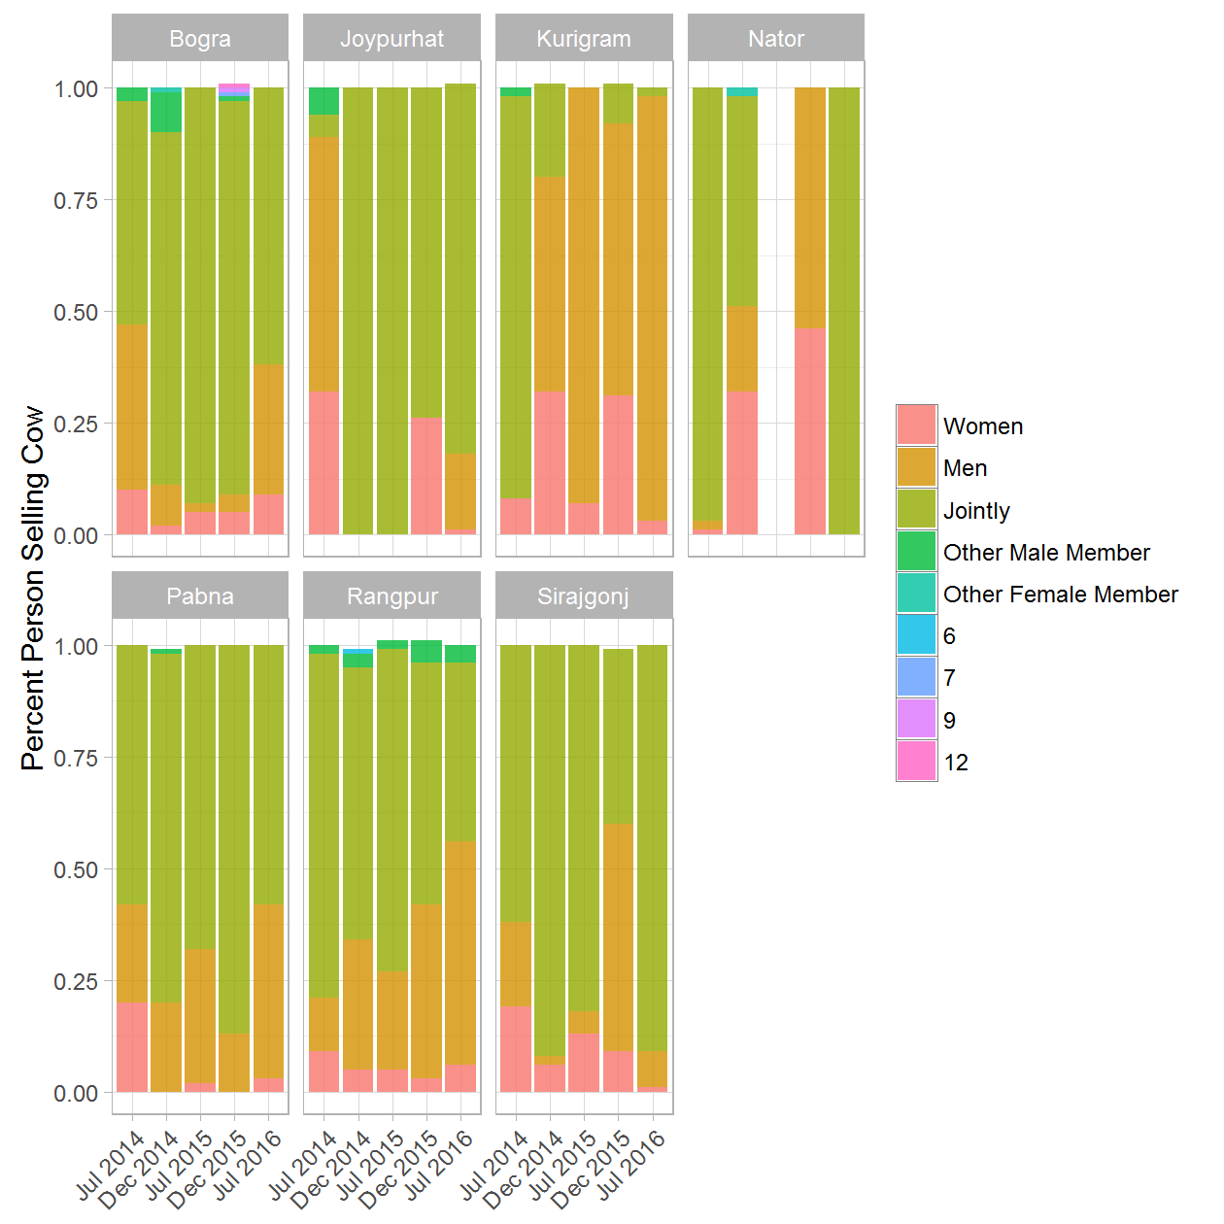

### GENDER: 7a. Person Milking Cow - (Treatment & Control) rounds 1 and 5

|  |  |  |  |  |
| --- | --- | --- | --- | --- |
| District | Round of Data Collection | Person Milking Cow | Treatment/Control Group | Percent |
| Bogra | Jul 2014 | Women | Treatment | 0.47 |
| Bogra | Jul 2014 | Women | Control | 0.53 |
| Bogra | Jul 2014 | Men | Treatment | 0.30 |
| Bogra | Jul 2014 | Men | Control | 0.29 |
| Bogra | Jul 2014 | Jointly | Treatment | 0.23 |
| Bogra | Jul 2014 | Jointly | Control | 0.18 |
| Bogra | Jul 2016 | Women | Treatment | 0.31 |
| Bogra | Jul 2016 | Women | Control | 0.52 |
| Bogra | Jul 2016 | Men | Treatment | 0.14 |
| Bogra | Jul 2016 | Men | Control | 0.10 |
| Bogra | Jul 2016 | Jointly | Treatment | 0.50 |
| Bogra | Jul 2016 | Jointly | Control | 0.32 |
| Bogra | Jul 2016 | Other Male Member | Treatment | 0.03 |
| Bogra | Jul 2016 | Other Male Member | Control | 0.04 |
| Bogra | Jul 2016 | Other Female Member | Treatment | 0.01 |
| Bogra | Jul 2016 | Other Female Member | Control | 0.03 |
| Joypurhat | Jul 2014 | Women | Treatment | 0.23 |
| Joypurhat | Jul 2014 | Women | Control | 0.57 |
| Joypurhat | Jul 2014 | Men | Treatment | 0.51 |
| Joypurhat | Jul 2014 | Men | Control | 0.07 |
| Joypurhat | Jul 2014 | Jointly | Treatment | 0.26 |
| Joypurhat | Jul 2014 | Jointly | Control | 0.36 |
| Joypurhat | Jul 2016 | Women | Treatment | 0.75 |
| Joypurhat | Jul 2016 | Women | Control | 0.84 |
| Joypurhat | Jul 2016 | Men | Treatment | 0.05 |
| Joypurhat | Jul 2016 | Men | Control | 0.12 |
| Joypurhat | Jul 2016 | Jointly | Treatment | 0.18 |
| Joypurhat | Jul 2016 | Jointly | Control | 0.04 |
| Joypurhat | Jul 2016 | Other Female Member | Treatment | 0.02 |
| Kurigram | Jul 2014 | Women | Treatment | 0.71 |
| Kurigram | Jul 2014 | Women | Control | 0.57 |
| Kurigram | Jul 2014 | Men | Treatment | 0.15 |
| Kurigram | Jul 2014 | Men | Control | 0.18 |
| Kurigram | Jul 2014 | Jointly | Treatment | 0.14 |
| Kurigram | Jul 2014 | Jointly | Control | 0.25 |
| Kurigram | Jul 2016 | Women | Treatment | 0.19 |
| Kurigram | Jul 2016 | Women | Control | 0.97 |
| Kurigram | Jul 2016 | Men | Treatment | 0.54 |
| Kurigram | Jul 2016 | Men | Control | 0.03 |
| Kurigram | Jul 2016 | Jointly | Treatment | 0.27 |
| Naogaon | Jul 2014 | Women | Control | 0.72 |
| Naogaon | Jul 2014 | Men | Control | 0.20 |
| Naogaon | Jul 2014 | Jointly | Control | 0.08 |
| Naogaon | Jul 2016 | Women | Control | 0.82 |
| Naogaon | Jul 2016 | Men | Control | 0.07 |
| Naogaon | Jul 2016 | Jointly | Control | 0.08 |
| Naogaon | Jul 2016 | Other Male Member | Control | 0.02 |
| Nator | Jul 2014 | Women | Treatment | 0.62 |
| Nator | Jul 2014 | Women | Control | 0.68 |
| Nator | Jul 2014 | Men | Treatment | 0.12 |
| Nator | Jul 2014 | Men | Control | 0.20 |
| Nator | Jul 2014 | Jointly | Treatment | 0.26 |
| Nator | Jul 2014 | Jointly | Control | 0.12 |
| Nator | Jul 2016 | Women | Treatment | 0.17 |
| Nator | Jul 2016 | Women | Control | 0.43 |
| Nator | Jul 2016 | Men | Treatment | 0.62 |
| Nator | Jul 2016 | Men | Control | 0.29 |
| Nator | Jul 2016 | Jointly | Treatment | 0.21 |
| Nator | Jul 2016 | Jointly | Control | 0.29 |
| Pabna | Jul 2014 | Women | Treatment | 0.35 |
| Pabna | Jul 2014 | Women | Control | 0.60 |
| Pabna | Jul 2014 | Men | Treatment | 0.47 |
| Pabna | Jul 2014 | Men | Control | 0.22 |
| Pabna | Jul 2014 | Jointly | Treatment | 0.18 |
| Pabna | Jul 2014 | Jointly | Control | 0.18 |
| Pabna | Jul 2016 | Women | Treatment | 0.06 |
| Pabna | Jul 2016 | Women | Control | 0.11 |
| Pabna | Jul 2016 | Men | Treatment | 0.48 |
| Pabna | Jul 2016 | Men | Control | 0.74 |
| Pabna | Jul 2016 | Jointly | Treatment | 0.46 |
| Pabna | Jul 2016 | Jointly | Control | 0.11 |
| Pabna | Jul 2016 | Other Male Member | Control | 0.04 |
| Pabna | Jul 2016 | Other Female Member | Control | 0.00 |
| Rangpur | Jul 2014 | Women | Treatment | 0.55 |
| Rangpur | Jul 2014 | Women | Control | 0.69 |
| Rangpur | Jul 2014 | Men | Treatment | 0.25 |
| Rangpur | Jul 2014 | Men | Control | 0.15 |
| Rangpur | Jul 2014 | Jointly | Treatment | 0.20 |
| Rangpur | Jul 2014 | Jointly | Control | 0.16 |
| Rangpur | Jul 2016 | Women | Treatment | 0.44 |
| Rangpur | Jul 2016 | Women | Control | 0.55 |
| Rangpur | Jul 2016 | Men | Treatment | 0.11 |
| Rangpur | Jul 2016 | Men | Control | 0.03 |
| Rangpur | Jul 2016 | Jointly | Treatment | 0.29 |
| Rangpur | Jul 2016 | Jointly | Control | 0.36 |
| Rangpur | Jul 2016 | Other Male Member | Treatment | 0.15 |
| Rangpur | Jul 2016 | Other Male Member | Control | 0.04 |
| Rangpur | Jul 2016 | Other Female Member | Treatment | 0.01 |
| Rangpur | Jul 2016 | Other Female Member | Control | 0.02 |
| Sirajgonj | Jul 2014 | Women | Treatment | 0.51 |
| Sirajgonj | Jul 2014 | Women | Control | 0.50 |
| Sirajgonj | Jul 2014 | Men | Treatment | 0.23 |
| Sirajgonj | Jul 2014 | Men | Control | 0.34 |
| Sirajgonj | Jul 2014 | Jointly | Treatment | 0.25 |
| Sirajgonj | Jul 2014 | Jointly | Control | 0.16 |
| Sirajgonj | Jul 2016 | Women | Treatment | 0.25 |
| Sirajgonj | Jul 2016 | Women | Control | 0.40 |
| Sirajgonj | Jul 2016 | Men | Treatment | 0.28 |
| Sirajgonj | Jul 2016 | Men | Control | 0.41 |
| Sirajgonj | Jul 2016 | Jointly | Treatment | 0.39 |
| Sirajgonj | Jul 2016 | Jointly | Control | 0.12 |
| Sirajgonj | Jul 2016 | Other Male Member | Treatment | 0.07 |
| Sirajgonj | Jul 2016 | Other Male Member | Control | 0.06 |
| Sirajgonj | Jul 2016 | Other Female Member | Control | 0.01 |

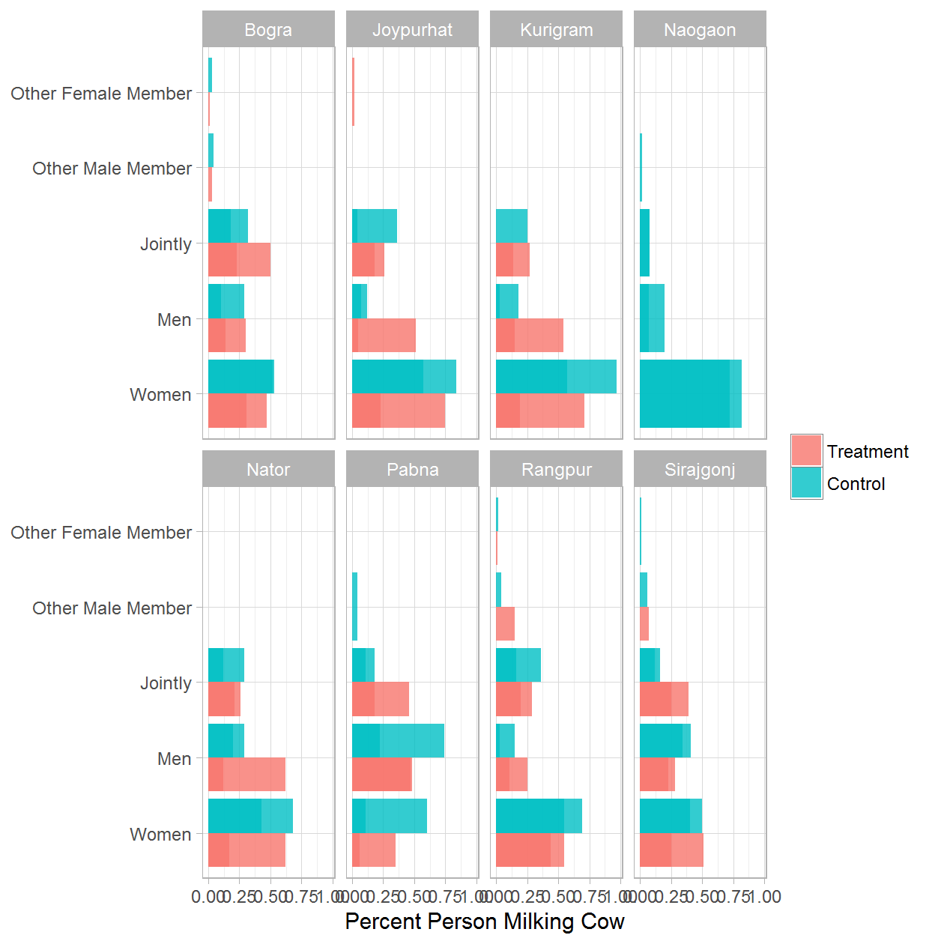

### GENDER: 7b. Person Milking Cow - Treatment Only

|  |  |  |  |
| --- | --- | --- | --- |
| District | Round of Data Collection | Person Milking Cow | Percent |
| Bogra | Jul 2014 | Women | 0.47 |
| Bogra | Jul 2014 | Men | 0.30 |
| Bogra | Jul 2014 | Jointly | 0.23 |
| Bogra | Dec 2014 | Women | 0.47 |
| Bogra | Dec 2014 | Men | 0.46 |
| Bogra | Dec 2014 | Jointly | 0.07 |
| Bogra | Jul 2015 | Women | 0.71 |
| Bogra | Jul 2015 | Men | 0.15 |
| Bogra | Jul 2015 | Jointly | 0.14 |
| Bogra | Dec 2015 | Women | 0.66 |
| Bogra | Dec 2015 | Men | 0.18 |
| Bogra | Dec 2015 | Jointly | 0.15 |
| Bogra | Jul 2016 | Women | 0.31 |
| Bogra | Jul 2016 | Men | 0.14 |
| Bogra | Jul 2016 | Jointly | 0.50 |
| Bogra | Jul 2016 | Other Male Member | 0.03 |
| Bogra | Jul 2016 | Other Female Member | 0.01 |
| Joypurhat | Jul 2014 | Women | 0.23 |
| Joypurhat | Jul 2014 | Men | 0.51 |
| Joypurhat | Jul 2014 | Jointly | 0.26 |
| Joypurhat | Dec 2014 | Women | 0.86 |
| Joypurhat | Dec 2014 | Men | 0.09 |
| Joypurhat | Dec 2014 | Jointly | 0.06 |
| Joypurhat | Jul 2015 | Women | 0.97 |
| Joypurhat | Jul 2015 | Men | 0.02 |
| Joypurhat | Jul 2015 | Jointly | 0.02 |
| Joypurhat | Dec 2015 | Women | 0.10 |
| Joypurhat | Dec 2015 | Men | 0.02 |
| Joypurhat | Dec 2015 | Jointly | 0.88 |
| Joypurhat | Jul 2016 | Women | 0.75 |
| Joypurhat | Jul 2016 | Men | 0.05 |
| Joypurhat | Jul 2016 | Jointly | 0.18 |
| Joypurhat | Jul 2016 | Other Female Member | 0.02 |
| Kurigram | Jul 2014 | Women | 0.71 |
| Kurigram | Jul 2014 | Men | 0.15 |
| Kurigram | Jul 2014 | Jointly | 0.14 |
| Kurigram | Dec 2014 | Women | 0.48 |
| Kurigram | Dec 2014 | Men | 0.19 |
| Kurigram | Dec 2014 | Jointly | 0.33 |
| Kurigram | Jul 2015 | Women | 0.79 |
| Kurigram | Jul 2015 | Men | 0.21 |
| Kurigram | Dec 2015 | Women | 0.70 |
| Kurigram | Dec 2015 | Men | 0.30 |
| Kurigram | Jul 2016 | Women | 0.19 |
| Kurigram | Jul 2016 | Men | 0.54 |
| Kurigram | Jul 2016 | Jointly | 0.27 |
| Nator | Jul 2014 | Women | 0.62 |
| Nator | Jul 2014 | Men | 0.12 |
| Nator | Jul 2014 | Jointly | 0.26 |
| Nator | Dec 2014 | Women | 0.10 |
| Nator | Dec 2014 | Men | 0.56 |
| Nator | Dec 2014 | Jointly | 0.34 |
| Nator | Dec 2015 | Women | 0.17 |
| Nator | Dec 2015 | Men | 0.83 |
| Nator | Jul 2016 | Women | 0.17 |
| Nator | Jul 2016 | Men | 0.62 |
| Nator | Jul 2016 | Jointly | 0.21 |
| Pabna | Jul 2014 | Women | 0.35 |
| Pabna | Jul 2014 | Men | 0.47 |
| Pabna | Jul 2014 | Jointly | 0.18 |
| Pabna | Dec 2014 | Women | 0.18 |
| Pabna | Dec 2014 | Men | 0.55 |
| Pabna | Dec 2014 | Jointly | 0.27 |
| Pabna | Jul 2015 | Women | 0.03 |
| Pabna | Jul 2015 | Men | 0.19 |
| Pabna | Jul 2015 | Jointly | 0.76 |
| Pabna | Jul 2015 | Other Male Member | 0.02 |
| Pabna | Jul 2015 | Other Female Member | 0.01 |
| Pabna | Dec 2015 | Women | 0.07 |
| Pabna | Dec 2015 | Men | 0.44 |
| Pabna | Dec 2015 | Jointly | 0.50 |
| Pabna | Jul 2016 | Women | 0.06 |
| Pabna | Jul 2016 | Men | 0.48 |
| Pabna | Jul 2016 | Jointly | 0.46 |
| Rangpur | Jul 2014 | Women | 0.55 |
| Rangpur | Jul 2014 | Men | 0.25 |
| Rangpur | Jul 2014 | Jointly | 0.20 |
| Rangpur | Dec 2014 | Women | 0.49 |
| Rangpur | Dec 2014 | Men | 0.28 |
| Rangpur | Dec 2014 | Jointly | 0.23 |
| Rangpur | Jul 2015 | Women | 0.31 |
| Rangpur | Jul 2015 | Men | 0.08 |
| Rangpur | Jul 2015 | Jointly | 0.61 |
| Rangpur | Dec 2015 | Women | 0.43 |
| Rangpur | Dec 2015 | Men | 0.38 |
| Rangpur | Dec 2015 | Jointly | 0.20 |
| Rangpur | Jul 2016 | Women | 0.44 |
| Rangpur | Jul 2016 | Men | 0.11 |
| Rangpur | Jul 2016 | Jointly | 0.29 |
| Rangpur | Jul 2016 | Other Male Member | 0.15 |
| Rangpur | Jul 2016 | Other Female Member | 0.01 |
| Sirajgonj | Jul 2014 | Women | 0.51 |
| Sirajgonj | Jul 2014 | Men | 0.23 |
| Sirajgonj | Jul 2014 | Jointly | 0.25 |
| Sirajgonj | Dec 2014 | Women | 0.21 |
| Sirajgonj | Dec 2014 | Men | 0.42 |
| Sirajgonj | Dec 2014 | Jointly | 0.38 |
| Sirajgonj | Jul 2015 | Women | 0.08 |
| Sirajgonj | Jul 2015 | Men | 0.43 |
| Sirajgonj | Jul 2015 | Jointly | 0.49 |
| Sirajgonj | Dec 2015 | Women | 0.21 |
| Sirajgonj | Dec 2015 | Men | 0.68 |
| Sirajgonj | Dec 2015 | Jointly | 0.11 |
| Sirajgonj | Jul 2016 | Women | 0.25 |
| Sirajgonj | Jul 2016 | Men | 0.28 |
| Sirajgonj | Jul 2016 | Jointly | 0.39 |
| Sirajgonj | Jul 2016 | Other Male Member | 0.07 |

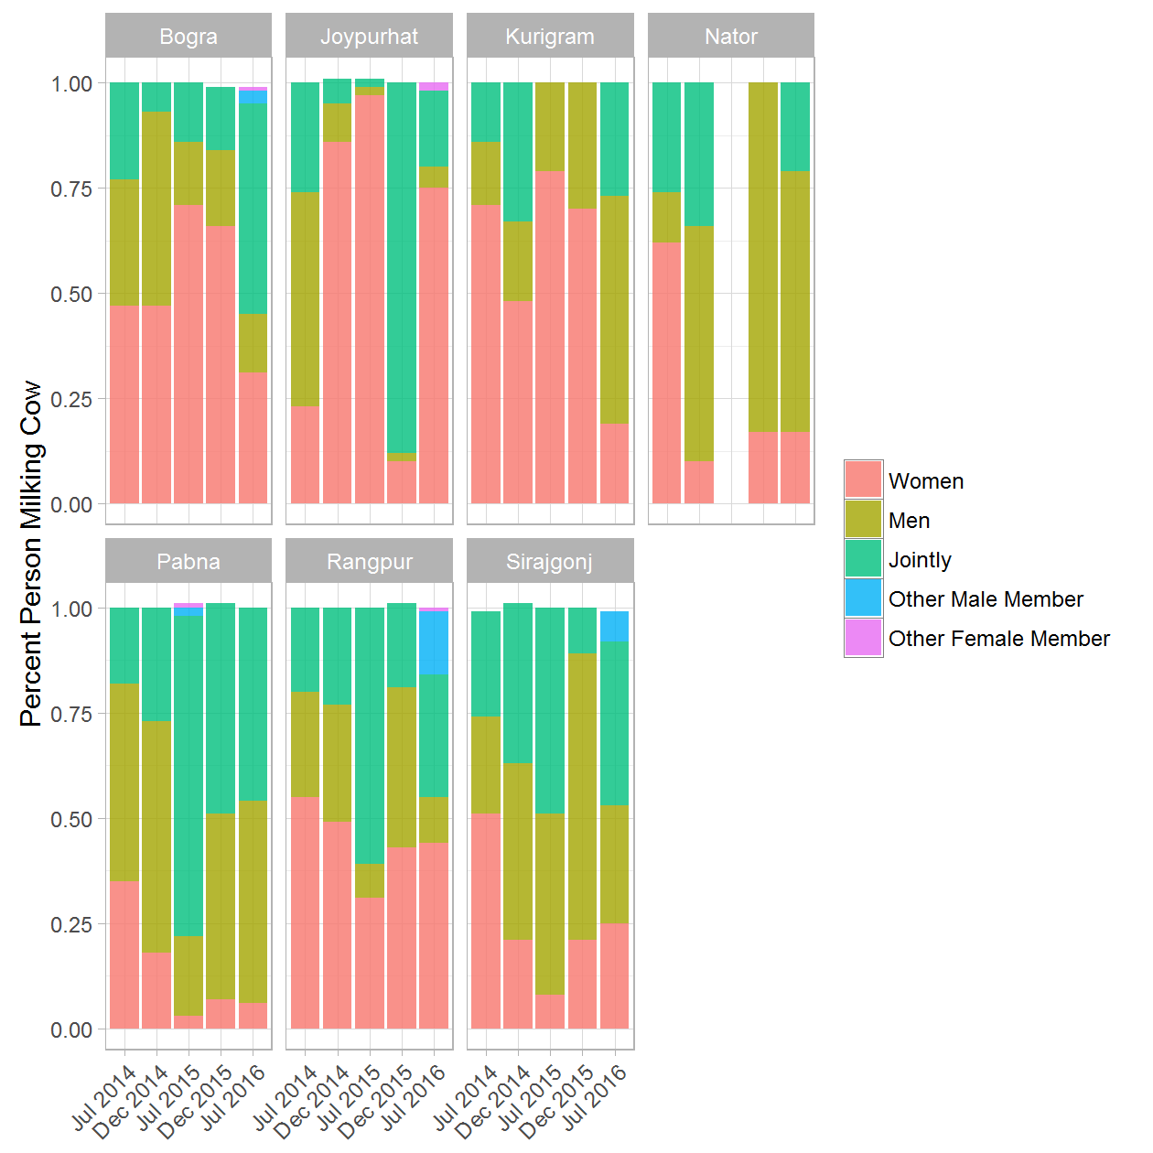

### WOMEN OWNERSHIP: 1a. Women Who Own Cattle - (Treatment & Control) rounds 1 and 5

|  |  |  |  |  |
| --- | --- | --- | --- | --- |
| District | Round of Data Collection | Women Who Own Cattle | Treatment/Control Group | Percent |
| Bogra | Jul 2014 | Yes | Treatment | 0.13 |
| Bogra | Jul 2014 | Yes | Control | 0.10 |
| Bogra | Jul 2014 | No | Treatment | 0.87 |
| Bogra | Jul 2014 | No | Control | 0.90 |
| Bogra | Jul 2016 | 0 | Control | 0.01 |
| Bogra | Jul 2016 | Yes | Treatment | 0.37 |
| Bogra | Jul 2016 | Yes | Control | 0.26 |
| Bogra | Jul 2016 | No | Treatment | 0.63 |
| Bogra | Jul 2016 | No | Control | 0.72 |
| Joypurhat | Jul 2014 | Yes | Treatment | 0.21 |
| Joypurhat | Jul 2014 | Yes | Control | 0.08 |
| Joypurhat | Jul 2014 | No | Treatment | 0.79 |
| Joypurhat | Jul 2014 | No | Control | 0.92 |
| Joypurhat | Jul 2016 | Yes | Treatment | 0.06 |
| Joypurhat | Jul 2016 | Yes | Control | 0.26 |
| Joypurhat | Jul 2016 | No | Treatment | 0.94 |
| Joypurhat | Jul 2016 | No | Control | 0.74 |
| Kurigram | Jul 2014 | Yes | Treatment | 0.52 |
| Kurigram | Jul 2014 | Yes | Control | 0.23 |
| Kurigram | Jul 2014 | No | Treatment | 0.48 |
| Kurigram | Jul 2014 | No | Control | 0.77 |
| Kurigram | Jul 2016 | Yes | Treatment | 0.06 |
| Kurigram | Jul 2016 | Yes | Control | 0.19 |
| Kurigram | Jul 2016 | No | Treatment | 0.94 |
| Kurigram | Jul 2016 | No | Control | 0.81 |
| Naogaon | Jul 2014 | Yes | Control | 0.48 |
| Naogaon | Jul 2014 | No | Control | 0.52 |
| Naogaon | Jul 2016 | Yes | Control | 0.18 |
| Naogaon | Jul 2016 | No | Control | 0.82 |
| Nator | Jul 2014 | Yes | Treatment | 0.23 |
| Nator | Jul 2014 | Yes | Control | 0.75 |
| Nator | Jul 2014 | No | Treatment | 0.77 |
| Nator | Jul 2014 | No | Control | 0.25 |
| Nator | Jul 2016 | Yes | Control | 0.88 |
| Nator | Jul 2016 | No | Treatment | 1.00 |
| Nator | Jul 2016 | No | Control | 0.12 |
| Pabna | Jul 2014 | Yes | Treatment | 0.07 |
| Pabna | Jul 2014 | Yes | Control | 0.08 |
| Pabna | Jul 2014 | No | Treatment | 0.93 |
| Pabna | Jul 2014 | No | Control | 0.92 |
| Pabna | Jul 2016 | Yes | Treatment | 0.42 |
| Pabna | Jul 2016 | Yes | Control | 0.17 |
| Pabna | Jul 2016 | No | Treatment | 0.58 |
| Pabna | Jul 2016 | No | Control | 0.83 |
| Rangpur | Jul 2014 | Yes | Treatment | 0.14 |
| Rangpur | Jul 2014 | Yes | Control | 0.19 |
| Rangpur | Jul 2014 | No | Treatment | 0.86 |
| Rangpur | Jul 2014 | No | Control | 0.81 |
| Rangpur | Jul 2016 | Yes | Treatment | 0.22 |
| Rangpur | Jul 2016 | Yes | Control | 0.08 |
| Rangpur | Jul 2016 | No | Treatment | 0.78 |
| Rangpur | Jul 2016 | No | Control | 0.92 |
| Sirajgonj | Jul 2014 | Yes | Treatment | 0.02 |
| Sirajgonj | Jul 2014 | Yes | Control | 0.07 |
| Sirajgonj | Jul 2014 | No | Treatment | 0.98 |
| Sirajgonj | Jul 2014 | No | Control | 0.93 |
| Sirajgonj | Jul 2016 | Yes | Treatment | 0.14 |
| Sirajgonj | Jul 2016 | Yes | Control | 0.14 |
| Sirajgonj | Jul 2016 | No | Treatment | 0.86 |
| Sirajgonj | Jul 2016 | No | Control | 0.86 |

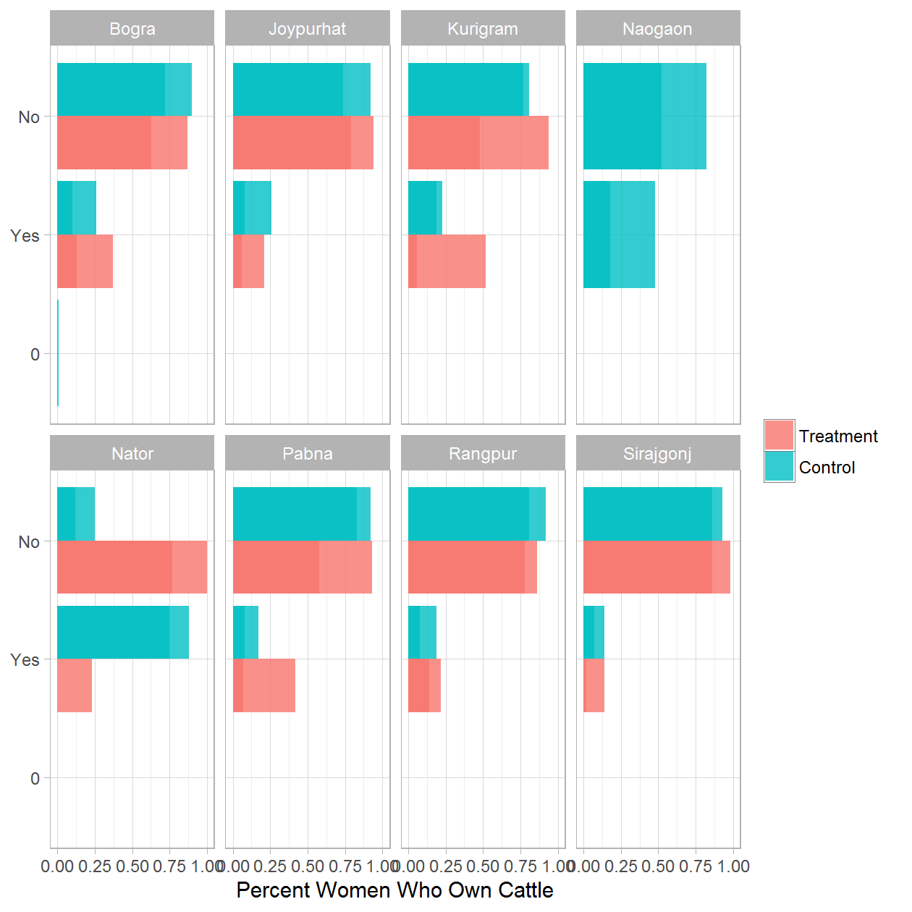

### WOMEN OWNERSHIP: 1b. Women Who Own Cattle - Treatment Only

|  |  |  |  |
| --- | --- | --- | --- |
| District | Round of Data Collection | Women Who Own Cattle | Percent |
| Bogra | Jul 2014 | Yes | 0.13 |
| Bogra | Jul 2014 | No | 0.87 |
| Bogra | Dec 2014 | Yes | 0.26 |
| Bogra | Dec 2014 | No | 0.74 |
| Bogra | Jul 2015 | Yes | 0.26 |
| Bogra | Jul 2015 | No | 0.74 |
| Bogra | Dec 2015 | Yes | 0.36 |
| Bogra | Dec 2015 | No | 0.64 |
| Bogra | Jul 2016 | Yes | 0.37 |
| Bogra | Jul 2016 | No | 0.63 |
| Joypurhat | Jul 2014 | Yes | 0.21 |
| Joypurhat | Jul 2014 | No | 0.79 |
| Joypurhat | Dec 2014 | Yes | 0.35 |
| Joypurhat | Dec 2014 | No | 0.65 |
| Joypurhat | Jul 2015 | Yes | 0.11 |
| Joypurhat | Jul 2015 | No | 0.89 |
| Joypurhat | Dec 2015 | Yes | 0.01 |
| Joypurhat | Dec 2015 | No | 0.99 |
| Joypurhat | Jul 2016 | Yes | 0.06 |
| Joypurhat | Jul 2016 | No | 0.94 |
| Kurigram | Jul 2014 | Yes | 0.52 |
| Kurigram | Jul 2014 | No | 0.48 |
| Kurigram | Dec 2014 | Yes | 0.27 |
| Kurigram | Dec 2014 | No | 0.73 |
| Kurigram | Jul 2015 | Yes | 0.26 |
| Kurigram | Jul 2015 | No | 0.74 |
| Kurigram | Dec 2015 | Yes | 0.08 |
| Kurigram | Dec 2015 | No | 0.92 |
| Kurigram | Jul 2016 | Yes | 0.06 |
| Kurigram | Jul 2016 | No | 0.94 |
| Nator | Jul 2014 | Yes | 0.23 |
| Nator | Jul 2014 | No | 0.77 |
| Nator | Dec 2014 | Yes | 0.02 |
| Nator | Dec 2014 | No | 0.98 |
| Nator | Dec 2015 | Yes | 0.29 |
| Nator | Dec 2015 | No | 0.71 |
| Nator | Jul 2016 | No | 1.00 |
| Pabna | Jul 2014 | Yes | 0.07 |
| Pabna | Jul 2014 | No | 0.93 |
| Pabna | Dec 2014 | Yes | 0.02 |
| Pabna | Dec 2014 | No | 0.98 |
| Pabna | Jul 2015 | Yes | 0.03 |
| Pabna | Jul 2015 | No | 0.97 |
| Pabna | Dec 2015 | Yes | 0.01 |
| Pabna | Dec 2015 | No | 0.99 |
| Pabna | Jul 2016 | Yes | 0.42 |
| Pabna | Jul 2016 | No | 0.58 |
| Rangpur | Jul 2014 | Yes | 0.14 |
| Rangpur | Jul 2014 | No | 0.86 |
| Rangpur | Dec 2014 | Yes | 0.10 |
| Rangpur | Dec 2014 | No | 0.90 |
| Rangpur | Jul 2015 | Yes | 0.05 |
| Rangpur | Jul 2015 | No | 0.95 |
| Rangpur | Dec 2015 | Yes | 0.09 |
| Rangpur | Dec 2015 | No | 0.91 |
| Rangpur | Jul 2016 | Yes | 0.22 |
| Rangpur | Jul 2016 | No | 0.78 |
| Sirajgonj | Jul 2014 | Yes | 0.02 |
| Sirajgonj | Jul 2014 | No | 0.98 |
| Sirajgonj | Dec 2014 | Yes | 0.03 |
| Sirajgonj | Dec 2014 | No | 0.97 |
| Sirajgonj | Jul 2015 | Yes | 0.12 |
| Sirajgonj | Jul 2015 | No | 0.88 |
| Sirajgonj | Dec 2015 | Yes | 0.13 |
| Sirajgonj | Dec 2015 | No | 0.87 |
| Sirajgonj | Jul 2016 | Yes | 0.14 |
| Sirajgonj | Jul 2016 | No | 0.86 |

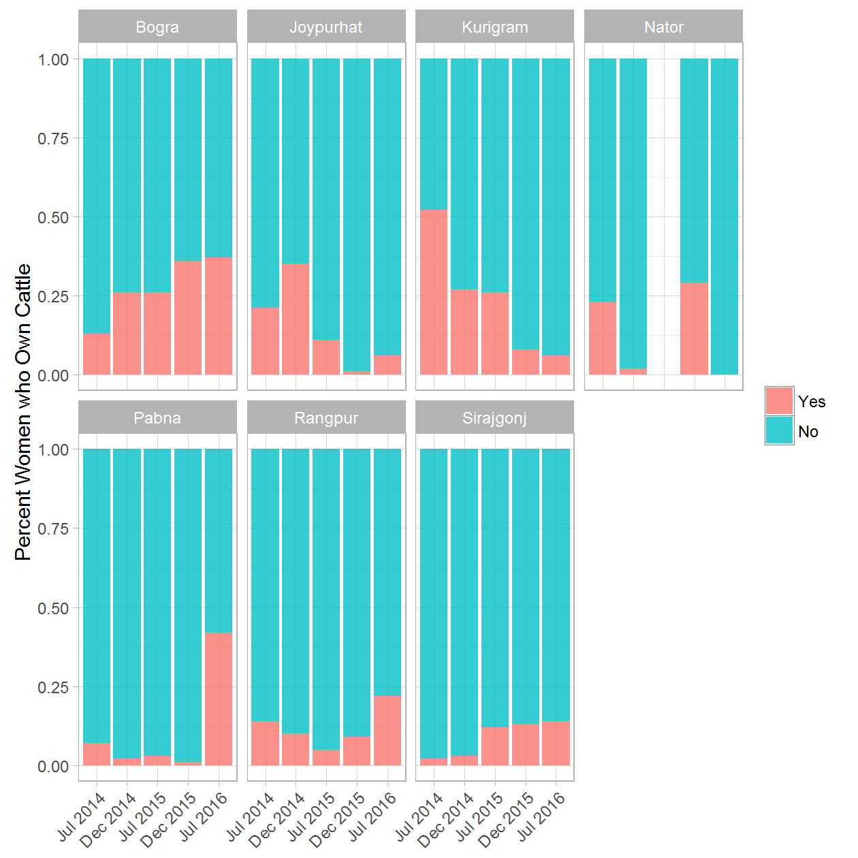

### WOMEN OWNERSHIP: 2a. Women Acquired Cattle - (Treatment & Control) rounds 1 and 5

|  |  |  |  |  |
| --- | --- | --- | --- | --- |
| District | Round of Data Collection | Women Acquired Cattle | Treatment/Control Group | Percent |
| Bogra | Jul 2014 | 0 | Treatment | 0.82 |
| Bogra | Jul 2014 | 0 | Control | 0.91 |
| Bogra | Jul 2014 | Inherited | Treatment | 0.07 |
| Bogra | Jul 2014 | Inherited | Control | 0.02 |
| Bogra | Jul 2014 | Gifted | Treatment | 0.06 |
| Bogra | Jul 2014 | Gifted | Control | 0.04 |
| Bogra | Jul 2014 | Bought with own income | Treatment | 0.04 |
| Bogra | Jul 2014 | Bought with own income | Control | 0.02 |
| Bogra | Jul 2014 | Others (specify) | Treatment | 0.01 |
| Bogra | Jul 2014 | Others (specify) | Control | 0.01 |
| Bogra | Jul 2016 | Inherited | Treatment | 0.31 |
| Bogra | Jul 2016 | Inherited | Control | 0.14 |
| Bogra | Jul 2016 | Gifted | Treatment | 0.19 |
| Bogra | Jul 2016 | Gifted | Control | 0.33 |
| Bogra | Jul 2016 | Bought with own income | Treatment | 0.50 |
| Bogra | Jul 2016 | Bought with own income | Control | 0.53 |
| Bogra | Jul 2016 | Lease | Treatment | 0.01 |
| Joypurhat | Jul 2014 | 0 | Treatment | 1.00 |
| Joypurhat | Jul 2014 | 0 | Control | 0.92 |
| Joypurhat | Jul 2014 | Inherited | Control | 0.02 |
| Joypurhat | Jul 2014 | Gifted | Control | 0.01 |
| Joypurhat | Jul 2014 | Bought with own income | Control | 0.04 |
| Joypurhat | Jul 2014 | Others (specify) | Control | 0.01 |
| Joypurhat | Jul 2016 | Inherited | Treatment | 0.10 |
| Joypurhat | Jul 2016 | Inherited | Control | 0.32 |
| Joypurhat | Jul 2016 | Gifted | Control | 0.04 |
| Joypurhat | Jul 2016 | Bought with own income | Treatment | 0.90 |
| Joypurhat | Jul 2016 | Bought with own income | Control | 0.64 |
| Kurigram | Jul 2014 | 0 | Treatment | 0.45 |
| Kurigram | Jul 2014 | 0 | Control | 0.71 |
| Kurigram | Jul 2014 | Inherited | Treatment | 0.18 |
| Kurigram | Jul 2014 | Gifted | Treatment | 0.14 |
| Kurigram | Jul 2014 | Gifted | Control | 0.17 |
| Kurigram | Jul 2014 | Bought with own income | Treatment | 0.23 |
| Kurigram | Jul 2014 | Bought with own income | Control | 0.13 |
| Kurigram | Jul 2016 | Inherited | Control | 0.85 |
| Kurigram | Jul 2016 | Bought with own income | Treatment | 1.00 |
| Kurigram | Jul 2016 | Bought with own income | Control | 0.15 |
| Naogaon | Jul 2014 | 0 | Control | 0.76 |
| Naogaon | Jul 2014 | Inherited | Control | 0.18 |
| Naogaon | Jul 2014 | Others (specify) | Control | 0.05 |
| Naogaon | Jul 2016 | Inherited | Control | 0.09 |
| Naogaon | Jul 2016 | Gifted | Control | 0.18 |
| Naogaon | Jul 2016 | Bought with own income | Control | 0.73 |
| Nator | Jul 2014 | 0 | Treatment | 0.83 |
| Nator | Jul 2014 | 0 | Control | 0.75 |
| Nator | Jul 2014 | Gifted | Treatment | 0.01 |
| Nator | Jul 2014 | Bought with own income | Treatment | 0.14 |
| Nator | Jul 2014 | Others (specify) | Treatment | 0.02 |
| Nator | Jul 2014 | Others (specify) | Control | 0.25 |
| Nator | Jul 2016 | Inherited | Control | 1.00 |
| Pabna | Jul 2014 | 0 | Treatment | 0.98 |
| Pabna | Jul 2014 | 0 | Control | 0.95 |
| Pabna | Jul 2014 | Inherited | Treatment | 0.00 |
| Pabna | Jul 2014 | Inherited | Control | 0.03 |
| Pabna | Jul 2014 | Gifted | Control | 0.01 |
| Pabna | Jul 2014 | Bought with own income | Treatment | 0.01 |
| Pabna | Jul 2014 | Bought with own income | Control | 0.02 |
| Pabna | Jul 2016 | Inherited | Treatment | 0.50 |
| Pabna | Jul 2016 | Inherited | Control | 0.34 |
| Pabna | Jul 2016 | Gifted | Treatment | 0.31 |
| Pabna | Jul 2016 | Gifted | Control | 0.29 |
| Pabna | Jul 2016 | Bought with own income | Treatment | 0.19 |
| Pabna | Jul 2016 | Bought with own income | Control | 0.37 |
| Rangpur | Jul 2014 | 0 | Treatment | 0.85 |
| Rangpur | Jul 2014 | 0 | Control | 0.82 |
| Rangpur | Jul 2014 | Inherited | Treatment | 0.04 |
| Rangpur | Jul 2014 | Inherited | Control | 0.03 |
| Rangpur | Jul 2014 | Gifted | Treatment | 0.05 |
| Rangpur | Jul 2014 | Gifted | Control | 0.03 |
| Rangpur | Jul 2014 | Bought with own income | Treatment | 0.03 |
| Rangpur | Jul 2014 | Bought with own income | Control | 0.09 |
| Rangpur | Jul 2014 | Others (specify) | Treatment | 0.03 |
| Rangpur | Jul 2014 | Others (specify) | Control | 0.04 |
| Rangpur | Jul 2016 | Inherited | Treatment | 0.18 |
| Rangpur | Jul 2016 | Inherited | Control | 0.11 |
| Rangpur | Jul 2016 | Gifted | Treatment | 0.20 |
| Rangpur | Jul 2016 | Gifted | Control | 0.15 |
| Rangpur | Jul 2016 | Bought with own income | Treatment | 0.59 |
| Rangpur | Jul 2016 | Bought with own income | Control | 0.74 |
| Rangpur | Jul 2016 | Gift | Treatment | 0.03 |
| Sirajgonj | Jul 2014 | 0 | Treatment | 0.97 |
| Sirajgonj | Jul 2014 | 0 | Control | 0.94 |
| Sirajgonj | Jul 2014 | Inherited | Treatment | 0.02 |
| Sirajgonj | Jul 2014 | Inherited | Control | 0.01 |
| Sirajgonj | Jul 2014 | Gifted | Treatment | 0.01 |
| Sirajgonj | Jul 2014 | Gifted | Control | 0.04 |
| Sirajgonj | Jul 2014 | Bought with own income | Treatment | 0.01 |
| Sirajgonj | Jul 2014 | Bought with own income | Control | 0.01 |
| Sirajgonj | Jul 2016 | Inherited | Treatment | 0.13 |
| Sirajgonj | Jul 2016 | Inherited | Control | 0.39 |
| Sirajgonj | Jul 2016 | Gifted | Treatment | 0.67 |
| Sirajgonj | Jul 2016 | Gifted | Control | 0.54 |
| Sirajgonj | Jul 2016 | Bought with own income | Treatment | 0.20 |
| Sirajgonj | Jul 2016 | Bought with own income | Control | 0.07 |

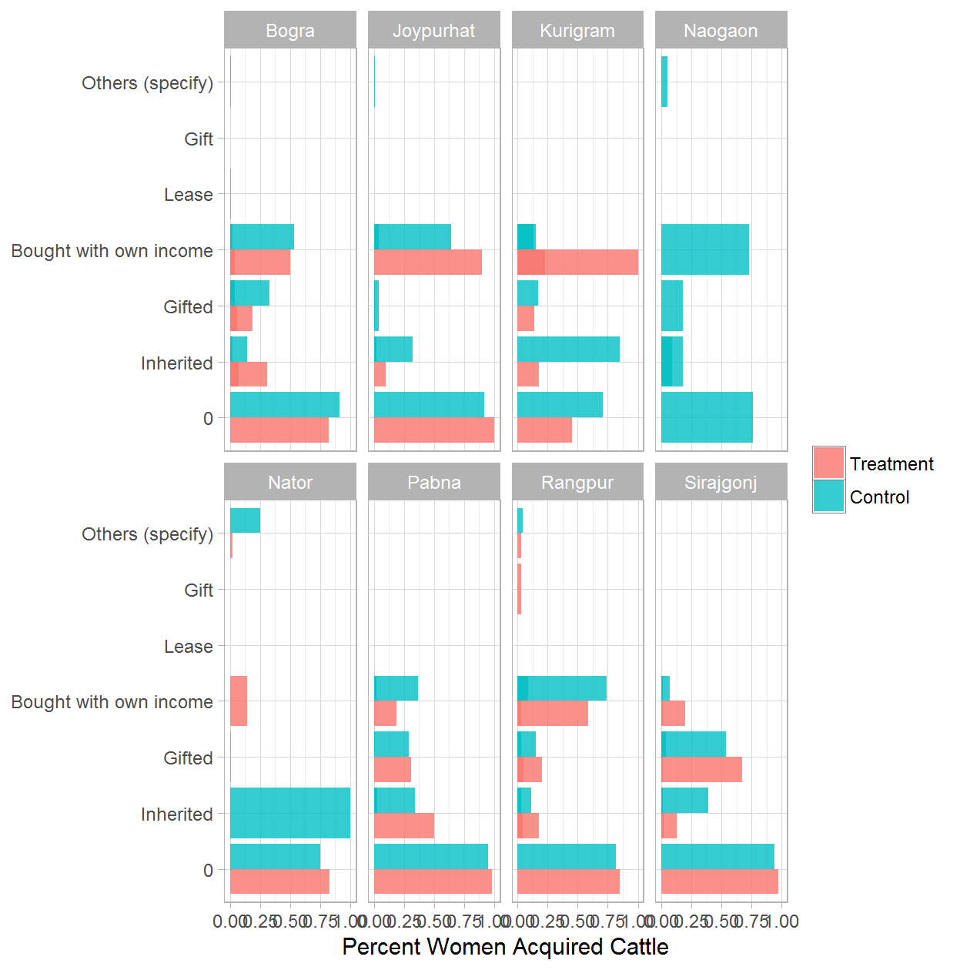

### WOMEN OWNERSHIP: 2b. Women Acquired Cattle - Treatment Only

|  |  |  |  |
| --- | --- | --- | --- |
| District | Round of Data Collection | Women Acquired Cattle | Percent |
| Bogra | Jul 2014 | 0 | 0.82 |
| Bogra | Jul 2014 | Inherited | 0.07 |
| Bogra | Jul 2014 | Gifted | 0.06 |
| Bogra | Jul 2014 | Bought with own income | 0.04 |
| Bogra | Jul 2014 | Others (specify) | 0.01 |
| Bogra | Dec 2014 | Inherited | 0.61 |
| Bogra | Dec 2014 | Gifted | 0.15 |
| Bogra | Dec 2014 | Bought with own income | 0.21 |
| Bogra | Dec 2014 | 99 | 0.02 |
| Bogra | Jul 2015 | Inherited | 0.06 |
| Bogra | Jul 2015 | Gifted | 0.24 |
| Bogra | Jul 2015 | Bought with own income | 0.66 |
| Bogra | Jul 2015 | Lease | 0.04 |
| Bogra | Dec 2015 | Inherited | 0.18 |
| Bogra | Dec 2015 | Gifted | 0.08 |
| Bogra | Dec 2015 | Bought with own income | 0.74 |
| Bogra | Jul 2016 | Inherited | 0.31 |
| Bogra | Jul 2016 | Gifted | 0.19 |
| Bogra | Jul 2016 | Bought with own income | 0.50 |
| Bogra | Jul 2016 | Lease | 0.01 |
| Joypurhat | Jul 2014 | 0 | 1.00 |
| Joypurhat | Dec 2014 | Inherited | 0.11 |
| Joypurhat | Dec 2014 | Gifted | 0.06 |
| Joypurhat | Dec 2014 | 99 | 0.83 |
| Joypurhat | Jul 2015 | Gifted | 0.71 |
| Joypurhat | Jul 2015 | Bought with own income | 0.29 |
| Joypurhat | Dec 2015 | Inherited | 1.00 |
| Joypurhat | Jul 2016 | Inherited | 0.10 |
| Joypurhat | Jul 2016 | Bought with own income | 0.90 |
| Kurigram | Jul 2014 | 0 | 0.45 |
| Kurigram | Jul 2014 | Inherited | 0.18 |
| Kurigram | Jul 2014 | Gifted | 0.14 |
| Kurigram | Jul 2014 | Bought with own income | 0.23 |
| Kurigram | Dec 2014 | Inherited | 0.05 |
| Kurigram | Dec 2014 | Gifted | 0.15 |
| Kurigram | Dec 2014 | Bought with own income | 0.80 |
| Kurigram | Jul 2015 | Inherited | 0.09 |
| Kurigram | Jul 2015 | Gifted | 0.73 |
| Kurigram | Jul 2015 | Bought with own income | 0.18 |
| Kurigram | Dec 2015 | Bought with own income | 1.00 |
| Kurigram | Jul 2016 | Bought with own income | 1.00 |
| Nator | Jul 2014 | 0 | 0.83 |
| Nator | Jul 2014 | Gifted | 0.01 |
| Nator | Jul 2014 | Bought with own income | 0.14 |
| Nator | Jul 2014 | Others (specify) | 0.02 |
| Nator | Dec 2014 | Bought with own income | 1.00 |
| Nator | Dec 2015 | Bought with own income | 1.00 |
| Pabna | Jul 2014 | 0 | 0.98 |
| Pabna | Jul 2014 | Inherited | 0.00 |
| Pabna | Jul 2014 | Bought with own income | 0.01 |
| Pabna | Dec 2014 | Inherited | 1.00 |
| Pabna | Jul 2015 | Gifted | 1.00 |
| Pabna | Dec 2015 | Inherited | 0.60 |
| Pabna | Dec 2015 | Gifted | 0.40 |
| Pabna | Jul 2016 | Inherited | 0.50 |
| Pabna | Jul 2016 | Gifted | 0.31 |
| Pabna | Jul 2016 | Bought with own income | 0.19 |
| Rangpur | Jul 2014 | 0 | 0.85 |
| Rangpur | Jul 2014 | Inherited | 0.04 |
| Rangpur | Jul 2014 | Gifted | 0.05 |
| Rangpur | Jul 2014 | Bought with own income | 0.03 |
| Rangpur | Jul 2014 | Others (specify) | 0.03 |
| Rangpur | Dec 2014 | Inherited | 0.24 |
| Rangpur | Dec 2014 | Gifted | 0.15 |
| Rangpur | Dec 2014 | Bought with own income | 0.56 |
| Rangpur | Dec 2014 | 99 | 0.06 |
| Rangpur | Jul 2015 | Inherited | 0.33 |
| Rangpur | Jul 2015 | Gifted | 0.33 |
| Rangpur | Jul 2015 | 99 | 0.33 |
| Rangpur | Dec 2015 | Inherited | 0.24 |
| Rangpur | Dec 2015 | Gifted | 0.29 |
| Rangpur | Dec 2015 | Bought with own income | 0.44 |
| Rangpur | Dec 2015 | 99 | 0.03 |
| Rangpur | Jul 2016 | Inherited | 0.18 |
| Rangpur | Jul 2016 | Gifted | 0.20 |
| Rangpur | Jul 2016 | Bought with own income | 0.59 |
| Rangpur | Jul 2016 | Gift | 0.03 |
| Sirajgonj | Jul 2014 | 0 | 0.97 |
| Sirajgonj | Jul 2014 | Inherited | 0.02 |
| Sirajgonj | Jul 2014 | Gifted | 0.01 |
| Sirajgonj | Jul 2014 | Bought with own income | 0.01 |
| Sirajgonj | Dec 2014 | Inherited | 0.25 |
| Sirajgonj | Dec 2014 | Gifted | 0.50 |
| Sirajgonj | Dec 2014 | 99 | 0.25 |
| Sirajgonj | Jul 2015 | Inherited | 0.22 |
| Sirajgonj | Jul 2015 | Gifted | 0.74 |
| Sirajgonj | Jul 2015 | Bought with own income | 0.04 |
| Sirajgonj | Dec 2015 | Inherited | 0.34 |
| Sirajgonj | Dec 2015 | Gifted | 0.45 |
| Sirajgonj | Dec 2015 | Bought with own income | 0.20 |
| Sirajgonj | Jul 2016 | Inherited | 0.13 |
| Sirajgonj | Jul 2016 | Gifted | 0.67 |
| Sirajgonj | Jul 2016 | Bought with own income | 0.20 |

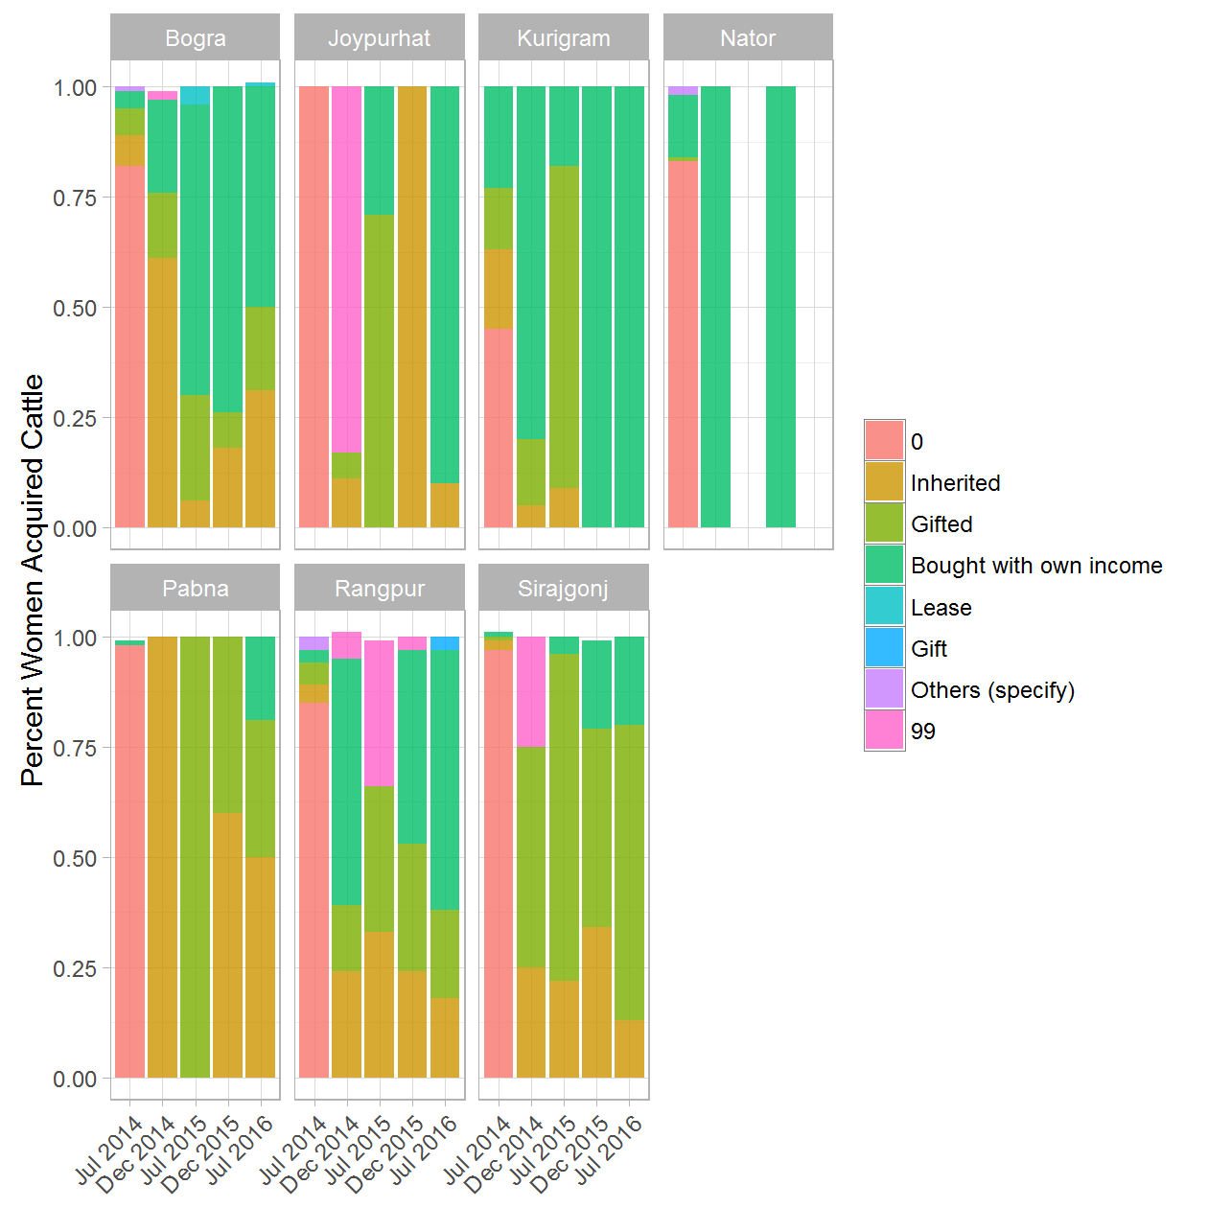

### WOMEN OWNERSHIP: 3a. Decision for Spending Woman's Milk Sales Income - (Treatment & Control) rounds 1 and 5

|  |  |  |  |  |
| --- | --- | --- | --- | --- |
| District | Round of Data Collection | Decision for Spending Woman's Milk Sales Income | Treatment/Control Group | Percent |
| Bogra | Jul 2014 | Self | Treatment | 0.18 |
| Bogra | Jul 2014 | Self | Control | 0.12 |
| Bogra | Jul 2014 | Husband | Treatment | 0.15 |
| Bogra | Jul 2014 | Husband | Control | 0.26 |
| Bogra | Jul 2014 | Jointly | Treatment | 0.65 |
| Bogra | Jul 2014 | Jointly | Control | 0.62 |
| Bogra | Jul 2014 | Other Male Member | Treatment | 0.02 |
| Bogra | Jul 2014 | Other Male Member | Control | 0.00 |
| Bogra | Jul 2014 | Other Female Member | Treatment | 0.00 |
| Bogra | Jul 2016 | Self | Treatment | 0.14 |
| Bogra | Jul 2016 | Self | Control | 0.15 |
| Bogra | Jul 2016 | Husband | Treatment | 0.10 |
| Bogra | Jul 2016 | Husband | Control | 0.26 |
| Bogra | Jul 2016 | Jointly | Treatment | 0.76 |
| Bogra | Jul 2016 | Jointly | Control | 0.59 |
| Bogra | Jul 2016 | Other Male Member | Treatment | 0.00 |
| Bogra | Jul 2016 | Other Female Member | Treatment | 0.00 |
| Joypurhat | Jul 2014 | Self | Treatment | 0.10 |
| Joypurhat | Jul 2014 | Self | Control | 0.08 |
| Joypurhat | Jul 2014 | Husband | Control | 0.23 |
| Joypurhat | Jul 2014 | Jointly | Treatment | 0.90 |
| Joypurhat | Jul 2014 | Jointly | Control | 0.69 |
| Joypurhat | Jul 2016 | Self | Treatment | 0.06 |
| Joypurhat | Jul 2016 | Self | Control | 0.10 |
| Joypurhat | Jul 2016 | Husband | Treatment | 0.32 |
| Joypurhat | Jul 2016 | Husband | Control | 0.18 |
| Joypurhat | Jul 2016 | Jointly | Treatment | 0.63 |
| Joypurhat | Jul 2016 | Jointly | Control | 0.72 |
| Kurigram | Jul 2014 | Self | Treatment | 0.29 |
| Kurigram | Jul 2014 | Self | Control | 0.15 |
| Kurigram | Jul 2014 | Husband | Treatment | 0.20 |
| Kurigram | Jul 2014 | Jointly | Treatment | 0.51 |
| Kurigram | Jul 2014 | Jointly | Control | 0.85 |
| Kurigram | Jul 2016 | Self | Treatment | 0.06 |
| Kurigram | Jul 2016 | Self | Control | 0.10 |
| Kurigram | Jul 2016 | Husband | Treatment | 0.13 |
| Kurigram | Jul 2016 | Husband | Control | 0.03 |
| Kurigram | Jul 2016 | Jointly | Treatment | 0.82 |
| Kurigram | Jul 2016 | Jointly | Control | 0.87 |
| Naogaon | Jul 2014 | Self | Control | 1.00 |
| Naogaon | Jul 2016 | Self | Control | 0.21 |
| Naogaon | Jul 2016 | Husband | Control | 0.14 |
| Naogaon | Jul 2016 | Jointly | Control | 0.64 |
| Nator | Jul 2014 | Self | Control | 1.00 |
| Nator | Jul 2014 | Husband | Treatment | 0.62 |
| Nator | Jul 2014 | Jointly | Treatment | 0.38 |
| Nator | Jul 2016 | Self | Control | 0.86 |
| Nator | Jul 2016 | Husband | Treatment | 0.19 |
| Nator | Jul 2016 | Jointly | Treatment | 0.81 |
| Nator | Jul 2016 | Jointly | Control | 0.14 |
| Pabna | Jul 2014 | Self | Treatment | 0.12 |
| Pabna | Jul 2014 | Husband | Treatment | 0.53 |
| Pabna | Jul 2014 | Husband | Control | 0.71 |
| Pabna | Jul 2014 | Jointly | Treatment | 0.31 |
| Pabna | Jul 2014 | Jointly | Control | 0.29 |
| Pabna | Jul 2014 | Other Male Member | Treatment | 0.04 |
| Pabna | Jul 2016 | Self | Treatment | 0.01 |
| Pabna | Jul 2016 | Self | Control | 0.07 |
| Pabna | Jul 2016 | Husband | Treatment | 0.28 |
| Pabna | Jul 2016 | Husband | Control | 0.02 |
| Pabna | Jul 2016 | Jointly | Treatment | 0.71 |
| Pabna | Jul 2016 | Jointly | Control | 0.91 |
| Rangpur | Jul 2014 | Self | Treatment | 0.09 |
| Rangpur | Jul 2014 | Self | Control | 0.36 |
| Rangpur | Jul 2014 | Husband | Treatment | 0.21 |
| Rangpur | Jul 2014 | Husband | Control | 0.15 |
| Rangpur | Jul 2014 | Jointly | Treatment | 0.69 |
| Rangpur | Jul 2014 | Jointly | Control | 0.50 |
| Rangpur | Jul 2014 | Other Male Member | Treatment | 0.01 |
| Rangpur | Jul 2016 | Self | Treatment | 0.06 |
| Rangpur | Jul 2016 | Self | Control | 0.06 |
| Rangpur | Jul 2016 | Husband | Treatment | 0.30 |
| Rangpur | Jul 2016 | Husband | Control | 0.08 |
| Rangpur | Jul 2016 | Jointly | Treatment | 0.62 |
| Rangpur | Jul 2016 | Jointly | Control | 0.86 |
| Rangpur | Jul 2016 | Other Male Member | Treatment | 0.02 |
| Sirajgonj | Jul 2014 | Self | Treatment | 0.02 |
| Sirajgonj | Jul 2014 | Self | Control | 0.12 |
| Sirajgonj | Jul 2014 | Husband | Treatment | 0.30 |
| Sirajgonj | Jul 2014 | Husband | Control | 0.71 |
| Sirajgonj | Jul 2014 | Jointly | Treatment | 0.67 |
| Sirajgonj | Jul 2014 | Jointly | Control | 0.16 |
| Sirajgonj | Jul 2014 | Other Male Member | Treatment | 0.01 |
| Sirajgonj | Jul 2014 | Other Male Member | Control | 0.01 |
| Sirajgonj | Jul 2016 | Self | Treatment | 0.02 |
| Sirajgonj | Jul 2016 | Self | Control | 0.07 |
| Sirajgonj | Jul 2016 | Husband | Treatment | 0.11 |
| Sirajgonj | Jul 2016 | Husband | Control | 0.40 |
| Sirajgonj | Jul 2016 | Jointly | Treatment | 0.87 |
| Sirajgonj | Jul 2016 | Jointly | Control | 0.49 |
| Sirajgonj | Jul 2016 | Other Male Member | Control | 0.03 |

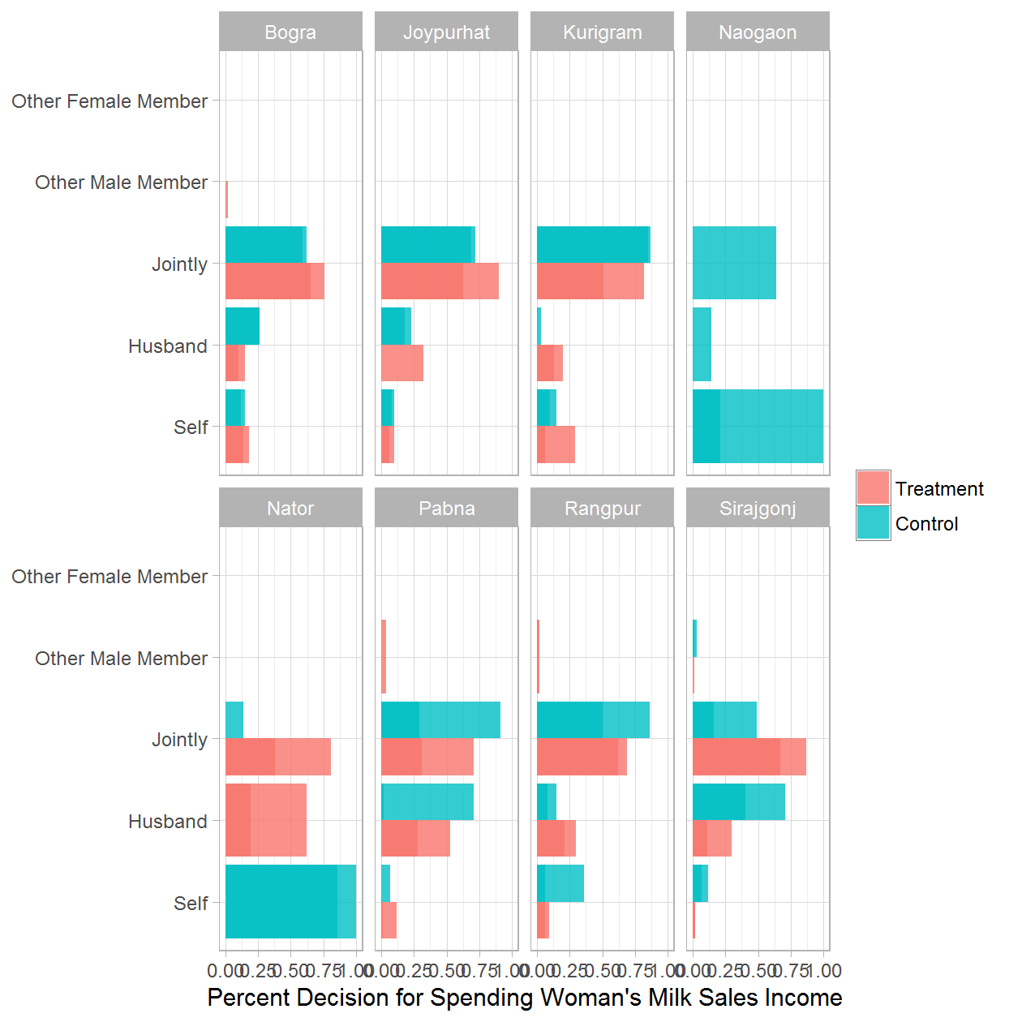

### WOMEN OWNERSHIP: 3b. Decision for Spending Woman's Milk Sales Income - Treatment Only

|  |  |  |  |
| --- | --- | --- | --- |
| District | Round of Data Collection | Decision for Spending Woman's Milk Sales Income | Percent |
| Bogra | Jul 2014 | Self | 0.18 |
| Bogra | Jul 2014 | Husband | 0.15 |
| Bogra | Jul 2014 | Jointly | 0.65 |
| Bogra | Jul 2014 | Other Male Member | 0.02 |
| Bogra | Jul 2014 | Other Female Member | 0.00 |
| Bogra | Dec 2014 | Self | 0.10 |
| Bogra | Dec 2014 | Husband | 0.23 |
| Bogra | Dec 2014 | Jointly | 0.66 |
| Bogra | Dec 2014 | Other Female Member | 0.02 |
| Bogra | Jul 2015 | Self | 0.34 |
| Bogra | Jul 2015 | Husband | 0.01 |
| Bogra | Jul 2015 | Jointly | 0.65 |
| Bogra | Dec 2015 | Self | 0.08 |
| Bogra | Dec 2015 | Husband | 0.01 |
| Bogra | Dec 2015 | Jointly | 0.91 |
| Bogra | Jul 2016 | Self | 0.14 |
| Bogra | Jul 2016 | Husband | 0.10 |
| Bogra | Jul 2016 | Jointly | 0.76 |
| Bogra | Jul 2016 | Other Male Member | 0.00 |
| Bogra | Jul 2016 | Other Female Member | 0.00 |
| Joypurhat | Jul 2014 | Self | 0.10 |
| Joypurhat | Jul 2014 | Jointly | 0.90 |
| Joypurhat | Dec 2014 | Self | 0.05 |
| Joypurhat | Dec 2014 | Jointly | 0.95 |
| Joypurhat | Jul 2015 | Self | 0.21 |
| Joypurhat | Jul 2015 | Husband | 0.14 |
| Joypurhat | Jul 2015 | Jointly | 0.66 |
| Joypurhat | Dec 2015 | Self | 0.23 |
| Joypurhat | Dec 2015 | Jointly | 0.77 |
| Joypurhat | Jul 2016 | Self | 0.06 |
| Joypurhat | Jul 2016 | Husband | 0.32 |
| Joypurhat | Jul 2016 | Jointly | 0.63 |
| Kurigram | Jul 2014 | Self | 0.29 |
| Kurigram | Jul 2014 | Husband | 0.20 |
| Kurigram | Jul 2014 | Jointly | 0.51 |
| Kurigram | Dec 2014 | Self | 0.17 |
| Kurigram | Dec 2014 | Husband | 0.21 |
| Kurigram | Dec 2014 | Jointly | 0.62 |
| Kurigram | Jul 2015 | Self | 0.07 |
| Kurigram | Jul 2015 | Jointly | 0.93 |
| Kurigram | Dec 2015 | Self | 0.08 |
| Kurigram | Dec 2015 | Husband | 0.22 |
| Kurigram | Dec 2015 | Jointly | 0.70 |
| Kurigram | Jul 2016 | Self | 0.06 |
| Kurigram | Jul 2016 | Husband | 0.13 |
| Kurigram | Jul 2016 | Jointly | 0.82 |
| Nator | Jul 2014 | Husband | 0.62 |
| Nator | Jul 2014 | Jointly | 0.38 |
| Nator | Dec 2014 | Husband | 0.43 |
| Nator | Dec 2014 | Jointly | 0.57 |
| Nator | Dec 2015 | Jointly | 1.00 |
| Nator | Jul 2016 | Husband | 0.19 |
| Nator | Jul 2016 | Jointly | 0.81 |
| Pabna | Jul 2014 | Self | 0.12 |
| Pabna | Jul 2014 | Husband | 0.53 |
| Pabna | Jul 2014 | Jointly | 0.31 |
| Pabna | Jul 2014 | Other Male Member | 0.04 |
| Pabna | Dec 2014 | Self | 0.10 |
| Pabna | Dec 2014 | Husband | 0.17 |
| Pabna | Dec 2014 | Jointly | 0.73 |
| Pabna | Jul 2015 | Self | 0.18 |
| Pabna | Jul 2015 | Husband | 0.36 |
| Pabna | Jul 2015 | Jointly | 0.46 |
| Pabna | Dec 2015 | Self | 0.01 |
| Pabna | Dec 2015 | Husband | 0.05 |
| Pabna | Dec 2015 | Jointly | 0.92 |
| Pabna | Dec 2015 | 7 | 0.02 |
| Pabna | Jul 2016 | Self | 0.01 |
| Pabna | Jul 2016 | Husband | 0.28 |
| Pabna | Jul 2016 | Jointly | 0.71 |
| Rangpur | Jul 2014 | Self | 0.09 |
| Rangpur | Jul 2014 | Husband | 0.21 |
| Rangpur | Jul 2014 | Jointly | 0.69 |
| Rangpur | Jul 2014 | Other Male Member | 0.01 |
| Rangpur | Dec 2014 | Self | 0.15 |
| Rangpur | Dec 2014 | Husband | 0.04 |
| Rangpur | Dec 2014 | Jointly | 0.77 |
| Rangpur | Dec 2014 | Other Male Member | 0.04 |
| Rangpur | Jul 2015 | Self | 0.04 |
| Rangpur | Jul 2015 | Jointly | 0.96 |
| Rangpur | Dec 2015 | Self | 0.16 |
| Rangpur | Dec 2015 | Husband | 0.03 |
| Rangpur | Dec 2015 | Jointly | 0.81 |
| Rangpur | Dec 2015 | Other Male Member | 0.01 |
| Rangpur | Jul 2016 | Self | 0.06 |
| Rangpur | Jul 2016 | Husband | 0.30 |
| Rangpur | Jul 2016 | Jointly | 0.62 |
| Rangpur | Jul 2016 | Other Male Member | 0.02 |
| Sirajgonj | Jul 2014 | Self | 0.02 |
| Sirajgonj | Jul 2014 | Husband | 0.30 |
| Sirajgonj | Jul 2014 | Jointly | 0.67 |
| Sirajgonj | Jul 2014 | Other Male Member | 0.01 |
| Sirajgonj | Dec 2014 | Self | 0.12 |
| Sirajgonj | Dec 2014 | Jointly | 0.88 |
| Sirajgonj | Jul 2015 | Self | 0.16 |
| Sirajgonj | Jul 2015 | Jointly | 0.84 |
| Sirajgonj | Dec 2015 | Husband | 0.12 |
| Sirajgonj | Dec 2015 | Jointly | 0.88 |
| Sirajgonj | Jul 2016 | Self | 0.02 |
| Sirajgonj | Jul 2016 | Husband | 0.11 |
| Sirajgonj | Jul 2016 | Jointly | 0.87 |

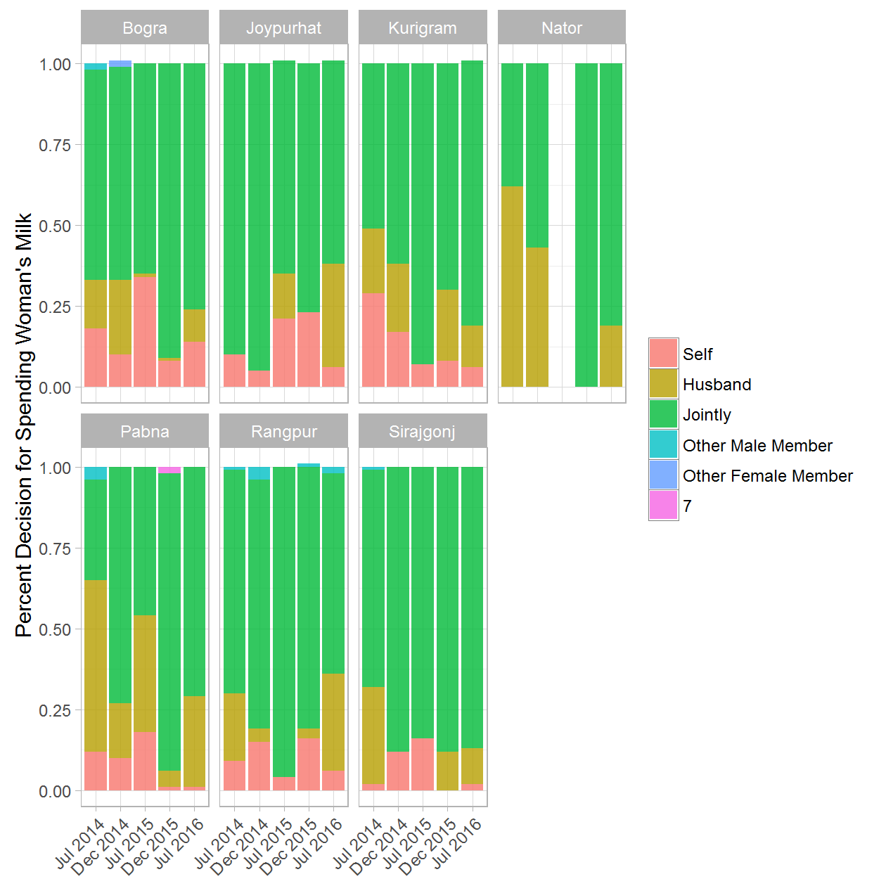

### WOMEN OWNERSHIP: 4a. Permission to attend group meetings - (Treatment & Control) rounds 1 and 5

|  |  |  |  |  |
| --- | --- | --- | --- | --- |
| District | Round of Data Collection | Permission to attend group meetings | Treatment/Control Group | Percent |
| Bogra | Jul 2014 | Yes | Treatment | 0.60 |
| Bogra | Jul 2014 | Yes | Control | 1.00 |
| Bogra | Jul 2014 | No | Treatment | 0.40 |
| Bogra | Jul 2014 | No | Control | 0.00 |
| Bogra | Jul 2016 | Yes | Treatment | 0.70 |
| Bogra | Jul 2016 | Yes | Control | 0.82 |
| Bogra | Jul 2016 | No | Treatment | 0.30 |
| Bogra | Jul 2016 | No | Control | 0.18 |
| Joypurhat | Jul 2014 | Yes | Treatment | 0.47 |
| Joypurhat | Jul 2014 | Yes | Control | 0.83 |
| Joypurhat | Jul 2014 | No | Treatment | 0.53 |
| Joypurhat | Jul 2014 | No | Control | 0.17 |
| Joypurhat | Jul 2016 | Yes | Treatment | 0.91 |
| Joypurhat | Jul 2016 | Yes | Control | 0.95 |
| Joypurhat | Jul 2016 | No | Treatment | 0.09 |
| Joypurhat | Jul 2016 | No | Control | 0.05 |
| Kurigram | Jul 2014 | Yes | Treatment | 0.94 |
| Kurigram | Jul 2014 | Yes | Control | 1.00 |
| Kurigram | Jul 2014 | No | Treatment | 0.06 |
| Kurigram | Jul 2016 | Yes | Treatment | 0.94 |
| Kurigram | Jul 2016 | Yes | Control | 0.95 |
| Kurigram | Jul 2016 | No | Treatment | 0.06 |
| Kurigram | Jul 2016 | No | Control | 0.05 |
| Naogaon | Jul 2014 | Yes | Control | 0.88 |
| Naogaon | Jul 2014 | No | Control | 0.12 |
| Naogaon | Jul 2016 | Yes | Control | 1.00 |
| Nator | Jul 2014 | Yes | Treatment | 0.53 |
| Nator | Jul 2014 | No | Treatment | 0.47 |
| Nator | Jul 2014 | No | Control | 1.00 |
| Nator | Jul 2016 | Yes | Treatment | 1.00 |
| Nator | Jul 2016 | Yes | Control | 0.88 |
| Nator | Jul 2016 | No | Control | 0.12 |
| Pabna | Jul 2014 | Yes | Treatment | 0.92 |
| Pabna | Jul 2014 | Yes | Control | 0.83 |
| Pabna | Jul 2014 | No | Treatment | 0.08 |
| Pabna | Jul 2014 | No | Control | 0.17 |
| Pabna | Jul 2016 | Yes | Treatment | 0.81 |
| Pabna | Jul 2016 | Yes | Control | 0.98 |
| Pabna | Jul 2016 | No | Treatment | 0.19 |
| Pabna | Jul 2016 | No | Control | 0.02 |
| Rangpur | Jul 2014 | Yes | Treatment | 0.83 |
| Rangpur | Jul 2014 | Yes | Control | 0.69 |
| Rangpur | Jul 2014 | No | Treatment | 0.17 |
| Rangpur | Jul 2014 | No | Control | 0.31 |
| Rangpur | Jul 2016 | Yes | Treatment | 0.87 |
| Rangpur | Jul 2016 | Yes | Control | 0.63 |
| Rangpur | Jul 2016 | No | Treatment | 0.13 |
| Rangpur | Jul 2016 | No | Control | 0.37 |
| Sirajgonj | Jul 2014 | Yes | Treatment | 0.93 |
| Sirajgonj | Jul 2014 | Yes | Control | 0.68 |
| Sirajgonj | Jul 2014 | No | Treatment | 0.07 |
| Sirajgonj | Jul 2014 | No | Control | 0.32 |
| Sirajgonj | Jul 2016 | Yes | Treatment | 0.88 |
| Sirajgonj | Jul 2016 | Yes | Control | 0.94 |
| Sirajgonj | Jul 2016 | No | Treatment | 0.12 |
| Sirajgonj | Jul 2016 | No | Control | 0.06 |

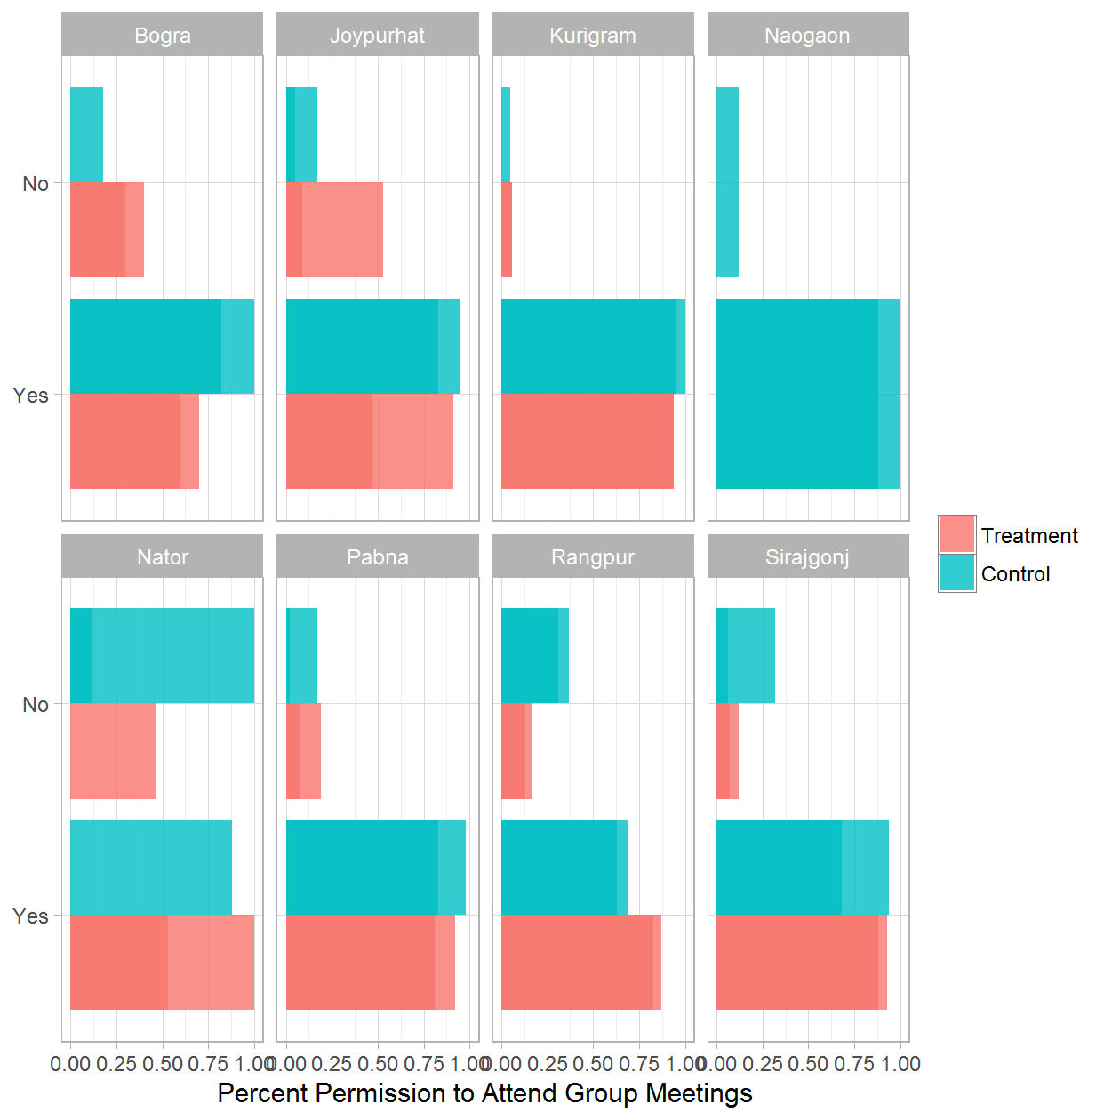

### WOMEN OWNERSHIP: 4b. Permission to attend group meetings - Treatment Only

|  |  |  |  |
| --- | --- | --- | --- |
| District | Round of Data Collection | Permission to attend group meetings | Percent |
| Bogra | Jul 2014 | Yes | 0.60 |
| Bogra | Jul 2014 | No | 0.40 |
| Bogra | Dec 2014 | Yes | 0.55 |
| Bogra | Dec 2014 | No | 0.45 |
| Bogra | Jul 2015 | Yes | 0.84 |
| Bogra | Jul 2015 | No | 0.16 |
| Bogra | Dec 2015 | Yes | 0.57 |
| Bogra | Dec 2015 | No | 0.43 |
| Bogra | Jul 2016 | Yes | 0.70 |
| Bogra | Jul 2016 | No | 0.30 |
| Joypurhat | Jul 2014 | Yes | 0.47 |
| Joypurhat | Jul 2014 | No | 0.53 |
| Joypurhat | Dec 2014 | Yes | 0.69 |
| Joypurhat | Dec 2014 | No | 0.31 |
| Joypurhat | Jul 2015 | No | 1.00 |
| Joypurhat | Dec 2015 | Yes | 0.91 |
| Joypurhat | Dec 2015 | No | 0.09 |
| Joypurhat | Jul 2016 | Yes | 0.91 |
| Joypurhat | Jul 2016 | No | 0.09 |
| Kurigram | Jul 2014 | Yes | 0.94 |
| Kurigram | Jul 2014 | No | 0.06 |
| Kurigram | Dec 2014 | Yes | 0.55 |
| Kurigram | Dec 2014 | No | 0.45 |
| Kurigram | Jul 2015 | Yes | 0.93 |
| Kurigram | Jul 2015 | No | 0.07 |
| Kurigram | Dec 2015 | Yes | 0.92 |
| Kurigram | Dec 2015 | No | 0.08 |
| Kurigram | Jul 2016 | Yes | 0.94 |
| Kurigram | Jul 2016 | No | 0.06 |
| Nator | Jul 2014 | Yes | 0.53 |
| Nator | Jul 2014 | No | 0.47 |
| Nator | Dec 2014 | Yes | 0.98 |
| Nator | Dec 2014 | No | 0.02 |
| Nator | Dec 2015 | Yes | 1.00 |
| Nator | Jul 2016 | Yes | 1.00 |
| Pabna | Jul 2014 | Yes | 0.92 |
| Pabna | Jul 2014 | No | 0.08 |
| Pabna | Dec 2014 | Yes | 0.94 |
| Pabna | Dec 2014 | No | 0.06 |
| Pabna | Jul 2015 | Yes | 0.98 |
| Pabna | Jul 2015 | No | 0.02 |
| Pabna | Dec 2015 | Yes | 0.64 |
| Pabna | Dec 2015 | No | 0.36 |
| Pabna | Jul 2016 | Yes | 0.81 |
| Pabna | Jul 2016 | No | 0.19 |
| Rangpur | Jul 2014 | Yes | 0.83 |
| Rangpur | Jul 2014 | No | 0.17 |
| Rangpur | Dec 2014 | Yes | 0.90 |
| Rangpur | Dec 2014 | No | 0.10 |
| Rangpur | Jul 2015 | Yes | 0.98 |
| Rangpur | Jul 2015 | No | 0.02 |
| Rangpur | Dec 2015 | Yes | 0.94 |
| Rangpur | Dec 2015 | No | 0.06 |
| Rangpur | Jul 2016 | Yes | 0.87 |
| Rangpur | Jul 2016 | No | 0.13 |
| Sirajgonj | Jul 2014 | Yes | 0.93 |
| Sirajgonj | Jul 2014 | No | 0.07 |
| Sirajgonj | Dec 2014 | Yes | 0.98 |
| Sirajgonj | Dec 2014 | No | 0.02 |
| Sirajgonj | Jul 2015 | Yes | 0.97 |
| Sirajgonj | Jul 2015 | No | 0.03 |
| Sirajgonj | Dec 2015 | Yes | 0.71 |
| Sirajgonj | Dec 2015 | No | 0.29 |
| Sirajgonj | Jul 2016 | Yes | 0.88 |
| Sirajgonj | Jul 2016 | No | 0.12 |

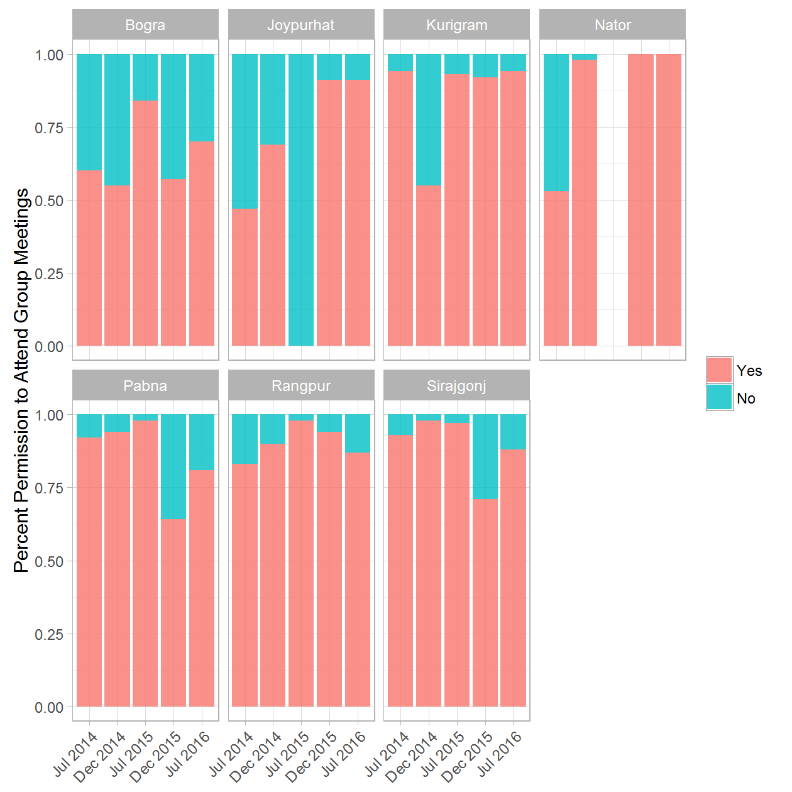

### WOMEN OWNERSHIP: 5a. Permission to attend group meetings by Cow Ownership - (Treatment & Control) rounds 1 and 5

|  |  |  |  |  |  |
| --- | --- | --- | --- | --- | --- |
| District | Round of Data Collection | Permission to attend group meetings | Cattle Ownnership | Treatment/Control Group | Percent |
| Bogra | Jul 2014 | Yes | Yes | Treatment | 0.09 |
| Bogra | Jul 2014 | No | Yes | Treatment | 0.91 |
| Bogra | Jul 2014 | Yes | Yes | Control | 0.12 |
| Bogra | Jul 2014 | No | Yes | Control | 0.88 |
| Bogra | Jul 2014 | Yes | No | Treatment | 0.19 |
| Bogra | Jul 2014 | No | No | Treatment | 0.81 |
| Bogra | Jul 2014 | No | No | Control | 1.00 |
| Bogra | Jul 2016 | Yes | Yes | Treatment | 0.45 |
| Bogra | Jul 2016 | No | Yes | Treatment | 0.55 |
| Bogra | Jul 2016 | Yes | Yes | Control | 0.26 |
| Bogra | Jul 2016 | No | Yes | Control | 0.74 |
| Bogra | Jul 2016 | Yes | No | Treatment | 0.20 |
| Bogra | Jul 2016 | No | No | Treatment | 0.80 |
| Bogra | Jul 2016 | Yes | No | Control | 0.41 |
| Bogra | Jul 2016 | No | No | Control | 0.59 |
| Joypurhat | Jul 2014 | Yes | Yes | Treatment | 0.12 |
| Joypurhat | Jul 2014 | No | Yes | Treatment | 0.88 |
| Joypurhat | Jul 2014 | Yes | Yes | Control | 0.12 |
| Joypurhat | Jul 2014 | No | Yes | Control | 0.88 |
| Joypurhat | Jul 2014 | Yes | No | Treatment | 0.28 |
| Joypurhat | Jul 2014 | No | No | Treatment | 0.72 |
| Joypurhat | Jul 2014 | Yes | No | Control | 0.19 |
| Joypurhat | Jul 2014 | No | No | Control | 0.81 |
| Joypurhat | Jul 2016 | Yes | Yes | Treatment | 0.01 |
| Joypurhat | Jul 2016 | No | Yes | Treatment | 0.99 |
| Joypurhat | Jul 2016 | Yes | Yes | Control | 0.29 |
| Joypurhat | Jul 2016 | No | Yes | Control | 0.71 |
| Joypurhat | Jul 2016 | Yes | No | Treatment | 0.31 |
| Joypurhat | Jul 2016 | No | No | Treatment | 0.69 |
| Joypurhat | Jul 2016 | Yes | No | Control | 0.38 |
| Joypurhat | Jul 2016 | No | No | Control | 0.62 |
| Kurigram | Jul 2014 | Yes | Yes | Treatment | 0.49 |
| Kurigram | Jul 2014 | No | Yes | Treatment | 0.51 |
| Kurigram | Jul 2014 | Yes | Yes | Control | 0.17 |
| Kurigram | Jul 2014 | No | Yes | Control | 0.83 |
| Kurigram | Jul 2014 | Yes | No | Treatment | 1.00 |
| Kurigram | Jul 2016 | No | Yes | Treatment | 1.00 |
| Kurigram | Jul 2016 | Yes | Yes | Control | 0.15 |
| Kurigram | Jul 2016 | No | Yes | Control | 0.85 |
| Kurigram | Jul 2016 | Yes | No | Treatment | 1.00 |
| Kurigram | Jul 2016 | Yes | No | Control | 1.00 |
| Naogaon | Jul 2014 | Yes | Yes | Control | 0.46 |
| Naogaon | Jul 2014 | No | Yes | Control | 0.54 |
| Naogaon | Jul 2014 | Yes | No | Control | 0.64 |
| Naogaon | Jul 2014 | No | No | Control | 0.36 |
| Naogaon | Jul 2016 | Yes | Yes | Control | 0.21 |
| Naogaon | Jul 2016 | No | Yes | Control | 0.79 |
| Nator | Jul 2014 | No | Yes | Treatment | 1.00 |
| Nator | Jul 2014 | Yes | No | Treatment | 0.49 |
| Nator | Jul 2014 | No | No | Treatment | 0.51 |
| Nator | Jul 2014 | Yes | No | Control | 0.75 |
| Nator | Jul 2014 | No | No | Control | 0.25 |
| Nator | Jul 2016 | No | Yes | Treatment | 1.00 |
| Nator | Jul 2016 | Yes | Yes | Control | 0.86 |
| Nator | Jul 2016 | No | Yes | Control | 0.14 |
| Nator | Jul 2016 | Yes | No | Control | 1.00 |
| Pabna | Jul 2014 | Yes | Yes | Treatment | 0.04 |
| Pabna | Jul 2014 | No | Yes | Treatment | 0.96 |
| Pabna | Jul 2014 | Yes | Yes | Control | 0.13 |
| Pabna | Jul 2014 | No | Yes | Control | 0.87 |
| Pabna | Jul 2014 | Yes | No | Treatment | 0.41 |
| Pabna | Jul 2014 | No | No | Treatment | 0.59 |
| Pabna | Jul 2014 | No | No | Control | 1.00 |
| Pabna | Jul 2016 | Yes | Yes | Treatment | 0.45 |
| Pabna | Jul 2016 | No | Yes | Treatment | 0.55 |
| Pabna | Jul 2016 | Yes | Yes | Control | 0.15 |
| Pabna | Jul 2016 | No | Yes | Control | 0.85 |
| Pabna | Jul 2016 | Yes | No | Treatment | 0.29 |
| Pabna | Jul 2016 | No | No | Treatment | 0.71 |
| Pabna | Jul 2016 | Yes | No | Control | 0.80 |
| Pabna | Jul 2016 | No | No | Control | 0.20 |
| Rangpur | Jul 2014 | Yes | Yes | Treatment | 0.12 |
| Rangpur | Jul 2014 | No | Yes | Treatment | 0.88 |
| Rangpur | Jul 2014 | Yes | Yes | Control | 0.15 |
| Rangpur | Jul 2014 | No | Yes | Control | 0.85 |
| Rangpur | Jul 2014 | Yes | No | Treatment | 0.26 |
| Rangpur | Jul 2014 | No | No | Treatment | 0.74 |
| Rangpur | Jul 2014 | Yes | No | Control | 0.25 |
| Rangpur | Jul 2014 | No | No | Control | 0.75 |
| Rangpur | Jul 2016 | Yes | Yes | Treatment | 0.20 |
| Rangpur | Jul 2016 | No | Yes | Treatment | 0.80 |
| Rangpur | Jul 2016 | Yes | Yes | Control | 0.02 |
| Rangpur | Jul 2016 | No | Yes | Control | 0.98 |
| Rangpur | Jul 2016 | Yes | No | Treatment | 0.35 |
| Rangpur | Jul 2016 | No | No | Treatment | 0.65 |
| Rangpur | Jul 2016 | Yes | No | Control | 0.19 |
| Rangpur | Jul 2016 | No | No | Control | 0.81 |
| Sirajgonj | Jul 2014 | Yes | Yes | Treatment | 0.02 |
| Sirajgonj | Jul 2014 | No | Yes | Treatment | 0.98 |
| Sirajgonj | Jul 2014 | Yes | Yes | Control | 0.05 |
| Sirajgonj | Jul 2014 | No | Yes | Control | 0.95 |
| Sirajgonj | Jul 2014 | No | No | Treatment | 1.00 |
| Sirajgonj | Jul 2014 | Yes | No | Control | 0.06 |
| Sirajgonj | Jul 2014 | No | No | Control | 0.94 |
| Sirajgonj | Jul 2016 | Yes | Yes | Treatment | 0.11 |
| Sirajgonj | Jul 2016 | No | Yes | Treatment | 0.89 |
| Sirajgonj | Jul 2016 | Yes | Yes | Control | 0.14 |
| Sirajgonj | Jul 2016 | No | Yes | Control | 0.86 |
| Sirajgonj | Jul 2016 | Yes | No | Treatment | 0.34 |
| Sirajgonj | Jul 2016 | No | No | Treatment | 0.66 |
| Sirajgonj | Jul 2016 | Yes | No | Control | 0.17 |
| Sirajgonj | Jul 2016 | No | No | Control | 0.83 |

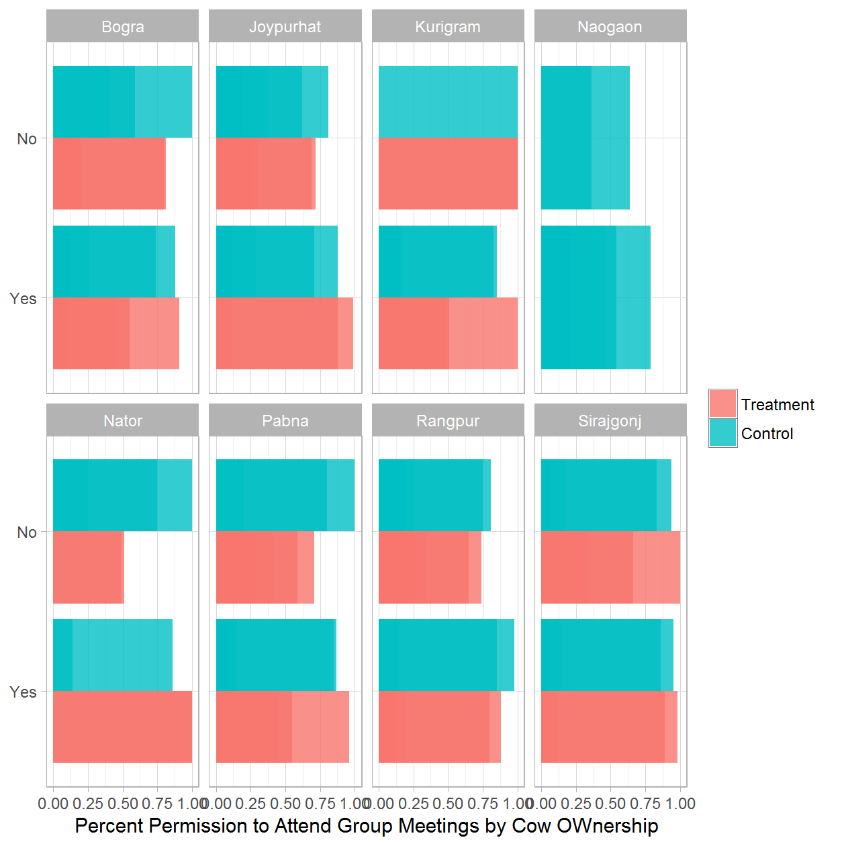

### WOMEN OWNERSHIP: 5b. Permission to attend group meetings by Cow Ownership - Treatment Only

|  |  |  |  |  |
| --- | --- | --- | --- | --- |
| District | Round of Data Collection | Permission to attend group meetings | Cattle Ownnership | Percent |
| Bogra | Jul 2014 | Yes | Yes | 0.09 |
| Bogra | Jul 2014 | No | Yes | 0.91 |
| Bogra | Jul 2014 | Yes | No | 0.19 |
| Bogra | Jul 2014 | No | No | 0.81 |
| Bogra | Dec 2014 | Yes | Yes | 0.26 |
| Bogra | Dec 2014 | No | Yes | 0.74 |
| Bogra | Dec 2014 | Yes | No | 0.26 |
| Bogra | Dec 2014 | No | No | 0.74 |
| Bogra | Jul 2015 | Yes | Yes | 0.26 |
| Bogra | Jul 2015 | No | Yes | 0.74 |
| Bogra | Jul 2015 | Yes | No | 0.21 |
| Bogra | Jul 2015 | No | No | 0.79 |
| Bogra | Dec 2015 | Yes | Yes | 0.43 |
| Bogra | Dec 2015 | No | Yes | 0.57 |
| Bogra | Dec 2015 | Yes | No | 0.26 |
| Bogra | Dec 2015 | No | No | 0.74 |
| Bogra | Jul 2016 | Yes | Yes | 0.45 |
| Bogra | Jul 2016 | No | Yes | 0.55 |
| Bogra | Jul 2016 | Yes | No | 0.20 |
| Bogra | Jul 2016 | No | No | 0.80 |
| Joypurhat | Jul 2014 | Yes | Yes | 0.12 |
| Joypurhat | Jul 2014 | No | Yes | 0.88 |
| Joypurhat | Jul 2014 | Yes | No | 0.28 |
| Joypurhat | Jul 2014 | No | No | 0.72 |
| Joypurhat | Dec 2014 | Yes | Yes | 0.49 |
| Joypurhat | Dec 2014 | No | Yes | 0.51 |
| Joypurhat | Dec 2014 | No | No | 1.00 |
| Joypurhat | Jul 2015 | Yes | No | 0.11 |
| Joypurhat | Jul 2015 | No | No | 0.89 |
| Joypurhat | Dec 2015 | No | Yes | 1.00 |
| Joypurhat | Dec 2015 | Yes | No | 0.17 |
| Joypurhat | Dec 2015 | No | No | 0.83 |
| Joypurhat | Jul 2016 | Yes | Yes | 0.01 |
| Joypurhat | Jul 2016 | No | Yes | 0.99 |
| Joypurhat | Jul 2016 | Yes | No | 0.31 |
| Joypurhat | Jul 2016 | No | No | 0.69 |
| Kurigram | Jul 2014 | Yes | Yes | 0.49 |
| Kurigram | Jul 2014 | No | Yes | 0.51 |
| Kurigram | Jul 2014 | Yes | No | 1.00 |
| Kurigram | Dec 2014 | Yes | Yes | 0.12 |
| Kurigram | Dec 2014 | No | Yes | 0.88 |
| Kurigram | Dec 2014 | Yes | No | 0.51 |
| Kurigram | Dec 2014 | No | No | 0.49 |
| Kurigram | Jul 2015 | Yes | Yes | 0.20 |
| Kurigram | Jul 2015 | No | Yes | 0.80 |
| Kurigram | Jul 2015 | Yes | No | 1.00 |
| Kurigram | Dec 2015 | No | Yes | 1.00 |
| Kurigram | Dec 2015 | Yes | No | 1.00 |
| Kurigram | Jul 2016 | No | Yes | 1.00 |
| Kurigram | Jul 2016 | Yes | No | 1.00 |
| Nator | Jul 2014 | No | Yes | 1.00 |
| Nator | Jul 2014 | Yes | No | 0.49 |
| Nator | Jul 2014 | No | No | 0.51 |
| Nator | Dec 2014 | No | Yes | 1.00 |
| Nator | Dec 2014 | Yes | No | 1.00 |
| Nator | Dec 2015 | Yes | Yes | 0.29 |
| Nator | Dec 2015 | No | Yes | 0.71 |
| Nator | Jul 2016 | No | Yes | 1.00 |
| Pabna | Jul 2014 | Yes | Yes | 0.04 |
| Pabna | Jul 2014 | No | Yes | 0.96 |
| Pabna | Jul 2014 | Yes | No | 0.41 |
| Pabna | Jul 2014 | No | No | 0.59 |
| Pabna | Dec 2014 | No | Yes | 1.00 |
| Pabna | Dec 2014 | Yes | No | 0.31 |
| Pabna | Dec 2014 | No | No | 0.69 |
| Pabna | Jul 2015 | Yes | Yes | 0.03 |
| Pabna | Jul 2015 | No | Yes | 0.97 |
| Pabna | Jul 2015 | No | No | 1.00 |
| Pabna | Dec 2015 | Yes | Yes | 0.01 |
| Pabna | Dec 2015 | No | Yes | 0.99 |
| Pabna | Dec 2015 | Yes | No | 0.02 |
| Pabna | Dec 2015 | No | No | 0.98 |
| Pabna | Jul 2016 | Yes | Yes | 0.45 |
| Pabna | Jul 2016 | No | Yes | 0.55 |
| Pabna | Jul 2016 | Yes | No | 0.29 |
| Pabna | Jul 2016 | No | No | 0.71 |
| Rangpur | Jul 2014 | Yes | Yes | 0.12 |
| Rangpur | Jul 2014 | No | Yes | 0.88 |
| Rangpur | Jul 2014 | Yes | No | 0.26 |
| Rangpur | Jul 2014 | No | No | 0.74 |
| Rangpur | Dec 2014 | Yes | Yes | 0.09 |
| Rangpur | Dec 2014 | No | Yes | 0.91 |
| Rangpur | Dec 2014 | Yes | No | 0.21 |
| Rangpur | Dec 2014 | No | No | 0.79 |
| Rangpur | Jul 2015 | Yes | Yes | 0.03 |
| Rangpur | Jul 2015 | No | Yes | 0.97 |
| Rangpur | Jul 2015 | Yes | No | 1.00 |
| Rangpur | Dec 2015 | Yes | Yes | 0.06 |
| Rangpur | Dec 2015 | No | Yes | 0.94 |
| Rangpur | Dec 2015 | Yes | No | 0.65 |
| Rangpur | Dec 2015 | No | No | 0.35 |
| Rangpur | Jul 2016 | Yes | Yes | 0.20 |
| Rangpur | Jul 2016 | No | Yes | 0.80 |
| Rangpur | Jul 2016 | Yes | No | 0.35 |
| Rangpur | Jul 2016 | No | No | 0.65 |
| Sirajgonj | Jul 2014 | Yes | Yes | 0.02 |
| Sirajgonj | Jul 2014 | No | Yes | 0.98 |
| Sirajgonj | Jul 2014 | No | No | 1.00 |
| Sirajgonj | Dec 2014 | Yes | Yes | 0.03 |
| Sirajgonj | Dec 2014 | No | Yes | 0.97 |
| Sirajgonj | Dec 2014 | Yes | No | 0.40 |
| Sirajgonj | Dec 2014 | No | No | 0.60 |
| Sirajgonj | Jul 2015 | Yes | Yes | 0.11 |
| Sirajgonj | Jul 2015 | No | Yes | 0.89 |
| Sirajgonj | Jul 2015 | Yes | No | 0.43 |
| Sirajgonj | Jul 2015 | No | No | 0.57 |
| Sirajgonj | Dec 2015 | Yes | Yes | 0.12 |
| Sirajgonj | Dec 2015 | No | Yes | 0.88 |
| Sirajgonj | Dec 2015 | Yes | No | 0.13 |
| Sirajgonj | Dec 2015 | No | No | 0.87 |
| Sirajgonj | Jul 2016 | Yes | Yes | 0.11 |
| Sirajgonj | Jul 2016 | No | Yes | 0.89 |
| Sirajgonj | Jul 2016 | Yes | No | 0.34 |
| Sirajgonj | Jul 2016 | No | No | 0.66 |

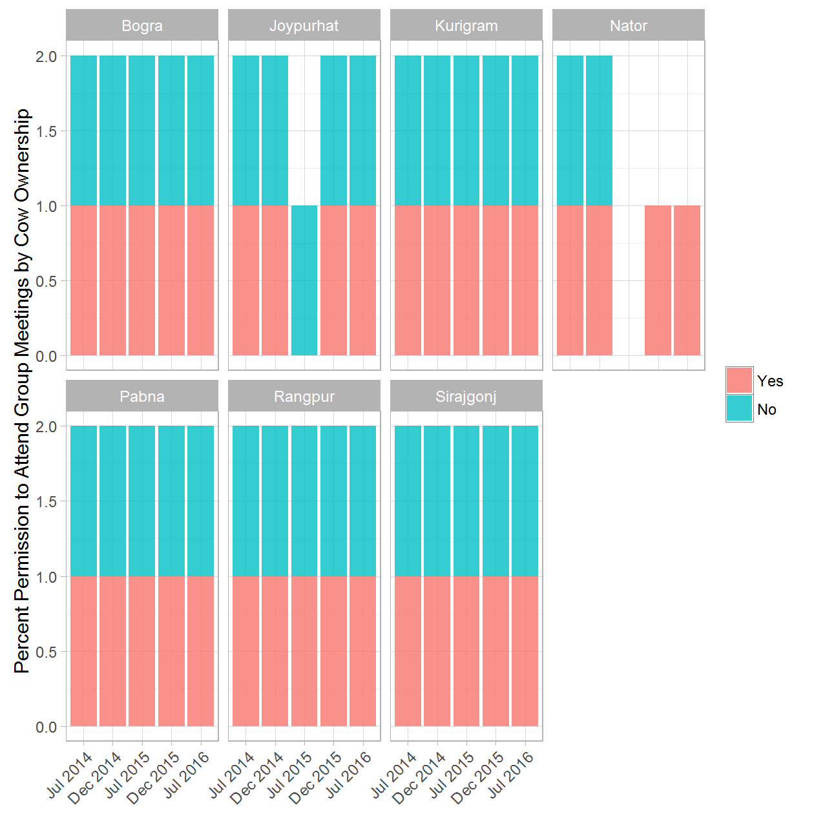

### WOMEN OWNERSHIP: 6a. Permission to attend group meetings at a distance - (Treatment & Control) rounds 1 and 5

|  |  |  |  |  |
| --- | --- | --- | --- | --- |
| District | Round of Data Collection | Permission to attend group meetings at a distance | Treatment/Control Group | Percent |
| Bogra | Jul 2014 | Yes | Treatment | 0.96 |
| Bogra | Jul 2014 | Yes | Control | 1.00 |
| Bogra | Jul 2014 | No | Treatment | 0.04 |
| Bogra | Jul 2016 | Yes | Treatment | 0.76 |
| Bogra | Jul 2016 | Yes | Control | 0.93 |
| Bogra | Jul 2016 | No | Treatment | 0.24 |
| Bogra | Jul 2016 | No | Control | 0.07 |
| Joypurhat | Jul 2014 | Yes | Treatment | 0.94 |
| Joypurhat | Jul 2014 | Yes | Control | 0.96 |
| Joypurhat | Jul 2014 | No | Treatment | 0.06 |
| Joypurhat | Jul 2014 | No | Control | 0.04 |
| Joypurhat | Jul 2016 | Yes | Treatment | 0.93 |
| Joypurhat | Jul 2016 | Yes | Control | 0.95 |
| Joypurhat | Jul 2016 | No | Treatment | 0.07 |
| Joypurhat | Jul 2016 | No | Control | 0.05 |
| Kurigram | Jul 2014 | Yes | Treatment | 1.00 |
| Kurigram | Jul 2014 | Yes | Control | 0.98 |
| Kurigram | Jul 2014 | No | Control | 0.02 |
| Kurigram | Jul 2016 | Yes | Treatment | 0.94 |
| Kurigram | Jul 2016 | Yes | Control | 0.95 |
| Kurigram | Jul 2016 | No | Treatment | 0.06 |
| Kurigram | Jul 2016 | No | Control | 0.05 |
| Naogaon | Jul 2014 | Yes | Control | 0.88 |
| Naogaon | Jul 2014 | No | Control | 0.12 |
| Naogaon | Jul 2016 | Yes | Control | 1.00 |
| Nator | Jul 2014 | Yes | Treatment | 0.77 |
| Nator | Jul 2014 | No | Treatment | 0.23 |
| Nator | Jul 2014 | No | Control | 1.00 |
| Nator | Jul 2016 | Yes | Treatment | 1.00 |
| Nator | Jul 2016 | Yes | Control | 0.88 |
| Nator | Jul 2016 | No | Control | 0.12 |
| Pabna | Jul 2014 | Yes | Treatment | 0.97 |
| Pabna | Jul 2014 | Yes | Control | 0.89 |
| Pabna | Jul 2014 | No | Treatment | 0.03 |
| Pabna | Jul 2014 | No | Control | 0.11 |
| Pabna | Jul 2016 | Yes | Treatment | 0.97 |
| Pabna | Jul 2016 | Yes | Control | 0.98 |
| Pabna | Jul 2016 | No | Treatment | 0.03 |
| Pabna | Jul 2016 | No | Control | 0.02 |
| Rangpur | Jul 2014 | Yes | Treatment | 0.97 |
| Rangpur | Jul 2014 | Yes | Control | 0.94 |
| Rangpur | Jul 2014 | No | Treatment | 0.03 |
| Rangpur | Jul 2014 | No | Control | 0.06 |
| Rangpur | Jul 2016 | Yes | Treatment | 0.95 |
| Rangpur | Jul 2016 | Yes | Control | 0.89 |
| Rangpur | Jul 2016 | No | Treatment | 0.05 |
| Rangpur | Jul 2016 | No | Control | 0.11 |
| Sirajgonj | Jul 2014 | Yes | Treatment | 0.96 |
| Sirajgonj | Jul 2014 | Yes | Control | 0.71 |
| Sirajgonj | Jul 2014 | No | Treatment | 0.04 |
| Sirajgonj | Jul 2014 | No | Control | 0.29 |
| Sirajgonj | Jul 2016 | Yes | Treatment | 0.95 |
| Sirajgonj | Jul 2016 | Yes | Control | 0.94 |
| Sirajgonj | Jul 2016 | No | Treatment | 0.05 |
| Sirajgonj | Jul 2016 | No | Control | 0.06 |

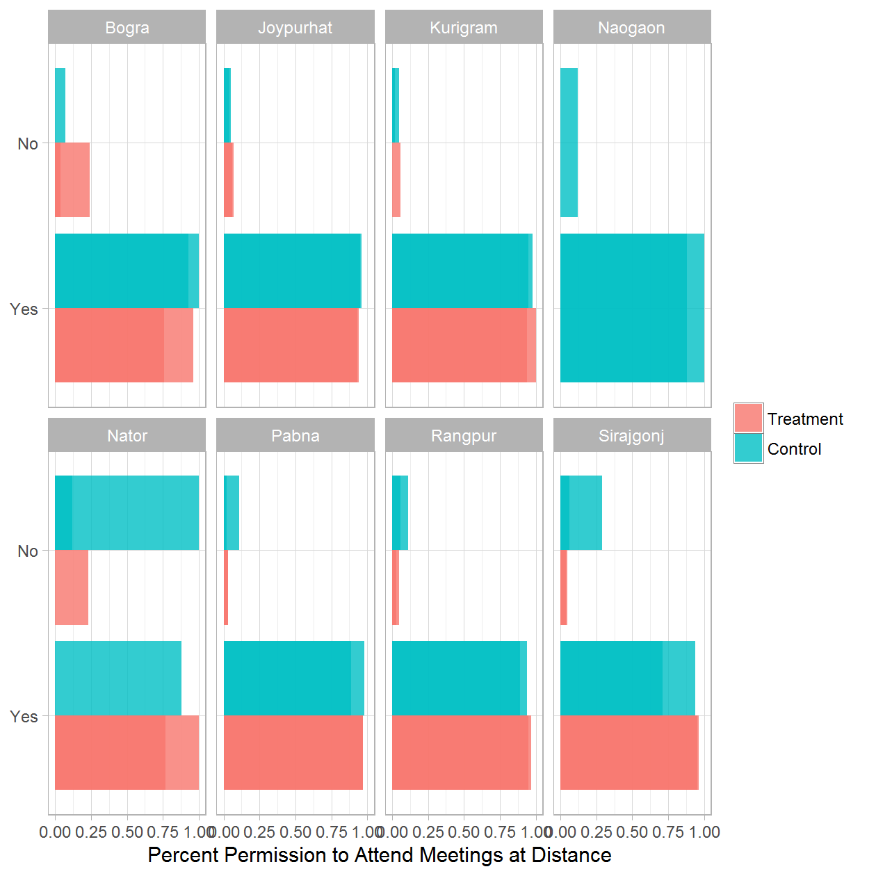

### WOMEN OWNERSHIP: 6b. Permission to attend group meetings at a distance - Treatment Only

|  |  |  |  |
| --- | --- | --- | --- |
| District | Round of Data Collection | Permission to attend group meetings at a distance | Percent |
| Bogra | Jul 2014 | Yes | 0.96 |
| Bogra | Jul 2014 | No | 0.04 |
| Bogra | Dec 2014 | Yes | 0.91 |
| Bogra | Dec 2014 | No | 0.09 |
| Bogra | Jul 2015 | Yes | 0.94 |
| Bogra | Jul 2015 | No | 0.06 |
| Bogra | Dec 2015 | Yes | 0.96 |
| Bogra | Dec 2015 | No | 0.04 |
| Bogra | Jul 2016 | Yes | 0.76 |
| Bogra | Jul 2016 | No | 0.24 |
| Joypurhat | Jul 2014 | Yes | 0.94 |
| Joypurhat | Jul 2014 | No | 0.06 |
| Joypurhat | Dec 2014 | Yes | 0.98 |
| Joypurhat | Dec 2014 | No | 0.02 |
| Joypurhat | Jul 2015 | Yes | 1.00 |
| Joypurhat | Dec 2015 | Yes | 0.91 |
| Joypurhat | Dec 2015 | No | 0.09 |
| Joypurhat | Jul 2016 | Yes | 0.93 |
| Joypurhat | Jul 2016 | No | 0.07 |
| Kurigram | Jul 2014 | Yes | 1.00 |
| Kurigram | Dec 2014 | Yes | 0.89 |
| Kurigram | Dec 2014 | No | 0.11 |
| Kurigram | Jul 2015 | Yes | 0.93 |
| Kurigram | Jul 2015 | No | 0.07 |
| Kurigram | Dec 2015 | Yes | 0.92 |
| Kurigram | Dec 2015 | No | 0.08 |
| Kurigram | Jul 2016 | Yes | 0.94 |
| Kurigram | Jul 2016 | No | 0.06 |
| Nator | Jul 2014 | Yes | 0.77 |
| Nator | Jul 2014 | No | 0.23 |
| Nator | Dec 2014 | Yes | 0.94 |
| Nator | Dec 2014 | No | 0.06 |
| Nator | Dec 2015 | Yes | 1.00 |
| Nator | Jul 2016 | Yes | 1.00 |
| Pabna | Jul 2014 | Yes | 0.97 |
| Pabna | Jul 2014 | No | 0.03 |
| Pabna | Dec 2014 | Yes | 0.97 |
| Pabna | Dec 2014 | No | 0.03 |
| Pabna | Jul 2015 | Yes | 0.98 |
| Pabna | Jul 2015 | No | 0.02 |
| Pabna | Dec 2015 | Yes | 0.93 |
| Pabna | Dec 2015 | No | 0.07 |
| Pabna | Jul 2016 | Yes | 0.97 |
| Pabna | Jul 2016 | No | 0.03 |
| Rangpur | Jul 2014 | Yes | 0.97 |
| Rangpur | Jul 2014 | No | 0.03 |
| Rangpur | Dec 2014 | Yes | 0.95 |
| Rangpur | Dec 2014 | No | 0.05 |
| Rangpur | Jul 2015 | Yes | 0.98 |
| Rangpur | Jul 2015 | No | 0.02 |
| Rangpur | Dec 2015 | Yes | 0.96 |
| Rangpur | Dec 2015 | No | 0.04 |
| Rangpur | Jul 2016 | Yes | 0.95 |
| Rangpur | Jul 2016 | No | 0.05 |
| Sirajgonj | Jul 2014 | Yes | 0.96 |
| Sirajgonj | Jul 2014 | No | 0.04 |
| Sirajgonj | Dec 2014 | Yes | 1.00 |
| Sirajgonj | Dec 2014 | No | 0.00 |
| Sirajgonj | Jul 2015 | Yes | 0.98 |
| Sirajgonj | Jul 2015 | No | 0.02 |
| Sirajgonj | Dec 2015 | Yes | 0.99 |
| Sirajgonj | Dec 2015 | No | 0.01 |
| Sirajgonj | Jul 2016 | Yes | 0.95 |
| Sirajgonj | Jul 2016 | No | 0.05 |

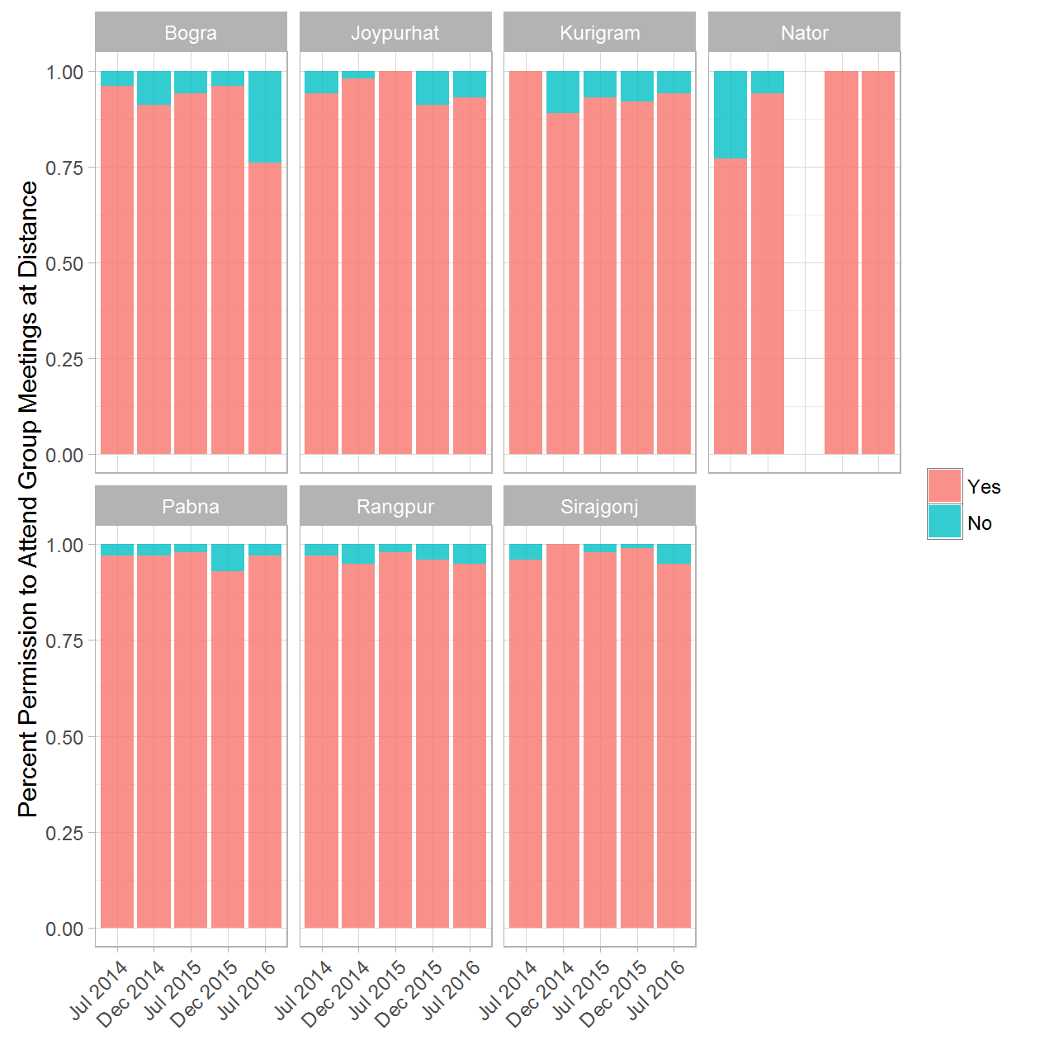

### WOMEN OWNERSHIP: 7a. Permission to attend group meetings at Distance by Cow Ownership - (Treatment & Control) rounds 1 and 5

|  |  |  |  |  |  |
| --- | --- | --- | --- | --- | --- |
| District | Round of Data Collection | Permission to attend group meetings at a distance | Cattle Ownnership | Treatment/Control Group | Percent |
| Bogra | Jul 2014 | Yes | Yes | Treatment | 0.11 |
| Bogra | Jul 2014 | No | Yes | Treatment | 0.89 |
| Bogra | Jul 2014 | Yes | Yes | Control | 0.12 |
| Bogra | Jul 2014 | No | Yes | Control | 0.88 |
| Bogra | Jul 2014 | Yes | No | Treatment | 0.74 |
| Bogra | Jul 2014 | No | No | Treatment | 0.26 |
| Bogra | Jul 2016 | Yes | Yes | Treatment | 0.43 |
| Bogra | Jul 2016 | No | Yes | Treatment | 0.57 |
| Bogra | Jul 2016 | Yes | Yes | Control | 0.31 |
| Bogra | Jul 2016 | No | Yes | Control | 0.69 |
| Bogra | Jul 2016 | Yes | No | Treatment | 0.20 |
| Bogra | Jul 2016 | No | No | Treatment | 0.80 |
| Bogra | Jul 2016 | No | No | Control | 1.00 |
| Joypurhat | Jul 2014 | Yes | Yes | Treatment | 0.16 |
| Joypurhat | Jul 2014 | No | Yes | Treatment | 0.84 |
| Joypurhat | Jul 2014 | Yes | Yes | Control | 0.12 |
| Joypurhat | Jul 2014 | No | Yes | Control | 0.88 |
| Joypurhat | Jul 2014 | Yes | No | Treatment | 1.00 |
| Joypurhat | Jul 2014 | Yes | No | Control | 0.40 |
| Joypurhat | Jul 2014 | No | No | Control | 0.60 |
| Joypurhat | Jul 2016 | Yes | Yes | Treatment | 0.03 |
| Joypurhat | Jul 2016 | No | Yes | Treatment | 0.97 |
| Joypurhat | Jul 2016 | Yes | Yes | Control | 0.29 |
| Joypurhat | Jul 2016 | No | Yes | Control | 0.71 |
| Joypurhat | Jul 2016 | Yes | No | Treatment | 0.18 |
| Joypurhat | Jul 2016 | No | No | Treatment | 0.82 |
| Joypurhat | Jul 2016 | Yes | No | Control | 0.38 |
| Joypurhat | Jul 2016 | No | No | Control | 0.62 |
| Kurigram | Jul 2014 | Yes | Yes | Treatment | 0.52 |
| Kurigram | Jul 2014 | No | Yes | Treatment | 0.48 |
| Kurigram | Jul 2014 | Yes | Yes | Control | 0.23 |
| Kurigram | Jul 2014 | No | Yes | Control | 0.77 |
| Kurigram | Jul 2014 | Yes | No | Control | 0.67 |
| Kurigram | Jul 2014 | No | No | Control | 0.33 |
| Kurigram | Jul 2016 | No | Yes | Treatment | 1.00 |
| Kurigram | Jul 2016 | Yes | Yes | Control | 0.15 |
| Kurigram | Jul 2016 | No | Yes | Control | 0.85 |
| Kurigram | Jul 2016 | Yes | No | Treatment | 1.00 |
| Kurigram | Jul 2016 | Yes | No | Control | 1.00 |
| Naogaon | Jul 2014 | Yes | Yes | Control | 0.46 |
| Naogaon | Jul 2014 | No | Yes | Control | 0.54 |
| Naogaon | Jul 2014 | Yes | No | Control | 0.64 |
| Naogaon | Jul 2014 | No | No | Control | 0.36 |
| Naogaon | Jul 2016 | Yes | Yes | Control | 0.21 |
| Naogaon | Jul 2016 | No | Yes | Control | 0.79 |
| Nator | Jul 2014 | No | Yes | Treatment | 1.00 |
| Nator | Jul 2014 | Yes | No | Treatment | 1.00 |
| Nator | Jul 2014 | Yes | No | Control | 0.75 |
| Nator | Jul 2014 | No | No | Control | 0.25 |
| Nator | Jul 2016 | No | Yes | Treatment | 1.00 |
| Nator | Jul 2016 | Yes | Yes | Control | 0.86 |
| Nator | Jul 2016 | No | Yes | Control | 0.14 |
| Nator | Jul 2016 | Yes | No | Control | 1.00 |
| Pabna | Jul 2014 | Yes | Yes | Treatment | 0.02 |
| Pabna | Jul 2014 | No | Yes | Treatment | 0.98 |
| Pabna | Jul 2014 | Yes | Yes | Control | 0.09 |
| Pabna | Jul 2014 | No | Yes | Control | 0.91 |
| Pabna | Jul 2014 | Yes | No | Treatment | 1.00 |
| Pabna | Jul 2014 | No | No | Control | 1.00 |
| Pabna | Jul 2016 | Yes | Yes | Treatment | 0.42 |
| Pabna | Jul 2016 | No | Yes | Treatment | 0.58 |
| Pabna | Jul 2016 | Yes | Yes | Control | 0.16 |
| Pabna | Jul 2016 | No | Yes | Control | 0.84 |
| Pabna | Jul 2016 | Yes | No | Treatment | 0.40 |
| Pabna | Jul 2016 | No | No | Treatment | 0.60 |
| Pabna | Jul 2016 | Yes | No | Control | 1.00 |
| Rangpur | Jul 2014 | Yes | Yes | Treatment | 0.14 |
| Rangpur | Jul 2014 | No | Yes | Treatment | 0.86 |
| Rangpur | Jul 2014 | Yes | Yes | Control | 0.14 |
| Rangpur | Jul 2014 | No | Yes | Control | 0.86 |
| Rangpur | Jul 2014 | Yes | No | Treatment | 0.24 |
| Rangpur | Jul 2014 | No | No | Treatment | 0.76 |
| Rangpur | Jul 2014 | Yes | No | Control | 0.79 |
| Rangpur | Jul 2014 | No | No | Control | 0.21 |
| Rangpur | Jul 2016 | Yes | Yes | Treatment | 0.21 |
| Rangpur | Jul 2016 | No | Yes | Treatment | 0.79 |
| Rangpur | Jul 2016 | Yes | Yes | Control | 0.02 |
| Rangpur | Jul 2016 | No | Yes | Control | 0.98 |
| Rangpur | Jul 2016 | Yes | No | Treatment | 0.50 |
| Rangpur | Jul 2016 | No | No | Treatment | 0.50 |
| Rangpur | Jul 2016 | Yes | No | Control | 0.53 |
| Rangpur | Jul 2016 | No | No | Control | 0.47 |
| Sirajgonj | Jul 2014 | Yes | Yes | Treatment | 0.02 |
| Sirajgonj | Jul 2014 | No | Yes | Treatment | 0.98 |
| Sirajgonj | Jul 2014 | Yes | Yes | Control | 0.06 |
| Sirajgonj | Jul 2014 | No | Yes | Control | 0.94 |
| Sirajgonj | Jul 2014 | No | No | Treatment | 1.00 |
| Sirajgonj | Jul 2014 | Yes | No | Control | 0.06 |
| Sirajgonj | Jul 2014 | No | No | Control | 0.94 |
| Sirajgonj | Jul 2016 | Yes | Yes | Treatment | 0.11 |
| Sirajgonj | Jul 2016 | No | Yes | Treatment | 0.89 |
| Sirajgonj | Jul 2016 | Yes | Yes | Control | 0.14 |
| Sirajgonj | Jul 2016 | No | Yes | Control | 0.86 |
| Sirajgonj | Jul 2016 | Yes | No | Treatment | 0.69 |
| Sirajgonj | Jul 2016 | No | No | Treatment | 0.31 |
| Sirajgonj | Jul 2016 | Yes | No | Control | 0.17 |
| Sirajgonj | Jul 2016 | No | No | Control | 0.83 |

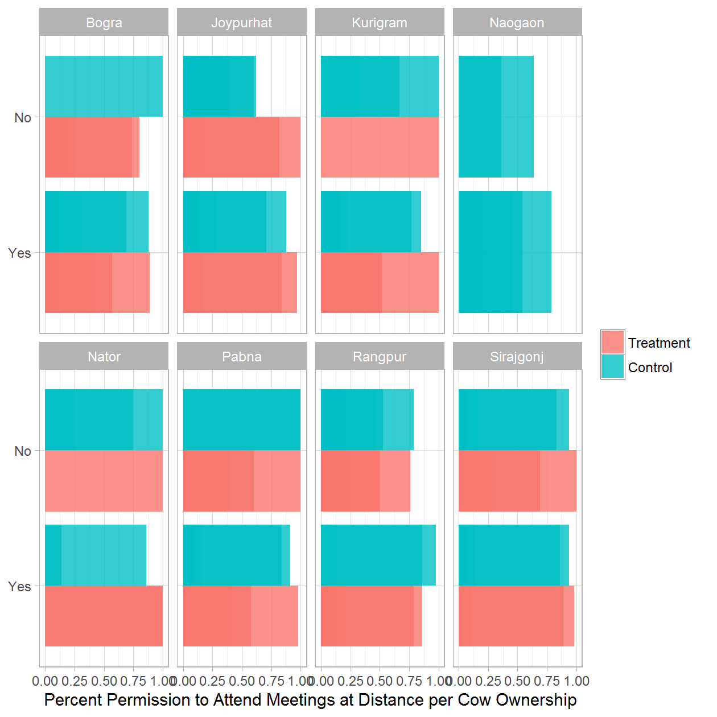

### WOMEN OWNERSHIP: 7b. Permission to attend group meetings at Distance by Cow Ownership - Treatment Only

|  |  |  |  |  |
| --- | --- | --- | --- | --- |
| District | Round of Data Collection | Permission to attend group meetings at a distance | Cattle Ownnership | Percent |
| Bogra | Jul 2014 | Yes | Yes | 0.11 |
| Bogra | Jul 2014 | No | Yes | 0.89 |
| Bogra | Jul 2014 | Yes | No | 0.74 |
| Bogra | Jul 2014 | No | No | 0.26 |
| Bogra | Dec 2014 | Yes | Yes | 0.26 |
| Bogra | Dec 2014 | No | Yes | 0.74 |
| Bogra | Dec 2014 | Yes | No | 0.26 |
| Bogra | Dec 2014 | No | No | 0.74 |
| Bogra | Jul 2015 | Yes | Yes | 0.24 |
| Bogra | Jul 2015 | No | Yes | 0.76 |
| Bogra | Jul 2015 | Yes | No | 0.50 |
| Bogra | Jul 2015 | No | No | 0.50 |
| Bogra | Dec 2015 | Yes | Yes | 0.35 |
| Bogra | Dec 2015 | No | Yes | 0.65 |
| Bogra | Dec 2015 | Yes | No | 0.61 |
| Bogra | Dec 2015 | No | No | 0.39 |
| Bogra | Jul 2016 | Yes | Yes | 0.43 |
| Bogra | Jul 2016 | No | Yes | 0.57 |
| Bogra | Jul 2016 | Yes | No | 0.20 |
| Bogra | Jul 2016 | No | No | 0.80 |
| Joypurhat | Jul 2014 | Yes | Yes | 0.16 |
| Joypurhat | Jul 2014 | No | Yes | 0.84 |
| Joypurhat | Jul 2014 | Yes | No | 1.00 |
| Joypurhat | Dec 2014 | Yes | Yes | 0.35 |
| Joypurhat | Dec 2014 | No | Yes | 0.65 |
| Joypurhat | Jul 2015 | Yes | Yes | 0.11 |
| Joypurhat | Jul 2015 | No | Yes | 0.89 |
| Joypurhat | Dec 2015 | No | Yes | 1.00 |
| Joypurhat | Dec 2015 | Yes | No | 0.17 |
| Joypurhat | Dec 2015 | No | No | 0.83 |
| Joypurhat | Jul 2016 | Yes | Yes | 0.03 |
| Joypurhat | Jul 2016 | No | Yes | 0.97 |
| Joypurhat | Jul 2016 | Yes | No | 0.18 |
| Joypurhat | Jul 2016 | No | No | 0.82 |
| Kurigram | Jul 2014 | Yes | Yes | 0.52 |
| Kurigram | Jul 2014 | No | Yes | 0.48 |
| Kurigram | Dec 2014 | Yes | Yes | 0.27 |
| Kurigram | Dec 2014 | No | Yes | 0.73 |
| Kurigram | Jul 2015 | Yes | Yes | 0.20 |
| Kurigram | Jul 2015 | No | Yes | 0.80 |
| Kurigram | Jul 2015 | Yes | No | 1.00 |
| Kurigram | Dec 2015 | No | Yes | 1.00 |
| Kurigram | Dec 2015 | Yes | No | 1.00 |
| Kurigram | Jul 2016 | No | Yes | 1.00 |
| Kurigram | Jul 2016 | Yes | No | 1.00 |
| Nator | Jul 2014 | No | Yes | 1.00 |
| Nator | Jul 2014 | Yes | No | 1.00 |
| Nator | Dec 2014 | Yes | Yes | 0.02 |
| Nator | Dec 2014 | No | Yes | 0.98 |
| Nator | Dec 2014 | No | No | 1.00 |
| Nator | Dec 2015 | Yes | Yes | 0.29 |
| Nator | Dec 2015 | No | Yes | 0.71 |
| Nator | Jul 2016 | No | Yes | 1.00 |
| Pabna | Jul 2014 | Yes | Yes | 0.02 |
| Pabna | Jul 2014 | No | Yes | 0.98 |
| Pabna | Jul 2014 | Yes | No | 1.00 |
| Pabna | Dec 2014 | Yes | Yes | 0.02 |
| Pabna | Dec 2014 | No | Yes | 0.98 |
| Pabna | Dec 2014 | No | No | 1.00 |
| Pabna | Jul 2015 | Yes | Yes | 0.03 |
| Pabna | Jul 2015 | No | Yes | 0.97 |
| Pabna | Jul 2015 | No | No | 1.00 |
| Pabna | Dec 2015 | Yes | Yes | 0.01 |
| Pabna | Dec 2015 | No | Yes | 0.99 |
| Pabna | Dec 2015 | No | No | 1.00 |
| Pabna | Jul 2016 | Yes | Yes | 0.42 |
| Pabna | Jul 2016 | No | Yes | 0.58 |
| Pabna | Jul 2016 | Yes | No | 0.40 |
| Pabna | Jul 2016 | No | No | 0.60 |
| Rangpur | Jul 2014 | Yes | Yes | 0.14 |
| Rangpur | Jul 2014 | No | Yes | 0.86 |
| Rangpur | Jul 2014 | Yes | No | 0.24 |
| Rangpur | Jul 2014 | No | No | 0.76 |
| Rangpur | Dec 2014 | Yes | Yes | 0.11 |
| Rangpur | Dec 2014 | No | Yes | 0.89 |
| Rangpur | Dec 2014 | No | No | 1.00 |
| Rangpur | Jul 2015 | Yes | Yes | 0.03 |
| Rangpur | Jul 2015 | No | Yes | 0.97 |
| Rangpur | Jul 2015 | Yes | No | 1.00 |
| Rangpur | Dec 2015 | Yes | Yes | 0.08 |
| Rangpur | Dec 2015 | No | Yes | 0.92 |
| Rangpur | Dec 2015 | Yes | No | 0.43 |
| Rangpur | Dec 2015 | No | No | 0.57 |
| Rangpur | Jul 2016 | Yes | Yes | 0.21 |
| Rangpur | Jul 2016 | No | Yes | 0.79 |
| Rangpur | Jul 2016 | Yes | No | 0.50 |
| Rangpur | Jul 2016 | No | No | 0.50 |
| Sirajgonj | Jul 2014 | Yes | Yes | 0.02 |
| Sirajgonj | Jul 2014 | No | Yes | 0.98 |
| Sirajgonj | Jul 2014 | No | No | 1.00 |
| Sirajgonj | Dec 2014 | Yes | Yes | 0.03 |
| Sirajgonj | Dec 2014 | No | Yes | 0.97 |
| Sirajgonj | Dec 2014 | No | No | 1.00 |
| Sirajgonj | Jul 2015 | Yes | Yes | 0.11 |
| Sirajgonj | Jul 2015 | No | Yes | 0.89 |
| Sirajgonj | Jul 2015 | Yes | No | 0.60 |
| Sirajgonj | Jul 2015 | No | No | 0.40 |
| Sirajgonj | Dec 2015 | Yes | Yes | 0.12 |
| Sirajgonj | Dec 2015 | No | Yes | 0.88 |
| Sirajgonj | Dec 2015 | Yes | No | 0.80 |
| Sirajgonj | Dec 2015 | No | No | 0.20 |
| Sirajgonj | Jul 2016 | Yes | Yes | 0.11 |
| Sirajgonj | Jul 2016 | No | Yes | 0.89 |
| Sirajgonj | Jul 2016 | Yes | No | 0.69 |
| Sirajgonj | Jul 2016 | No | No | 0.31 |

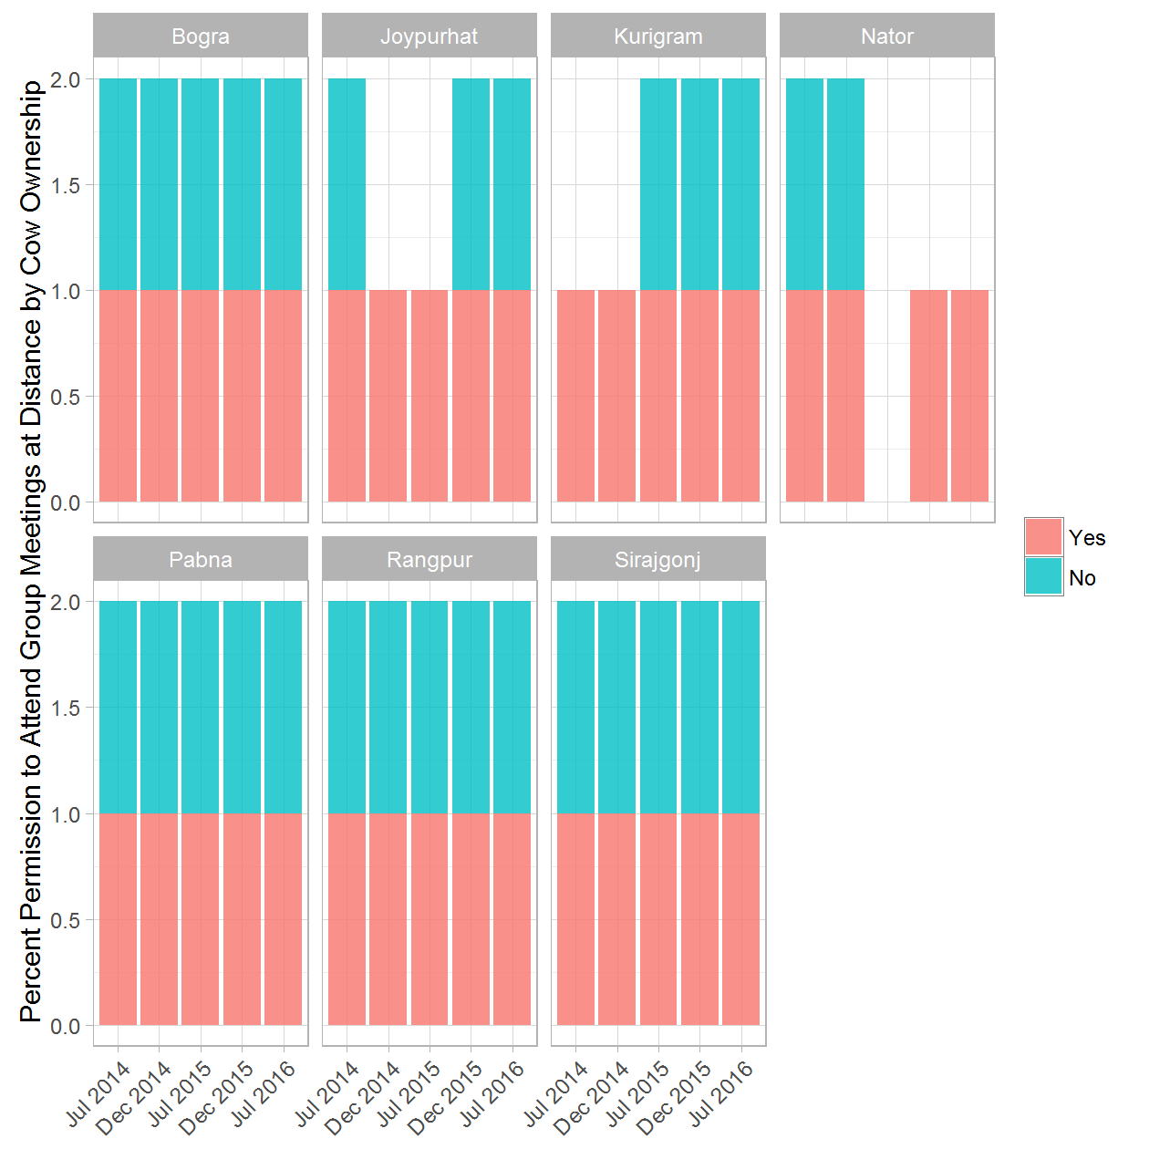

### WOMEN OWNERSHIP: 8a. Husbands' Level of Household Help - (Treatment & Control) rounds 1 and 5

|  |  |  |  |  |
| --- | --- | --- | --- | --- |
| District | Round of Data Collection | Husbands' Level of Household Help | Treatment/Control Group | Percent |
| Bogra | Jul 2014 | Yes | Treatment | 0.86 |
| Bogra | Jul 2014 | Yes | Control | 0.95 |
| Bogra | Jul 2014 | No | Treatment | 0.14 |
| Bogra | Jul 2014 | No | Control | 0.05 |
| Bogra | Jul 2016 | Yes | Treatment | 0.93 |
| Bogra | Jul 2016 | Yes | Control | 0.84 |
| Bogra | Jul 2016 | No | Treatment | 0.07 |
| Bogra | Jul 2016 | No | Control | 0.16 |
| Joypurhat | Jul 2014 | Yes | Treatment | 1.00 |
| Joypurhat | Jul 2014 | Yes | Control | 0.97 |
| Joypurhat | Jul 2014 | No | Control | 0.03 |
| Joypurhat | Jul 2016 | Yes | Treatment | 0.89 |
| Joypurhat | Jul 2016 | Yes | Control | 0.94 |
| Joypurhat | Jul 2016 | No | Treatment | 0.11 |
| Joypurhat | Jul 2016 | No | Control | 0.06 |
| Kurigram | Jul 2014 | Yes | Treatment | 0.90 |
| Kurigram | Jul 2014 | Yes | Control | 0.95 |
| Kurigram | Jul 2014 | No | Treatment | 0.10 |
| Kurigram | Jul 2014 | No | Control | 0.05 |
| Kurigram | Jul 2016 | Yes | Treatment | 0.94 |
| Kurigram | Jul 2016 | Yes | Control | 0.92 |
| Kurigram | Jul 2016 | No | Treatment | 0.06 |
| Kurigram | Jul 2016 | No | Control | 0.08 |
| Naogaon | Jul 2014 | Yes | Control | 0.91 |
| Naogaon | Jul 2014 | No | Control | 0.09 |
| Naogaon | Jul 2016 | Yes | Control | 0.80 |
| Naogaon | Jul 2016 | No | Control | 0.20 |
| Nator | Jul 2014 | Yes | Treatment | 0.71 |
| Nator | Jul 2014 | No | Treatment | 0.29 |
| Nator | Jul 2014 | No | Control | 1.00 |
| Nator | Jul 2016 | Yes | Treatment | 1.00 |
| Nator | Jul 2016 | Yes | Control | 0.25 |
| Nator | Jul 2016 | No | Control | 0.75 |
| Pabna | Jul 2014 | Yes | Treatment | 0.96 |
| Pabna | Jul 2014 | Yes | Control | 0.87 |
| Pabna | Jul 2014 | No | Treatment | 0.04 |
| Pabna | Jul 2014 | No | Control | 0.13 |
| Pabna | Jul 2016 | Yes | Treatment | 0.94 |
| Pabna | Jul 2016 | Yes | Control | 0.97 |
| Pabna | Jul 2016 | No | Treatment | 0.06 |
| Pabna | Jul 2016 | No | Control | 0.03 |
| Rangpur | Jul 2014 | Yes | Treatment | 0.78 |
| Rangpur | Jul 2014 | Yes | Control | 0.58 |
| Rangpur | Jul 2014 | No | Treatment | 0.22 |
| Rangpur | Jul 2014 | No | Control | 0.42 |
| Rangpur | Jul 2016 | Yes | Treatment | 0.87 |
| Rangpur | Jul 2016 | Yes | Control | 0.75 |
| Rangpur | Jul 2016 | No | Treatment | 0.13 |
| Rangpur | Jul 2016 | No | Control | 0.25 |
| Sirajgonj | Jul 2014 | Yes | Treatment | 0.73 |
| Sirajgonj | Jul 2014 | Yes | Control | 0.83 |
| Sirajgonj | Jul 2014 | No | Treatment | 0.27 |
| Sirajgonj | Jul 2014 | No | Control | 0.17 |
| Sirajgonj | Jul 2016 | Yes | Treatment | 0.97 |
| Sirajgonj | Jul 2016 | Yes | Control | 0.94 |
| Sirajgonj | Jul 2016 | No | Treatment | 0.03 |
| Sirajgonj | Jul 2016 | No | Control | 0.06 |

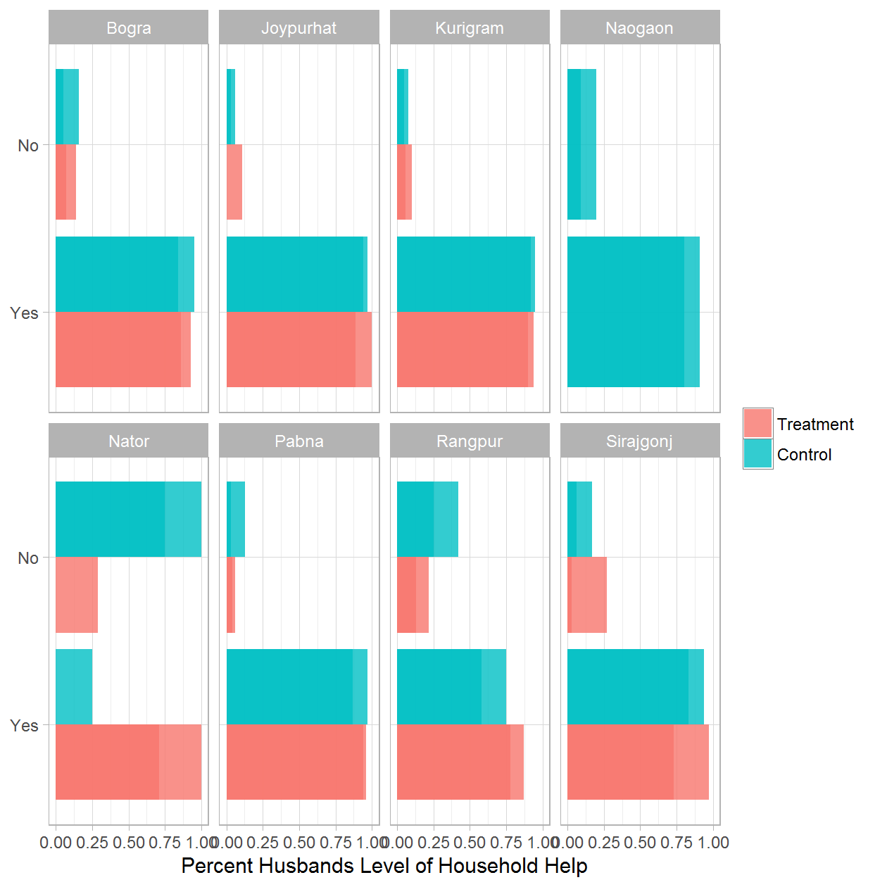

### WOMEN OWNERSHIP: 8b. Husbands' Level of Household Help - Treatment Only

|  |  |  |  |
| --- | --- | --- | --- |
| District | Round of Data Collection | Husbands' Level of Household Help | Percent |
| Bogra | Jul 2014 | Yes | 0.86 |
| Bogra | Jul 2014 | No | 0.14 |
| Bogra | Dec 2014 | Yes | 0.84 |
| Bogra | Dec 2014 | No | 0.16 |
| Bogra | Jul 2015 | Yes | 0.92 |
| Bogra | Jul 2015 | No | 0.08 |
| Bogra | Dec 2015 | Yes | 0.87 |
| Bogra | Dec 2015 | No | 0.13 |
| Bogra | Jul 2016 | Yes | 0.93 |
| Bogra | Jul 2016 | No | 0.07 |
| Joypurhat | Jul 2014 | Yes | 1.00 |
| Joypurhat | Dec 2014 | Yes | 0.77 |
| Joypurhat | Dec 2014 | No | 0.23 |
| Joypurhat | Jul 2015 | Yes | 0.98 |
| Joypurhat | Jul 2015 | No | 0.02 |
| Joypurhat | Dec 2015 | Yes | 0.84 |
| Joypurhat | Dec 2015 | No | 0.16 |
| Joypurhat | Jul 2016 | Yes | 0.89 |
| Joypurhat | Jul 2016 | No | 0.11 |
| Kurigram | Jul 2014 | Yes | 0.90 |
| Kurigram | Jul 2014 | No | 0.10 |
| Kurigram | Dec 2014 | Yes | 0.83 |
| Kurigram | Dec 2014 | No | 0.17 |
| Kurigram | Jul 2015 | Yes | 0.93 |
| Kurigram | Jul 2015 | No | 0.07 |
| Kurigram | Dec 2015 | Yes | 0.92 |
| Kurigram | Dec 2015 | No | 0.08 |
| Kurigram | Jul 2016 | Yes | 0.94 |
| Kurigram | Jul 2016 | No | 0.06 |
| Nator | Jul 2014 | Yes | 0.71 |
| Nator | Jul 2014 | No | 0.29 |
| Nator | Dec 2014 | Yes | 1.00 |
| Nator | Dec 2015 | Yes | 1.00 |
| Nator | Jul 2016 | Yes | 1.00 |
| Pabna | Jul 2014 | Yes | 0.96 |
| Pabna | Jul 2014 | No | 0.04 |
| Pabna | Dec 2014 | Yes | 0.98 |
| Pabna | Dec 2014 | No | 0.02 |
| Pabna | Jul 2015 | Yes | 0.94 |
| Pabna | Jul 2015 | No | 0.06 |
| Pabna | Dec 2015 | Yes | 0.94 |
| Pabna | Dec 2015 | No | 0.06 |
| Pabna | Jul 2016 | Yes | 0.94 |
| Pabna | Jul 2016 | No | 0.06 |
| Rangpur | Jul 2014 | Yes | 0.78 |
| Rangpur | Jul 2014 | No | 0.22 |
| Rangpur | Dec 2014 | Yes | 0.89 |
| Rangpur | Dec 2014 | No | 0.11 |
| Rangpur | Jul 2015 | Yes | 0.97 |
| Rangpur | Jul 2015 | No | 0.03 |
| Rangpur | Dec 2015 | Yes | 0.94 |
| Rangpur | Dec 2015 | No | 0.06 |
| Rangpur | Jul 2016 | Yes | 0.87 |
| Rangpur | Jul 2016 | No | 0.13 |
| Sirajgonj | Jul 2014 | Yes | 0.73 |
| Sirajgonj | Jul 2014 | No | 0.27 |
| Sirajgonj | Dec 2014 | Yes | 0.93 |
| Sirajgonj | Dec 2014 | No | 0.07 |
| Sirajgonj | Jul 2015 | Yes | 0.98 |
| Sirajgonj | Jul 2015 | No | 0.02 |
| Sirajgonj | Dec 2015 | Yes | 0.95 |
| Sirajgonj | Dec 2015 | No | 0.05 |
| Sirajgonj | Jul 2016 | Yes | 0.97 |
| Sirajgonj | Jul 2016 | No | 0.03 |

