**GUI speed Improvements**:

**View Data**:

Performance improved in get data by implementing memory efficient technique. You can see in below test cases with different queries result with code changes and without code changes. Results of Get Data graph shows time reduced in many test cases.

**Results of Get Data**:

X-axis – Total items matching all parameters  
 Y-axis – Time in Seconds

**Test case #1**:

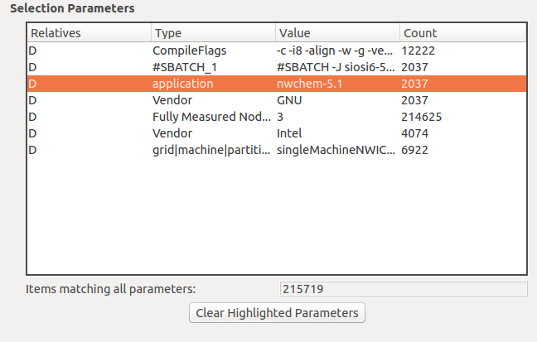

Result without code changes:

submitting query 12:51:46.224

result table populated 12:51:47.516

query completed 12:51:49.563

starting to read data 12:51:49.620

done reading data 12:51:57.674 -- **total time**: around 11 sec

Result with code changes:

submitting query 12:43:04.250

executing: INSERT INTO results_temp(saved, result_id, start_time, end_time, value, chk, units, metric, label, combined) SELECT 1, pr.id, pr.start_time, pr.end_time, pr.value, pr.chk, pr.units, riA.name, pr.label, pr.combined FROM performance_result pr, resource_item riA , performance_result_has_focus prhf, contexts_temp foci WHERE pr.id = prhf.performance_result_id AND prhf.focus_id = foci.focus_id AND prhf.focus_type = 'primary' AND riA.id = pr.metric_id

result table populated 12:43:05.551

query completed 12:43:07.721

starting to read data 12:43:07.722

end read data 12:43:10.312

done reading data 12:43:10.312 --- **total time**: around 6 sec

**Test case #2**:

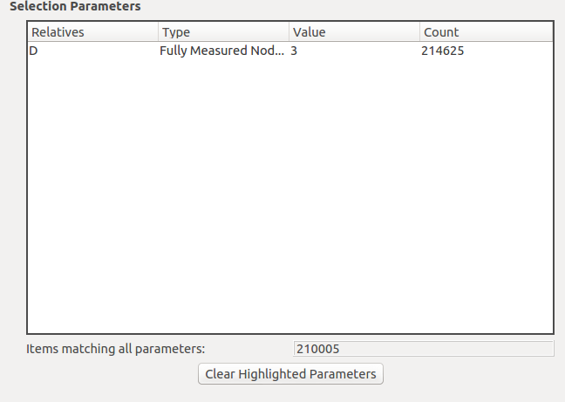

Result without code changes:

submitting query 12:53:58.879

result table populated 12:54:05.932

query completed 12:54:08.345

starting to read data 12:54:08.671

done reading data 12:54:12.035 -- **total time** around 14 sec.

Result with code changes:

submitting query 12:57:21.892

executing: INSERT INTO results_temp(saved, result_id, start_time, end_time, value, chk, units, metric, label, combined) SELECT 1, pr.id, pr.start_time, pr.end_time, pr.value, pr.chk, pr.units, riA.name, pr.label, pr.combined FROM performance_result pr, resource_item riA , performance_result_has_focus prhf, contexts_temp foci WHERE pr.id = prhf.performance_result_id AND prhf.focus_id = foci.focus_id AND prhf.focus_type = 'primary' AND riA.id = pr.metric_id

result table populated 12:57:23.111

query completed 12:57:25.117

starting to read data 12:57:25.118

end read data 12:57:27.270

done reading data 12:57:27.270 -- **Total time**: around 6 sec

**Test case #3**:

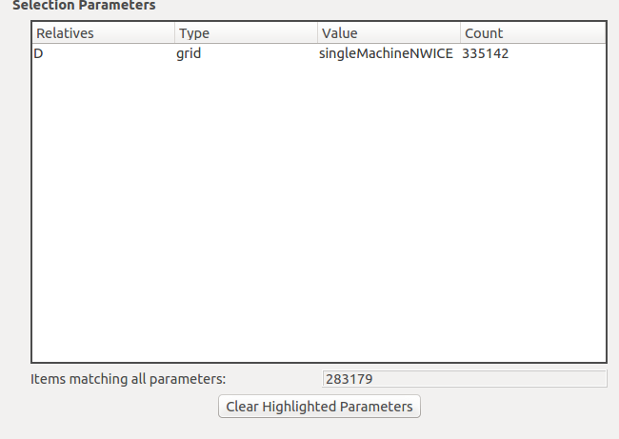

Result without code changes:

submitting query 13:03:40.493

result table populated 13:03:42.025

query completed 13:03:44.636

starting to read data 13:03:44.637

done reading data 13:03:48.360 -- **Total time**: around 8 sec.

After code changes:

submitting query 13:00:47.083

executing: INSERT INTO results_temp(saved, result_id, start_time, end_time, value, chk, units, metric, label, combined) SELECT 1, pr.id, pr.start_time, pr.end_time, pr.value, pr.chk, pr.units, riA.name, pr.label, pr.combined FROM performance_result pr, resource_item riA , performance_result_has_focus prhf, contexts_temp foci WHERE pr.id = prhf.performance_result_id AND prhf.focus_id = foci.focus_id AND prhf.focus_type = 'primary' AND riA.id = pr.metric_id

result table populated 13:00:49.197

query completed 13:00:51.817

starting to read data 13:00:52.030

end read data 13:01:01.897

done reading data 13:01:01.898 -- Total time: around 13 sec

Second time:

submitting query 13:48:52.662

executing: INSERT INTO results_temp(saved, result_id, start_time, end_time, value, chk, units, metric, label, combined) SELECT 1, pr.id, pr.start_time, pr.end_time, pr.value, pr.chk, pr.units, riA.name, pr.label, pr.combined FROM performance_result pr, resource_item riA , performance_result_has_focus prhf, contexts_temp foci WHERE pr.id = prhf.performance_result_id AND prhf.focus_id = foci.focus_id AND prhf.focus_type = 'primary' AND riA.id = pr.metric_id

result table populated 13:48:54.023

query completed 13:48:56.549

starting to read data 13:48:56.550

end read data 13:48:59.563

done reading data 13:48:59.563 -- **Total rime** is 7 sec

**Test case #4**:

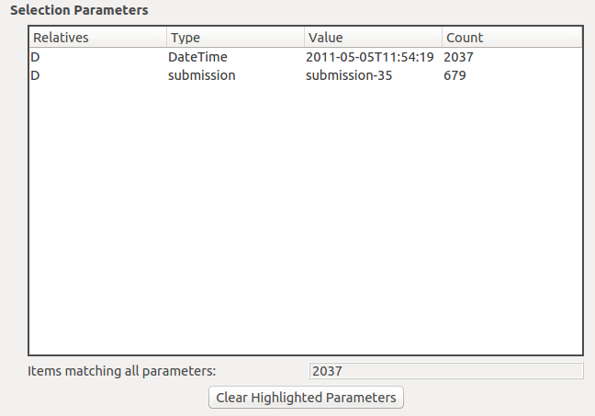

Result without code changes:

submitting query 13:08:53.579

result table populated 13:08:53.944

query completed 13:08:54.032

starting to read data 13:08:54.436

done reading data 13:08:54.477 --**Total time**: 0.898 ms

Result with code changes:  
  
submitting query 13:11:58.285

executing: INSERT INTO results_temp(saved, result_id, start_time, end_time, value, chk, units, metric, label, combined) SELECT 1, pr.id, pr.start_time, pr.end_time, pr.value, pr.chk, pr.units, riA.name, pr.label, pr.combined FROM performance_result pr, resource_item riA , performance_result_has_focus prhf, contexts_temp foci WHERE pr.id = prhf.performance_result_id AND prhf.focus_id = foci.focus_id AND prhf.focus_type = 'primary' AND riA.id = pr.metric_id

result table populated 13:11:58.739

query completed 13:11:58.765

starting to read data 13:11:58.766

end read data 13:11:58.795

done reading data 13:11:58.795 --- **Total time**: 0.510 ms

**Test case #5**:

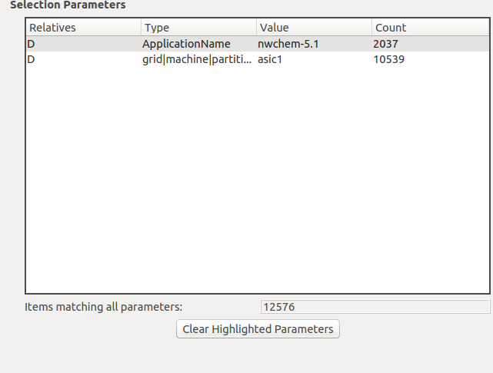

Result without code changes:

submitting query 13:18:03.940

result table populated 13:18:04.425

query completed 13:18:04.548

starting to read data 13:18:04.548

done reading data 13:18:04.704 --- **Total time**: 0.764 ms

Result with code changes:

submitting query 13:13:26.072

executing: INSERT INTO results_temp(saved, result_id, start_time, end_time, value, chk, units, metric, label, combined) SELECT 1, pr.id, pr.start_time, pr.end_time, pr.value, pr.chk, pr.units, riA.name, pr.label, pr.combined FROM performance_result pr, resource_item riA , performance_result_has_focus prhf, contexts_temp foci WHERE pr.id = prhf.performance_result_id AND prhf.focus_id = foci.focus_id AND prhf.focus_type = 'primary' AND riA.id = pr.metric_id

result table populated 13:13:26.543

query completed 13:13:26.665

starting to read data 13:13:26.670

end read data 13:13:26.817

done reading data 13:13:26.818 -- **Total time**: 0.746 ms

**Test case #6**:

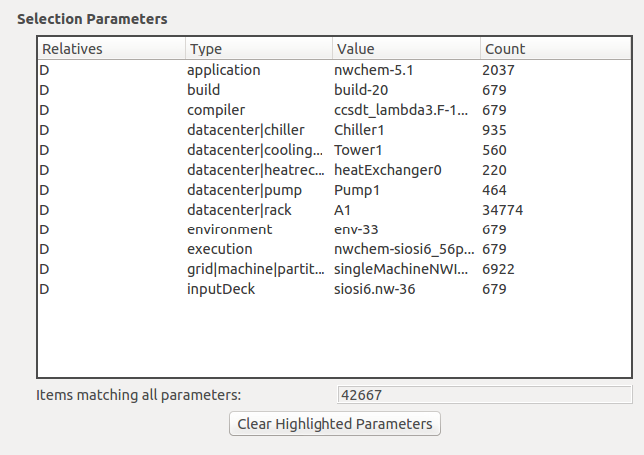

Result without code changes:

submitting query 15:19:51.221

result table populated 15:19:51.845

query completed 15:19:52.230

starting to read data 15:19:52.231

done reading data 15:19:52.781

**Total time**: 1.56 sec

Result with code changes:

submitting query 15:11:42.481

executing: INSERT INTO results_temp(saved, result_id, start_time, end_time, value, chk, units, metric, label, combined) SELECT 1, pr.id, pr.start_time, pr.end_time, pr.value, pr.chk, pr.units, riA.name, pr.label, pr.combined FROM performance_result pr, resource_item riA , performance_result_has_focus prhf, contexts_temp foci WHERE pr.id = prhf.performance_result_id AND prhf.focus_id = foci.focus_id AND prhf.focus_type = 'primary' AND riA.id = pr.metric_id

result table populated 15:11:43.093

query completed 15:11:43.490

starting to read data 15:11:43.491

end read data 15:11:43.978

done reading data 15:11:43.979

**Total time**: 1.498 sec

**Test case #7**:

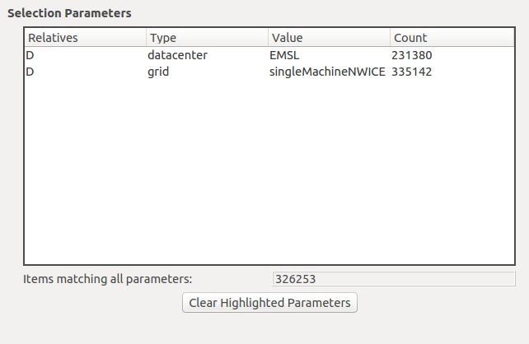

Result without code changes:

submitting query 15:25:02.037

result table populated 15:25:04.587

query completed 15:25:07.729

starting to read data 15:25:07.803

done reading data 15:25:15.257 -- **Total time**: 13.2 sec

Result with code changes:

submitting query 15:28:40.000

executing: INSERT INTO results_temp(saved, result_id, start_time, end_time, value, chk, units, metric, label, combined) SELECT 1, pr.id, pr.start_time, pr.end_time, pr.value, pr.chk, pr.units, riA.name, pr.label, pr.combined FROM performance_result pr, resource_item riA , performance_result_has_focus prhf, contexts_temp foci WHERE pr.id = prhf.performance_result_id AND prhf.focus_id = foci.focus_id AND prhf.focus_type = 'primary' AND riA.id = pr.metric_id

result table populated 15:28:42.284

query completed 15:28:45.341

starting to read data 15:28:45.341

end read data 15:28:48.834

done reading data 15:28:48.834 -- total time: 8.8 sec

**Test case #8**:

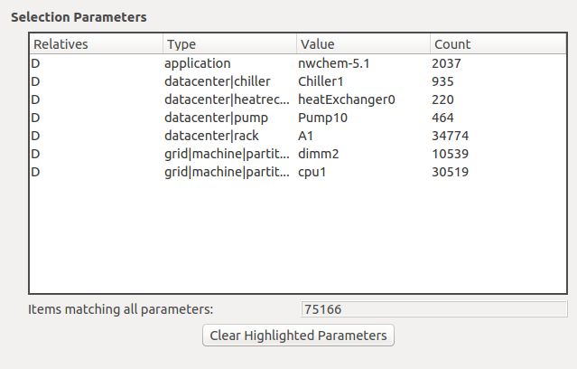

Result without code changes:

submitting query 15:51:51.612

result table populated 15:51:52.429

query completed 15:51:53.102

starting to read data 15:51:53.102

done reading data 15:51:54.195 -- **Total_time** : 2.6 sec

Result with code changes:

submitting query 15:47:50.384

executing: INSERT INTO results_temp(saved, result_id, start_time, end_time, value, chk, units, metric, label, combined) SELECT 1, pr.id, pr.start_time, pr.end_time, pr.value, pr.chk, pr.units, riA.name, pr.label, pr.combined FROM performance_result pr, resource_item riA , performance_result_has_focus prhf, contexts_temp foci WHERE pr.id = prhf.performance_result_id AND prhf.focus_id = foci.focus_id AND prhf.focus_type = 'primary' AND riA.id = pr.metric_id

result table populated 15:47:51.405

query completed 15:47:52.242

starting to read data 15:47:52.720

end read data 15:47:53.414

done reading data 15:47:53.414 --- **Total time**: 3.1 sec