



MONTHLY  
NEWSLETTER

ISSUE

01

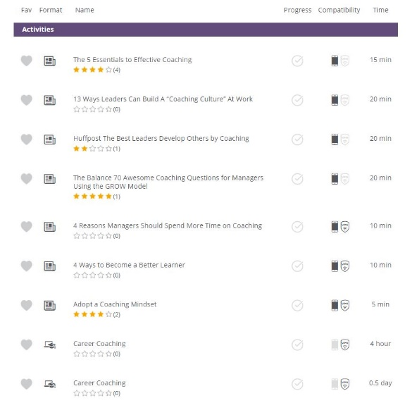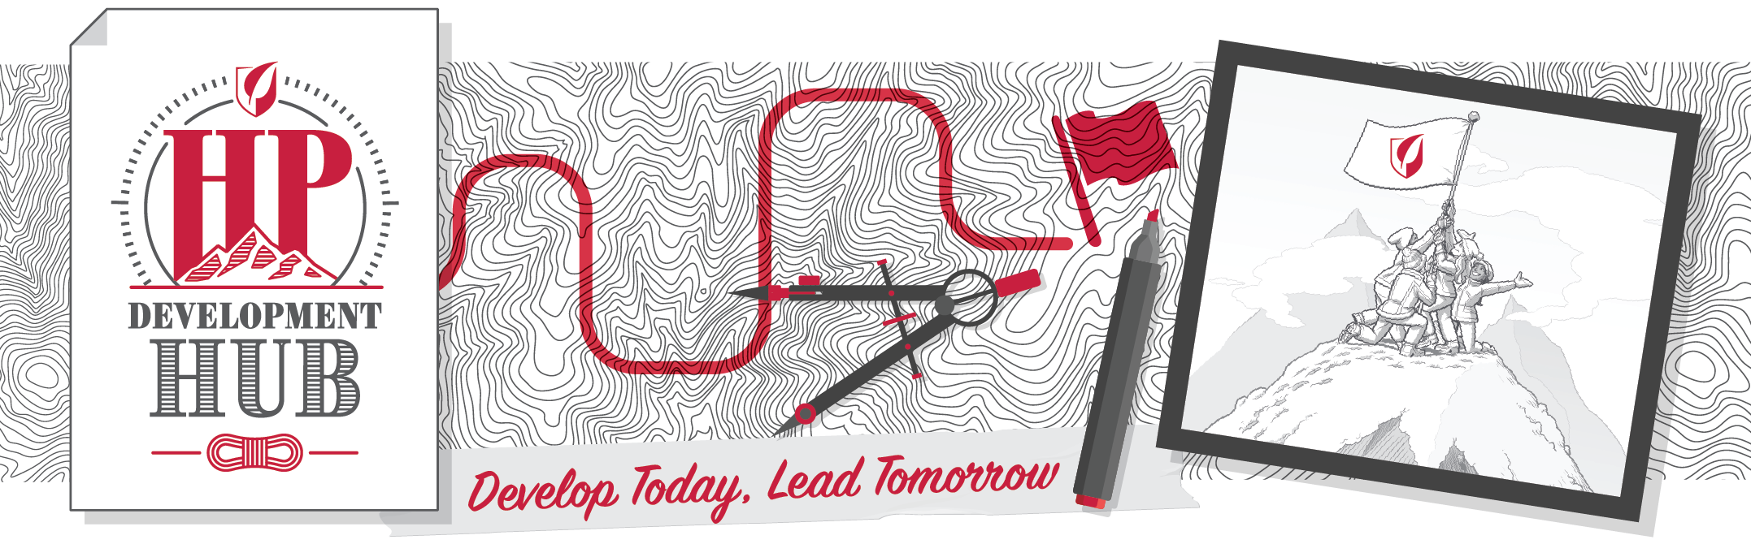

**TOP MOUNTANIEERS**

**(All time)**

1. Amaury Dumont (France) 3210 points

2. Vera Vallova (Czech) 3070 points

3. Beverly Francis (Canada) 2980 points

4. Allan Garlik Jensen (Denmark) 2760 points

5. Gabriele Forcina (Italy) 2670 points

**MOST VISITED COURSES (All Time)**

1. LEADING THE CHANGE. Bronze

2. HEALTHCARE LANDSCAPE AWARENESS v1.0. Bronze

3. SCIENTIFIC COMMUNICATION. Bronze

4. PROJECT MANAGEMENT. Bronze

5. PERSONAL INITIATIVE. Bronze

**TOP COUNTRIES (TOTAL POINTS All time)**

**TOP COUNTRIES (Average points per user All time)**

All of you that are interested on develop your skills on coaching, no matter if you are not a people manager right now, can find a dedicated course in HP2020+.

It is on the Collaborative pathway (the purple mountain) and it is called “**COACHING**”

There you will find 9 activities in different formats and different duration (from 5 min to 0.5 days).

“Coaching is unlocking a person´s potential to maximise their own performance It is helping them to learn rather than teaching them.”

*John Whitmore, in Coaching for Performance*

**CZECHIA 614**

**DENMARK 800**

**SLOVAKIA 1700**

**SPAIN 4500**

**FRANCE 10.000**

**ITALY 10.990**

FEBRUARY  
2021

There is also an additional activity outside this course: Set the Tone for Trust – Create an Enviroment in Which People Hear Your Message. HAPPY COACHING !!

**Coaching: what is in HP2020+ for me?**