

Not displaying correctly? [Read in web browser](https://gileadlandd.newsweaver.com/az87xnw5ar/t0hya71xeyt1k1gmsygu7u?lang=en&a=6&p=3366450&t=297166)

Global Newsletter

April 2021 - Issue 112

Editors-in-Chief: Rhowena Hawkins, Effy Zhang

***In this Issue:***

*Global Training Calendar*

*Featured Articles (Introducing the New Gilead 101 Lecture Series, The Global Best Practice portal open for submissions, New edX Website for MA & Development, The Job Shadow pilot program is Live, Development Discussion Time)*

*Career Spotlight (Meet Jamie Dettler-Leonard, Oncology MS)*

*Medical Affairs Stories (ACE Aspiring Leaders are fearless, Catch up with the Global Medical Information Team, MA Strategic Planning Training, Use the Medical Affairs Competencies Guides, HP Development Hub)*

*Coaches Corner (Practicing Radical Candor) MA World Tour (Easter in Greece)*

*Just For Fun (Really really short workout, Sports Trivia Quiz)*

*Additional Training Resources (Rheumatology Training Academy, Upcoming Library & Information Services Database Training, MA L&D / Tech Training Site, PPT Tips & Tricks, Medical Affairs Coaching Resources, MA Calendar)*

"Recommend this article"

Click this button at the end of any article to email it to a colleague!

# [Global Training Calendar](https://gileadlandd.newsweaver.com/az87xnw5ar/51tykj9f7x11k1gmsygu7u?lang=en&a=1&p=3366450&t=1126699)

Upcoming Medical Affairs training programs in the coming months:

**April 2021**

ACE HDV Training: DAQ Workshop

Virtual 01/APR



ACE HDV Training: Hepcludex DAQ Debrief Virtual

01/APR

ACE Covid 19 Timing of Treatments DAQ Workshop Virtual

07/APR - 08/APR

ACE SSC 2021 Phase 1 Coaching Virtual

08/APR

ACE Oncology Phase 1 Training Virtual

09/APR - 15/APR

ACE Post-CROI Training Virtual

12/APR - 14/APR

INTL APAC Post CROI Training Virtual

13/APR - 15/APR

ACE SSC 2021 Phase 1 Coaching Virtual

13/APR

ACE MAAC

Virtual 19/APR - 13/MAY

INTL China MA All Hands Meeting Xishuangbanna

26/APR - 29/APR

Global MA Strategy Discussion: Developing An Aligned and Measurable Medical POA Virtual

28/APR

Global MA Strategy Discussion: Developing An Aligned and Measurable Medical POA Virtual

29/APR

***

[**Read more »**](https://gileadlandd.newsweaver.com/az87xnw5ar/51tykj9f7x11k1gmsygu7u?lang=en&a=2&p=3366450&t=1126699)

**FEATURED ARTICLES**

# Introducing the New Gilead 101 Lecture Series

**by Medical Affairs Learning & Development**



In 2015, we launched the Gilead 101 Lecture Series with the goal of ensuring all Gilead employees, regardless of function or TA affiliation, would be inspired by our scientific accomplishments on behalf of patients around the world.

We are now very excited to announce the NEW Gilead 101 Lecture Series, presented in a completely updated format with a new set of speakers from across the global Medical Affairs organization.

Visit the link below for the first video in this new series, focused on HIV Treatment, and look forward to more videos on other therapeutic areas in the coming months.

[Gilead 101: HIV Treatment (featuring David Piontkowsky, VP Global Medical Affairs)](https://gileadlandd.newsweaver.com/az87xnw5ar/6rds30bq72k1k1gmsygu7u/external?a=5&p=3366450&t=739634)

[Gilead 101: HIV Prevention (featuring Kesha O’Reilly, HIV Prevention Medical Scientist)](https://gileadlandd.newsweaver.com/az87xnw5ar/1ht080jaumy1k1gmsygu7u/external?a=5&p=3366450&t=739634)

# [The Global Best Practice portal is open for submissions!](https://gileadlandd.newsweaver.com/az87xnw5ar/1l89q7i0odz1k1gmsygu7u?lang=en&a=1&p=3366450&t=739634)

**by Adriana Martinez**

Learn more about how to submit your best practices.

[**Read More!**](https://gileadlandd.newsweaver.com/az87xnw5ar/1l89q7i0odz1k1gmsygu7u?lang=en&a=2&p=3366450&t=739634)

# [New edX Website for Medical Affairs and Development](https://gileadlandd.newsweaver.com/az87xnw5ar/gxu333v738h1k1gmsygu7u?lang=en&a=1&p=3366450&t=739634)

**by Sandra Lai (USMA Events, Internal/L&D)**

We’re excited to announce the new edX landing page created just for Medical Affairs and Development team members looking to take advantage of

this remarkable resource. If you’re looking to up-level a skill set or learn something [completely new, edX + Medical Affairs and Development makes it possible with](https://gileadlandd.newsweaver.com/az87xnw5ar/pdukxosoag11k1gmsygu7u/external?a=5&p=3366450&t=739634) access to 1,000+ on-demand courses from prestigious universities such as Harvard, MIT, and Columbia.

[**Read more »**](https://gileadlandd.newsweaver.com/az87xnw5ar/gxu333v738h1k1gmsygu7u?lang=en&a=2&p=3366450&t=739634)

# [The Job Shadow pilot program is Live!](https://gileadlandd.newsweaver.com/az87xnw5ar/h8pb5kpgxw71k1gmsygu7u?lang=en&a=1&p=3366450&t=739634)

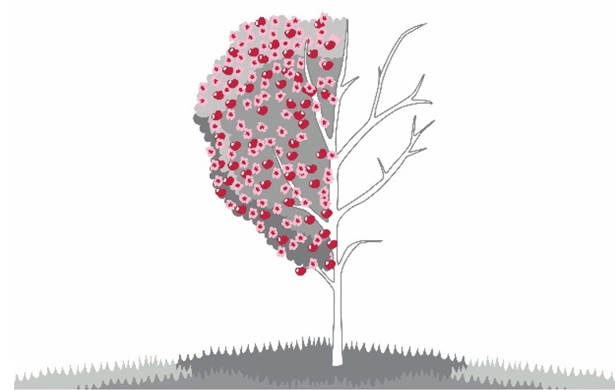

**by Stuart Yau, Drea Pangilinan, Yulia Ivanets, Mia Li**

Job Shadow is a short and informal opportunity to walk in a colleague’s shoes to broaden insights. The pilot program is available for Gilead/Kite Medical Affairs employees only. Let’s make 2021 the year of reconnection through sharing experiences across the globe.

[**Read more »**](https://gileadlandd.newsweaver.com/az87xnw5ar/h8pb5kpgxw71k1gmsygu7u?lang=en&a=2&p=3366450&t=739634)

# Development Discussion Time

**by HR TDI and HP2020+ Innovative Solutions Team**

Having introduced the core themes of Growth Mindset we want to ensure both managers and employees are protecting time in their schedules to discuss development and career progress, challenges and opportunities, regularly.

This month, we urge you to ensure you have this valuable discussion time with your manager and your employees.

Check your calendar now and invest the time!

**CAREER SPOTLIGHT**

# [Meet Jamie Dettler-Leonard, Oncology MS,](https://gileadlandd.newsweaver.com/az87xnw5ar/bjo7v8vsq3k1k1gmsygu7u?lang=en&a=1&p=3366450&t=739636)

[**Dallas,TX USA**](https://gileadlandd.newsweaver.com/az87xnw5ar/bjo7v8vsq3k1k1gmsygu7u?lang=en&a=1&p=3366450&t=739636)

**by : Jamie Dettler-Leonard, 2020 Immunomedics/Gilead Sciences Oncology Alvan Fisher Award Winner**

From Immunomedics to Gilead Sciences; An exciting opportunity in oncology...

[**Read more »**](https://gileadlandd.newsweaver.com/az87xnw5ar/bjo7v8vsq3k1k1gmsygu7u?lang=en&a=2&p=3366450&t=739636)

**MEDICAL AFFAIRS STORIES**

# [ACE Aspiring Leaders are fearless](https://gileadlandd.newsweaver.com/az87xnw5ar/k64567xywdv1k1gmsygu7u?lang=en&a=1&p=3366450&t=390584)

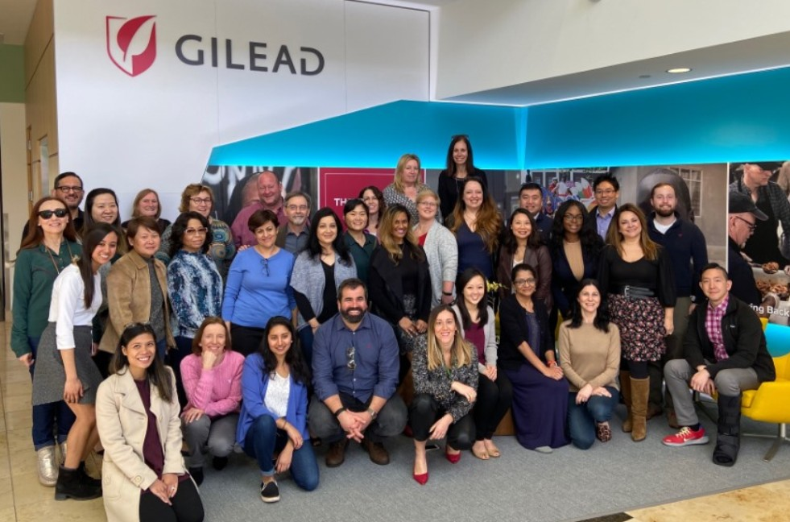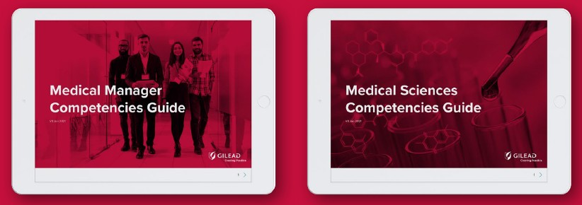

**by Samer El-Ali, Jason De Mel, Naomi Moore**

Learn and replicate ACE’s leadership discussion about growth mindset and psychological safety.

[**Read more »**](https://gileadlandd.newsweaver.com/az87xnw5ar/k64567xywdv1k1gmsygu7u?lang=en&a=2&p=3366450&t=390584)

# [Catch up with the Global Medical Information Team](https://gileadlandd.newsweaver.com/az87xnw5ar/14bxkov2mh91k1gmsygu7u/external?a=1&p=3366450&t=390584)

**by Global Medical Information Team**

Gilead Medical Information Teams across the world continue to be a key resource for patients during the COVID-19 pandemic. View videos on the experiences of our medical information teams as they navigate ways to support patients and healthcare professionals during a pandemic.

[**Read More!**](https://gileadlandd.newsweaver.com/az87xnw5ar/14bxkov2mh91k1gmsygu7u/external?a=2&p=3366450&t=390584)

# [MA Strategic Planning Training](https://gileadlandd.newsweaver.com/az87xnw5ar/1fje9k9v1g61k1gmsygu7u?lang=en&a=1&p=3366450&t=390584)

**by Strategic Planning and L&D Teams**

Looking to know more about effective Medical Affairs Strategic Planning? Check out training that was conducted with Medical-ILT team members that may be of interest to you.

[**Read more »**](https://gileadlandd.newsweaver.com/az87xnw5ar/1fje9k9v1g61k1gmsygu7u?lang=en&a=2&p=3366450&t=390584)

# [Own your development: Use the Medical Affairs Competencies Guides](https://gileadlandd.newsweaver.com/az87xnw5ar/pco4tpgpkqf1k1gmsygu7u?lang=en&a=1&p=3366450&t=390584)

**by Pim Nieuwenhuizen on behalf of G-MASCOT**

Start using these career planning resources that help YOU make your own development plan.

[**Read more »**](https://gileadlandd.newsweaver.com/az87xnw5ar/pco4tpgpkqf1k1gmsygu7u?lang=en&a=2&p=3366450&t=390584)



# [HP Development Hub: Focus on Coaching and Usage Analytics](https://gileadlandd.newsweaver.com/az87xnw5ar/t0ywr3kmm1n1k1gmsygu7u?lang=en&a=1&p=3366450&t=390584)

**by HubCoreTeam**

Nelson Mandela quoted this sentence that could define what it is resilience: *“Do not judge me by my success, judge me by how many times I fell down and got back up again”.*

Discover what you can find in HP2020+ about resilience and see also some usage analytics

[**Read more »**](https://gileadlandd.newsweaver.com/az87xnw5ar/t0ywr3kmm1n1k1gmsygu7u?lang=en&a=2&p=3366450&t=390584)

**COACHES CORNER**

# [Practicing Radical Candor](https://gileadlandd.newsweaver.com/az87xnw5ar/1ijxchdtt9v1k1gmsygu7u?lang=en&a=1&p=3366450&t=844324)

**by David West and Berna Ozelgun**

This month’s topic focuses on radical candor and how caring personally and challenging directly can improve our team dynamics and our performance.

[**Read more »**](https://gileadlandd.newsweaver.com/az87xnw5ar/1ijxchdtt9v1k1gmsygu7u?lang=en&a=2&p=3366450&t=844324)

**MA World Tour**

## [Greek Easter](https://gileadlandd.newsweaver.com/az87xnw5ar/1isw97o7vsl1k1gmsygu7u?lang=en&a=1&p=3366450&t=1062701)

**by George Galanopoulos, Sr Director of Greece Medical Affairs**

Easter is considered as the most important festival in the Eastern Orthodox Church, far more important than Christmas, because it celebrates God's victory over sin and death. Moreover, as it falls in spring, Easter symbolizes the revival of nature

[**Read more »**](https://gileadlandd.newsweaver.com/az87xnw5ar/1isw97o7vsl1k1gmsygu7u?lang=en&a=2&p=3366450&t=1062701)

**JUST FOR FUN**

## [Really, Really Short Workouts](https://gileadlandd.newsweaver.com/az87xnw5ar/1u8b9d8t17u1k1gmsygu7u?lang=en&a=1&p=3366450&t=1062681)

Think you’re too busy to work out? We have the workout for you. Check out the 7-min workout that is scientifically proven to work!

[**Read more »**](https://gileadlandd.newsweaver.com/az87xnw5ar/1u8b9d8t17u1k1gmsygu7u?lang=en&a=2&p=3366450&t=1062681)



## [Sports Trivia Quiz](https://gileadlandd.newsweaver.com/az87xnw5ar/15959jik8461k1gmsygu7u/external?a=1&p=3366450&t=1062681)

**by Medical Affairs L&D Team**

Have you checked the Really Really Short Workouts we prepared for you?

Well, now it is time for the Sports Quiz Challenge. Have fun :)

[**Click to Play**](https://gileadlandd.newsweaver.com/az87xnw5ar/15959jik8461k1gmsygu7u/external?a=2&p=3366450&t=1062681)

**ADDITIONAL TRAINING RESOURCES**

# [Rheumatology Training Academy (RTA)](https://gileadlandd.newsweaver.com/az87xnw5ar/1a279q7yj3h1k1gmsygu7u/external?a=1&p=3366450&t=320328)

**by Vickie Yau, International Medical Affairs L&D Team**

We have uploaded the resources that KOL are accessing on RTA in the FILGOOD folder!

[**Please access here!**](https://gileadlandd.newsweaver.com/az87xnw5ar/1a279q7yj3h1k1gmsygu7u/external?a=2&p=3366450&t=320328)

# [Upcoming Library & Information Services Database Training](https://gileadlandd.newsweaver.com/az87xnw5ar/14saceabndu1k1gmsygu7u?lang=en&a=1&p=3366450&t=320328)

**by Magan Stephens, Library & Information Services**

Is it essential for you to identify top players, key indications, and mechanisms of action for drugs under active development?

[**Read more »**](https://gileadlandd.newsweaver.com/az87xnw5ar/14saceabndu1k1gmsygu7u?lang=en&a=2&p=3366450&t=320328)

# [MA L&D / Tech Training Site](https://gileadlandd.newsweaver.com/az87xnw5ar/80chrmr76uc1k1gmsygu7u/external?a=1&p=3366450&t=320328)



**by Medical Affairs L&D and Tech Training**

Visit this one stop shop for all your training needs and resources!

[**Click here to view the training site**](https://gileadlandd.newsweaver.com/az87xnw5ar/80chrmr76uc1k1gmsygu7u/external?a=2&p=3366450&t=320328)

# [PowerPoint Tips & Tricks: How to Add Data Labels](https://gileadlandd.newsweaver.com/az87xnw5ar/1bojwvz20u51k1gmsygu7u/external?a=1&p=3366450&t=320328)

**by Graphics**

*For this month’s PowerPoint Tips and Tricks short video,*

*the Graphics Services team will talk about Data Labels*

[**Click here to view a quick 1-min video**](https://gileadlandd.newsweaver.com/az87xnw5ar/1bojwvz20u51k1gmsygu7u/external?a=2&p=3366450&t=320328)

# [Medical Affairs Coaching Resources](https://gileadlandd.newsweaver.com/az87xnw5ar/1pzj39725jo1k1gmsygu7u?lang=en&a=1&p=3366450&t=320328)

**by Anna Rathmell-Davey**

Find out what coaching resources are available to you and your teams: There are a number of coaching resources available to individuals at all levels in Medical Affairs, ranging from general presentation skills coaching to small group and 1:1 tailored programs.

[**Read more »**](https://gileadlandd.newsweaver.com/az87xnw5ar/1pzj39725jo1k1gmsygu7u?lang=en&a=2&p=3366450&t=320328)

# [Want to know when key Medical Affairs' events are occurring?](https://gileadlandd.newsweaver.com/az87xnw5ar/xfjhejfe5r71k1gmsygu7u?lang=en&a=1&p=3366450&t=320328)

**by PFMES Team**

[**Read more »**](https://gileadlandd.newsweaver.com/az87xnw5ar/xfjhejfe5r71k1gmsygu7u?lang=en&a=2&p=3366450&t=320328)

# [Course Catalog](https://gileadlandd.newsweaver.com/az87xnw5ar/noqvi83a4q81k1gmsygu7u?lang=en&a=1&p=3366450&t=320328)

Check out our current G.Learn course catalog

[**Read more »**](https://gileadlandd.newsweaver.com/az87xnw5ar/noqvi83a4q81k1gmsygu7u?lang=en&a=2&p=3366450&t=320328)

# [Therapeutic Area Training eBooks](https://gileadlandd.newsweaver.com/az87xnw5ar/1pa0neq8yir1k1gmsygu7u/external?a=1&p=3366450&t=320328)

We've developed a series of eBooks to complement the interactive therapeutic area training available in G.Learn. The eBooks are in PDF format and were created for those looking to view on the iPad or PC.



**The Medical Affairs Learning & Development Team:**

**FOSTER CITY**

Alycia Shilton-Lloyd, Exec. Director Jeff Narvid, Sr. Director (Global Lead) Sebastian Teague, Director

Molly LoMastro, Administrative Assistant Ashley Costa, PFMES Associate

**STOCKLEY PARK**

Naomi Moore, Sr. Director (ACE Lead) Anna Rathmell-Davey, Assoc. Director Rhowena Hawkins, Project Manager Madeleine Steer, PFMES Associate

**HONG KONG**

Vickie Yau, Assoc. Director

**SHANGHAI**

Chunyan (Helen) He, Director (International Lead) Effy Zhang, Coordinator (International)

Share your thoughts on Yammer Medical Affairs

[Issue archive](https://gileadlandd.newsweaver.com/az87xnw5ar/mji0ozxcvz81k1gmsygu7u?lang=en&a=6&p=3366450&t=297159) | [Print friendly version](https://gileadlandd.newsweaver.com/az87xnw5ar/mdx5xvddyx71k1gmsygu7u?lang=en&a=6&p=3366450&t=297159)

[**Click here to check!**](https://gileadlandd.newsweaver.com/az87xnw5ar/1pa0neq8yir1k1gmsygu7u/external?a=2&p=3366450&t=320328)