**Antenna**

All S.M.A.R.T. Alarm modules will use the provided antenna that come standard on the XBee XB24-API-001. However, since the main hub will not be mounted on a wall once the system is set up, but most likely set up in a server room or something similar, there may be a need for an external antenna to help extend and strengthen the main hub transmission range. Therefore, this module (XBee XB24-AUI-001) will be connect to an external antenna via a U. FL coaxial connector.

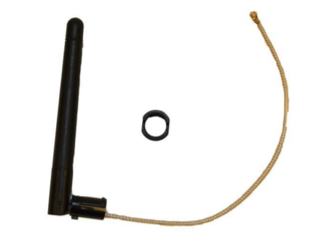

The antenna chosen to pair with the XB24-AUI-001 is the MikroTik 2.4/5 GHz Omni Swivel Antenna. This antenna offers a gain of 2dBi in the 2.4 GHz frequency range. This antenna has a small nominal impedance of 50 ohms and has a length of 86mm. The operation temperature of this antenna is -20 – 60oC. The antenna can rotate and mount in a through hole manner. The S.M.A.R.T. Alarm team believe this antenna will give the necessary range extension and transmission signal boost to be able to operate properly.