STA302 Three Research Proposals and Analysis Portfolio
Group 62 | University of Toronto | Fall 2026 | Updated 2 November 2026
This portfolio brings together three alternative regression projects: regional differences in new-home prices, service-type differences in transit ridership, and sector differences in faculty compensation. Each proposal states a research question, describes its data, summarizes relevant literature, assesses an uncorrected preliminary model and lays out the remaining analysis. The later technical sections preserve the completed exploratory work, robustness checks and limitations needed to compare the alternatives.
Select one project for the course submission. The combined portfolio supports that decision; the course deliverable is one proposal PDF with its matching Rmd, data and signed teamwork agreement. A Google Docs copy is a collaboration document and does not replace the required Quercus files or UofT OneDrive data link.

Project comparison
Project | Analysis unit and sample | Focal interaction | Preliminary R² | Main limitation
New homes | 6,185 homes; 4,330 training | Floor area by nine divisions | 0.713 | Small regional cells and unobserved builder dependence
Transit | 2,135 agencies; 1,494 training | Log service hours by service type | 0.930 | Joint determination of service and ridership
Faculty salary | 1,070 institutions; 749 training | Log10 endowment by public/private sector | 0.849 | Accounting differences and prior holdout overlap

The housing option has a particularly clear preliminary-diagnostics-to-transformation narrative and a separate-year sample of houses. The salary option presents a substantial sector contrast but has a smaller sample and important measurement limitations. The transit option has strong descriptive fit, much of which reflects agency scale; it cannot estimate the causal ridership gain from adding service. Model fit across different responses or transformation scales is not a common measure of project quality.

How the document is organized
- Three Part 1 proposals, each with its own bibliography, numerical summaries and residual figures.
- Three technical supplements covering the existing Part 2 analyses, complete specifications, sensitivity checks and limitations.
- Course requirements, submission checklist and reproducibility record.
Contributions and named task owners are intentionally blank for the group to complete. No signatures or contributions are inferred.

Published repositories
The umbrella repository and all three component repositories were confirmed public on GitHub on 2 November 2026. The downloaded archives include Rmd files, data, figures and proposals.
Repository | Published snapshot
Project collection | 4449bf9
New home prices | 2867c81
Transit ridership | 2c10d5d
Faculty salary | 5acad2f

The revised English documents in this portfolio are a later editorial and requirements-alignment version; the links above identify the published analysis snapshots, not an upload of this revision.

Floor Area and Regional Differences in New Home Prices
STA302H1 Fall 2026 | Group 62 | Part 1 Research Proposal

Contributions
Group 62
Member name | Contribution to this proposal
__________ | __________
__________ | __________
__________ | __________
__________ | __________

Introduction
Among detached single-family homes sold in the United States in 2025, how is sale price associated with finished floor area, and does this association differ across the nine Census divisions after adjustment for lot size, rooms, amenities, construction features and sale timing? Sale price includes the lot and is measured in thousands of dollars; floor area is measured in hundreds of square feet.
Comparing average prices per square foot would mix regional differences with differences in housing characteristics. Multiple linear regression separates these conditional associations. A floor-area-by-division interaction estimates nine adjusted slopes. Their confidence intervals and the joint partial F-test of eight interaction coefficients answer the question. These are observational associations, not the causal return to adding space to a particular house.
Rosen (1974) developed a theoretical model in which differentiated goods trade at prices related to their characteristics. This motivates treating floor space and amenities as separate hedonic attributes; the theory does not itself establish a causal construction effect. Gyourko and Saiz (2006), studying US housing markets, found economically substantial variation in construction costs associated with wages, unionization, topography and regulation. This motivates regional differences while retaining structural controls. Glaeser et al. (2005) found that Manhattan housing prices substantially exceeded construction costs and presented evidence of supply restrictions in other US markets. Their high-rise setting differs from detached homes, so it motivates investigating regional heterogeneity rather than predicting our coefficients directly.
Our application brings these ideas to a recent national microdata sample, comparing all nine divisions within one specification. It does not claim that regional price differences are a new discovery. Builders and housing analysts can use the estimates to describe how the conditional value of space varies across the observed markets; buyers should not interpret them as individual appraisals.

Data description
Census SOC 2025 surveys builders/owners using sampled permits and area canvassing to produce construction and sales statistics (Census Bureau, 2026). We retain 6,185 complete detached homes sold in 2025; 4,330 train and 1,855 test. Price is continuous but right-skewed, with disclosure-coded extremes. Distinct houses may share unobserved builders. Regional construction costs motivate area-by-division interaction (Gyourko & Saiz, 2006).
Table 1. Training summaries; N: mean(SD), C: counts by level; reference first. Missing cases excluded. Prices/lot sizes are skewed; rare categories require caution.
Variable | Type | Summary
Price ($1000) | N | 527(307); median 433; range 210–3300
Area (100sqft) | N | 25.4(9.9)
Lot (1000sqft) | N | 14.1(16.6)
Sale month | N | 6.3(3.4)
Division | C | SouthAtlantic:1308; NewEngland:39; MidAtlantic:119; EastNorthCentral:510; WestNorthCentral:313; EastSouthCentral:344; WestSouthCentral:850; Mountain:473; Pacific:374
Stories | C | 1:2120; 2:2116; 3+:94
Bedrooms | C | ≤2:154; 3:1780; 4:1777; 5+:619
Full bathrooms | C | ≤1:46; 2:2664; 3:1203; 4+:417
Half bathrooms | C | 0:2373; 1:1897; 2+:60
Garage | C | 1:158; 2:3124; 3+:919; other:129
Foundation | C | basement:992; crawl:403; slab:2926; other:9
Fireplaces | C | 0:2781; 1:1383; 2+:166
HOA | C | no:1109; yes:3221
Age restriction | C | no:4216; yes:114
Wall | C | brick:897; wood:169; stucco:906; vinyl:1362; stone:56; fiber-cement:926; other:14
Heating | C | electric:2147; gas:2083; propane:52; other:48
Sewer | C | public:3893; septic/other:437
Sale stage | C | completed:2452; construction:1344; unstarted:534

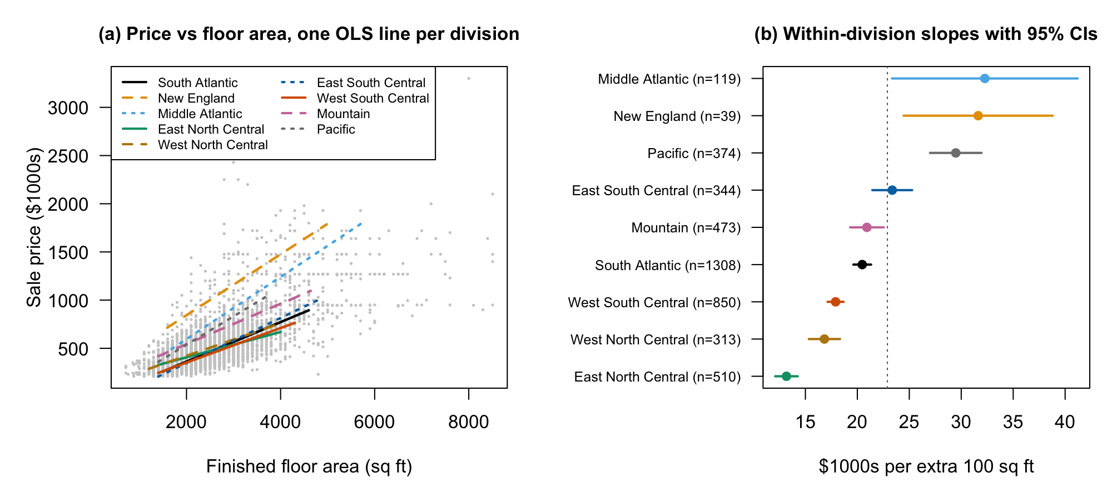
Figure 1. Unadjusted price–area relationships by division.

Ethics discussion
The first ethics module asks whether data are collected or simulated, whether metadata and original sources are documented, and whether third-party use supports trustworthiness. SOC records come from a documented Census survey, not simulated examples; the published definitions, sampling information and disclosure flags provide traceable metadata. Government origin supports provenance but does not remove sampling, reporting or measurement error.
For privacy, the public file suppresses detailed geography and identifying addresses and codes extreme values. We will not attempt re-identification or publish individual-house appraisals. Regarding consent, public statistical release is distinct from participants consenting to arbitrary new uses: we limit our use to aggregate housing research compatible with the collection purpose and do not claim to have independently audited every respondent's consent. Regarding ownership, we acknowledge the Census Bureau and HUD and retain source attribution. The estimates describe conditional associations; regional labels must not be used to stereotype households or imply causal effects of adding floor space.

Preliminary results
OLS uses 17 predictors plus the interaction (52 coefficients; n=4,330). R²=0.713 and adjusted R²=0.710; the interaction adds 0.020, F(8,4278)=37.3. Table 2 reports conditional slopes with conventional uncertainty, which is provisional under the violations below.
Conditions 1–2 are approximately satisfied: observed versus fitted prices are broadly linear and numerical predictor pairs lack strong curvature (Figure 2). Linearity is mildly violated by bending residual smoothers. Constant variance fails: residuals fan out and group spreads differ approximately fivefold. Normality fails: the Q–Q upper tail is heavy, with 36 standardized residuals beyond ±4 (Figures 3–4). Independence is not established because subdivision/builder identifiers are unavailable. No remedies are applied here.
Regional differences are compatible with Gyourko and Saiz (2006) and Glaeser et al. (2005), without demonstrating construction-cost or regulatory mechanisms. Lot size is unexpectedly inconclusive (p=0.28); the negative bedroom association conditions on fixed area. Sparse New England observations make that slope uncertain.
Table 2. Preliminary estimates, standard errors and 95% confidence intervals.
Division | n | Slope | SE | 95% CI | Difference from South Atlantic (SE)
South Atlantic (reference) | 1,308 | 11.83 | 0.63 | (10.60, 13.07) | —
New England | 39 | 19.26 | 2.15 | (15.05, 23.47) | 7.43 (2.17)
Middle Atlantic | 119 | 24.56 | 1.14 | (22.32, 26.79) | 12.72 (1.21)
East North Central | 510 | 6.85 | 0.85 | (5.19, 8.51) | −4.98 (0.91)
West North Central | 313 | 10.57 | 1.15 | (8.32, 12.82) | −1.26 (1.20)
East South Central | 344 | 13.78 | 0.97 | (11.88, 15.68) | 1.95 (1.00)
West South Central | 850 | 9.27 | 0.79 | (7.71, 10.82) | −2.57 (0.82)
Mountain | 473 | 14.60 | 0.80 | (13.03, 16.17) | 2.77 (0.87)
Pacific | 374 | 21.70 | 1.14 | (19.47, 23.92) | 9.86 (1.17)

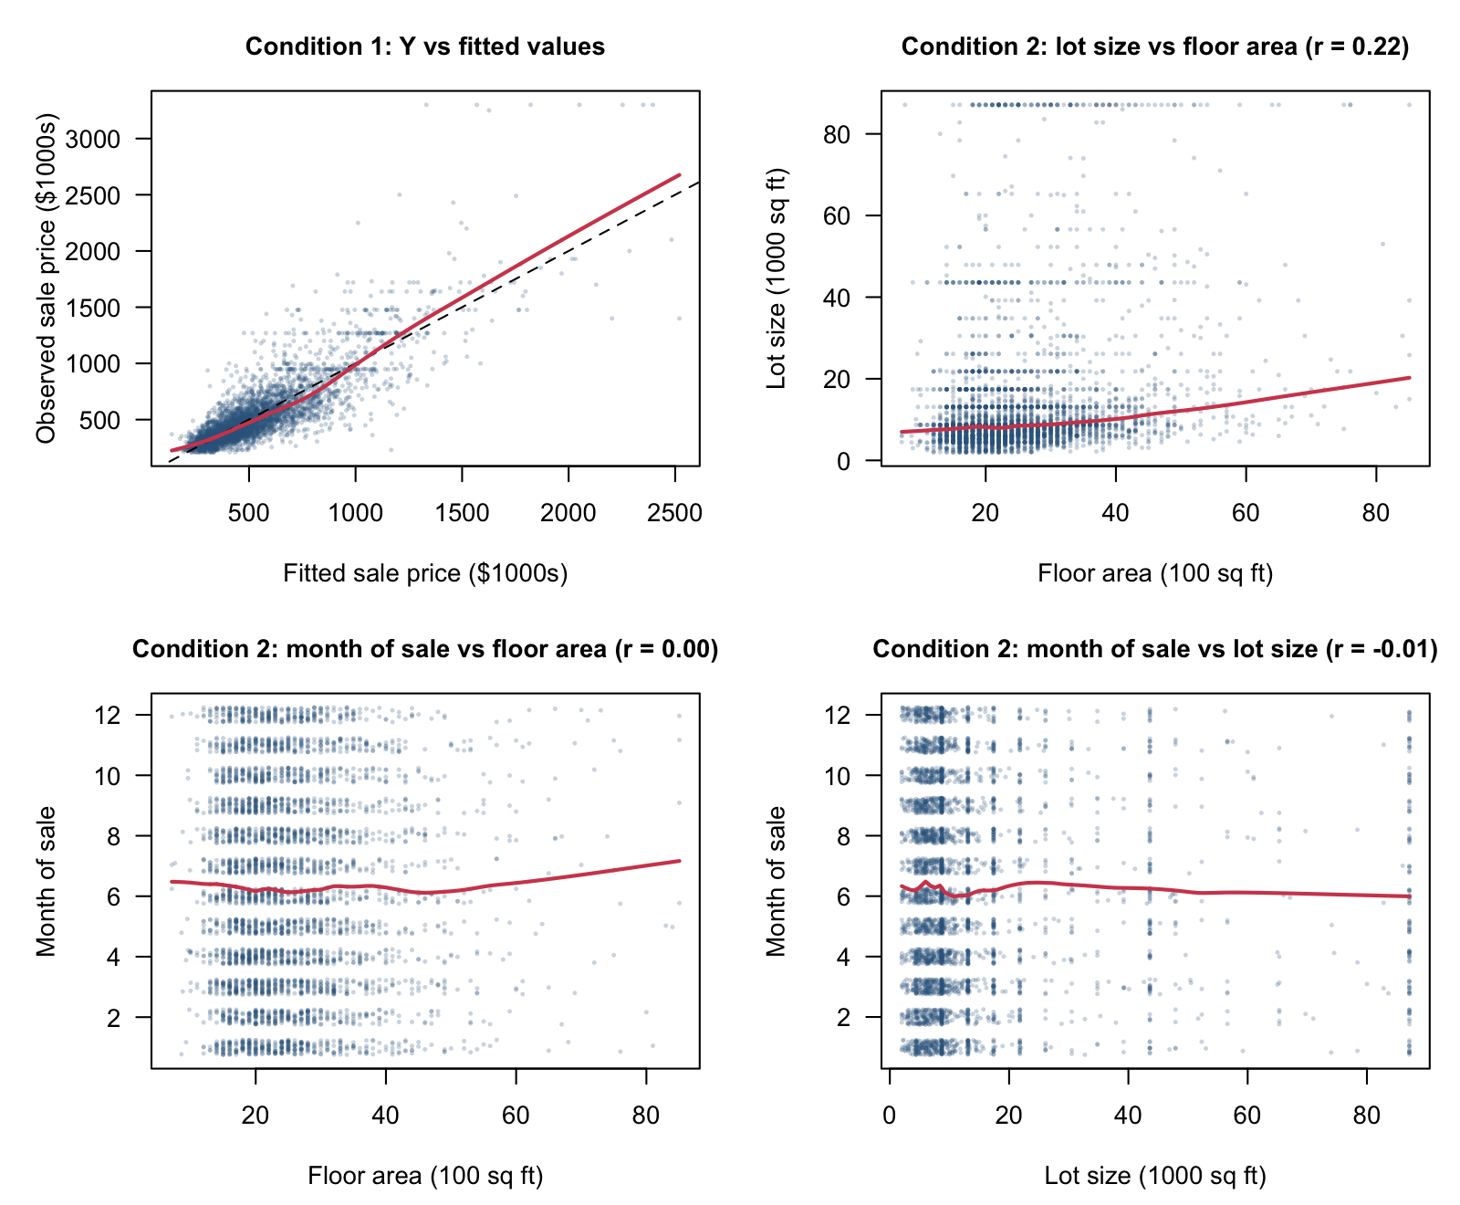
Figure 2. Observed–fitted relationship and predictor pairs.
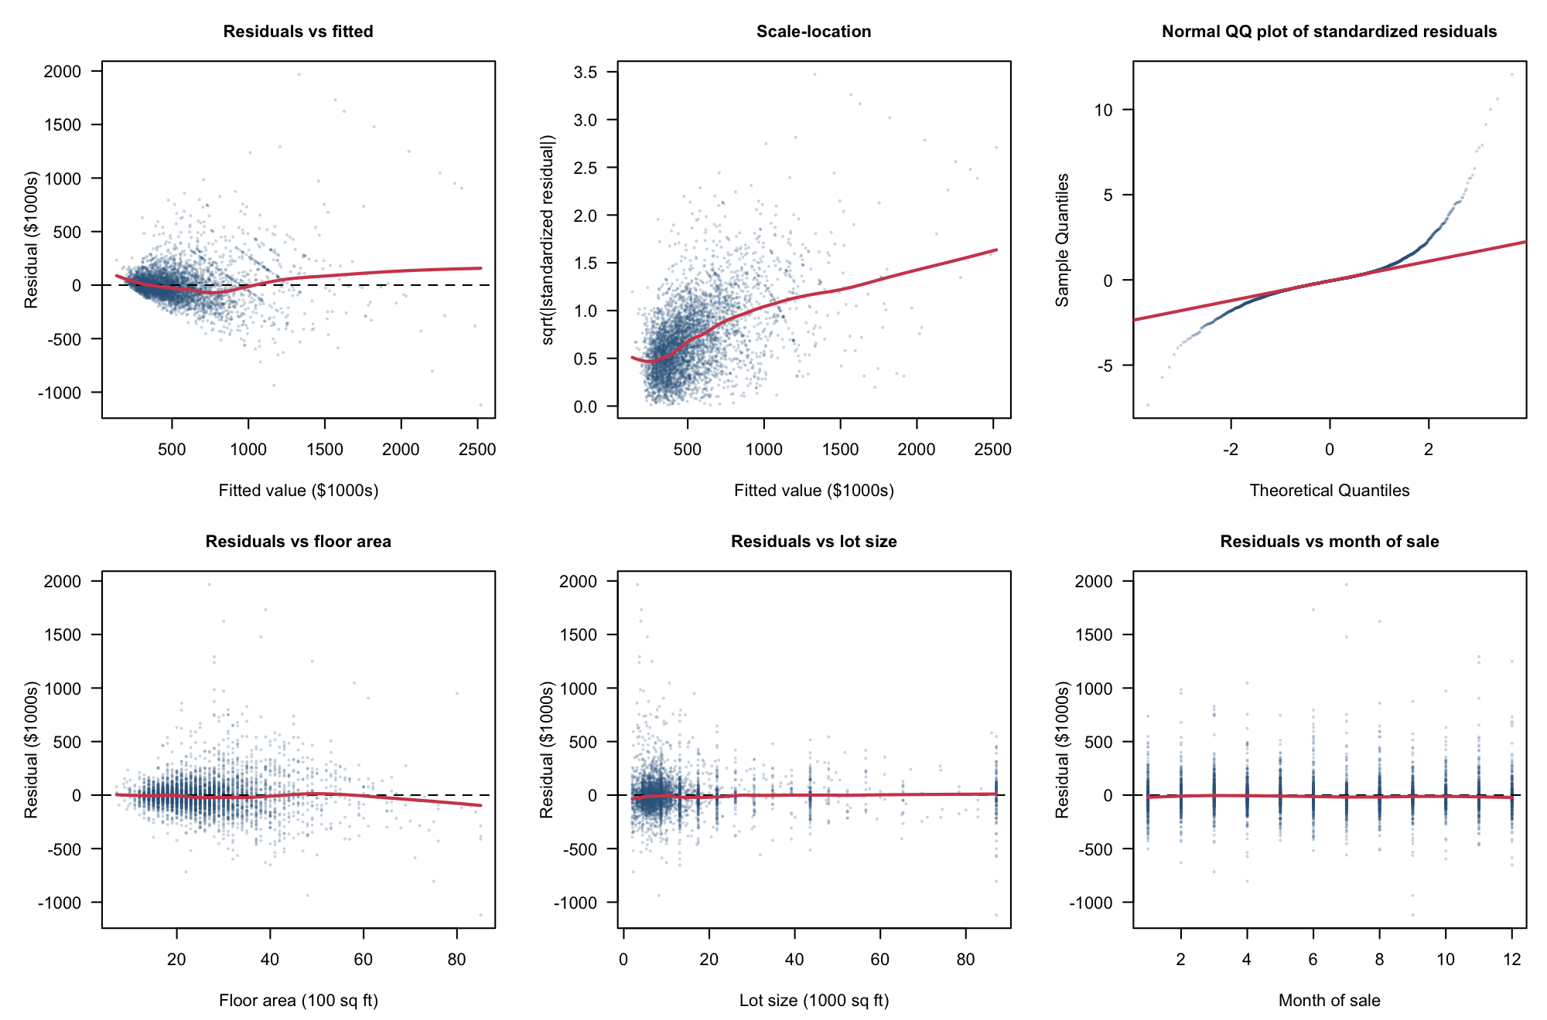
Figure 3. Residuals, scale-location, Q–Q and numerical predictors.
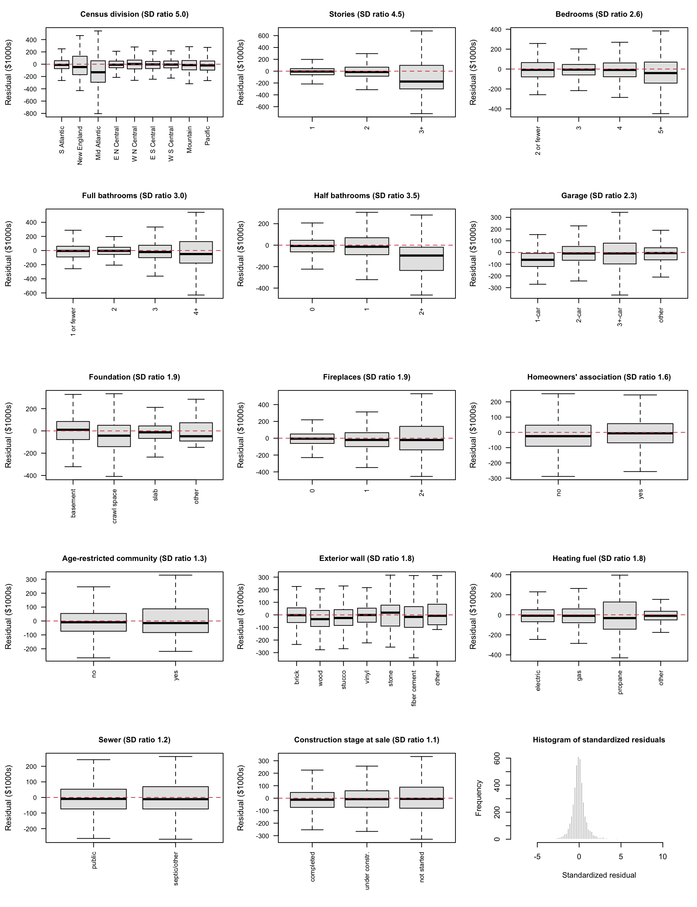
Figure 4. Categorical residuals and standardized-residual distribution.

Plan
Keep floor area, division and their interaction because they define the question; retain lot size on hedonic grounds (Rosen, 1974). Compare grouped backward selection by BIC with AIC and partial F-tests, preserving interaction hierarchy. Report disagreements rather than treating a significance threshold and BIC as identical rules. Use generalized variance inflation factors to assess collinearity.
Evaluate a Box–Cox transformation of price, including log price; compare log floor area if curvature persists. Recheck Conditions 1–2, residuals against fitted values and every predictor, constant variance and normality after each transformation and selection step. Investigate leverage, standardized residuals, Cook's distance, DFFITS and DFBETAS; remove observations only for documented errors. Assess remaining heteroscedasticity with HC3 and weighted least squares, including survey-weight sensitivity. Neither robust errors nor regional effects prove independence.
Freeze the final model before one test-set evaluation. Disclose full-sample descriptive inspection before the split and distinguish 2024 replication from held-out 2025 validation.
Completion date in 2026 | Task | Responsible member
November 12 | Transformations and diagnostics | __________
November 19 | Variable selection and influence checks | __________
November 22 | Robustness and frozen-model validation | __________
November 27 | Poster draft | __________
November 30 | Poster review | __________
December 2 | Record and review presentation | __________
December 3 | Final checks and submission | __________

Table 3. Proposed team schedule in Toronto time; assign members before submission.

Bibliography
Fox, J., & Weisberg, S. (2019). An R companion to applied regression (3rd ed.). Sage.
Glaeser, E. L., Gyourko, J., & Saks, R. (2005). Why is Manhattan so expensive? Regulation and the rise in housing prices. The Journal of Law and Economics, 48(2), 331–369. https://doi.org/10.1086/429979
Gyourko, J., & Saiz, A. (2006). Construction costs and the supply of housing structure. Journal of Regional Science, 46(4), 661–680. https://doi.org/10.1111/j.1467-9787.2006.00472.x
R Core Team. (2025). R: A language and environment for statistical computing (Version 4.4.3) [Computer software]. R Foundation for Statistical Computing. https://www.R-project.org/
Rosen, S. (1974). Hedonic prices and implicit markets: Product differentiation in pure competition. Journal of Political Economy, 82(1), 34–55. https://doi.org/10.1086/260169
University of Toronto. (2026). STA302 Embedded Ethics: Dataset ethics [Course slides]. Quercus.
U.S. Census Bureau. (n.d.). Survey of Construction microdata files: General information and variable descriptions [Documentation]. https://www.census.gov/construction/chars/pdf/socmicro_info.pdf
U.S. Census Bureau. (2026). Survey of Construction (SOC) microdata: 2025 annual file [Data set]. https://www.census.gov/construction/chars/microdata.html

Appendix A All coefficients of the preliminary model
Term | Estimate | SE | 95% CI
Intercept | 127.03 | 35.11 | (58.20, 195.86)
Floor area (per 100 sq ft) | 11.83 | 0.63 | (10.60, 13.07)
Division: New England | 355.76 | 76.85 | (205.09, 506.43)
Division: Middle Atlantic | −76.08 | 40.73 | (−155.92, 3.77)
Division: East North Central | 145.53 | 25.92 | (94.71, 196.35)
Division: West North Central | 34.89 | 32.17 | (−28.18, 97.96)
Division: East South Central | −39.31 | 27.28 | (−92.79, 14.18)
Division: West South Central | 33.91 | 23.00 | (−11.17, 79.00)
Division: Mountain | 81.27 | 25.37 | (31.53, 131.01)
Division: Pacific | −61.96 | 30.57 | (−121.89, −2.03)
Lot size (per 1000 sq ft) | 0.21 | 0.20 | (−0.17, 0.60)
Stories: 2 | −32.17 | 7.01 | (−45.91, −18.43)
Stories: 3+ | 211.47 | 19.53 | (173.17, 249.76)
Bedrooms: 3 | −35.26 | 15.73 | (−66.10, −4.42)
Bedrooms: 4 | −54.27 | 16.67 | (−86.95, −21.59)
Bedrooms: 5+ | −76.19 | 19.06 | (−113.56, −38.81)
Full bathrooms: 2 | 49.28 | 27.39 | (−4.41, 102.97)
Full bathrooms: 3 | 122.62 | 28.57 | (66.62, 178.63)
Full bathrooms: 4+ | 312.07 | 30.78 | (251.71, 372.42)
Half bathrooms: 1 | 48.75 | 6.81 | (35.41, 62.09)
Half bathrooms: 2+ | 172.85 | 23.90 | (125.99, 219.72)
Garage: 2-car | −60.46 | 14.35 | (−88.59, −32.32)
Garage: 3+-car | −33.40 | 16.08 | (−64.92, −1.88)
Garage: other | −44.13 | 20.08 | (−83.50, −4.75)
Foundation: crawl space | 91.67 | 11.23 | (69.64, 113.69)
Foundation: slab | −3.26 | 8.64 | (−20.19, 13.68)
Foundation: other | 36.24 | 57.46 | (−76.42, 148.90)
Fireplaces: 1 | 77.14 | 6.53 | (64.33, 89.95)
Fireplaces: 2+ | 93.55 | 14.50 | (65.13, 121.98)
Homeowners' association: yes | −11.59 | 6.65 | (−24.62, 1.44)
Age-restricted: yes | 27.14 | 16.95 | (−6.10, 60.37)
Exterior wall: wood | 19.68 | 15.69 | (−11.08, 50.44)
Exterior wall: stucco | 25.70 | 11.07 | (4.00, 47.39)
Exterior wall: vinyl | −31.32 | 9.71 | (−50.36, −12.28)
Exterior wall: stone | 13.42 | 23.28 | (−32.22, 59.05)
Exterior wall: fiber cement | 15.60 | 9.46 | (−2.94, 34.14)
Exterior wall: other | 52.35 | 45.44 | (−36.74, 141.44)
Heating fuel: gas | 21.83 | 6.80 | (8.51, 35.16)
Heating fuel: propane | −61.53 | 26.73 | (−113.94, −9.13)
Heating fuel: other | 9.10 | 25.77 | (−41.41, 59.62)
Sewer: septic or other | −13.59 | 10.66 | (−34.49, 7.32)
Stage at sale: under construction | −1.83 | 5.81 | (−13.22, 9.57)
Stage at sale: not started | 15.31 | 8.38 | (−1.11, 31.74)
Month of sale | 1.44 | 0.74 | (−0.02, 2.90)
Floor area × New England | 7.43 | 2.17 | (3.17, 11.68)
Floor area × Middle Atlantic | 12.72 | 1.21 | (10.36, 15.09)
Floor area × East North Central | −4.98 | 0.91 | (−6.76, −3.21)
Floor area × West North Central | −1.26 | 1.20 | (−3.62, 1.10)
Floor area × East South Central | 1.95 | 1.00 | (−0.02, 3.91)
Floor area × West South Central | −2.57 | 0.82 | (−4.18, −0.96)
Floor area × Mountain | 2.77 | 0.87 | (1.06, 4.47)
Floor area × Pacific | 9.86 | 1.17 | (7.56, 12.16)

Table A1. Ordinary least squares estimates for the preliminary model (response: sale price in $1000s; training set, n = 4,330; R² = 0.713). Reference levels are listed in Table 1. Code: Part1_Code.Rmd.

Service Supply and Ridership Across Transit Agency Types
STA302H1 Fall 2026 | Group 62 | Part 1 Research Proposal

Contributions
Group 62
Member name | Contribution to this proposal
__________ | __________
__________ | __________
__________ | __________
__________ | __________

Introduction
For US transit agencies in 2024, does the association between annual passenger trips and vehicle revenue hours differ between the fixed-route comparison group and demand-response-only agencies, after adjustment for service composition, speed, number of modes, rural status, organizational form and region? Unlinked passenger trips count boardings, including transfers; vehicle revenue hours measure time providing passenger service.
The response is log annual trips. In a log–log linear regression, the service-hours slope is an elasticity: the approximate percentage difference in trips associated with a 1% difference in service hours. The service-type interaction estimates the difference between the two slopes. We report its confidence interval and partial F-test, together with both group slopes. Comparing mean trips per hour would not adjust for agency size and composition.
Parry and Small (2009) modelled transit pricing and service in Washington, Los Angeles and London. Their welfare analysis supported substantial subsidies after accounting for congestion and service-related economies. It motivates considering service supply, but does not imply that our cross-sectional elasticity must exceed one. Taylor et al. (2009) analysed 265 US urbanized areas with simultaneous-equation models, finding important roles for external conditions and service provision. Their treatment of joint supply and demand highlights an identification limitation of our descriptive OLS model. Currie and Fournier (2020) reviewed international demand-responsive and microtransit services, finding high failure rates associated with costs. This motivates service-type heterogeneity, but failure rates do not establish a ridership elasticity.
Our contribution is a recent agency-level comparison with an explicit service-type interaction and documented grouping rule. We do not equate a larger agency with a successful service expansion. Transit planners can use the results to benchmark agencies and formulate questions about service design. Causal forecasts of additional riders would require stronger identification; equity and accessibility benefits must be assessed separately.

Data description
FTA's NTD 2024 administrative reports document service for funding allocation and industry monitoring (FTA, n.d.). Aggregating modes and excluding flags, zero activity and territories leaves 2,135 agencies; 1,494 train and 641 test. Log trips are continuous; agencies may share state conditions. DR-only means demand-response hours share ≥0.999, near a natural spike at one; the continuous share remains a control. This grouping motivates the service-hours interaction without identifying causal expansion effects.
Table 1. Training summaries; N: mean(SD), C: category counts, reference first. No missing values after cleaning. Raw totals are highly skewed; most rail/vanpool shares are zero.
Variable | Type | Summary
Log trips (Y) | N | 11.24(2.25); median 10.94; range 3.61–19.55
Log hours | N | 9.88(1.65)
DR share | N | 0.60(0.41); 651 exactly one
Rail share | N | 0.017(0.123)
Vanpool share | N | 0.014(0.104)
Contracted share | N | 0.22(0.40)
Log speed (mph) | N | 2.73(0.43)
Modes | N | 1.55(0.74)
Service type | C | fixed-route:842; DR-only:652
Rural | C | no:726; yes:768
Organization | C | government:744; authority:285; nonprofit:249; other:137; tribe:79
Region | C | Midwest:507; South:431; West:396; Northeast:160

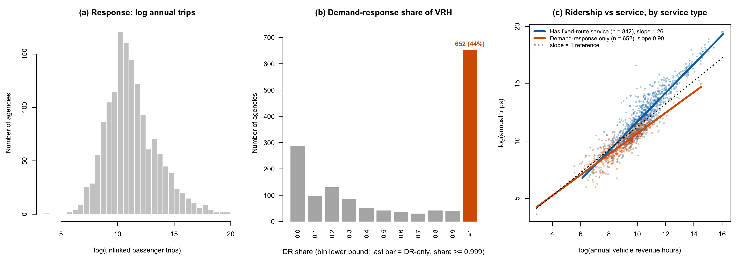
Figure 1. Log trips, DR-share distribution and unadjusted group relationships.

Ethics discussion
Under the first ethics module's trustworthiness criteria, these are collected administrative records rather than simulated data. FTA provides an identifiable original source, variable definitions and reporting guidance. Validation flags allow documented exclusions; a public agency's involvement is useful provenance, not a guarantee that every self-reported value is correct. We use fields available across reporter types and disclose selection from excluding flagged agencies.
Privacy risks are limited because the analysis concerns agency aggregates, not identifiable passengers. For consent, reporting obligations attached to public funding are not equivalent to individual passenger consent; we do not infer either from the availability of a file. For ownership, we attribute FTA and preserve the source and definitions. Our descriptive use is consistent with industry monitoring. Lower observed ridership per service hour does not mean demand-responsive trips have less social value: agencies may serve disabled people, older adults or isolated communities. Results therefore cannot, on their own, justify service cuts or causal forecasts.

Preliminary results
OLS uses 11 predictors plus the service interaction, on log trips (n=1,494). The log–log form defines the elasticity response. R²=0.930, adjusted R²=0.929; the slope difference is −0.311 (SE=0.025). Table 2 shows conventional uncertainty, conditional on assumptions.
Conditions 1–2 are approximately satisfied by the observed–fitted and predictor-pair plots. Residual smoothers show no marked curvature. Constant variance is mildly violated by narrowing spread; normality is mildly violated by heavy tails and 16 standardized residuals beyond ±3. State residual ICC≈0.04 suggests possible dependence (Figures 2–4). No remedies are applied.
Service-type differences are compatible with the settings of Parry and Small (2009) and Currie and Fournier (2020), but do not demonstrate their mechanisms. Taylor et al. (2009) emphasize simultaneous supply and demand, which limits causal interpretation. The negative speed association may reflect long commuter services; number of modes is inconclusive.
Table 2. Preliminary estimates, standard errors and 95% confidence intervals.
Term | Estimate | SE | 95% CI
Intercept | 12.903 | 0.121 | (12.666, 13.141)
log VRH, centred (fixed-route elasticity) | 1.222 | 0.018 | (1.186, 1.258)
DR-only (vs fixed-route) | 0.113 | 0.075 | (−0.035, 0.261)
log VRH × DR-only | −0.311 | 0.025 | (−0.360, −0.263)
DR-only elasticity (sum of the two slopes) | 0.910 | 0.019 | (0.873, 0.947)
Demand-response share | −1.532 | 0.079 | (−1.688, −1.376)
Rail share | 0.765 | 0.135 | (0.500, 1.029)
Vanpool share | −0.631 | 0.168 | (−0.961, −0.301)
Contracted share | −0.157 | 0.043 | (−0.242, −0.073)
log speed | −0.239 | 0.039 | (−0.316, −0.161)
Number of modes | −0.026 | 0.036 | (−0.095, 0.044)
Rural reporter | −0.135 | 0.039 | (−0.213, −0.058)
Org.: Authority | 0.022 | 0.048 | (−0.072, 0.116)
Org.: Non-profit | −0.125 | 0.047 | (−0.218, −0.032)
Org.: Other | 0.032 | 0.060 | (−0.085, 0.150)
Org.: Tribe | −0.623 | 0.082 | (−0.783, −0.463)
Region: Northeast | −0.068 | 0.059 | (−0.184, 0.047)
Region: South | −0.196 | 0.041 | (−0.276, −0.116)
Region: West | −0.046 | 0.044 | (−0.133, 0.041)

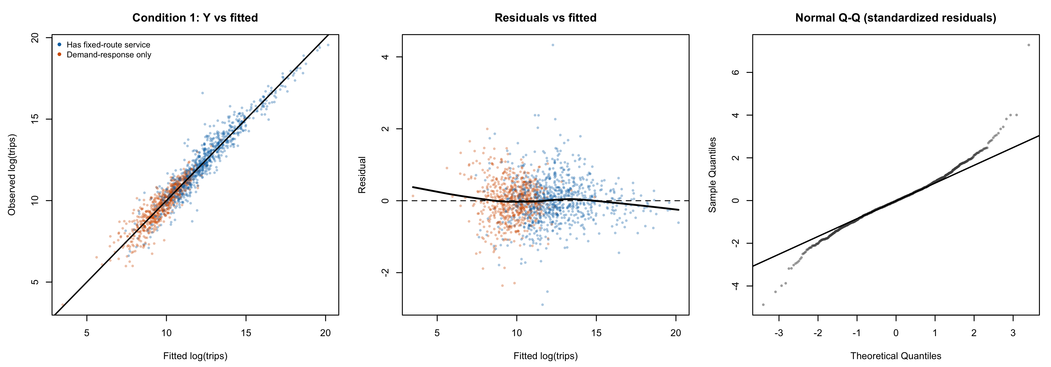
Figure 2. Observed–fitted, residual–fitted and Q–Q plots.
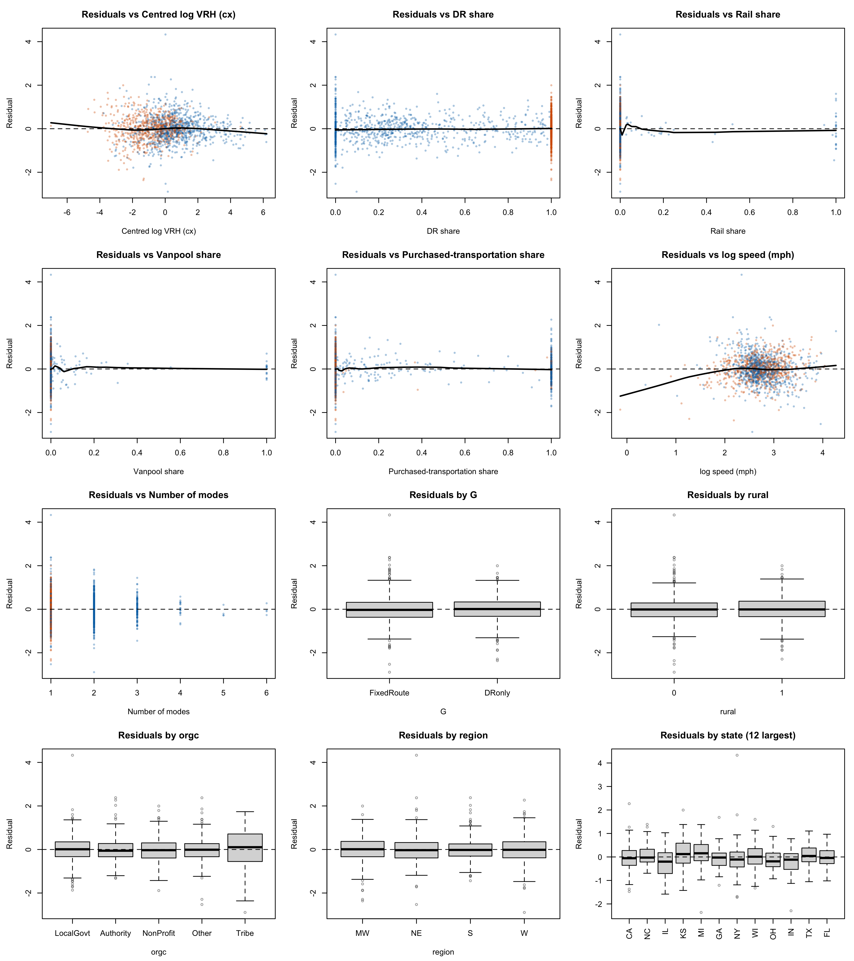
Figure 3. Residuals against all numerical and categorical predictors.
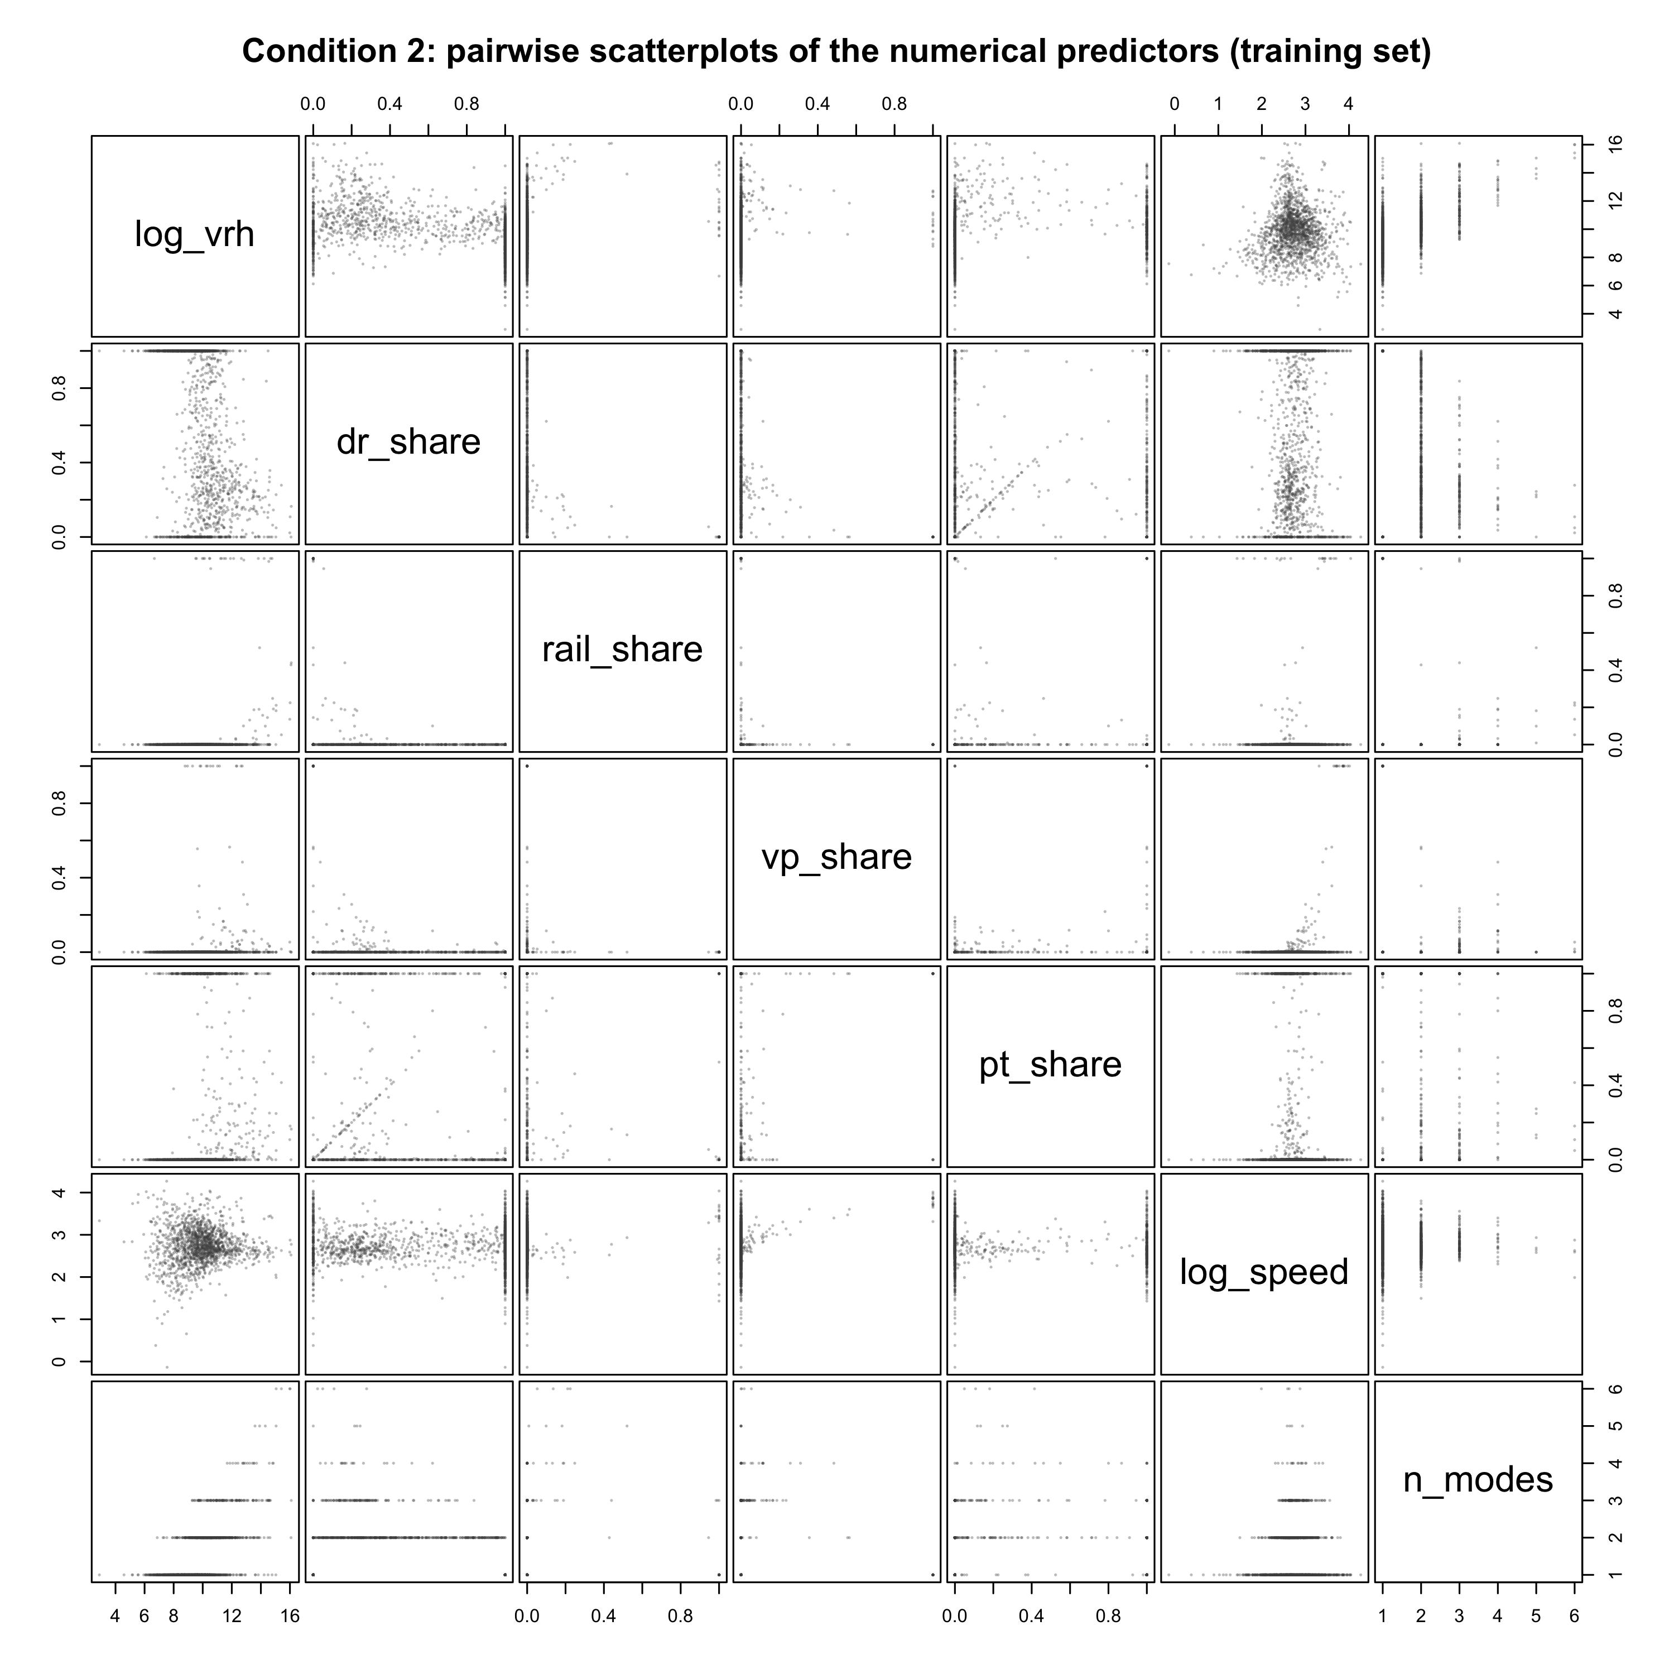
Figure 4. Numerical predictor pairs.

Plan
Keep service hours, service type and their interaction; retain demand-response share and rural status to address composition differences. Compare grouped backward BIC selection with AIC, adjusted R² and partial F-tests, preserving hierarchy and theoretically necessary terms. Evaluate rival service-hours interactions and alternative DR-only thresholds as sensitivity checks, not as a search for smaller p-values.
After every model change, redraw Conditions 1–2 and residual plots for fitted values and all predictors. Examine influence and generalized variance inflation factors. Use Box–Cox as a diagnostic of the chosen response scale; assess remaining unequal variance using HC3 and weighted least squares. Compare region with state effects and examine residual spatial dependence and state-clustered uncertainty. These checks do not resolve joint determination of service supply and demand.
Freeze the model before one test-set evaluation. Disclose exploratory changes to the service-type definition and the earlier overlapping-year probe. The corrected 2023 check excludes current test agencies but remains a repeated-agency stability check, not independent replication.
Completion date in 2026 | Task | Responsible member
November 12 | Transformations and diagnostics | __________
November 19 | Variable selection and influence checks | __________
November 22 | Robustness and frozen-model validation | __________
November 27 | Poster draft | __________
November 30 | Poster review | __________
December 2 | Record and review presentation | __________
December 3 | Final checks and submission | __________

Table 3. Proposed team schedule in Toronto time; assign members before submission.

Bibliography
Currie, G., & Fournier, N. (2020). Why most DRT/Micro-Transits fail – What the survivors tell us about progress. Research in Transportation Economics, 83, Article 100895. https://doi.org/10.1016/j.retrec.2020.100895
Federal Transit Administration. (n.d.). 2024 annual data view: Service (by mode) [Data set]. U.S. Department of Transportation. Retrieved September 30, 2026, from https://data.transportation.gov/d/4fir-qbim
Litman, T. (2004). Transit price elasticities and cross-elasticities. Journal of Public Transportation, 7(2), 37–58. https://doi.org/10.5038/2375-0901.7.2.3
National transit database, 49 U.S.C. § 5335 (2024).
Parry, I. W. H., & Small, K. A. (2009). Should urban transit subsidies be reduced? American Economic Review, 99(3), 700–724. https://doi.org/10.1257/aer.99.3.700
Taylor, B. D., Miller, D., Iseki, H., & Fink, C. (2009). Nature and/or nurture? Analyzing the determinants of transit ridership across US urbanized areas. Transportation Research Part A: Policy and Practice, 43(1), 60–77. https://doi.org/10.1016/j.tra.2008.06.007
University of Toronto. (2026). STA302 Embedded Ethics: Dataset ethics [Course slides]. Quercus.

Endowment Wealth and Faculty Salaries Across University Sectors
STA302H1 Fall 2026 | Group 62 | Part 1 Research Proposal

Contributions
Group 62
Member name | Contribution to this proposal
__________ | __________
__________ | __________
__________ | __________
__________ | __________

Introduction
Among US four-year public and private nonprofit institutions, how is average full-time instructional salary associated with endowment wealth per full-time-equivalent student, and does the association differ by sector after adjustment for institution type, geography, enrolment, tuition, staffing and student composition? Salary is an institution-level average across ranks, standardized to nine-month contracts and measured in thousands of dollars. The exposure is log10 endowment per student, so one unit represents a tenfold wealth difference.
Sector means alone mix endowment with research intensity, location and workforce composition. Multiple linear regression adjusts for those measured characteristics. The endowment-by-sector coefficient estimates the slope difference; its confidence interval, partial F-test and the two implied sector slopes answer our question. These estimates cannot establish that increasing an institution's endowment would increase pay.
Alexander (2001) examined US public–private faculty compensation differences since 1980 and found faster compensation growth at private research and doctoral universities. This motivates sector comparisons and adjustment for institutional type. Rippner and Toutkoushian (2015), using more than 1,000 institutions, found that the public salary disadvantage was concentrated in research-intensive institutions and widened during 2001–2011 after adjustment for financial resources. This supports retaining Carnegie classification and cautions against attributing sector differences solely to wealth. Martinello (2006) studied 15 Ontario universities during 1970/71–2003/04; salary changes tracked funding regimes and varied with staffing. This motivates attention to public funding and faculty composition, while its Canadian setting limits direct extrapolation.
Ehrenberg's (2003) published presidential address additionally connects private-sector salary dispersion with endowments and public-sector dispersion with appropriations. It supplies a mechanism, alongside the three research articles above. Our 2023 application estimates the sector-specific endowment associations within one model. University boards and faculty associations can use these descriptive benchmarks when comparing institutional resources and compensation, without treating them as causal policy effects or individual salary predictions.

Data description
NCES IPEDS 2023 uses mandatory institutional reports for federal statistics and consumer information (NCES, n.d.). We join directory, salary, finance and enrolment files, retain complete public/nonprofit four-year institutions with ≥20 instructional staff, and select the largest campus per system: 1,070 institutions; 749 train, 321 test. Salary is continuous and right-skewed. Distinct employers may remain dependent. Sector-specific resources motivate endowment-by-sector interaction; log10 wealth accommodates its wide range.
Table 1. Training summaries; N: mean(SD), C: counts, reference first. Complete cases; tuition/rank shares are skewed. Small categories and institutional averages limit interpretation.
Variable | Type | Summary
Salary ($1000) | N | 81.74(27.39); median 76.06; range 26.10–217.91
Log10 endowment/FTE ($1000) | N | 1.51(0.66)
Log10 FTE | N | 3.47(0.52)
Tuition/FTE ($1000) | N | 16.25(8.30)
Student–faculty ratio | N | 12.90(3.84)
Full professors (%) | N | 27.53(11.90)
Instructors/lecturers/unranked (%) | N | 15.29(16.22)
Women students (%) | N | 57.45(11.25)
Sector | C | public:163; private:586
Carnegie | C | BA-arts:132; BA-diverse:108; doctoral-professional:92; masters-large:133; masters-other:139; R1:85; R2:60
State group | C | 42 levels; reference AL; largest PA:54; smallest NM:3
Locale | C | city:358; rural:63; suburb:178; town:150
Medical school | C | no:664; yes:85
HBCU | C | no:714; yes:35

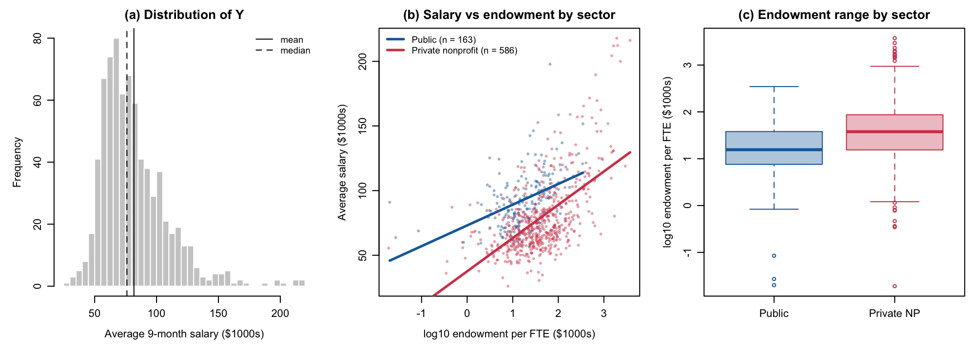
Figure 1. Salary distribution and sector-specific endowment relationships.

Ethics discussion
The first ethics module distinguishes collected data from simulation and asks for metadata, source provenance and external scrutiny. IPEDS consists of institutional reports with published definitions and edit procedures. NCES provenance and documentation support trustworthiness, but institutional reporting errors and differences between GASB and FASB accounting remain possible. Public endowments held by separate foundations may be incompletely measured.
Privacy is protected by analysing institutional salary aggregates rather than individual pay. The repository's directory copies omit chief-administrator names and titles; those fields are unnecessary for the research. Regarding consent, mandatory institutional reporting for federal aid participation should not be described as personal consent from every employee. Our use stays at the institutional level and avoids re-identification. Regarding ownership, we cite NCES and retain data provenance. We will not rank individual institutions or interpret associations as the causal effects of wealth on employee salaries. Filters exclude for-profit and small institutions, so conclusions must not be generalized to all higher education employers.

Preliminary results
OLS fits 13 predictors plus endowment-by-sector interaction (62 coefficients; n=749). R²=0.849, adjusted R²=0.836. Table 2 reports conventional uncertainty; the slope difference is $15.04k (SE=1.88) per tenfold endowment difference.
Conditions 1–2 approximately hold: observed–fitted association is linear and numerical predictor pairs show only mild curvature. Linearity is mildly violated by U-shaped residuals. Variance increases with fitted salary and differs by Carnegie class. Normality is violated by a heavy upper tail; ten standardized residuals exceed three. Figures 2–4 support these diagnoses. One campus per system reduces a dependence source, but state effects do not prove independence. No remedies are applied.
Private salaries show a stronger wealth association, compatible with Ehrenberg (2003) and Alexander (2001). The R1 premium supports Carnegie adjustment (Rippner & Toutkoushian, 2015); staffing/funding patterns are consistent with Martinello (2006). The negative women-student coefficient is not an individual gender-pay effect. Public estimates remain uncertain; near-zero is not proof of no association.
Table 2. Preliminary estimates, SEs and 95% intervals; 41 state effects omitted. Complete estimates appear in Appendix A.
Term | Estimate | SE | 95% CI
log10 endowment per FTE (public slope) | −0.25 | 1.72 | (−3.62, 3.11)
Private nonprofit (at log endowment = 0) | −22.10 | 2.78 | (−27.56, −16.64)
log endowment × private (slope difference) | 15.04 | 1.88 | (11.34, 18.73)
Implied private slope | 14.78 | 1.11 | (12.60, 16.97)
Carnegie: R1 | 20.59 | 2.87 | (14.96, 26.23)
Carnegie: R2 | 5.79 | 2.43 | (1.01, 10.56)
Carnegie: doctoral/professional | 2.19 | 1.91 | (−1.56, 5.94)
Carnegie: master's large | 2.41 | 1.82 | (−1.17, 5.99)
Carnegie: master's medium/small | 2.51 | 1.61 | (−0.66, 5.68)
Carnegie: baccalaureate diverse | 1.02 | 1.73 | (−2.37, 4.41)
log10 FTE enrolment | 22.88 | 2.04 | (18.86, 26.89)
Tuition revenue per FTE ($1000s) | 0.63 | 0.08 | (0.47, 0.79)
Student–faculty ratio | −0.61 | 0.18 | (−0.95, −0.26)
% full professors | 0.24 | 0.04 | (0.15, 0.33)
% instructors/lecturers/no rank | 0.06 | 0.03 | (0.01, 0.12)
% women students | −0.16 | 0.04 | (−0.24, −0.08)
Locale: rural / suburb / town | −3.57 / 0.60 / −0.85 | 1.69 / 1.10 / 1.24 | (−6.89, −0.24) / (−1.56, 2.75) / (−3.29, 1.58)
Medical school | −1.05 | 1.91 | (−4.81, 2.71)
HBCU | 2.42 | 2.18 | (−1.85, 6.69)
Intercept | −5.60 | 7.76 | (−20.83, 9.63)

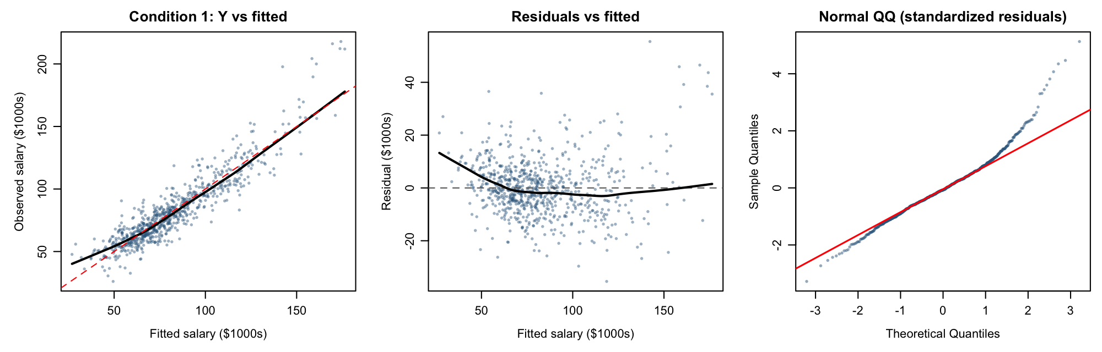
Figure 2a. Observed–fitted, residual–fitted and Q–Q plots.
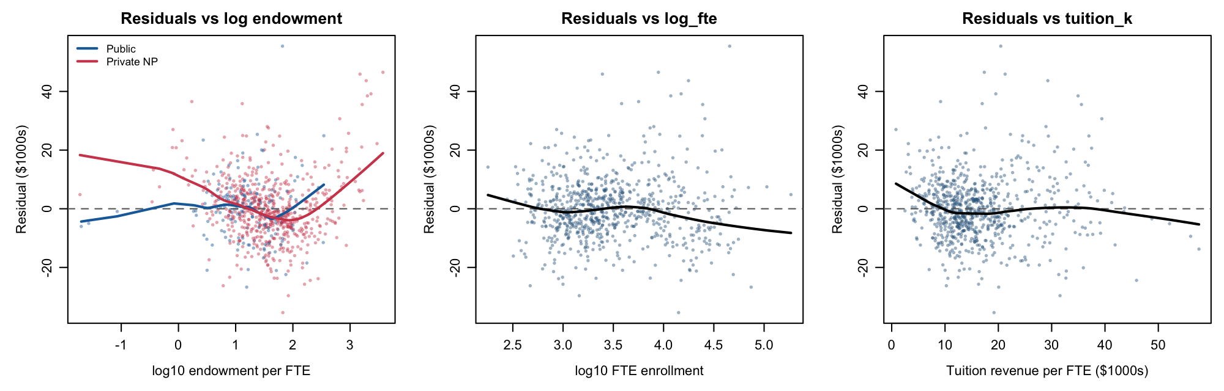
Figure 2b. Numerical predictor residuals.
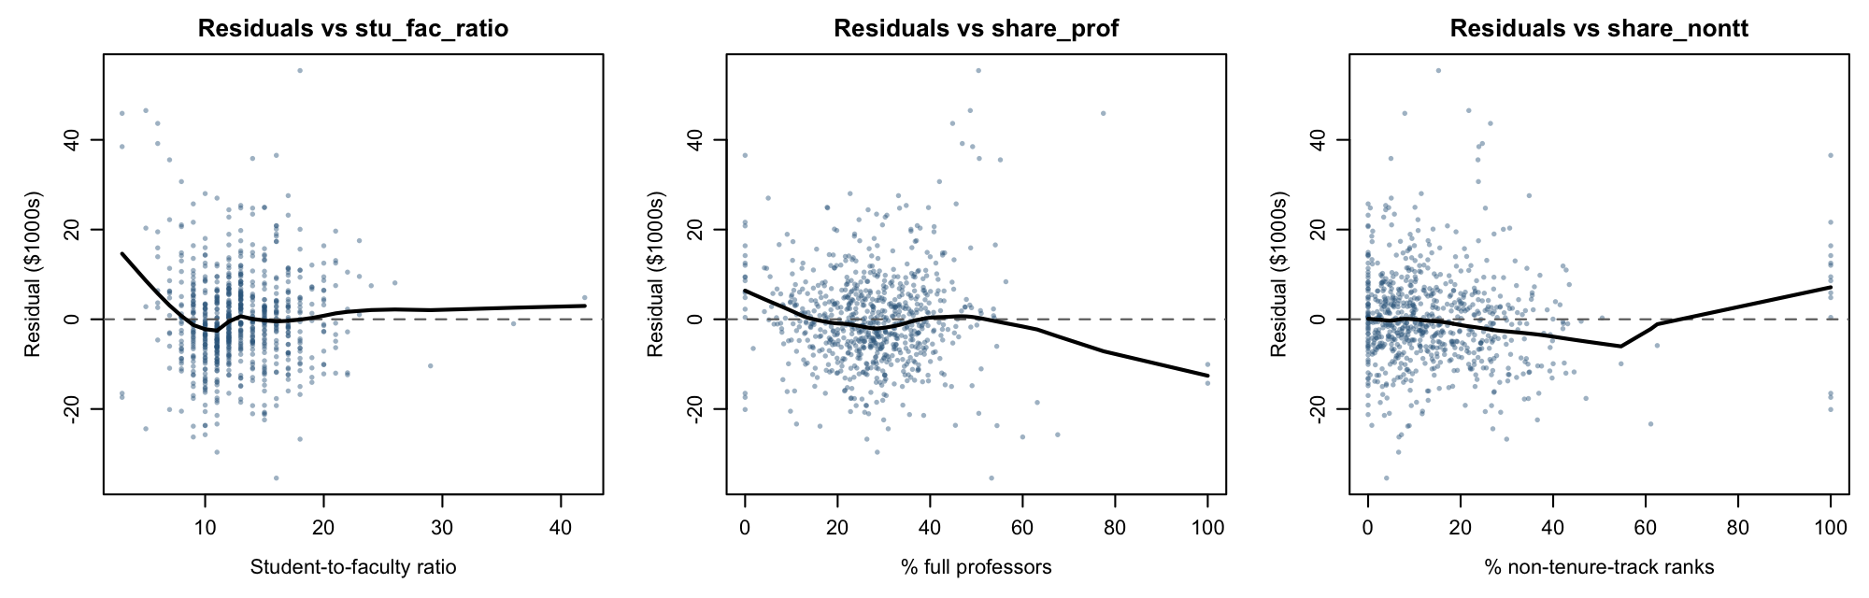
Figure 2c. Numerical predictor residuals.
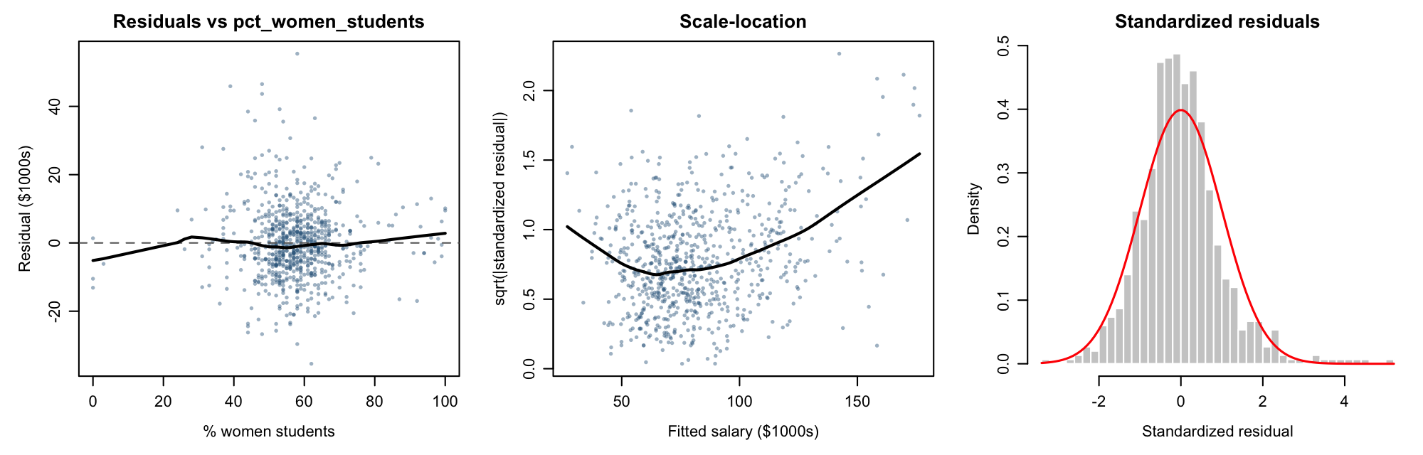
Figure 2d. Numerical residuals and distribution diagnostics.
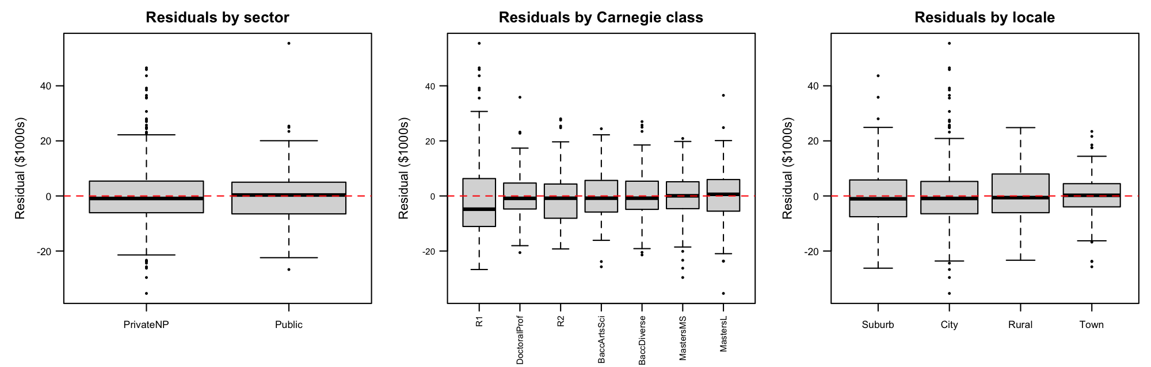
Figure 3a. Categorical predictor residuals.
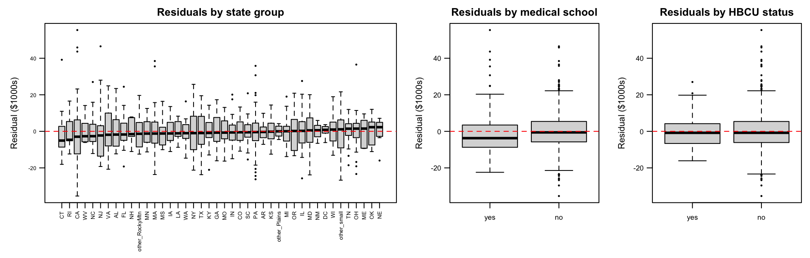
Figure 3b. Remaining categorical predictor residuals.
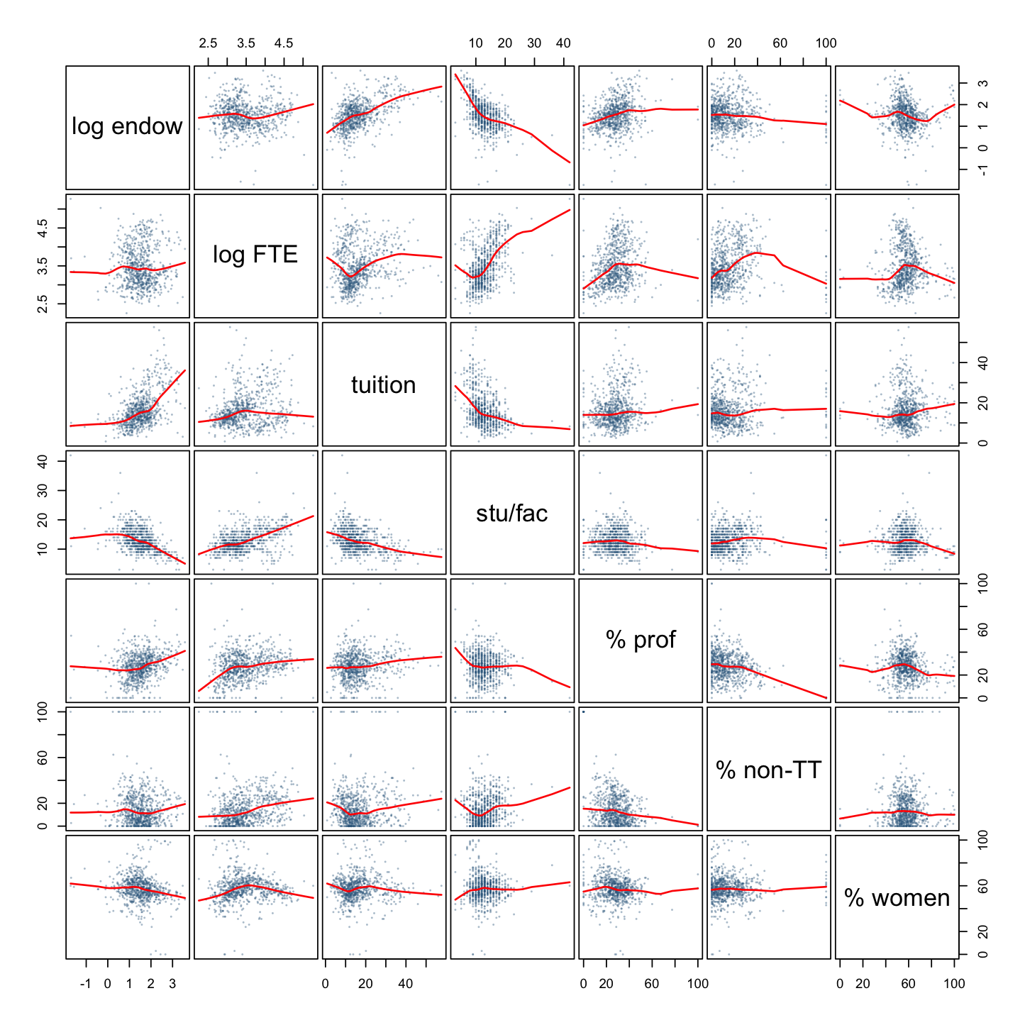
Figure 4. Numerical predictor pairs.

Plan
Retain endowment, sector, their interaction, Carnegie classification and state group for the research question and institutional context. Compare grouped backward BIC selection with AIC, adjusted R² and partial F-tests; retain hierarchy and explain any trade-off with substantive controls.
Use Box–Cox to assess salary transformations, comparing the suggested power with log salary. Centre log endowment to improve interpretation and reduce structural collinearity. If curvature remains, evaluate a centred quadratic endowment term and its sector interaction. Reassess Conditions 1–2 and all residual plots after every transformation and every selection step, then on the final model. Investigate leverage, standardized residuals, Cook's distance, DFFITS and DFBETAS without deleting valid records solely for influence.
Assess HC3 and state-clustered uncertainty, spatial residual association, admission-rate and appropriation controls, competing interactions and the staff threshold of ten. Freeze the final model before one evaluation on the existing test IDs. Disclose that earlier alternative probes overlapped the present test institutions; the corrected R workflow does not restore a completely untouched holdout.
Completion date in 2026 | Task | Responsible member
November 12 | Transformations and diagnostics | __________
November 19 | Variable selection and influence checks | __________
November 22 | Robustness and frozen-model validation | __________
November 27 | Poster draft | __________
November 30 | Poster review | __________
December 2 | Record and review presentation | __________
December 3 | Final checks and submission | __________

Table 3. Proposed team schedule in Toronto time; assign members before submission.

Bibliography
Alexander, F. K. (2001). The silent crisis: The relative fiscal capacity of public universities to compete for faculty. The Review of Higher Education, 24(2), 113–129. https://doi.org/10.1353/rhe.2000.0027
Ehrenberg, R. G. (2003). Studying ourselves: The academic labor market. Journal of Labor Economics, 21(2), 267–287. https://doi.org/10.1086/345558
Fox, J., & Weisberg, S. (2019). An R companion to applied regression (3rd ed.). Sage.
Martinello, F. (2006). University revenues and faculty salaries in Ontario: 1970/71–2003/04. Canadian Public Policy, 32(4), 349–371. https://doi.org/10.3138/8624-6wh4-5457-873n
National Center for Education Statistics. (n.d.). Integrated Postsecondary Education Data System (IPEDS): Complete data files [Data set]. U.S. Department of Education, Institute of Education Sciences. Retrieved September 30, 2026, from https://nces.ed.gov/ipeds/datacenter/DataFiles.aspx
R Core Team. (2025). R: A language and environment for statistical computing (Version 4.4.3) [Computer software]. R Foundation for Statistical Computing. https://www.R-project.org/
Rippner, J. A., & Toutkoushian, R. K. (2015). The 'Big Bang' in public and private faculty salaries. Journal of Education Finance, 41(2), 103–123. https://doi.org/10.1353/jef.2015.a602601
University of Toronto. (2026). STA302 Embedded Ethics: Dataset ethics [Course slides]. Quercus.
Venables, W. N., & Ripley, B. D. (2002). Modern applied statistics with S (4th ed.). Springer.

Appendix A Complete preliminary coefficient estimates
All 62 estimates are in thousands of dollars, with conventional standard errors and 95% intervals. State effects use Alabama as reference. These are uncorrected preliminary-model estimates.
Model term | Estimate | SE | 95% CI
Intercept | -5.60 | 7.76 | (-20.83, 9.63)
Log10 endowment per FTE | -0.25 | 1.72 | (-3.62, 3.11)
Private nonprofit | -22.10 | 2.78 | (-27.56, -16.64)
Carnegie BaccDiverse | 1.02 | 1.73 | (-2.37, 4.41)
Carnegie DoctoralProf | 2.19 | 1.91 | (-1.56, 5.94)
Carnegie MastersL | 2.41 | 1.82 | (-1.17, 5.99)
Carnegie MastersMS | 2.51 | 1.61 | (-0.66, 5.68)
Carnegie R1 | 20.59 | 2.87 | (14.96, 26.23)
Carnegie R2 | 5.79 | 2.43 | (1.01, 10.56)
State AR | -7.39 | 4.84 | (-16.88, 2.10)
State CA | 16.84 | 3.82 | (9.34, 24.34)
State CO | 1.14 | 4.81 | (-8.31, 10.59)
State CT | 11.00 | 4.83 | (1.52, 20.49)
State DC | 9.44 | 6.05 | (-2.44, 21.32)
State FL | 6.27 | 4.19 | (-1.96, 14.51)
State GA | -3.32 | 4.15 | (-11.46, 4.83)
State IA | -2.22 | 4.38 | (-10.83, 6.38)
State IL | 0.99 | 3.77 | (-6.41, 8.39)
State IN | -4.25 | 4.05 | (-12.20, 3.70)
State KS | -3.80 | 4.65 | (-12.93, 5.32)
State KY | -4.30 | 4.26 | (-12.65, 4.06)
State LA | -8.46 | 5.63 | (-19.51, 2.59)
State MA | 12.70 | 3.92 | (5.00, 20.40)
State MD | 6.08 | 5.17 | (-4.08, 16.24)
State ME | 5.61 | 5.74 | (-5.67, 16.88)
State MI | -0.87 | 3.96 | (-8.65, 6.90)
State MN | 0.77 | 4.54 | (-8.14, 9.67)
State MO | -1.35 | 4.00 | (-9.20, 6.50)
State MS | -10.12 | 6.08 | (-22.06, 1.82)
State NC | 0.26 | 3.92 | (-7.43, 7.96)
State NE | -3.20 | 5.16 | (-13.33, 6.93)
State NH | 4.98 | 6.09 | (-6.97, 16.94)
State NJ | 20.53 | 4.29 | (12.11, 28.96)
State NM | 2.10 | 7.24 | (-12.11, 16.32)
State NY | 6.30 | 3.69 | (-0.94, 13.54)
State OH | -2.10 | 3.74 | (-9.45, 5.25)
State OK | -4.83 | 4.81 | (-14.27, 4.61)
State OR | 4.07 | 4.63 | (-5.02, 13.15)
State PA | 2.24 | 3.67 | (-4.96, 9.43)
State RI | 13.18 | 5.38 | (2.62, 23.73)
State SC | -1.75 | 4.00 | (-9.60, 6.10)
State TN | -4.13 | 4.16 | (-12.29, 4.03)
State TX | -2.19 | 3.85 | (-9.74, 5.37)
State VA | 5.50 | 3.90 | (-2.15, 13.15)
State WA | 3.50 | 4.70 | (-5.74, 12.73)
State WI | 2.94 | 4.27 | (-5.44, 11.32)
State WV | -3.65 | 5.16 | (-13.77, 6.48)
State other_Plains | -0.90 | 6.03 | (-12.74, 10.94)
State other_RockyMtn | 4.04 | 4.55 | (-4.89, 12.96)
State other_small | 9.64 | 4.42 | (0.96, 18.33)
Locale Rural | -3.57 | 1.69 | (-6.89, -0.24)
Locale Suburb | 0.60 | 1.10 | (-1.56, 2.75)
Locale Town | -0.85 | 1.24 | (-3.29, 1.58)
log_fte | 22.88 | 2.04 | (18.86, 26.89)
tuition_k | 0.63 | 0.08 | (0.47, 0.79)
stu_fac_ratio | -0.61 | 0.18 | (-0.95, -0.26)
share_prof | 0.24 | 0.04 | (0.15, 0.33)
share_nontt | 0.06 | 0.03 | (0.01, 0.12)
pct_women_students | -0.16 | 0.04 | (-0.24, -0.08)
medicalyes | -1.05 | 1.91 | (-4.81, 2.71)
hbcuyes | 2.42 | 2.18 | (-1.85, 6.69)
Endowment by private nonprofit | 15.04 | 1.88 | (11.34, 18.73)

Technical Supplements for the Three Projects
These sections describe exploratory training-set work already present in the project repositories. They are separate from the uncorrected preliminary results in the Part 1 proposals. The numbers below are training fit and sensitivity results unless a different sample is explicitly identified. They are not held-out predictive performance.

New home prices

Data construction and specification
The source file contains 25,246 SOC records. Filtering leaves 16,849 homes built for sale, 8,901 with a 2025 sales contract, 8,532 with reported price, 7,062 detached homes outside condominium projects, 6,315 with reported floor and lot area, and 6,185 with valid categorical codes. The fixed split contains 4,330 training and 1,855 test homes.
The preliminary response is price in thousands of dollars. Its 17 predictors are floor area, division, lot size, sale month, stories, bedrooms, full bathrooms, half bathrooms, garage, foundation, fireplaces, homeowners' association, age restriction, wall material, heating fuel, sewer and sale stage. Floor area interacts with division. Category indicators count as levels of a predictor, not separate predictors for the course minimum. Sale stage is constructed from dates; lot value, permit valuation and final-price fields are excluded to avoid mechanically explaining price with its components or proxies.

Transformations and selection
The Box–Cox profile for the preliminary response peaks at approximately −0.421, with a 95% profile interval of −0.470 to −0.372. Both logarithmic and approximately inverse-square-root responses were explored. A log response was retained for interpretation, with log floor area addressing curvature; this choice is a trade-off, not a claim that every assumption is satisfied. Log floor area was centred to reduce structural collinearity.
Grouped backward BIC selection retained the focal interaction and lot size, while removing homeowners' association, age restriction, sewer, sale month and sale stage. AIC retained more controls. The final training specification has log price as response and log floor area by division, lot size, stories, bedrooms, both bathroom counts, garage, foundation, fireplaces, wall material and heating fuel as predictors. It contains 46 coefficients.
Measure | Preliminary | Selected log model
R² / adjusted R² | 0.713 / 0.710 | 0.756 / 0.753
Residual skewness / excess kurtosis | 2.04 / 18.0 | 0.48 / 2.52
Largest Cook distance | 0.18 | 0.022
Interaction HC3 p | 7.5e-24 | 1.6e-10

R² changes across response scales should not be read as a direct improvement in original-dollar predictive accuracy. The final residuals remain imperfect; neither the transformation nor a small interaction p-value establishes independent errors.

Regional estimates and sensitivity
Division | Log-model elasticity | 95% interval | Associated price difference for 10% more area
South Atlantic | 0.679 | 0.630–0.727 | 6.7%
New England | 0.632 | 0.448–0.815 | 6.2%
Middle Atlantic | 0.735 | 0.633–0.837 | 7.3%
East North Central | 0.525 | 0.462–0.589 | 5.1%
West North Central | 0.535 | 0.462–0.608 | 5.2%
East South Central | 0.702 | 0.628–0.775 | 6.9%
West South Central | 0.734 | 0.677–0.791 | 7.2%
Mountain | 0.584 | 0.523–0.645 | 5.7%
Pacific | 0.727 | 0.650–0.804 | 7.2%

The interaction persists under alternative interactions, survey weighting, exclusion of disclosure-coded prices and AIC selection. Adding all seven rival interactions gives HC3 p=1.3e-7 for the focal interaction block. However, the East-North-Central-versus-South-Atlantic contrast becomes inconclusive in that demanding specification (p≈0.076). The broader Midwest contrast is more stable: the elasticity difference is approximately −0.152; division-clustered inference using t with eight degrees of freedom gives p≈0.00059. With only nine divisions, an eight-parameter cluster-robust joint test is not a reliable substitute for this limited contrast.
Applying the selected specification to 6,118 homes sold in 2024 gives R²=0.752 and interaction HC3 p=1.2e-17. The repository treats this as a different-house replication sample. It does not establish transportability to every future housing market. The final interaction alone adds only about 0.003 to R², even though it is statistically detectable.

Remaining limitations and disclosure
New England has only 39 training homes. Price and other variables have disclosure coding; complete-case filtering changes the analysed population. Geography is too coarse to identify builder or subdivision clustering. A near-zero residual division ICC after including division effects is partly an algebraic consequence and is not proof of independence. Full-sample division-level descriptive statistics were viewed before the fixed split; the current test set therefore is not completely untouched. Estimates describe associations, not the value caused by enlarging a particular house.

Transit ridership

Data construction and specification
The 2024 NTD table has 3,734 agency-mode records. Aggregation gives 2,239 agencies. Excluding 54 agencies with flagged records, one with zero trips or service hours and 49 in US territories leaves 2,135 agencies. The fixed split contains 1,494 training and 641 test agencies. The grouping rule labels a demand-response hours share of at least 0.999 as DR-only; the remainder forms the fixed-route comparison group. The label is an operational grouping, not a perfect description of every service offered.
The preliminary response is natural-log unlinked passenger trips. Predictors are centred log vehicle revenue hours, service type, demand-response, rail, vanpool and purchased-service hour shares, log speed, number of modes, rural status, organization type and Census region. Service hours interact with service type. Both the continuous share and group indicator are retained, and their functional dependence makes careful interpretation and collinearity checks necessary.

Completed model development
The exploratory workflow compared variable selection criteria, Box–Cox diagnostics, influence measures, variance inflation, weighted least squares and robust uncertainty. The main later specification replaced four Census regions with state effects and removed number of modes. It retained the service-type interaction and core composition controls. The response and main exposure stayed logarithmic so that slopes retain an elasticity interpretation.
Measure | Preliminary region model | Later state-effects model
R² / adjusted R² | 0.930 / 0.929 | 0.935 / 0.932
Fixed-route elasticity | 1.222 (1.186–1.258) | 1.210 (1.179–1.241)
DR-only elasticity | 0.910 (0.873–0.947) | 0.904 (0.863–0.944)
Slope difference | −0.311 | −0.306
Later interaction uncertainty | — | HC3 p=2.5e-29; state-clustered p=8.6e-18
Residual Moran statistic | 0.053, p=0.001 | 0.019, p=0.062

Most descriptive fit comes from scale: log service hours alone explains about 0.855 of the log-response variance, while the interaction adds approximately 0.007. A non-significant Moran test in one neighbourhood specification does not prove spatial independence.

Sensitivity and interpretation
Checks include service-hours interactions with rural status, continuous DR share, speed and organization type; a quadratic hours term; separate rural and urban samples; DR-only cutoffs of 0.95 and 0.90; feasible generalized least squares; influence-point sensitivity; and state/spatial clustering. The reported group contrast persists through these checks. These analyses are exploratory and do not remove unmeasured demand, route design, population density, fares or joint supply-and-demand determination.
A separate 2023 analysis excludes agencies assigned to the 2024 test sample. Approximately 97% of the annual agency samples overlap, so this is temporal stability evidence, not independent replication. Earlier probes included overlapping test agencies before the corrected R workflow. The service grouping itself was changed after an earlier specification failed; this researcher discretion should be disclosed.

Remaining limitations
An elasticity above one across agencies is not proof of increasing causal returns from adding service to one agency. A tenfold cross-sectional size contrast is especially unsuitable as a policy forecast. DR-only agencies often provide accessibility and coverage rather than maximizing boardings; lower ridership elasticity is not evidence of lower social value. The chosen log response is an initial elasticity specification, but the course's requirement not to repair preliminary-model assumptions should be kept distinct from later diagnostics and remedies.

Faculty salaries

Data construction and specification
The analysis merges the 2023 IPEDS directory, salary, derived-finance and derived-enrolment files by institution ID. It retains active public and private nonprofit doctoral, master's and baccalaureate institutions in the states and DC, with at least 20 full-time instructional staff and complete analysis fields. Only the largest-FTE campus is retained from each multi-campus system. The final dataset has 1,070 institutions; the training sample has 749, including 163 public and 586 private nonprofits, with 321 institutions reserved for testing.
The response is average nine-month-equivalent instructional salary. The focal exposure is log10 endowment per FTE student. Controls are Carnegie class, state group, locale, log10 FTE, tuition revenue per FTE, student–faculty ratio, full-professor share, instructor/lecturer/unranked share, women-student share, medical-school status and HBCU status. The endowment-by-sector term compares slopes. The preliminary model has 62 coefficients.

Completed transformations and selection
Box–Cox favoured a salary power near 0.16. The workflow compared that power with log salary and centred endowment. Backward BIC selection removed the instructor/lecturer/unranked share, medical-school status, HBCU status and locale, retaining the focal terms, state group and Carnegie classification. AIC retained locale. The later model has 56 coefficients and nine predictor concepts plus the focal interaction.
Measure | Preliminary salary model | Later log-salary model
R² / adjusted R² | 0.849 / 0.836 | 0.847 / 0.835
Residual skewness / excess kurtosis | 0.77 / 2.68 | −0.42 / 2.99
Breusch–Pagan p | approximately 1.1e-14 | approximately 0.25
Interaction | 15.04 thousand dollars | 0.147 log points
HC3 / state-clustered interaction p | 2.1e-10 / 4.2e-8 | 2.2e-12 / 2.5e-10

For a tenfold endowment difference, the later model estimates 18.6% higher salary for private nonprofits (95% interval 15.8%–21.6%) and 2.4% for publics (−1.3%–6.3%). This contrast is compatible with different resource environments, but does not establish a causal endowment effect or prove that public-sector wealth has no association.

Sensitivity
Check | Estimated interaction in log salary | HC3 p
Eight rival interactions, separately | 0.115–0.155 | at most 4.1e-8
All rival interactions together | 0.142 | 3.2e-5
Admission rate and interactions, n=707 | 0.120 | 8.4e-7
State-appropriation controls | 0.153 | 7.1e-14
Quadratic sector slopes at median endowment | 0.135 | 9.1e-6
Excluding R1 institutions, n=664 | 0.121 | 4.1e-7
Baccalaureate/master's only, n=512 | 0.113 | 1.8e-5
Outside multi-campus systems, n=683 | 0.143 | 1.6e-9
2022 check excluding test IDs, n=761 | 0.132 | 4.4e-9
Staff threshold ten, training n=770 | 0.147 | 3.3e-12

Remaining limitations and disclosure
Institutions share regional labour markets, funding and policy conditions; system filtering and state effects do not establish IID errors. GASB/FASB reporting and separately held public foundations can create sector-dependent measurement error. Salary averages mix ranks and disciplines. The sample threshold leaves only modest room above 1,000 institutions, and the public group is much smaller.
The earlier un-deduplicated probe included 206 current test institutions in its training set, and the staff-threshold-ten probe included 216. An earlier 2022 check also used those institutions. Only aggregate coefficients were inspected, but this is still prior exposure. Corrected R analyses exclude present test IDs from those checks; they do not erase the history. The 2022 sample largely repeats institutions and is not independent replication. The final test-evaluation chunk remains disabled.
The literature basis now includes Alexander, Rippner and Toutkoushian, and Martinello as three research articles. Ehrenberg's presidential address is additional theoretical context rather than the sole third article satisfying the minimum.

Expanded Training Data Summaries
These tables supplement the compact summaries in the proposals. Numerical outlier counts use the 1.5 IQR rule and do not by themselves justify deleting observations.

New home prices
Variable | Type (reference level) | Training-set summary
Sale price, $1000s (response) | Numerical | Mean 527, SD 307, min 210, median 433, max 3,300; skewness 3.04
Floor area, 100 sq ft | Numerical | Mean 25.4, SD 9.9, min 7.1, median 23.0, max 85.1; skewness 1.67
Lot size, 1000 sq ft | Numerical | Mean 14.1, SD 16.6, min 2.0, median 8.7, max 87.1; skewness 3.10
Month of sale (1–12) | Numerical | Mean 6.3, SD 3.4, min 1, median 6, max 12; skewness 0.09
Census division | 9 levels (South Atlantic) | South Atlantic 1,308; New England 39; Middle Atlantic 119; East North Central 510; West North Central 313; East South Central 344; West South Central 850; Mountain 473; Pacific 374
Stories | 3 (one) | 1: 2,120; 2: 2,116; 3+: 94
Bedrooms | 4 (two or fewer) | ≤2: 154; 3: 1,780; 4: 1,777; 5+: 619
Full bathrooms | 4 (one or fewer) | ≤1: 46; 2: 2,664; 3: 1,203; 4+: 417
Half bathrooms | 3 (none) | 0: 2,373; 1: 1,897; 2+: 60
Garage | 4 (one-car) | 1-car: 158; 2-car: 3,124; 3+-car: 919; other: 129
Foundation | 4 (basement) | Basement: 992; crawl space: 403; slab: 2,926; other: 9
Fireplaces | 3 (none) | 0: 2,781; 1: 1,383; 2+: 166
Homeowners' association | 2 (no) | No: 1,109; yes: 3,221
Age-restricted community | 2 (no) | No: 4,216; yes: 114
Exterior wall material | 7 (brick) | Brick 897; wood 169; stucco 906; vinyl 1,362; stone 56; fiber cement 926; other 14
Heating fuel | 4 (electricity) | Electricity 2,147; natural gas 2,083; propane 52; other 48
Sewer | 2 (public) | Public 3,893; septic or other 437
Construction stage at sale | 3 (completed) | Completed 2,452; under construction 1,344; not started 534

Transit ridership
Numerical variable (role) | Mean | SD | Median | Min | Max | Skew | Notes
Annual trips, UPT (Y, raw) | 2,213,374 | 16,450,306 | 56,135 | 37 | 309,197,026 | 14.09 | Max: Chicago Transit Authority
log trips (Y) | 11.24 | 2.25 | 10.94 | 3.61 | 19.55 | 0.63 | Roughly symmetric
Vehicle revenue hours, VRH (raw) | 117,663 | 577,005 | 19,487 | 18 | 9,748,485 | 12.11 | Extremely skewed
log VRH (X; centred in model) | 9.88 | 1.65 | 9.88 | 2.89 | 16.09 | 0.35
Demand-response (DR) share | 0.60 | 0.41 | 0.75 | 0 | 1 | −0.29 | Bimodal: 216 at 0, 651 at 1
Rail share | 0.017 | 0.123 | 0 | 0 | 1 | 7.62 | Non-zero for 47
Vanpool share | 0.014 | 0.104 | 0 | 0 | 1 | 8.81 | Non-zero for 76
Contracted (purchased) share | 0.22 | 0.40 | 0 | 0 | 1 | 1.39 | 1,063 at 0; 292 at 1
log speed (mph) | 2.73 | 0.43 | 2.71 | −0.14 | 4.27 | −0.38 | 15 agencies below 5 mph
Number of modes | 1.55 | 0.74 | 1 | 1 | 6 | 1.66 | Discrete

Categorical variable | Levels: n (%) | Notes
Service type (G) | Fixed-route (reference) 842 (56.4%); DR-only 652 (43.6%) | Derived from DR share
Rural reporter | No (reference) 726 (48.6%); Yes 768 (51.4%) | 74% of DR-only are rural
Organization type | Local government (reference) 744 (49.8%); Authority 285 (19.1%); Non-profit 249 (16.7%); Other 137 (9.2%); Tribe 79 (5.3%)
Census region | Midwest (reference) 507 (33.9%); South 431 (28.8%); West 396 (26.5%); Northeast 160 (10.7%)

Faculty salaries
Numeric variable | Unit | Mean (SD) | Median [min, max] | Skewness | IQR outliers
Average 9-month salary (Y) | $1000s | 81.74 (27.39) | 76.06 [26.10, 217.91] | 1.56 | 27
log10 endowment per FTE (X) | log10 $1000s | 1.51 (0.66) | 1.51 [−1.72, 3.57] | −0.25 | 24
log10 FTE enrolment | log10 students | 3.47 (0.52) | 3.37 [2.25, 5.27] | 0.60 | 2
Tuition & fees revenue per FTE | $1000s | 16.25 (8.30) | 14.30 [0.80, 57.62] | 1.39 | 47
Student–faculty ratio | students per faculty | 12.90 (3.84) | 12.00 [3, 42] | 1.24 | 8
Full professors | % of FT staff | 27.53 (11.90) | 27.59 [0, 100] | 0.62 | 7
Instructors, lecturers, no rank | % of FT staff | 15.29 (16.22) | 11.22 [0, 100] | 2.84 | 18
Women students | % of enrolment | 57.45 (11.25) | 57.00 [0, 100] | 0.03 | 40

Categorical variable | Levels (training counts; first = reference)
Sector (G) | Public 163; Private nonprofit 586
Carnegie 2021 class | Baccalaureate arts & sciences 132; Baccalaureate diverse 108; Doctoral/professional 92; Master's large 133; Master's medium/small 139; R1 85; R2 60
State group | 42 levels (AL reference); largest PA 54; smallest NM 3
Locale | City 358; Rural 63; Suburb 178; Town 150
Medical school | No 664; Yes 85
HBCU | No 714; Yes 35

Course Requirements and Submission Record

Verified course materials
The live Quercus assignment and rubric were checked on 2 November 2026, together with the locally saved official Part 0 and Part 1 instructions and the first embedded-ethics slides. The project information page identifies a proposal and signed teamwork agreement, followed by a poster/video presentation and an individual group-work reflection.
- Part 0 and Part 1 assignment and rubric
- Project information and dates
- Part 0 and Part 1 details
Part 0/1 is due 5 November at 11:59 p.m. Toronto time, equivalent to 6 November at 12:59 p.m. Shanghai time. The separate NQA deadline is 8 November at 11:59 p.m. Toronto time, equivalent to 9 November at 12:59 p.m. Shanghai time. Part 2/3 is due 3 December at 11:59 p.m. Toronto time; the listed NQA date is 6 December. The schedule in each proposal targets the ordinary deadline.
The live assignment says no additional late submissions after the NQA deadline, while the general project page describes an hourly late penalty. Plan to the explicit assignment deadline rather than relying on that inconsistency. Detailed Part 2 and Part 3 instructions were not linked from the project-information table at this check; the later analyses are therefore preparation for those components, not certification against an unpublished rubric.

Requirements matrix
Requirement | Where addressed | Status
Open original data and collection purpose | Data description and bibliography | Three official-source datasets
At least 1,000 observations | Full cleaned datasets | SOC 6,185; NTD 2,135; IPEDS 1,070
At least nine predictors, numerical and categorical | Variable summary tables | 17; 11; 13 predictor concepts
Justified categorical interaction | Introduction and Data description | Division, service type or sector
Three relevant peer-reviewed papers | Each Introduction and Bibliography | Three research articles per proposal; additional context identified
Numerical summary of all model variables | Table 1 | One concise summary table per proposal; expanded tables in portfolio
Trustworthiness and ethical collection/use | Ethics discussion | Source, metadata, privacy, consent and ownership addressed
Complete residual analysis | Preliminary results and figure grids | Conditions 1–2; linearity, variance, normality and dependence
Preliminary estimates with uncertainty | Table 2; housing coefficient appendix | Conventional SEs/intervals; violations disclosed
No repairs in Part 1 results | Main proposal versus supplement | Later repairs are separated
Analysis plan and diagnostics after changes | Plan | Selection, transformations, influence and reassessment
Dates for analysis, poster and recording | Team schedule | Dates filled; member assignments intentionally blank
Contributions | Opening table | Intentionally blank pending group completion
Word limits | Word-count record | Main-section headings, prose, captions and table cells checked
APA citations; no R console output in proposal | Bibliographies and formatted tables | Tables are edited displays, not console dumps
Reproducible Rmd | Matching repositories and local package | Part 1 and Part 2 knitted successfully for all three
Signed teamwork agreement | Separate Part 0 submission | Must be agreed and signed by the group
Original and cleaned CSVs on UofT OneDrive | Data folders | Local files available; institution-only link still required

The dataset minimum refers to each full cleaned dataset; the salary proposal transparently states that its preliminary model uses 749 training institutions. The course instructions do not explicitly require a 1,000-row training partition. No high R², small p-value or unique ID is treated as proof that the regression assumptions hold.

Submission package for the selected project
One group member submits the signed teamwork-agreement PDF, the selected proposal PDF and its matching Rmd. Original and cleaned CSVs go to UofT OneDrive with access set to anyone in UofT with the link; the link belongs in the Quercus submission comment. Include split_ids.csv with the data because the Rmd reads the fixed assignment. For IPEDS, identify the removal of unused chief-administrator name/title fields from repository directory copies.
The three-project portfolio, Google Docs and GitHub are supporting collaboration resources. They do not replace those required components. Contributions, task owners, signatures and the OneDrive permission check remain explicit completion steps. No course submission has been made as part of preparing this portfolio.

Reproducibility and version scope
Fresh copies of all four public GitHub repositories were downloaded. Each Part1_Code.Rmd was knitted using R 4.4.3 from the original CSVs and fixed split files. Each Part2_Analysis.Rmd was then knitted on training data. All six renders completed successfully. Test-set evaluation blocks were left disabled. Runtime logs and cleaned-data comparisons are retained with the local delivery.
The older R-versus-Python verification reports describe 281 housing checks, 818 transit checks and 321 salary checks. Those historical cross-language audits are preserved as provenance; this preparation reran the R workflows and did not repeat every independent Python comparison. Deterministic OLS on the fixed split does not require averaging artificial repeated seeds. The exploratory selection and prior holdout exposure described in the supplements must still be disclosed.

