**Assignment Questions:**

1.

//WAP to print Fibonacci Series up to a Given Number

#include <stdio.h>

int main()

{

int n, first = 0, second = 1, next;

printf("Enter the number up to which the Fibonacci series must be printed: ");

scanf("%d", &n);

printf("Fibonacci Series: ");

printf("%d %d ", first, second);

next = first + second;

while (next <= n) {

printf("%d ", next);

first = second;

second = next;

next = first + second;

}

printf("\n");

return 0;

}

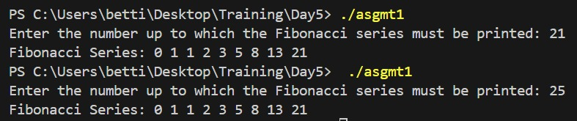

2.

//WAP to print factorial of a number

#include <stdio.h>

int main()

{

int num, fact = 1;

printf("Enter the number: ");

scanf("%d", &num);

while (num > 0)

{

fact *= num;

num--;

}

printf("Factorial of the number is: %d\n", fact);

return 0;

}

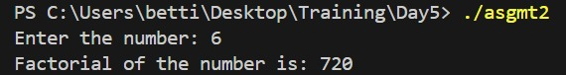

3.

//WAP to check whether the number is Prime or not

#include<stdio.h>

int main()

{

int num, i = 2, flag = 0;

printf("Enter the number: ");

scanf("%d", &num);

while(i < num/2)

{

if(num % i == 0)

{

flag = 1;

break;

}

i++;

}

if(num == 1)

{

printf("%d is neither a prime nor a composite.\n", num);

return 0; // Exit the program as 1 is not a prime number

}

else if(flag == 0)

{

printf("%d is a prime number.\n", num);

}

else

{

printf("%d is not a prime number.\n", num);

}

return 0;

}

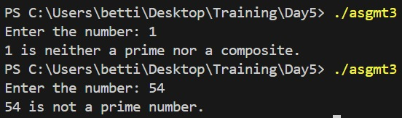

4.

//WAP to print lower case alphabets

#include <stdio.h>

int main() {

char c = 'a';

while (c <= 'z') {

printf("%c ", c);

c++;

}

return 0;

}



**Challenge Questions:**

1.

/*WAP to calculate the electricity bill based on the formula mentioned below

Calculations

To calculate your electricity bill, follow these steps:

Watts = (amps) x (volts)

Kilowatt-hours = (watts) x (usage) / 1000.

Cost = (kilowatt-hours) x (electricity rate)

1. Subtract the current meter reading from the previous month’s reading to find the energy consumption.

2. Multiply the units consumed by the per-unit charges based on the applicable slabs (e.g., Rs. 4.22 for 1-100 units,

Rs. 5.02 for 101-200 units).

3. Add the fixed charge and energy duty (e.g., Rs. 40 fixed charge and Rs. 0.15 per unit) to the energy charges.

4. The sum of the energy charges, fixed charge, and energy duty gives you the total bill amount.

Example: If you consumed 250 units with the applicable slabs mentioned above, the energy charges would be Rs. 1218.

Adding the fixed charge and energy duty, the total bill amount would be Rs. 1296.

Requirements:

inputs : amps, volts, prev_month, this_month

comparison : >=, <=

control statements : if...elseif...else

number of variables : 9

data type of variables : float

scopes of variables : local */

#include <stdio.h>

int main() {

float amps, volts, watts, kilowatt_hours, usage, rate = 0, cost, prev_month, this_month;

printf("Enter the amplitude: ");

scanf("%f", &amps);

printf("Enter the voltage: ");

scanf("%f", &volts);

printf("Enter the previous month's reading: ");

scanf("%f", &prev_month);

printf("Enter the current month's reading: ");

scanf("%f", &this_month);

usage = this_month - prev_month;

if (usage < 0) {

printf("Current reading cannot be less than previous reading.\n");

return 1;

}

watts = amps * volts;

kilowatt_hours = watts * usage / 1000;

if (kilowatt_hours >= 1 && kilowatt_hours <= 100) {

rate = 4.22;

} else if (kilowatt_hours >= 101 && kilowatt_hours <= 200) {

rate = 5.02;

} else if (kilowatt_hours > 200) {

rate = 5.82;

} else {

printf("The readings are invalid!\n");

return 1;

}

cost = kilowatt_hours * rate + 40 + (kilowatt_hours * 0.15);

printf("Total cost: Rs. %.2f\n", cost);

return 0;

}

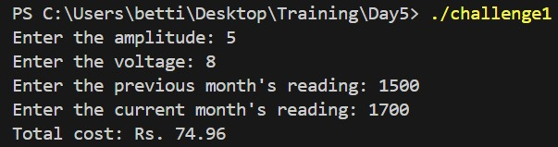

2.

/*Program to calculate weekly pay using if else statemments.

Requirements:

Ask user to enter the number of hours worked in a week.

Output the gross_pay, tax, and the net_pay.

Assumptions:

Basic pay_rate = $12.00/hr

Overtime (in excess of 40 hours) = time and a half

Tax rate:

15% of the first $300

20% of the next $150

25% of the rest

inputs : hours_worked

outputs : gross_pay, tax, net_pay

comparison : >, <=

control statements : if...elseif...else, if...else

number of variables : 4

data type of variables : float, int

scopes of variables : local

*/

#include <stdio.h>

int main()

{

int hours_worked;

float gross_pay, net_pay, tax;

printf("Enter the number of hours worked in a week: ");

scanf("%d", &hours_worked);

if (hours_worked > 40)

{

gross_pay = (40 * 12.00) + ((hours_worked - 40) * 12.00 * 1.5);

}

else

{

gross_pay = hours_worked * 12.00;

}

if (gross_pay <= 300)

{

tax = 0.15 * gross_pay;

}

else if (gross_pay > 300 && gross_pay <= 450)

{

tax = (0.15 * 300) + (0.20 * (gross_pay - 300));

}

else

{

tax = (0.15 * 300) + (0.20 * 150) + 0.25 * (gross_pay - 450);

}

net_pay = gross_pay - tax;

printf("Gross Pay: $%.2f\n", gross_pay);

printf("Tax: $%.2f\n", tax);

printf("Net Pay: $%.2f\n", net_pay);

return 0;

}

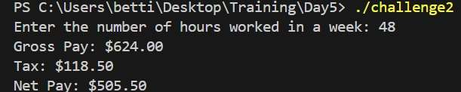

**In-class Assignments:**

1.

//program to check for a valid triangle

#include<stdio.h>

int main()

{

int side1, side2, side3;

printf("Enter the lengths of three sides of a triangle: ");

scanf("%d %d %d", &side1, &side2, &side3);

if(side1 + side2 > side3 && side1 + side3 > side2 && side2 + side3 > side1)

printf("The given sides form a valid triangle.\n");

printf("The program execution is complete.\n");

return 0;

}

Output:

PS C:\Users\betti\Desktop\Training\Day5> ./prgm1

Enter the lengths of three sides of a triangle: 4 5 6

The given sides form a valid triangle.

The program execution is complete.

2.

//program to check if a character is alphabet

#include<stdio.h>

#include<stdlib.h>

int main() {

char ch;

printf("Enter a character: ");

scanf("%c", &ch);

if ((ch >= 'a' && ch <= 'z') || (ch >= 'A' && ch <= 'Z'))

printf("%c is an alphabet.\n", ch);

printf("The program execution is complete.\n");

return 0;

}

Output:

PS C:\Users\betti\Desktop\Training\Day5> ./prgm2

Enter a character: 2

The program execution is complete.

PS C:\Users\betti\Desktop\Training\Day5> ./prgm2

Enter a character: a

a is an alphabet.The program execution is complete.

3.

//program to check leap year

#include<stdio.h>

int main()

{

int year;

printf("Enter a year: ");

scanf("%d", &year);

if((0 == year % 4 && 0 != year % 100) || (0 == year % 400))

printf("%d is a leap year.\n", year);

printf("Program is complete.\n ");

}

Output:

PS C:\Users\betti\Desktop\Training\Day5> ./prgm3

Enter a year: 1400

Program is complete.

PS C:\Users\betti\Desktop\Training\Day5> ./prgm3

Enter a year: 2004

2004 is a leap year.

Program is complete.

4.

// program to check if a number is divisible by 3

#include<stdio.h>

int main()

{

int number;

printf("Enter a number: ");

scanf("%d", &number);

if(0 == number % 3)

printf("%d is divisible by 3.\n", number);

printf("Program is complete.\n ");

return 0;

}

Output:

PS C:\Users\betti\Desktop\Training\Day5> ./prgm4

Enter a number: 54

54 is divisible by 3.

Program is complete.

5.

//program to check for uppercase characters in a string

#include<stdio.h>

int main() {

char str[100];

int i, count = 0;

printf("Enter a string: ");

fgets(str, sizeof(str), stdin);

for(i = 0; str[i] != '\0'; i++) {

if(str[i] >= 'A' && str[i] <= 'Z') {

count++;

}

}

printf("Number of uppercase characters in the string: %d\n", count);

return 0;

}

Output:

PS C:\Users\betti\Desktop\Training\Day5> ./prgm5_v2

Enter a string: Hello World

Number of uppercase characters in the string: 2

6.

//program to check for special characters

#include<stdio.h>

#include<ctype.h>

int main() {

char str[100];

printf("Enter a string: ");

fgets(str, sizeof(str), stdin);

int i;

int specialCharCount = 0;

for(i = 0; str[i] != '\0'; i++) {

if(!isalnum(str[i]) && !isspace(str[i])) {

specialCharCount++;

}

}

printf("Number of special characters: %d\n", specialCharCount);

return 0;

}

Output:

PS C:\Users\betti\Desktop\Training\Day5> ./prgm6

Enter a string: $200 and fine!

Number of special characters: 2

7.

/*program to perform calculation using switch case

+ = addition

- = subtraction

* = multiplication

/ = division

% = modulus*/

#include<stdio.h>

int main()

{

char op;

float num1, num2;

printf("Enter the numbers to perform the calculation: ");

scanf("%f %f", &num1, &num2);

printf("Enter the operator (+, -, *, /, %%): ");

scanf(" %c", &op);

switch(op) {

case '+':

printf("%.2f + %.2f = %.2f\n", num1, num2, num1 + num2);

break;

case '-':

printf("%.2f - %.2f = %.2f\n", num1, num2, num1 - num2);

break;

case '*':

printf("%.2f * %.2f = %.2f\n", num1, num2, num1 * num2);

break;

case '/':

if (num2 != 0) {

printf("%f / %f = %.2f\n", num1, num2, num1 / num2);

} else {

printf("Error: Division by zero!\n");

}

break;

case '%':

printf("%d %% %d = %d\n", (int)num1, (int)num2, (int)num1 % (int)num2);

break;

default:

printf("Invalid operator!\n");

break;

}

return 0;

}

Output:

PS C:\Users\betti\Desktop\Training\Day5> ./prgm7

Enter the numbers to perform the calculation: 8 9

Enter the operator (+, -, *, /, %): +

8.00 + 9.00 = 17.00

8.

//program to reverse a numbere

#include<stdio.h>

int main()

{

int num, rev = 0, rem = 0;

printf("enter the number to be reversed: ");

scanf("%d", &num);

int temp = num;

while (temp != 0) {

rem = temp % 10;

rev = rev * 10 + rem;

temp = temp / 10;

}

printf("The reverse of the number %d is %d.", num, rev);

return 0;

}

Output:

PS C:\Users\betti\Desktop\Training\Day5> ./prgm8

enter the number to be reversed: 8754

The reverse of the number 8754 is 4578.

9.

//program to determine largest of three numbers

// inputs: num1,num2,num3

// comparison: >=

// control statements: if.....elseif...else

// how many variables used: 3

// data type of variables: int

// preffered scope of variables: local

#include<stdio.h>

int main() {

int num1, num2, num3;

printf("Enter three numbers: ");

scanf("%d %d %d", &num1, &num2, &num3);

if (num1 >= num2) {

if (num1 >= num3){

printf("The largest number is %d\n", num1);

}

else {

printf("The largest number is %d\n", num3);

}

}

else if (num2 >= num3) {

printf("The largest number is %d\n", num2);

}

else {

printf("The largest number is %d\n", num3);

}

return 0;

}

Output:

PS C:\Users\betti\Desktop\Training\Day5> ./prgm9

Enter three numbers: 78 89 74

The largest number is 89

10.

/* program to determine the grade of astudent based on the following

Grade A = marks >= 90

Grade B = marks >= 80 and marks < 90

Grade C = marks >= 70 and marks < 80

Grade D = marks >= 70 and marks <70

Grade F = marks < 60

Requirements:

inputs : mark

comparison : >=, <

control statements : if...else

number of variables : 2 (grade, mark)

data type of variables : int, char

scopes of variables : local */

#include<stdio.h>

int main()

{

int mark;

printf("Enter the mark: ");

scanf("%d", &mark);

char grade;

if(mark >= 90)

{

grade = 'A';

}

else if(mark >= 80 && mark < 90)

{

grade = 'B';

}

else if(mark >= 70 && mark < 80)

{

grade = 'C';

}

else if(mark >= 60 && mark < 70)

{

grade = 'D';

}

else if(mark >= 0 && mark < 60)

{

grade = 'F';

}

else

{

printf("Invalid mark. Please enter a valid mark between 0 and 100.\n");

return 1; // terminate the program with an error code

}

printf("The grade is %c\n", grade);

return 0;

}

Output:

PS C:\Users\betti\Desktop\Training\Day5> ./prgm10

Enter the mark: 78

The grade is C

11.

// program to count number of digits in a number using while loop

#include<stdio.h>

int main(){

int num, count = 0;

printf("Enter a number: ");

scanf("%d", &num);

int temp = num;

while(temp != 0){

temp = temp / 10;

count++;

}

printf("Number of digits in %d is: %d\n",num, count);

return 0;

}

Output:

PS C:\Users\betti\Desktop\Training\Day5> ./prgm11

Enter a number: 546

Number of digits in 546 is: 3