**We Plan We Execute**  **We Satisfy**

We organize any event from We mange every detail We turn dreams

start to finish! of the event! into reality!

**About Us**

Heavenly Designs specializes in weddings, corporate and private events. It is an all-in-one stop for events. We can start with an idea as small as a mustard seed and create phenomenal memories. Come experience a taste of heaven on earth!

**Services**

**Private Events**

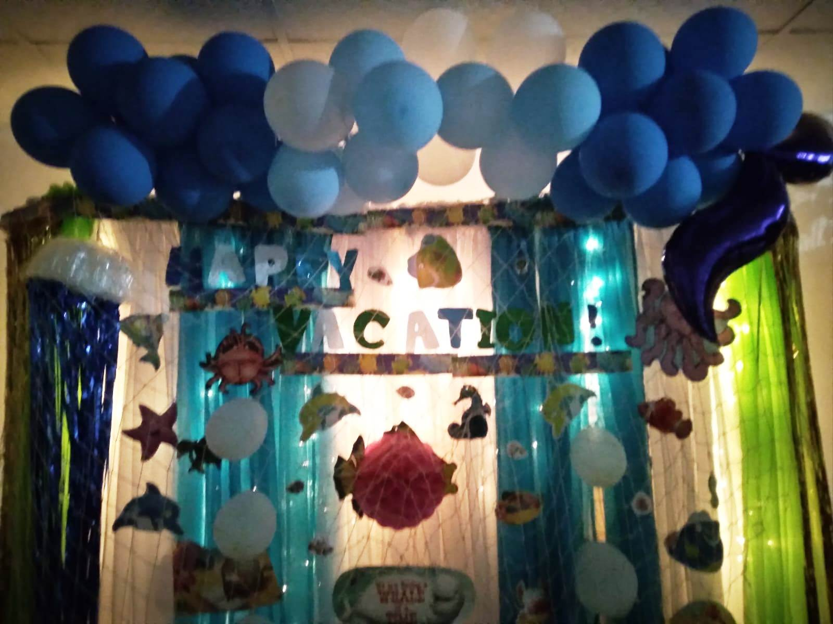

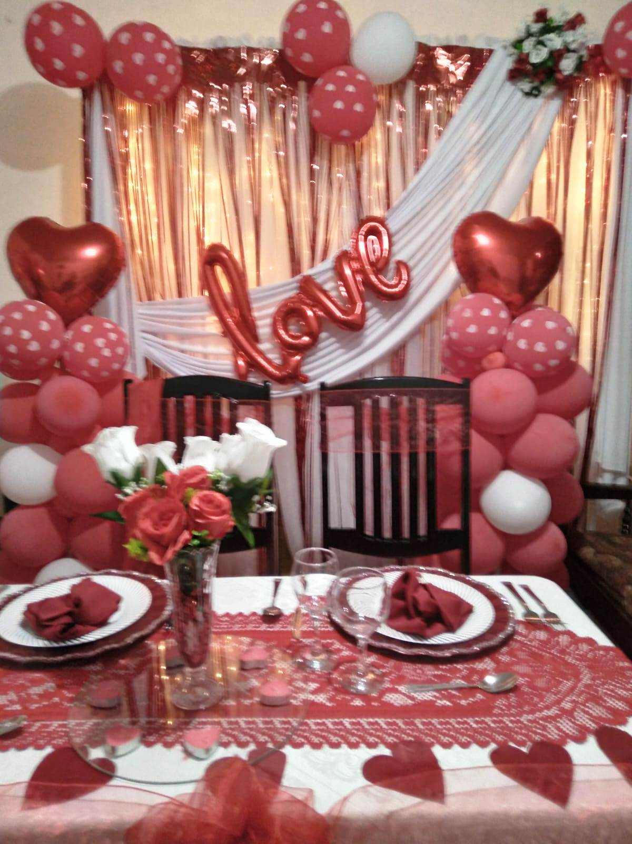

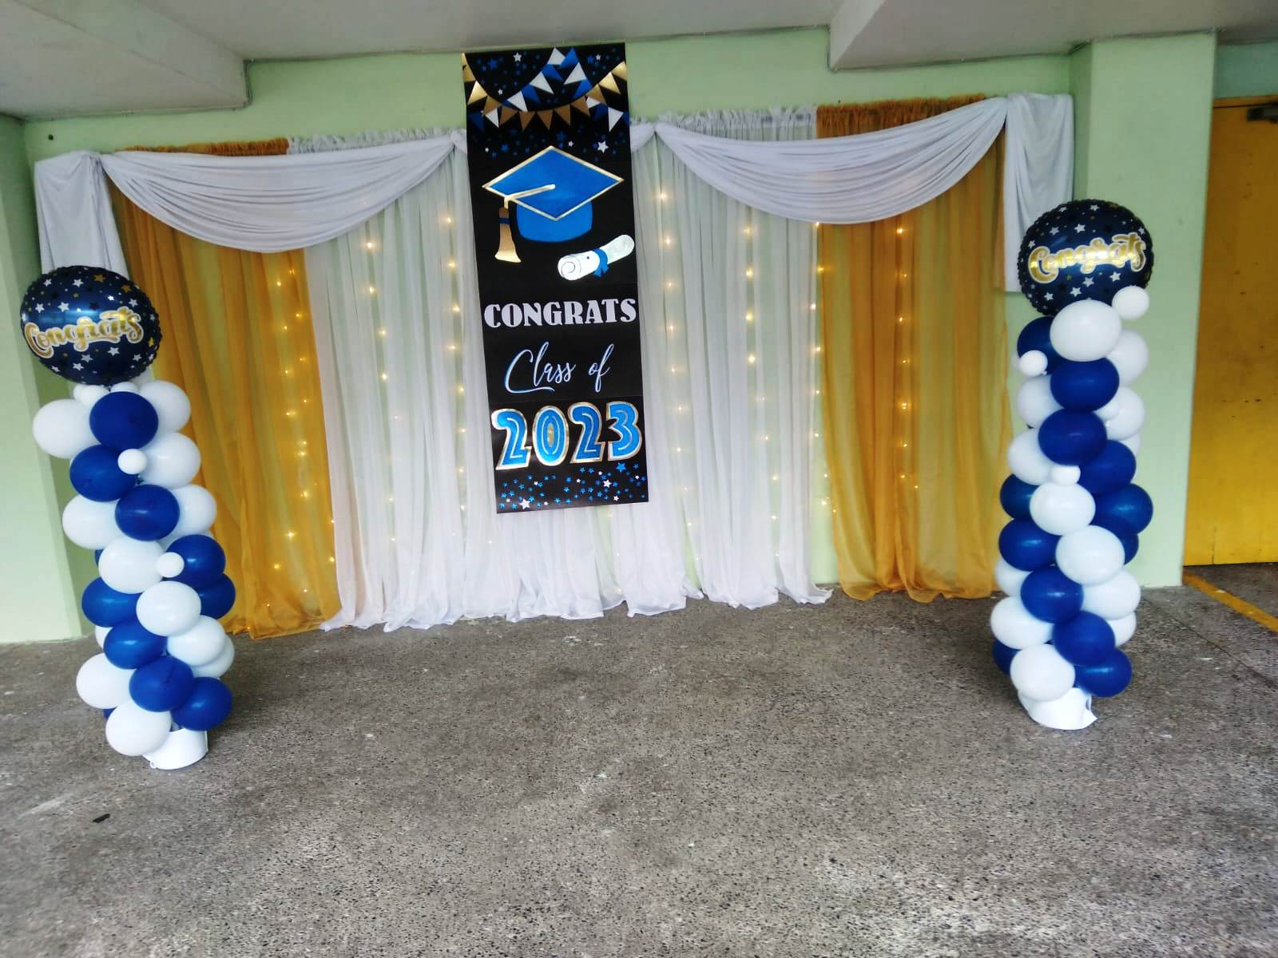

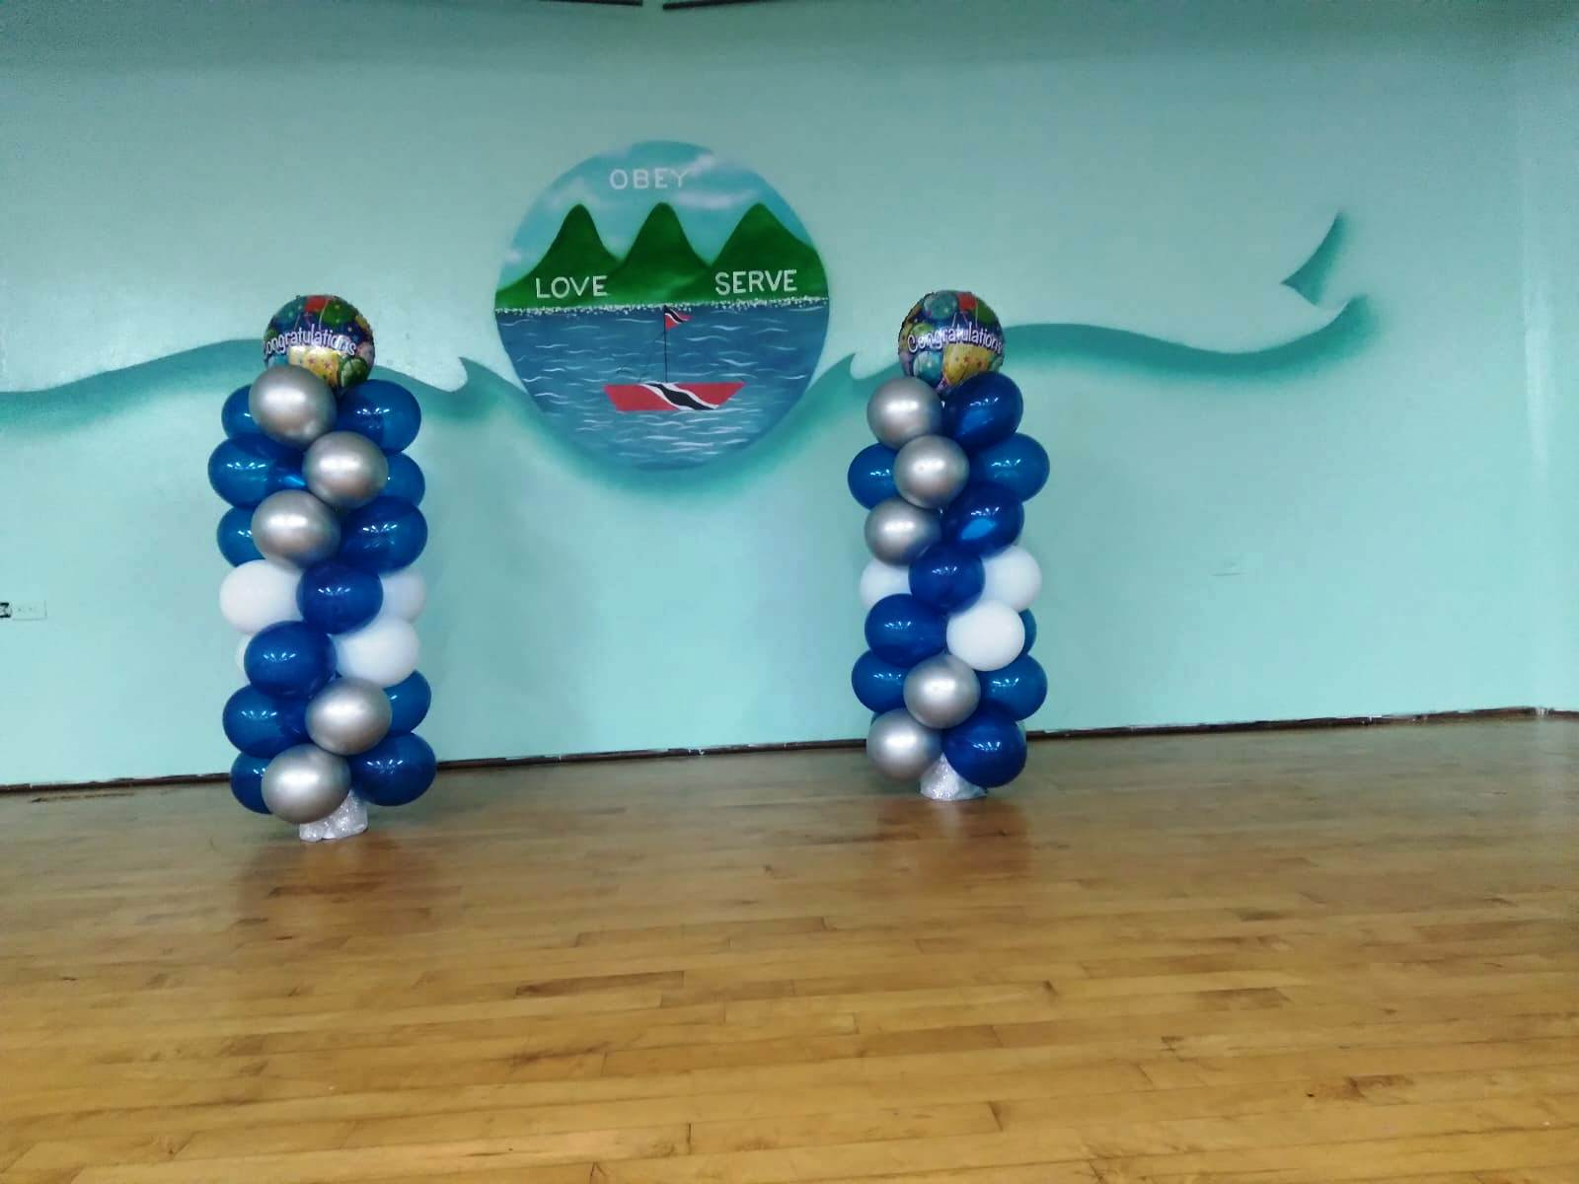

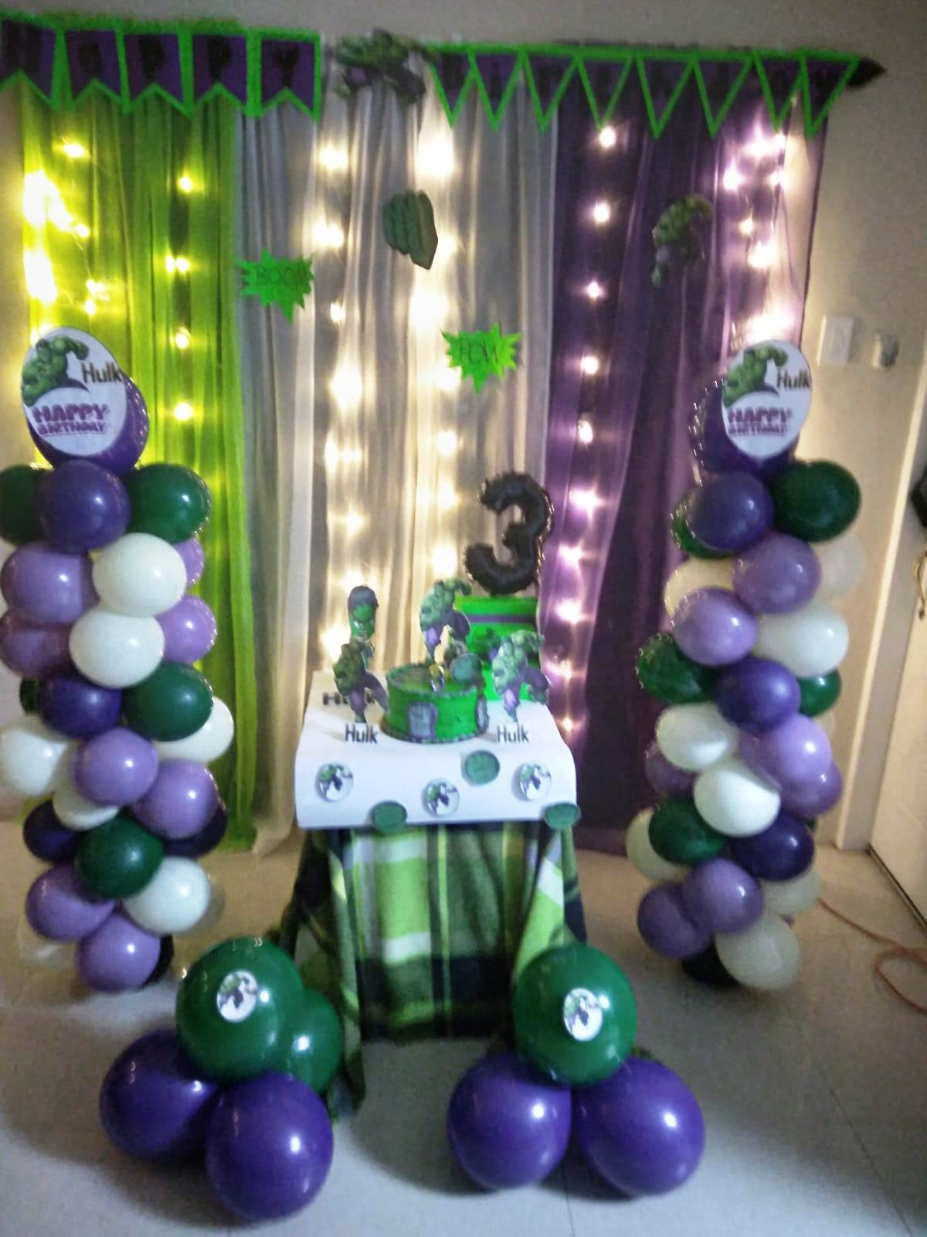



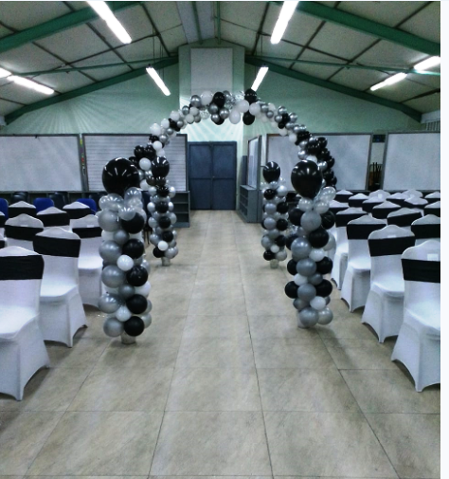

**Wedding**

