HYDROCHAR TECHNOLOGY COMPANY
BTC Consulting sp. z o.o.

HTC TECHNOLOGY FOR SEWAGE SLUDGE MANAGEMENT

11 years of research · 6 WWTPs in Poland · Engineering concept: MPWiK Lubin
1. CONTEXT: SEWAGE SLUDGE MANAGEMENT CRISIS
Where the pressure comes from — and why it is growing

Poland produces approx. 550,000–600,000 tonnes of dry matter (DM) of sewage sludge per year (Eurostat 2023). Existing disposal pathways are being systematically closed:
Disposal pathway | Status / Risk
Landfilling | Landfill Directive 1999/31/EC prohibits landfilling of waste with high organic content without pre-treatment. Option de facto eliminated.
Agricultural land application | PFAS / heavy metals. Draft amendment of the Ministry of Climate and Environment regulation excludes agricultural use for practically all Polish sludge.
Incineration (mono-incineration) | Required infrastructure is out of reach for small and medium WWTPs. Costs: PLN 800–1,200/tonne.
Composting | Currently one of the main disposal routes in Poland. Does not destroy pharmaceuticals or hormones — they remain active in compost applied to land. EU countries are ahead on regulation: the Netherlands banned agricultural sludge use in 1995, Belgium (Flanders) has a complete ban, Germany requires phosphorus recovery from 2032 for WWTPs ≥50,000 PE — effectively directing sludge to incineration. Amendment of Directive 86/278 (in progress) moves in the same direction for the entire EU. HTC destroys pathogens, pharmaceuticals and hormones thermally; hydrochar — unlike sludge — has excellent sorption properties, is odourless and a good soil amendment additive when not applied as sludge directly.

WWTPs face a choice: invest in new technology or face growing penalties and contracts for disposal at ever-increasing market prices.

2. EU REGULATIONS — PRESSURE ON WWTP OPERATORS
New EU regulations eliminate existing sludge disposal pathways

Directive | Key requirement | Deadline / consequence
UWWTD 2024/3019  (revision of Directive 91/271) | Mandatory 4th stage of treatment. Phosphorus recovery from sludge for WWTPs >100,000 PE from 2045, >10,000 PE under consideration. | WWTPs ≥150,000 PE: by 2033.  WWTPs ≥10,000 PE in sensitive areas: by 2039.  WWTPs ≥10,000 PE (others): by 2045.
PFAS Restriction  (ECHA 2023) | Ban on agricultural application of PFAS-containing sludge. 99%+ of Polish sludge exceeds proposed limits. | Draft regulation 2025–2026.  Effective ban on agricultural disposal.
UWWTD 2024/3019 — micropollutants  (pharmaceuticals, hormones, microplastics) | Art. 7: 4th stage of wastewater treatment (liquid phase) — removal of ≥80% micropollutants from effluent. Applies to WWTPs ≥150,000 PE unconditionally and ≥10,000 PE in sensitive areas. HTC does not replace 4th stage but addresses the second emission pathway: pharmaceuticals adsorb onto organic particles in primary settlers and accumulate in sludge — independently of effluent quality. HTC destroys these compounds thermally (39–97%, temp. >180°C). The Zero Pollution Package intent is to eliminate pharmaceuticals from all pathways back to the environment — both through water and through sludge. Amendment of Sludge Directive 86/278 (in progress) will close this gap legally. | WWTPs >150k PE: by 2045.  WWTPs >10k PE: conditionally by 2045.  Amendment of Sludge Directive 86/278 — in progress.
UWWTD 2024/3019 Art. 20  — phosphorus recovery | Mandatory minimum phosphorus recovery and recycling from sludge. Specific percentage: EU Commission delegated acts by end of 2027. P recovery from HTC process: up to 98% via chemical extraction. | Requirements effective after 2027. Hydrochar = ready P carrier for extraction or use as fertiliser.

HTC is the only technology that simultaneously: reduces sludge mass by more than 4×, eliminates PFAS in-process (temperature approx. 200°C), produces HTC process water enabling phosphorus recovery, and generates hydrochar as a P-bearing product for land application or extraction.

3. EUROPEAN MARKET — SCALE OF THE CHALLENGE
21,437 WWTPs across the EU facing new requirements

Scale of the challenge | Data
Number of WWTPs in the EU subject to new regulations (EEA — European Environment Agency 2023) | 21,437 treatment plants above 2,000 PE — all under pressure from UWWTD and PFAS regulations
WWTPs above 10,000 PE | approx. 6,800 facilities — mandatory 4th stage and phosphorus recovery
WWTPs 2,000–10,000 PE | approx. 14,600 facilities — PFAS and sludge regulation pressure
Annual sludge production in the EU | 10–12 million tonnes DM/year — mass requiring new management solutions
Poland (EEA — European Environment Agency 2023) | 1,643 WWTPs ≥2,000 PE, of which approx. 400–500 ≥10,000 PE

Regulatory pressure across selected EU countries — HTC at an early stage of commercialisation, market potential enormous:
Country | Regulatory pressure | Context
Germany (DE) | Highest — KrWBewV (2023) bans agricultural sludge application | Market already requires an alternative to landfilling and agriculture
Poland (PL) | UWWTD, draft MKiŚ regulation amendment (PFAS), FENX 2026–2027 | First commercial HTC deployment — BTC/Lubin project
Czech Republic / Slovakia | UWWTD implementation, limited access to incineration infrastructure | No domestic alternative at scale
France (FR) | Plan Eau 2023 — P recovery a national priority | Actively seeking phosphorus recovery technology
Hungary / Romania | EU cohesion funds — WWTP modernisation by 2027 | Emerging market, high investment needs

No WWTP is alone — identical regulatory challenges face thousands of facilities across the EU. HTC exists in individual pilot and commercial installations in Germany, Switzerland and Spain — the market is at an early stage of commercialisation. Potential: over 6,800 WWTPs >10,000 PE in the EU without a solution compliant with new regulations. In Poland — first commercial deployment on municipal sludge — the BTC/MPWiK Lubin project.

4. WHY EXISTING METHODS ARE NOT SUFFICIENT
Comparison of available disposal pathways

Technology | Main drawback | Indicative cost (industry estimate)
Incineration (mono-incineration) | CAPEX EUR 15–40M. Not viable for WWTPs <100k PE. | PLN 600–900/t (only at full load)
Thermal drying + co-processing | Logistics. Dependency on cement plants and CHP facilities. No guaranteed offtake. | PLN 350–600/t
Agricultural land application (R10) | Effectively blocked by PFAS and heavy metals. Legal risk for WWTP operators. | PLN 80–400/t (but risk of penalties)
Composting | Does not destroy pharmaceuticals or hormones — they remain active in compost applied to land. Once micropollutant limits for sludge enter into force (amendment of Directive 86/278/EEC — in progress), sludge composting may lose eligibility. HTC or incineration are the only alternatives that destroy these compounds. | PLN 150–400/t
HTC (BTC) | None — fully closed technology. Hydrochar = commercial product. | Individual quotation — BTC will prepare an estimate for your WWTP

5. HTC TECHNOLOGY — HOW IT WORKS
Hydrothermal carbonisation of sewage sludge

HTC (Hydrothermal Carbonization) is a thermochemical process: sludge + water → reactor (approx. 200°C, approx. 25 bar, up to 2 hours) → hydrochar + HTC process water (returned to anaerobic digestion, phosphorus recovery and biological treatment).
Process parameter | Value / description
Reactor temperature | approx. 200°C
Pressure | approx. 25 bar (saturated steam)
Retention time | up to 2 hours
Mass reduction (DM) | 40–70%
Hydrochar calorific value | 11–15 MJ/kg (comparable to lignite)
PFAS elimination | 80–100% destruction (depends on PFAS type and retention time; AGH pilot data)
Final volume reduction | 70–80% relative to raw sludge
Pathogens | Complete sterilisation (>160°C)
Process water (PW) | Returned to anaerobic digestion, phosphorus recovery and biological treatment

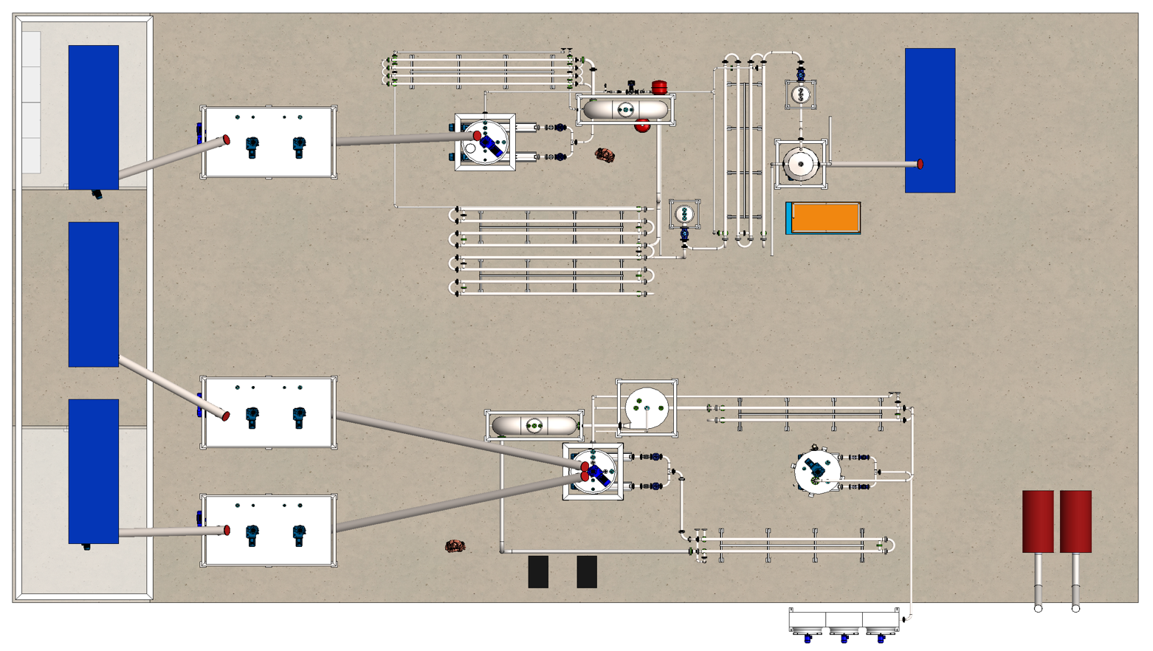
Layout of nodes and equipment of the TH+HTC installation in the process hall

6. THREE BTC INSTALLATION VARIANTS
Solution tailored to the sludge treatment stage at your WWTP

BTC offers three installation variants, matched to the current technological configuration of the treatment plant:
Variant | For whom | Energy outcome
HTC-S  (carbonisation of dewatered excess sludge  in WWTPs without primary settler) | Treatment of sludge "after biology" — without prior stabilisation. From 14 January 2026, the anaerobic HTC process may be used for sludge stabilisation (requirement: reduction of organic matter by min. 38% — HTC reduces significantly more). | Biogas from HTC process water covers the heat demand of the installation.
HTC-D  (carbonisation of dewatered digestate  from methane fermentation) | Treatment of sludge after aerobic or anaerobic digestion. Designed for WWTPs with digestion chambers. | Additional biogas covers the heat demand of the installation.
TH+HTC  (thermal hydrolysis + carbonisation — integrated system) | Thermal hydrolysis (TH) before methane fermentation + HTC after fermentation. Full material and energy integration of both processes. Variant for WWTPs planning comprehensive modernisation. | Additional biogas is sufficient to generate electricity and heat for the installation — full energy neutrality.
↳ Variant selection | Depends on your WWTP configuration. BTC conducts a free preliminary analysis and recommends the optimal variant.

7. 11 YEARS OF RESEARCH — POLISH DATABASE
The largest HTC database in Poland from real treatment plants

BTC/BioTheCon holds a unique research database — 11 years of laboratory and pilot tests on sludge from 6 Polish WWTPs:
Milestone | Year / Description
HTC research launched — AGH Krakow | 2015 — Collaboration with the Department of Thermal Engineering and Environmental Protection, AGH University. Research on sludge for HTC process application.
Tests at Polish WWTPs | 2015–2026 — WWTPs: Gliwice, Kraków/Płaszów, Chrzanów, Orzesze, Żory, Lublin, Tychy. Semi-technical research reactors.
Pilot reactors | 2019–2021 — 200 L TH process; 2021–2023 — 200 L HTC process
PFAS elimination research (AGH) | 2021–2022 — Reduction >98.5% PFAS at 220°C, 6h
Agreement — MPWiK Lubin | 2021–2025 — Development of Research and Design Concept for Phase II modernisation of the WWTP in Lubin (TH-AD-HTC technology with TH+HTC installation). Oct. 2025 — purchase of intellectual property rights for implementation at the Lubin WWTP.

8. TECHNICAL RESULTS — WHAT WE ACHIEVE
Data from tests on Polish municipal sludge

Parameter | HTC result (BTC) | Reference / standard
DM mass reduction | 75–80% | Other technologies: 20–40%
Hydrochar calorific value | 11–15 MJ/kg | Lignite: 8–15 MJ/kg
Water content (hydrochar) | <10% after drying; 30–40% after process without drying | Dewatered stabilised sludge: 60–85%
PFAS elimination | 80–100% destruction | EU standard (draft): <0.1 mg/kg DM
Volume reduction to landfill | 75–80% | Incineration: 90% (but 10× higher cost)
Pathogen sterilisation | 100% | Requirement: Class A (USEPA)
Phosphorus recovery (extraction from HTC process water and dewatering centrate) | Up to 85–98% P via chemical extraction (HCl + precipitation / struvite). Phosphorus remains in hydrochar as fertiliser. | UWWTD 2024 Art. 20 requirement: minimum P recovery rate — specific values by EU Commission by 2027.
CO₂ emissions (vs. incineration) | -65% | HTC emission: 0.18 t CO₂/t DM

9. HYDROCHAR — A PRODUCT WITH MARKET VALUE
Sludge becomes a product, not waste

Hydrochar is the solid product of the HTC process. It is not waste — it is a material with commercial value:
Hydrochar application | Quality requirements | Market price (2024)
Alternative fuel (RDF/SRF)  — cement plants, CHP facilities | CV >11 MJ/kg, Cl <0.2%, metals <IED standards. Requires classification of hydrochar as product, not waste. | Currently sludge as waste for incineration = cost for WWTP (WWTP pays). Hydrochar after RDF certification may change the economic relationship.
Soil amendment (after certification)  — Biochar EU Regulation | No heavy metals above standard, PFAS <limits | PLN 200–800/t (premium market)
Phosphorus extraction  — phosphate fertilisers from secondary raw materials | P total >3%, cadmium <60 mg/kg P₂O₅ | P value: PLN 400–900/t of end product
Activated carbon precursor  — water filtration | Technical specification of the buyer | PLN 1,200–3,000/t (niche market)

BTC is negotiating framework agreements with hydrochar offtake partners for RDF prior to commissioning of the first commercial installation.
Why is phosphorus recovery easier from HTC than from incineration ash? [A]
HTC retains 97.7–98.7% of phosphorus from sludge in HTC process water and hydrochar [A]. Key mechanism: at HTC temperature (approx. 200°C), phosphorus from sludge dry matter migrates into the HTC process water and remains in hydrochar. From HTC process water, P is precipitated as struvite or calcium phosphate — a ready-to-use fertiliser [B].
Incineration (>800°C) converts phosphorus into stable apatite minerals. Recovery from ash requires strong acids or alkaline processes — more expensive, less efficient, and with no option to recover other components.

10. REFERENCE: MPWiK LUBIN — TECHNOLOGY VALIDATION
Licence agreement as proof of credibility

In 2025, Miejskie Przedsiębiorstwo Wodociągów i Kanalizacji in Lubin (MPWiK Lubin — Municipal Water and Sewage Company) purchased from BioTheCon the Research and Design Concept for Phase II modernisation of the wastewater treatment plant based on TH-AD-HTC technology (variant with TH+HTC installation).
Agreement element | Details
Subject | HTC know-how adapted to municipal sludge, research results 2020–2023, TH+HTC installation design concept
Scope | Right to implement and commercialise in Poland and the CE region
Transaction value | Commercial information (available to investors under NDA)
Status | Agreement active. Project ongoing.
Market significance | First commercial HTC deployment on municipal sludge in Poland. Reference for WWTPs across the region.

MPWiK Lubin serves as a reference for treatment plants considering BTC technology implementation. Technical details available during a site visit.
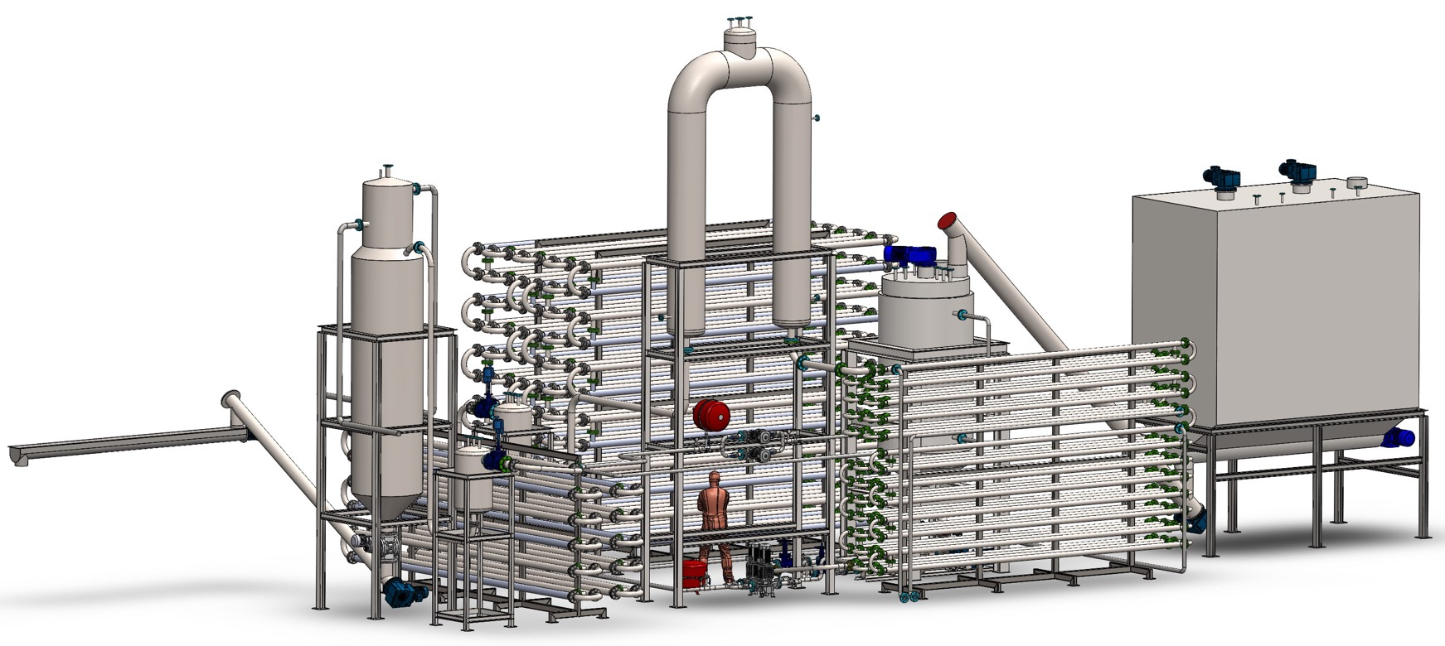

11. WHO WE ARE — BTC AND BIOTHECON
Knowledge succession, not a start from scratch

Entity | Role and history
BioTheCon sp. z o.o. | R&D entity. Owner of 11 years of HTC research results. Sale of engineering concept to MPWiK Lubin (2025).
BTC Consulting sp. z o.o.  (Hydrochar Technology Company) | Commercial entity — operator and contractor of installations. Lubin pilot project as first realisation.
Founders | Andrzej Krop — CEO. Karol Surmacewicz — COO.
Business model | EPC (design + build) + multi-year service + hydrochar sales. Not resale: own installation, own product.
Why not a startup? | 11 years of research + licence agreement + MPWiK Lubin reference = technology validated by the market.

12. TEAM
Expertise in technology, sales and science

Name | Role | Key experience
Andrzej Krop | CEO | Commercialisation of environmental technologies. Management of R&D implementation projects. EU markets.
Karol Surmacewicz | COO | Sales, renewable energy, international markets.
dr hab. inż. Małgorzata Wilk, prof. AGH | CSO / Chief Science Officer | 11 years of HTC research / AGH Krakow. Author of key publications. Expert in PFAS and hydrochar. Co-developer of HTC, AD-HTC and TH-AD-HTC technologies.
dr inż. Eugeniusz Krop | Technical Director | Co-developer of HTC, AD-HTC and TH-AD-HTC technologies. Co-founder of BioTheCon. PhD, Silesian University of Technology. 3 technologies deployed in 28 installations (incl. ORLEN, PERN).
mgr inż. Jarosław Kulig | Lead Design Engineer | Lead designer of HTC-S, HTC-D and TH+HTC installations.

13. WHY BTC — AND NOT SOMEONE ELSE?
Competitive advantages unavailable to foreign suppliers

BTC advantage | What it means for your WWTP
Polish database from 6 WWTPs | Process parameters are calibrated on Polish sludge — not on Swiss or Swedish data. Lower technical risk.
Know-how grant: 11 years of scientific work  deposited in BioTheCon | You do not pay for "learning". The technology is ready for deployment.
TH-AD-HTC as an integrated system | None of the global HTC suppliers offer full integration with anaerobic digestion and thermal hydrolysis as an energy-neutral system.
MPWiK Lubin design concept (2025)  as a market reference in Poland | We are not the first "test installation" — Lubin is a reference for the regulator and financing banks.
Local presence and response speed | Service, operation and emergency response — a Polish company, no foreign intermediaries.
Compatibility with FENX and NFOŚiGW  (Polish intellectual property) | EU funding applications are easier when the technology comes from a domestic entity.
Time window 2026–2027 | BTC can submit a FENX application jointly with your WWTP. Foreign companies do not have access to this funding channel.

14. TECHNOLOGY COMPARISON
HTC vs. available alternatives

Criterion | HTC (BTC) | Incineration (mono-incineration)
Installation CAPEX | Individual quotation — depends on throughput and installation variant | —
Availability for WWTPs <100k PE | YES — modular scaling | NO — economics only at large scale
PFAS elimination | YES — 80–100% destruction | YES — but higher CAPEX
Phosphorus recovery | YES — from hydrochar (extraction) | NO — phosphorus in ash, difficult extraction
Commercial product | YES — hydrochar / RDF | Ash (limited market)
Energy neutrality | YES — from own biogas (TH-AD) | NO — requires external energy
CO₂ emissions | Low — 0.18 t/t DM | High — 0.5–0.8 t/t DM
Implementation time | 12–18 months | 36–60 months
FENX eligibility | YES (RES + circular economy) | Limited

15. COOPERATION MODEL — 5 STAGES
From first meeting to installation operation

Stage | Scope / Duration
STAGE 0 — Free preliminary analysis | Analysis of data from your WWTP: sludge quantity, composition, AD parameters. HTC potential assessment. Duration: 2–3 weeks. Cost: PLN 0.
STAGE 1 — Technical concept and preliminary business case | Technology selection and installation concept. CAPEX/OPEX estimate. Assessment of FENX co-financing opportunities. Duration: 4–8 weeks.
STAGE 2 — Co-financing application preparation | Complete FENX/NFOŚiGW application (BTC supports you as applicant or project partner). Duration: 3–4 months.
STAGE 3 — Technical design and construction | Detailed design, installation delivery, assembly, commissioning tests. Duration: 12–24 months.
STAGE 4 — Operation and service | Multi-year service agreement. Process monitoring. Hydrochar sales (optionally via BTC). Duration: from commissioning, indefinitely.

BTC's offer can cover technology only (EPC), or a full package of EPC + financing + service + hydrochar offtake — depending on your preferences.

16. INSTALLATION FINANCING — EU FUNDS 2026–2027
How to minimise the own contribution

Funding source | Conditions / Intensity
FENX — European Funds for Infrastructure, Climate and Environment | Up to 70% CAPEX as non-repayable grant. Priority: circular economy, resource recovery. Planned calls: 2026–2027.
NFOŚiGW — preferential loans  (National Fund for Environmental Protection) | Supplementing own contribution. Interest rate 0.5–1.5%. WFOŚ as regional channel.
BGK — Guarantees and EIB loans  (Bank Gospodarstwa Krajowego) | Bridge or supplementary financing for local authorities. Asset-backed security.
Effective WWTP own contribution | FENX (70%) + NFOŚiGW (20%) = up to 90% CAPEX coverage. Own contribution: 10–15%.

BTC offers support in application preparation. Track record: BTC demonstration project (EUR 3M) currently in preparation.

17. TIMELINE — FROM DECISION TO ACTION
Realistic implementation plan for the first Polish commercial installation

Period | Activities
Q3–Q4 2026 | Preliminary analysis + technical concept. FENX application submission (2026 call). Decision to enter the project.
Q1–Q2 2027 | FENX application review. Detailed technical design. Reactor procurement.
Q3 2027 – Q2 2028 | Construction phase. Reactor and process node assembly. Commissioning trials.
Q3 2028 | Installation commissioning. Hydrochar production. First RDF batch sales.
2028–2033 | Operation. Hydrochar certification as EU biochar. Integration with phosphate fertiliser market.

18. NEXT STEP — THREE PATHWAYS
No commitments, full transparency

Pathway | What we do | Time / Cost
A — Free preliminary analysis  (recommended) | You send basic WWTP data (sludge quantity, test results). BTC prepares a preliminary HTC potential assessment and CAPEX estimate. | 2–3 weeks / PLN 0
B — Site visit in Lubin | Your technical team visits MPWiK Lubin — review of the installation design and technical documentation. | To be agreed / PLN 0
C — Full concept + FENX application | BTC prepares a full technical concept and complete FENX co-financing application on your behalf. | 3–4 months / individual quotation

19. CONTACT
We invite you to a conversation

Andrzej Krop
CEO — BTC Consulting / BioTheCon
andrzej.krop@biotc.pl
www.biotc.pl

Sources and references
[A] Shettigondahalli Ekanthalu V. et al., "Acid leaching of hydrothermally carbonized sewage sludge: phosphorus recovery and hydrochar characteristics", Frontiers in Environmental Engineering, 2023. DOI: 10.3389/fenve.2023.1223247
[B] Pérez et al., "Phosphorus recovery from sewage sludge-derived hydrochar: Balancing phosphorus recovery, heavy metal concomitant leaching and residual hydrochar utilization", Science of The Total Environment, 2025.
[C] European Parliament and Council Directive (EU) 2024/3019 of 27 November 2024 on urban wastewater treatment (UWWTD). Official Journal of the EU L 2024/3019.
[D] ECHA, "Universal PFAS Restriction Proposal", 2023. European Chemicals Agency.
[E] EEA, "Urban Wastewater Treatment", European Environment Agency, 2023.
[F] Global Market Insights, "Sewage Sludge Treatment Market", 2024.
[G] Measurlabs / Cehtra, "Revision of the UWWTD 2024 — Micropollutants and Pharmaceuticals", 2024–2025.

Document prepared by BTC Consulting sp. z o.o. / BioTheCon sp. z o.o. Technical information based on BioTheCon research results 2015–2026.

