Cairo University Faculty of Computers and Information



**CS352 – Software Engineering II**

**Phase 1-a**

**2015**

**Project Team**

|  |  |  |  |
| --- | --- | --- | --- |
| **ID** | **Name** | **Email** | **Mobile** |
| 20120516 | Heba Ahmed Khazbak | heba.khazbak@gmail.com | 01009595942 |
| 20120185 | Ziad Mohamed | Ziad_mohamed9473@hotmail.com | 01271777806 |
| 20120191 | Sarah Hany Tammam | sarahHtammam@gmail.com | 01008332618 |
| 20120166 | Dalia Maher Mohamed | dalia.maher94@gmail.com | 01111267812 |
|  |  |  |  |
|  |  |  |  |

**Staff: Dr Mohammad El-Ramly m.elramly@fci-cu.edu.eg**

**Eng Desoky Abd El-qawy d.abdelqawy@fci-cu.edu.eg**

Contents

Github repository link 3

Used Technologies 4

Frontend environment 5

Role of each member in the team 5

# Github repository link

**Git was very helpful to our team in SWE-1. It's an online server that provided us with the help needed to interact easily with each other. Each time someone modifies a line of code, he can commit that change and the rest of team becomes always updated with the smallest modifications added to the project. Github also keeps a revision history so we can be able to retrieve any previous versions of a certain file.**

**Github will also make our work available to the whole world to see.**

**URL : https://github.com/heba-khazbak/FCI-CS352-CS_2.git**

**snapshot :**

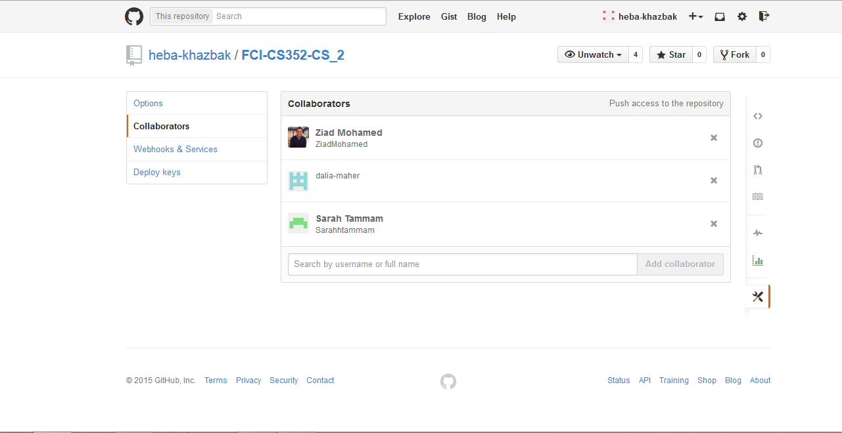

# Used Technologies

**1.Java language:** The Java language is on the top of programming languages nowadays. It has its own structure, syntax rules, and programming paradigm. The Java language is based on the concept of object-oriented programming (OOP).  
Some advantages of Java are:  
Easy to learn, designed to be easy to use and easy to write, compile, debug, and learn than other programming languages, it also allows you to create reusable code, and Java is platform-independent.  
  
**2. JAX-RS:** JAX-RS is a Java programming language API that provides support in creating web services according to the REST architecture. It stands for Java API for RESTful Web Services.  
In our project we will use Jersey framework which is a specific implementation of JAX-RS.  
By using REST, it is easy to develop web services that communicate using HTTP request. Also it increases the simplicity, performance of our application and allow it to be used in different platforms such as (web, android, ios). Moreover it is easy to extend our system and add new functionalities.   
  
**3.JSP:** JSP stands for JavaServer Pages. As it runs on the server, you need to have a web server with a servlet container such as Apache TomCat, Blazix or others. JSP simply puts Java inside HTML pages. Your jsp file gets compiled on the server after being turned into a java file. The compilation happens each time you change something in the code. JSP is then able to generate dynamic HTML pages. It means that they change in response to user actions and they produce a different user interface from user to user.  
 **4.JSON:** JSON (JavaScript Object Notation) is a lightweight data-interchange format used for storing and exchanging data. It uses human-readable text to transmit data objects and easy for machines to parse and generate. It can be parsed by a standard JavaScript function.  
Also, JSON is an easier-to-use alternative to XML with higher and better performance and a language-independent data format. It is based on a subset of the JavaScript scripting language and uses its syntax hence, no extra software is needed to work with JSON within JavaScript. **5.Google app engine :** Google app engine supports the delivery, testing and development of software on demand in a Cloud computing environment.  
It presents the platform to those who want to develop SaaS solutions at competitive costs and enables you to build web applications for your business.  
App Engine applications are easy to develop, maintain, and can scale as your traffic and data storage needs grow.

**6. Google Big Table:** Google Big Table is a distributed storage system for managing large volume, structured data. It's built on Google File System, Chubby Lock Service, SSTable. The database was designed to be deployed on clustered systems using a simple data model and its implementation consists of three major components:

1- Library linked into every client.

2- Single master server.

3- Many tablet servers for read/write.

It satisfies goals of high-availability, high performance, self-managing, massively scalable data storage and serves as the database for real apps (such as Google App Engine Datastore and Google Earth) and has influenced the NoSQL database market place.

**7.Trello:** Trello make it very easy to assign tasks to the team members and keep track of what's required next in our project. You can have multiple boards. Each one can have a specific project with its team members assigned into it. Each board has a list of tasks like a to-do list. Each task is called a card that has a due date and some team members assigned to it.

# Frontend environment

**Web application**

# Role of each member in the team

|  |  |
| --- | --- |
| Member name | Role |
| Heba Khazbak | Scrum master |
| Ziad Mohammed |  |
| Sarah Hany |  |
| Dalia Maher |  |