**Cairo University Faculty of Computers and Information**



**CS352 – Software Engineering II**

**Phase 2-b Template**

**2015**

**Project Team**

|  |  |  |  |
| --- | --- | --- | --- |
| **ID** | **Name** | **Email** | **Mobile** |
| 20120516 | Heba Ahmed Khazbak | heba.khazbak@gmail.com | 01009595942 |
| 20120185 | Ziad Mohamed | Ziad_mohamed9473@hotmail.com | 01271777806 |
| 20120191 | Sarah Hany Tammam | sarahHtammam@gmail.com | 01008332618 |
| 20120166 | Dalia Maher Mohamed | dalia.maher94@gmail.com | 01111267812 |

**Staff: Dr Mohammad El-Ramly m.elramly@fci-cu.edu.eg**

**Eng Desoky Abd El-qawy d.abdelqawy@fci-cu.edu.eg**

Contents

Your Restful API 3

Class diagram design 15

Trello workspace screenshot 16

Daily scrum Meetings 16

Github repository link 16

# Your Restful API

|  |  |
| --- | --- |
| **Service name** | **SERVICE NAME** |
| **Input type** | **GET or POST** |
| **Service URL** | **URL** |
| **Parameters** | |  |  | | --- | --- | | **NAME** | **Description** | | **PARAMETER_NAME** | **PARAMETER_DESC** | |
| **Example request** |  |
| **Example response** |  |

|  |  |
| --- | --- |
| **Service name** | **CreateUserPostService** |
| **Input type** | **POST** |
| **Service URL** | **http://** **socialnetwork-fci.appspot.com/rest/ CreateUserPost** |
| **Parameters** | |  |  | | --- | --- | | **NAME** | **Description** | | **owner** | **The author user** | | **content** | **The content of the post** | | **onWall** | **The name of the user's timeline** | | **privacy** | **Provided privacy (public,private,custom)** | | **feeling** | **Provided feeling** | | **custom** | **jsonArray of cutom users which can see the post if the privacy is custom** | |
| **Example request** | **POST**  **http://** **socialnetwork-fci.appspot.com/rest/ CreateUserPost? owner =** **Heba& content=posst1& onWall=Heba& privacy =public& feeling =Happy& custom=** |
| **Example response** | **{"Status":"OK"}** |

|  |  |
| --- | --- |
| **Service name** | **CreateFriendPostService** |
| **Input type** | **POST** |
| **Service URL** | **http://** **socialnetwork-fci.appspot.com/rest/ CreateFriendPost** |
| **Parameters** | |  |  | | --- | --- | | **NAME** | **Description** | | **owner** | **The author user** | | **content** | **The content of the post** | | **onWall** | **The name of the user's timeline** | | **privacy** | **Provided privacy (public,private,custom)** | | **custom** | **jsonArray of cutom users which can see the post if the privacy is custom** | |
| **Example request** | **POST**  **http://** **socialnetwork-fci.appspot.com/rest/ CreateFriendPostService? owner =** **Heba& content=posst1& onWall=Sarah& privacy =public&& custom=** |
| **Example response** | **{"Status":"OK"}** |

|  |  |
| --- | --- |
| **Service name** | **CreatePagePostService** |
| **Input type** | **POST** |
| **Service URL** | **http://** **socialnetwork-fci.appspot.com/rest/ CreatePagePost** |
| **Parameters** | |  |  | | --- | --- | | **NAME** | **Description** | | **owner** | **The author user** | | **content** | **The content of the post** | | **onWall** | **Name of the page** | | **privacy** | **Provided privacy (public,private,custom)** | | **custom** | **jsonArray of cutom users which can see the post if the privacy is custom** | |
| **Example request** | **POST**  **http://** **socialnetwork-fci.appspot.com/rest/ CreateFriendPostService? owner =** **Heba& content=posst3& onWall=fatafet& privacy =private&& custom=** |
| **Example response** | **{"Status":"OK"}** |

|  |  |
| --- | --- |
| **Service name** | **CreateSharePostService** |
| **Input type** | **POST** |
| **Service URL** | **http://** **socialnetwork-fci.appspot.com/rest/ CreateSharePost** |
| **Parameters** | |  |  | | --- | --- | | **NAME** | **Description** | | **postID** | **Original post ID** | | **owner** | **The user that shared the post** | | **content** | **The content of the post** | | **onWall** | **Name of the page** | | **privacy** | **Provided privacy (public,private,custom)** | | **custom** | **jsonArray of cutom users which can see the post if the privacy is custom** | |
| **Example request** | **POST**  **http://** **socialnetwork-fci.appspot.com/rest/ CreateFriendPostService? postID=3&owner =** **Heba& content=posst1& onWall=Heba& privacy =private&& custom=** |
| **Example response** | **{"Status":"OK"}** |

# 

|  |  |
| --- | --- |
| **Service name** | **getTrendsService** |
| **Input type** | **POST** |
| **Service URL** | **http://** **socialnetwork-fci.appspot.com/rest/getTrendsService** |
| **Parameters** | **NONE** |
| **Example request** | **POST**  **http://socialnetwork-fci.appspot.com/rest/getTrendsService** |
| **Example response** | **{ {"hashtagLink":"<form action='viewHashtagPosts' method='POST'><input type='hidden' name='hashtagName' value='project'><div class='buttonHolder'><input type='submit' class='submitLink' value='project'></div></form><br><br>"**  **"} ,   {"hashtagLink":"<form action='viewHashtagPosts' method='POST'><input type='hidden' name='hashtagName' value='SWE'><div class='buttonHolder'><input type='submit' class='submitLink' value='SWE'></div></form><br><br>"**  **"} }** |

# 

|  |  |
| --- | --- |
| **Service name** | **getHashtagPostsService** |
| **Input type** | **POST** |
| **Service URL** | **http://** **socialnetwork-fci.appspot.com/rest/ GetHashtagPostsService** |
| **Parameters** | |  |  | | --- | --- | | **NAME** | **Description** | | **hashtagName** | **name of the desired hashtag** | | **uname** | **username of the currently logged in user** | |
| **Example request** | **POST**  **http://** **socialnetwork-fci.appspot.com/rest/ GetHashtagPostsService? hashtagName=SWE&uname =** **Ziad** |
| **Example response** | **{ {"post":"Ziad posted on Heba’s timeline<br>This is a testing post<br><form action='like' method='POST' style ='display:inline;'><input type='hidden' name='postID' value='2'><input type='submit' value='Like'></form><pre style ='display:inline;'> </pre><form action='share' method='POST' style ='display:inline;'><input type='hidden' name='postID' value='2'><input type='submit' value='Share'></form><br><br><br><br>"},**  **{"post":"Ziad posted<br>This is a testing post<br>feeling great<br><form action='like' method='POST' style ='display:inline;'><input type='hidden' name='postID' value='3'><input type='submit' value='Like'></form><pre style ='display:inline;'> </pre><form action='share' method='POST' style ='display:inline;'><input type='hidden' name='postID' value='3'><input type='submit' value='Share'></form><br><br><br><br>"} }** |

# 

# 

|  |  |
| --- | --- |
| **Service name** | **GetNewsFeed** |
| **Input type** | **POST** |
| **Service URL** | **http://** **socialnetwork-fci.appspot.com/rest/GetNewsFeed** |
| **Parameters** | |  |  | | --- | --- | | **NAME** | **Description** | | **uname** | **username of the currently logged in user** | |
| **Example request** | **POST**  **http://** **socialnetwork-fci.appspot.com/rest/ GetNewsFeed? uname =** **Ziad** |
| **Example response** | **{ {"post":"Ziad posted on Heba’s timeline<br>This is a testing post<br><form action='like' method='POST' style ='display:inline;'><input type='hidden' name='postID' value='2'><input type='submit' value='Like'></form><pre style ='display:inline;'> </pre><form action='share' method='POST' style ='display:inline;'><input type='hidden' name='postID' value='2'><input type='submit' value='Share'></form><br><br><br><br>"},**  **{"post":"Ziad posted<br>This is a testing post<br>feeling great<br><form action='like' method='POST' style ='display:inline;'><input type='hidden' name='postID' value='3'><input type='submit' value='Like'></form><pre style ='display:inline;'> </pre><form action='share' method='POST' style ='display:inline;'><input type='hidden' name='postID' value='3'><input type='submit' value='Share'></form><br><br><br><br>"} }** |

# 

# 

|  |  |
| --- | --- |
| **Service name** | **GetPostsForTimeLineService** |
| **Input type** | **POST** |
| **Service URL** | **http://**  **socialnetwork-fci.appspot.com/rest/GetPostsForTimeLine** |
| **Parameters** | |  |  | | --- | --- | | **NAME** | **Description** | | **onWall** | **name of the user/page that has the post on its wall** | | **uname** | **username of the currently logged in user** | |
| **Example request** | **POST**  **http://** **socialnetwork-fci.appspot.com/rest/ GetPostsForTimeLine? uname =** **Ziad** |
| **Example response** | **{ {"post":"Ziad posted on Heba’s timeline<br>This is a testing post<br><form action='like' method='POST' style ='display:inline;'><input type='hidden' name='postID' value='2'><input type='submit' value='Like'></form><pre style ='display:inline;'> </pre><form action='share' method='POST' style ='display:inline;'><input type='hidden' name='postID' value='2'><input type='submit' value='Share'></form><br><br><br><br>"},**  **{"post":"Ziad posted<br>This is a testing post<br>feeling great<br><form action='like' method='POST' style ='display:inline;'><input type='hidden' name='postID' value='3'><input type='submit' value='Like'></form><pre style ='display:inline;'> </pre><form action='share' method='POST' style ='display:inline;'><input type='hidden' name='postID' value='3'><input type='submit' value='Share'></form><br><br><br><br>"} }** |

# 

|  |  |
| --- | --- |
| **Service name** | **LikePage** |
| **Input type** | **POST** |
| **Service URL** | **http://** **socialnetwork-fci.appspot.com/rest/ likePage** |
| **Parameters** | |  |  | | --- | --- | | **NAME** | **Description** | | **CurrentUser** | **The user who will like the page** | | **pageName** | **Name of page to be liked** | |
| **Example request** | **POST**  **http://** **socialnetwork-fci.appspot.com/rest/ LikePage? currentUser =** **Sarah& pageName=FCI** |
| **Example response** | ("Status", "you've already liked this page") |

|  |  |
| --- | --- |
| **Service name** | **createPage** |
| **Input type** | **POST** |
| **Service URL** | **http://** **socialnetwork-fci.appspot.com/rest/ createPage** |
| **Parameters** | |  |  | | --- | --- | | **NAME** | **Description** | | **Name** | **Name of page to be created** | | **Category** | **Page's category ( entertainment, science ,... )** | | **numberOfLikes** | **Number of people who liked this page** | | **owner** | **Name of page creator/owner** | |
| **Example request** | **POST**  **http://** **socialnetwork-fci.appspot.com/rest/ createPage? name =** **FCI& owner=Sarah&category=education&numberOfLikes=1** |
| **Example response** | ("Status", "Page has been successfully created") |

# Class diagram design

# 

# Trello workspace screenshot

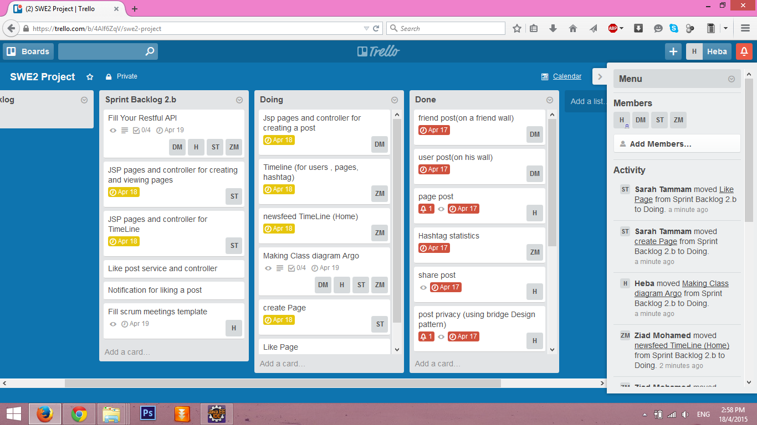

# Daily scrum Meetings

**Filled 5 templates for 5 meetings**

# Github repository link

**https://github.com/heba-khazbak/FCI-CS352-CS_2.git  
  
Google app Engine V3**