Cairo University Faculty of Computers and Information



**CS352 – Software Engineering II**

**Phase 1-a Template**

**2015**

**Project Team**

|  |  |  |  |
| --- | --- | --- | --- |
| **ID** | **Name** | **Email** | **Mobile** |
| 20120516 | Heba Ahmed Khazbak | heba.khazbak@gmail.com | 01009595942 |
| 20120185 | Ziad Mohamed | Ziad_mohamed9473@hotmail.com | 01271777806 |
| 20120191 | Sarah Hany Tammam | sarahHtammam@gmail.com | 01008332618 |
|  |  |  |  |
|  |  |  |  |
|  |  |  |  |

**Staff: Dr Mohammad El-Ramly m.elramly@fci-cu.edu.eg**

**[Write here your TA name only in your lab]**

**TAs: Eng Mohamed Samir m.samir@fci-cu.edu.egEng Yomna Magdy Mohamed yomna@fci-cu.edu.egEng Desoky Abd El-qawy d.abdelqawy@fci-cu.edu.egEng Omar Khaled Ali Ragab o.khaled@fci-cu.edu.egEng Ahmed Mohamed Sayed a.mohamed@fci-cu.edu.eg**

**Eng Ayat Khairy ayat.khairy@fci-cu.edu.eg**

Title page has no header or footer.

Docs must be supplied as pdf –files re-named as requested

Contents

Github repository link 2

Used Technologies 3

Frontend environment 3

Role of each member in the team 4

Comments 4

# Github repository link

* **Summarize the purpose of the github repository – in One paragraph**
* **Provide url of your repository**
* **You should add your team members to your repository – Provide snapshot with names**
* **Your repository name should follow this naming conventions (FCI-CS352-TeamName)**

**URL : https://github.com/heba-khazbak/FCI-CS352-CS_2.git**

**snapshot :**

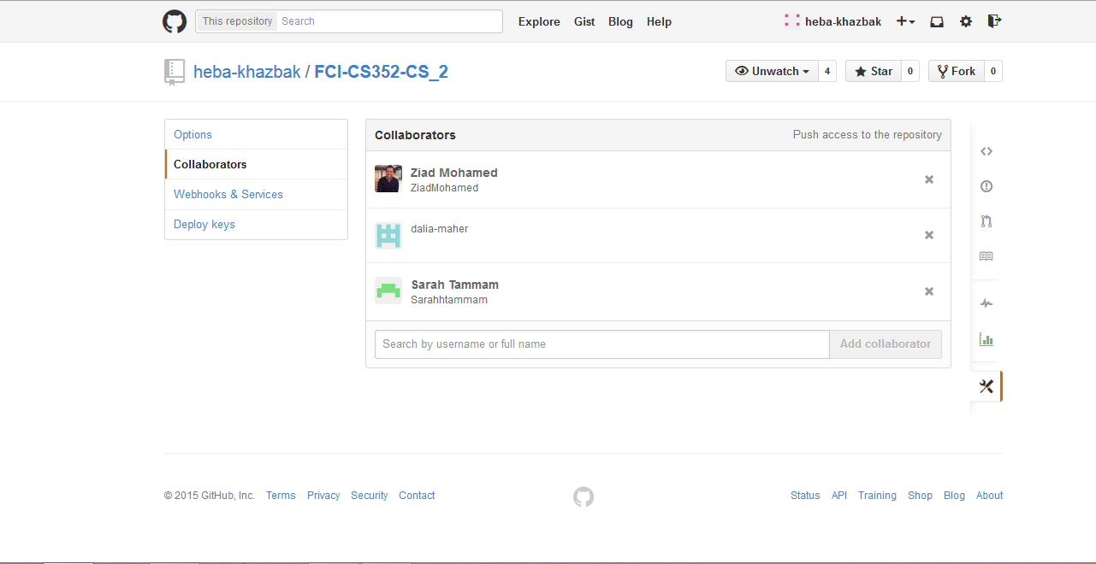

# Used Technologies

* **List technologies you will use in this project**
* **In each technology, you should write technology name, description and why you need technology – in one paragraph each**

# Frontend environment

* **Select frontend technology you will use (Web or Android)  
  Web application**

# Role of each member in the team

|  |  |
| --- | --- |
| Member name | Role |
| Heba Ahmed Khazbak |  |
|  |  |
|  |  |
|  |  |

# Comments

* **If you have any additional comments you want to add – or advice for us**