Cairo University Faculty of Computers and Information



**CS352 – Software Engineering II**

**Phase 1-c Template**

**2015**

**Project Team**

|  |  |  |  |
| --- | --- | --- | --- |
| **ID** | **Name** | **Email** | **Mobile** |
| 20120516 | Heba Ahmed Khazbak | heba.khazbak@gmail.com | 01009595942 |
| 20120185 | Ziad Mohamed | Ziad_mohamed9473@hotmail.com | 01271777806 |
| 20120191 | Sarah Hany Tammam | sarahHtammam@gmail.com | 01008332618 |
| 20120166 | Dalia Maher Mohamed | dalia.maher94@gmail.com | 01111267812 |
|  |  |  |  |
|  |  |  |  |

**Staff: Dr Mohammad El-Ramly m.elramly@fci-cu.edu.eg**

**Eng Desoky Abd El-qawy d.abdelqawy@fci-cu.edu.eg**

Contents

Your Restful API 3

Frontend 7

Daily scrum Meetings 11

Github repository link 11

# Your Restful API

|  |  |
| --- | --- |
| **Service name** | **registrationService** |
| **Input type** | **POST** |
| **Service URL** | **http://socialnetwork-fci.appspot.com/rest/RegistrationService** |
| **Parameters** | |  |  | | --- | --- | | **NAME** | **Description** | | **uname** | **provided username** | | **email** | **provided user email** | | **password** | **provided password** | |
| **Example request** | **http://socialnetwork-fci.appspot.com/rest/RegistrationService?uname=** **MohamedSamir3&email=m.samir@fci-cu.edu.eg&password=123456789** |
| **Example response** | **{"id":2,"Status":"OK"}** |

|  |  |
| --- | --- |
| **Service name** | **LoginService** |
| **Input type** | **POST** |
| **Service URL** | **http://socialnetwork-fci.appspot.com/rest/LoginService** |
| **Parameters** | |  |  | | --- | --- | | **NAME** | **Description** | | **uname** | **Provided user name** | | **Password** | **Provided user password** | |
| **Example request** | **POST**  **http://socialnetwork-fci.appspot.com/rest/LoginService?uname=** **MohamedSamir3&password=123456789** |
| **Example response** | **{"id":1,"Status":"OK","email":"mohamed","name":"MohamedSamir3","password":"123456789"}** |

|  |  |
| --- | --- |
| **Service name** | **addFriendService** |
| **Input type** | **POST** |
| **Service URL** | **http://socialnetwork-fci.appspot.com/rest/sendFriendRequestService** |
| **Parameters** | |  |  | | --- | --- | | **NAME** | **Description** | | **uname** | **Friend's username** | | **currentUser** | **current user in the system** | |
| **Example request** | **http://socialnetwork-fci.appspot.com/rest/sendFriendRequestService?uname=ziadMohamed&currentUser=MohamedSamir3** |
| **Example response** | **{"id":1,"Status":"Exists"}** |

|  |  |
| --- | --- |
| **Service name** | **acceptFriendService** |
| **Input type** | **POST** |
| **Service URL** | **http://socialnetwork-fci.appspot.com/rest/acceptFriendRequestService** |
| **Parameters** | |  |  | | --- | --- | | **NAME** | **Description** | | **uname** | **Friend's username** | | **currentUser** | **current user in the system** | |
| **Example request** | **http://socialnetwork-fci.appspot.com/rest/acceptFriendRequestService?uname=MohamedSamir3&currentUser=ziadMohamed** |
| **Example response** | **{"id":3,"Status":"OK"}** |

# Frontend

Link: <http://1-dot-socialnetwork-fci.appspot.com/>

HomePage:

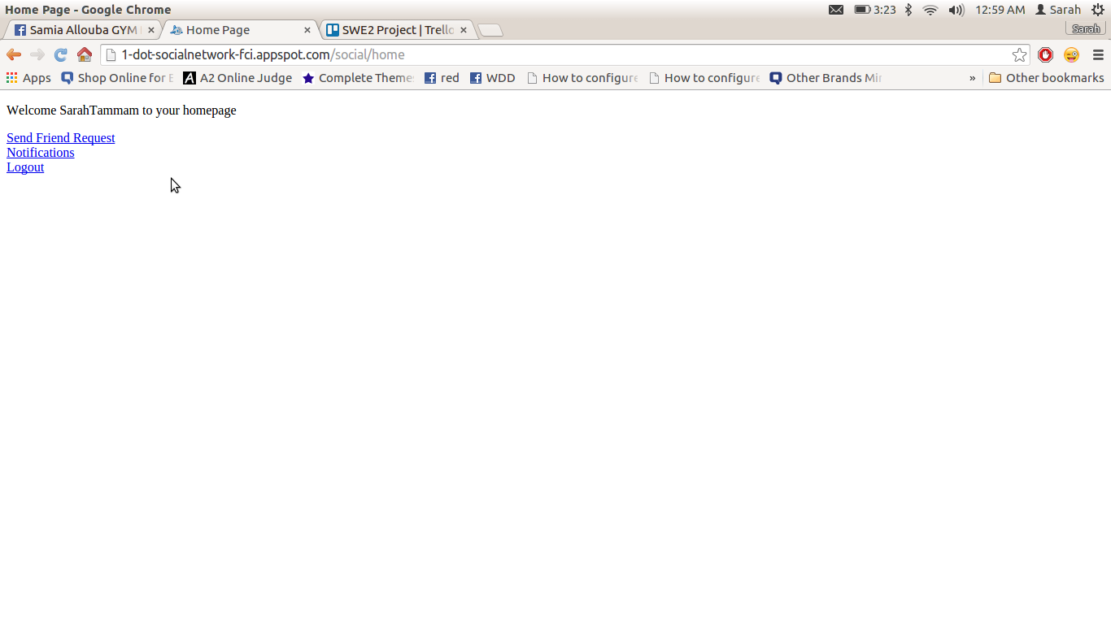

Send Friend request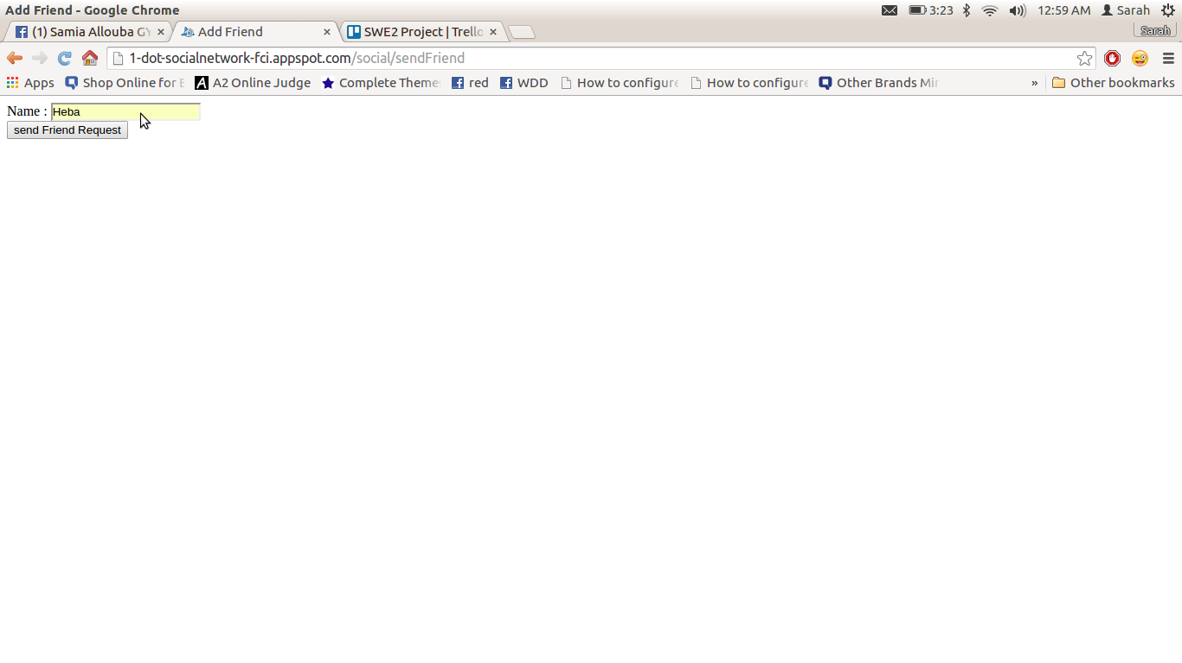

Notifications (people who sent you a friend request)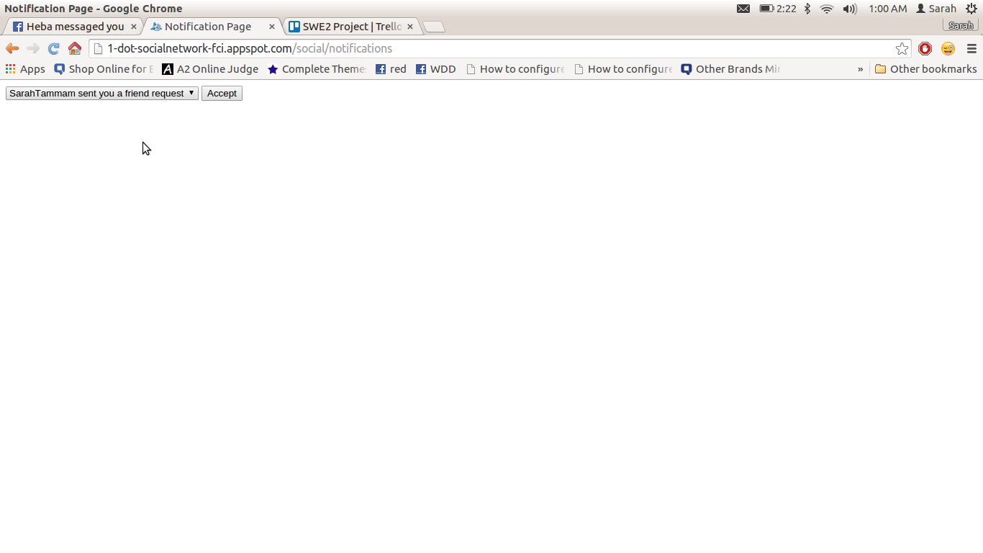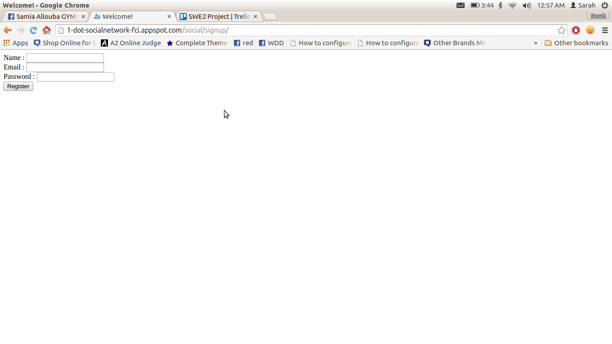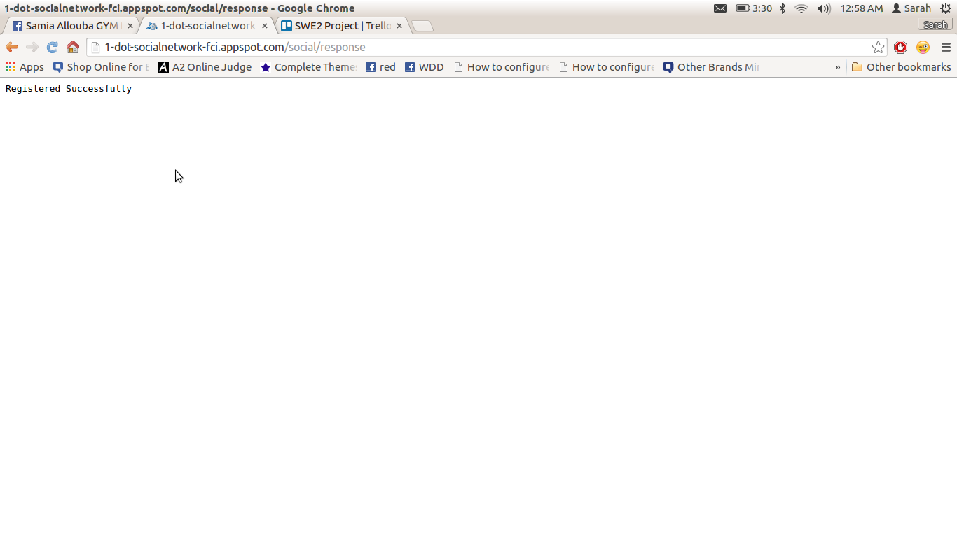

# Daily scrum Meetings

**Note : We uploaded our project on google app engine last monday. Also in phase 1.b we already developed the services and it's frontend.**

**Filled 3 templates for 3 meetings**

# Github repository link

**https://github.com/heba-khazbak/FCI-CS352-CS_2.git**