**School management database design  
all sql statements used in the project attached in this file   
  
**

**1. ER diagram analysis:**

**a. identify all the primary keys and foreign in the schema**

**The primary keys:**

**Entities and Primary Keys**:

1. **classroom → classroom_id**
2. **grade → grade_id**
3. **course → course_id**
4. **student → student_id**
5. **parent → parent_id**
6. **teacher → teacher_id**
7. **classroom_student → classroom_id, student_id**
8. **attendance → date, student_id**
9. **exam_type → exam_type_id**
10. **exam → exam_id**
11. **exam_result → exam_id, student_id, course_id**

**The foreign keys:  
Table, Foreign Key, References Table, and References Column**:

1. classroom
   * Foreign Key: grade_id → References Table: grade → References Column: grade_id
   * Foreign Key: teacher_id → References Table: teacher → References Column: teacher_id
2. course
   * Foreign Key: grade_id → References Table: grade → References Column: grade_id
3. student
   * Foreign Key: parent_id → References Table: parent → References Column: parent_id
4. classroom_student
   * Foreign Key: classroom_id → References Table: classroom → References Column: classroom_id
   * Foreign Key: student_id → References Table: student → References Column: student_id
5. attendance
   * Foreign Key: student_id → References Table: student → References Column: student_id
6. exam
   * Foreign Key: exam_type_id → References Table: exam_type → References Column: exam_type_id
7. exam_result
   * Foreign Key: exam_id → References Table: exam → References Column: exam_id
   * Foreign Key: student_id → References Table: student → References Column: student_id
   * Foreign Key: course_id → References Table: course → References Column: course_id

**2. Review the provided ER diagram:**

**Table overview**:

* **classroom**:  
  Stores details about classrooms, including grade, section, teacher, and additional remarks.
* **grade**:  
  Contains grade-specific information, such as grade name and a brief description.
* **course**:  
  Holds course details, including their associated grades.
* **student**:  
  Manages student data, including personal details, relationships with parents, and enrollment status.
* **parent**:  
  Stores parent or guardian information, including contact details.
* **teacher**:  
  Contains teacher records, including their personal information and contact details.
* **classroom_student**:  
  Manages many-to-many relationships between students and classrooms.
* **attendance**:  
  Tracks student attendance with dates, statuses ,and remarks.
* **exam_type**:  
  Defines various exam types, such as quizzes, midterms, and finals.
* **exam**:  
  Stores exam details, including type, date, and start time.
* **exam_result**:  
  Records students' performance and scores in specific courses.

**3. List the relationships (one-to-one, one-to-many, many-to-many) between entities and explain.**

### Relationships Between Entities

1. **Classroom → Grade**
   * **Relationship Type:** One-to-Many
   * **Foreign Key in Table 1:** grade_id
   * **References Column in Table 2:** grade_id
   * **Description:** Each classroom belongs to one grade, but one grade can have many classrooms.
2. **Classroom → Teacher**
   * **Relationship Type:** One-to-One
   * **Foreign Key in Table 1:** teacher_id
   * **References Column in Table 2:** teacher_id
   * **Description:** Each classroom is assigned to one teacher, and each teacher manages one class.
3. **Course → Grade**
   * **Relationship Type:** One-to-Many
   * **Foreign Key in Table 1:** grade_id
   * **References Column in Table 2:** grade_id
   * **Description:** Each course is assigned to one grade, but one grade can have many courses.
4. **Student → Parent**
   * **Relationship Type:** One-to-Many
   * **Foreign Key in Table 1:** parent_id
   * **References Column in Table 2:** parent_id
   * **Description:** Each student has one parent, but one parent can have multiple students.

**SQL Table Relationships**

1. **Classroom_Student → Classroom**
   * **Relationship Type:** Many-to-One
   * **Foreign Key in Table 1:** classroom_id
   * **References Column in Table 2:** classroom_id
   * **Description:** Links multiple students to a single classroom.
2. **Classroom_Student → Student**
   * **Relationship Type:** Many-to-One
   * **Foreign Key in Table 1:** student_id
   * **References Column in Table 2:** student_id
   * **Description:** Links multiple classrooms to a single student.
3. **Attendance → Student**
   * **Relationship Type:** Many-to-One
   * **Foreign Key in Table 1:** student_id
   * **References Column in Table 2:** student_id
   * **Description:** Tracks attendance for each student in the system.
4. **Exam → Exam_Type**
   * **Relationship Type:** One-to-Many
   * **Foreign Key in Table 1:** exam_type_id
   * **References Column in Table 2:** exam_type_id
   * **Description:** Each exam is categorized under a specific exam type.
5. **Exam_Result → Exam**
   * **Relationship Type:** Many-to-One
   * **Foreign Key in Table 1:** exam_id
   * **References Column in Table 2:** exam_id
   * **Description:** Tracks results for multiple students in one exam.
6. **Exam_Result → Student**
   * **Relationship Type:** Many-to-One
   * **Foreign Key in Table 1:** student_id
   * **References Column in Table 2:** student_id
   * **Description:** Tracks results for each student in various exams.
7. **Exam_Result → Course**
   * **Relationship Type:** Many-to-One
   * **Foreign Key in Table 1:** course_id
   * **References Column in Table 2:** course_id
   * **Description:** Tracks exam results for specific courses.

|  |  |  |  |  |  |  |  |  |  |  |  |
| --- | --- | --- | --- | --- | --- | --- | --- | --- | --- | --- | --- |
| **table 1** | **table 2** | **relationship Type** | |  | | --- | | **Foreign Key in Table 1** |  |  | | --- | |  | | |  | | --- | | **References Column in Table 2** |  |  | | --- | |  | | | **Description** | | --- |  |  | | --- | |  | |
| classroom | grade | |  | | --- | | One-to-Many |  |  | | --- | |  | | grade_id | grade_id | |  | | --- | | Each classroom belongs to one grade, but one grade can have many classrooms. |  |  | | --- | |  | |
| classroom | teacher | One-to-One | teacher_id | teacher_id | |  | | --- | | Each classroom is assigned to one teacher, and each teacher manages one class. |  |  | | --- | |  | |
| course | grade | |  | | --- | | One-to-Many |  |  | | --- | |  | | grade_id | grade_id | |  | | --- | | Each course is assigned to one grade, but one grade can have many courses. |  |  | | --- | |  |  |  | | --- | |  | |
| student | |  | | --- | | parent |  |  | | --- | |  | | |  | | --- | | One-to-Many |  |  | | --- | |  | | parent_id | parent_id | |  | | --- | | Each student has one parent, but one parent can have multiple students. |  |  | | --- | |  | |
| classroom_student | classroom | |  | | --- | | Many-to-One |  |  | | --- | |  | | classroom_id | classroom_id | |  | | --- | | Links multiple students to a single classroom. |  |  | | --- | |  | |
| classroom_student | student | |  | | --- | | Many-to-One |  |  | | --- | |  | | student_id | student_id | |  | | --- | | Links multiple classrooms to a single student. |  |  | | --- | |  | |
| attendance | student | |  | | --- | | Many-to-One |  |  | | --- | |  | | student_id | student_id | |  | | --- | | Tracks attendance for each student in the system. |  |  | | --- | |  | |
| exam | exam_type | |  | | --- | | One-to-Many |  |  | | --- | |  | | exam_type_id | exam_type_id | |  | | --- | | Each exam is categorized under a specific exam type. |  |  | | --- | |  | |
| exam_result | exam | |  | | --- | | Many-to-One |  |  | | --- | |  | | exam_id | exam_id | |  | | --- | | Tracks results for multiple students in one exam. |  |  | | --- | |  | |
| exam_result | student | |  | | --- | | Many-to-One |  |  | | --- | |  | | student_id | student_id | |  | | --- | | Tracks results for each student in various exams. |  |  | | --- | |  | |
| exam_result | course | |  | | --- | | Many-to-One |  |  | | --- | |  | | course_id | course_id | |  | | --- | |  |  |  | | --- | |  |   Tracks exam results for specific courses. |

**2. Sql table relation :**

**This file contains the tables, relationships between the tables, constraints, and explanation for each attribute in each table**

**  
3) Insert sample data for the following tables:**

**In the attached file:**



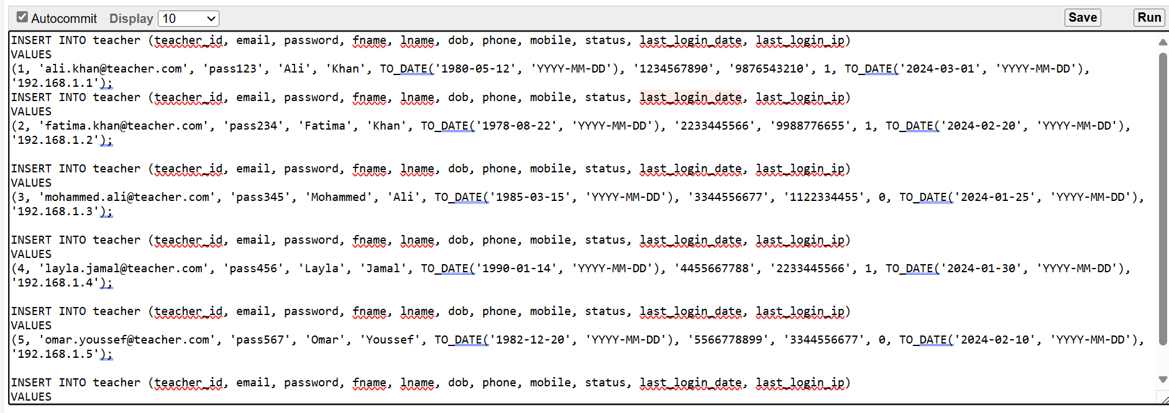

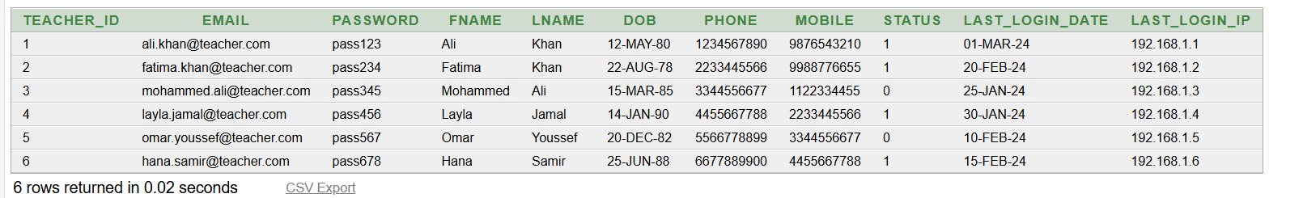

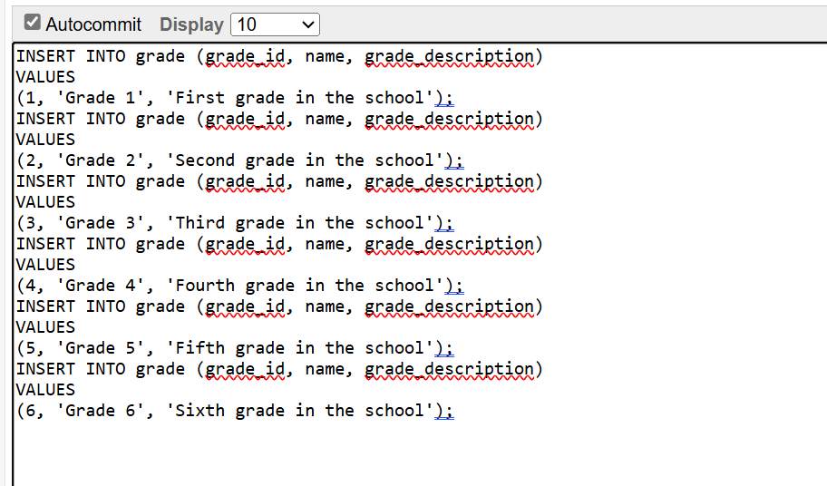

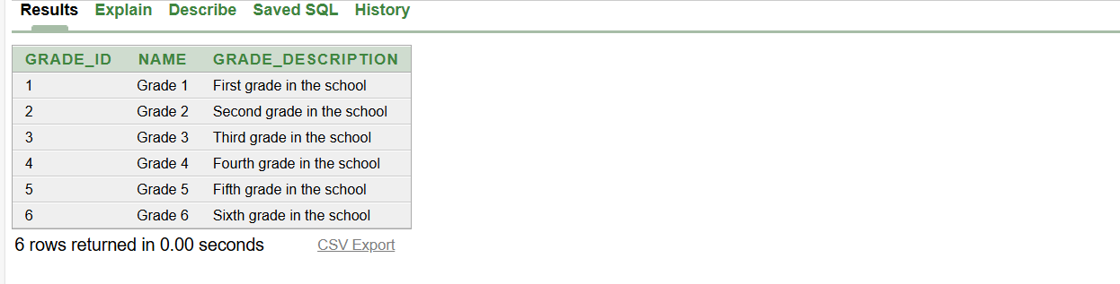

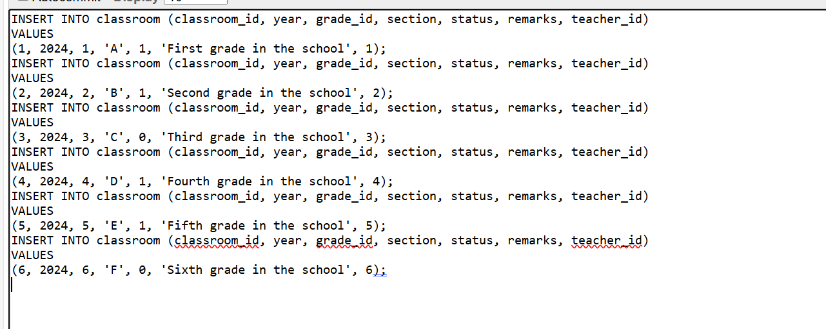

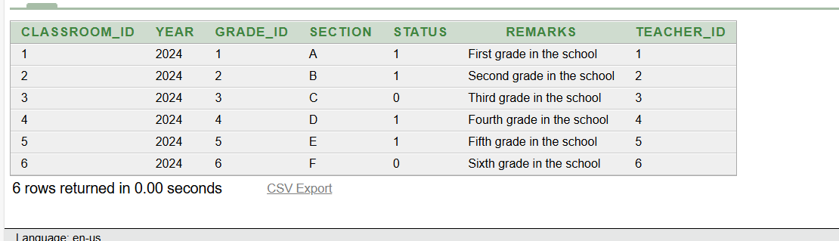

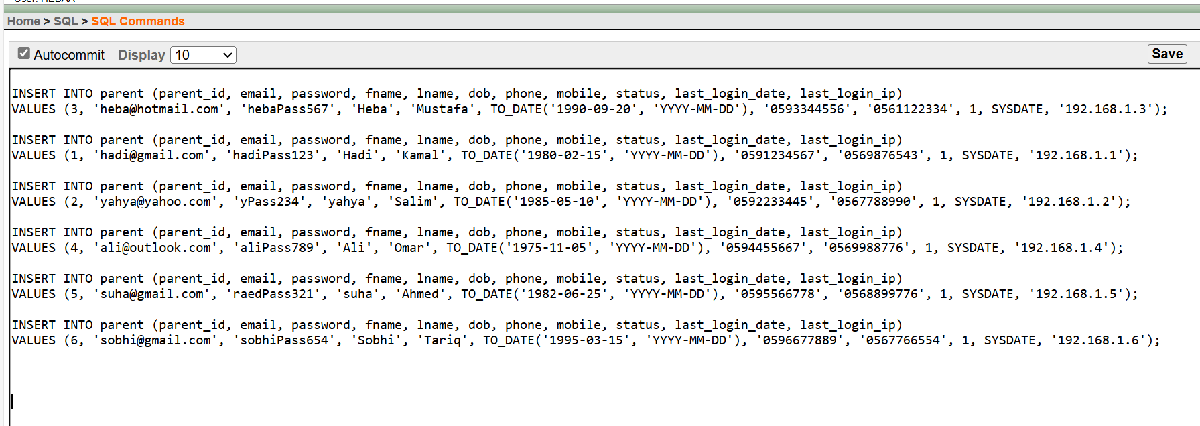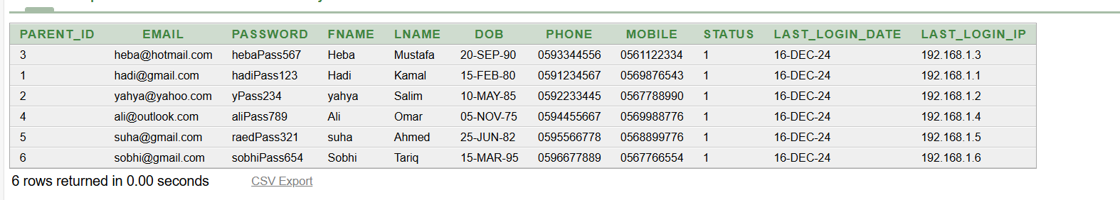

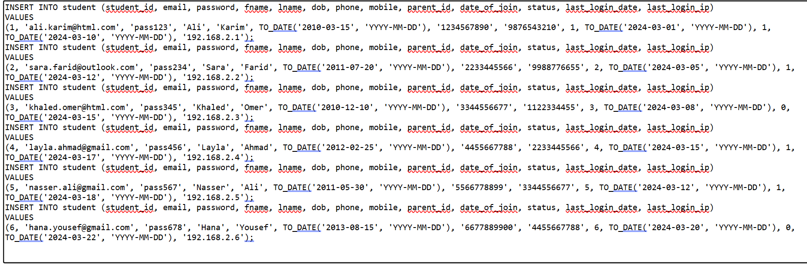

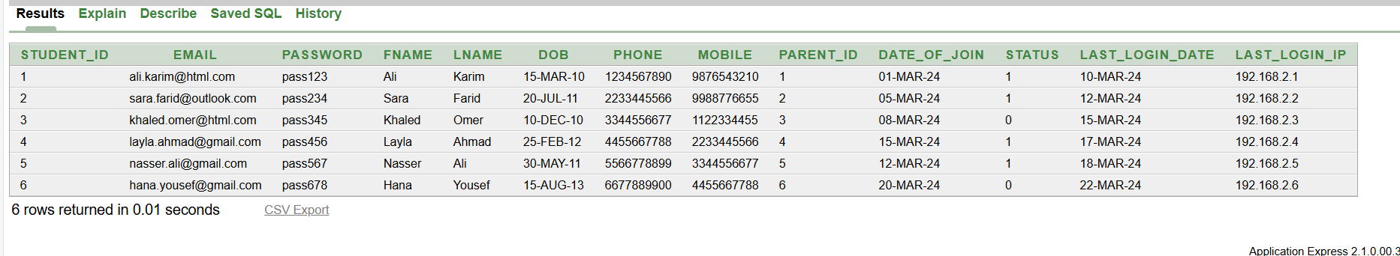

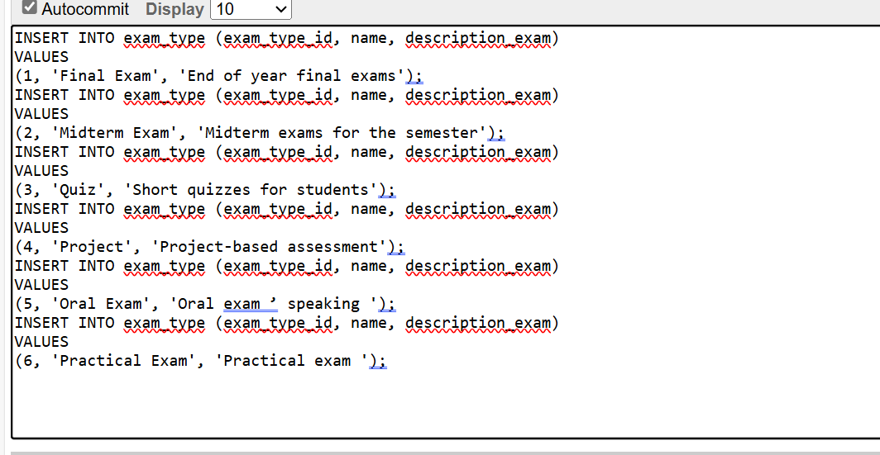

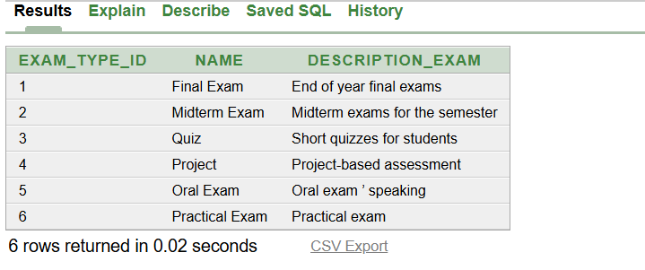

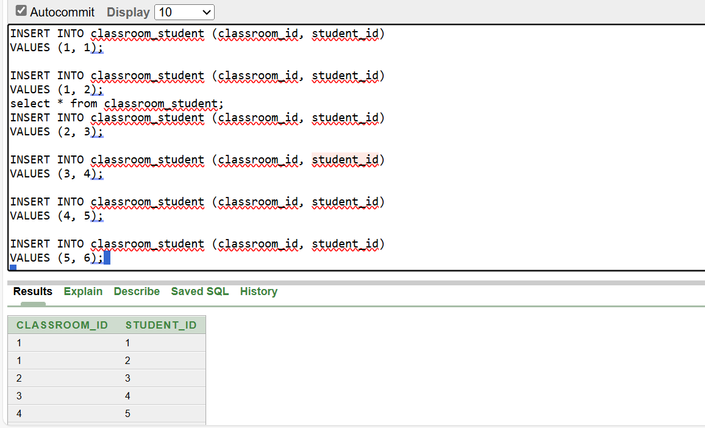

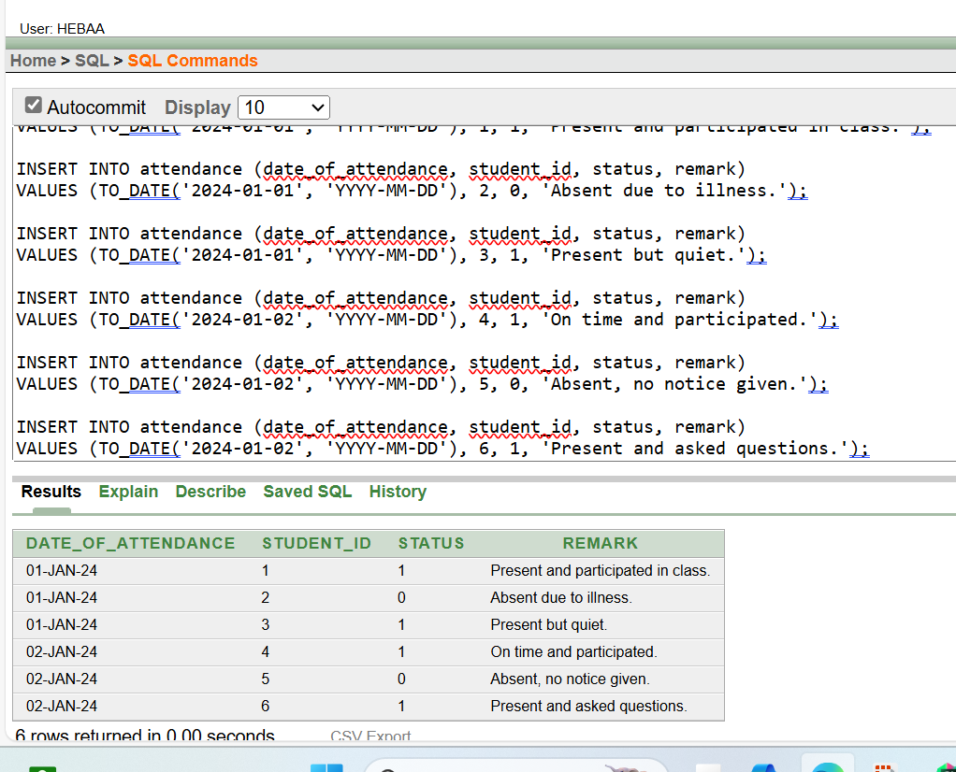********************************************************************  
**sql queries in this file**   


1. **Retrieve a list of all students in a specific classroom along with their grade:  
   select**

**c.classroom_id as classroom_id,**

**s.fname || ' ' || s.lname as student_name,**

**g.name as grade_name,**

**g.grade_description as grade_desc**

**from**

**student s**

**join**

**classroom_student cs on s.student_id = cs.student_id**

**join**

**classroom c on cs.classroom_id = c.classroom_id**

**join**

**grade g on c.grade_id = g.grade_id**

**order by c.classroom_id, s.lname;**

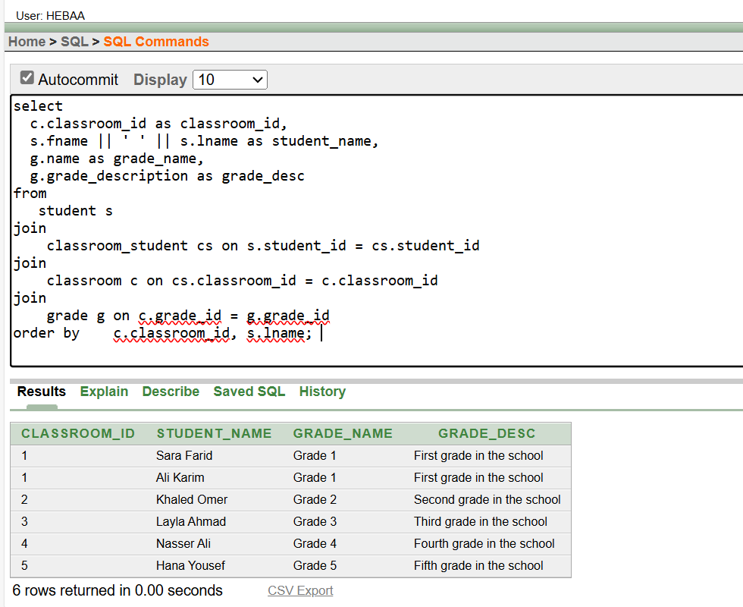

**2)Fetch the details of all teachers teaching a specific course.**

**SELECT t.teacher_id, t.fname || ' ' || t.lname AS teacher_name, t.email, t.phone**

**FROM teacher t**

**JOIN classroom c ON t.teacher_id = c.teacher_id**

**JOIN course cr ON c.grade_id = cr.grade_id  
WHERE cr.course_id = 4;**

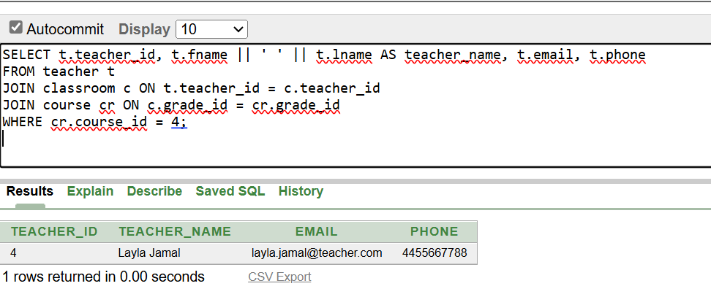

**3)Find all exams taken by a student along with their marks.:**

**SELECT e.name AS exam_name, et.name AS exam_type, er.marks  
FROM exam_result er  
JOIN exam e ON er.exam_id = e.exam_id  
JOIN exam_type et ON e.exam_type_id = et.exam_type_id  
WHERE er.student_id = 3;**

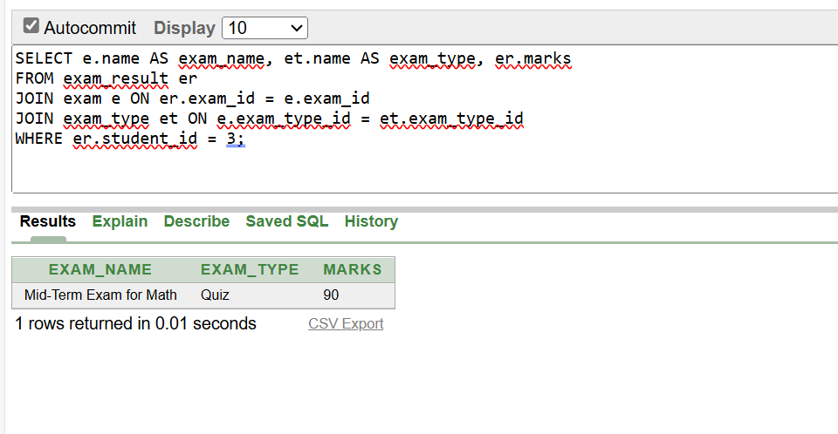

**4) . Retrieve the attendance records for a specific student within a given date range.  
SELECT A.date_of_attendance,   
A.status,   
A.remark  
FROM   
attendance A  
WHERE   
A.student_id = 6 AND A.date_of_attendance   
 BETWEEN TO_DATE('2024-01-01', 'YYYY-MM-DD')   
AND TO_DATE('2024-01-31', 'YYYY-MM-DD')  
ORDER BY   
A.date_of_attendance;**

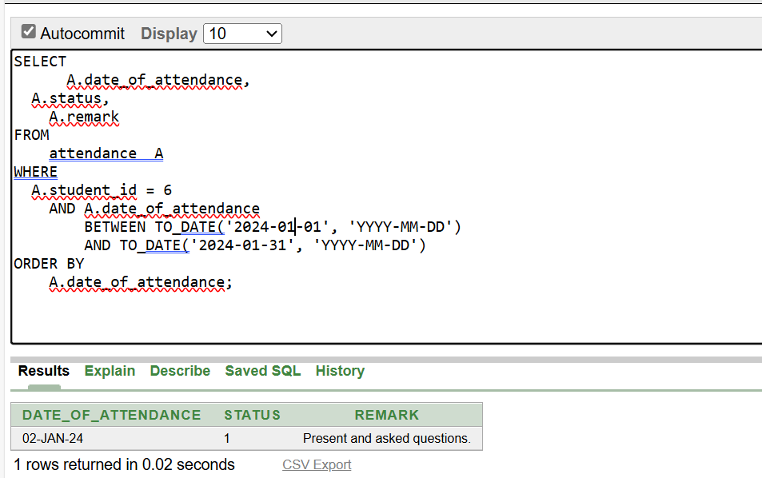

**5). List the parents' contact information for all students in a particular grade**

**SELECT p.fname || ' ' || p.lname AS parent_name, p.phone, p.mobile, p.email  
FROM parent p  
JOIN student s ON p.parent_id = s.parent_id  
JOIN classroom_student cs ON s.student_id = cs.student_id  
JOIN classroom c ON cs.classroom_id = c.classroom_id  
JOIN grade g ON c.grade_id = g.grade_id  
WHERE g.grade_id = 1;**

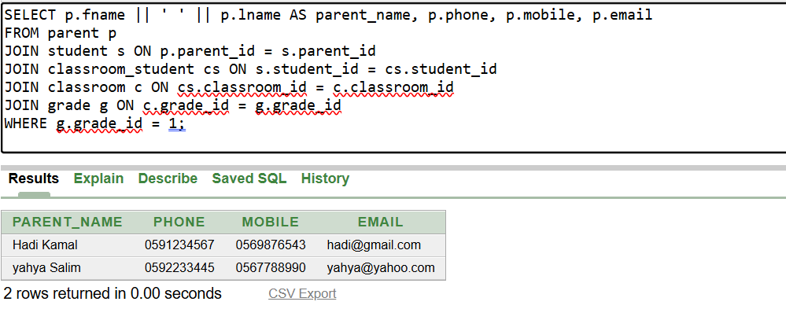

**6). Fetch the average marks for each exam type for a specific course.**

**SELECT et.name AS exam_type, AVG(TO_NUMBER(er.marks)) AS average_marks  
FROM exam_result er  
JOIN exam e ON er.exam_id = e.exam_id  
JOIN exam_type et ON e.exam_type_id = et.exam_type_id  
WHERE er.course_id = 1  
GROUP BY et.name;**

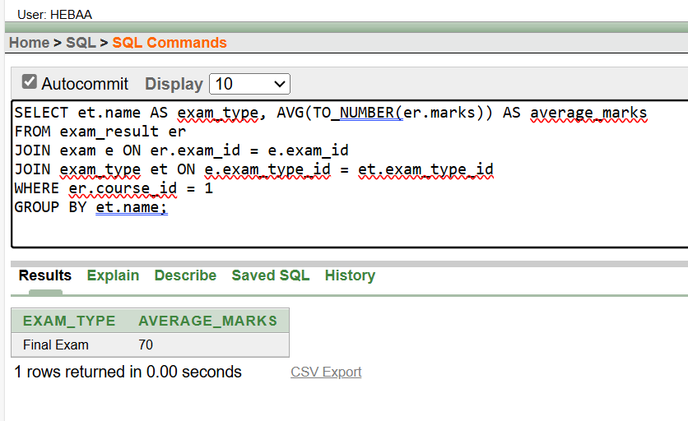

**7). Display all courses along with their associated grade and teacher.**

**SELECT cr.name AS course_name, g.name AS grade_name, t.fname || ' ' || t.lname AS teacher_name  
FROM course cr  
JOIN grade g ON cr.grade_id = g.grade_id  
JOIN classroom c ON g.grade_id = c.grade_id  
JOIN teacher t ON c.teacher_id = t.teacher_id;**

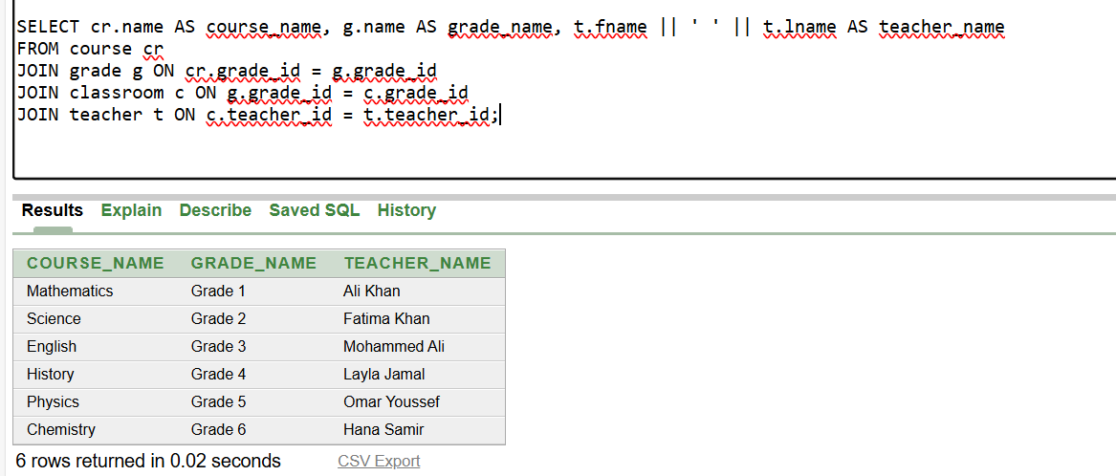

**8). List all classrooms along with the number of students in each**

**SELECT c.classroom_id, c.year, c.section, COUNT(cs.student_id) AS student_count  
FROM classroom c  
LEFT JOIN classroom_student cs ON c.classroom_id = cs.classroom_id  
GROUP BY c.classroom_id, c.year, c.section  
ORDER BY c.classroom_id;**

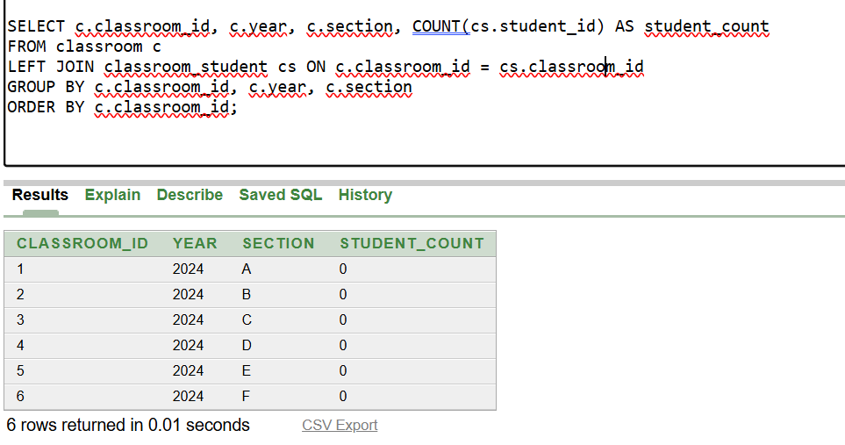

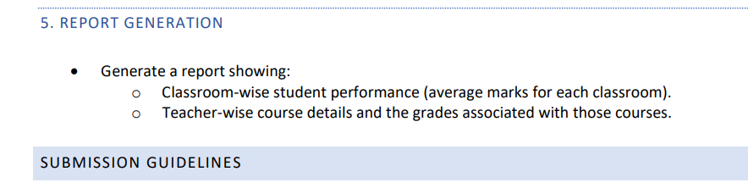

**Sql file**

  
**1.**

**CREATE OR REPLACE VIEW report1 AS  
SELECT   
c.classroom_id,  
c.year,  
c.section,  
AVG(TO_NUMBER(er.marks)) AS average_marks  
FROM   
classroom c  
JOIN classroom_student cs ON c.classroom_id = cs.classroom_id  
JOIN exam_result er ON cs.student_id = er.student_id  
GROUP BY   
c.classroom_id, c.year, c.section  
ORDER BY   
c.classroom_id;  
desc report1;  
select * from report1;**

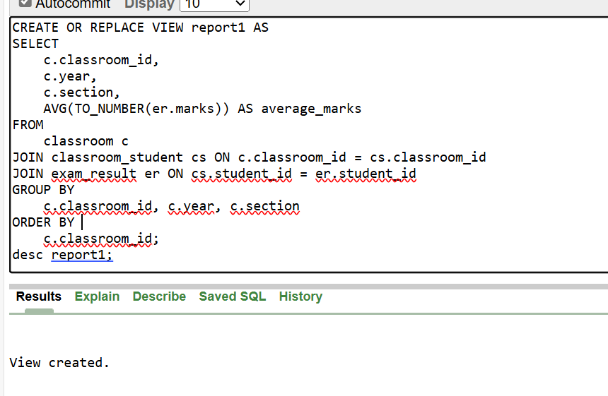

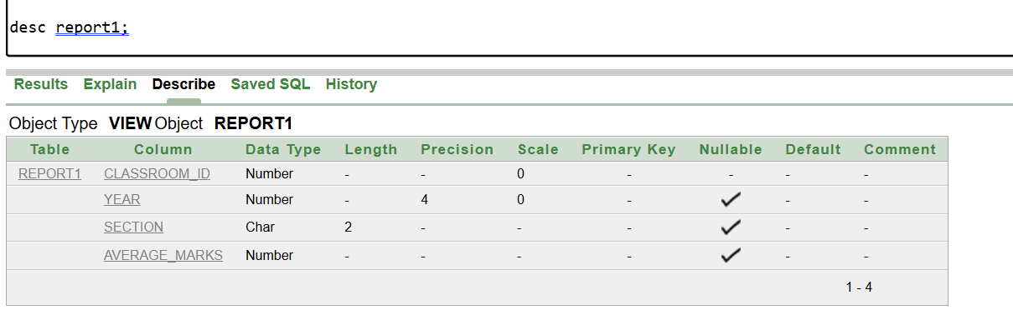

**2.  
CREATE OR REPLACE VIEW report2 AS  
SELECT   
t.teacher_id,  
t.fname || ' ' || t.lname AS teacher_name,  
cr.course_id,  
cr.name AS course_name,  
g.grade_id, g.name AS grade_name FROM   
teacher t JOIN classroom c ON t.teacher_id = c.teacher_id  
JOIN grade g ON c.grade_id = g.grade_id  
JOIN course cr ON g.grade_id = cr.grade_id ORDER BY t.teacher_id, cr.course_id; desc report2; select * from report2;**

