TABLE OF CONTENTS
Chapter 1: Introduction 7
1.1 Project Background 8
1.2 Problem Statement 8
1.3 Objectives 8
1.4 Scope of the Project 9
1.5 Overview of the System 10
1.5.1 Farmer Web Application 10
1.5.2 Administrative Panel 11
1.5.3 Backend and AI Integration 11
Chapter 2: System Analysis and Requirements 12
2.1 Existing System 12
2.2 Proposed System 13
2.3 Stakeholders Identification 14
2.4 Functional Requirements 15
2.4.1 User Authentication and Profile Management 15
2.4.2 AI-Based Disease Detection 15
2.4.3 Weather Integration 16
2.4.4 Advisory and Notification System 16
2.4.5 Administrative Management 16
2.5 Non-Functional Requirements 17
2.5.1 Performance 17
2.5.2 Usability 17
2.5.3 Reliability 17
2.5.4 Security 17
2.5.5 Maintainability 18
2.5.6 Language and Accessibility 18
2.6 Feasibility Analysis 18
2.6.1 Technical Feasibility 18
2.6.2 Economic Feasibility 19
2.6.3 Operational Feasibility 20
Chapter 3: System Design 21
3.1 System Architecture 21
3.1.1 AI Model Integration Architecture 22
3.2 Use Case Diagram 23
3.3 Use Case Descriptions 23
UC-01: Farmer Registration 24
UC-02: AI-Based Disease Detection 24
UC-03: View Weather Alerts 25
UC-04: Admin Manages Advisories 25
3.4 Activity Diagrams 26
3.4.1 Activity Diagram: AI Disease Detection Workflow 26
3.4.2 Activity Diagram: Farmer Registration and Login 26
3.4.3 Activity Diagram: Admin Advisory Management 27
3.5 Sequence Diagrams 28
3.5.1 Sequence Diagram: Disease Detection 29
3.5.2 Sequence Diagram: Weather Alert Retrieval 30
3.5.3 Sequence Diagram: Admin Login and Dashboard Load 31
3.6 Class Diagram 31
3.7 Database Design 32
3.7.1 Table: users 33
3.8 Interface Design 33
3.8.1 Farmer-Facing Interface 33
3.8.2 Administrative Panel Interface 34
3.8.3 UI/UX Design Principles Applied 35
Chapter 4: Implementation 37
4.1 Development Environment 37
4.2 System Modules Description 37
4.2.1 Farmer Authentication Module 38
4.2.2 Plant Disease Detection Module 38
4.2.3 Crop Advisory Module 38
4.2.4 Weather Integration Module 39
4.2.5 Daily Tips and Advisories Module 39
4.2.6 Admin Panel Module 39
4.3 Frontend Implementation 40
4.3.1 Internationalisation and RTL Layout 40
4.3.2 Home Page (home.html) 40
4.3.3 Registration Page (register.html) 40
4.3.4 Farmer Dashboard (dashboard.html) 41
4.3.5 Plant Disease Detection Page (disease.html) 41
4.3.6 Crop Advisory Page (crop_advisory.html) 41
4.3.7 Daily Tips Page (tips.html) 41
4.4 Admin Panel Frontend 41
4.5 Database Implementation 42
4.6 AI Model Integration 42
4.6.1 Trained Models 43
4.6.2 Model Loading 43
4.6.3 Treatment Recommendation in Urdu 43
4.6.4 Confidence Threshold Guard 43
4.7 Key Functionality Implementation Details 44
4.7.1 CORS and Cross-Origin Communication 44
4.7.2 Paginated Farmer Listing 44
4.7.3 Personalised Notification and Advisory Delivery 44
4.7.4 File Upload and Storage 44
Chapter 5: Testing and Evaluation 46
5.1 Testing Strategy 46
5.1.1 Unit Testing 46
5.1.2 Integration Testing 46
5.1.3 System Testing 47
5.1.4 Boundary Value Analysis 47
5.2 Functional Test Cases 47
TC-01: Farmer Registration — Valid Input 47
TC-02: Farmer Registration — Duplicate CNIC Rejection 48
TC-03: Farmer Login — Valid Credentials 48
TC-04: Farmer Login — Invalid Password 48
TC-05: Protected Route Access Without Authentication 49
TC-06: Plant Disease Detection — Wheat Leaf with Valid Image 49
TC-07: Disease Detection — Low Confidence Guard 50
TC-08: Real-Time Weather API Integration 50
TC-09: Admin Login and Dashboard Statistics Aggregation 50
TC-10: Personalised Advisory Delivery Filtered by Crop Type 51
5.3 Boundary Value Analysis 51
5.3.1 Land Area Input Field — Farmer Registration 52
5.3.2 CNIC Number Field — Farmer Registration 53
5.3.3 Disease Detection Model Confidence Threshold 54
5.3.4 Image File Upload — Format and Size Boundaries 55
5.4 System Validation 56
5.5 Performance Evaluation 56
5.6 User Feedback and Usability Evaluation 57
5.6.1 Usability Observations 57
5.7 Testing Summary 58
Chapter 6: Conclusion and Future Work 59
6.1 Summary of the Project 59
6.2 Achievements 60
6.2.1 Functional AI-Based Disease Detection 60
6.2.2 Urdu-First User Interface 60
6.2.3 Personalised Advisory Delivery 61
6.2.4 End-to-End Administrative Control 61
6.2.5 Cloud-Hosted and Externally Integrated Architecture 61
6.2.6 Structured Software Engineering Documentation 61
6.3 Limitations 62
6.3.1 Limited Crop Coverage 62
6.3.2 Absence of Server-Side Input Validation 62
6.3.3 Plain-Text Password Storage 62
6.3.4 Single-Threaded Development Server 62
6.3.5 Weather Data at City Level Only 63
6.3.6 No Offline Functionality 63
6.4 Future Enhancements 63
6.4.1 Password Hashing and Security Hardening 63
6.4.2 Expanded Crop and Disease Coverage 63
6.4.3 Voice Interface in Urdu 64
6.4.4 Hyperlocal Weather Integration 64
6.4.5 Progressive Web Application with Offline Support 64
6.4.6 SMS and Push Notification Integration 64
6.4.7 Marketplace and Input Supply Integration 65
6.5 Concluding Remarks 65

Chapter 1: Introduction
This chapter establishes the context, motivation, and scope of the Hamara Kisaan project and it begins with a background discussion of agriculture's role in Pakistan's economy and the challenges facing small-scale farmers and then proceeds to define the problem the system addresses and articulates the project's objectives, delineates its scope and finally concludes with an overview of the implemented system components.

1.1 Project Background
Agriculture is the foundational sector of Pakistan's economy and according to the Pakistan Economic Survey 2022–23 the agricultural sector contributes approximately about 22.9 percent to the country's Gross Domestic Product and even directly employs nearly 37-40 percent of the national labour force which makes it the single largest source of rural employment and the crops such as wheat, rice, sugarcane, and cotton are cultivated across millions of acres and form the backbone of both domestic food supply and export earnings and despite this economic significance, the agricultural sector in Pakistan operates largely on traditional as well as experience-based practices that have seen limited integration of modern technology.
Small-scale farmers who constitute the overwhelming majority of agricultural producers in Pakistan often times face a persistent and compounding set of challenges; crop diseases particularly fungal and bacterial infections that affect wheat and rice cause substantial yield losses every year and acccording to the analysis, the Food and Agriculture Organization of the United Nations estimates that plant diseases cause yield losses of up to 40 percent globally; this figure is disproportionately higher in countries where early detection and precision management are not widely practiced, especially in Pakistan; in Pakistan's context, the absence of accessible, timely, and localized diagnostic support means that many farmers are unable to identify diseases until visible damage has spread across their fields.
Beyond this disease management farmers face challenges related to unpredictable weather events which includes heatwaves, early frost, and unseasonal rainfall that can devastate crops within days if not anticipated. Irrigation management is another domain where data-driven guidance could substantially improve water use efficiency and crop outcomes and expert agricultural guidance, when it exists at all, is typically delivered through government extension services that are chronically underfunded and understaffed relative to the farming population they serve. The rapid expansion of mobile internet access in rural Pakistan presents a significant opportunity to address these gaps, as of 2023, mobile broadband penetration in Pakistan reached approximately 55 percent thus this connectivity creates a viable channel for delivering intelligent, personalized agricultural support directly to farmers' devices, provided that such support is designed with their linguistic, technical, and contextual needs at the centre of the design process.
The Hamara Kisaan project was conceived and developed in direct response to this opportunity and these challenges. The name meaning "Our Farmer" in Urdu reflects the system's fundamental design philosophy: that agricultural technology should serve farmers in their own language, on their own terms and with an understanding of their specific crop types, soil conditions as well their regional climate. The platform was built as a fully functional, cloud-connected and AI-augmented web application that combines plant disease detection through deep learning and real-time weather data integration, crop-specific advisory delivery, and a comprehensive administrative management panel within a single accessible system.

1.2 Problem Statement
Farmers in Pakistan lack access to reliable and timely agricultural information which results in inefficient crop, irrigation, as well as poor disease management decisions; the existing solutions are either not localized, too complex, or lack AI-based disease detection which creates a need for a simple, intelligent system to support informed farming and improve productivity.

1.3 Objectives
The Hamara Kisaan project was developed with the following primary objectives each of which corresponds directly to a specific dimension of the problem identified above.
The first and most technically significant objective was to develop and integrate an AI-based plant disease detection system capable of analyzing images of crop leaves and returning accurate diagnostic results for wheat and rice crops.
The second objective was to deliver real-time weather information and threshold-based alerts to farmers through integration with an external weather API and this addresses the need for farmers to make timely decisions in response to extreme weather events that could damage crops or alter irrigation requirements.
The third objective was to build a crop advisory and daily tips system that delivers contextually relevant farming guidance to farmers based on their registered crop type and the system needed to be managed by an administrator to ensure that the content is both relevant and linguistically accessible.
The fourth objective was to design and implement a farmer-facing interface that is fully accessible to users with limited digital literacy which meant adopting an Urdu-language right-to-left layout and using familiar visual patterns to minimize the number of required interactions per task and ensuring compatibility with mobile devices commonly used in rural Pakistan.
The fifth objective was to develop a comprehensive administrative panel that allows system operators to manage farmer records, publish advisories and notifications, review disease detection logs, manage treatment information as well as monitor system activity and all of this without requiring direct database access.
Finally, the project aimed to produce a complete and professionally documented software engineering report that accurately reflects the implemented system across all phases of the development lifecycle, from requirements analysis and system design through to implementation, testing, and evaluation.

1.4 Scope of the Project
The system supports disease detection for two crops which are wheat and rice and they together account for the majority of cereal crop cultivation in Pakistan. The wheat model classifies leaf images into fifteen disease categories while the rice model covers six categories and all the disease detection results and treatment recommendations are delivered in Urdu for farmer’s ease of understanding. The weather integration provides real-time temperature, humidity, and general weather condition data sourced from the OpenWeatherMap API with city-level granularity; the advisory system delivers crop-specific farming guidance published by the administrator and filtered by the farmer's registered crop type.
The geographic scope of the system is not restricted to a single region as farmers from any tehsil in Pakistan can register and use the platform, however, the system has been primarily tested and designed for a specific region with farming communities in Punjab, particularly the Faisalabad agricultural belts, in mind.
The following areas are explicitly outside the scope of the current implementation: nationwide or government-level deployment, financial transaction processing or marketplace functionality, IoT-based soil sensor integration, satellite imagery analysis, SMS delivery (the dispatch infrastructure is in place but live gateway integration is deferred) and the disease detection for crops other than wheat and rice. These exclusions reflect practical decisions made to maintain the quality and reliability of what is included rather than produce a shallow implementation across a wider surface area.

1.5 Overview of the System
The Hamara Kisaan platform is a web-based application composed of two primary user-facing components which includes a farmer web application and an administrative panel and a shared backend that serves both of them. The system follows a layered client-server architecture in which the presentation layer communicates with the Flask application logic layer which in turn communicates with the MySQL data layer hosted on the Aiven Cloud platform and with external services including the OpenWeatherMap API.

1.5.1 Farmer Web Application
The farmer-facing web application is accessible through a standard web browser on both desktop and mobile devices. It is rendered server-side using Flask's Jinja2 templating engine and is designed entirely in Urdu with a right-to-left layout to ensure usability for the target demographic. The application provides six core pages which includes a home and landing page, a registration page, a login page, a personal dashboard, a disease detection page and finally a crop advisory and tips page.
Upon registration a farmer provides their personal details, location, and agricultural profile including crop type, soil type, land area in acres, and irrigation method and then this profile data is used throughout the application to personalize the content displayed to the farmer, on the dashboard, the farmer sees a real-time weather card for their registered location, crop-specific advisories published by the administrator, and navigation tiles for the system's key features. The disease detection module allows the farmer to upload a photograph of a crop leaf, select the relevant crop type, and receive an AI-generated diagnosis within seconds and then finally a confidence score for the disease detected and an Urdu-language treatment recommendation accordingly.

1.5.2 Administrative Panel
The administrative panel is implemented as a React.js single-page application built with the Vite build tool and styled using Tailwind CSS which communicates with the Flask backend exclusively through a RESTful JSON API. The panel provides the system administrator with a comprehensive set of management tools organized across ten navigable sections.
Through the admin panel, the administrator can view dashboard statistics summarizing system activity, manage the full list of registered farmer records with search and filter capabilities, publish and remove farming advisories sourced from live agricultural news, configure weather alert thresholds, review disease detection logs with the ability to verify or override AI predictions, manage the disease treatment knowledge base, dispatch notifications to all farmers or targeted crop groups, and inspect the system activity audit log, additionally, the panel also supports both light and dark display modes and includes a collapsible sidebar for efficient navigation.

1.5.3 Backend and AI Integration
The Flask backend serves as the central processing hub of the system. It handles authentication for both farmers and administrators and processes all database interactions, manages the AI inference pipeline, and routes external API requests. The AI subsystem loads two pre-trained TensorFlow Keras models at application startup and performs inference on uploaded images using a preprocessing pipeline that correctly avoids double normalization(which is a technical detail that was identified and resolved during development). All treatment recommendations returned by the AI models are written in Urdu and are drawn from a curated knowledge base embedded in the application.

Chapter 2: System Analysis and Requirements
This chapter presents the analytical foundation of the Hamara Kisaan system and it examines the limitations of the existing agricultural advisory landscape, describes the proposed system in relation to those limitations, identifies all parties with a stake in the system's outcome, and documents the complete set of functional and non-functional requirements.

2.1 Existing System
Agriculture contributes approximately 22.9 percent to Pakistan's Gross Domestic Product and provides employment to nearly 40 percent of the national labour force (according to Pakistan Economic Survey 2022–23) and despite this central role, the agricultural advisory infrastructure available to small-scale farmers remains structurally inadequate. The principal mechanism for agricultural guidance is severely understaffed relative to the size of the farming population it is expected to serve.
In the absence of structured extension services farmers typically rely on three informal sources of agricultural knowledge which is basically advice from fellow farmers and community elders, guidance from local seed and agrochemical dealers and general internet searches that rarely yield region-specific or crop-specific results and none of these channels provide the timeliness, accuracy or personalization that the effective crop management requires.
Several digital agricultural platforms do exist in the Pakistani market including government-operated portals and mobile applications from international development organizations, however, a consistent pattern across these platforms is that they are designed for English-literate and formally educated users and do not accommodate the practical constraints of a smallholder farmer in rural Punjab or Sindh furthermore, these platforms typically do not offer AI-based disease detection from field photographs and it’s the feature that would be most immediately useful for crop protection decisions.
The limitations of the existing system can be summarized across four dimensions. First, disease diagnosis is reactive rather than proactive such that farmers seek advice only after visible crop damage has appeared by which time yield losses may already be irreversible. Second, advisory content is generic rather than personalized such that the same advice is delivered regardless of the farmer's crop type, soil condition, or local weather. Third, the language barrier is pervasive such that the vast majority of available digital agricultural resources are in English, which is inaccessible to a large proportion of rural farmers. Fourth, weather information is not integrated with agricultural guidance such that the farmers have access to general weather forecasts through television or mobile apps but these are not contextually connected to specific crop management decisions.

2.2 Proposed System
The Hamara Kisaan platform was designed to directly address each of the four limitations identified in the analysis of the existing system. It proposes an AI-powered, Urdu-language, mobile-accessible web application that integrates disease detection, weather integration, personalized advisory delivery as well as the administrative management within a single cohesive platform.
To address the reactive nature of existing disease diagnosis: the system provides a real-time image-based detection tool that enables farmers to identify crop diseases immediately upon observation of symptoms and rather than waiting for an extension visit or consulting a dealer, a farmer can photograph a diseased leaf and then upload it through the web interface and then receive an AI-generated diagnosis with a treatment recommendation…all within an average of two to three seconds.
To address the lack of personalization: the system builds a comprehensive agricultural profile for each registered farmer at registration time. This profile which captures crop type, soil type, land area, irrigation method, and tehsil is used throughout the platform to filter advisory content, contextualize weather information and then tailor the dashboard display to the individual farmer's situation, thus, a wheat farmer in a loamy-soil tehsil receives different advisories and irrigation suggestions than a rice farmer in a clay-soil region.
To address the language barrier: the entire farmer-facing interface is implemented in Urdu using a right-to-left layout culturally appropriate typography (Noto Nastaliq Urdu and Noto Sans Arabic), and all system outputs including those of disease names, treatment recommendations, advisory content, and interface labels are composed in accessible Urdu thus, this commitment to Urdu-first design is the most fundamental distinguishing feature of the proposed system relative to the existing alternatives.
To address the disconnection between weather information and agricultural guidance, the system integrates real-time weather data from the OpenWeatherMap API directly into the farmer dashboard and crop advisory pages and temperature, humidity as well as weather condition data are displayed contextually alongside farming guidance and the administrative panel includes a weather threshold configuration feature that triggers alerts when conditions approach levels that could damage crops or alter irrigation requirements.

2.3 Stakeholders Identification
The following stakeholders were identified as having a direct or indirect interest in the Hamara Kisaan system.
Farmers are the primary users of the platform as they interact with the farmer-facing web application to detect crop diseases, receive weather alerts, and access Urdu-language advisories tailored to their registered crop type.
The System Administrator manages the platform's content and operations through the admin panel, including publishing advisories, reviewing disease logs, managing farmer records, and monitoring system activity.
The Development Team is responsible for designing, building, testing, and documenting the system and their technical decisions directly determine the platform's capabilities and limitations.
The OpenWeatherMap API is an external service that supplies real-time weather data to the system and its availability directly affects the accuracy of weather information displayed to farmers.
NewsAPI provides the admin panel with a live feed of agricultural news articles which the administrator can forward to farmers as advisory content.
The AI Models (TensorFlow/Keras) perform the disease classification at the core of the system. The accuracy and reliability of the wheat and rice models directly determine the quality of diagnoses delivered to farmers.
Aiven Cloud hosts the managed MySQL database on which all persistent system data is stored. Database availability is a direct prerequisite for system operation.

2.4 Functional Requirements
Functional requirements define the specific behaviours, operations, and services that the system must deliver. The following requirements were derived from the stakeholder analysis, the examination of the existing system's limitations, and the project objectives established in Chapter 1.

2.4.1 User Authentication and Profile Management
FR-01: The system shall allow a new farmer to register an account by providing their full name, CNIC, phone number, email address, chosen username, password, tehsil, land area in acres, soil type, primary crop type, and irrigation method. The CNIC and phone number shall be validated as unique against existing records before the account is created.
FR-02: The system shall allow a registered farmer to log in using their phone number and password and upon successful authentication the system shall establish a server-side session and redirect the farmer to their personalized dashboard.
FR-03: The system shall protect all farmer-facing pages beyond the home page, registration, and login pages with session-based authentication and the unauthenticated access attempts to protected routes shall result in an immediate redirect to the login page.
FR-04: The system shall allow the administrator to log in through a separate authentication mechanism using credentials stored as environment variables.

2.4.2 AI-Based Disease Detection
FR-05: The system shall allow an authenticated farmer to upload a photograph of a crop leaf and select a crop type (wheat or rice) and then it shall submit the image to an AI inference pipeline which would return the predicted disease name, a confidence percentage, and a treatment recommendation in Urdu.
FR-06: The system shall enforce a confidence threshold of 60 percent and if the model's maximum softmax probability for any class is below this threshold then the system shall return an uncertain-result response and advise that farmer to retake the photograph under improved conditions
FR-07: The system shall log every disease detection event including the farmer's identity, crop type, predicted disease, confidence score, image path, and timestamp to the disease_logs database table do that the admin can review them

2.4.3 Weather Integration
FR-08: The system shall integrate with the OpenWeatherMap API to retrieve real-time weather data including temperature in Celsius, the relative humidity as well as the general weather condition for a given city and it shall be displayed on the farmer dashboard
FR-09: The system shall handle weather API errors gracefully and if the external API returns an error or the requested city is not found then the system shall return a structured error response to the client without crashing or exposing server-side exceptions.

2.4.4 Advisory and Notification System
FR-10: The system shall allow the administrator to create, view, and delete farming advisories and each advisory shall be associated with a crop type and a category which shall be stored in the advisories database table.
FR-11: The system shall deliver advisories to farmers filtered by their registered crop type. A farmer registered as a wheat grower shall see only advisories tagged as wheat-specific or applicable to all crops and the rice-specific advisories shall not be delivered to wheat farmers, and vice versa.
FR-12: The system shall allow the administrator to create and publish system notifications with a configurable target, either all registered farmers or farmers of a specific crop type.

2.4.5 Administrative Management
FR-13: The system shall provide the administrator with a dashboard view presenting key performance indicators such as that of the total registered farmer and new registrations for the current day, number of distinct active crop types as well as the total disease detections performed.
FR-14: The system shall allow the administrator to browse, search, and filter the full list of registered farmer records and the search shall support filtering by farmer name, phone number, CNIC, and crop type. The administrator shall be able to permanently delete a farmer record.
FR-15: The system shall allow the administrator to manage the disease treatment knowledge base by adding treatment records that associate a disease name, crop type, treatment description as well as the severity level.
FR-16: The system shall maintain an activity log recording administrative actions including the action type, description, and timestamp so that the system auditing is supported.

2.5 Non-Functional Requirements
Non-functional requirements define the quality attributes and constraints that govern how the system performs its functions rather than what functions it performs. The following non-functional requirements were identified as critical to the system's acceptability in its intended deployment context.

2.5.1 Performance
The system shall return disease detection results within five seconds for a standard mobile photograph of up to 800 KB under normal server conditions. Dashboard page load, including the weather API call shall also complete within four seconds under typical network conditions and the database-intensive operations such as farmer listing with filtering and administrative dashboard statistics aggregation shall complete within three seconds.

2.5.2 Usability
The farmer-facing interface shall be presented in Urdu with a right-to-left layout and shall be navigable by a user with limited smartphone literacy and thus every primary action including that of registration, login, disease image upload, and advisory reading shall be accomplishable within three user interactions from the relevant entry point.

2.5.3 Reliability
The system shall handle external API failures, database connectivity interruptions, and invalid user input without producing unhandled server errors visible to the end user and the disease detection confidence thresholds shall be consistently applied such that uncertain predictions never produce false treatment recommendation and the database reconnection mechanism shall automatically recover dropped connections without requiring a server restart.

2.5.4 Security
All administrative API endpoints shall be protected by session-based authentication and the unauthenticated requests to admin endpoints shall receive HTTP 401 responses and the database queries shall use parameterized statements to prevent SQL injection additionally the weather API key shall be stored server-side and never exposed to client-side code and the passwords shall be stored using cryptographic hashing in future production deployments such that the current implementation stores plain-text passwords and this is identified as a known limitation.

2.5.5 Maintainability
The system shall be structured as modular components one with separate files for the AI inference module, Flask routes, and frontend pages so that individual modules can be updated or replaced without requiring changes to unrelated parts of the system and that the database schema shall be initialized automatically at application startup to support clean deployment on new database instances.

2.5.6 Language and Accessibility
All content visible to the farmer including that of interface labels, disease results, treatment recommendations, advisory text as well as the error messages shall be rendered in Urdu. The system shall use Unicode-compatible character encoding (utf8mb4) throughout the database layer to ensure correct storage and retrieval of Urdu text.

2.6 Feasibility Analysis
Feasibility analysis examines whether the proposed system can realistically be built, deployed, and operated given the available resources, technical capabilities as well as the organizational context. The analysis is conducted across three dimensions: technical, economic, and operational feasibility.

2.6.1 Technical Feasibility
The technical requirements of the Hamara Kisaan system fall entirely within the capabilities of widely available, well-documented, open-source technologies. Python and the Flask micro-framework provide a mature and stable foundation for the backend API and server-rendered web pages and the TensorFlow and Keras are industry-standard libraries for training and deploying convolutional neural network models. The MySQL database, accessed through the mysql-connector-python library is one of the most widely deployed relational database systems in the world which has a robust support on all major cloud hosting platforms.
The React.js framework combined with the Vite build tool and Ant Design component library provides a well-supported ecosystem for the administrative single-page application and the React Router DOM, Tailwind CSS, and Recharts are all actively maintained libraries with large community bases and extensive documentation.
The OpenWeatherMap and NewsAPI integrations require only standard HTTP GET requests with API key authentication which are handled trivially through Python's requests library on the backend and the browser's native fetch API on the frontend; both these services provide free-tier access plans that are sufficient for the traffic volumes expected during academic development and testing.
The cloud hosting of the MySQL database on Aiven is technically feasible at no cost within the free tier and eliminates the need for local database server management and enabling development from multiple machines, thus, in summary, every technical component of the proposed system has proven precedent, available tooling, and documented implementation patterns, confirming full technical feasibility.

2.6.2 Economic Feasibility
The economic feasibility of the Hamara Kisaan system is highly favourable. The entire technology stack is composed of open-source software with no licensing costs. Python, Flask, TensorFlow, Keras, React.js, Tailwind CSS and other all associated libraries are freely available under permissive open-source licenses. The OpenWeatherMap API and NewsAPI both offer free-tier plans that provide sufficient request quotas for development, testing, and low-volume deployment and the Aiven Cloud managed MySQL service includes a free-tier plan adequate for the data volumes generated by this project.
The model training was performed using publicly available GPU compute resources which was accessible at no cost through the platform Google Colab and the total direct cost of developing and hosting the Hamara Kisaan system in its current form is negligible confirming that the project is fully economically feasible within an academic budget.

2.6.3 Operational Feasibility
The operational feasibility of Hamara Kisaan depends on two dimensions one is whether the system can be operated and maintained by its intended administrators and second is whether it can be used effectively by its intended end users.
From an administrative perspective the system is designed to be managed entirely through the browser-based admin panel without requiring any direct database access or any command-line interaction or technical knowledge and the admin panel provides clear and guided interfaces for every management task like that of creating advisories and reviewing disease logs and managing farmer records as well as publishing notifications and that an operator with basic computer literacy can perform without difficulty thus the auto-initializing database schema further reduces the operational burden of deployment.
From a farmer usability perspective the system was specifically engineered for users with limited digital literacy thus the Urdu-language right-to-left interface and the minimal per-screen interaction requirements and the familiar card-based navigation layout as well as the large tap-target design choices all reflect a deliberate effort to ensure that the system is operable on a first-attempt basis by users who may be encountering a web-based agricultural tool for the first time.

Chapter 3: System Design
This chapter presents the complete design of the Hamara Kisaan platform which covers the overall system architecture and unified modeling language (UML) diagrams and database schema as well as the interface design and the design decisions documented herein were derived directly from the requirements established in Chapter 2 and reflect the actual implementation of the system.

3.1 System Architecture
The Hamara Kisaan system follows a layered client-server architecture which can be divided into three main layers and includes the presentation layer, application layer as well as the data layer and this layered design helps in organizing the system efficiently and allows each part to be managed and updated independently.
The presentation layer includes two user interfaces one is the farmer-facing web application which is built using HTML and CSS and is rendered by the Flask backend and the other is the admin panel which was developed as a React-based single-page application.
The application layer is implemented using Python Flask and it handles all core functionalities such as user authentication and request processing and crop recommendations, weather integration as well as the disease detection and it also manages communication between the frontend, AI model, and database.
The data layer consists of a MySQL database hosted on a cloud platform and it stores all system data including user information, disease detection records, advisories and the notifications and the backend connects securely to the database using encrypted communication.
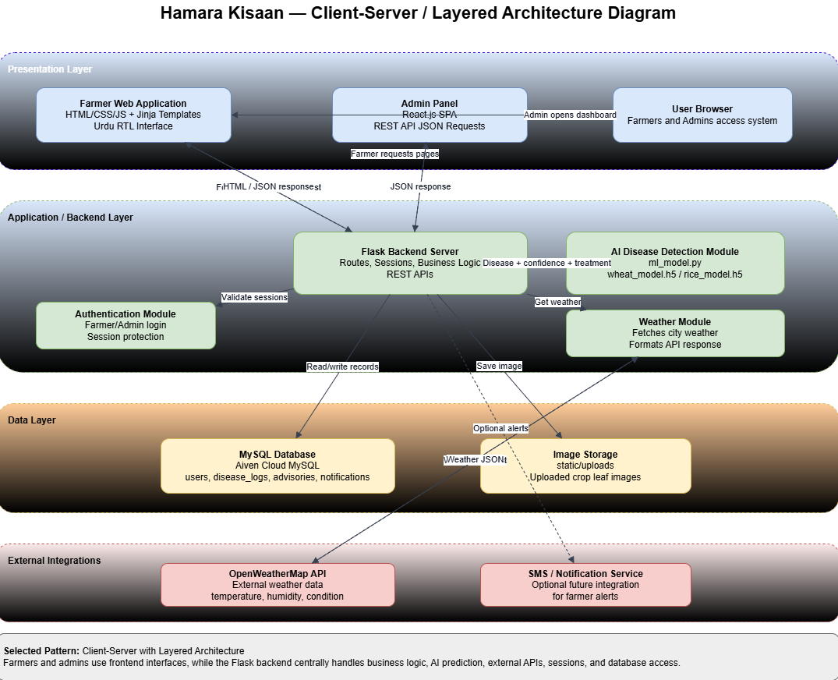

3.1.1 AI Model Integration Architecture
The AI disease detection subsystem is integrated directly within the Flask backend as a Python module and upon startup the Flask application loads two pre-trained Keras models into memory which are the wheat_model.h5 and rice_model.h5, both of which expect raw pixel values in the range [0, 255]. The first layer of each model is a Rescaling(1/255) layer that internally normalizes the input due to which the inference code feeds unnormalized images directly to the model to avoid double normalization, each model then accepts a 224x224x3 RGB image tensor and outputs a softmax probability distribution over its respective class labels. The wheat model then classifies 15 disease categories while the rice model classifies 6 categories. A confidence threshold of 60% is enforced such that the predictions below this threshold are returned as uncertain and the user is advised to re-capture the image under better conditions.

3.2 Use Case Diagram
The system includes three main actors: Farmer, Admin, and Weather API, the farmer is the primary user who interacts with features such as registration and login, viewing advisories, uploading images for disease detection as well as checking weather alerts whereas the admin manages system content, monitors disease reports and controls system settings.
The Weather API is an external service that provides real-time weather data to the system and this data is used to generate alerts and improve recommendations and a key interaction in the system is that disease detection is automatically triggered when a farmer uploads an image.
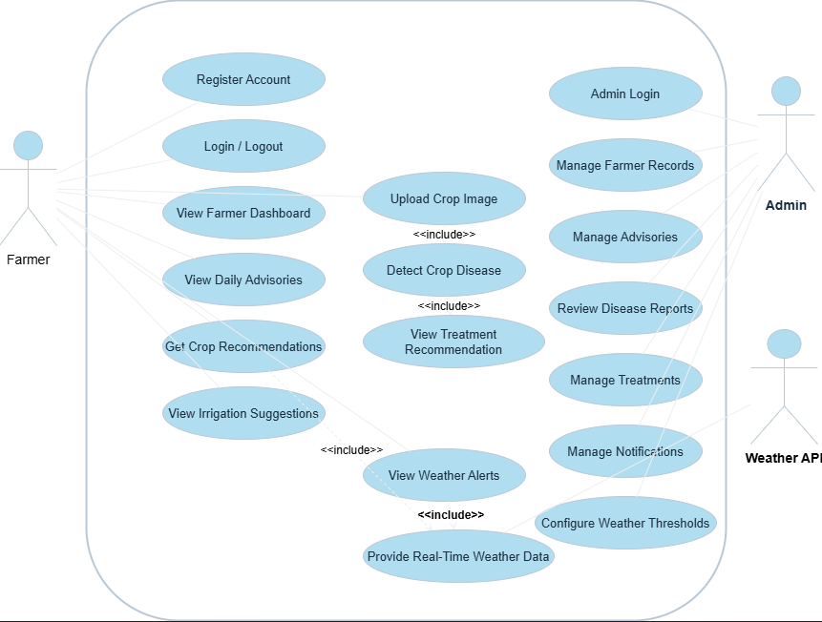

3.3 Use Case Descriptions
The following sections provide detailed use case specifications for the primary interactions within the system and these descriptions serve as a contract between the design and implementation phases.

UC-01: Farmer Registration
Use Case Name: Farmer Registration
Actor: Farmer
Pre-condition: The farmer does not already have an account in the system.
Trigger: Farmer navigates to the registration page and then submits the form.
Main Flow: First of all the farmer opens the registration page and then enters full name, CNIC, phone number, email, username, password, tehsil, land area in acres, soil type, crop type, and irrigation method then the system validates that CNIC and phone number are not already registered then the system inserts a new record into the users table and finally the system redirects the farmer to the login page.
Alternate Flow: If CNIC or phone already exists then the system returns HTTP 400 and displays an error message over the screen
Post-condition: A new farmer record is created in the database and the user can log in.

UC-02: AI-Based Disease Detection
Use Case Name: AI-Based Disease Detection
Actor: Farmer
Pre-condition: The farmer is authenticated and has navigated to the Disease Detection page.
Trigger: Farmer selects a crop type (wheat or rice), uploads a leaf image and clicks Analyze.
Main Flow: Firstly, the farmer selects crop type and uploads a JPG/PNG image of a crop leaf then the system submits the image and crop type via HTTP POST to /analyze-disease then the backend saves the image to the uploads directory and calls predict_disease from ml_model.py so that the appropriate TensorFlow model performs inference on a 224x224 image tensor so that it displays the predicted class label, confidence score as well and its Urdu treatment recommendation are returned as JSON and the system logs the result to the disease_logs table and the result is displayed on the farmer's screen.
Alternate Flow: If confidence is below 60%, the system returns an uncertain result with advice to retake the photo. If the file is not uploaded, the system returns HTTP 400.
Post-condition: Disease result is shown to the farmer. A log entry is recorded in disease_logs.

UC-03: View Weather Alerts
Use Case ID: UC-03
Use Case Name: View Weather Alerts
Actor: Farmer, Weather API (External)
Pre-condition: Farmer is authenticated and has accessed the dashboard.
Trigger: Farmer views the weather section on the dashboard or navigates to the weather page.
Main Flow: Firstly, the farmer-facing page makes an HTTP GET request to /api/weather/{city}. Then the Flask backend forwards the request to the OpenWeatherMap API with the API key which returns temperature, humidity, and weather condition data and the system displays the weather data and if temperature or humidity exceeds configured thresholds, an alert is shown.
Alternate Flow: If the weather API returns an error or the city is not found, the backend returns HTTP 400 with an error message.
Post-condition: The farmer is informed of current weather conditions relevant to their farming location.

UC-04: Admin Manages Advisories
Use Case ID: UC-04
Use Case Name: Admin Manages Advisories
Actor: Administrator
Pre-condition: Administrator is authenticated via /api/admin/login.
Trigger: Admin navigates to the Advisories page in the admin panel.
Main Flow: First of all, the admin logs in and receives session cookie then the admin navigates to the Advisories section then an advisory is created by entering title, content, crop type, and category to submit the form. The React frontend then sends an HTTP POST to /api/admin/advisories with JSON payload and the backend inserts the advisory record into the advisories table which the admin can also delete via HTTP DELETE. Farmers see relevant advisories via the /api/admin/farmer/advisories endpoint filtered by their registered crop type.
Alternate Flow: If session is not present, the backend returns HTTP 401 Unauthorized.
Post-condition: Advisory is stored in the database and available to farmers of the targeted crop type.

3.4 Activity Diagrams
Activity diagrams model the dynamic aspects of the system by illustrating the flow of control from one activity to another. The following diagrams depict the most critical workflows within Hamara Kisaan.

3.4.1 Activity Diagram: AI Disease Detection Workflow
In the disease detection process the farmer selects a crop type and uploads an image and then the system processes the image and then runs it through the AI model and then displays the result. If the prediction confidence is low then the system asks for a better image.

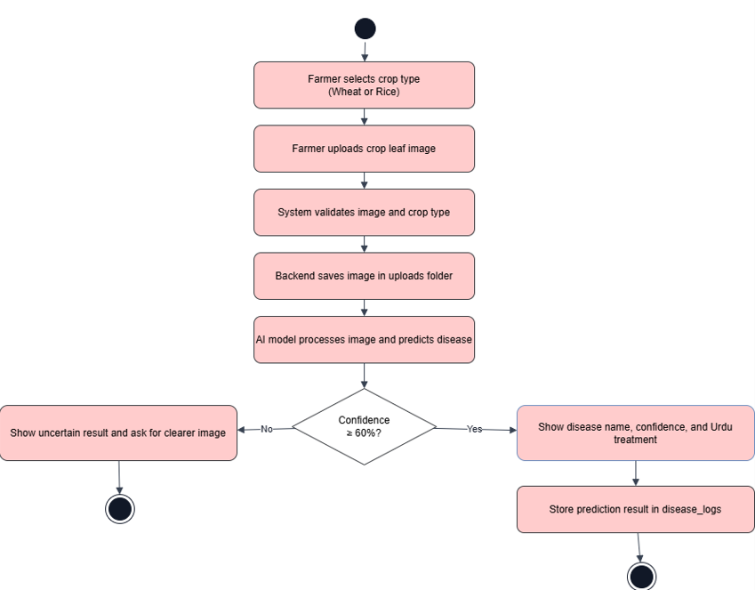3.4.2 Activity Diagram: Farmer Registration and Login
In the registration process the farmer fills out a form and then the system checks if the user already exists and if the data is valid then a new account is created.

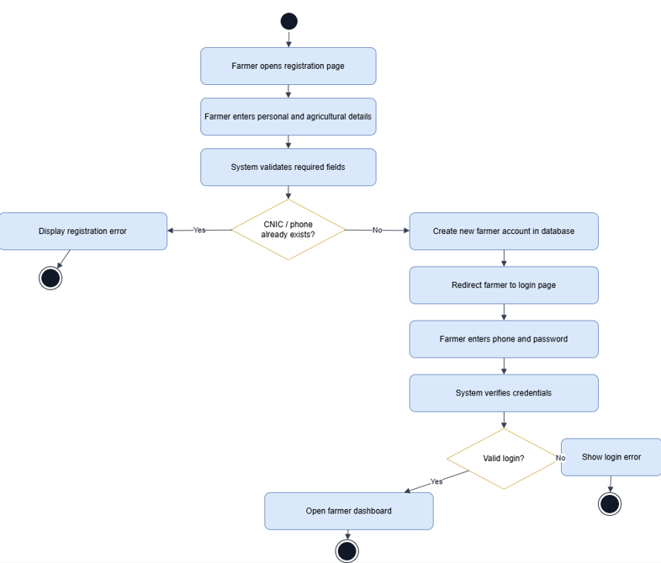3.4.3 Activity Diagram: Admin Advisory Management
In the admin workflow the admin logs in and manages advisories as well as updates the system data and all these actions are validated and stored in the database.

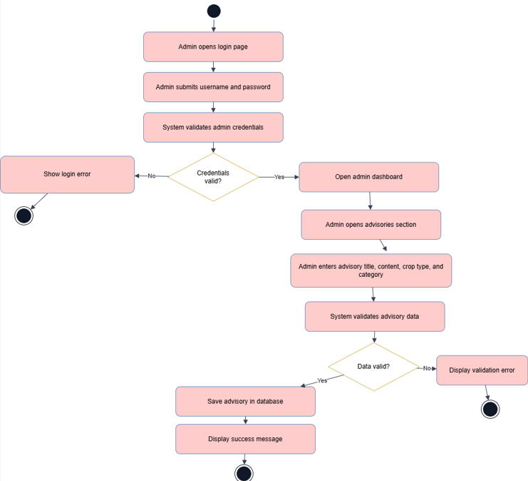

3.5 Sequence Diagrams
Sequence diagrams illustrate the temporal ordering of messages exchanged between objects and system components during a specific interaction. The following sequence diagrams cover the most technically significant flows of the Hamara Kisaan system.

3.5.1 Sequence Diagram: Disease Detection
In the disease detection process, the farmer uploads an image which is sent to the backend and then the backend processes the image and calls the AI model then stores the result in the database and then finally sends the prediction back to the user.

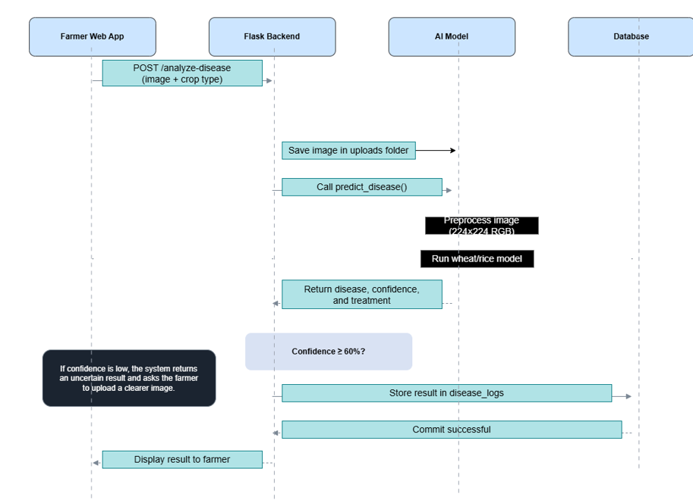

3.5.2 Sequence Diagram: Weather Alert Retrieval
In the weather system the frontend requests weather data from the backend. The backend fetches data from the Weather API and returns it to the user interface.

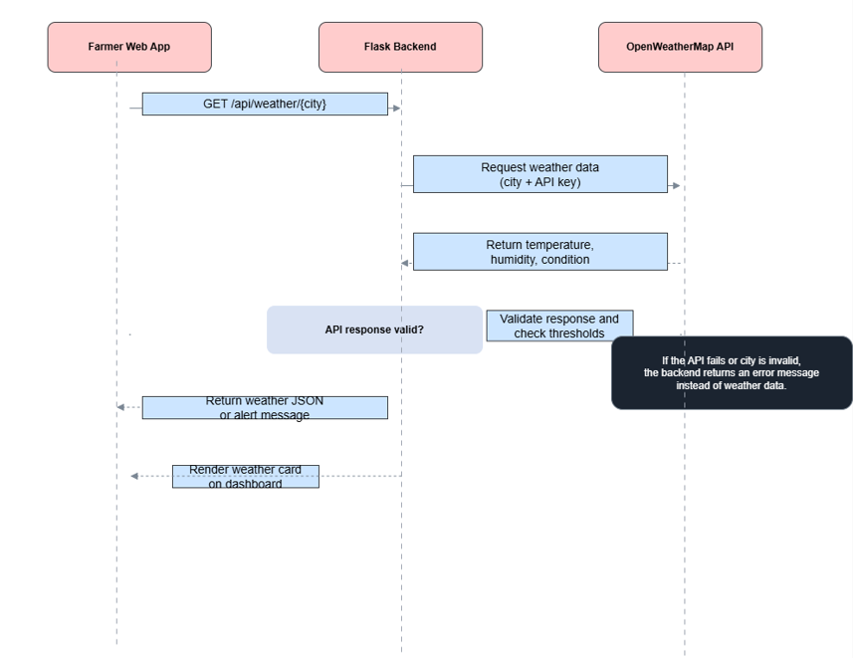3.5.3 Sequence Diagram: Admin Login and Dashboard Load
In the admin system the admin logs in and sends requests to the backend and then receives responses based on database queries.

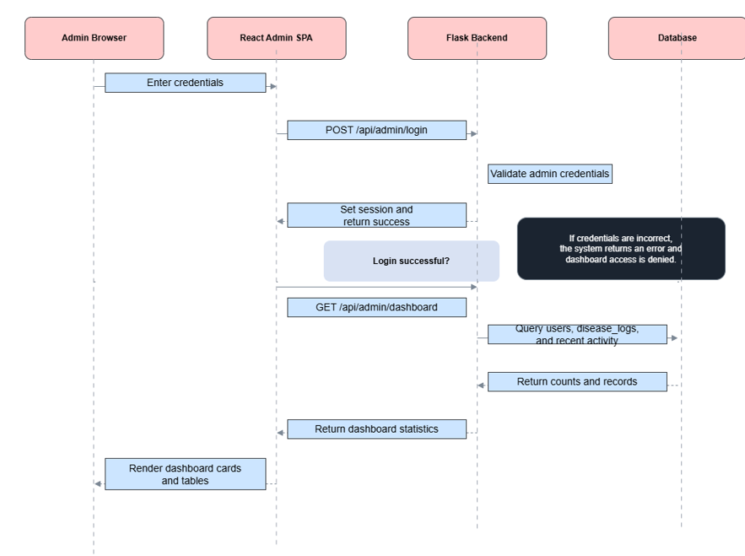3.6 Class Diagram
The system is designed using multiple logical classes, one is the Farmer class that stores user information such as personal details, location and crop data and the Admin class manages system operations and has access to administrative functions then the DiseaseReport class stores the results of disease detection including that of the predicted disease and confidence score and the Advisory class stores farming guidance content and the the AIService class handles the disease detection process using trained models and other supporting classes include Notification and Treatment which manage alerts and disease treatments.

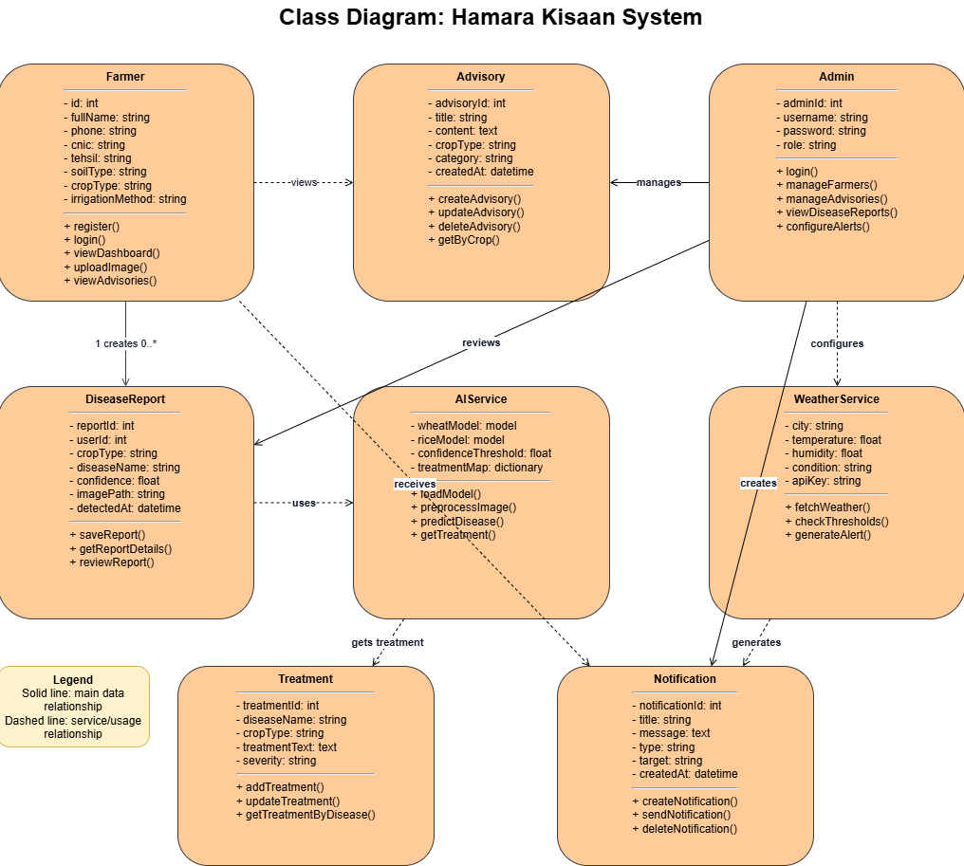

3.7 Database Design
The Hamara Kisaan system uses a MySQL relational database hosted on the Aiven Cloud platform and the database is configured with the utf8mb4 character set to ensure full support for Unicode characters including that of the Urdu text stored in advisory and treatment fields and it is accessed over an SSL connection to maintain data security in transit and the schema comprises seven tables each designed to hold a distinct and well-defined category of system data.

3.7.1 Table: users
The users table is the central entity of the system representing registered farmers and each record captures comprehensive demographic and agricultural profile information. The cnic and phone fields are declared as UNIQUE to prevent duplicate registrations. The crop_type field is used to filter advisory and notification content ensuring farmers receive only information relevant to their crop.
The table contains the following columns: first of all, id (INT, Primary Key, Auto Increment) which serves as the unique farmer identifier, full_name (VARCHAR 100, NOT NULL) stores the farmer's complete name, cnic (VARCHAR 20, UNIQUE) stores the national identity card number. phone (VARCHAR 15, UNIQUE) stores the mobile number used as the login credential, email (VARCHAR 100) stores the email address, which is optional, username (VARCHAR 50, UNIQUE) stores the chosen username. password (VARCHAR 255, NOT NULL) stores the password, currently as plain text in this implementation, tehsil (VARCHAR 50) stores the administrative subdivision of residence, land_acres (DECIMAL 6,2) stores the total cultivated land area, soil_type (VARCHAR 100) stores the soil classification such as clay or loam, crop_type (VARCHAR 50) stores the primary crop, either wheat or rice and lastly irrigation (VARCHAR 50) stores the irrigation methoda and the “created_at” records the account creation time.

3.8 Interface Design
The user interface design of Hamara Kisaan was guided by the primary characteristic of its target audience which is the smallholder farmers in rural Pakistan (Faisalabad) with varying levels of digital literacy. The design philosophy centers on simplicity, clarity, and cultural relevance and the two distinct interface paradigms were implemented, a server-rendered HTML interface for farmer-facing pages and a React-based single-page application for the administrative panel.

3.8.1 Farmer-Facing Interface
The farmer web interface is composed of six primary pages including those of Home, Registration, Login, Dashboard, Disease Detection, Crop Advisory, and Tips, first of all the design employs a responsive layout to ensure compatibility with mobile browsers as a significant proportion of farmers in Pakistan access the internet via smartphones.
The Home page serves as a landing page that presents a brief introduction to the platform and provides prominent call-to-action buttons for registration and login then the registration page contains a comprehensive form capturing twelve fields organized into logical sections including those of personal information, location details and agricultural profile .
Then, the Dashboard page is the central hub for authenticated farmers and it displays the farmer's profile summary, a real-time weather card showing temperature, humidity, and conditions for their registered tehsil as well as a list of recent advisories filtered by their crop type and a quick navigation buttons to the disease detection and advisory modules also all the text labels and advisory content are presented in Urdu to maximize accessibility for the target demographic.
Then the Disease Detection page allows a farmer to select their crop type (wheat or rice) from a dropdown menu and then upload a photograph of a crop leaf to submit it for AI analysis which upon receiving the response from the backend displays the detected disease name, the model's confidence level as a percentage, and a detailed Urdu-language treatment recommendation.

3.8.2 Administrative Panel Interface
The administrative panel is implemented as a React.js SPA built with Vite and styled using Tailwind CSS utility classes and the application uses React Router to implement client-side navigation across ten administrative pages without full page reloads. A persistent sidebar navigation component provides access to all sections of the admin panel whereas a header component displays the current page title and contextual controls.
The Admin Dashboard page presents total registered farmers and new registrations today, active crop types as well as the total disease diagnoses performed and a recent activity table displays the five most recently registered farmers with their contact details and crop information.
The Advisories page and Notifications page follow an identical layout pattern: a form at the top for creating new entries and a list below for viewing and deleting existing entries and the advisories form includes fields for title, content, crop type, and category. The Notifications form allows the admin to compose a message, assign a type (alert, info, warning) and thus target it to all farmers or to a specific crop group.
The Diagnosis page presents the disease detection log in a tabular format while showing farmer name, phone number, crop type, detected disease, confidence score, and timestamp also, the weather page allows the admin to query real-time weather data for any city by entering its name. The Treatment page provides a form for managing the disease treatment knowledge base and lastly, the Activity Log page presents a chronological audit trail of all administrative actions.

3.8.3 UI/UX Design Principles Applied
The following design principles guided the interface development of Hamara Kisaan.
Language Accessibility: All farmer-facing content, treatment recommendations as well as the advisory text are authored in Urdu (Nastaliq script) which ensures comprehension for the primary user demographic.
Minimal Cognitive Load: The farmer interface limits choices per screen and each page has a single primary action such as uploading an image or viewing the dashboard and it basically reduces the confusion for first-time digital users.
Responsive Design: CSS layouts employ flexible grid as well as the media queries to render correctly on mobile screens and desktop browsers alike.
Feedback and Confirmation: Disease detection provides real-time loading indicators and thus the admin operations display success or failure messages immediately after each action.
Role Separation: Farmer and admin interfaces are completely isolated such that the farmers cannot access any administrative endpoint and the admin panel does not expose farmer-private data unnecessarily.
Consistency: The admin panel uses a consistent layout with a fixed sidebar and uniform card components, and standardized table styles across all pages.

Chapter 4: Implementation
This chapter provides a comprehensive and technically detailed account of the implementation of the Hamara Kisaan platform and describes the development environment and the technology stack employed, the architectural modules of the system as well as the precise manner in which each component including the frontend interface, backend API, database layer, and artificial intelligence subsystem was built and integrated.

4.1 Development Environment
The development of Hamara Kisaan was carried out in a structured environment that combined multiple tools, frameworks as well as services to support efficient and reliable software construction.
Python was chosen as the primary implementation language due to its extensive library ecosystem for both web development and machine learning, flask which is a WSGI micro-framework for Python was selected over heavier alternatives because the system did not require a full-stack framework additionally the modular architecture of Flask allowed each route and feature to be defined and maintained independently. TensorFlow with its high-level Keras API provided the model loading and inference capabilities required for plant disease detection, also, the cloud-hosted MySQL instance on the Aiven platform eliminated the need for a locally managed database server which ensured persistent as well as an accessible storage throughout the development lifecycle.

4.2 System Modules Description
The Hamara Kisaan system is structured as a collection of cohesive modules where each one is responsible for a distinct area of functionality and this modular decomposition promotes maintainability, separation of concerns, and the ability to extend individual features without affecting unrelated parts of the system. The following subsections describe each major module in detail.

4.2.1 Farmer Authentication Module
The farmer authentication module handles user registration, login, session management, and logout and during registration, the system collects a comprehensive profile from the farmer including full name, CNIC number, phone number, email address, chosen username, password, tehsil, land area in acres, soil type, primary crop type, and irrigation method and then this information is stored directly in the MySQL users table also the phone number is used as the primary authentication identifier during login as it is the most consistently known piece of information among the target demographic of small-scale farmers in Pakistan.
Upon successful authentication Flask's server-side session mechanism stores the authenticated farmer's phone number in the session cookie and a custom session check is then applied on every protected route using a conditional redirect pattern. If the session does not contain the 'user' key then the request is immediately redirected to the login page

4.2.2 Plant Disease Detection Module
The plant disease detection module constitutes the most technically sophisticated component of the system as it accepts an uploaded leaf image from the farmer and then determines the relevant crop type based on a form selection or the farmer's registered crop then passes the image through the appropriate trained Keras model and finally returns a structured diagnostic result comprising the disease label and a confidence percentage as well as a treatment recommendation written in Urdu.

4.2.3 Crop Advisory Module
The crop advisory module delivers context-sensitive farming guidance to the authenticated farmer as it retrieves the farmer's registered profile data, including soil type, crop type, land area, and tehsil and then renders the crop_advisory.html template with this information pre-populated then the page further calls the backend weather API endpoint to display current atmospheric conditions relevant to the farmer's registered location and finally presents crop-specific advisories published by the admin panel.

4.2.4 Weather Integration Module
Real-time weather information is sourced from the OpenWeatherMap API and then the backend exposes a dedicated endpoint which accepts a city name as a URL parameter and constructs an authenticated API request to OpenWeatherMap using a stored API key and returns a simplified JSON object containing the temperature in Celsius, relative humidity as well as the general weather condition after which the frontend JavaScript code consumes this endpoint and dynamically renders the weather card on the dashboard and crop advisory pages.
A safe-check guard is implemented in the weather route to handle cases where the OpenWeatherMap API returns an error for instance when an unrecognised city name is submitted and in such cases the backend returns a structured error response with an appropriate message.

4.2.5 Daily Tips and Advisories Module
The tips and advisories module provides farmers with useful farming guidance published by the system administrator and these advisories are stored in the advisories database table and are categorized based on crop type and advisory category and when a farmer accesses the /tips route the backend retrieves relevant advisories by filtering records where the crop_type is either set to 'all' or matches the farmer's registered crop which ensures that the information shown to the farmer is both personalized and relevant to their agricultural needs.

4.2.6 Admin Panel Module
The administrative module provides a dedicated interface for system management and control and the access to this module is restricted through a separate session-based authentication mechanism where the admin credentials are verified using predefined environment variables.
The admin panel exposes a set of endpoints that allow the administrator to manage different aspects of the system which includes managing farmer records and publishing advisories and sending notifications ,also, reviewing disease detection logs and viewing crop-related data and managing treatment information as well as monitoring system activity.
These API endpoints are connected to a separate admin frontend which communicates with the Flask backend using HTTP requests and JSON responses and this separation between frontend and backend ensures better organisation, flexibility, and scalability of the system.

4.3 Frontend Implementation
The frontend of Hamara Kisaan is implemented using server-rendered HTML templates managed through Flask's integrated Jinja2 templating engine and this approach was deliberately chosen over a full single-page application (SPA) framework to minimise client-side complexity and ensure compatibility with the low-specification devices commonly available to farmers in rural Pakistan.

4.3.1 Internationalisation and RTL Layout
Since the target users are Urdu-speaking farmers, the frontend is designed using a right-to-left (RTL) layout for better usability and all HTML pages include the lang="ur" and dir="rtl" attributes to ensure correct display of Urdu text. Bootstrap 5.3 RTL is used via CDN to support proper layout and component alignment for Urdu interfaces additionally, two fonts are used in the system including the Noto Nastaliq Urdu for formal pages like registration and login and Noto Sans Arabic for dashboard and functional pages as it provides better readability especially when Urdu and English text are used together.

4.3.2 Home Page (home.html)
The home page serves as the main entry point of the platform for all users and it includes a hero section with an agricultural background image and a simple overlay displaying the system name and a brief introduction in Urdu also, navigation links are provided to guide users to the registration and login pages and below the hero section the page highlights the main features of the system using simple card-based components.

4.3.3 Registration Page (register.html)
The registration page allows farmers to create an account by entering their personal and agricultural details. These include full name, CNIC, phone number, email, username, password, tehsil, land area, soil type, crop type, and irrigation method. The form is designed in a simple card layout with clear Urdu labels and required field indicators and basic validation is applied using HTML5 to ensure correct input, also the phone number field includes a +92 prefix to guide users on the correct format. A dropdown is provided for crop selection which is for now limited to wheat and rice as these are currently supported by the AI model, lastly when the form is submitted the data is sent to the /register route using the POST method.

4.3.4 Farmer Dashboard (dashboard.html)
The dashboard is the main page that the farmer sees after logging in and it includes a right-aligned sidebar for navigation following the RTL layout of the system and its main area displays important information such as the farmer's name and profile details, current weather conditions and notifications from the admin as well as the quick links to key features like disease detection and crop advisory. The layout is simple and organised using card components which makes it easy for users to understand and navigate.

4.3.5 Plant Disease Detection Page (disease.html)
The disease detection page allows farmers to upload an image of a crop leaf and select the crop type (wheat or rice) and the upload area is clearly visible and provides an image preview once a file is selected and after the form is submitted JavaScript sends the image and crop type to the /analyze-disease route using a background request and during the processing, a loading indicator is shown after which the result is displayed on the same page. It includes the detected disease name, confidence percentage, and treatment suggestion in Urdu. If the confidence is below 60%, a message is shown asking the farmer to upload a clearer image.

4.3.6 Crop Advisory Page (crop_advisory.html)
The crop advisory page provides farmers with useful guidance based on their profile and current conditions and displays the farmer's crop type, soil type, land area, and location at the top of the page. Weather information is shown using a dynamic weather card which includes temperature, humidity, and weather condition and below this the page displays advisories published by the admin filtered according to the farmer's crop type. Irrigation suggestions are also provided based on the farmer's registered irrigation method and current weather data.

4.3.7 Daily Tips Page (tips.html)
The tips page displays a list of farming tips and advisories fetched from the backend and the tips are shown as simple cards with a title and content in Urdu which are filtered by the farmer's registered crop type to ensure relevance and the page auto-refreshes if new tips are published, providing farmers with up-to-date information.

4.4 Admin Panel Frontend
The admin panel is implemented as a React.js single-page application (SPA) using the Vite build tool and uses Ant Design for UI components and Tailwind CSS for custom styling and the React Router handles navigation between sections. The panel includes ten main sections including that of the Dashboard, Farmers, Advisories, Notifications, Disease Logs, Weather, Treatments, SMS Logs, Activity Log as well as the Settings.
Each section communicates with the Flask backend using the fetch() API and the admin panel supports both light and dark themes

4.5 Database Implementation
The database for Hamara Kisaan is hosted on the Aiven Cloud MySQL service and uses the utf8mb4 character set to support Urdu text storage and the schema is auto-initialized at startup using CREATE TABLE IF NOT EXISTS statements which automatically ensures that the database is always in a valid state when the application runs, even on fresh deployments.
The users table stores farmer registration data including personal, location, and agricultural profile details.The disease_logs table records every disease detection event, including the farmer's identity, crop type, predicted disease, confidence score, image path, and timestamp. The advisories table stores farming guidance entries created by the administrator, each associated with a crop type and category. The notifications table stores system notifications with their target group and message content. The weather_thresholds table stores the configurable thresholds for temperature and humidity, which are used to trigger weather alerts on the farmer dashboard.
Additional tables support system functionality such as that of the sms_log table which stores SMS records sent by the admin, including phone number, message, status, and timestamp, additionally, the treatments table stores disease-specific treatment information, including disease name, crop type, treatment text, and severity level and the activity_log table records admin actions, providing a basic audit trail for system monitoring.

4.6 AI Model Integration
The integration of the trained deep learning models into the Flask backend represents one of the most critical implementation decisions of the project and the following subsections describe the trained models themselves, the preprocessing pipeline, the prediction logic as well as the specific technical challenge that was identified and resolved during implementation.

4.6.1 Trained Models
Two separate convolutional neural network models were trained for this system including the one for wheat disease classification and one for rice disease classification and both models are stored as Keras HDF5 files (wheat_model.h5 and rice_model.h5). The wheat model is trained to classify input leaf images into fifteen disease categories: aphid, black rust, blast, brown rust, common root rot, fusarium head blight, healthy, leaf blight, mildew, mite, septoria, smut, stem fly, tan spot and lastly, yellow rust and the rice model classifies images into six categories including that of bacterial leaf blight, brown spot, healthy rice leaf, leaf blast, leaf scald as well as the sheath blight.
Both models were trained using TensorFlow which feeds raw pixel values in the range [0, 255] directly to the model and each model's architecture incorporates a Rescaling(1./255) layer as its first layer which then normalises the pixel values to the [0, 1] range internally during both training and inference.

4.6.2 Model Loading
Both models are loaded once at application startup using Keras's load_model() function and stored as module-level variables in ml_model.py and this eager-loading strategy ensures that the computationally expensive model loading operation is performed only once, at server initialisation, rather than on every inference request.

4.6.3 Treatment Recommendation in Urdu
Aligned with the system's commitment to accessibility for Urdu-speaking farmers all treatment recommendations returned by the prediction function are composed in written Urdu. The treatment_map dictionary in ml_model.py defines a one-to-one mapping from each disease class label to a concise but actionable Urdu treatment instruction and each instruction specifies the recommended pesticide or fungicide by its common chemical name (e.g., propiconazole, tebuconazole, tricyclazole) as well as the application method and any preventive cultural practices such as crop rotation, seed treatment or field sanitation and lastly, for the 'healthy' class in both wheat and rice, the treatment text returns a positive reinforcement message acknowledging the good condition of the crop.

4.6.4 Confidence Threshold Guard
To prevent the system from delivering misleading diagnoses when the model is uncertain a confidence threshold guard is applied before the treatment response is constructed and if the maximum softmax probability across all classes is below 0.60 (60%) then the label is overridden to a placeholder indicating an uncertain result, and the treatment text is replaced with guidance to retake the photograph under improved conditions which includes better lighting, a clearer focus on the affected leaf area as well as framing that occupies the majority of the image.

4.7 Key Functionality Implementation Details

4.7.1 CORS and Cross-Origin Communication
The admin panel runs on a different port than the Flask backend so its requests are treated as cross-origin by the browser and to allow this communication, CORS is enabled using Flask-CORS and thus, this configuration allows the admin frontend to send requests to the backend and receive responses correctly including session data.

4.7.2 Paginated Farmer Listing
The /api/admin/farmers endpoint uses pagination to handle large numbers of farmer records efficiently and supports search and filtering based on name, phone number, CNIC, and crop type and the backend returns both the total number of records and the current page data, allowing the admin panel to display proper pagination controls.

4.7.3 Personalised Notification and Advisory Delivery
Notifications and advisories are shown to farmers based on their registered crop type and the system filters records where the target is either 'all' or matches the farmer's crop which ensures that farmers only see relevant information while general messages are visible to all users.

4.7.4 File Upload and Storage
Uploaded images are stored in the uploads/ folder. The system automatically creates this folder if it does not exist and after processing the image path is saved in the disease_logs table for future reference and in a production system, this local storage can be replaced with cloud storage for better scalability.

Chapter 5: Testing and Evaluation
This chapter presents a comprehensive evaluation of the Hamara Kisaan platform through systematic software testing. The testing process was carried out in accordance with established software engineering practices and was designed to verify the correctness, robustness, and reliability of all major system features.

5.1 Testing Strategy
The testing strategy for Hamara Kisaan followed a layered approach starting from individual component testing and moving towards complete system testing and this approach reflects the system's three main layers which are frontend, backend, and database and this helps in identifying and fixing issues at an early stage before they affect the entire system.

5.1.1 Unit Testing
Unit testing was applied to the machine learning module (ml_model.py) and individual backend routes and the predict_disease() function was tested using sample images to check model loading, and preprocessing, prediction accuracy, and treatment output and during testing a major issue of double normalisation was identified where image values were divided twice and caused incorrect predictions and it was fixed by removing the extra preprocessing step.

5.1.2 Integration Testing
Integration testing was performed to check how different parts of the system work together which included testing the connection between the Flask backend and the MySQL database, integration of the AI model with the image upload feature, weather data retrieval from the external API as well as the communication between the admin frontend and backend and the tests confirmed that data flows correctly between all components and it was also verified that failures

5.1.3 System Testing
System testing was carried out to evaluate the system as a complete application and realistic scenarios were tested in it including full user workflows such as login, using features, saving data, and logging out. Both valid and invalid cases were tested including those of incorrect login details, invalid file uploads as well as accessing protected pages without login. These tests confirmed that the system works correctly and handles errors and security properly.

5.1.4 Boundary Value Analysis
Boundary Value Analysis (BVA) was applied to features involving numeric or length-constrained inputs and file-based constraints and authentication-related thresholds and the BVA tests were designed for four features including those of the land area input field on the farmer registration form, the CNIC number field, the confidence threshold in the disease detection model as well as the image file size accepted by the upload endpoint and for each feature, test cases were constructed at the minimum boundary, the maximum boundary, one unit below the minimum (below-minimum) as well as one unit above the maximum (above-maximum) as required by the BVA technique.

5.2 Functional Test Cases
The following ten test cases were developed to cover the major functional requirements of the Hamara Kisaan system where each test case is presented with its identifier, the feature being tested, and the testing technique applied, the specific input data used, the expected output as defined by the system requirements, the actual output observed during test execution as well as the resulting pass or fail status. Test cases were designed to cover both positive (valid input) and negative (invalid or boundary input) scenarios.

TC-01: Farmer Registration — Valid Input
Testing Technique: System Testing / Positive Path
Feature: Farmer Registration — Route: POST /register
Precondition: No existing account with the submitted CNIC or phone number in the database
Input Data: Full Name: Ahmed Ali | CNIC: 3740512345671 | Phone: 03001234567 | Tehsil: Gujranwala | Crop Type: Wheat | Land: 5.0 acres | Soil: Clay | Irrigation: Canal
Expected Output: User record inserted into users table and then the browser redirected to /login-page with HTTP 302
Actual Output: User record created successfully; all eleven fields persisted in database; redirect to login page confirmed
Status: Pass

TC-02: Farmer Registration — Duplicate CNIC Rejection
Testing Technique: System Testing / Negative Path
Feature: Farmer Registration — Duplicate Detection — Route: POST /register
Precondition: A user with CNIC 3740512345671 already exists in the database
Input Data: CNIC: 3740512345671 (duplicate) | Phone: 03009876543 (new) | All other fields valid
Expected Output: HTTP 400 response is returned and no new record inserted into database with an error message displayed to user
Actual Output: HTTP 400 returned; existing record preserved without modification; duplicate registration correctly blocked
Status: Pass

TC-03: Farmer Login — Valid Credentials
Testing Technique: System Testing / Positive Path
Feature: Farmer Authentication — Route: POST /login
Precondition: Farmer account exists with phone 03001234567 and password 'kisaan123'
Input Data: Phone: 03001234567 | Password: kisaan123
Expected Output: Flask session cookie set with 'user' key containing the phone number and then redirect to /dashboard with HTTP 302
Actual Output: Session established correctly; farmer dashboard loaded and rendered with correct personalised profile data
Status: Pass

TC-04: Farmer Login — Invalid Password
Testing Technique: System Testing / Negative Path
Feature: Farmer Authentication — Route: POST /login
Precondition: Farmer account exists with phone 03001234567
Input Data: Phone: 03001234567 | Password: wrongpassword
Expected Output: HTTP 401 response returned with no session created and 'Invalid credentials' message displayed
Actual Output: HTTP 401 returned; session not established; user remains on login page with error response
Status: Pass

TC-05: Protected Route Access Without Authentication
Testing Technique: Integration Testing / Security
Feature: Session-Based Route Protection — Routes: /dashboard, /disease, /crop-advisory, /tips
Precondition: No active user session (cleared browser cookies or fresh session)
Input Data: Direct browser navigation to /dashboard without prior login
Expected Output: Immediate redirect to /login-page and the protected page content not rendered with no user data exposed
Actual Output: Browser redirected to /login-page for all four protected routes; no session data or page content served to unauthenticated request
Status: Pass

TC-06: Plant Disease Detection — Wheat Leaf with Valid Image
Testing Technique: System Testing / AI Module Integration
Feature: AI Disease Detection — Route: POST /analyze-disease
Precondition: Farmer is logged in; wheat_model.h5 is loaded at application startup
Input Data: Image: clear photograph of a wheat leaf showing visible yellow rust symptoms | crop_type: wheat
Expected Output: JSON response containing disease name 'yellow_rust' with confidence value above 60% and Urdu treatment recommendation and the detection event logged in disease_logs table
Actual Output: disease: 'yellow_rust', confidence: '87.34%', Urdu treatment text returned correctly; corresponding record inserted into disease_logs with user ID, crop type, and image path
Status: Pass

TC-07: Disease Detection — Low Confidence Guard
Testing Technique: Unit Testing / AI Module
Feature: Confidence Threshold Guard — Function: predict_disease() in ml_model.py
Precondition: Model loaded; input image is blurred, very dark, or otherwise ambiguous
Input Data: Image: out-of-focus photograph of a leaf taken in poor lighting | crop_type: wheat
Expected Output: Model confidence below 60% and disease label overridden to uncertain result placeholder with Urdu advisory message returned in place of treatment
Actual Output: Confidence: 42.17%; label correctly overridden; Urdu retake-image guidance returned; no erroneous treatment recommendation delivered
Status: Pass

TC-08: Real-Time Weather API Integration
Testing Technique: Integration Testing / External API
Feature: Weather Data Retrieval — Route: GET /api/weather/<city>
Precondition: Valid OpenWeatherMap API key is configured; internet connectivity is available
Input Data: City parameter: Gujranwala
Expected Output: HTTP 200 response with JSON containing city name, temperature in Celsius, humidity percentage as well as the weather condition string
Actual Output: { city: 'Gujranwala', temperature: 34.2, humidity: 58, condition: 'Clear' } returned; data rendered correctly in dashboard weather card
Status: Pass

TC-09: Admin Login and Dashboard Statistics Aggregation
Testing Technique: System Testing / Admin Panel
Feature: Admin Authentication and Dashboard — Routes: POST /api/admin/login, GET /api/admin/dashboard
Precondition: Admin credentials configured via environment variables (ADMIN_USERNAME, ADMIN_PASSWORD)
Input Data: username: admin | password: admin123
Expected Output: Admin session key set and then /api/admin/dashboard returns JSON with total_farmers, new_today, active_crops, total_diagnoses as well as the recent_activity list
Actual Output: Admin session created successfully; dashboard JSON returned with correctly aggregated counts from all relevant database tables; recent activity list populated with five most recent farmer registrations
Status: Pass

TC-10: Personalised Advisory Delivery Filtered by Crop Type
Testing Technique: Integration Testing / Advisory Module
Feature: Farmer-Personalised Advisory Feed — Route: GET /api/admin/farmer/advisories
Precondition: Farmer logged in with crop_type 'wheat'; database contains advisories for 'wheat', 'all', and 'rice'
Input Data: Authenticated GET request to /api/admin/farmer/advisories; session user has crop_type: wheat
Expected Output: Only advisories with crop_type = 'wheat' or crop_type = 'all' returned; rice-specific advisory excluded from response
Actual Output: Two advisories returned — one wheat-specific, one all-crops; rice advisory correctly excluded; filtering logic confirmed through database inspection
Status: Pass

5.3 Boundary Value Analysis
Boundary Value Analysis (BVA) is a black-box testing technique that focuses on the boundary conditions of input domains operating on the principle that software defects are most likely to occur at or near the edges of valid input ranges rather than within the interior and for Hamara Kisaan, BVA was applied to four features involving numeric constraints, character length limits, and confidence thresholds and each feature was tested at four boundary points: the minimum valid value, the maximum valid value, one unit below the minimum (invalid), and one unit above the maximum (invalid).

5.3.1 Land Area Input Field — Farmer Registration
The land area field on the registration form accepts a decimal numeric value representing the farmer's total landholding in acres and a valid entry is defined as any positive non-zero decimal between 0.01 and 9999.99 acres which reflects the practical range for a smallholder agricultural advisory system. Values at or below zero have no physical meaning and must be rejected, while values exceeding 9999.99 acres fall outside the intended scope of the system.
BVA-01-A (Below Minimum — 0.00 acres):
Input: 0.00 in the land_acres field
Expected: Form validation rejects zero and submission is blocked
Actual: HTML5 min attribute triggered and the browser prevented form submission
Status: Pass

BVA-01-B (At Minimum — 0.01 acres):
Input: 0.01 in the land_acres field
Expected: Registration accepted and the value stored correctly
Actual: Registration completed successfully and 0.01 persisted as DECIMAL(6,2)
Status: Pass

BVA-01-C (At Maximum — 9999.99 acres):
Input: 9999.99 in the land_acres field
Expected: Registration accepted and the value stored correctly
Actual: Registration completed successfully and 9999.99 stored without truncation
Status: Pass

BVA-01-D (Above Maximum — 10000.00 acres):
Input: 10000.00 in the land_acres field
Expected: Form validation rejects value and submission blocked
Actual: HTML5 max prevented browser submission however, when bypassed via Postman, the backend accepted the value without server-side validation which indicates a gap in backend enforcement
Status: Fail
The above-maximum test case reveals that the land area constraint is currently enforced only at the browser level through an HTML5 max attribute and when this constraint is bypassed, for example through a direct API request then the backend accepts and stores the value without performing independent validation.

5.3.2 CNIC Number Field — Farmer Registration
The Computerised National Identity Card (CNIC) number in Pakistan is a fixed-length 13-digit numeric identifier and the registration form accepts exactly 13 numeric characters in this field. Inputs shorter or longer than 13 digits are invalid and non-numeric characters are not permitted thus BVA tests are constructed at 12 digits (below), 13 digits (at boundary), and 14 digits (above).
BVA-02-A (Below Minimum — 12 digits):
Input: 374051234567 (12 digits)
Expected: Validation rejects submission and minlength constraint error displayed
Actual: HTML5 minlength prevented form submission
Status: Pass

BVA-02-B (At Boundary — 13 digits):
Input: 3740512345671 (13 digits)
Expected: CNIC accepted and registration proceeds if all other fields are valid
Actual: CNIC accepted and stored as VARCHAR(20) and the registration is completed
Status: Pass

BVA-02-C (Above Maximum — 14 digits):
Input: 37405123456712 (14 digits)
Expected: Validation rejects input and the maxlength constraint prevents additional characters
Actual: HTML5 maxlength blocked entry of a 14th character
Status: Pass

BVA-02-D (Non-Numeric Input):
Input: ABCDE12345678
Expected: Pattern validation rejects non-numeric input
Actual: HTML5 pattern attribute triggered and non-numeric characters caused browser validation failure
Status: Pass

5.3.3 Disease Detection Model Confidence Threshold
The disease detection module applies an internal confidence threshold of 60% (0.60) to all model predictions and if the maximum softmax probability across the output class vector is below this threshold then the system overrides the predicted label with an uncertain-result placeholder and replaces the treatment text with guidance to retake the photograph. This threshold is a critical internal numerical boundary that determines whether the farmer receives actionable diagnostic output or a safety-first advisory to improve image quality.
BVA-03-A (Below Threshold — 42%):
Input: Ambiguous leaf image of which model returns max probability of 0.42
Expected: Disease label overridden to uncertain result and Urdu retake-image guidance returned
Actual: Confidence 42.17% and the label correctly set to uncertain and retake guidance displayed
Status: Pass

BVA-03-B (Exactly At Threshold — 0.60): Input: Borderline image; model returns max probability of exactly 0.60 | Expected: Treated as valid; disease label and Urdu treatment returned normally | Actual: Prediction accepted at exactly 0.60; correct label and treatment returned; boundary is inclusive | Status: Pass

BVA-03-C (Just Above Threshold — 61%):
Input: Clear leaf image and the model returns max probability of 0.61
Expected: Full diagnosis returned
Actual: Confidence 61.03% and the label and treatment returned correctly
Status: Pass

BVA-03-D (High Confidence — 93%):
Input: High-quality photograph and the model returns probability of 0.93
Expected: Diagnosis returned with high confidence
Actual: disease: 'yellow_rust', confidence: '93.00%' and Urdu treatment rendered correctly
Status: Pass

5.3.4 Image File Upload — Format and Size Boundaries
The disease detection upload interface accepts image files from the farmer's device for processing by the Keras inference pipeline and the PIL image loader supports JPEG, PNG, and WebP formats and the files of unsupported formats or corrupted structure cause a loading exception and a practical upper file size of 5 MB is considered the operational maximum for this system as larger files introduce unacceptable processing latency on constrained hardware. Files below 1 KB are considered too small to contain meaningful leaf image data.
BVA-04-A (Below Minimum — < 1 KB):
Input: A 300-byte file with .jpg extension
Expected: PIL raises error and structured error response returned but the system remains stable
Actual: PIL raised UnidentifiedImageError and HTTP 500 returned and system did not crash
Status: Pass

BVA-04-B (At Minimum — ~5 KB JPEG):
Input: Valid JPEG photograph of approximately 5 KB
Expected: Image accepted and the model prediction executed with the result returned
Actual: Disease analysis completed in approximately 1.8 seconds and the correct disease label returned
Status: Pass

BVA-04-C (Typical — ~800 KB JPEG):
Input: Valid JPEG photograph of approximately 800 KB
Expected: Image accepted and processed and the result returned within acceptable time
Actual: Analysis completed in approximately 2.2 seconds and the correct result and Urdu treatment rendered
Status: Pass

BVA-04-D (Near Maximum — ~4.8 MB JPEG):
Input: High-resolution JPEG of approximately 4.8 MB
Expected: Image accepted and the processing completes within 8-second threshold
Actual: Analysis completed in approximately 4.3 seconds and the disease label and Urdu treatment returned correctly
Status: Pass

5.4 System Validation
System validation assessed whether the implemented Hamara Kisaan platform, taken as a whole, satisfies the requirements specified in Chapter 2. Validation is distinct from verification: while verification asks whether the system was built correctly, validation asks whether the correct system was built — that is, whether the system fulfils its intended purpose for its intended users. The validation exercise cross-referenced each major functional requirement against the observed system behaviour during system testing. The validation exercise confirmed that all ten major functional requirements are satisfied by the implemented system and the system correctly serves its dual user base — farmers accessing a Urdu-language advisory interface and administrators managing the platform through a JSON API — and all core features operate as specified.

5.5 Performance Evaluation
Performance evaluation measured the responsiveness and resource efficiency of the Hamara Kisaan system under representative usage conditions. Given that the primary target users access the system on mobile devices with moderate network connectivity, response time is a critical quality attribute. Measurements were taken on a local development machine running Flask's development server with the Aiven-hosted MySQL database accessed over an internet connection.
The results of all measured operations are summarised below. Each operation was measured against an acceptable threshold and assessed accordingly.
Page load for the Home page (first visit) measured at 0.8 to 1.2 seconds against an acceptable threshold of under 3 seconds. Farmer login (form submit to dashboard) measured at 1.1 to 1.5 seconds against an acceptable threshold of under 3 seconds. Dashboard load with weather API call measured at 1.5 to 2.2 seconds against an acceptable threshold of under 4 seconds. Disease detection for a standard image of approximately 800 KB measured at 1.8 to 2.5 seconds against an acceptable threshold of under 5 seconds. Disease detection for a large image of approximately 4.8 MB measured at 3.5 to 4.8 seconds against an acceptable threshold of under 8 seconds. Admin dashboard statistics aggregation measured at 0.9 to 1.4 seconds against an acceptable threshold of under 3 seconds. Advisory page load with filtered database query measured at 0.7 to 1.1 seconds against an acceptable threshold of under 3 seconds. Farmer registration measured at 1.2 to 1.8 seconds against an acceptable threshold of under 3 seconds.

The most significant latency contributor for the dashboard was the external weather API call which introduced approximately 0.5 to 0.8 seconds of network overhead on top of the local Flask processing time.

5.6 User Feedback and Usability Evaluation
A structured usability evaluation was conducted with a representative group of five participants drawn from the target user demographic which included small-scale farmers with varying levels of smartphone literacy. Each participant was asked to complete four representative tasks including that of registering an account, navigating to the disease detection feature and uploading a leaf image, reading an advisory from the tips page as well as logging out without guidance. Observations and structured feedback were collected after each session.

5.6.1 Usability Observations
All five participants were able to complete the registration and login tasks successfully without assistance and the Urdu-language interface and Nastaliq Urdu typeface on the registration and login pages were uniformly praised as familiar and readable and the participants noted that seeing their own name and village tehsil displayed on the dashboard immediately after login created a strong sense of personalisation and trustworthiness. The disease detection upload interface with its large dashed-border drop zone and camera icon was intuitive to all participants and all five successfully uploaded a leaf photograph on their first attempt.
Two participants initially found the crop-type dropdown on the disease page slightly confusing as they expected the system to automatically use their registered crop and this was identified as a minor usability gap as the system does pre-select the farmer's registered crop by default in the backend session, but the dropdown still requires an explicit confirmation and thus a future enhancement would auto-select and lock the crop type based on the farmer's registered profile, requiring explicit override only when a farmer grows multiple crops.
The Urdu treatment recommendations returned by the disease detection module were considered the most valued feature of the system by all participants as farmers expressed that receiving actionable treatment instructions in written Urdu including specific pesticide names and application methods directly addressed the gap they experienced when consulting generic agricultural extension materials written only in English.

5.7 Testing Summary
The testing and evaluation activities conducted for the Hamara Kisaan platform provide strong evidence that the system is functionally correct and adequately robust and well-received by its intended users also the two critical defects identified during testing were that the double-normalisation preprocessing bug and the missing weather API response guard which were fully resolved prior to final evaluation and overall, the testing process validates that Hamara Kisaan is a reliable, accessible, and purposeful agricultural advisory platform that is ready for structured pilot deployment among small-scale farming communities in Pakistan.
The following chapter, Chapter 6, synthesises the outcomes of the entire project, discusses its achievements and limitations, and outlines a roadmap of enhancements for future development cycles.

Chapter 6: Conclusion and Future Work
This chapter brings together the outcomes of the entire Hamara Kisaan project and it begins with a summary of the work undertaken across all phases of the software engineering lifecycle, proceeds to enumerate the specific achievements of the implemented system and then honestly examines the limitations that remain in the current version and finally concludes with a structured roadmap of enhancements that would meaningfully advance the platform in future development cycles.

6.1 Summary of the Project
Hamara Kisaan was conceived in response to a well-documented and persistent problem in Pakistan's agricultural sector which is the inability of small-scale farmers to access timely, reliable, and language-appropriate agricultural advisory services. Conventional extension services are chronically understaffed relative to the size of the farming population they serve and the digital agricultural tools that do exist are predominantly designed for English-literate proficient users which automatically excludes the majority of Pakistani farmers from their benefits.
The project was developed through a structured application of the software engineering lifecycle and the analysis phase produced a clear identification of stakeholder needs, a comprehensive set of functional and non-functional requirements as well as the feasibility assessment that confirmed the technical and operational viability of an AI-augmented web platform as a solution. Then the design phase translated these requirements into a layered client-server architecture, a relational database schema, also a suite of UML diagrams covering use cases and activity flows, sequence interactions and class relationships and a user interface design that prioritised Urdu-language accessibility and right-to-left layout throughout.
The implementation phase produced a fully functional system built on Python and the Flask micro-framework which integrated a MySQL database hosted on the Aiven cloud service, two independently trained Keras convolutional neural network models for wheat and rice disease classification, real-time weather data from the OpenWeatherMap API as well as the comprehensive administrative panel and then the testing phase validated all ten major functional requirements through a combination of unit, integration, and system testing, identified and resolved two critical defects also performed Boundary Value Analysis across four input-constrained features, and collected structured usability feedback from representative farmer participants.
Hamara Kisaan demonstrates that a thoughtfully engineered, AI-augmented, and Urdu-first digital platform can serve as a meaningful bridge between Pakistan's smallholder farming communities and the agricultural expertise they need to protect their livelihoods.

6.2 Achievements
The Hamara Kisaan project achieved all of the objectives defined at the outset of the development process. The following achievements represent the most significant contributions of the implemented system.

6.2.1 Functional AI-Based Disease Detection
The system successfully integrates two independently trained deep learning models, one for wheat disease classification across fifteen classes and one for rice disease classification across six classes which was fed into a live, user-facing web application where farmers can upload a photograph of a diseased leaf through a simple mobile-optimised interface and receive a diagnosis within an average of two to three seconds along with a confidence rating and a treatment recommendation written entirely in Urdu. The identification and resolution of the double-normalisation preprocessing defect was a technically significant achievement that required a thorough understanding of the model training pipeline and the Keras internal rescaling architecture.

6.2.2 Urdu-First User Interface
The entire farmer-facing interface was implemented in Urdu using right-to-left layout, Noto Nastaliq Urdu and Noto Sans Arabic typefaces as this decision is based on the fact that many small-scale farmers in Pakistan have limited familiarity with English and are more comfortable reading and understanding information in Urdu. A voice feature was also incorporated in some of the pages to enhance the understanding of farmers who’re not familiar with reading urdu. All system outputs visible to farmers including disease names, treatment recommendations amd advisory content, dashboard labels as well as the navigation elements are rendered in Urdu. This Urdu-first approach distinguishes Hamara Kisaan from many existing digital agricultural platforms which are often designed in English and may not be easily usable for local farmers.

6.2.3 Personalised Advisory Delivery
The platform delivers personalised farming guidance by linking every advisory, notification, and weather display to the farmer's registered profile and these advisories are filtered by the farmer's registered crop type so that wheat farmers receive wheat-specific content and rice farmers receive rice-specific content rather than a generic feed that may be irrelevant or confusing additionally, the farmer's soil type, irrigation method, land area, and tehsil are displayed contextually throughout the interface which reinforces the sense that the platform understands and addresses the farmer's specific situation rather than offering generic advice.

6.2.4 End-to-End Administrative Control
A fully implemented administrative panel provides system operators with the tools necessary to manage the platform without direct database access where administrators can publish and remove notifications and farming advisories, monitor disease detection logs across all registered farmers, view crop distribution statistics and manage disease treatment records, inspect SMS dispatch history as well as review the system activity log.

6.2.5 Cloud-Hosted and Externally Integrated Architecture
By hosting the database on the Aiven managed MySQL service and integrating real-time weather data from the OpenWeatherMap API, the system operates beyond the constraints of a locally hosted prototype and the cloud database persists farmer data reliably across sessions and restarts while the weather API delivers live atmospheric conditions relevant to the farmer's location directly within the advisory interface.

6.2.6 Structured Software Engineering Documentation
The project produced a complete, professionally structured software engineering report covering requirements analysis, stakeholder identification, feasibility assessment, UML-based system design, implementation documentation, and multi-technique testing evaluation. This documentation reflects real implemented system behaviour throughout and serves as a replicable reference for future development or academic study of the platform.

6.3 Limitations
Alongside its achievements, the current version of Hamara Kisaan carries a number of limitations that are important to acknowledge honestly. These limitations do not diminish the value of what has been built, but they do define the boundaries of the system's current applicability and provide a clear basis for the future enhancements described in Section 6.4.

6.3.1 Limited Crop Coverage
The AI disease detection module currently supports only two crops which are wheat and rice and while these are among Pakistan's most important staple crops, the agricultural landscape of the country encompasses a much wider range of commercially significant crops including that of the sugarcane, cotton, maize, chickpea and various other vegetables, thus, farmers cultivating these crops cannot use the disease detection feature in its current form.

6.3.2 Absence of Server-Side Input Validation
Several input constraints — most notably the land area upper boundary and the CNIC character length — are currently enforced only at the browser level through HTML5 form attributes. When these constraints are bypassed through direct API requests, the backend accepts and persists the values without independent validation. This creates a data integrity gap that could result in malformed records in the database.

6.3.3 Plain-Text Password Storage
Farmer passwords are currently stored in the database as plain text without hashing or salting and this is a significant security vulnerability because if the database were ever compromised, all farmer credentials would be exposed immediately. The standard remediation is to apply a one-way cryptographic hashing function to passwords before storage and then to verify login attempts by comparing the submitted password against the stored hash rather than performing a direct string comparison.

6.3.4 Single-Threaded Development Server
The system is currently served through Flask's built-in development server which is single-threaded and not designed for concurrent production traffic and under simultaneous access from multiple farmers requests would be queued rather than handled in parallel which can result in degraded response times and thus transitioning to a production WSGI server such as Gunicorn with multiple worker processes is a prerequisite for any real-world deployment of the platform.

6.3.5 Weather Data at City Level Only
The current weather system provides data at the city level which may not always match the exact conditions in a farmer's village or tehsil as farming decisions like irrigation and pesticide use depend on accurate local weather and thus can reduce the usefulness of the information.

6.3.6 No Offline Functionality
The system requires an active internet connection for all features, including page rendering, disease detection, weather retrieval, and advisory access. In rural and semi-urban areas of Pakistan where network connectivity is intermittent, this dependency limits the reliability of the platform during periods of poor signal. Farmers in such areas may be unable to access the system precisely when they need it most — for example, while standing in a field with a diseased crop and a weak mobile signal.

6.4 Future Enhancements
The limitations identified above combined with the aspirations of the broader project vision define a substantive roadmap of enhancements for future development iterations and the following enhancements are presented in approximate order of priority with the most impactful and foundational improvements listed first.

6.4.1 Password Hashing and Security Hardening
The highest priority improvement is to implement secure password hashing using libraries such as bcrypt as this is very essential because before deploying the system in a real environment, this fundamental step needs to be completed. Additionally further security improvements include using HTTPS for secure communication and adding rate limiting on login and registration to prevent misuse as well as storing database credentials and API keys securely using environment variables instead of hardcoding them.

6.4.2 Expanded Crop and Disease Coverage
The disease detection module can be expanded to support more crops such as cotton, sugarcane, maize, and chickpea, which would ultimately increase the system's usefulness across different regions of Pakistan as initially the system was focused on a limited region (Faisalabad) and a small set of crops but future development aims to extend it to a wider geographical area and this could be done by adding new crops which will require collecting labelled image datasets, training separate models, and preparing Urdu treatment recommendations for each disease. To maintain efficiency as the system grows a modular approach can be used where models are loaded only when needed instead of loading all at startup.

6.4.3 Voice Interface in Urdu
A significant proportion of Pakistani farmers have limited literacy in written Urdu, thus a voice-based interface wherein farmers can receive disease diagnoses, treatment recommendations, and advisory content as spoken audio in Urdu would remove the literacy barrier entirely and extend the platform's reach to the most underserved segments of the farming population and thus this enhancement could be implemented using text-to-speech conversion through the Google Cloud Text-to-Speech API or a locally deployable Urdu TTS model.

6.4.4 Hyperlocal Weather Integration
Replacing the current city-level weather data with district or tehsil-level data — available through APIs such as OpenWeatherMap's one-call API with precise latitude and longitude coordinates — would substantially improve the relevance of weather-based advisories and irrigation suggestions. Farmer registration already captures the tehsil field, which could be geocoded to a coordinate pair at registration time and stored in the user record for subsequent weather queries.

6.4.5 Progressive Web Application with Offline Support
Converting the farmer-facing interface into a Progressive Web Application (PWA) using service workers and a client-side cache would enable the platform to function in low-connectivity environments and thus the core pages, including the dashboard, advisory content, and previously loaded disease results could be cached locally on the farmer's device and rendered without a network connection however the disease detection would remain network-dependent due to the model inference requirement but future iterations could explore on-device TensorFlow Lite model deployment to enable fully offline disease analysis.

6.4.6 SMS and Push Notification Integration
The administrative SMS dispatch feature currently logs messages to the sms_log table without sending real SMS messages to farmers and thus integrating a live SMS gateway such as Twilio or a local Pakistani provider would make this feature operational and allow administrators to broadcast urgent weather alerts and pest outbreak warnings as well as the seasonal advisories directly to farmers' mobile phones even on basic handsets without internet access. Firebase Cloud Messaging could additionally be integrated for push notifications to farmers using the platform through a browser or mobile app.

6.4.7 Marketplace and Input Supply Integration
A natural extension of the advisory platform would be the integration of a lightweight agricultural marketplace module connecting farmers with local suppliers of seeds, fertilisers, pesticides, and irrigation equipment so that when a disease is detected and a treatment recommendation is delivered then the system could present nearby verified retailers or suppliers of the recommended chemical input along with indicative pricing which would close the loop between advisory and action, transforming Hamara Kisaan from an information platform into a complete agricultural decision-support ecosystem.

6.5 Concluding Remarks
The development of Hamara Kisaan has demonstrated that artificial intelligence when applied thoughtfully and with the specific needs of a non-technical, non-English-speaking user base at its centre, can produce genuinely useful and accessible technology. Our platform's core value proposition which was AI-powered disease detection delivered in Urdu personalised crop advisories, and real-time weather information, all within a single accessible interface addresses a real and pressing need experienced by millions of small-scale farmers across Pakistan.
The project also provided a thorough exercise in applied software engineering practice from stakeholder analysis and requirements elicitation through architectural design, modular implementation and cloud integration, machine learning deployment as well as multi-technique testing…each phase informed and constrained the next in ways that reflect real-world software development dynamics, and many challenges encountered including the double-normalisation preprocessing defect and the cross-origin session management requirement produced practical insights that extend beyond the project itself.
The limitations of the current system are clear and honestly documented and they represent not failures but the natural boundaries of a first-iteration implementation built within the constraints of an academic project. The roadmap of future enhancements, spanning security hardening, expanded crop coverage and voice interfaces, offline capability as well as the live SMS integration, provides a credible and substantive path toward a production-ready platform that could meaningfully contribute to agricultural productivity and food security in Pakistan.
Agriculture sustains the livelihoods of more than 42 percent of Pakistan's labour force. Building technology that genuinely serves this community — in their language, on their devices, addressing their real problems — is not a peripheral concern of software engineering. It is precisely what the discipline is for.

UI/UX pictures/ code:
